Basic definitions
Harut-element is a fundamental unit of the model. You may think of it as a simple black dot.
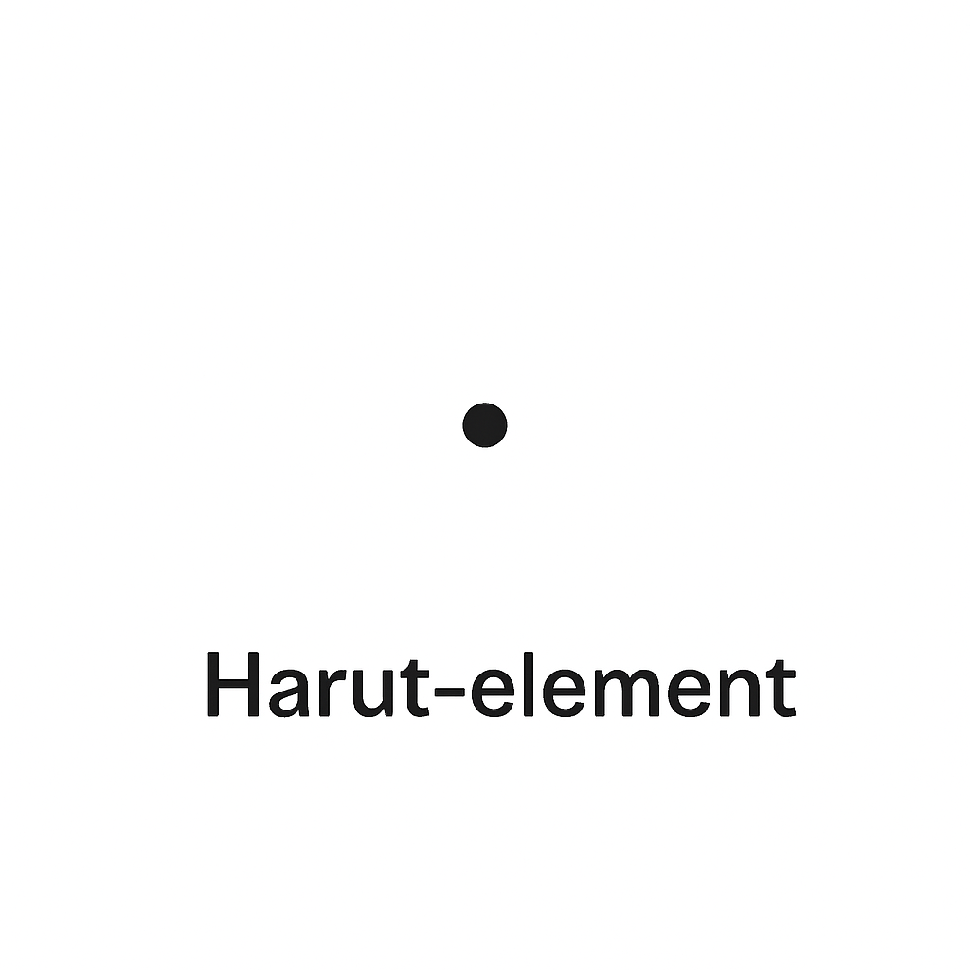
Harut-couple is a pair of two Harut-elements.
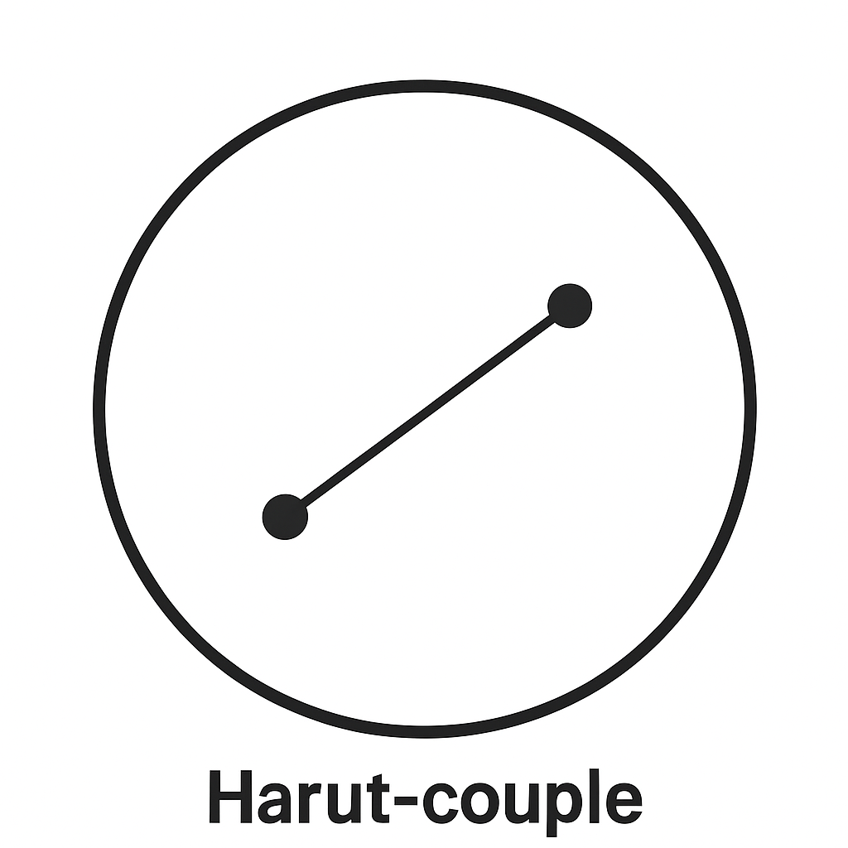
Harut-system is a set that may consist of Harut-elements and Harut-couples.

Notation
The Harut-element is denoted by the letter `h`.
The Harut-couple is denoted by the letter `H`.
The Harut-system is denoted using parenthesis.

Classification of Harut-systems
Harut-systems can be stable or unstable.
Stable Harut-system is a system that consists of only Harut-couples. It is denoted as (H, …).
Unstable Harut-system is a system in which there is one Harut-element. It is denoted as (H, …, h).

Fundamental principles
- A Harut-element tends to form a pair with another Harut-element.
- A stable Harut-system tends to split into two equal parts.
Examples:
(h, h) = (H)
(H, H) = (H) (H)
(H, H, H) = (H, H, h, h) = (H, h) (H, h)

Harut-system dimension
It is the number of Harut-couples in the system. It is denoted as (H, ...)_{N}, where N represents the dimension of the system.

Mutation
A mutation is any change in a Harut-system. By change, we mean that elements may be added to or removed from the system. The system may also be divided into equal parts, or parts may be repeated.
Mutations may have a stabilizing or destabilizing effect on the system.
Examples:
(H, …, h)_{N} + (h) = (H, ...)_{N} + (h, h) = (H, ...)_{N} + (H) = (H, ...)_{N+1}
3 x (H, …, h)_{N} = (H, …, h)_{N} + (H, …, h)_{N} + (H, …, h)_{N} = (H, ...)_{3N} + (h, h) + (h) = (H, ...)_{3N} + (H) + (h) = (H, …, h)_{3N+1}
3 x (H, …, h)_{N} + (h) = (H, …, h)_{3N+1} + (h) = (H, ...)_{3N+1} + (h, h) = (H, ...)_{3N+2}

Decomposability
Decomposability is the property of a stable Harut-system to be divided into an equal number of smaller systems without breaking its stability.
This property is denoted as ^{m}(H, ...)_{N}, where m indicates the number of equal parts into which the system can be decomposed while preserving stability.
Any decomposable stable Harut-system is denoted by the letter S (e.g. ²S – 2-decomposable stable Harut-system)

Harut-mutation
We will refer to a mutation of the form 3 x (²S, h) + h as a Harut-mutation.
Theorem: The Harut-mutation has a stabilizing effect on the Harut-system; however, if applied recursively to a system that exists according to its own fundamental life cycle rules, the system degrades. This means that, as a result of its division, all stable Harut-couples will ultimately exist outside the framework of the system, becoming self-contained.
Proof: We will describe the chain of system stabilization and division in accordance with the fundamental principles of Harut-system lifecycle.
²(H, …, h)_{N}
→ (stabilization) 3 x ²(H, …, h)_{N} + (h)
→ ²(H, …, h)_{N} + ²(H, …, h)_{N} + ²(H, …, h)_{N} + (h)
→ ²(H, …)_{N} + ²(H, …)_{N} + ²(H, …)_{N} + (h, h, h, h)
→ ²(H, …)_{N} + ²(H, …)_{N} + ²(H, …)_{N} + (H, H)
→ (division) ²(H, …)_{N} + ²(H, …)_{N/2} + H
→ (H, …)_{N+N/2+1}
After stabilization and division, the Harut-system ²(H, …, h)_{N} mutates into (H, …)_{N+N/2+1}. Since the Harut-system initially had the 2-decomposable property, we cannot guarantee that the system still possesses this property. We are sure, though, that it is still stable.
Therefore, in accordance with the fundamental principles, the Harut-system must divide into two equal parts; however, after division, it may break down into two stable systems or two unstable ones.
(H, …)_{N+N/2+1} → (H, …)_{(N+N/2+1)/2}
Or
(H, …)_{N+N/2+1} → (H, …, h)_{[(N+N/2+1)/2]}
After all mutations, the rank of the system will stably be
$$⌊\frac{N+\frac{N}{2}+1}{2}⌋$$
and, in the longest mutation scenario, will enter the life cycle of
$$N→⌊\frac{N+N/2+1}{2}⌋$$
We will prove that the recursive function converges.
$$N=⌊\frac{N+N/2+1}{2}⌋$$
Proof using the deviation from the fixed point method.
The stationary point is L = 2.
Let’s consider the difference D_{i} = N_{i} – 2.
$$N_{i+1}−2=⌊\frac{3⋅N_{i}+2}{4}⌋−2=⌊\frac{3⋅N_{i}+2−8}{4}⌋=⌊\frac{3⋅N_{i}−6}{4}⌋=⌊\frac{3⋅\left(N_{i}−2\right)}{4}⌋=⌊\frac{3⋅D_{i}}{4}⌋$$
D_{i+1} = [3D_{i} / 4], D_{i} > 0 => D_{i+1} < D_{i}
$$D_{i+1}=⌊\frac{3D_{i}}{4}⌋,D_{i}>0→D_{i+1}<D_{i},Q.E.D.$$

The Collatz Conjecture
The Collatz Conjecture states that if you take any positive integer n and apply the following rules repeatedly, you will eventually reach the number 1.
The rules are:
If n is even, divide it by 2
If n is odd, multiply it by 3 and add 1
Let us draw an analogy between numbers and Harut-systems.
2(H, …, h)N = (H, …, h)2N
The (H, …, h)2N system represents a number A, such that A mod 4 = 1.
The (H, …)8n+2 system represents a number B, such that B mod 4 = 2.
The two divisions in a row indicate that the degradation actually begins with a number C, such that C mod 4 = 0.
Harut-mutation represents the 3x+1 function
Thus, for all numbers where the remainder modulo 4 is 0, 1 or 2, the Collatz Conjecture is verified.
Let us prove that for any number D such that D mod 4 = 3, the Collatz Conjecture also holds.
D mod 4 = 3 => D = 4k + 3
4k + 3 is an odd number => C(D) = 3(4k + 3) + 1 = 12k + 10
(12k + 10) mod 4 = (12k mod 4) + (10 mod 4) = 10 mod 4 = (8 + 2) mod 4 = 2 mod 4 = 2
Thus, any number D such that D mod 4 = 3 will lead to a number E such that E mod 4 = 2.
The hypothesis for such numbers E has already been proven.
Q.E.D.

