**Output Screenshots for Week-2**

**SL4J**

* **Exercise 1: Logging Error Messages and Warning Levels**

Task: Write a Java application that demonstrates logging error messages and warning levels using SLF4J.

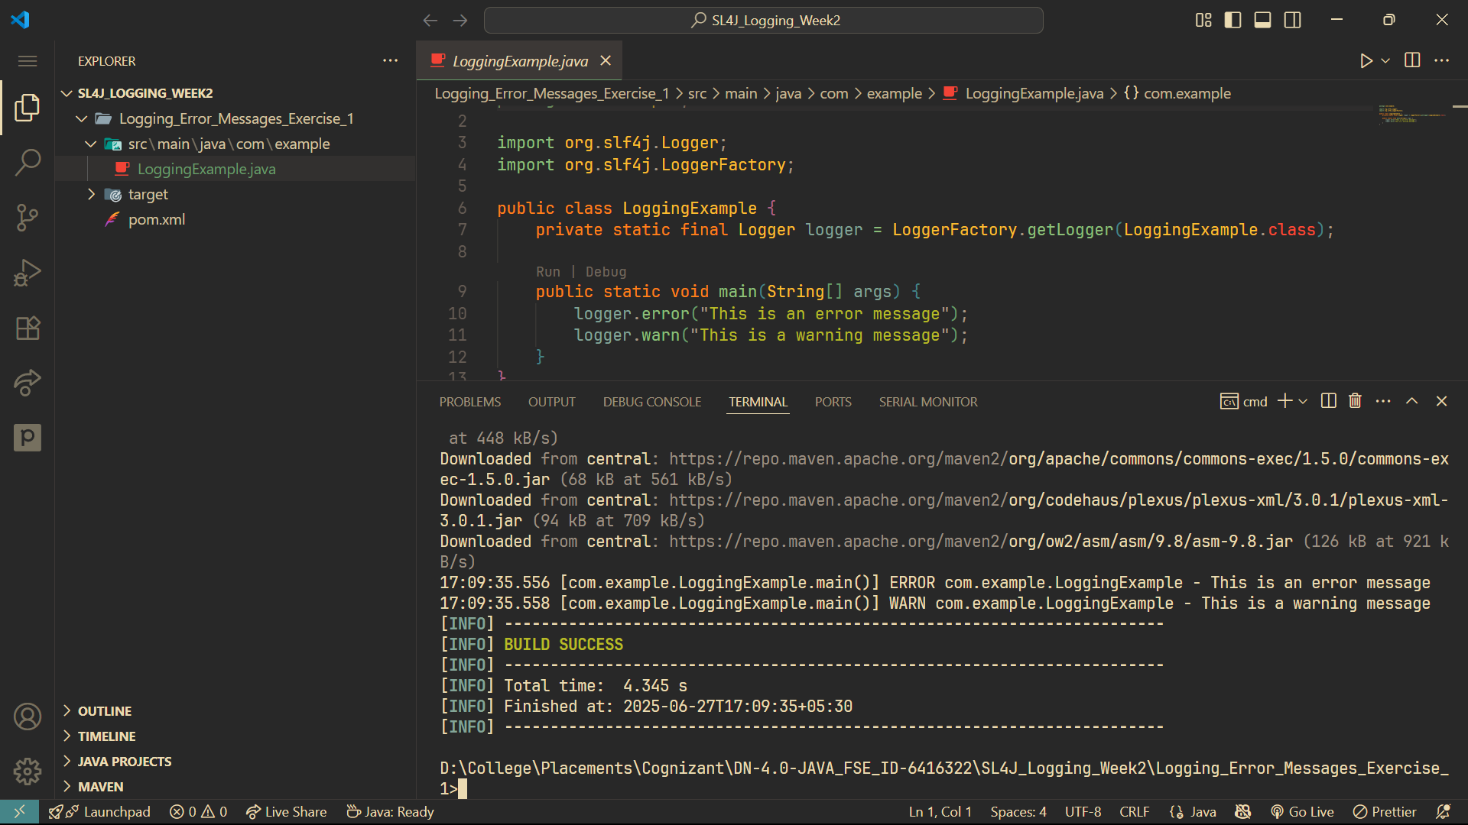**Output**