**Output Screenshots for Week-2**

**Mockito**

* **Exercise 1: Mocking and Stubbing**

**Scenario:**

You need to test a service that depends on an external API. Use Mockito to mock the

external API and stub its methods.

1. Create a mock object for the external API.

Mockito.mock() is used to create a mock of ExternalApi.

ExternalApi mockApi = Mockito.mock(ExternalApi.class);

1. Stub the methods to return predefined values.

getData() is stubbed to return "Mock Data" using when(...).thenReturn(...)

when(mockApi.getData()).thenReturn("Mock Data");

1. Write a test case that uses the mock object.

We injected the mock into MyService and asserted the output using JUnit.

MyService service = new MyService(mockApi);

assertEquals("Mock Data", service.fetchData());

Output:

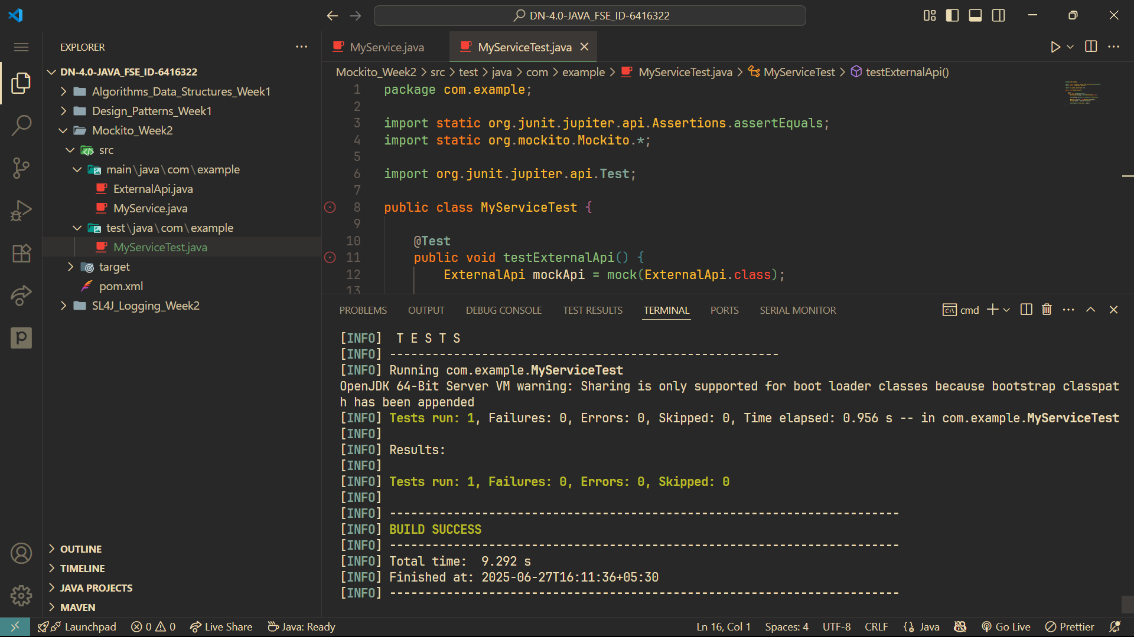

* **Exercise 2: Verifying Interactions**

**Scenario:**

You need to ensure that a method is called with specific arguments.

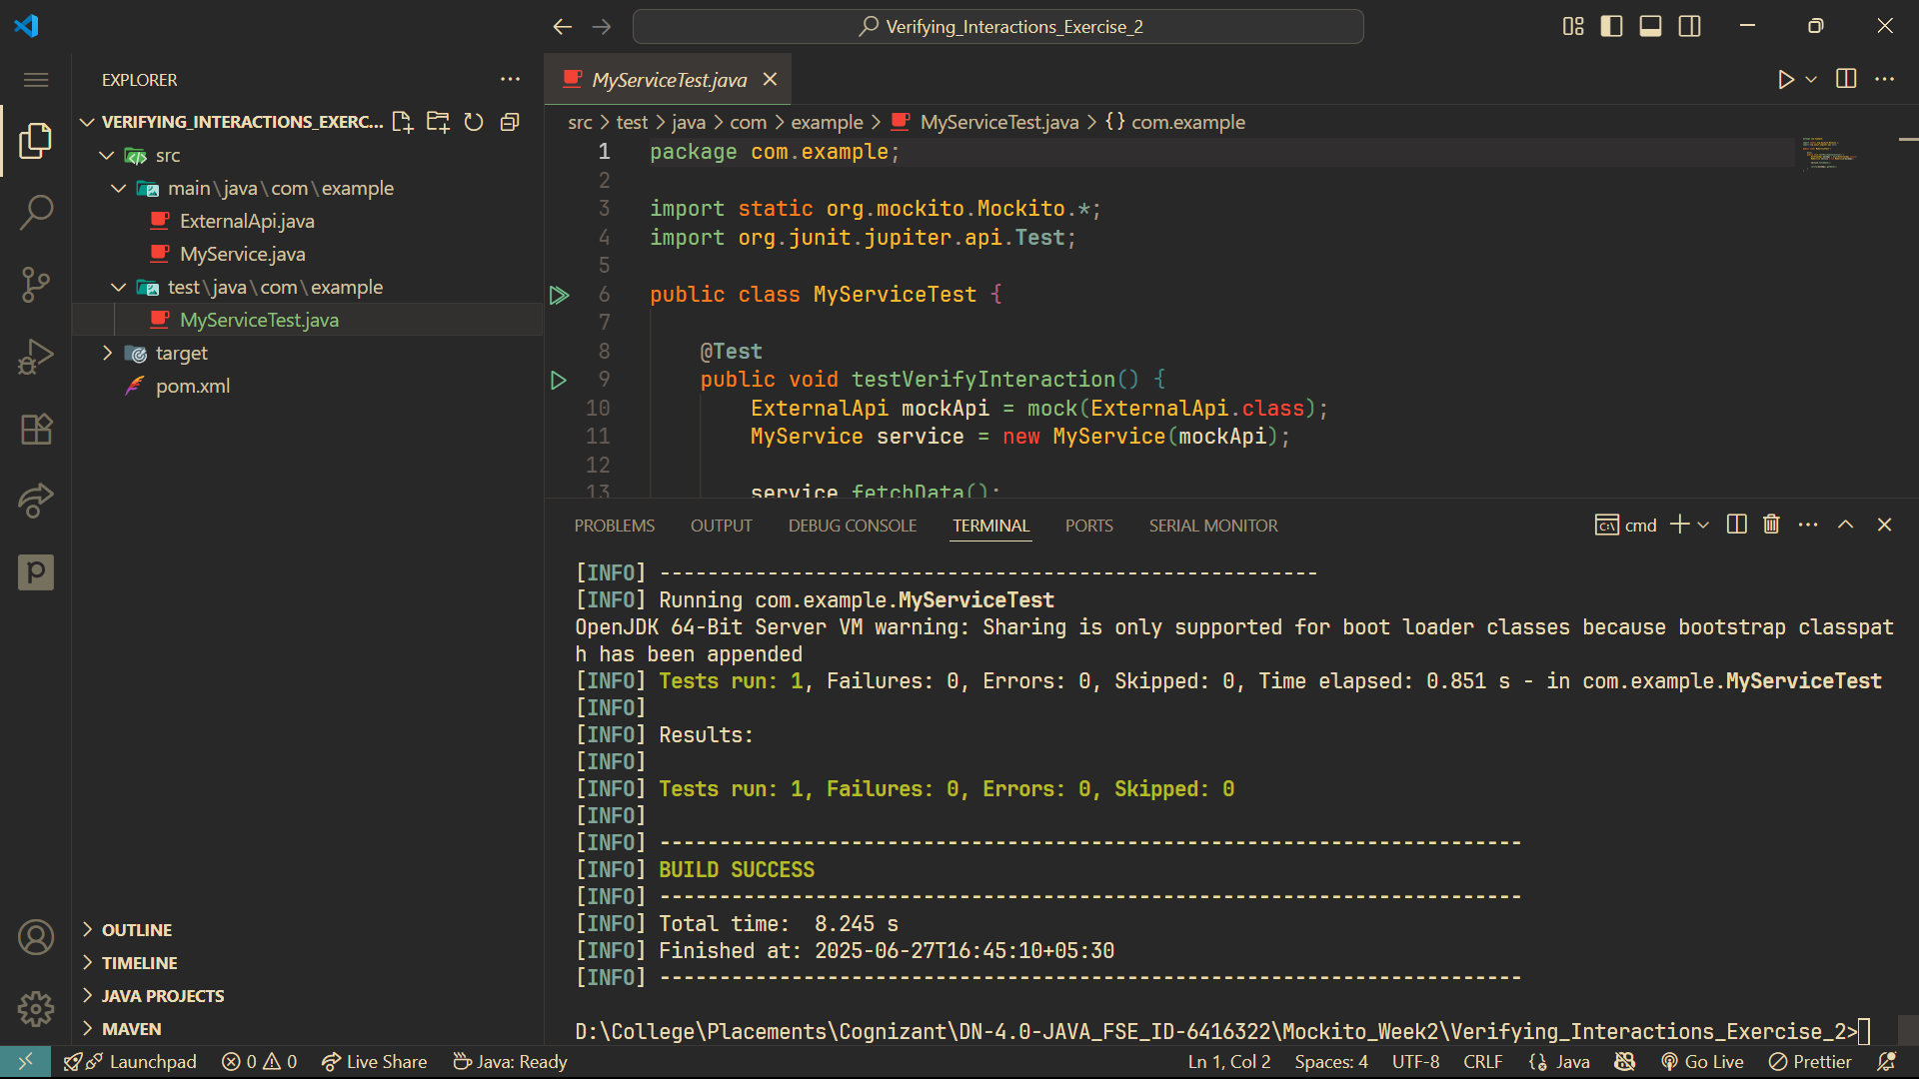Output: