**Creating Microservices for account and loan**

**Week 5**

Outputs :

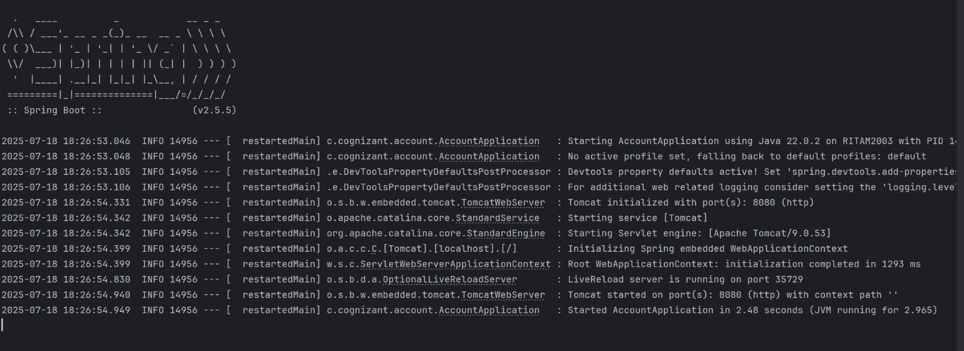Accounts microservice

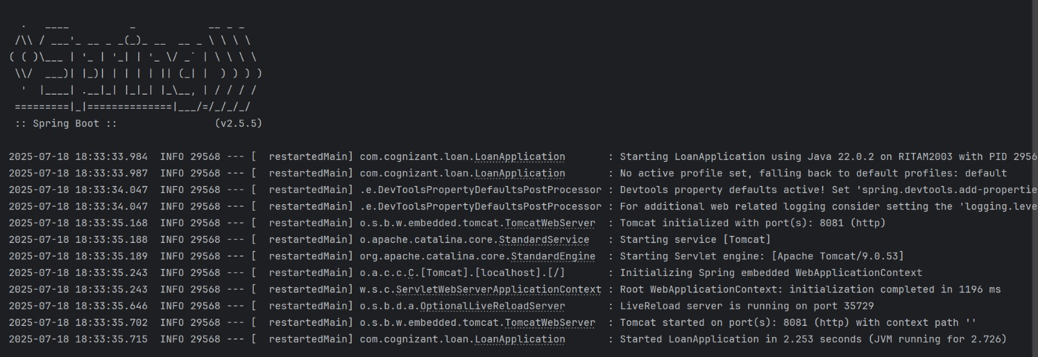

Loan