CD LAB : WEEK2 PROGRAMS AND SCREENSHOTS

SAGNIK CHATTERJEE

180905478

SEC-B

ROLLNO 61

1. Program that takes file as input and replaces blank spaces and tabs by single space and writes the output to a file.

CODE :

/*

AUTHOR: SAGNIK CHATTERJEE

DATE : 9 DEC,2020

USAGE: ./q1 file1 file2

file1 is the input file

file2 is the output file

*/

#include <stdio.h>

#include <stdlib.h>

#include <string.h>

int main(int argc ,char **argv){

FILE *fd , *fd1;

char buffer[1024],ch ;

//argv[1] is the name of the input file passed

fd=fopen(argv[1],"r");

if(fd==NULL){

printf("Cannot open file for reading \n");

exit(0);

}

//argv[2] is the name of the output file to which result is written

fd1=fopen(argv[2],"w");

if(fd1==NULL){

printf("[ERROR] Can't open file or writing \n");

exit(0);

}

//discard extra whitespace and tabs

while((ch=getc(fd))!=EOF){

if(ch==' '||ch=='\t'){

while(ch==' ' || ch=='\t') ch= getc(fd);

putc(' ',fd1);

}

putc(ch,fd1);

}

printf("Wrote to the output file.\n");

fclose(fd);

fclose(fd1);

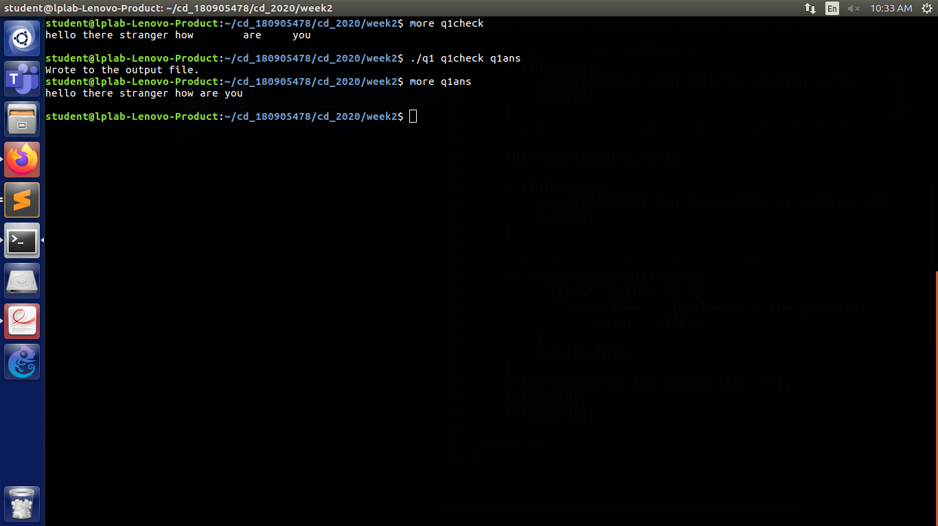return 0;}

Q2 Program to discard processor directives from the given input c file.

CODE:

/*

AUTHOR :SAGNIK CHATTERJEE

DATE :dec9,2020

Usage : ./q2 file1 file2

file1 is the input C file

file2 is the result file

Here input taken from file1check.c and written to file2

*/

#include <stdio.h>

#include <stdlib.h>

#include <string.h>

int main(int argc,char **argv){

FILE *fa, *fb;

//argv[1] is the input file for reading

char ch;

fa=fopen(argv[1],"r");

fb=fopen(argv[2],"w");

if(fa==NULL){

printf("[ERROR] Couldnt the open for reading .\n");

exit(0);

}

if(fb==NULL){

printf("[ERROR] Couldn't open the file for writing.\n");

exit(0);

}

char buffer[1024];//the buffer from whcih we will write to fd

char ignore[1024];//we would read the line but will write to this ignore array

char *line=NULL;

size_t len=0;

ssize_t read;

buffer[1023]='\n';

while((read =getline(&line,&len,fa))!=-1){

if(strstr(line,"#define")!=NULL || strstr(line,"#include")!=NULL){

continue;

}

else{

fputs(line,fb);

}

}

printf("Contents copied to %s",argv[2]);

fclose(fa);

fclose(fb);

return 0;

}

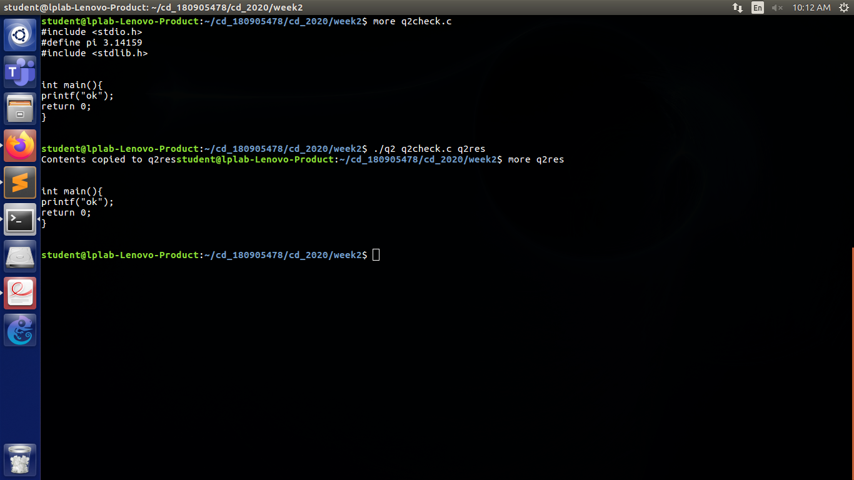

3. Program takes c file as input and recognise all the keywords and prints them in upper case.

Code :

/*

AUTHOR: SAGNIK CHATTERJEE

DATE : DEC 9,2020

USAGE : ./q3 file1

where file1 is the input c file

prints the result to the console

*/

#include <stdio.h>

#include <string.h>

#include <stdlib.h>

#include <ctype.h>

//#include <stdbool.h>

#include <stddef.h>

const char *keywords[32] = {

"auto","double","int","struct","break","else","long",

"switch","case","enum","register","typedef","char",

"extern","return","union","continue","for","signed",

"void","do","if","static","while","default",

"goto","sizeof","volatile","const","float","short",

"unsigned"

};

const char delimiters[]=" .,;:!-()\n\t";

int isKeyword (char *word) {

int i;

for (i = 0; i < 32; ++i) {

if (strcmp(word, keywords[i]) == 0) {

return 1;

}

}

return 0;

}

void printUpperCase (char *word) {

int l = strlen(word);

char z;

int i;

printf("Keywords are :\n");

for (i = 0; i < l; ++i) {

z = word[i];

printf("%c", z > 96 ? z - 32 : z);

}

printf("\n");

}

int main(int argc ,char **argv){

FILE *fd1;

//argv[1] is the input c file we give

fd1=fopen(argv[1],"r");

if(fd1==NULL){

printf("[ERROR] Can't open the file to read from. \n");

exit(0);

}

char buffer[1024];

while(fgets(buffer,1024,fd1) >0){

//temp copy of string

char *cp =(char*)malloc(1024*sizeof(char));

strcpy(cp,buffer);

char *token=(char*)malloc(256*sizeof(char));

do {//strsep :- extract the token from string,returns null if token not found

token =strsep(&cp,delimiters);

if(token!=NULL)

{

if(isKeyword(token)){

printUpperCase(token);

}

}

}while(token!=NULL);

}

fclose(fd1);

//while writing to file use toupper() to make it capital

//since toupper() runs on a char , run a loop or can use ascii style

return 0;

}

