Name:- Chakshu Saraswat
Semester:- 5th
Section:- C
Registration Number:- 180905482
Roll No.:- 57

CD LAB 8

#include <stdio.h>
#include <stdlib.h>
#include <string.h>

#include "q1.c"

void prog();
void dec();
void ilist();
void iprime();
void dtype();
void slist();
void s();
void AS();
void expn();
void eprime();
void se();
void seprime();
void t();
void tprime();
void f();
void relop();
void ao();
void mo();

struct token tkn;
FILE *f1;

void invalid()
{
printf("~~~~~~~~~~INVALID~~~~~~~~~~\n");
exit(0);
}

void valid()
{
printf("~~~~~~~~~~SUCCESS~~~~~~~~~~\n");
exit(0);
}

void updatecurrent()
{
tkn=getNextToken(f1);
}

void prog()
{
updatecurrent();
if(strcmp(tkn.lexemeName,"main")==0)
{
updatecurrent();
if(strcmp(tkn.lexemeName,"(")==0)
{
updatecurrent();
if(strcmp(tkn.lexemeName,")")==0)
{
updatecurrent();
if(strcmp(tkn.lexemeName,"{")==0)
{
dec();
slist();
updatecurrent();
if(strcmp(tkn.lexemeName,"}")!=0)
invalid();
}
else
invalid();
}
else
invalid();
}
else
invalid();
}
else
invalid();
}

void dec()
{
updatecurrent();
if(strcmp(tkn.lexemeName,"int")==0||strcmp(tkn.lexemeName,"char")==0)
{
dtype();
ilist();
if(strcmp(tkn.lexemeName,";")==0)
{
dec();
}
else
invalid();
}
else
return;
}

void slist()
{
if(strcmp(tkn.lexemeName,"id")==0)
{
s();
if(strcmp(tkn.lexemeName,"id")==0)
{
slist();
}
}
else
return;
}

void s()
{
AS();
updatecurrent();
if(strcmp(tkn.lexemeName,";")!=0)
invalid();
}

void AS()
{
if(strcmp(tkn.lexemeName,"id")==0)
{
updatecurrent();
if(strcmp(tkn.lexemeName,"=")==0)
{
expn();
}
else
invalid();
}
else
invalid();
}

void expn()
{
se();
eprime();
}

void se()
{
t();
seprime();
}

void t()
{
f();
tprime();
}

void f()
{
updatecurrent();
if(strcmp(tkn.lexemeName,"id")!=0&&strcmp(tkn.lexemeName,"num")!=0)
invalid();
}

void seprime()
{
if(strcmp(tkn.lexemeName,"+")==0||strcmp(tkn.lexemeName,"-")==0)
{
ao();
t();
seprime();
}
else
return;
}

void tprime()
{
if(strcmp(tkn.lexemeName,"*")==0||strcmp(tkn.lexemeName,"/")==0||strcmp(tkn.lexemeName,"%")==0)
{
mo();
f();
tprime();
}
else
return;
}

void eprime()
{
if(strcmp(tkn.lexemeName,"==")==0||strcmp(tkn.lexemeName,"!=")==0||strcmp(tkn.lexemeName,"<=")==0||strcmp(tkn.lexemeName,">=")==0||strcmp(tkn.lexemeName,"<")==0||strcmp(tkn.lexemeName,">")==0)
{
relop();
se();
}
else
return;
}

void relop()
{
updatecurrent();
if(strcmp(tkn.lexemeName,"==")!=0&&strcmp(tkn.lexemeName,"!=")!=0&&strcmp(tkn.lexemeName,"<=")!=0&&strcmp(tkn.lexemeName,">=")!=0&&strcmp(tkn.lexemeName,">")!=0&&strcmp(tkn.lexemeName,"<")!=0)
invalid();
}

void ao()
{
updatecurrent();
if(strcmp(tkn.lexemeName,"+")!=0&&strcmp(tkn.lexemeName,"-")!=0)
invalid();
}

void mo()
{
updatecurrent();
if(strcmp(tkn.lexemeName,"*")!=0&&strcmp(tkn.lexemeName,"/")!=0&&strcmp(tkn.lexemeName,"%")!=0)
invalid();
}

void dtype()
{
if(strcmp(tkn.lexemeName,"int")!=0&&strcmp(tkn.lexemeName,"char")!=0)
invalid();
}

void ilist()
{
updatecurrent();
if(strcmp(tkn.lexemeName,"id")!=0)
invalid();
iprime();
}

void iprime()
{
updatecurrent();
if(strcmp(tkn.lexemeName,",")==0)
ilist();
else if(strcmp(tkn.lexemeName,"[")==0)
{
updatecurrent();
if(strcmp(tkn.lexemeName,"num")==0)
{
updatecurrent();
if(strcmp(tkn.lexemeName,"]")==0)
{
updatecurrent();
if(strcmp(tkn.lexemeName,",")==0)
{
ilist();
}
else
return;
}
else
invalid();
}
else invalid();
}
else
return;
}

void parse()
{
prog();
valid();
}

int main()
{
f1 = fopen("input.c","r");
if(f1==NULL)
{
printf("File does not exist!!!\n");
exit(0);
}
parse();
}

OUTPUT:-

Case 1:-

main()
{
int b;
int a[100];
char b,c;
a = 5;
}

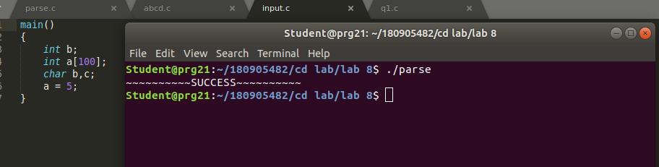

Case 2:-

main()
{
int b;
int a[100];
char b,;
a = 5;
}

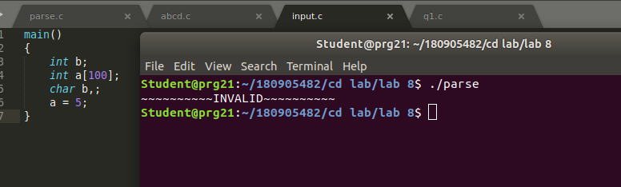

Case 3:-

main()
{
int b;
int a[100];
a = 5;
}

