LAB-6 Compiler Design :Recursive Descent Parser

Name : Sagnik Chatterjee

Sec :B

Roll No :61

Reg :180905478

Q1.

cODE:

#include <stdio.h>

#include <string.h>

#include <stdlib.h>

int curr=0;

char str[100];

void S();

void T();

void TPrime();

void invalid() {

printf("------ ERROR-------\n");

exit(1);

}

void valid() {

printf("--------SUCCESS------\n");

exit(0);

}

void S() {

if(str[curr]=='a'){

curr++;

return;

}

else if(str[curr]='>'){

curr++;

return;

}

else if(str[curr]=='('){

curr++;

T();

if(str[curr]==')'){

curr++;

return ;

}

invalid();

}

else

{

invalid();

}

}

void T() {

S();

TPrime();

}

void TPrime(){

if(str[curr]==','){

curr++;

S();

}

}

int main() {

printf("Enter string \n");

scanf("%s",str);

S();

if(str[curr]=='$'){

valid();

}

else{

invalid();

}

}

Screenshot:

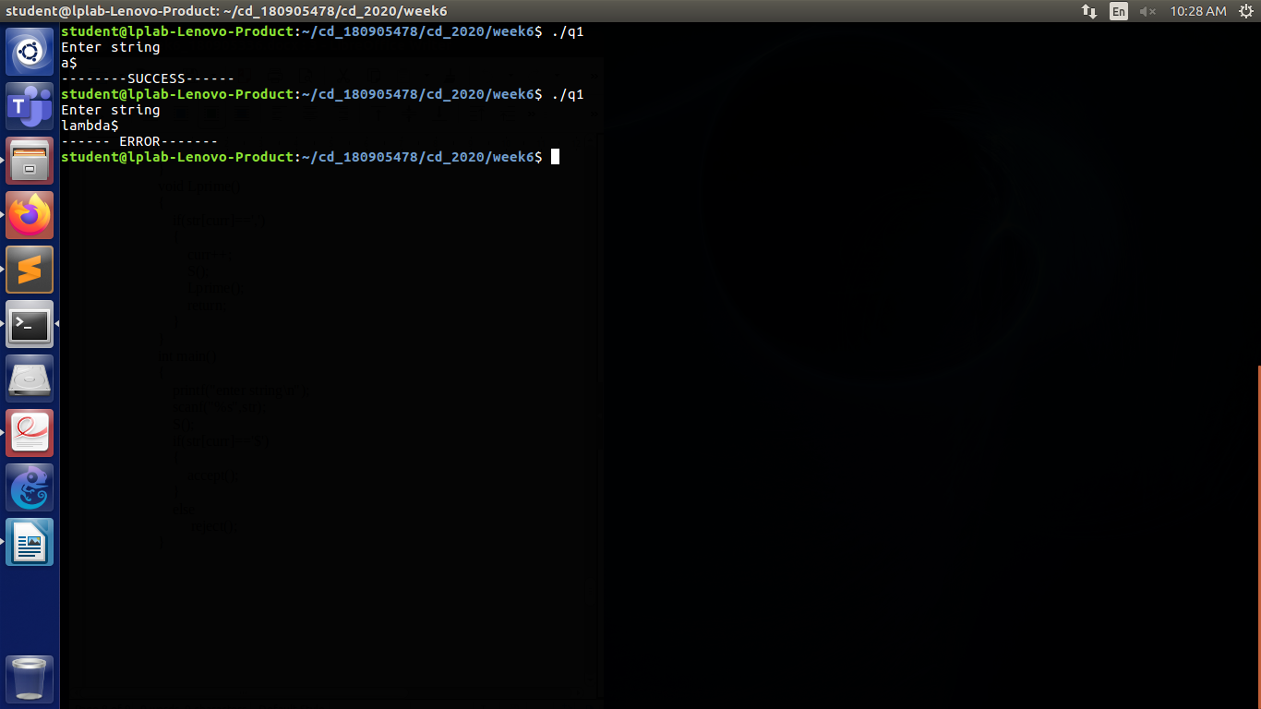

Q2

Code:

#include <stdio.h>

#include <stdlib.h>

#include <string.h>

int curr = 0;

char str[100];

void S();

void U();

void V();

void W();

void invalid() {

printf("------ERROR-----\n");

exit(0);

}

void valid() {

printf("------SUCCESS-----\n");

exit(0);

}

void S() {

U();

V();

W();

}

void U() {

if (str[curr] == '(') {

curr++;

S();

if (str[curr] == ')') {

curr++;

return ;

}

else{

invalid();

}

}

else if (str[curr] == 'a') {

curr++;

S();

if(str[curr++] = 'b'){

curr++;

return ;

}

else{

invalid();

}

}

else if(str[curr++] = 'd'){

curr++;

return ;

}

else {

invalid();

}

}

void V() {

if (str[curr] == 'a') {

curr++;

V();

return ;

}

}

void W() {

if (str[curr] == 'c') {

curr++;

W();

return ;

}

}

int main() {

printf("Enter string\n");

scanf("%s", str);

S();

if (str[curr] == '$')

valid();

else {

invalid();

}

}

Screenshot:

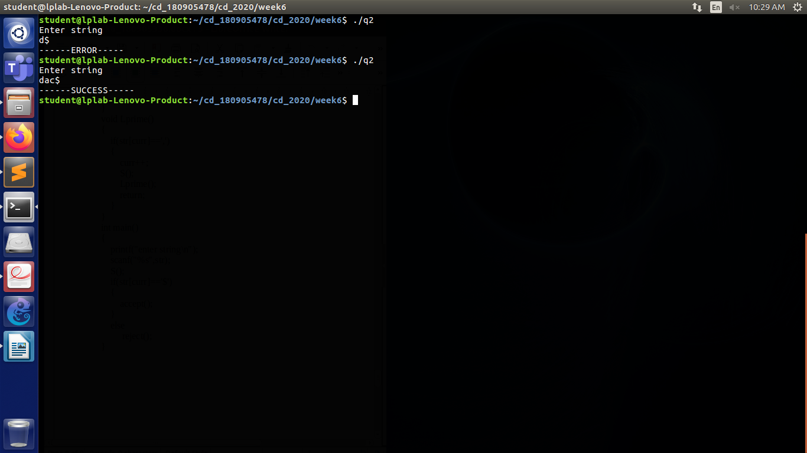

Q3

CODE:

#include <stdio.h>

#include <stdlib.h>

#include <string.h>

int curr = 0;

char str[100];

void S();

void A();

void APrime();

void B();

void valid() {

printf("------VALID-----\n");

exit(0);

}

void invalid() {

printf("------INVALID-----\n");

exit(0);

}

void S() {

if (str[curr] == 'a') {

curr++;

A();

if (str[curr] == 'c') {

curr++;

B();

if (str[curr] == 'e') {

curr++;

return ;

}

else{

invalid();

}

}

else{

invalid();

}

}

else {

invalid();

}

}

void APrime(){

if(str[curr]=='b'){

curr++;

APrime();

return ;

}

}

void A() {

if (str[curr] == 'b') {

curr++;

APrime();

}

else{

invalid();

}

}

void B(){

if(str[curr]=='d'){

curr++;

return ;

}

}

int main() {

printf("Enter the string \n");

scanf("%s", str);

S();

if (str[curr] == '$')

valid();

else invalid();

return 0;

}

Screenshot:

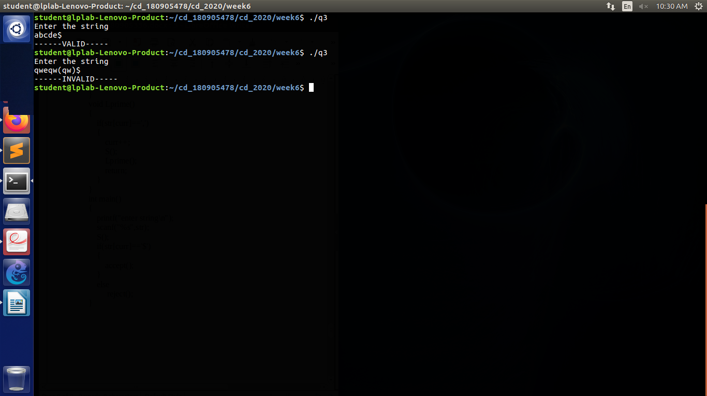

Q4

Code:

#include <stdio.h>

#include <stdlib.h>

#include <string.h>

int curr=0;

char str[100];

void invalid() {

printf("------ERROR-----\n");

exit(0);

}

void valid() {

printf("------SUCCESS-----\n");

exit(0);

}

void S();

void L();

void LPrime();

void S(){

if(str[curr]=='('){

curr++;

L();

if(str[curr]==')'){

curr++;

return ;

}

invalid();

}

else if(str[curr]=='a'){

curr++;

return ;

}

else {

invalid();

}

}

void L(){

S();

LPrime();

}

void LPrime(){

if(str[curr]==','){

curr++;

S();

LPrime();

return ;

}

}

int main(){

printf("Enter string \n");

scanf("%s",str);

S();

if(str[curr]=='$'){

valid();

}

else{

invalid();

}

}

Screenshot:

