Devesh Mahajan
180905242
B-34

5.1 PC-1
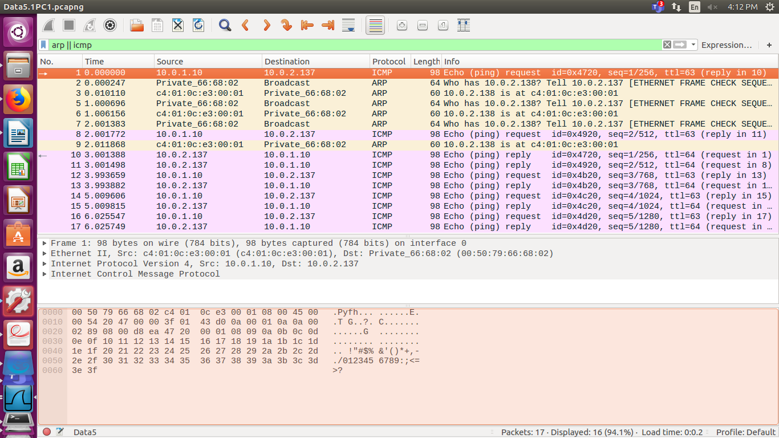
5.1 PC-3
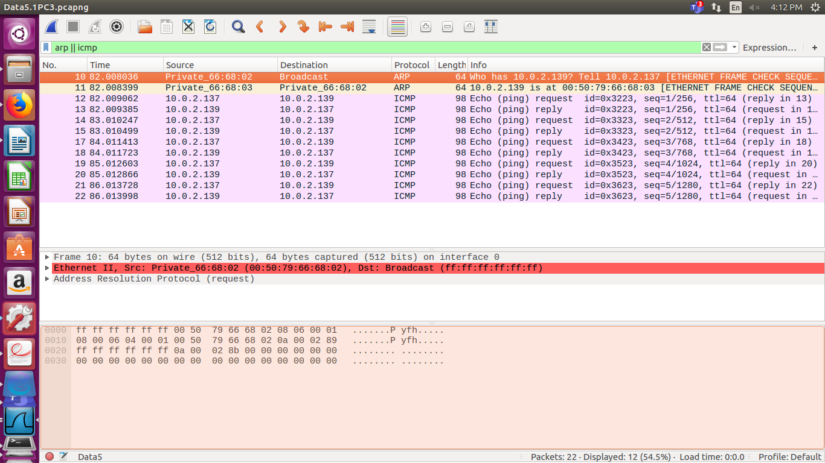
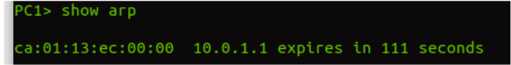
ARP Table pc1
ARP table PC3

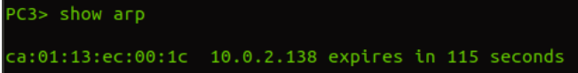

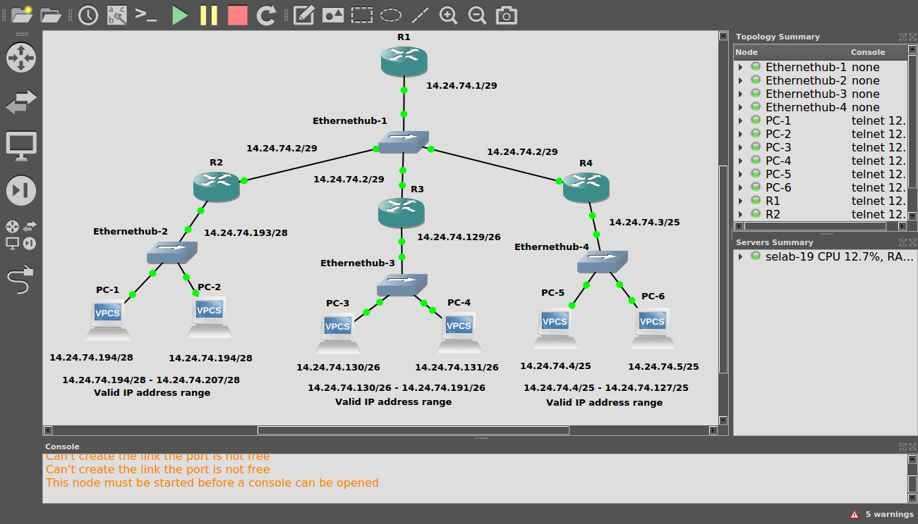
5.2

There are 232 -24 =256 addressesin this block. the first address is 14.24.74.0/24; The last address is 14.24.74.255/24.
To satisfy the third requirment ,we assign addresses to subblocks, starting with the largest and ending with the smallest one.
1) The number of addresses in the largest subblock ,which requires 120 addresses, is not power of 2, we allocate 128 addresses .The subnet mask for this subnet can be found as 32 -log2128 =25. The first address in this block is 14.24.74.0/25 ; the last address is 14.24.74.127/25.
2)The number of addresses in the second largest subblock , which requires 60 addresses , is not a power of 2 either, we allocate 64 addresses .The subnet mask for this subnet can be found as 32 - log264 = 26.The first address in this block is 14.24.74.128/26;The last address is 14.24.74.191/26
3) The number of addresses in the smallest subblock ,which requires 10 addresses, is not a power of 2 either.we allocate 16 addresses.The subnet mask for this subnet can be found as 32-log216 = 28. The first address in this block is 14.24.74.192/28; The last address is 14.24.74.207/28

Communication between PC1 and PC2
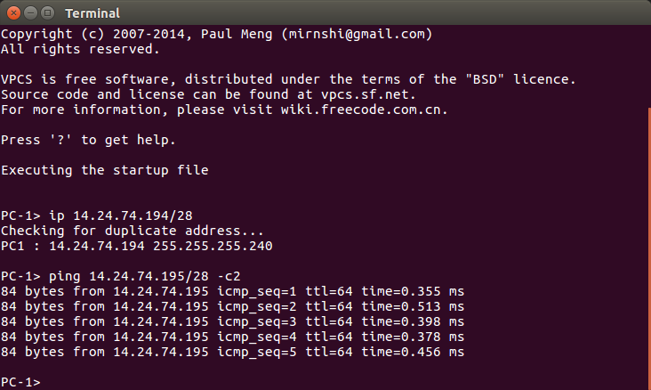
Communication between PC3 and PC4
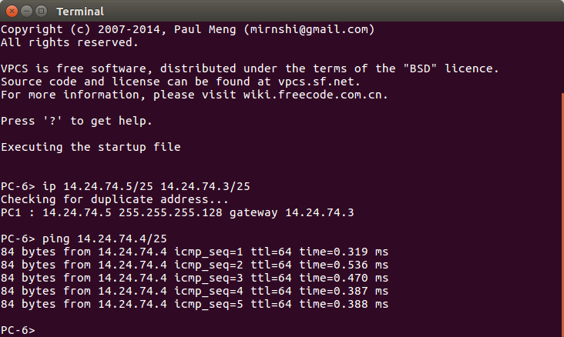

Communication between PC5 and PC6
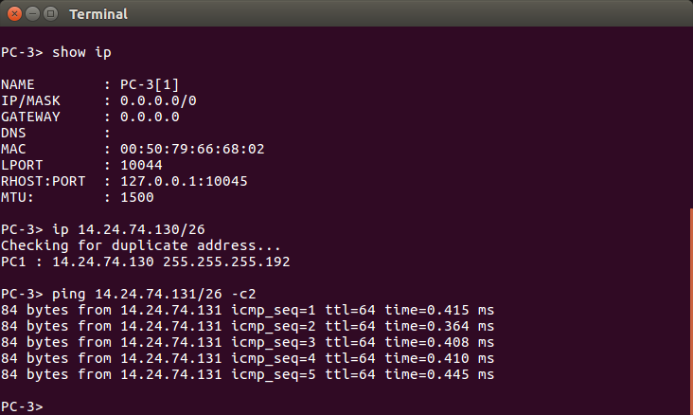
7.1
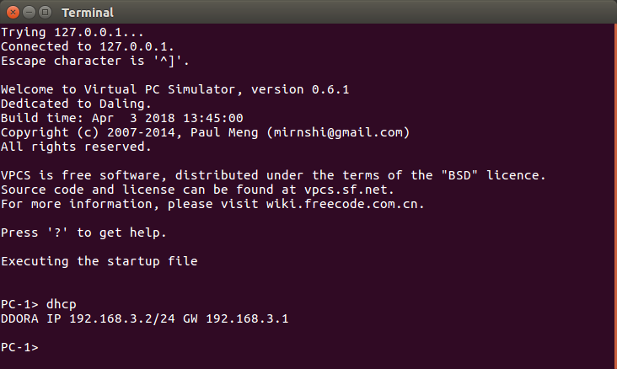

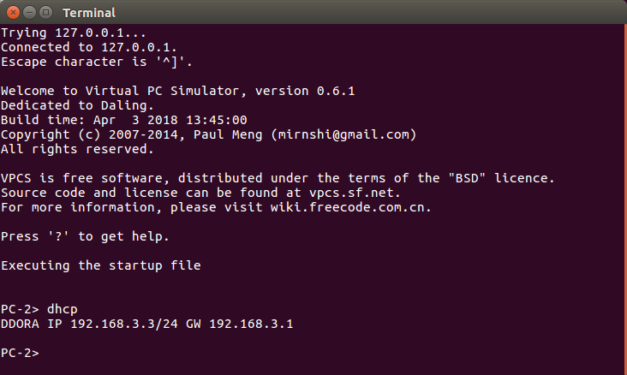
7.2

