https://protechgurus.com/how-to-use-vpcs-in-gns3/
http://gns3-tutorials.blogspot.com/2015/01/router-basic-command-and-static-route.html

How To Use VPCS in GNS3

In order to perform CCNA and CCNP lab exercises, first, you need to create a topology. We know that arranging hardware devices such as router, switch, and PCs are not possible for everyone. Fortunately, there are various simulators such as Cisco Packet Tracer and GNS3 are available that can be used to perform all the lab exercises for the learning purpose. Here , we will learn how to use VPCS in GNS3.

1. Adding VPCS in GNS3
We assume that you have already installed GNS3 on your system. Once you are familiar with the GNS3 simulator, let see how to use VPCS in GNS3. In order to use VPCS in GNS3, you need to following steps:

- In the GNS3 console, drag an Ethernet Switch in the work view area.
- Drag two VPCS machines in the work view area.
- Connect PC1 to port 1 of Ethernet switch and connect PC2 to port 2 of Ethernet switch.
- Right-click on PC1 and then select Start to start it. Similarly, start PC2 also.
The following figure shows how to add VPCS in GNS3.
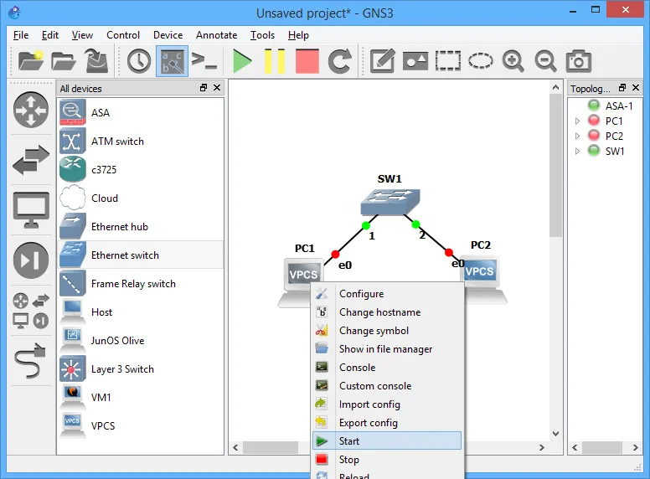
2. Configure IP address on VPCS in GNS3

Once you have created the preceding topology in GNS3, the next task is configuring IP addresses and other TCP/IP settings on VPCS machines. In order to configure IP addresses on VPCS in GNS3, you need to perform the following steps:

- Select and right-click PC1 and select Console to open its console. The CLI prompt window will be displayed.
- In the CLI prompt window, use the following syntax to configure TCP/IP settings on the VPCS.
ip <IP Address> </Subnet Mask> <Default Gateway>

Eg: ip 192.168.100.1/24 192.168.100.254

ip 192.168.100.1 255.255.255.0 192.168.100.254

- Next, use the following syntax to configure DNS server IP address.
ip dns <DNS server IP address>

Eg: ip dns 192.168.100.155

- If you want to obtain TCP/IP setting on VPCS machine using the DHCP server, use the following syntax to obtain the TCP/IP settings from the DHCP server.

ip dhcp
- Once you have configured appropriate IP addresses on a VPCS machine, use the following command to view the TCP/IP settings.

show ip

Router basic command and static route configuration

Task 1: Execute basic command in each router: host name, enable secret, password, login...
1. Change router name from R1 to GNS3
R1>enable
R1#configure terminal
R1(config)#hostname GNS3
GNS3(config)#
2. Enable password before enter to privilege mode (password: gns3)

R1#configure terminal
R1(config)#enable secret gns3

3. Configure Banner
R1>enable
Password:
R1#configure terminal
Enter configuration commands, one per line. End with CNTL/Z.
R1(config)#banner motd #
Warning! This is my banner :)#

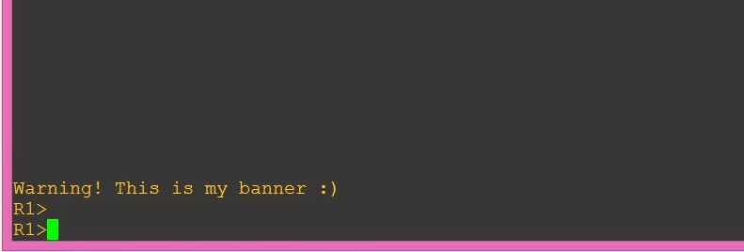
Show banner in user mode window

4. Configure password telnet, this configuration will help your router more secure.
R1>enable
Password:
R1#configure terminal
Enter configuration commands, one per line. End with CNTL/Z.
R1(config)#line vty 0 4
R1(config-line)#password gns3
R1(config-line)#login

5. Use show running-configure to show result

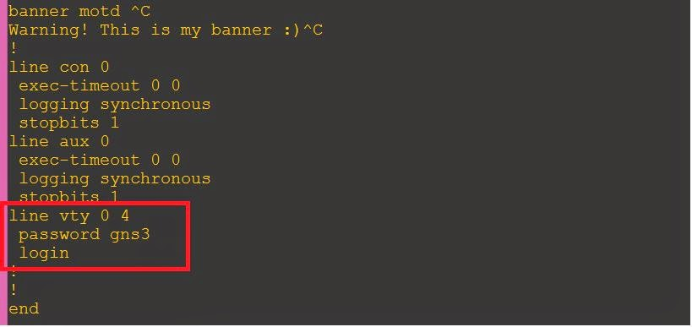
Password in clear text, easy to attack.

6. We should use "service password-encryption" to increase secure for telnet password.

R1#configure terminal
Enter configuration commands, one per line. End with CNTL/Z.
R1(config)#service password-encryption
R1(config)#exit

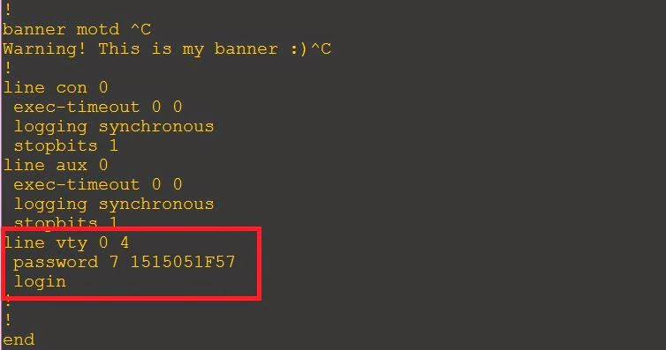
Telnet password already encrypted

7. To save router configuration use command "copy running-config startup-config"
R1#copy running-config startup-config
Destination filename [startup-config]?
Building configuration...
[OK]
8. Clear configuration in router use command "erase startup-config"
R1#erase startup-config
Erasing the nvram filesystem will remove all configuration files! Continue? [confirm]
[OK]

Task 2: Configure IP for each interface in each router and PCs

1. For a Router R1 configuring ip address for port serial 2/0 and f0/0

R1>enable
Password:

R1#configure terminal
Enter configuration commands, one per line. End with CNTL/Z
R1(config)#interface serial 2/0
R1(config-if)#ip address 172.16.2.1 255.255.255.0
R1(config-if)#clock rate 64000
R1(config-if)#no shutdown
R1(config-if)#exit

R1(config)#interface fastEthernet 0/0
R1(config-if)#ip address 172.16.3.1 255.255.255.0
R1(config-if)#no shutdown

2. Show result, use command "show ip interface brief"

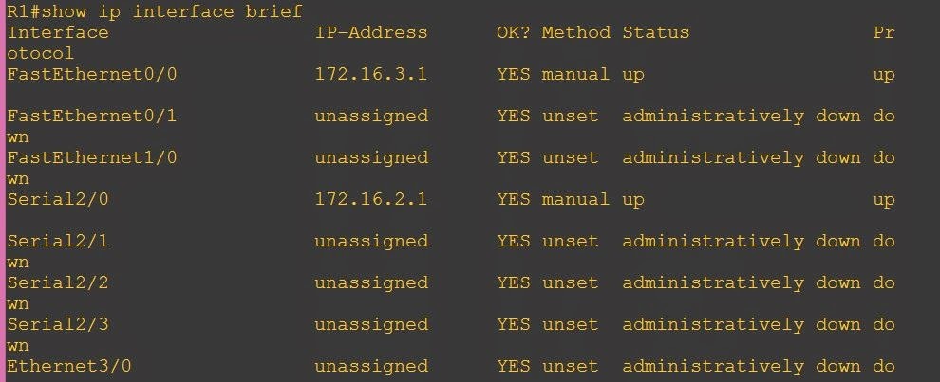

Show detail port information in router R1

Task 3: Configure static route
Enable debug routing use command "debug ip routing"
R1#debug ip routing
IP routing debugging is on

Static route syntax

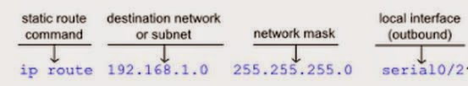
or

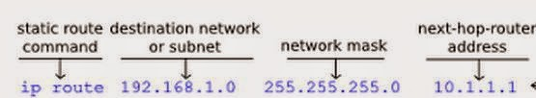

3. To remove ip route, use command "no ip route"
Example: R3(config)#no ip route 172.16.1.0 255.255.255.0 serial 2/0

Show ip route table use "show ip route" command

