REG: 180905478

NAME: SAGNIK CHATTERJEE

ROLL NO: 61

SECTION : 6B

Q1 Write a program to find the area of rectangle. Take input from user.

COde:

x=int(input("Enter length: "))

y=int(input("Enter breadth: "))

print(f"Area of the rectangle is :{x*y}")

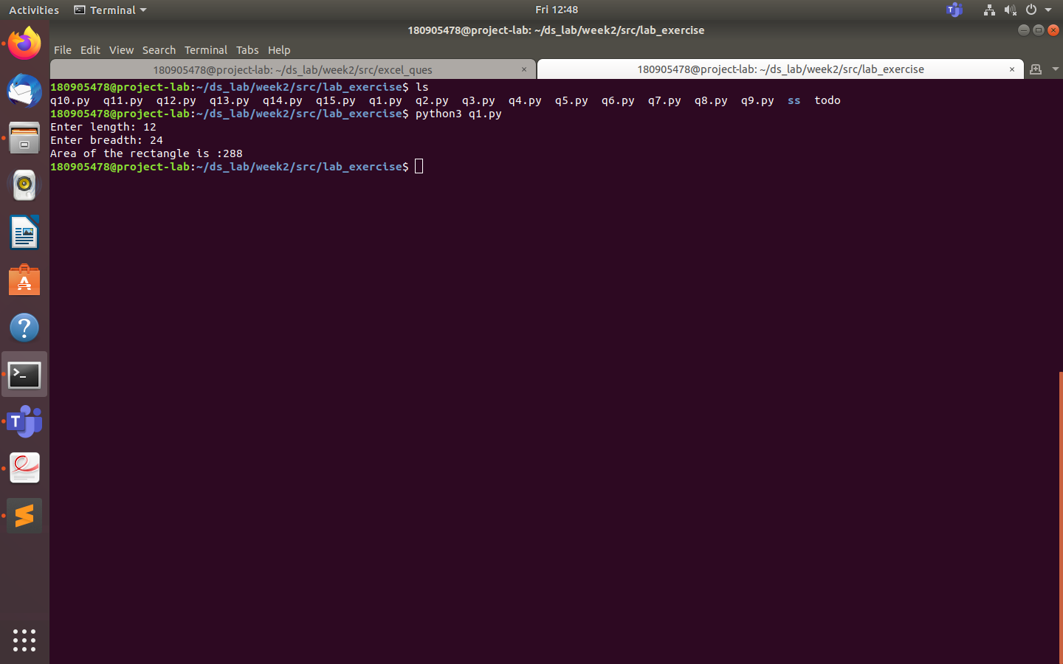

Q2 Write a program to swap the values of two variables.

Code:

x=int(input("Enter the first number : "))

y=int(input("Enter the second number : "))

print("The numbers after swapping")

x,y=y,x

print(f"The first number after swapping :{x}")

print(f"The second number after swapping :{y}")

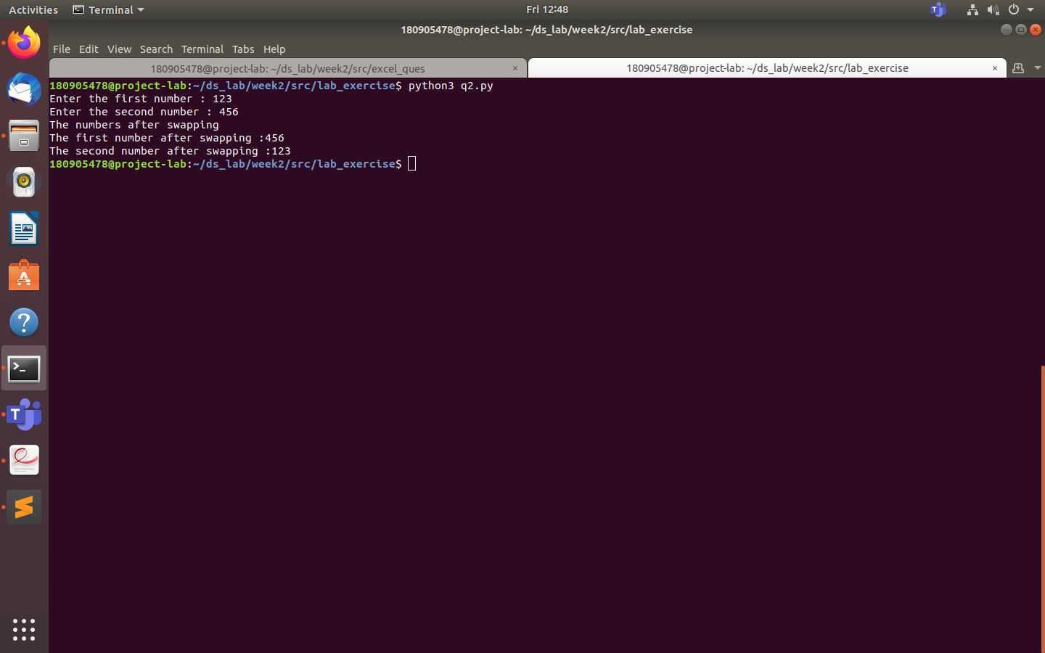

Q3 Write a program to find whether a number is even or odd.

x=int(input("Enter the number: "))

if(x%2==0):

print(f"No: {x} is even")

else:

print(f"No: {x} is odd")

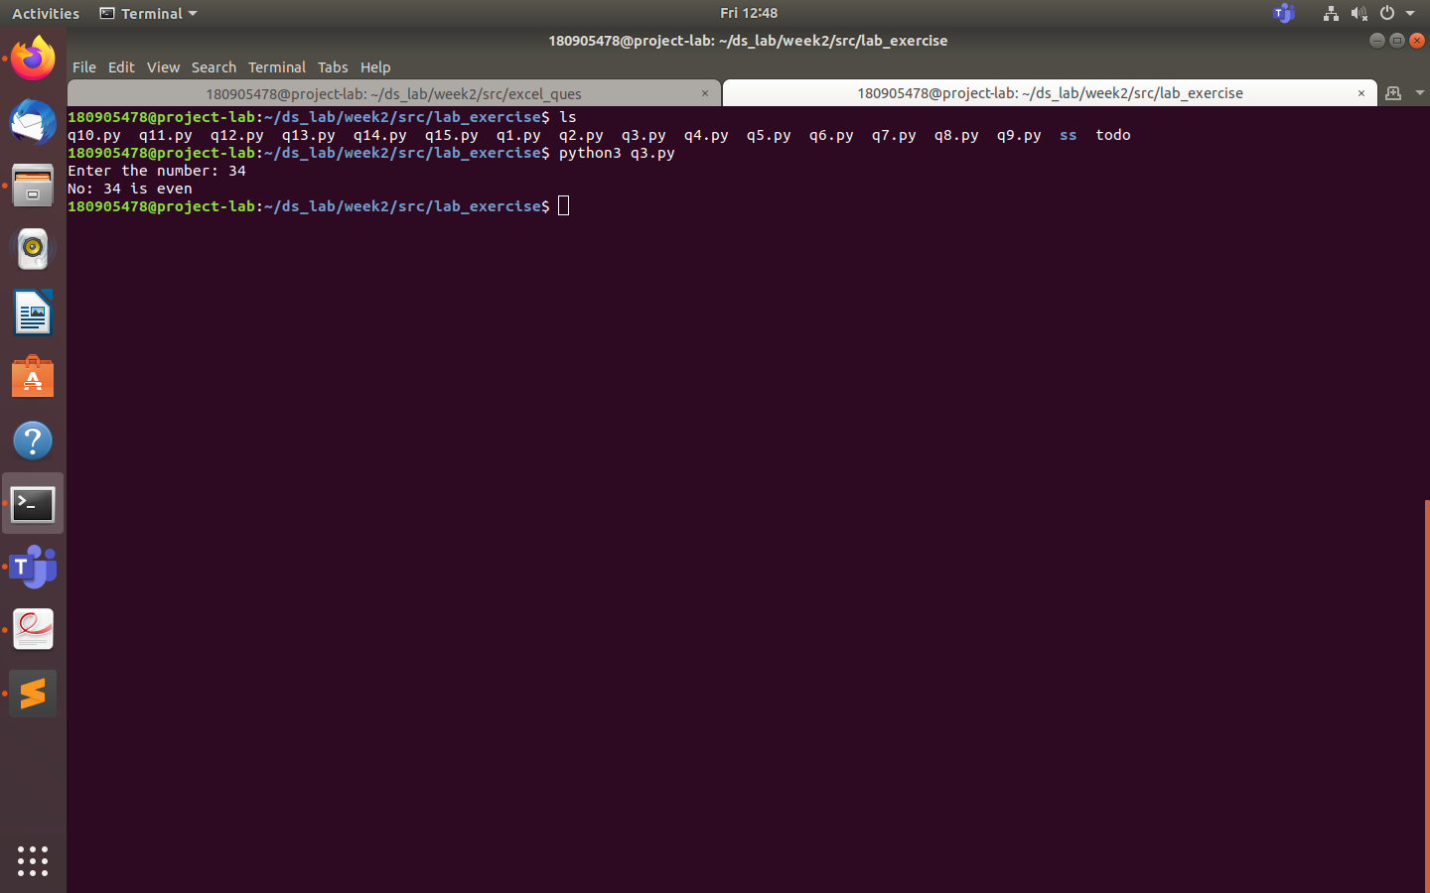

Q4 Write a program to check the largest among the given three numbers.

a=int(input("Enter the first number: "))

b=int(input("Enter the second number: "))

c=int(input("Enter the third number: "))

if c<b<a or b<c<a:

print(f"the largest number is : {a}")

elif a<c<b or c<a<b:

print(f"the largest number is : {b}")

elif a<b<c or b<a<c:

print(f"the largest number is : {c}")

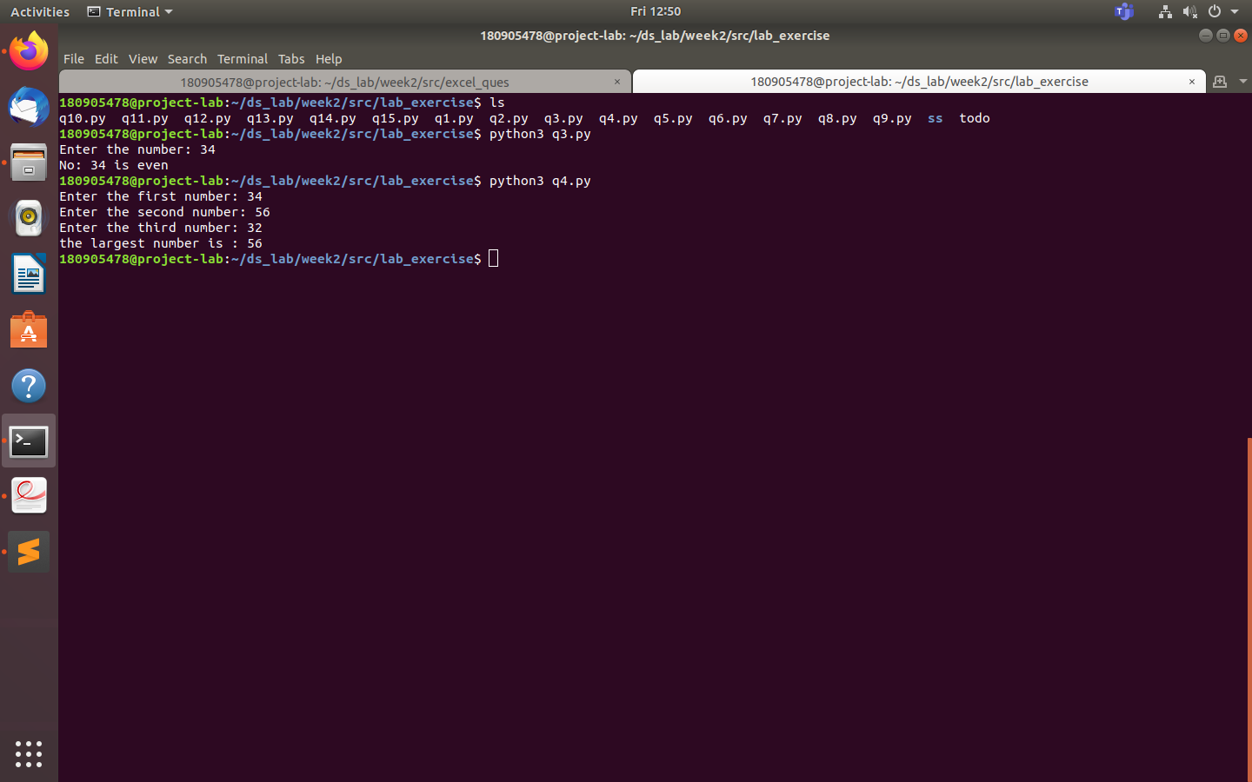

Q5 Write a program to demonstrate while loop with else.

print("While loop with else program")

x=int(input("Enter a number: "))

while x>0:

if x%2==0:

print(f"The value of x is : {x/2}")

else:

print(f"The value of x is : {x}")

x=x-1

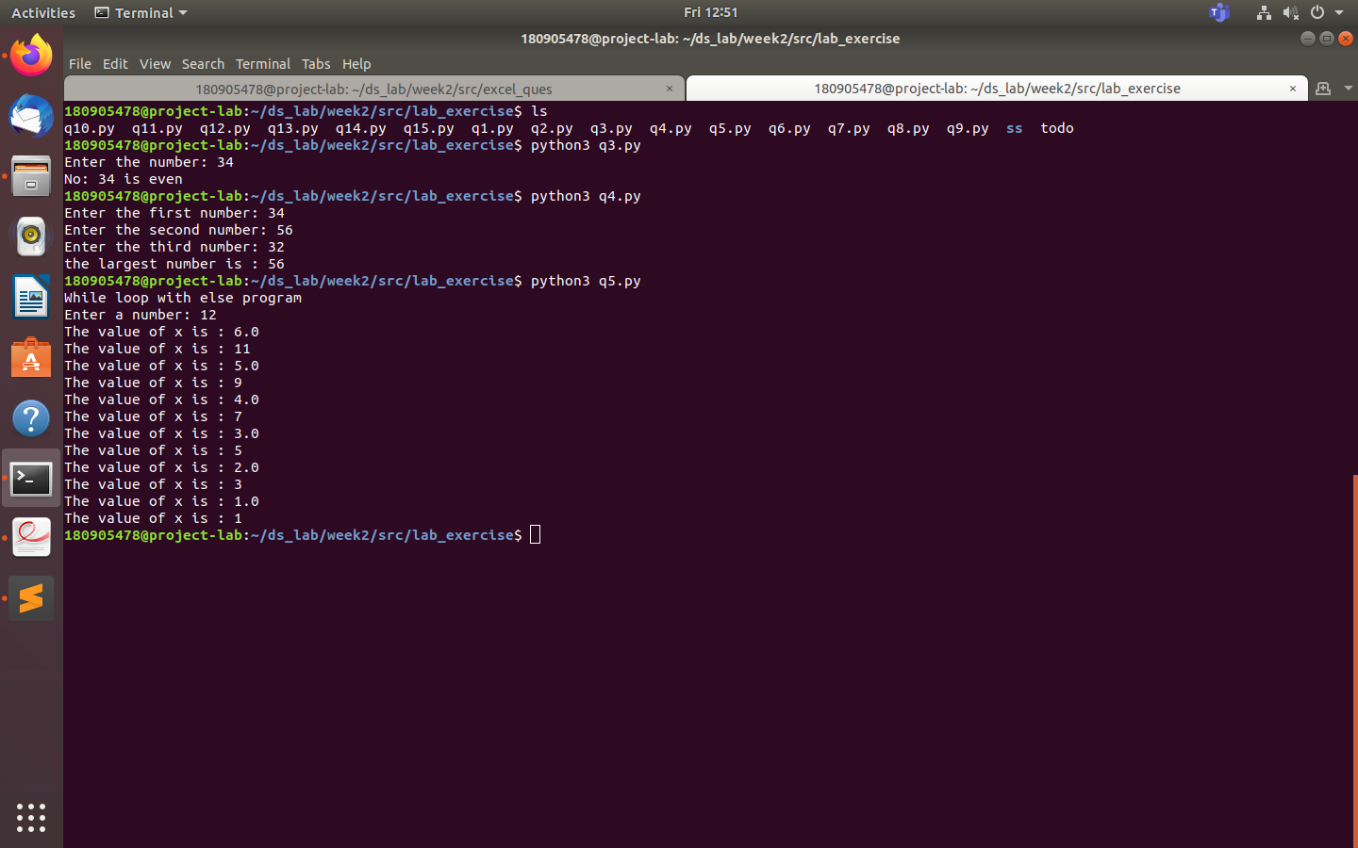

Q6 Write a program to print the prime numbers for a user provided range.

x=int(input("ENter the start number (for prime range) : "))

y=int(input("Enter the end number (for prime range): "))

print("Prime numbers between", x, "and", y, "are:")

for i in range(x, y + 1):

if i > 1:

for j in range(2, i):

if (i % j) == 0:

break

else:

print(i,end='\n')

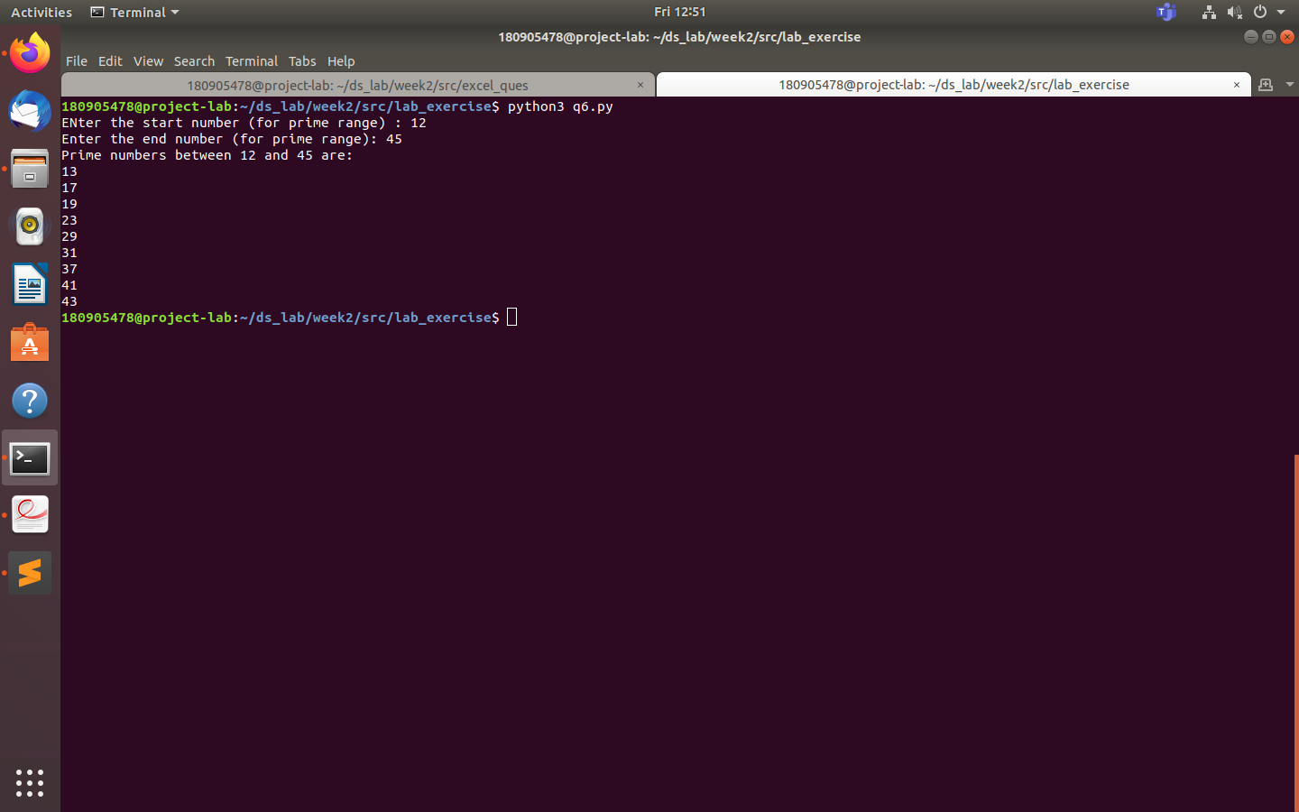

Q7 Write a program to demonstrate List functions and operations.

list = ['beta',786,2.23,'lambda',7123.2]

print("List: ",list)

print("1st element: ",list[0])

print("2nd to 4th element: ", list[1:4])

print("Elements from 3rd posn: ", list[2:])

print("List * 2: ", list*2)

print("Concat: ", list + ['party'])

list.append('john')

print("List append: ", list)

del list[2]

print("Deleted 3rd element: ",list)

print("Length of list: ",len(list))

print("Count of 'john' in list: ", list.count('john'))

print("Last element of list popped: ", list.pop())

list.insert(3,'party')

print("Insert 'party' at index 3: ", list)

list.remove('party')

print("Remove 'party':", list)

list.reverse()

print("Reversed list: ",list)

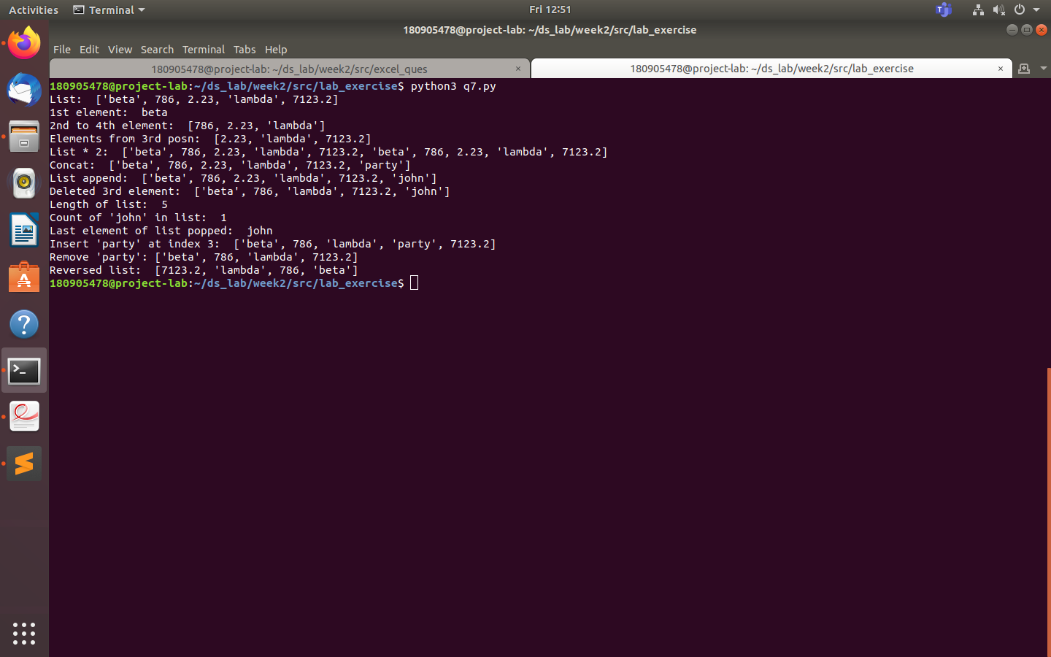

Q8 Consider the tuple(1,3,5,7,9,2,4,6,8,10). Write a program to print half its values in one line and

the other half in the next line.

tp=(1,3,5,7,9,2,4,6,8,10)

tp1=tp[:5]

tp2=tp[5:]

print(tp1,end='\n')

print(tp2,end='\n')

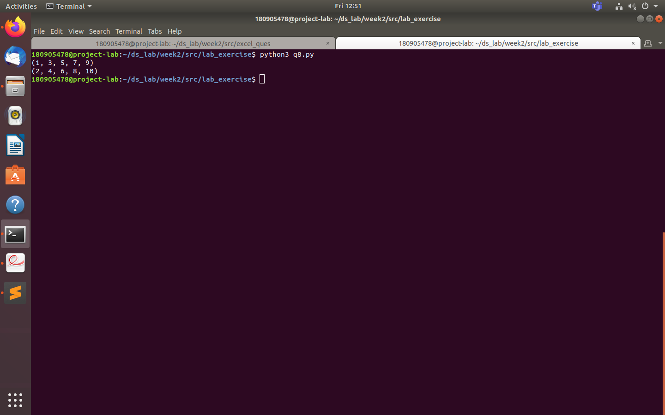

Q9 Consider the tuple (12, 7, 38, 56, 78 ). Write a program to print another tuple whose values are

even number in the given tuple.

tp=(12,7,38,56,78)

x=tuple(x for x in tp if x%2==0)

print(x)

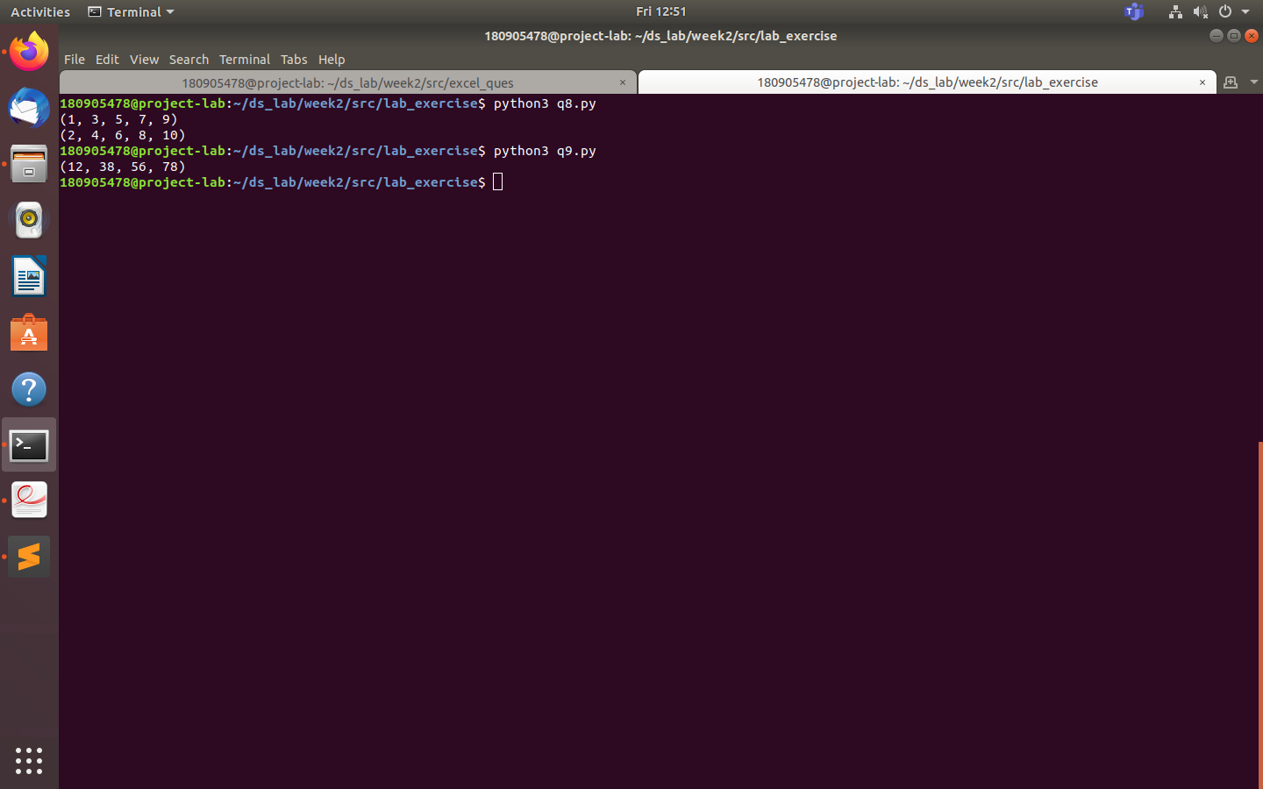

Q10 Write a Python program to print negative Numbers in a List using for loop. Eg. [11, -21, 0, 45,

66, -93].

list_1= [11,-21,0,45,66,-93]

for i in list_1:

if i<0:

print(i,end='\n')

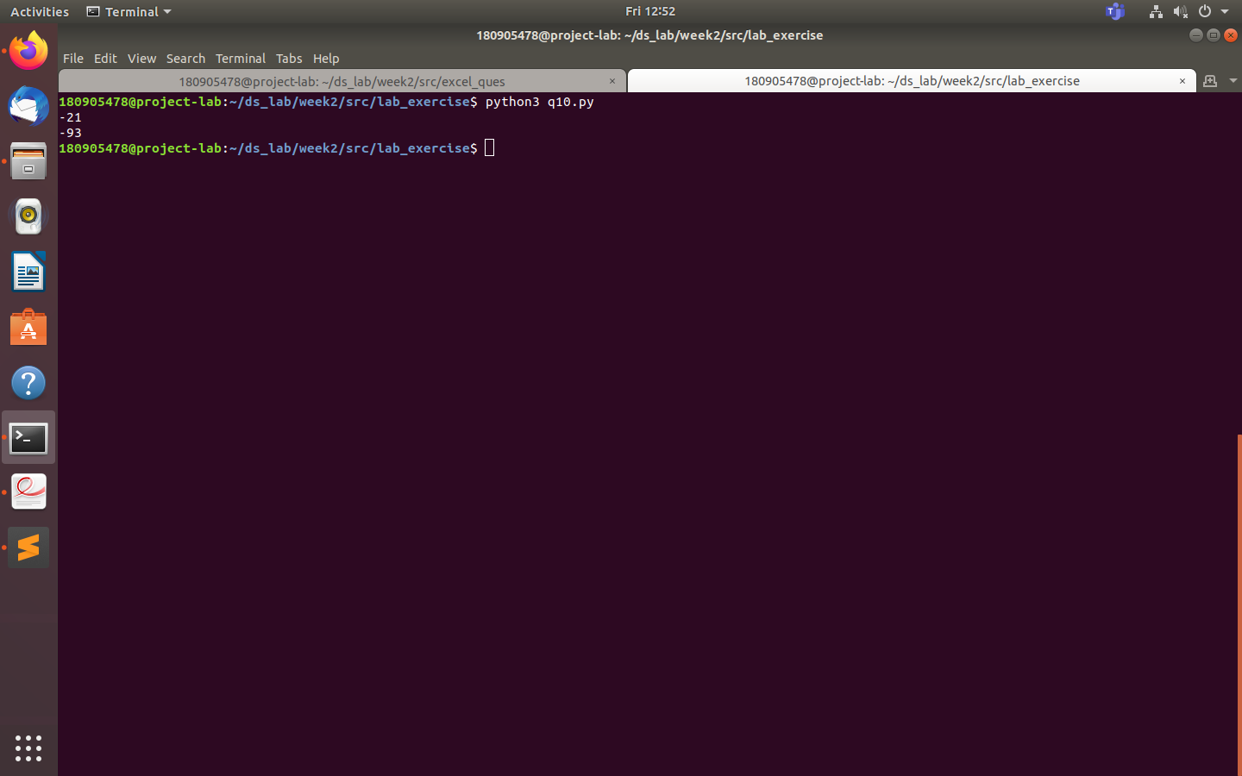

Q11 Write a program to print negative Numbers in a List using while loop.

list1 = [-10, 21, -4, -45, -66, 93]

count = 0

while(count < len(list1)):

if list1[count] < 0:

print(list1[count], end = "\n" )

count += 1

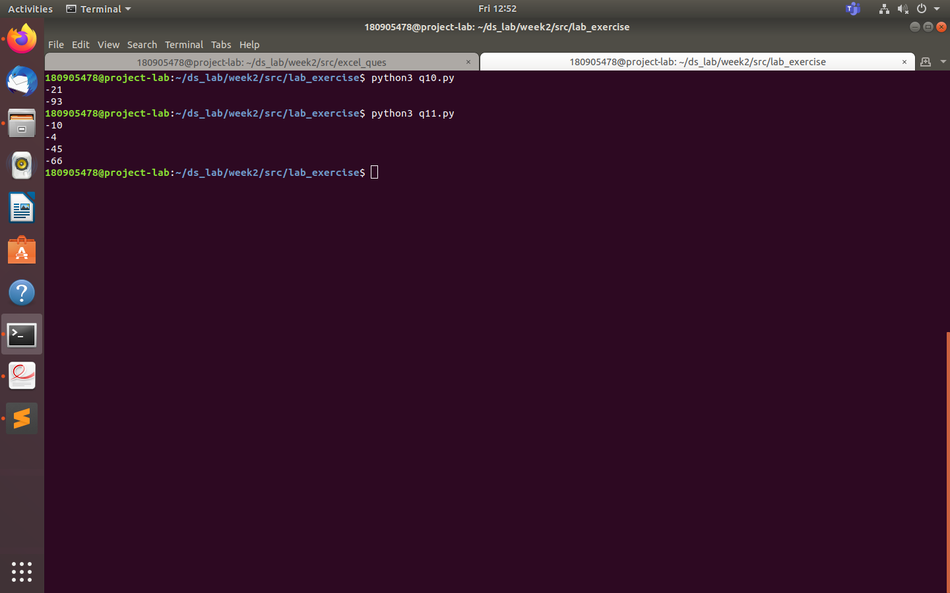

Q12 Write a Python program to count positive and negative numbers in a List.

list1=[123,-456,789,-987,654,-321,-21345]

count_pos=0

count_neg=0

for i in list1:

if i>0:

print(f"Positive number found in list is : {i}")

count_pos+=1

elif i<0:

print(f"Negative number found in list is :{i}")

count_neg+=1

else:

print("Zeroes found in list , at index ")

print(count_pos)

print(count_neg

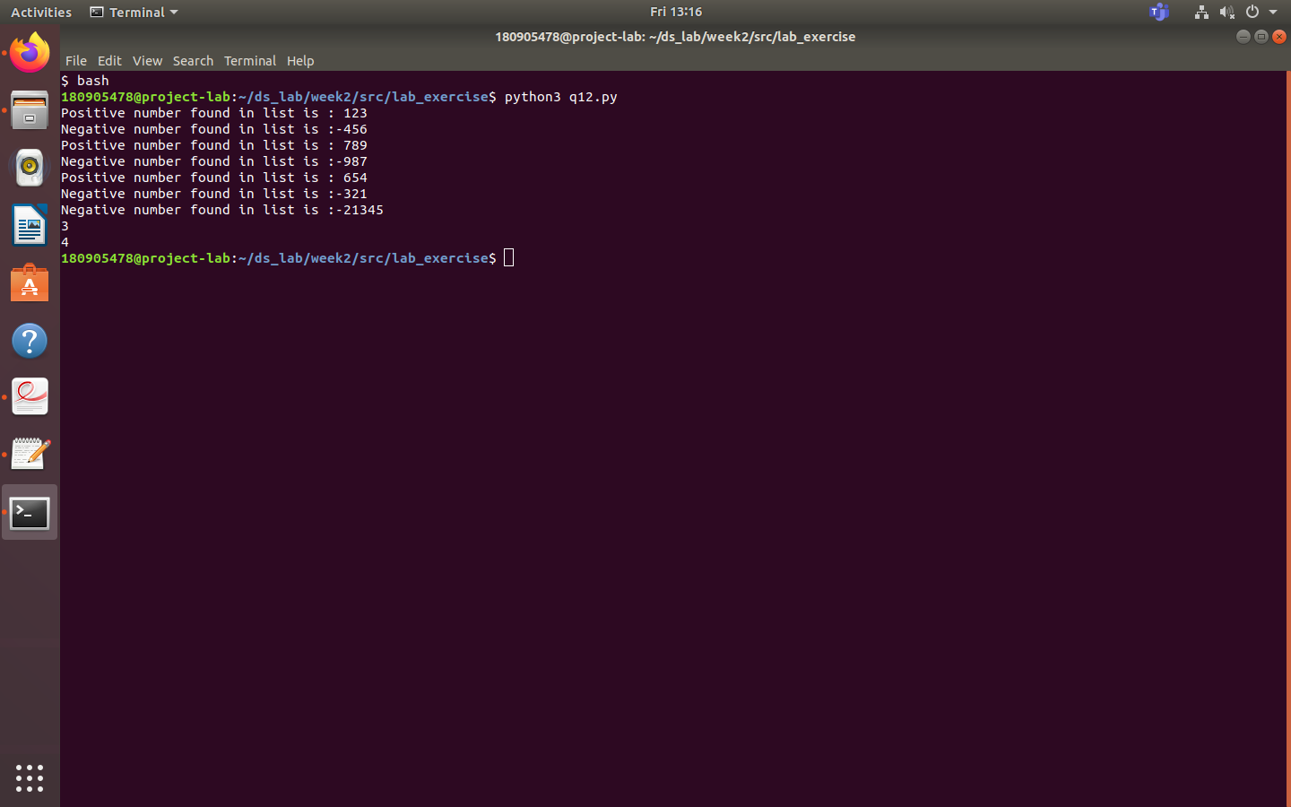

Q13 Write a Python program to remove all even elements from a list

list1=[1,23,4,5,67,91,123,345,678,123123,23213,123,4342,1312]

print("The list before removing even elements in list :",list1)

for i in list1:

if i%2==0:

list1.remove(i)

print("The list after removing even elements ",list1)

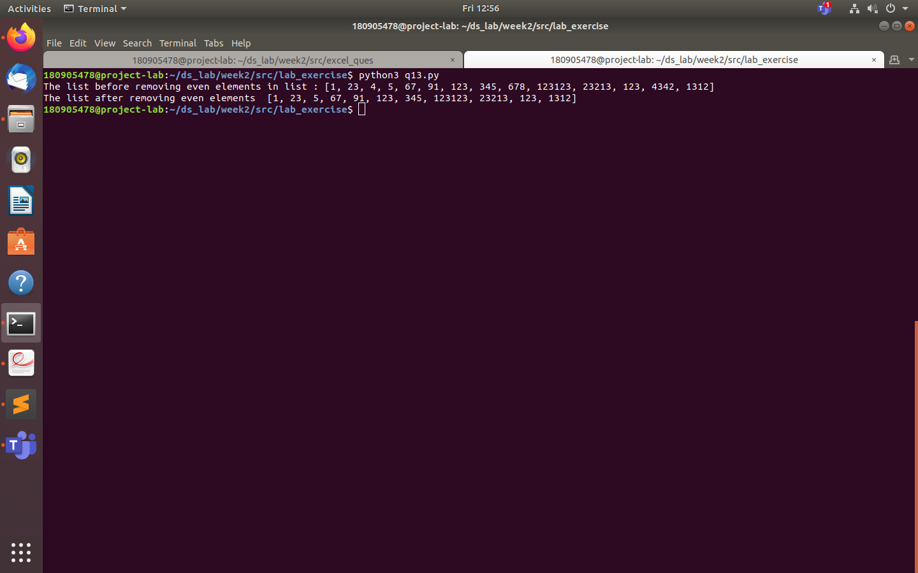

Q14 Define a dictionary containing Students data {Name, Height, Qualification}.

a) Convert the dictionary into DataFrame

b) Declare a list that is to be converted into a new column (Address}

c) Using 'Address' as the column name and equate it to the list and display the result.

import pandas as pd

dict1 = {

"Name":["lambda","beta","alpha"],

"Height":["180","195","210"],

"Qualification":["Btech","BArch","BSc"]

}

new = pd.DataFrame.from_dict(dict1)

print(new)

address = ["omega","alpha","zeta"]

dict1.update({"Address":address})

print("updated dictionary is:",dict1)

new2 = pd.DataFrame.from_dict(dict1)

print(new2)

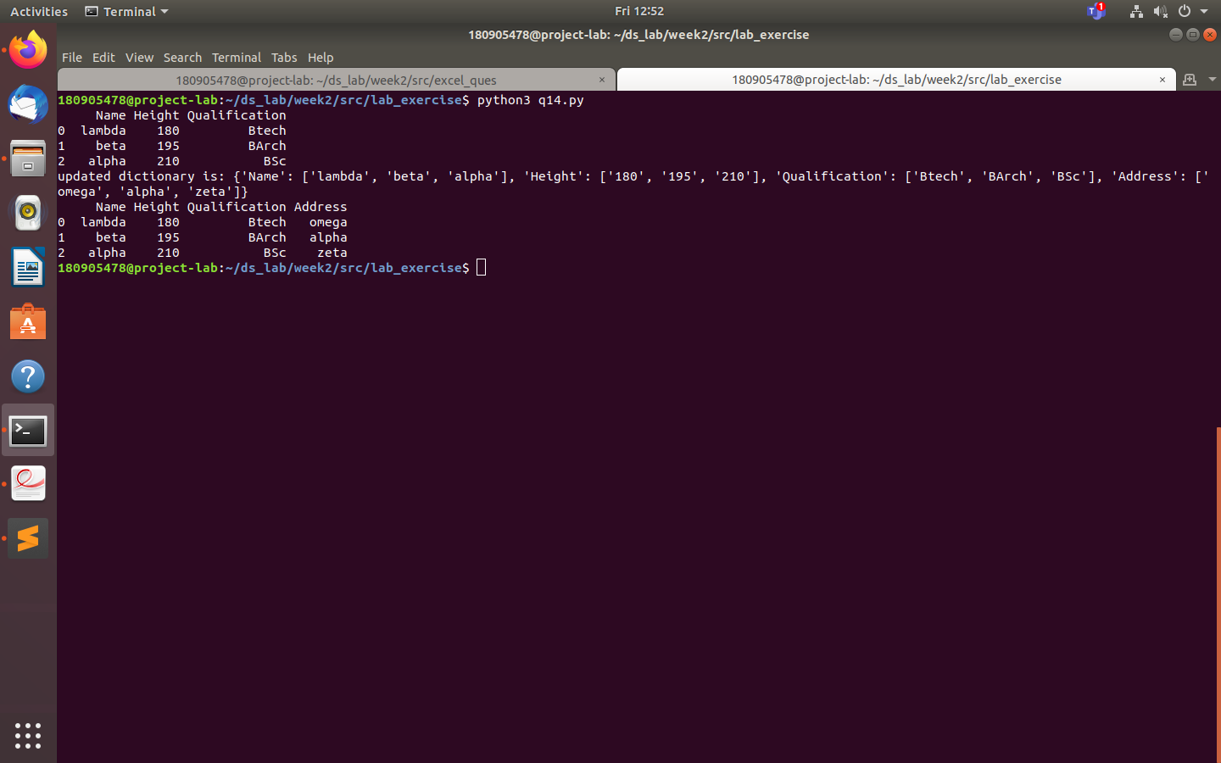

Q15 Define a dictionary containing Students data {Name, Height, Qualification}.

a) Convert the dictionary into DataFrame

b) Use DataFrame.insert() to add a column and display the result.

import pandas as pd

dct = {'Name':['H', 'R', 'P'], 'Height':[180, 182, 190], 'Qualification':['BTech', 'BArch', 'BSc']}

new = pd.DataFrame.from_dict(dct)

print(new)

address = ['Manipal', 'Udupi', 'Surathkal']

print("address list:", address)

#dct['address'] = address

new.insert(3, "address", address, True)

print(new)

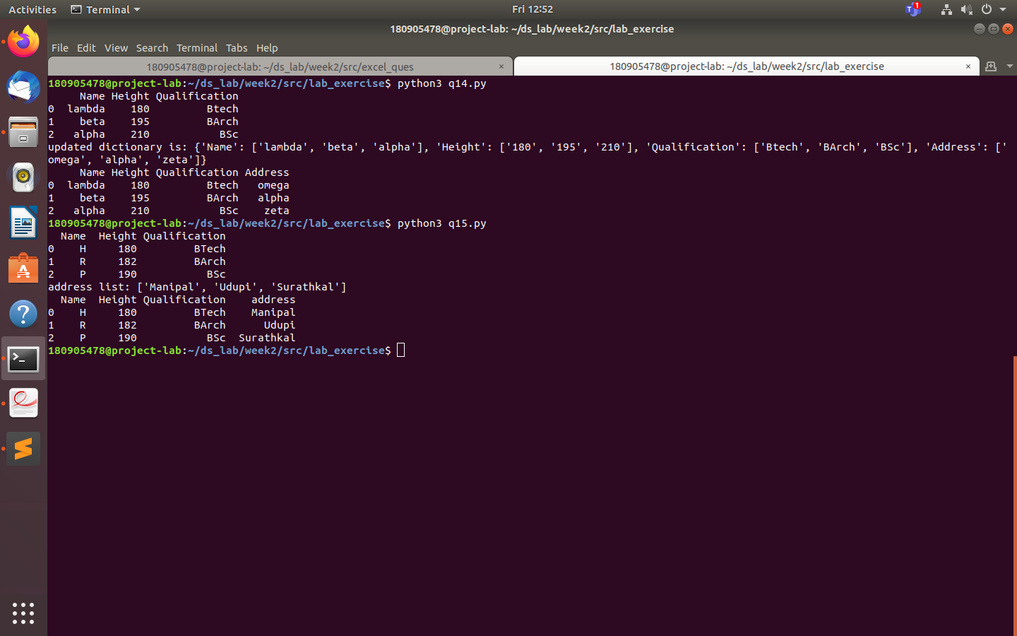

German-Excel sheet :

Code:

import pandas as pd

import numpy as np

import matplotlib.pyplot as plt

df = pd.read_excel("German Credit.xlsx", header=0, engine="openpyxl")

print(df.head())

print(df.tail())

plt.scatter(df['CreditAmount'],df['DurationOfCreditInMonths'])

plt.xlabel('CreditAmount')

plt.ylabel('DurationOfCreditInMonths')

plt.show()#Figure_1

df['CreditAmount'].hist()

plt.show()#Figure_2

plt.boxplot(df,notch=True)

f = df['Creditability'].value_counts()

f.plot(kind='bar')

plt.show()#Figure_3

f.plot(kind='pie')

plt.show()#Figure_4

f = pd.crosstab(df['Creditability'],df['DurationOfCreditInMonths'])

f.plot(kind='bar')

plt.show() #Figure_5

