LAB2 IT-LAB

NAME: SAGNIK CHATTERJEE

REG: 180905478

ROLL NO: 61

SEM: VI

BATCH: B2

Q1

html:

<!DOCTYPE html>

<html lang="en">

<head>

<!-- Required meta tags -->

<meta charset="utf-8" />

<meta

name="viewport"

content="width=device-width, initial-scale=1, shrink-to-fit=no"

/>

<!-- <link rel="stylesheet" href="main.css" /> -->

<!-- <script type="javascript" src="q1.js" ></script> -->

<!-- Bootstrap CSS -->

<link

rel="stylesheet"

href="https://cdn.jsdelivr.net/npm/bootstrap@4.6.0/dist/css/bootstrap.min.css"

integrity="sha384-B0vP5xmATw1+K9KRQjQERJvTumQW0nPEzvF6L/Z6nronJ3oUOFUFpCjEUQouq2+l"

crossorigin="anonymous"

/>

<style></style>

<title>Student Form Q1</title>

</head>

<body>

<div class="container" style="background: orange; margin-top: 3rem">

<div class="row justify-content-md-center" style="padding: 1rem">

<div class="col-md-12">

<p class="text-center font-weight-bold" style="font-size: 2rem">

Student Registration Form

</p>

</div>

<div class="col-md-6">

<form action="">

<div class="form-group">

<label for="name">Name</label>

<input

type="text"

id="name"

name="name"

placeholder="Your Name"

class="form-control"

/>

</div>

<div class="form-group">

<label for="gender">Gender</label><br />

<input type="radio" name="gender" id="gender" value="male" /> Male

<input type="radio" name="gender" id="gender" value="female" />

Female

<input

type="radio"

name="gender"

id="gender"

value="other"

checked

/>

Others

</div>

<div class="form-group">

<label for="message">Message</label><br />

<textarea

name="message"

id="message"

cols="50"

rows="3"

placeholder="Type your message here ... "

class="form-control"

></textarea>

</div>

<div class="form-group form-check">

<label for="interests" class="form-check-label"

>Choose Your Interests</label

><br />

<input

type="checkbox"

name="interests"

id="interests"

value="athematics"

class="form-check-input"

/>

Mathematics

<br />

<input

type="checkbox"

name="interests"

id="interests"

value="coding"

checked

class="form-check-input"

/>

Coding <br />

<input

type="checkbox"

name="interests"

id="interests"

value="walking"

class="form-check-input"

/>

Walking <br />

<input

type="checkbox"

name="interests"

id="interests"

value="singing"

class="form-check-input"

/>

Singing <br />

</div>

<table class="table table-dark table-striped">

<thead>

<tr>

<th scope="col">ID No.</th>

<th scope="col">First Name</th>

<th scope="col">Last Name</th>

<th scope="col">Department</th>

</tr>

</thead>

<tbody>

<tr>

<th scope="row">1</th>

<td>Sagnik</td>

<td>Chatterjee</td>

<td>CS</td>

</tr>

<tr>

<th scope="row">2</th>

<td>Richard</td>

<td>Feynmann</td>

<td>Physics</td>

</tr>

<tr>

<th scope="row">3</th>

<td>Leonarhd</td>

<td>Euler</td>

<td>Maths</td>

</tr>

</tbody>

</table>

<button type="button" class="btn btn-primary">Submit</button>

</form>

</div>

</div>

</div>

<!-- Include Bootstrap -->

<script

src="https://code.jquery.com/jquery-3.5.1.slim.min.js"

integrity="sha384-DfXdz2htPH0lsSSs5nCTpuj/zy4C+OGpamoFVy38MVBnE+IbbVYUew+OrCXaRkfj"

crossorigin="anonymous"

></script>

<script

src="https://cdn.jsdelivr.net/npm/bootstrap@4.6.0/dist/js/bootstrap.bundle.min.js"

integrity="sha384-Piv4xVNRyMGpqkS2by6br4gNJ7DXjqk09RmUpJ8jgGtD7zP9yug3goQfGII0yAns"

crossorigin="anonymous"

></script>

</body>

</html>

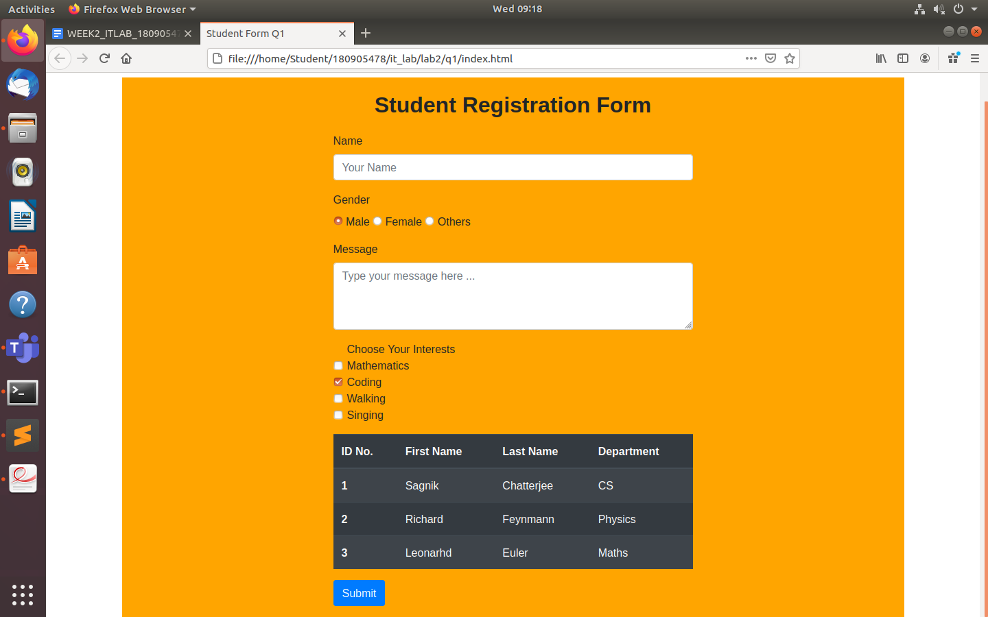

Q2

HTML

<!DOCTYPE html>

<html lang="en">

<head>

<!-- Required meta tags -->

<meta charset="utf-8" />

<meta name="viewport" content="width=device-width, initial-scale=1, shrink-to-fit=no" />

<!-- Bootstrap CSS -->

<link rel="stylesheet" href="https://cdn.jsdelivr.net/npm/bootstrap@4.6.0/dist/css/bootstrap.min.css"

integrity="sha384-B0vP5xmATw1+K9KRQjQERJvTumQW0nPEzvF6L/Z6nronJ3oUOFUFpCjEUQouq2+l" crossorigin="anonymous" />

<title>CRUD Employee Q2</title>

</head>

<body>

<div class="container" style="margin-top: 2rem">

<table class="table table-dark table-striped">

<thead>

<tr>

<th scope="col">Name</th>

<th scope="col">Email ID</th>

<th scope="col">Age</th>

<th scope="col">Department</th>

<th scope="col">Actions</th>

</tr>

</thead>

<tbody>

<tr>

<td>Lambda Calculas</td>

<td>lambdacalculas@gmail.com</td>

<td>21</td>

<td>R & D</td>

<td>

<button class="btn btn-primary" value="showAlert" onclick="shouldEdit();">

Edit

</button>

<button class="btn btn-danger" value="showAlert" onclick="showDelete();">

Delete

</button>

</td>

</tr>

<tr>

<td>Bernhard Reimann</td>

<td>breimann@gmail.com</td>

<td>41</td>

<td>Human Resources</td>

<td>

<button class="btn btn-primary" value="showAlert" onclick="shouldEdit();">

Edit

</button>

<button class="btn btn-danger" value="showAlert" onclick="showDelete();">

Delete

</button>

</td>

</tr>

<tr>

<td>Tom Hardy</td>

<td>th1425@gmail.com</td>

<td>23</td>

<td>Administration</td>

<td>

<button class="btn btn-primary" value="showAlert" onclick="shouldEdit();">

Edit

</button>

<button class="btn btn-danger" value="showAlert" onclick="showDelete();">

Delete

</button>

</td>

</tr>

</tbody>

</table>

</div>

</div>

<div class="container" style="background: orange; margin-top: 1rem">

<div class="row justify-content-md-center" style="padding: 1rem">

<div class="col-md-12">

<p class="text-center font-weight-bold" style="font-size: 2rem">

Employee ADD

</p>

</div>

<div class="col-md-6">

<form action="">

<div class="form-group">

<label for="name">Name</label>

<input type="text" id="name" name="name" placeholder="Ex : John Doe" class="form-control" />

</div>

<div class="form-group">

<label for="email">Email</label>

<input type="email" name="email" id="email" placeholder="Ex: john.doe@xyz.com" class="form-control" />

</div>

<div class="form-group">

<label for="age">Age</label><br />

<input type="number" name="age" id="age" class="form-control" />

</div>

<div class="form-group">

<label for="dept">Choose Department</label><br />

<input type="radio" name="dept" id="dept" value="ad" checked />

Administration <br />

<input type="radio" name="dept" id="dept" value="rd" /> R & D

<br />

<input type="radio" name="dept" id="dept" value="hr" /> Human Resources

<br />

<input type="radio" name="dept" id="dept" value="finance" /> Finance

</div>

<button type="submit" class="btn btn-primary">Add</button>

</form>

</div>

</div>

</div>

<!-- Include Bootstrap -->

<script src="https://code.jquery.com/jquery-3.5.1.slim.min.js"

integrity="sha384-DfXdz2htPH0lsSSs5nCTpuj/zy4C+OGpamoFVy38MVBnE+IbbVYUew+OrCXaRkfj" crossorigin="anonymous">

</script>

<script src="https://cdn.jsdelivr.net/npm/bootstrap@4.6.0/dist/js/bootstrap.bundle.min.js"

integrity="sha384-Piv4xVNRyMGpqkS2by6br4gNJ7DXjqk09RmUpJ8jgGtD7zP9yug3goQfGII0yAns" crossorigin="anonymous">

</script>

</body>

</html>

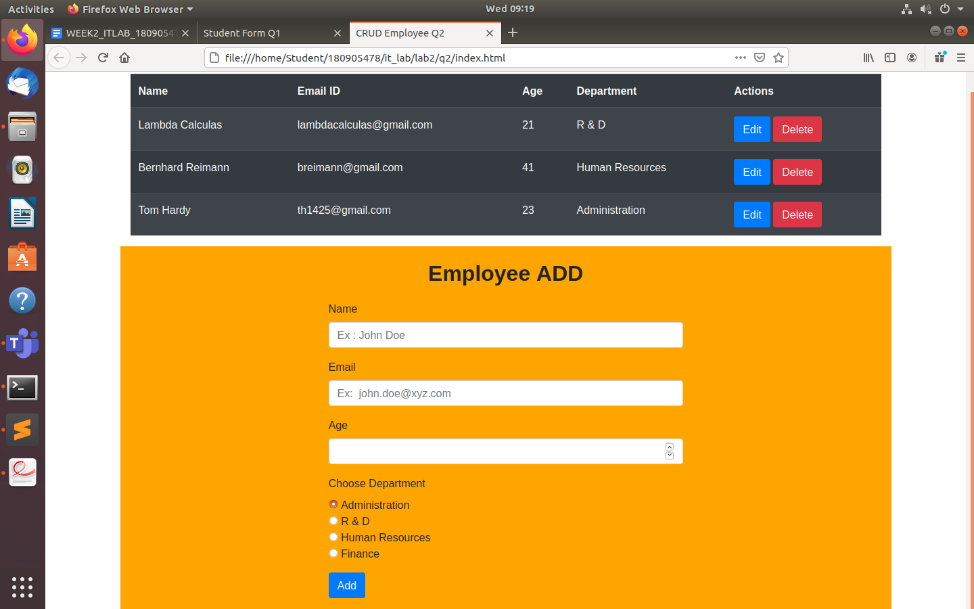

Q3

HTML

<!doctype html>

<html lang="en">

<head>

<!-- Required meta tags -->

<meta charset="utf-8">

<meta name="viewport" content="width=device-width, initial-scale=1, shrink-to-fit=no">

<!-- Bootstrap CSS -->

<link rel="stylesheet" href="https://cdn.jsdelivr.net/npm/bootstrap@4.6.0/dist/css/bootstrap.min.css" integrity="sha384-B0vP5xmATw1+K9KRQjQERJvTumQW0nPEzvF6L/Z6nronJ3oUOFUFpCjEUQouq2+l" crossorigin="anonymous">

<title> Q3 </title>

</head>

<body>

<div class="container mt-5">

<div class="row border mb-5" style="background-color:black;">

<div class="col-sm-6 border" style="background-color: orange;">

<h2>Input Group</h2>

<div class="input-group mb-3">

<div class="input-group-prepend">

<span class="input-group-text" id="basic-addon1">@</span>

</div>

<input type="text" class="form-control" placeholder="Username" aria-label="Username" aria-describedby="basic-addon1">

</div>

<div class="input-group mb-3">

<div class="input-group-prepend">

<span class="input-group-text">First and Last name</span>

</div>

<input type="text" aria-label="First name" class="form-control">

<input type="text" aria-label="Last name" class="form-control">

</div>

<div class="input-group mb-3">

<div class="input-group-prepend">

<div class="input-group-text">

<input type="checkbox" aria-label="Checkbox for following text input">

</div>

</div>

<input type="text" class="form-control" aria-label="Text input with checkbox">

</div>

<div class="input-group">

<div class="input-group-prepend">

<div class="input-group-text">

<input type="radio" aria-label="Radio button for following text input" placeholder="Enter somethign here ... ">

</div>

</div>

<input type="text" class="form-control" aria-label="Text input with radio button">

</div>

</div>

<div class="col-sm-6 border" style="background-color: orange;">

<div class="form-check">

<input class="form-check-input" type="radio" name="flexRadioDefault" id="flexRadioDefault1">

<label class="form-check-label" for="flexRadioDefault1">

Some Option1

</label>

</div>

<div class="form-check">

<input class="form-check-input" type="radio" name="flexRadioDefault" id="flexRadioDefault2" checked>

<label class="form-check-label" for="flexRadioDefault2">

Some Option2

</label>

</div>

</div>

</div>

<div class="row p-1" style="background-color: black;">

<div class="col-sm-4 border" style="background-color: orange;text-align: center;">

<h2>Button Styles</h2>

<button type="button" class="btn btn-primary btn-sm">Primary</button>

<button type="button" class="btn btn-secondary btn-sm">Secondary</button>

<button type="button" class="btn btn-success btn-sm">Success</button>

<button type="button" class="btn btn-danger btn-sm">Danger</button>

</div>

<div class="col-sm-4 border" style="background-color: orange;text-align: center;">

<h2>Button Group</h2>

<div class="btn-group" role="group" aria-label="Basic example">

<button type="button" class="btn btn-primary">Spacex</button>

<button type="button" class="btn btn-primary">Tesla</button>

<button type="button" class="btn btn-primary">SOlarCIty</button>

</div>

</div>

<div class="col-sm-4 border" style="background-color: orange;text-align: center;">

<h2>Input example</h2>

<div class="form-group">

<label for="name">Name</label>

<input type="text" id="name" name="name" placeholder="Your Name" class="form-control">

</div>

<button type="button" class="btn btn-success">Submit Name</button>

<center><h3>Badges Example</h3></center>

<button type="button" class="btn btn-primary">

People visited this page<span class="badge badge-light">10</span>

<span class="sr-only">unread messages</span>

</button>

</div>

<div class="col-sm-12 border" style="background-color: orange;text-align: center;">

<a href="#" class="badge badge-info">Made using Bootstrap</a>

</div>

</div>

</div>

<!-- Include Bootstrap -->

<script src="https://code.jquery.com/jquery-3.5.1.slim.min.js" integrity="sha384-DfXdz2htPH0lsSSs5nCTpuj/zy4C+OGpamoFVy38MVBnE+IbbVYUew+OrCXaRkfj" crossorigin="anonymous"></script>

<script src="https://cdn.jsdelivr.net/npm/bootstrap@4.6.0/dist/js/bootstrap.bundle.min.js" integrity="sha384-Piv4xVNRyMGpqkS2by6br4gNJ7DXjqk09RmUpJ8jgGtD7zP9yug3goQfGII0yAns" crossorigin="anonymous"></script>

</body>

</html>

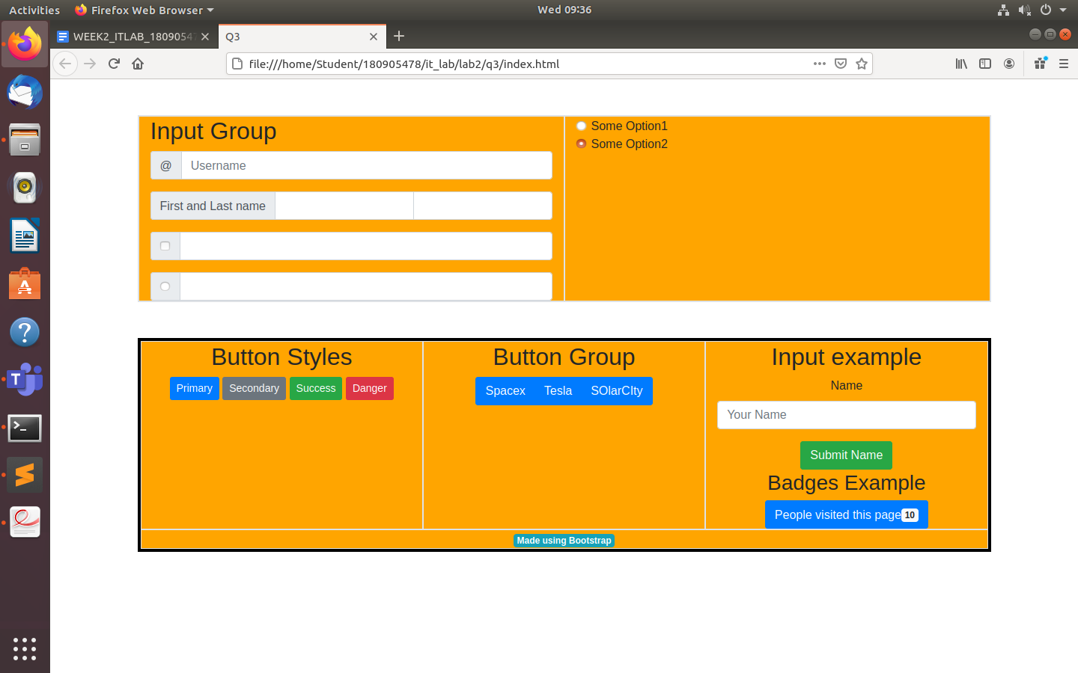

Q4

Html

<!DOCTYPE html>

<htm>

<head>

<meta charset="UTF-8" />

<meta name="viewport" content="width=device-width, initial-scale=1.0" />

<link

rel="stylesheet"

href="https://cdn.jsdelivr.net/npm/bootstrap@4.5.3/dist/css/bootstrap.min.css"

integrity="sha384-TX8t27EcRE3e/ihU7zmQxVncDAy5uIKz4rEkgIXeMed4M0jlfIDPvg6uqKI2xXr2"

crossorigin="anonymous"

/>

<title>TimeTable Q4</title>

</head>

<body >

<div>

<h2>

Time Table CSE-VI(B)

</h2>

</div>

<div id="carousels" class="carousel slide" data-ride="carousel">

<div class="carousel-inner">

<div class="carousel-item active" >

<table class="table table-striped table-dark " style="text-align: center;">

<thead>

<tr>

<th scope="col" colspan="0.5"></th>

<th scope="col" colspan="2" class="bg-info">8:00-9:30 AM</th>

<th scope="col" colspan="2" class="bg-info">10:00-11:30 AM</th>

<th scope="col" colspan="0.5" class="bg-info"></th>

<th scope="col" colspan="2" class="bg-info">2:00-3:30 PM</th>

<th scope="col" colspan="2" class="bg-info">4:00-5:30 PM</th>

</tr>

</thead>

<tbody>

<tr>

<th scope="row" class="bg-warning">MON</th>

<td colspan="2">------</td>

<td colspan="2">------</td>

<td class="bg-dark"></td>

<td colspan="2">EEFM</td>

<td colspan="2">DS</td>

</tr>

<tr>

<th scope="row" class="bg-warning">TUE</th>

<td colspan="2">PCAP</td>

<td colspan="2">PE-I</td>

<td class="bg-dark"></td>

<td colspan="2">------</td>

<td colspan="2">------</td>

</tr>

<tr>

<th scope="row" class="bg-warning">WED</th>

<td colspan="2">------</td>

<td colspan="2">------</td>

<td class="bg-dark"></td>

<td colspan="2">PE-II</td>

<td colspan="2">OE-III</td>

</tr>

<tr>

<th scope="row" class="bg-warning">THU</th>

<td colspan="2">EEFM</td>

<td colspan="2">DS</td>

<td class="bg-dark"></td>

<td colspan="2">-----</td>

<td colspan="2">-----</td>

</tr>

<tr>

<th scope="row" class="bg-warning">FRI</th>

<td colspan="2">------</td>

<td colspan="2">------</td>

<td class="bg-dark"></td>

<td colspan="2">PCAP</td>

<td colspan="2">PE-I</td>

</tr>

<tr>

<th scope="row" class="bg-warning">SAT</th>

<td colspan="2">PE-II</td>

<td colspan="2">OE</td>

<td class="bg-dark"></td>

<td colspan="2">------</td>

<td colspan="2">------</td>

</tr>

</tbody>

</table>

</div>

<div class="carousel-item">

<table class="table table-striped table-dark" style="margin:auto;text-align: center;height: auto;">

<thead>

<tr>

<th scope="col" colspan="0.5"></th>

<th scope="col" colspan="2" class="bg-info">8:00 AM -10:00 AM</th>

<th scope="col" colspan="2" class="bg-info">10:00 AM -11:00 AM</th>

<th scope="col" colspan="2" class="bg-info">11:00 AM-1:00 PM</th>

<th scope="col" colspan="0.5" class="bg-info"></th>

<th scope="col" colspan="2" class="bg-info">1:00 PM -3:00 PM</th>

<th scope="col" colspan="2" class="bg-info">3:00 PM -4:00 PM</th>

<th scope="col" colspan="2" class="bg-info">4:00 PM -6:00 PM</th>

</tr>

</thead>

<tbody>

<tr>

<th scope="row" class="bg-warning">MON </th>

<td colspan="2">------</td>

<td colspan="2">------</td>

<td colspan="2">ITL(B1)</td>

<td class="bg-dark"></td>

<td colspan="2">------</td>

<td colspan="2">------</td>

<td colspan="2">------</td>

</tr>

<tr>

<th scope="row" class="bg-warning">TUE </th>

<td colspan="2">------</td>

<td colspan="2">------</td>

<td colspan="2">------</td>

<td class="bg-dark"></td>

<td colspan="2">PPL(B2)/DSL(B1)</td>

<td colspan="2">------</td>

<td colspan="2">------</td>

</tr>

<tr>

<tr>

<th scope="row" class="bg-warning">WED </th>

<td colspan="2">ITL(B2)</td>

<td colspan="2">------</td>

<td colspan="2">------</td>

<td class="bg-dark"></td>

<td colspan="2">------</td>

<td colspan="2">------</td>

<td colspan="2">------</td>

</tr>

<tr>

<th scope="row" class="bg-warning">THU </th>

<td colspan="2">------</td>

<td colspan="2">------</td>

<td colspan="2">------</td>

<td class="bg-dark"></td>

<td colspan="2">------</td>

<td colspan="2">------</td>

<td colspan="2">------</td>

</tr>

<tr>

<th scope="row" class="bg-warning">FRI </th>

<td colspan="2">PPL(B1)</td>

<td colspan="2">------</td>

<td colspan="2">DSL(B2)</td>

<td class="bg-dark"></td>

<td colspan="2">------</td>

<td colspan="2">------</td>

<td colspan="2">------</td>

</tr>

<tr>

<th scope="row" class="bg-warning">SAT </th>

<td colspan="2">------</td>

<td colspan="2">------</td>

<td colspan="2">------</td>

<td class="bg-dark"></td>

<td colspan="2">------</td>

<td colspan="2">------</td>

<td colspan="2">------</td>

</tr>

</tbody>

</table>

</div>

</div>

</div>

<a class="carousel-control-prev" href="#carousels" role="button" data-slide="prev" >

<span class="carousel-control-prev-icon" aria-hidden="true" style="filter: invert(100%)"></span>

<span class="sr-only">Previous</span>

</a>

<a class="carousel-control-next" href="#carousels" role="button" data-slide="next">

<span class="carousel-control-next-icon" aria-hidden="true" style="filter: invert(100%)"></span>

<span class="sr-only">Next</span>

</a>

</div>

<script src="https://code.jquery.com/jquery-3.5.1.slim.min.js" integrity="sha384-DfXdz2htPH0lsSSs5nCTpuj/zy4C+OGpamoFVy38MVBnE+IbbVYUew+OrCXaRkfj" crossorigin="anonymous"></script>

<script src="https://cdn.jsdelivr.net/npm/bootstrap@4.5.3/dist/js/bootstrap.bundle.min.js" integrity="sha384-ho+j7jyWK8fNQe+A12Hb8AhRq26LrZ/JpcUGGOn+Y7RsweNrtN/tE3MoK7ZeZDyx" crossorigin="anonymous"></script>

</body>

</html>

