ITLAB: WEEK3

NAME: SAGNIK CHATTERJEE

REG: 180905478

ROLL NO: 61 BATCH: B2

SECTION : B SEM:6

Q1

Write a python program to implement simple calculator which perform addition, subtraction, multiplication, and division

Code :

'''

@author Sagnik Chatterjee

Python program to implement a simple calculator which performs addition,

subtraction, multiplication and division

'''

def addition(num1=0 ,num2=0):

'''

Adds the 2 args provided

Return:

The value obtained after adding the 2 values

'''

return num1+num2

def subtraction(num1=0,num2=0):

'''

Subtracts the 2 args provided

Return:

The value obtained after subtracting these 2 values

'''

return num1-num2

def divides_float(num1 ,num2):

'''

Floating point divison of the 2 args provided

Return:

The value obtained after dividing the 2 values

'''

try:

return num1/num2

except Exception as e:

print(e)

def divides_int(num1,num2):

'''

Integer type divison of the 2 args provided

Return:

The value obtained after dividing the 2 values

'''

try:

return num1//num2

except Exception as e:

print(e)

def multiplication(num1 ,num2):

'''

Adds the 2 args provided

Return:

The value obtained after multiplying the 2 values

'''

return num1*num2

def main():

status=True

while status:

num1=int(input('Enter the first value:- '))

num2=int(input('Enter the second value:- '))

op=input("Enter the operation to be done :- \n")

if op=='+':

print(addition(num1,num2))

elif op=='-':

print(subtraction(num1,num2))

elif op=='*':

print(multiplication(num1,num2))

elif op=='/':

print(divides_float(num1,num2))

elif op=='//':

print(divides_int(num1,num2))

else:

print("Invalid choice .")

h=input("Continue ?(y|N)")

if(h=='y' or y=='Y'):

status=True

else:

status=False

break

main()

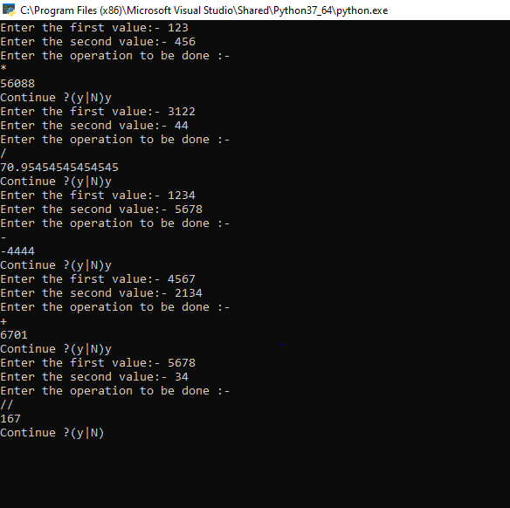

Q2

Write a python program to reverse a content of a file and store it in another file.

CODE:

'''

@author Sagnik Chatterjee

Python program to reverse a content of a file and store it

in another file.

'''

def reverse_file_contents(file_input_name:str,file_output_name:str,file_directory:str= '.\\' ):

##some hack for windows as windows reads in this current directory as .\

'''

Reverse the file contents and writes to another file

,provided the file is persent in this directory.

By default it will assume in current directory

'''

try:

f1=open(file_directory+file_output_name,"w")

with open(file_directory+file_input_name,"r")as fileread:

data = fileread.read()

data_rev = data[::-1]

f1.write(data_rev)

f1.close()

print("Done writing in output file.")

return True

except Exception as e:

print(e)

return False

def main():

file_input_name=input("Enter the input file name:- ")

file_directory=input("Enter the directory name:- ")

file_output_name=input("Enter the output file name:- ")

reverse_file_contents(file_input_name,file_output_name,file_directory)

if __name__=='__main__':

main()

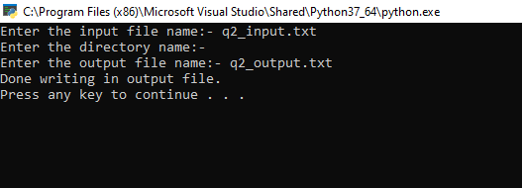

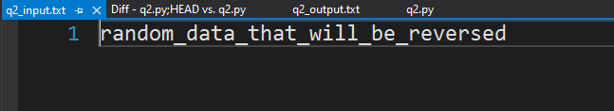

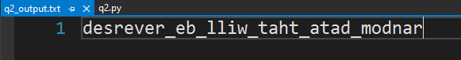

Q3

Write a python program to implement binary search with recursion

Code:

'''

@author Sagnik Chatterjee

Python program to implement binary search with recursion

'''

from typing import List

def binary_search_recursive(arr:List, elem:int, start:int, end:int):

'''

Recursive binary search algorithm that finds the element in a list

in O(logn) array.

'''

if start > end:

return -1

mid = (start + end) // 2

if elem == arr[mid]:

return mid

if elem < arr[mid]:

return binary_search_recursive(arr, elem, start, mid-1)

# elem > arr[mid]

return binary_search_recursive(arr, elem, mid+1, end)

def main():

n=int(input("Enter the size of the list for binary search: "))

list_1=[]

print("Now enter the elements of the list")

while n>0:

p=int(input(""))

list_1.append(p)

n=n-1

list_1.sort() ## sorting the list incase it was not sorted as binary search will not work without sorted list

check=int(input("Enter the element to search :- "))

result = binary_search_recursive(list_1,check,0,len(list_1)-1)

if result!=-1:

print("Element found at index :- ",result)

else:

print("Element not found")

main()

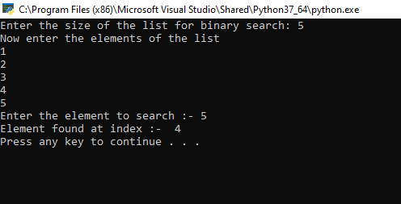

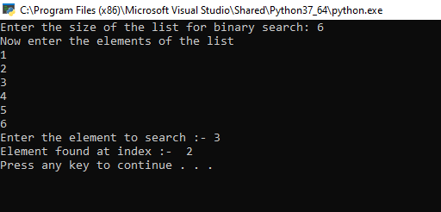

Q4

Write a python program to sort words in alphabetical order.

Code:

'''

@author Sagnik Chatterjee

Python program to sort words in alphabetical order

'''

def main():

print("Enter the string")

str_1=input()

words = [word for word in str_1.split()]

print("The original words without sorting are:- \n")

for word in words:

print(word)

##sorting the list

words.sort()

print("The sorted words are :- \n")

for word in words:

print(word)

if __name__=='__main__':

main()

