Lab 4 submission

Q1)#include<stdio.h>
#include<stdlib.h>
#include<sys/types.h>
#include<sys/stat.h>
#include<unistd.h>
#include <fcntl.h>

int main(int argc, char const *argv[])
{
struct stat sb;
int ret;
if(argc < 2){
fprintf(stderr, "\nusage: %s\n", argv[0]);
return 1;
}
int fd;
fd = open(argv[1], O_RDONLY);
if(fd == -1){
printf("\nThe file does not exists\n");
exit(0);
}
ret = fstat(fd, &sb);

if(ret){
perror("stat");
return 1;
}

printf("\nInode number of %s is %lu\n", argv[1], sb.st_ino);
return 0;
}
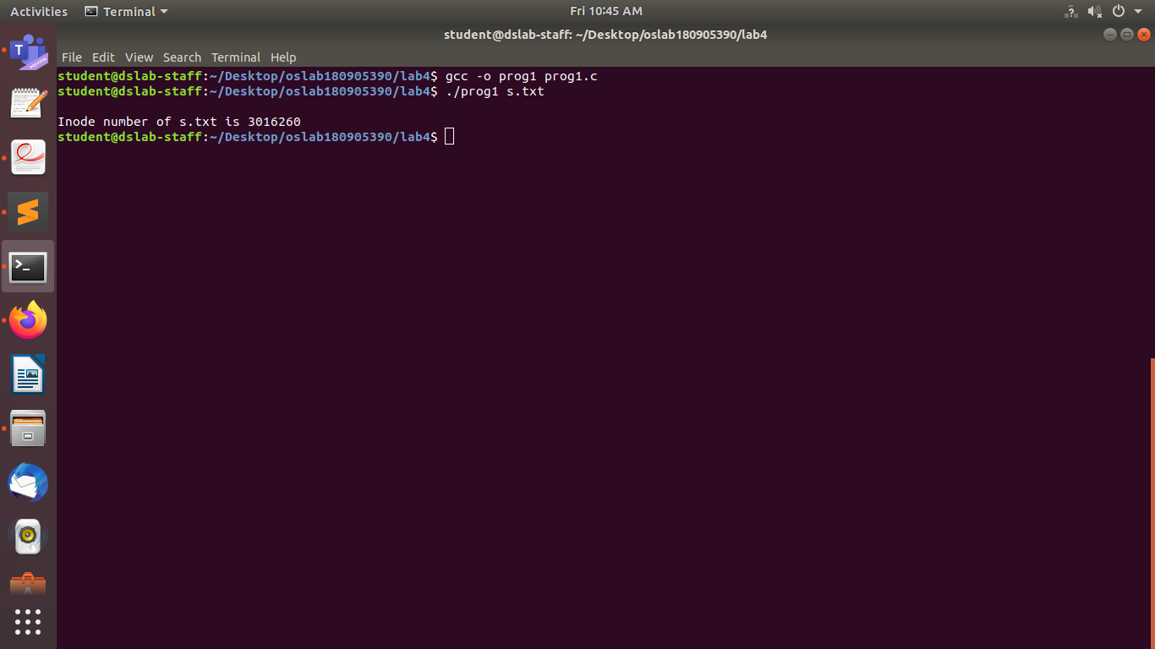
Q2)#include <sys/types.h>
#include <sys/stat.h>
#include <unistd.h>
#include <stdio.h>
#include <time.h>
#include <fcntl.h>
#include<stdlib.h>
#include<stdio.h>

char* formatdate(char* str, time_t val){
strftime(str, 36, "%d.%m.%Y %H:%M:%S", localtime(&val));
return str;
}

int main(int argc, char const *argv[])
{
struct stat sb;
int ret;
char date[256];
if(argc < 2){
fprintf(stderr, "\nusage: %s\n", argv[0]);
return 1;
}
int fd;
fd = open(argv[1], O_RDONLY);
if(fd == -1){
printf("\nThe file does not exists\n");
exit(0);
}
ret = fstat(fd, &sb);

if(ret){
perror("stat");
return 1;
}
printf("\nID - %ld\n", sb.st_dev);
printf("\nINO - %lu\n", sb.st_ino);
printf("\nFile Mode - %hu\n",sb.st_mode);
printf("\nNo of Hard Links - %ld\n",sb.st_nlink);
printf("\nUser ID - %u\n", sb.st_uid);
printf("\nGroup ID - %u\n", sb.st_gid);
printf("\nFile size - %ld\n", sb.st_size);
printf("\nBlocksize - %ld\n", sb.st_blksize);
printf("\nNo. of Blocks - %ld\n", sb.st_blocks);
printf("\nLast access time - %s\n", formatdate(date,sb.st_atime));
printf("\nLast modification time - %s\n", formatdate(date,sb.st_mtime));
printf("\nLast change time - %s\n", formatdate(date,sb.st_ctime));
return 0;
}

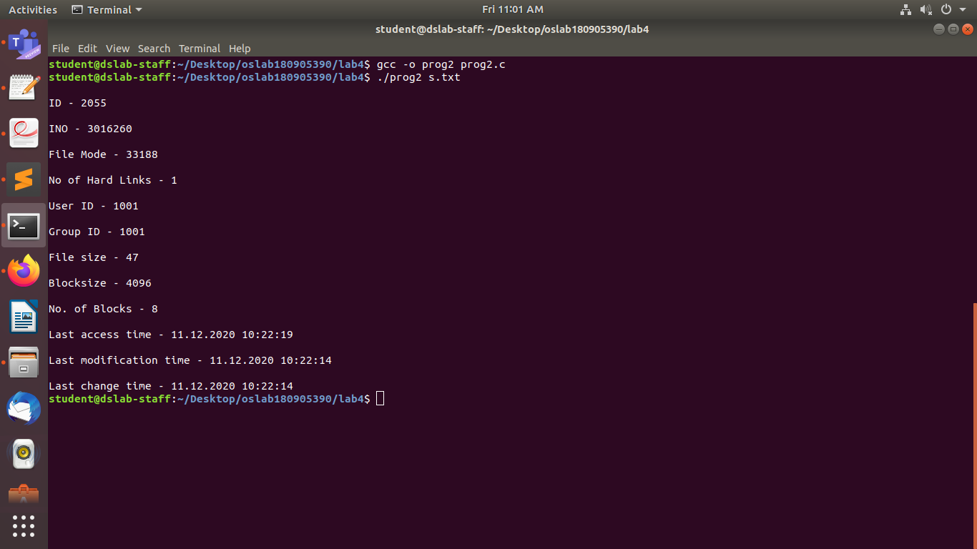

Q3)#include <sys/types.h>
#include <sys/stat.h>
#include <unistd.h>
#include <stdio.h>
#include <time.h>
#include <fcntl.h>
#include<stdlib.h>
#include<stdio.h>

int main(int argc, char const *argv[])
{
struct stat sb;
int ret, ret1, ret2, ret3, ret4, ret5;
//char date[256];
if(argc < 2){
fprintf(stderr, "\nusage: %s\n", argv[0]);
return 1;
}
ret = stat(argv[1], &sb);
if(ret){
perror("stat");
return 1;
}
printf("\nInitial Number of Hard Links: %ld\n", sb.st_nlink);
ret1 = link(argv[1], "sam.txt");
if(ret1){
perror("link");
return 1;
}
printf("\nHard Link created\n");
ret3 = stat(argv[1], &sb);
if(ret3){
perror("stat");
return 1;
}
printf("\nNumber of Hard Links after creation of new link: %ld\n", sb.st_nlink);
printf("\nUnlinking..\n");
printf("\nPress enter to unlink\n");
getchar();
getchar();
ret4 = unlink("sam.txt");
if(ret4){
perror("unlink");
return 1;
}
printf("\nUnlinking successful\n");
ret5 = stat("s.txt", &sb);
printf("No. of links after unlinking of hard link : %ld\n",sb.st_nlink );
return 0;
}

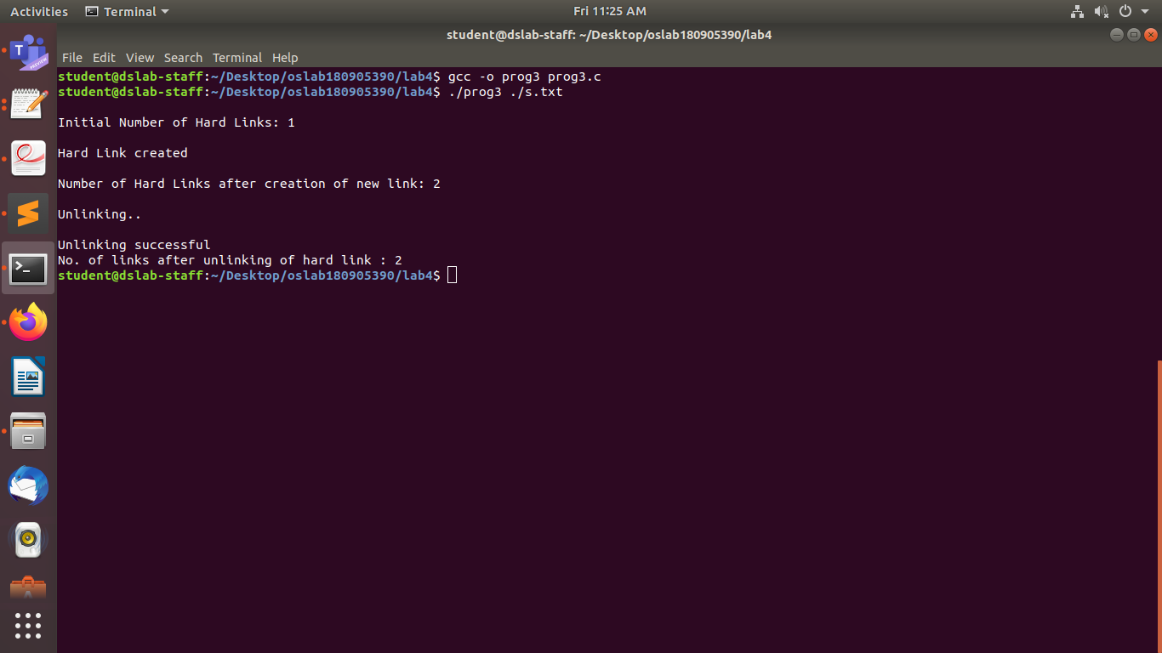
Q4)#include <sys/types.h>
#include <sys/stat.h>
#include <unistd.h>
#include <stdio.h>
#include <time.h>
#include <fcntl.h>
#include<stdlib.h>
#include<stdio.h>

int main(int argc, char const *argv[])
{
struct stat sb;
int ret, ret1, ret2, ret3, ret4, ret5;
//char date[256];
if(argc < 2){
fprintf(stderr, "\nusage: %s\n", argv[0]);
return 1;
}
ret = stat(argv[1], &sb);
if(ret){
perror("stat");
return 1;
}
printf("\nInitial Number of Hard Links: %ld\n", sb.st_nlink);
ret1 = symlink(argv[1], "sam.txt");
if(ret1){
perror("links");
return 1;
}
printf("\nUnlinking...\n");
printf("\nPlease press enter to unlink\n");
getchar();
getchar();
ret3 = unlink("sam.txt");
if(ret3){
perror("unlinking");
return 1;
}
printf("\nUnlinking successful..\n");
return 0;
}

