NAME AYUSH THAKUR
REGNO: 180905420
SECTION:B

OS_SESSION3

Q1)
//PRODUCER.C

#include<unistd.h>
#include<stdio.h>
#include<stdlib.h>
#include<string.h>
#include<limits.h>
#include<fcntl.h>
#include<sys/types.h>
#include<sys/stat.h>
#define FIFO_NAME "/tmp/my_fifo"

int main()
{
int pipe_fd;
int res;
int open_mode = O_WRONLY;
int bytes_sent = 0;
int buffer;

if(access(FIFO_NAME,F_OK)==-1)
{
res = mkfifo(FIFO_NAME,0777);
if(res!=0)
{
fprintf(stderr,"Could not create fifo %s\n",FIFO_NAME );
exit(EXIT_FAILURE);
}
}

printf("Process %d opening FIFO O_WRONLY\n",getpid());
pipe_fd = open(FIFO_NAME,open_mode);
printf("Process %d result %d\n",getpid(),pipe_fd);
if(pipe_fd!=-1)
{
while(bytes_sent<4*sizeof(int))
{
printf("Enter a number\n");
scanf("%d",&buffer);
res = write(pipe_fd,&buffer,sizeof(int));
if(res==-1)
{
fprintf(stderr,"Write error\n");
exit(EXIT_FAILURE);
}
bytes_sent += sizeof(int);
}
(void)close(pipe_fd);
}
else
{
exit(EXIT_FAILURE);
}
printf("Process %d finished\n",getpid());
exit(EXIT_SUCCESS);
}

//CONSUMER.C

#include<unistd.h>
#include<stdio.h>
#include<stdlib.h>
#include<unistd.h>
#include<stdio.h>
#include<stdlib.h>
#include<string.h>
#include<limits.h>
#include<fcntl.h>
#include<sys/types.h>
#include<sys/stat.h>
#define FIFO_NAME "/tmp/my_fifo"

int main()
{
int pipe_fd;
int res;
int open_mode = O_RDONLY;
int bytes_read=0;
int buffer;

printf("Process %d opening FIFO O_RDONLY\n",getpid());
pipe_fd = open(FIFO_NAME,open_mode);
printf("Process %d result %d\n",getpid(),pipe_fd);

if(pipe_fd!=-1)
{
do
{
res = read(pipe_fd,&buffer,sizeof(int));
printf("\nInteger read is: %d, of size: %d\n", buffer, res);
bytes_read+= res;
}while(bytes_read<4*sizeof(int));

(void)close(pipe_fd);
}
else
{
exit(EXIT_FAILURE);
}
printf("Process %d finished,%d bytes read\n",getpid(),bytes_read);
exit(EXIT_SUCCESS);
return 0;

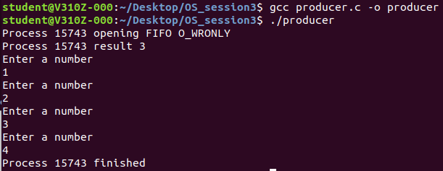
}

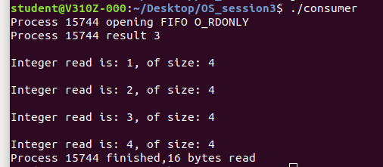

Q2)

#include<sys/wait.h>
#include<unistd.h>
#include<stdio.h>
#include<string.h>
#include<stdlib.h>
#include<assert.h>

int main()
{
int pfd[2];
pid_t cpid;
int buf;

//assert(argc==2);
if(pipe(pfd)==-1)
{
perror("Pipe failure\n");
exit(EXIT_FAILURE);
}

cpid = fork();
if(cpid==-1)
{
perror("Fork error\n");
exit(EXIT_FAILURE);
}
else
{
printf(“Pipe created\n”);
}

if(cpid==0) //child process reads from pipe
{
close(pfd[1]);
int y;
read(pfd[0],&y,sizeof(int));
close(pfd[0]);
printf("Got %d from the parent\n",y);
}
else //parent writes to child
{
close(pfd[0]);
printf("Enter a number\n");
scanf("%d",&buf);
write(pfd[1],&buf,sizeof(int));
close(pfd[1]);
wait(NULL);
exit(EXIT_SUCCESS);
}
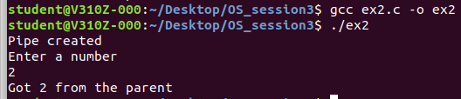
}

Q3)

//FIRST PROCESS

#include<stdio.h>
#include<stdlib.h>
#include <string.h>
#include<fcntl.h>
#include<unistd.h>
#include<sys/wait.h>
#include<sys/stat.h>
#include<limits.h>
#define FILE_NAME "/tmp/my_fifo"

int main()
{
int pipe_fd;
int res;
char buffer[1024];

memset(buffer,'\0',sizeof(buffer));

//first writing and then reading

if(access(FILE_NAME,F_OK)==-1)
{
res = mkfifo(FILE_NAME,0777);
if(res!=0)
{
fprintf(stderr,"Couldn't create fifo %s\n", FILE_NAME);
exit(EXIT_FAILURE);
}
}

printf("Process %d opens FIFO_WRONLY",getpid());
pipe_fd = open(FILE_NAME,O_WRONLY);
printf("[INFO]Input....\n");

fgets(buffer,1024,stdin);

write(pipe_fd,buffer,strlen(buffer)+1);
close(pipe_fd);

printf("Process %d opens FIFO_RDONLY\n",getpid());
pipe_fd = open(FILE_NAME,O_RDONLY);

memset(buffer,'\0',sizeof(buffer));
read(pipe_fd,buffer,1024);
close(pipe_fd);

printf("Output: Process %d reads %s\n",getpid(),buffer);
return 0;

}

//SECOND PROCESS

#include<stdio.h>
#include<stdlib.h>
#include <string.h>
#include<fcntl.h>
#include<unistd.h>
#include<sys/wait.h>
#include<sys/stat.h>
#include<limits.h>
#define FILE_NAME "/tmp/my_fifo"

int main()
{
int pipe_fd;
int res;
char buffer[1024];

//first reading and then writing

if(access(FILE_NAME,F_OK)==-1)
{
res = mkfifo(FILE_NAME,0777);
if(res!=0)
{
fprintf(stderr,"Couldn't create fifo %s\n", FILE_NAME);
exit(EXIT_FAILURE);
}
}

printf("Process %d opens FIFO_RDONLY\n",getpid());
pipe_fd = open(FILE_NAME,O_RDONLY);

memset(buffer,'\0',sizeof(buffer));
read(pipe_fd,buffer,1024);
close(pipe_fd);

printf("Output: Process %d reads %s\n",getpid(),buffer);

printf("Process %d opens FIFO_WRONLY",getpid());
pipe_fd = open(FILE_NAME,O_WRONLY);
printf("[INFO]Input....\n");
memset(buffer,'\0',sizeof(buffer));
fgets(buffer,1024,stdin);

write(pipe_fd,buffer,strlen(buffer)+1);
close(pipe_fd);

return 0;

}

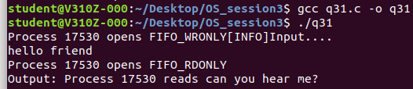

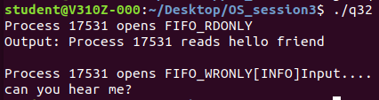

Q4)
#include <stdio.h>

#include <stdlib.h>

int main()

{
FILE *fptr;

int num;

int num1=0;

fptr = fopen("math.bin","wb+");
printf("Enter 2 integers: \n");
for(int i=1;i<=2;i++)
{
scanf("%d",&num);
fwrite(&num, sizeof(int), 1, fptr);
}

printf("[INFO] Write finished\n");
fclose(fptr);

printf("[INFO] will try to read now\n");

fptr = fopen("math.bin","rb");
printf("[INFO] Reading\n");
for(int i=1;i<=2;i++)

{
fread(&num1, sizeof(int), 1, fptr);
printf("%d\n",num1);
}

printf("[INFO] Read finished\n");
fclose(fptr);
return 0;
}

