LAB3 PCAP LAB
SAGNIK CHATTERJEE
180905478
SEC:B BATCH-2
ROLL NO 61

PCAP LAB WEEK3 SUBMISSION FILE

Q1
CODE:
/**
AUTHOR : SAGNIK CHATTERJEE

MPI program to read N values in the root process. Root process sends one value to
each process. Every process receives it and finds the factorial of that number and returns it
to the root process. Root process gathers the factorial and finds sum of it.

*/

#include <mpi.h>
#include <stdio.h>
#include <stdlib.h>

int factorial(int n)
{
int arr[n];
//base case
arr[0] = 1;
arr[1] = 1;

for (int i = 2; i <= n; i++)
{
arr[n] = n * factorial(n - 1);
}
return arr[n];

}

int sumvalue(int *arr, int size)
{
int sum = 0;
for (int i = 0; i < size; i++)
{
sum = sum + arr[i];
}
return sum;
}

int main(int argc, char **argv)
{
int rank, size, N, fac_value, c;
int send_buffer[4], recv_buffer[4];
MPI_Init(&argc, &argv);
MPI_Comm_rank(MPI_COMM_WORLD, &rank);
MPI_Comm_size(MPI_COMM_WORLD, &size);

if (rank == 0)
{
N = size;
printf("Enter %d values:-\n ", N);
for (int i = 0; i < N; i++)
{
scanf("%d", &send_buffer[i]);
if (send_buffer[i] < 0) {
printf("PLEASE DON'T PUT NEGATIVE VALUES !!!!");
MPI_Abort(MPI_COMM_WORLD, EXIT_FAILURE);
}
}
}
MPI_Scatter(send_buffer, 1, MPI_INT, &c, 1, MPI_INT, 0, MPI_COMM_WORLD);

printf("\n Received %d in process %d\n", c, rank);
int h = factorial(c);
MPI_Gather(&h, 1, MPI_INT, recv_buffer, 1, MPI_INT, 0, MPI_COMM_WORLD);

if (rank == 0)
{
printf("The final result after summing the factorials are :\n");
printf(" %d\n ", sumvalue(recv_buffer, N));
}

MPI_Finalize();
return 0;

}

SCREENSHOT:
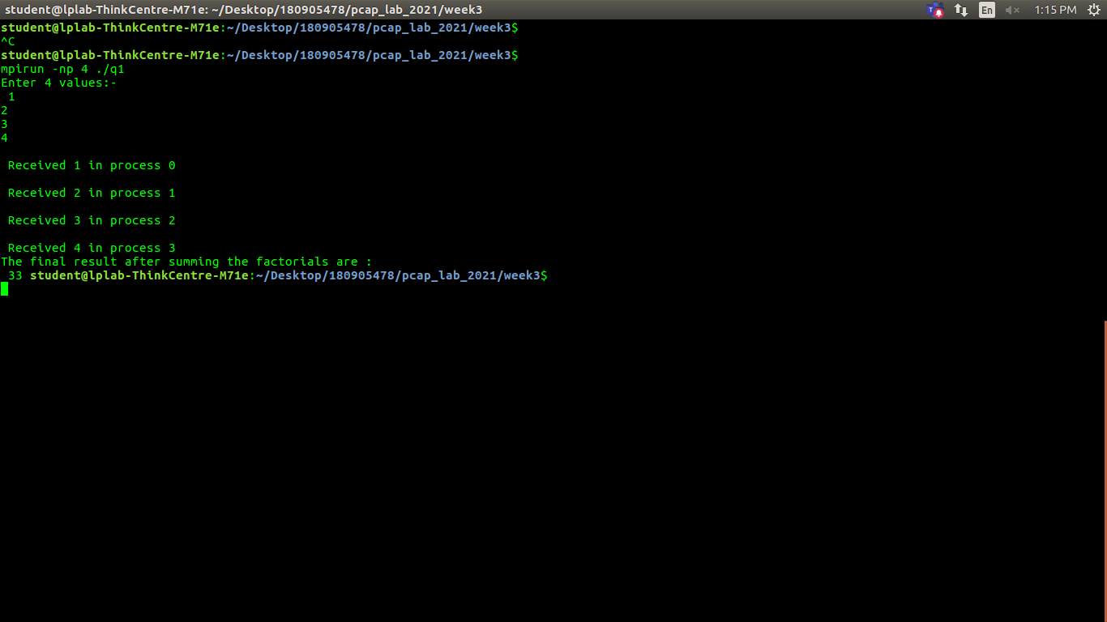

Q2
CODE:
/**
AUTHOR : SAGNIK CHATTERJEE
MPI program to read an integer value M and NXM elements into an 1D array in
the root process, where N is the number of processes. Root process sends M elements to
each process. Each process finds average of M elements it received and sends these average
values to root. Root collects all the values and finds the total average.
Use collective communication routines.

*/

#include <mpi.h>
#include <stdio.h>
#include <string.h>
#include <stdlib.h>

int main(int argc, char **argv)
{

int rank, size;
float avg = 0;
float b[100];

int i, n, m;

int arr[100], c[100];

MPI_Init(&argc, &argv);

MPI_Comm_rank(MPI_COMM_WORLD, &rank);
MPI_Comm_size(MPI_COMM_WORLD, &size);

if (rank == 0)
{
n = size;
printf("Enter m : \n");
scanf("%d", &m);

printf("Enter %d x %d = %d elements:", n, m, (n * m));
getchar();

for (i = 0; i < (n * m); i++)
{
scanf("\n %d", &arr[i]);
}

}

MPI_Bcast(&m, 1, MPI_INT, 0, MPI_COMM_WORLD);
MPI_Scatter(arr, m, MPI_INT, c, m, MPI_INT, 0, MPI_COMM_WORLD);

for (i = 0; i < m; ++i)
{
avg += c[i];
}

avg /= m;
printf("Process :- %d gives Average = %.2f\n", rank, avg);

MPI_Gather(&avg, 1, MPI_FLOAT, b, 1, MPI_FLOAT, 0, MPI_COMM_WORLD);

if (rank == 0)
{

float tavg = 0;
for (i = 0; i < n; i++)
tavg += b[i];
tavg /= n;
printf("Total average = %.2f\n", tavg);

}

MPI_Finalize();
return 0;
}

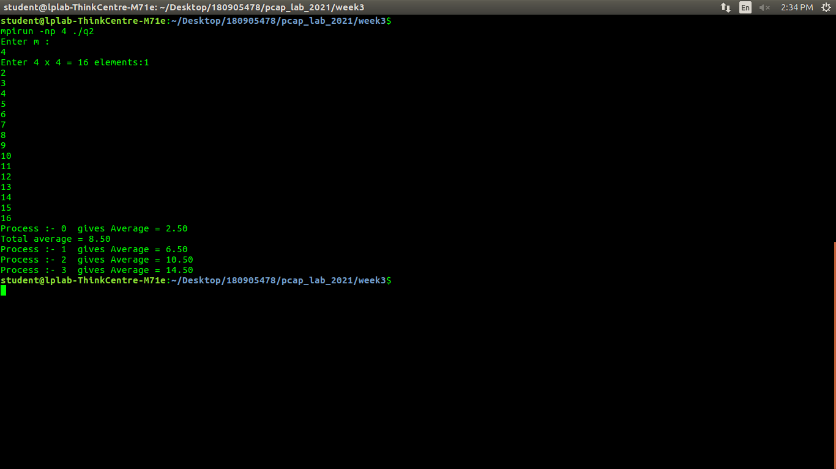

Q3
CODE
/**
AUTHOR : SAGNIK CHATTERJEE
program to read a string. Using N processes (string length is evenly divisible
by N), find the number of non-vowels in the string. In the root process print number of
non-vowels found by each process and print the total number of non-vowels.
*/
#include <mpi.h>
#include <stdio.h>
#include <string.h>
#include <stdlib.h>

int main(int argc, char **argv)
{

int rank, size;
int count = 0;
int b[100] = {0};

int i, n, l;

char str[100], c[100];

MPI_Init(&argc, &argv);

MPI_Comm_rank(MPI_COMM_WORLD, &rank);
MPI_Comm_size(MPI_COMM_WORLD, &size);

if (rank == 0)
{

n = size;

printf("Enter the string: \n");
scanf("%[^\n]%*c", str);

l = strlen(str) / n;

}

MPI_Bcast(&l, 1, MPI_INT, 0, MPI_COMM_WORLD);

MPI_Scatter(str, l, MPI_CHAR, c, l, MPI_CHAR, 0, MPI_COMM_WORLD);

count = 0;
for (i = 0; i < l; ++i)
{
if (strchr("aeiouAEIOU", c[i]) == NULL)
count += 1;
}

MPI_Gather(&count, 1, MPI_INT, b, 1, MPI_INT, 0, MPI_COMM_WORLD);
if (rank == 0)
{

int tcount = 0;
for (i = 0; i < n; i++) {
printf("The process %d has the number of no-vowels:- %d \n", i, b[i]);
tcount += b[i];
}
printf("Total non vowels = %d\n", tcount);

}

MPI_Finalize();
return 0;
}

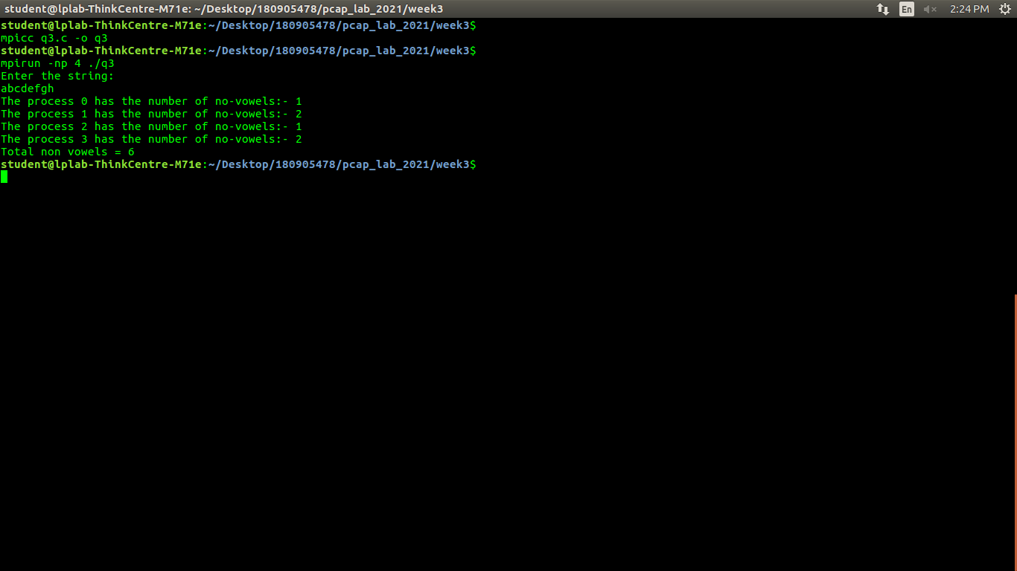
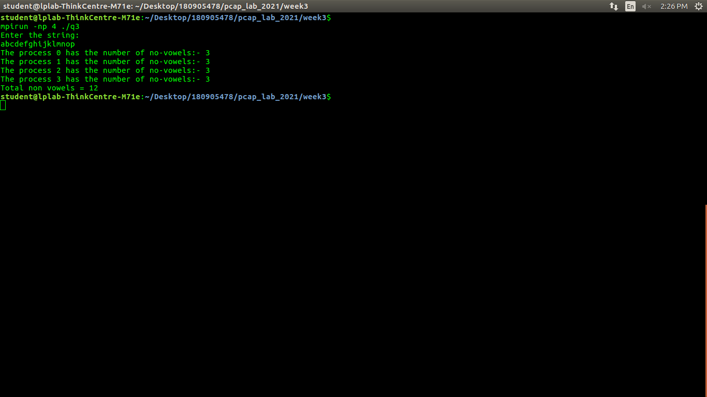

Q4
CODE
/**
AUTHOR : SAGNIK CHATTERJEE

MPI Program to read two strings S1 and S2 of same length in the root process.
Using N processes including the root (string length is evenly divisible by N), produce the
resultant string as shown below. Display the resultant string in the root process. Use
Collective communication routines.
Example:
String S1: string
String S2: length
Resultant String : slternigntgh

*/

#include <mpi.h>
#include <stdio.h>
#include <stdlib.h>
#include <string.h>

int main(int argc, char **argv )
{

int rank, size;

float avg = 0;
char temp[100], str1[100], str2[100], c1[100], c2[100], concatted[100];

int i, j, m;

MPI_Init(&argc, &argv);

MPI_Comm_rank(MPI_COMM_WORLD, &rank);
MPI_Comm_size(MPI_COMM_WORLD, &size);

if (rank == 0)
{

printf("Enter the string 1 : \n");
scanf("%[^\n]%*c", str1);
printf("Enter the string 2 : \n");
scanf("%[^\n]%*c", str2);
m = strlen(str1) / size;
}

MPI_Bcast(&m, 1, MPI_INT, 0, MPI_COMM_WORLD);

MPI_Scatter(str1, m, MPI_CHAR, c1, m, MPI_CHAR, 0, MPI_COMM_WORLD);
MPI_Scatter(str2, m, MPI_CHAR, c2, m, MPI_CHAR, 0, MPI_COMM_WORLD);

int t = 0;

for (t = 0; t <= (2 * m); t += 2)
{
concatted[t] = c1[t / 2];
concatted[t + 1] = c2[t / 2];
}
concatted[2 * m] = '\0';

MPI_Gather(concatted, 2 * m, MPI_CHAR, temp, 2 * m, MPI_CHAR, 0, MPI_COMM_WORLD);

if (rank == 0)
{
temp[m * size * 2] = '\0';
printf("Concated string is :%s\n", temp);
}

MPI_Finalize();
return 0;
}

