LAB -1 PCAP-LAB
Name: Sagnik Chatterjee
Reg: 180905478
Batch :B2
Roll No : 61

Q1

#include <mpi.h>
#include <stdio.h>
#include <stdlib.h>
#include <time.h>
#include <math.h>

int main(int argc , char **argv) {
int rank , size;
//taking random value for x

srand(time(0));

MPI_Init(&argc, &argv);
MPI_Comm_rank(MPI_COMM_WORLD, &rank);
int r = rand() % 100; //for keeping it in range 0-100
int h = pow(r, rank);
printf("The value of the power is :- %d\n", h);
printf("The random value is :- %d\n", r);
printf("The rank of the value is :-%d\n", rank);
MPI_Finalize();
return 0;
}

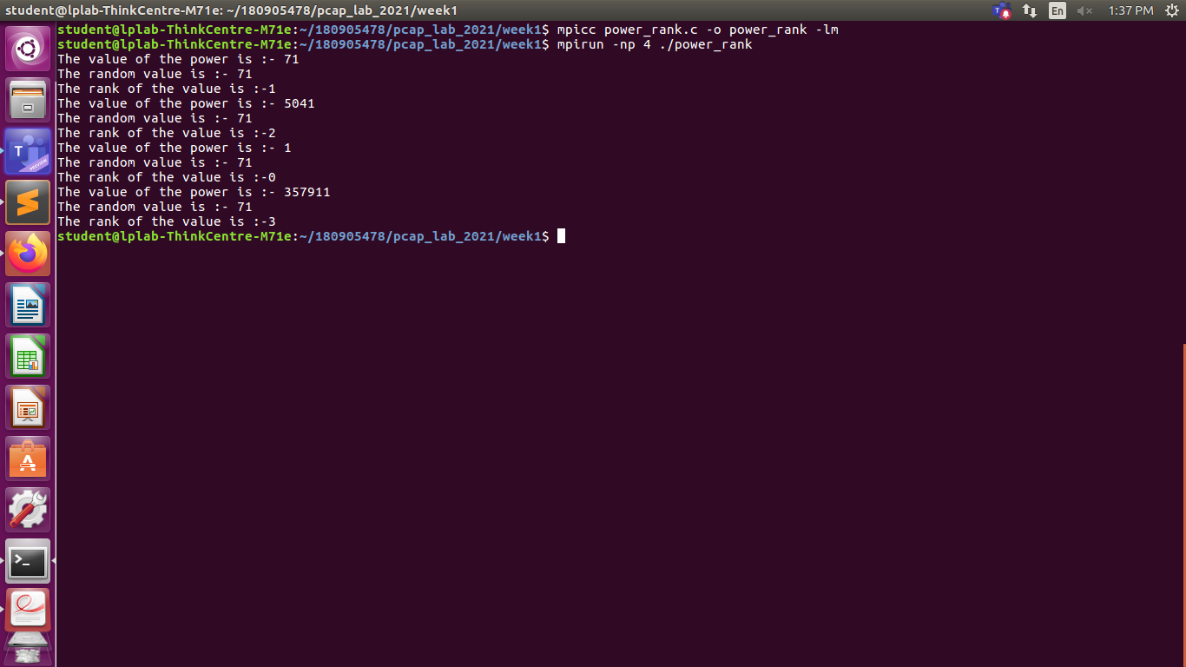
Q2
#include <stdio.h>
#include <mpi.h>

int main(int argc , char **argv) {

int rank;
MPI_Init(&argc , &argv);
MPI_Comm_rank(MPI_COMM_WORLD, &rank);
if (rank % 2 == 0) {
printf("Hello\n");
printf("The rank is %d\n", rank);
}
else {
printf("World\n");
printf("The rank is %d\n", rank);
}
MPI_Finalize();
return 0;
}
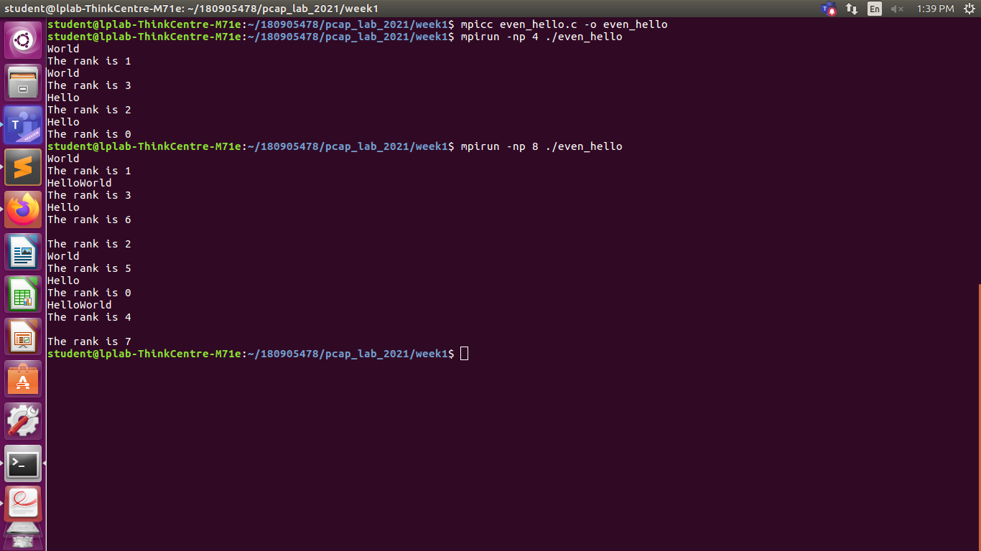

Q3
#include <stdio.h>
#include <math.h>
#include <mpi.h>
#include <stdlib.h>
#include <time.h>

int main(int argc , char **argv) {
int rank, size;

srand(time(NULL));
int p = rand() % 500;
int q = rand() % 700;
MPI_Init(&argc , &argv);
MPI_Comm_rank(MPI_COMM_WORLD, &rank);
MPI_Comm_size(MPI_COMM_WORLD, &size);
if (size != 4) {
printf("Must use 4 processes for running for the 4 operations");
exit(0);
}

if (rank == 0) {
printf("The values are :%d ,%d", p, q);
printf("The result is :- %d\n", p + q);
}
if (rank == 1) {
printf("The values are: %d %d ", p, q);
printf("The result is:- %d\n", p - q);
}
if (rank == 2) {
printf("The values are : %d %d", p, q);
printf("The result is :- %d\n", p * q);
}
if (rank == 3) {
printf("The values are : %d %d", p, q);
printf("The result is :- %f\n", (double)p / q);
}
MPI_Finalize();
return 0;
}

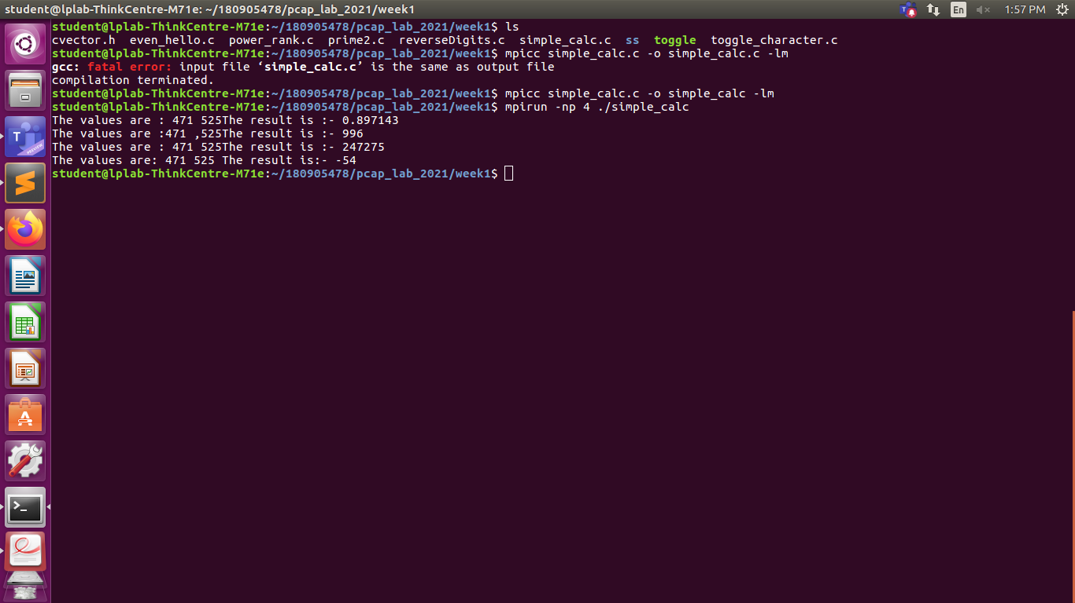

Q4
#include <mpi.h>
#include <stdio.h>
#include <stdlib.h>
#include <string.h>

int main(int argc, char **argv) {

int rank, size;
int size_of_str;

char str[5] = "HeLLO";

MPI_Init(&argc , &argv);
MPI_Comm_rank(MPI_COMM_WORLD, &rank);
MPI_Comm_size(MPI_COMM_WORLD, &size);

if (size != 5) {
printf("Need exactly %d process , since process will togglee each character", size);
exit(0);
}

if (str[rank] >= 'a' && str[rank] <= 'z') {
str[rank] = str[rank] - 32;
}
else {
str[rank] = str[rank] + 32;
}

printf("The rank is %d ,modified string =%s\n", rank, str);
MPI_Finalize();

return 0;
}
