LAB 2
PCAP LAB

NAME: SAGNIK CHATTERJEE
REG: 180905478
ROLL NO: 61
BATCH : B2
SEM :6TH

Q1

Code:

#include<mpi.h>
#include<stdio.h>
#include<stdlib.h>
#include<string.h>

char *char_toggle(char *a)
{
int i;
for(i = 0; i < strlen(a); i++)
{
if(a[i] >= 97 && a[i] <= 122)
{
a[i] = a[i] - 32;
}
else
{
a[i] = a[i] + 32;
}
}
return a;
}

int main(int argc, char *argv[])
{
int rank, size, n = 0;
char word[10]; // assuming the size of the string does not cross this

MPI_Status status;
MPI_Init(&argc, &argv);
MPI_Comm_rank(MPI_COMM_WORLD, &rank);
MPI_Comm_size(MPI_COMM_WORLD, &size);

if(rank == 0)
{
printf("\nEnter a word:\n");
scanf("%s", word);
n = strlen(word);
printf("\nThe length of the string is %d\n", n);
MPI_Ssend(&word, n, MPI_CHAR, 1, 0, MPI_COMM_WORLD);
printf("\nMessage sent :- %s from rank:- %d\n", word,rank);
printf("\nWaiting for message.\n");
MPI_Recv(&word, 5, MPI_CHAR, 1, 0, MPI_COMM_WORLD, MPI_STATUS_IGNORE);
printf("\nMessage received:- %s\n", word);
}
else
{
char mess[10], *ans;
MPI_Recv(&mess, 5, MPI_CHAR, 0, 0, MPI_COMM_WORLD, &status);
printf("\n Received message :- %s from rank %d\n", mess, rank);
ans = char_toggle(mess);
MPI_Ssend(&mess, strlen(mess), MPI_CHAR, status.MPI_SOURCE, 0, MPI_COMM_WORLD);
printf("\n Message sent back to sender.\n");
}
MPI_Finalize();
return 0;
}

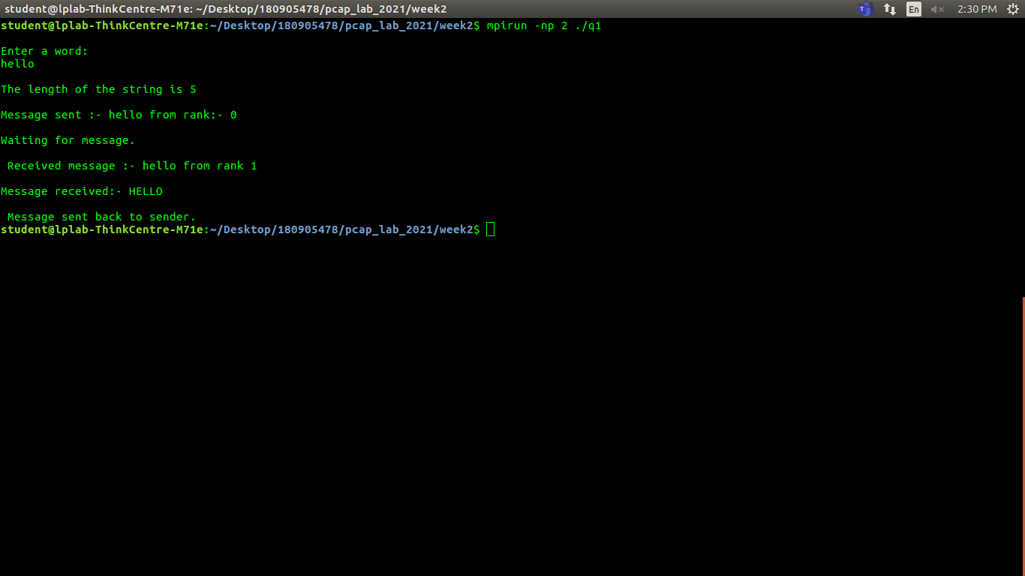
Q2
code :
#include <mpi.h>
#include <stdio.h>
#include <stdlib.h>

#define SIZE sizeof(int)

int main (int argc, char *argv [])
{

int size, rank;
MPI_Status status;

MPI_Init(&argc, &argv);

MPI_Comm_size(MPI_COMM_WORLD, &size);
MPI_Comm_rank(MPI_COMM_WORLD, &rank);

int *number = (int *)malloc(SIZE);

for(int i = 0; i < SIZE; i++)
{
//fill up the number array with random numbers
number[i] = rand() % ((i + 1) * 100) + 1;
}

if (rank == 0)
{

for (int i = 1; i < size; ++i)
{
printf("Sending rank :- %d. Sent to proces of rank %d:- %d\n", rank, i, *number);
// Send to the process with ID = i
MPI_Send(number, SIZE, MPI_INT, i, i, MPI_COMM_WORLD);
}

}
else
{

// Revc from the process with ID = 0
MPI_Recv(number, SIZE, MPI_INT, 0, rank, MPI_COMM_WORLD, &status);

printf("The receiver rank:- %d. Received:- %d\n", rank, *number);

}

MPI_Finalize();
return 0;
}

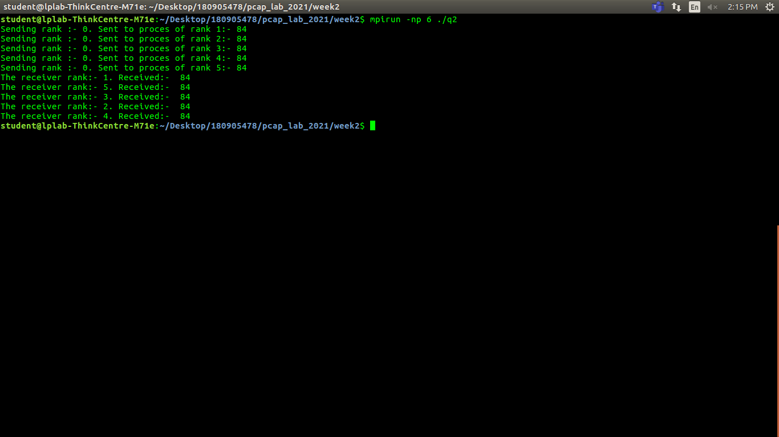

Q3

#include <mpi.h>
#include <stdio.h>
#include <stdlib.h>
#include <string.h>
#include <unistd.h>

int main(int argc, char *argv[])
{
int rank, size;
MPI_Status status;
int root_rank = 0;

MPI_Init(&argc, &argv);
MPI_Comm_rank(MPI_COMM_WORLD, &rank);
MPI_Comm_size(MPI_COMM_WORLD, &size);

if (rank == 0 )
{
for (int i = 1; i < size; i++)
{
int value = rand()%(512+i) + 1;
printf("process of rank %d , sending data %d to process with rank %d \n", rank, value, i);
int buffer_size = sizeof(int) + MPI_BSEND_OVERHEAD;
void *buffer = malloc(buffer_size);
MPI_Buffer_attach(buffer, buffer_size);
MPI_Bsend(&value, 1, MPI_INT, i, 0, MPI_COMM_WORLD);
MPI_Buffer_detach(&buffer, &buffer_size);

}
}
else
{
int value;
MPI_Recv(&value, 1, MPI_INT, 0, 0, MPI_COMM_WORLD, &status);
int ans ;
if(rank %2 ==0 ){
ans = value *value;
}
else {
ans = value *value *value;
}
printf("process of rank %d received value %d from process of rank %d and calculated %d\n", rank, value, root_rank, ans);
}
MPI_Finalize();
return 0;
}

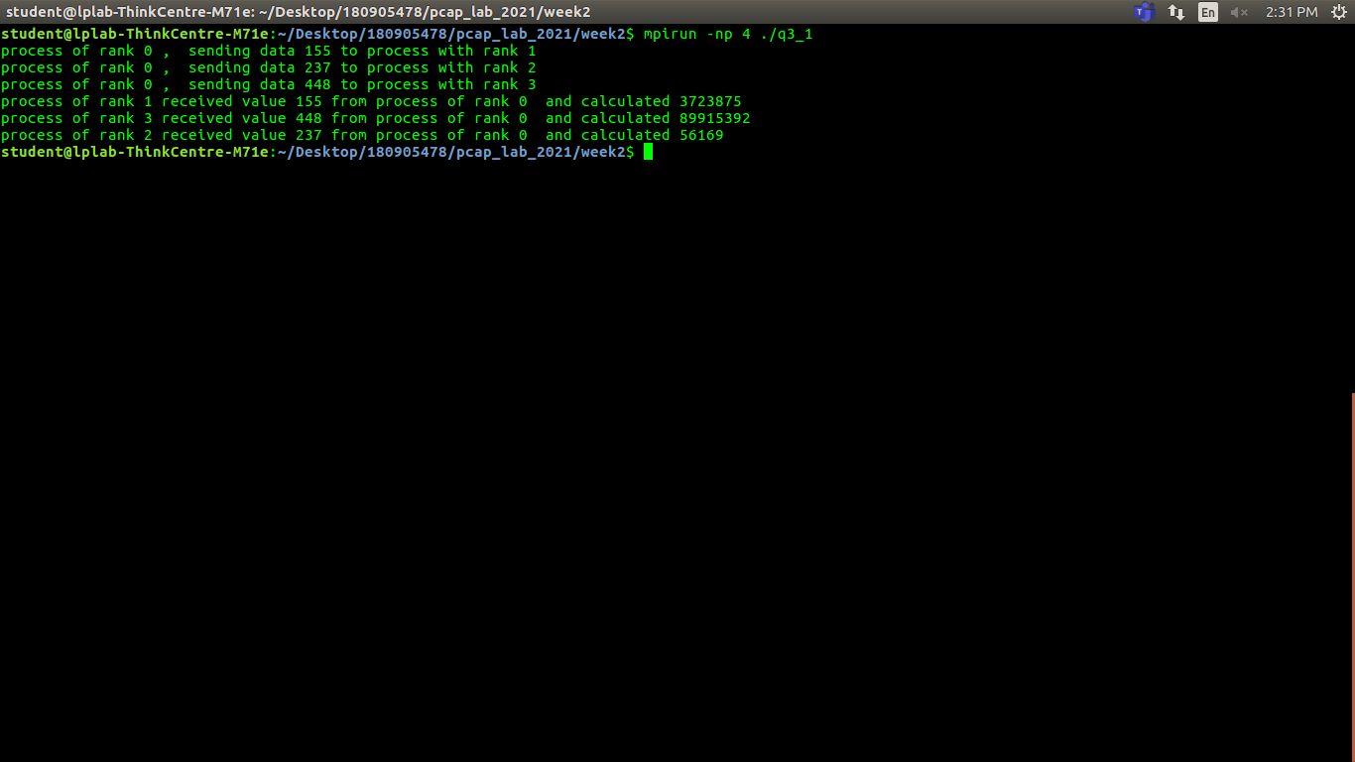

Q4
#include <mpi.h>
#include <stdio.h>
#include <stdlib.h>

#define SIZE sizeof(int)

int main (int argc, char *argv [])
{

int size, rank;
//int value;
MPI_Init(&argc, &argv);
MPI_Status status;
MPI_Comm_size(MPI_COMM_WORLD, &size);
MPI_Comm_rank(MPI_COMM_WORLD, &rank);

if(rank == 0)
{
int value;
printf("Enter the number :- \n");
scanf("%d", &value);
MPI_Send(&value, 1, MPI_INT, 1, 0, MPI_COMM_WORLD);
MPI_Recv(&value, 1, MPI_INT, size - 1, 0, MPI_COMM_WORLD, &status);
printf("process of rank %d got value back %d\n", rank, value);
}
else
{
int value;
int beforerank = rank - 1;
int afterrank = (rank + 1) % size;
MPI_Recv(&value, 1, MPI_INT, beforerank, 0, MPI_COMM_WORLD, &status);
printf("process of rank :- %d got value %d from process sent rank :- %d \n", rank, value, beforerank);
value++;
printf("process of rank :- %d sent value %d to process of rank :-%d \n", rank, value, afterrank);
MPI_Send(&value, 1, MPI_INT, afterrank, 0, MPI_COMM_WORLD);
}

MPI_Finalize();
return 0;
}

