WEEK4
PCAP LAB
Name: Sagnik Chatterjee
Reg:180905478
BATCH: B2
ROLLNO:61
SEM:6TH

Q1
/**
AUTHOR: SAGNIK CHATTERJEE
Write a MPI program using N processes to find 1! + 2! +.....+N!. Use scan. Also, handle
different errors using error handling routines.
*/

#include<mpi.h>
#include<stdio.h>
#include<stdlib.h>

void ErrorHandler(int error_code) {
if (error_code != MPI_SUCCESS) {
char error_string[BUFSIZ];
int length_of_error_string, error_class;
MPI_Error_class(error_code, &error_class);
MPI_Error_string(error_code, error_string, &length_of_error_string);
printf("Errors:= %d \t %s\n", error_class, error_string);
}
}

int factorial(int num) {
if (num <= 1) {
return 1;
}
else {
return num * factorial(num - 1);
}
}

int main(int argc, char **argv) {

int rank, size, factorial_final_ans = 0, error_code;
MPI_Init(&argc, &argv);
MPI_Errhandler_set(MPI_COMM_WORLD, MPI_ERRORS_RETURN);
error_code = MPI_Comm_rank(MPI_COMM_WORLD, &rank);
ErrorHandler(error_code);
error_code = MPI_Comm_size(MPI_COMM_WORLD, &size);
ErrorHandler(error_code);
int factorial_value = factorial(rank);
MPI_Scan(&factorial_value, &factorial_final_ans, 1, MPI_INT, MPI_SUM, MPI_COMM_WORLD);
printf(" The sum of all the factorials is:- %d\n", factorial_final_ans);
MPI_Finalize();
return 0;
}
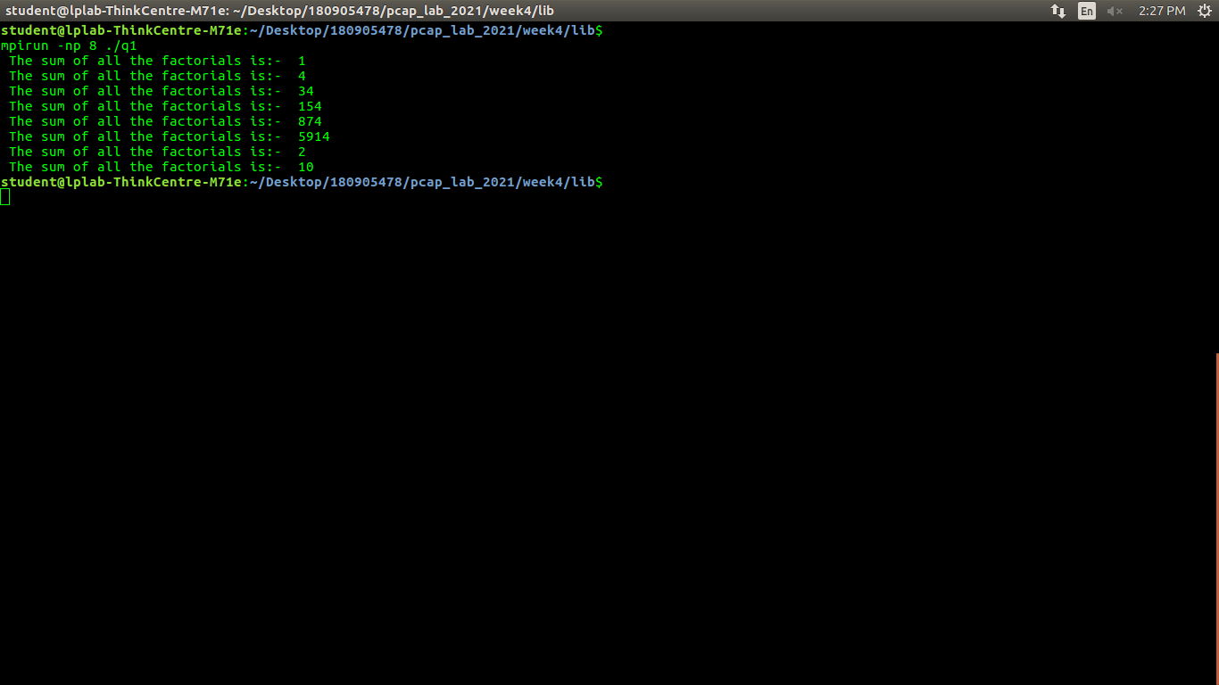

Q2
/**
AUTHOR : SAGNIK CHATTERJEE
Write a MPI program to calculate π-value by integrating f(x) = 4 /(1+x 2 ) . Area under the
curve is divided into rectangles and the rectangles are distributed to the processors. Also
handle different errors using error handling routines,
*/

#include <stdio.h>
#include <mpi.h>

#define Ntot 10000
#define d1 0.0001
#define d2 0.00000001

void ErrorHandler(int error_code) {
if (error_code != MPI_SUCCESS) {
char error_string[BUFSIZ];
int length_of_error_string, error_class;
MPI_Error_class(error_code, &error_class);
MPI_Error_string(error_code, error_string, &length_of_error_string);
printf("Errors:= %d \t %s\n", error_class, error_string);
}
}

int main (int argc, char* argv[])
{
int rank, size, error_code, i;
double pi_value = 0.0, result_rect = 0.0, sum = 0.0, begin = 0.0, end = 0.0, x2;

MPI_Init (&argc, &argv);
MPI_Errhandler_set(MPI_COMM_WORLD, MPI_ERRORS_RETURN);
error_code = MPI_Comm_rank(MPI_COMM_WORLD, &rank);
ErrorHandler(error_code);
error_code = MPI_Comm_size(MPI_COMM_WORLD, &size);
ErrorHandler(error_code);

//Each process will caculate a part of the sum
//as the sum of the rectangles are calculated in each process
//and them passed to reduce
//Ntot is the maximum processes we can calcualte for i.e asuming user doesnt cross 10000 threads
for (i = rank; i < Ntot; i += size)
{
//since we need to integrate the area from 0 to 1 ,(as 1+x^2 integrating is tan-^1(x) and at 1 it gives pi/4 so 4*this is 4*pi/4 i.e pi)
// we divide the total area by the total threads that is possible
//now on the xaxis we go on incrementing the distance x by size , since
//on each increment we increase by that onlyi.e dx increase in length
x2 = d2 * i * i;//small area that we are considering
result_rect += 4.0 / (1.0 + x2);
}

MPI_Reduce(&result_rect, &sum, 1, MPI_DOUBLE, MPI_SUM, 0, MPI_COMM_WORLD);

if (rank == 0)
{
//pi_value now has the product
pi_value = d1 * sum;
printf("Total process used = %d -----> Pi value output = %lf\n", size, pi_value);
}
MPI_Finalize();
return 0;
}

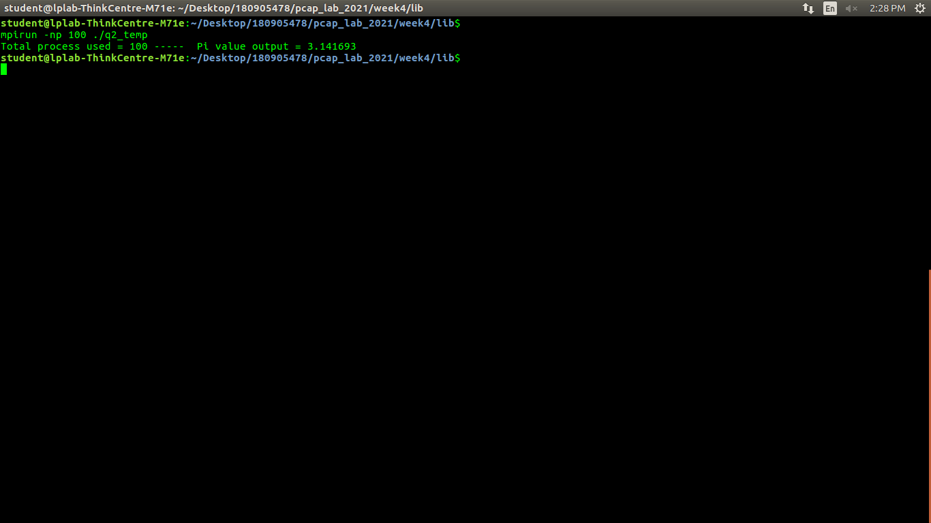
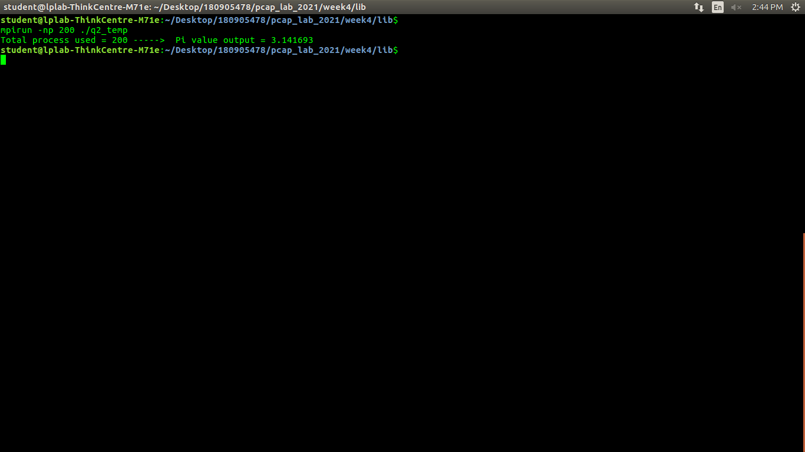

Q3
/**
AUTHOR: SAGNIK CHATTERJEE
Write a MPI program to read a 3 X 3 matrix. Enter an element to be searched in the root
process. Find the number of occurrences of this element in the matrix using three processes.
Also, handle different errors using error handling routines
*/

#include<mpi.h>
#include<stdio.h>
#include<stdlib.h>

void ErrorHandler(int error_code) {
if (error_code != MPI_SUCCESS) {
char error_string[BUFSIZ];
int length_of_error_string, error_class;
MPI_Error_class(error_code, &error_class);
MPI_Error_string(error_code, error_string, &length_of_error_string);
printf("Errors:= %d \t %s\n", error_class, error_string);
}
}

int main(int argc, char **argv) {
int rank, size, error_code;
int arr[3][3], arr2[3], i, j, ele, pos;
MPI_Init(&argc, &argv);
MPI_Errhandler_set(MPI_COMM_WORLD, MPI_ERRORS_RETURN);
error_code = MPI_Comm_rank(MPI_COMM_WORLD, &rank);
ErrorHandler(error_code);
error_code = MPI_Comm_size(MPI_COMM_WORLD, &size);
ErrorHandler(error_code);

if (rank == 0) {
printf("Enter the elements of the 3*3 matrix :\n");
for (i = 0; i < 3; i++) {
for (j = 0; j < 3; j++) {
scanf("%d", &arr[i][j]);
}
}
printf("Enter the element to be searched:- \n");
scanf("%d", &ele);
}
MPI_Bcast(&ele, 1, MPI_INT, 0, MPI_COMM_WORLD);
MPI_Scatter(arr, 3, MPI_INT, arr2, 3, MPI_INT, 0, MPI_COMM_WORLD);
int count = 0;
for (int i = 0; i < 3; i++) {
if (arr2[i] == ele) {
count++;

}
}
MPI_Reduce(&count, &pos, 1, MPI_INT, MPI_SUM, 0, MPI_COMM_WORLD);

if (rank == 0) {
printf("The element %d is found %d times in the matrix.\n", ele, pos);
}
MPI_Finalize();
return 0;
}

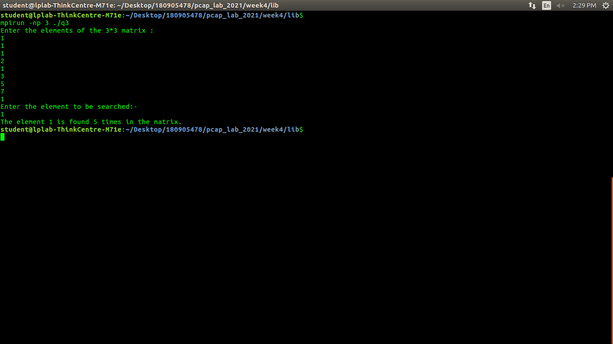

Q4
/**
AUTHOR: SAGNIK CHATTERJEE
Write a MPI program to read 4 X 4 matrix and display the following output using four
processes.
I/p matrix: 1 2 3 4
O/p matrix: 1 2 3 4
1 2 3 1
1 1 1 1
2 1 2 1
2 4 6 5
3 5 7 6
5 6 9 7

*/

#include<mpi.h>
#include<stdio.h>
#include<stdlib.h>

void ErrorHandler(int error_code) {
if (error_code != MPI_SUCCESS) {
char error_string[BUFSIZ];
int length_of_error_string, error_class;
MPI_Error_class(error_code, &error_class);
MPI_Error_string(error_code, error_string, &length_of_error_string);
printf("Errors:= %d \t %s\n", error_class, error_string);
}
}
int main(int argc, char **argv) {
int rank, size, error_code;
int arr[4][4], arr2[4], partsum[20], i, j, ele, pos;
MPI_Init(&argc, &argv);
MPI_Errhandler_set(MPI_COMM_WORLD, MPI_ERRORS_RETURN);
error_code = MPI_Comm_rank(MPI_COMM_WORLD, &rank);
ErrorHandler(error_code);
error_code = MPI_Comm_size(MPI_COMM_WORLD, &size);
ErrorHandler(error_code);

if (rank == 0) {
printf("Enter 4X4 matrix\n");
for (i = 0; i < 4; i++) {
for (j = 0; j < 4; j++) {
scanf("%d", &arr[i][j]);
}
}
}

MPI_Scatter(arr, 4, MPI_INT, arr2, 4, MPI_INT, 0, MPI_COMM_WORLD);
MPI_Scan(arr2, partsum, 4, MPI_INT, MPI_SUM, MPI_COMM_WORLD);

for (i = 0; i < 4; i++) {
printf("%d ", partsum[i]);
}
MPI_Finalize();
return 0;
}

