# Methodology

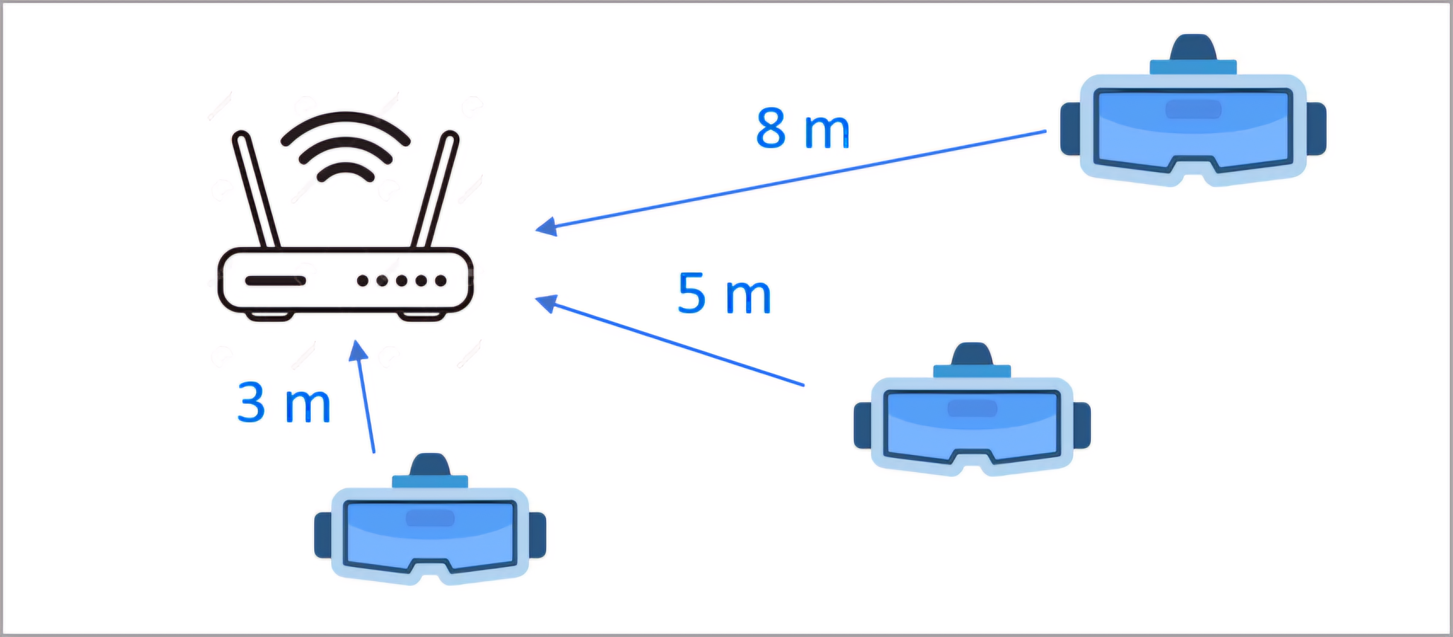

XR Scenario

The Generalized Decision-Feedback Equalizer (GDFE) resolves multiuser crosstalk issues. To achieve this, each user’s data is detected based on all previously decoded users with each symbol , .

This work compares the performance of non-linear (GDFE) receivers and linear receivers, both using basic OFDM. The specific focus is energy consumption. Initially, the receiver analysis uses the Simultaneous Water-Filling (SWF) algorithm with the linear receiver. This SWF optimizes the sum data rate for a given available energy. Subsequently, a receiver uses the GDFE, targeting the data rate determined by the SWF algorithm, to minimize energy. The objective is to demonstrate how the GDFE receiver can substantially reduce energy consumption in attaining the same SWF data rate values obtained.

Notation includes: $U$ denotes the number of users. $\overset{‾}{N}$ represents the number of tones. $L_{x}$ and $L_{y}$ are the total number of users’ antennas and the total number of antennas at the access point, respectively. $L_{x,u}$ is the number of antennas for the $u^{th}$ user. Moreover, the subscripts $u$ and $n$ represent user $u$ and $n^{th}$ tone, respectively. For instance, $H_{u}$ is user $u$’s channel matrix. There are two weighted-sum optimization problems: Energy Sum Minimization (1.1) and Data Rate Sum Maximization (1.2).

## Energy Sum Minimization

The weighted Energy Sum Minimization is formulated as follows:

$$\begin{matrix}\min_{\left\{R_{xx}\left(u\right)\right\}} & \sum_{u=1}^{U}{w_{u}}⋅trace\underset{E_{u}}{\underset{⏟}{\{R_{xx}\left(u\right)\}}} \\ \text{s.t.} & b≽{\left[b_{1,min},b_{2,min},…,b_{U,min}\right]}^{*} \\ & E≥0 \\ & \end{matrix}$$

Where $R_{xx}\left(u\right)$ and $b_{u,min}$ are the autocorrelation matrix and user $u$’s minimum data rate, respectively. Also, the vector $w∈R_{0+}^{U}$ represents non-negative weights for each user’s energy. The corresponding Lagrangian function is:

$$\begin{matrix}L_{minE}\left(R_{xx},b,w,θ\right)=\max_{θ}\min_{R_{xx}} & \sum_{u=1}^{U}{w_{u}}⋅trace\left\{R_{xx}\left(u\right)\right\} \\ & +θ_{u}⋅b_{u}-θ_{u}⋅b_{min,u}\end{matrix}$$

## Data Rate Sum Maximization

The weighted Data Rate Sum Maximization problem can be formulated as follows:

$$\begin{matrix}\max_{\left\{R_{xx}\left(u\right)\right\}} & \sum_{u=1}^{U}{θ_{u}}⋅b_{u} \\ \text{s.t.} & E_{x}≼{\left[E_{1,max},E_{2,\text{max}},…,E_{U,\text{max}}\right]}^{*} \\ & b≽0\end{matrix}$$

Similar to the previous part, we can expand the Lagrangian function:

$$\begin{matrix}L_{maxR}\left(R_{xx},b,w,θ\right)=\min_{w}\max_{R_{xx}} & \sum_{u=1}^{U}{w_{u}}⋅trace\left\{R_{xx}\left(u\right)\right\} \\ & + θ_{u}⋅b_{u}-w_{u}⋅E_{max,u}\end{matrix}$$

The common term $w_{u}⋅trace\left\{R_{xx}\left(u\right)\right\}+θ_{u}⋅b_{u}$ in both optimization problems implies their duality. Therefore, a primal-dual approach solves the optimization problem.This locates the optimal autocorrelation matrix $R_{xx}$, while fulfilling both the data rate and energy constraints.

It can be proven that the aforementioned optimization problems can be solved for each tone separately. In other words, an independent GDFE is assigned to each tone, and the total energy can be calculated by summing up all tones. The corresponding energy minimization problem for each tone is as follows:

$$\begin{matrix}\min_{\left\{R_{xx}\left(u,n\right)\right\}} & \sum_{u=1}^{U}{\sum_{n=0}^{\overset{‾}{N}}{w_{u}}}⋅trace\left\{R_{xx}\left(u,n\right)\right\} \\ \text{s.t.} & b=\sum_{n=0}^{\overset{‾}{N}}{{\left[b_{1,n},b_{2,n},…,b_{U,n}\right]}^{*}}≽b_{min}≽0\end{matrix}$$

Where $R_{xx}\left(u,n\right)∈R^{L_{x,u}×L_{x,u}}$ is the autocorrelation matrix of $x$ for user $u$ on the $n^{th}$ tone.

Similarly, the data rate maximization problem per each tone is:

$$\begin{matrix}\max_{\left\{R_{xx}\left(u,n\right)\right\}} & \sum_{u=1}^{U}{θ_{u}}⋅\left\{\sum_{n=0}^{\overset{‾}{N}}{b_{u,n}}\right\} \\ \text{s.t.} & E=\sum_{n=0}^{\overset{‾}{N}}{{\left[E_{1,n},E_{2,n},…,E_{U,n}\right]}^{*}}≼E_{max} .\end{matrix}$$

Equation [tonalE] ’s Lagrangian function is:

Insert equation

Where $R_{xx}\left(n\right)=blkdiag\left\{R_{xx}\left(U,n\right),…,R_{xx}\left(1,n\right)\right\}$, and the operator $blkdiag$ aligns matrices along the diagonal of another matrix. The term $L_{n}\left(R_{xx}\left(n\right),b_{n},w,θ\right)$ is called the Tonal Lagrangian term. Since $L_{n}$ does not depend on $b_{u}$, minimizing the tonal lagrangian term is synonymous with optimizing:

$$L_{minE}\left(θ,n\right)≜\min_{\left\{R_{xx}\left(u,n\right),b_{u,n}\right\}}L\left(R_{xx}\left(n\right),b_{n},w,θ\right)$$

Therefore, the min-max problem [minmaxE] reduces to :

Insert equation

Moreover, the data rates must lie in the system’s capacity region. The capacity region, denoted as $C\left(b\right)$, refers to the set of all possible rate vectors $b$ for users with independent messages, where each message employs a code that achieves the single-user capacity. This code is used for all systems and differences in their performance therefore solely derives from the GDFE improvement over the linear receiver. This set characterizes the rates at which all users can be reliably decoded with a negligible average error probability by a Maximum A Posteriori (MAP) detector or equivalently, a Maximum Likelihood (ML) detector with equally likely messages for all independent users. The capacity region is essentially the combination of rates at which the system can operate such that all users’ messages are delivered correctly. The capacity region follows from the Shannon capacity formula as :

$$0≤b_{n}≤\log_{2}\left|\left(\sum_{u=1}^{U}{{\tilde{H}}_{u,n}}⋅R_{xx}\left(u,n\right)⋅{\tilde{H}}_{u,n}^{*}\right)+I\right|$$

${\tilde{H}}_{u,n}=R_{NN}^{-1/2}\left(n\right)⋅H_{u,n}$ is the equivalent-white-noise channel per each tone.

A semi-definite programming (SDP) method solves the inner part of the optimization problem [final] ($L_{minE}\left(θ,n\right)$), while an Ellipsoid method

If the channel matrix $H_{u,n}$ is non-singular with the ideal common codes mentioned ($Γ=0\text{dB}$), the ellipsoid method finds a unique optimal solution. In other words, the system assigns different dimensions, such as time and frequency, to each user separately. However, if the channel is singular, the Hessian matrix computed at each ellipsoid-method iteration degradeds, and the optimization problem does not have a unique solution. In this case, the algorithm allows more than one user to use some specific dimensions at the same time, which is known as “time-sharing”. When the users “time-share” with one another, the algorithm only finds the weighted sum. A separate time-sharing step then applies to ensure all users meet their target data rate.

This minPMAC algorithm appears as Algorithm 2. Initially, the SWF algorithm provides first ellipsoid parameters. Then, minPMAC alternates between two optimization problems until convergence. It prioritizes the users’ decoding process based on $θ$ at each iteration.

**Inputs: $H,L_{x},R_{nn}$ $R_{\text{noise }}^{-1/2}\left(u\right)⋅H_{u}=F_{u}⋅Λ_{u}⋅M_{u}^{*}$ $E_{u,l}=max\left\{0,\frac{1}{L_{x}}\left(E_{u}-\sum_{k=1}^{L_{x}}{\frac{1}{λ_{u,k}^{2}}}\right)-\frac{1}{λ_{u,l}^{2}}\right\}$** **return $E_{u}$**

**Inputs: $H$** , $L_{xu}$, $b_{u}$, $w$

**Initialize:** Insert equation