
Fraudulent Claim Detection
Case Study Report

SAGNIK SAHA
OMKAR TERDAL

Contents
Problem Statement 2
Business Objective 2
1. Data Loading 2
2.Data Preparation & Cleaning 3
3. Train-Validation Split 3
4. Exploratory Data Analysis on Training Data 4
4.1 Univariate analysis 4
4.2 Correlation analysis 5
4.3 Check class balance 5
4.4 Bivariate analysis 6
6. Feature Engineering 13
6.1 Perform resampling 13
6.2 Feature Creation 13
6.3 Handle redundant columns 13
6.4 Combine values in Categorical Columns 14
6.5 Dummy variable creation 14
6.6 Feature scaling 14
7. Model Building 14
7.1 Logistic Regression 14
7.2 Random Forest Model 18
8. Prediction and Model Evaluation 20
9. Conclusion 21

Problem Statement
Global Insure, a leading insurance company, processes thousands of claims annually. However, a significant percentage of these claims turn out to be fraudulent, resulting in considerable financial losses. The companys current process for identifying fraudulent claims involves manual inspections, which are time-consuming and inefficient. Fraudulent claims are often detected too late in the process, after the company has already paid out significant amounts. Global Insure wants to improve its fraud detection process using data-driven insights to classify claims as fraudulent or legitimate early in the approval process. This would minimize financial losses and optimize the overall claims handling process.

Business Objective
Global Insure wants to build a model to classify insurance claims as either fraudulent or legitimate based on historical claim details and customer profiles. By using features like claim amounts, customer profiles and claim types, the company aims to predict which claims are likely to be fraudulent before they are approved.

1. Data Loading
The insurance claims data has 40 Columns and 1000 Rows. The following data dictionary provides the description for each column present in dataset:
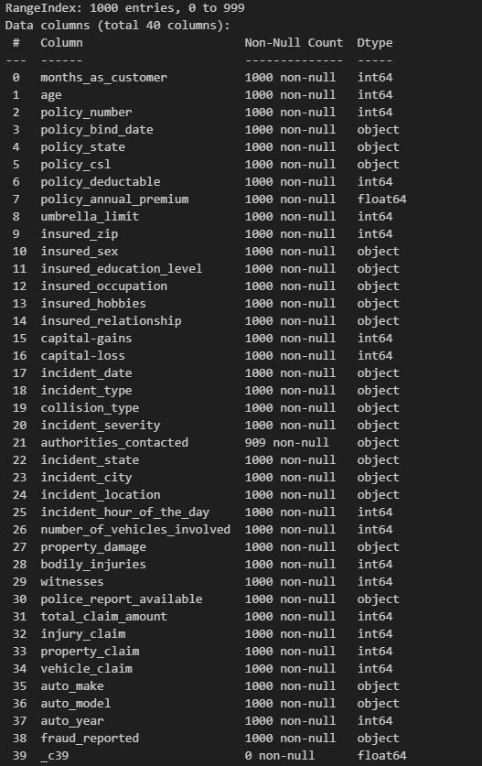

2.Data Preparation & Cleaning
- Null values are present for 2 feature authorities_contacted & _c39.
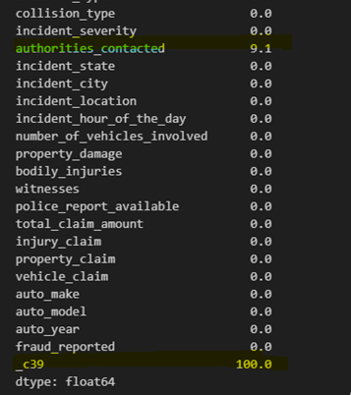
- Replace the ? by the most common collision type as we are unaware of the type.
- Replace NaN values in authorities_contacted column most common values.
- Dropped feature “_c39” which is empty.
- Identified and removed columns where a large proportion of the values are unique or near unique, as these columns are likely to be identifiers or have very limited predictive power
  - policy_number
  - incident_location
  - insured_zip
- Fixed the datatype for datetime features policy_bind_date & incident_date.

3. Train-Validation Split
- Performed train-train split with 70% training & 30% validation data.
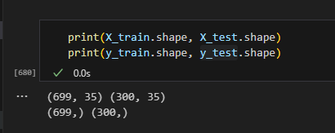

4. Exploratory Data Analysis on Training Data

4.1 Univariate analysis
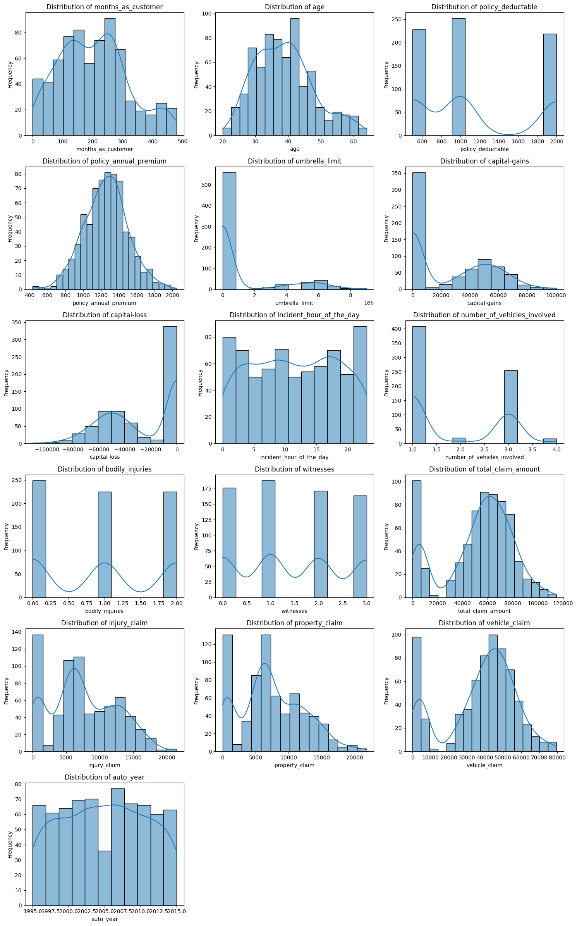

4.2 Correlation analysis
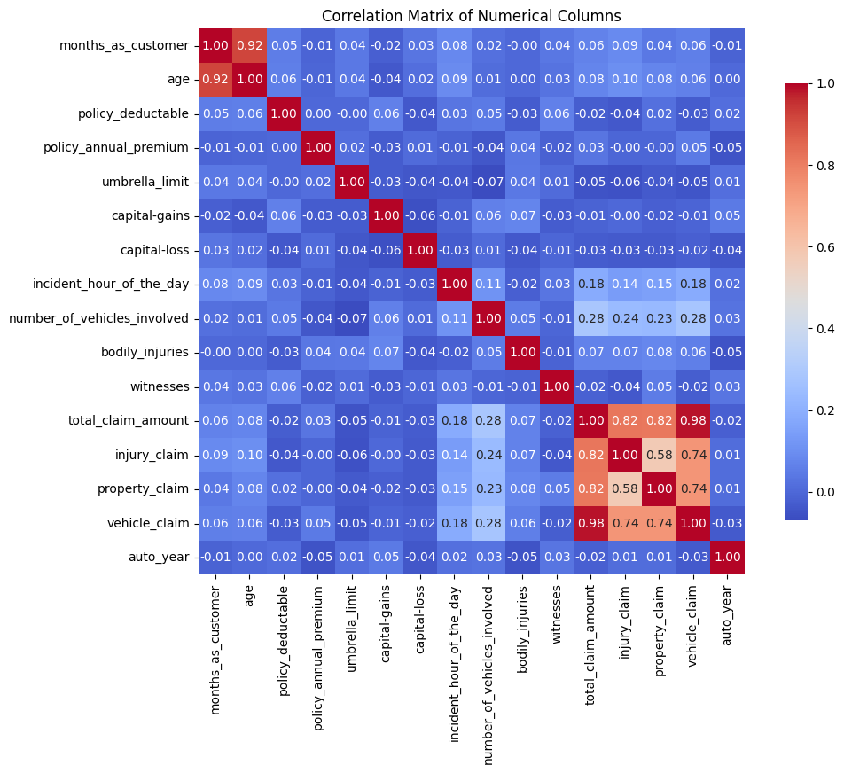
- The top high correlated features are
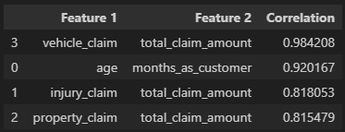

4.3 Check class balance
- Distribution of the target variable to identify potential class imbalances using visualization for better understanding.
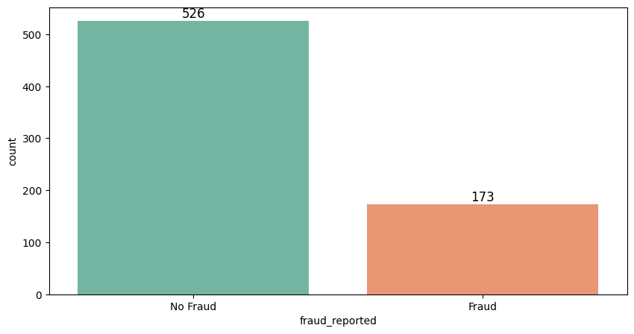

4.4 Bivariate analysis
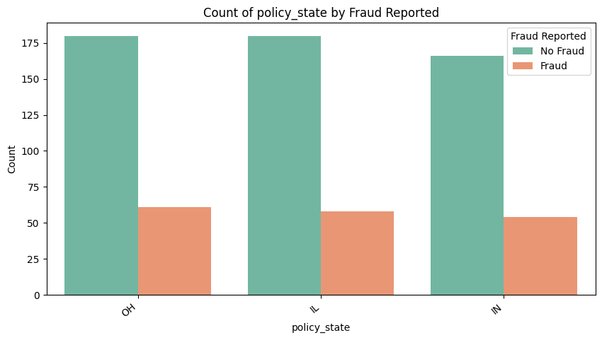
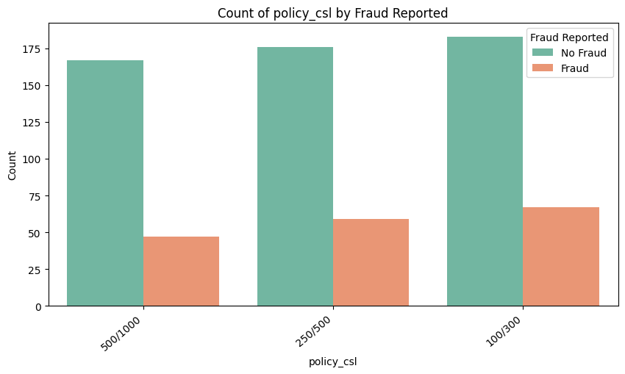
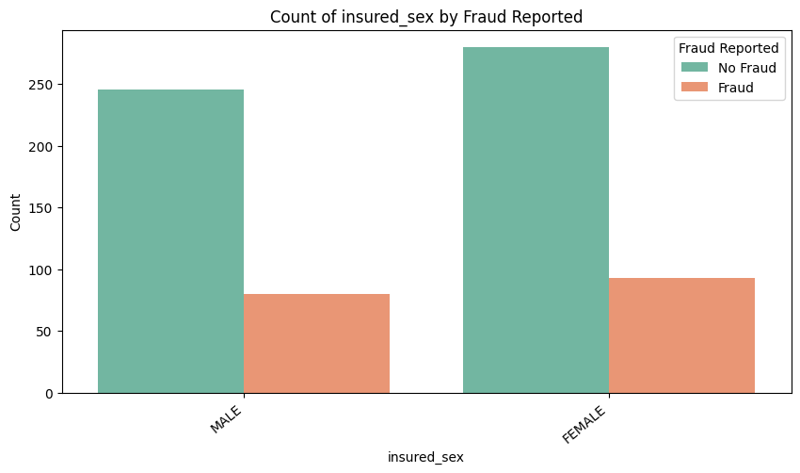
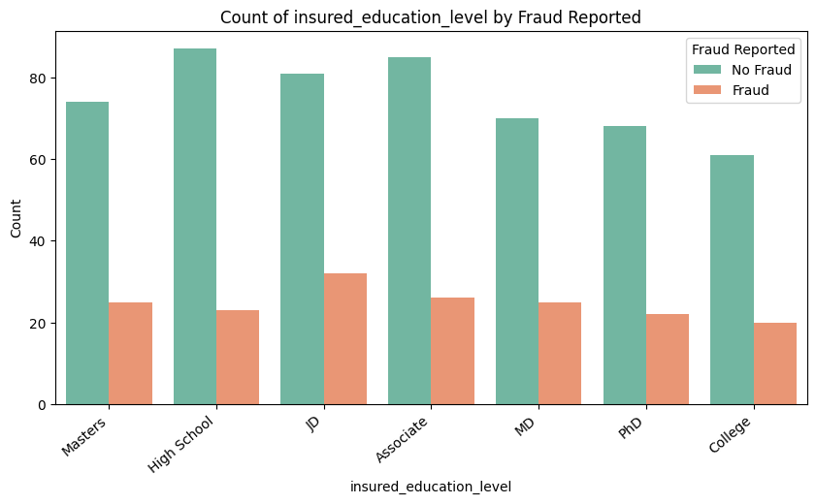
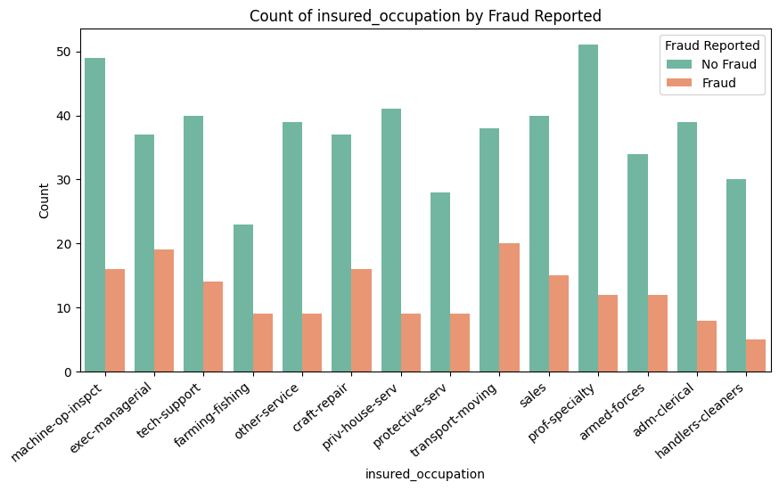
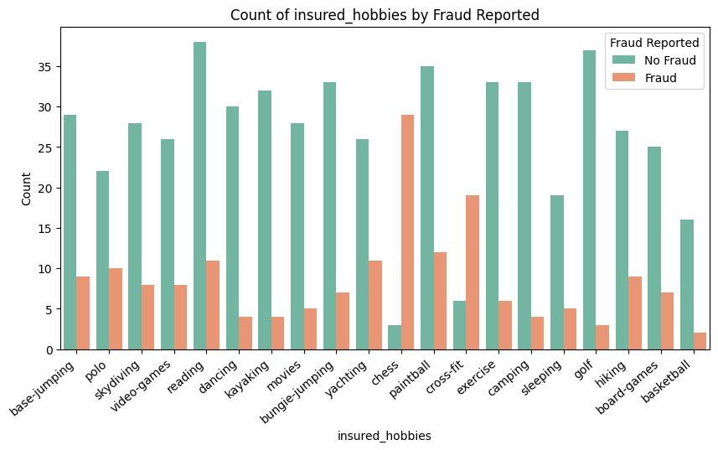
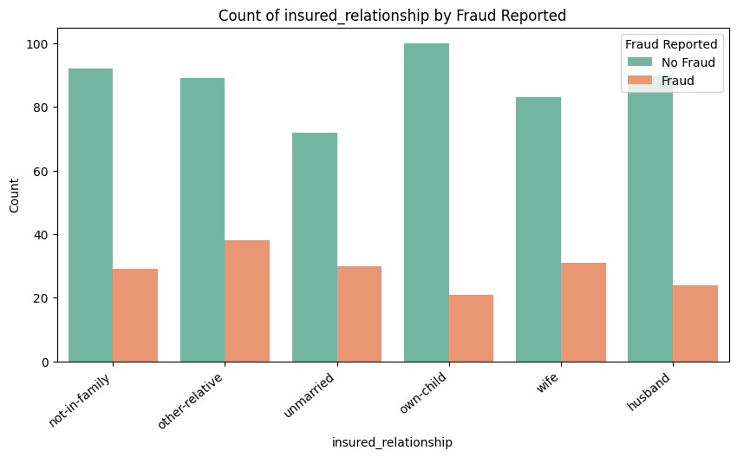
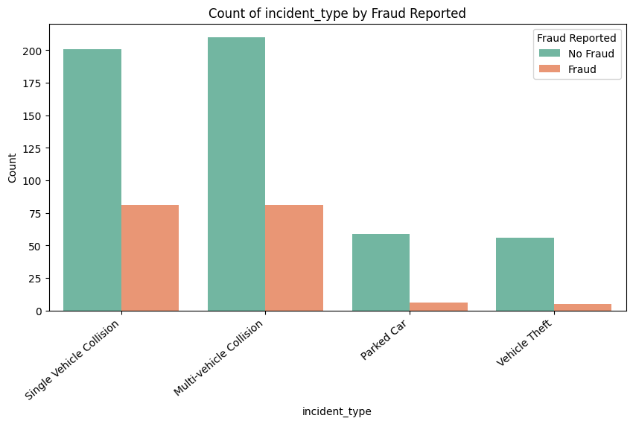
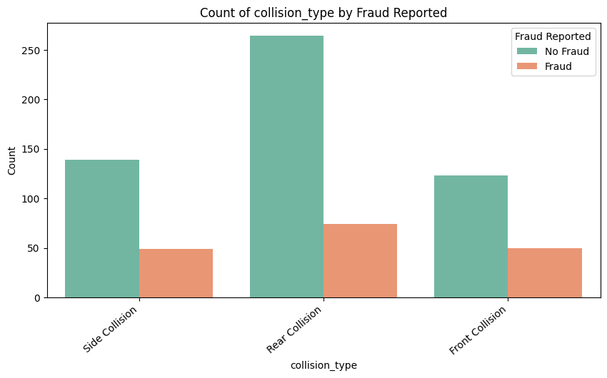

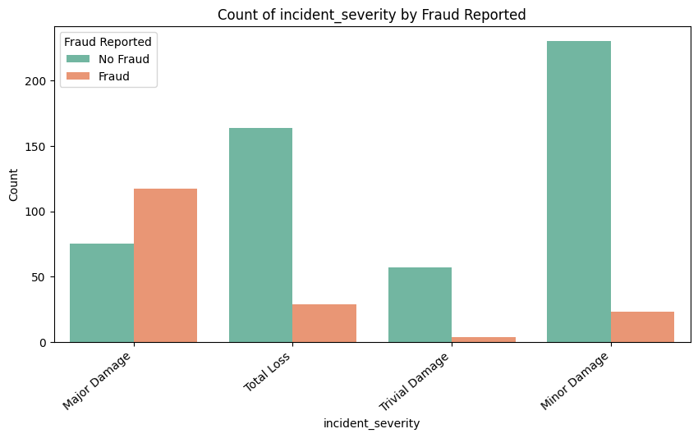
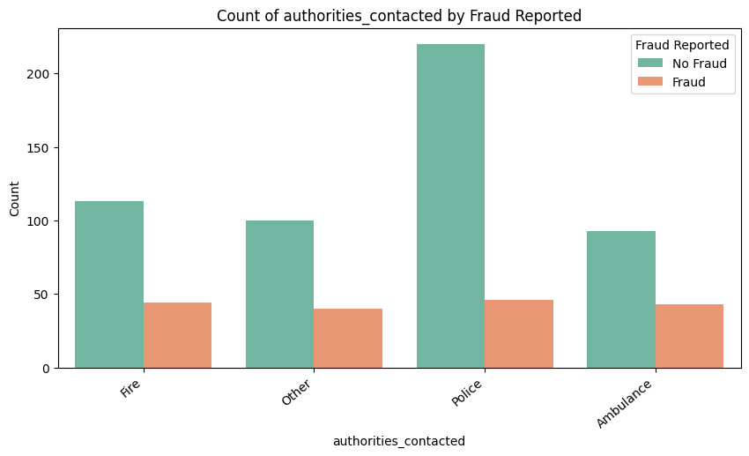
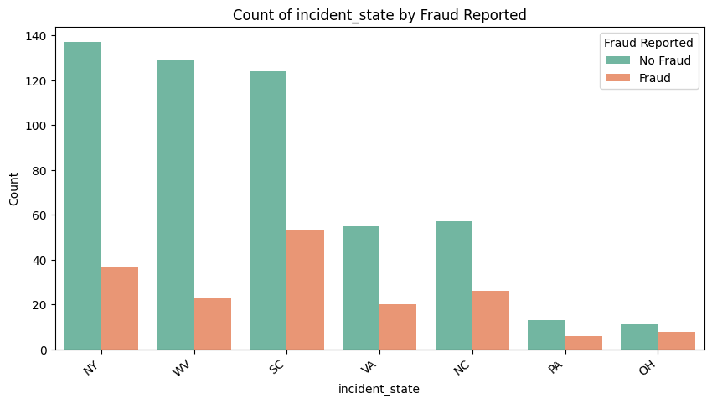
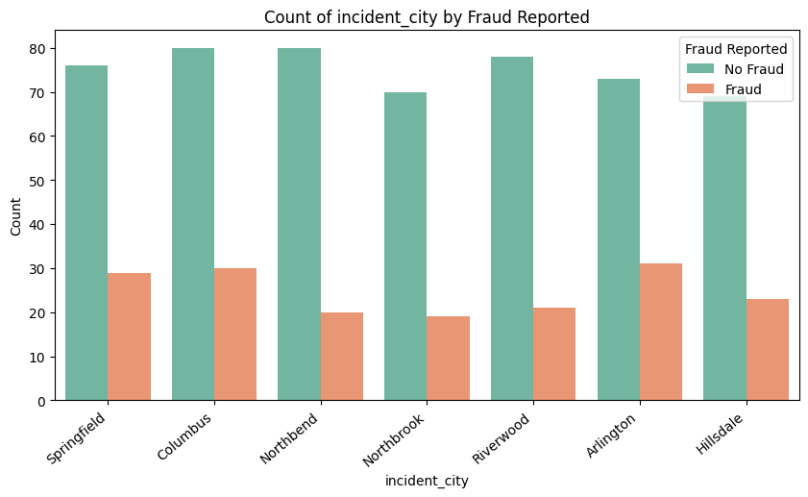
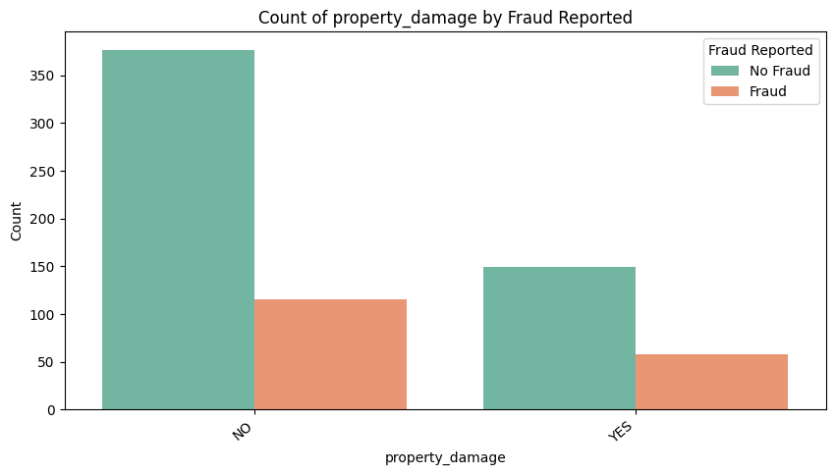
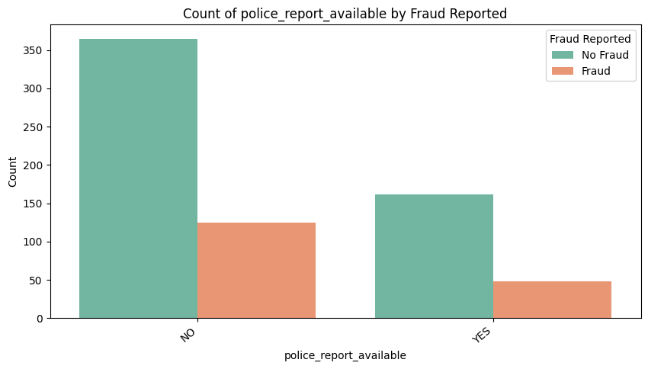

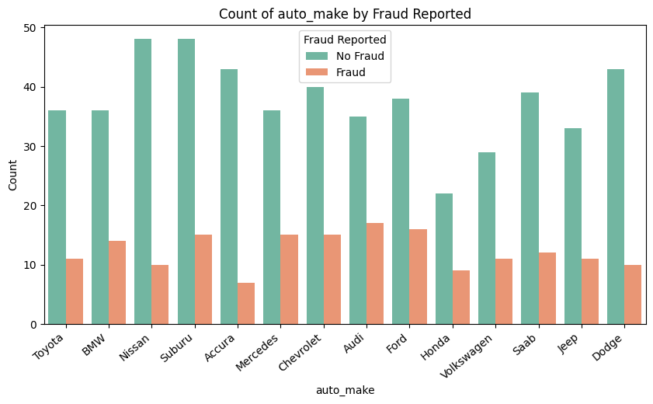

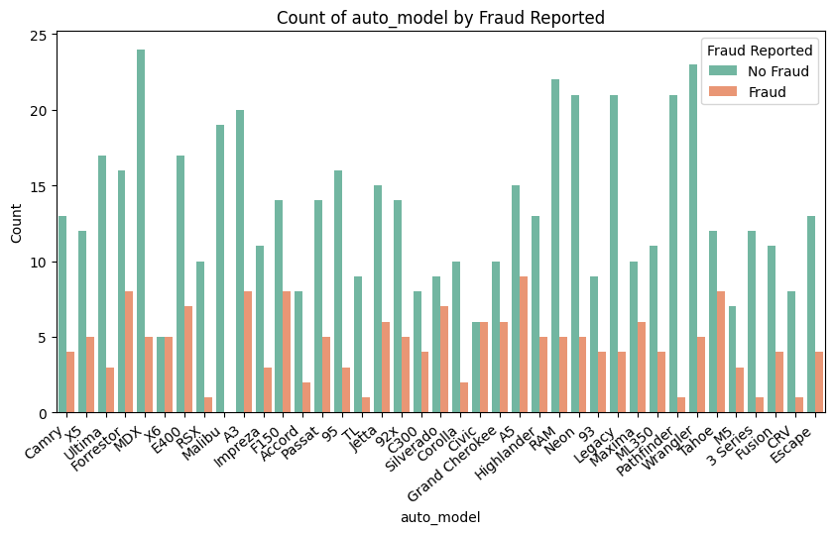

4.4.2 Relationships between numerical features and the target variable to understand their impact on the target outcome.
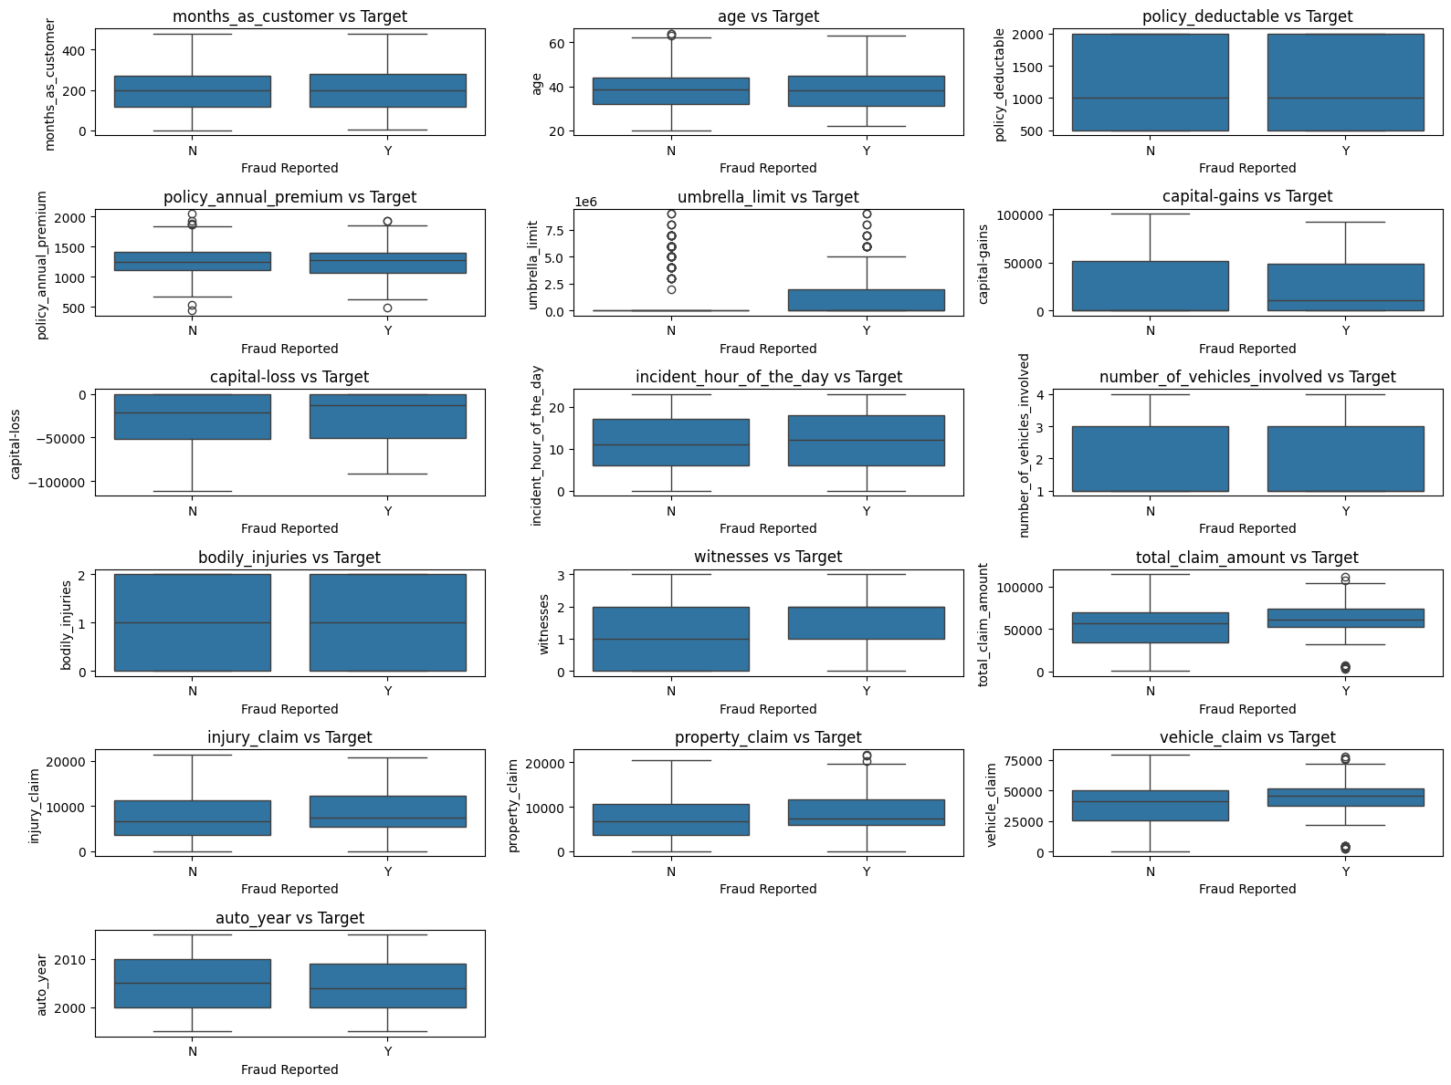

6. Feature Engineering

6.1 Perform resampling
- Using RandomOverSampler technique to balance the data and handle class imbalance.
- This method increases the number of samples in the minority class by randomly duplicating them, creating synthetic data points with similar characteristics.
- This helps prevent the model from being biased toward the majority class and improves its ability to predict the minority class more accurately.
- Results after resampling
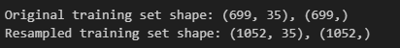

6.2 Feature Creation
- Below new features are created using the existing features
  - age_group – Using the age column, created age group bins.
  - vehicle_age - Derived the age of the vehicle based on the year value.
  - policy_age_years – Derived the policy age at the time of the incident using incident_date & policy_bind_date.
  - injury_claim_ratio, property_claim_ratio, vehicle_claim_ratio – Derived the claim ratio from the total types of claims and there claim amount.
  - claim_per_vehicle – Created claim per vehicle.
  - auto_full_name – Derived by using the auto_make & auto_model.

6.3 Handle redundant columns
- Removed the below features which have low correlation and redundant.
  - policy_csl
  - policy_bind_date
  - incident_date
  - auto_year
  - auto_model
  - auto_make
  - incident_hour_of_the_day
  - csl_per_person
  - csl_per_accident

6.4 Combine values in Categorical Columns

- From EDA found that for insured_hobbies feature vs target variable, chess and cross-fit are among the top. So apart from these 2 values, replaced all values in other categories.

6.5 Dummy variable creation
- Transform categorical variables into numerical representations using dummy variables. Ensure consistent encoding between training and validation data.
- The shape for both training and validation data after dummy variable creation
Train | (1052, 109)
Test | (300, 109)

6.6 Feature scaling
- Scale numerical features to a common range to prevent features with larger values from dominating the model. Choose a scaling method appropriate for the data and the chosen model. Apply the same scaling to both training and validation data.

7. Model Building

7.1 Logistic Regression
Top features based on RPECV
- insured_occupation_exec-managerial,
- insured_occupation_handlers-cleaners,
- insured_occupation_other-service,
- insured_occupation_priv-house-serv,
- insured_education_level_PhD,
- insured_education_level_MD,
- insured_education_level_JD,
- insured_occupation_craft-repair,
- insured_relationship_unmarried,
- collision_type_Side Collision,
- insured_relationship_not-in-family,
- insured_hobbies_chess,
- incident_state_WV,
- incident_city_Columbus,
- incident_city_Northbrook,
- incident_severity_Minor Damage,
- incident_severity_Total Loss,
- incident_severity_Trivial Damage,
- incident_state_OH,
- incident_state_NY,
- incident_city_Northbend,
- incident_state_VA,
- incident_type_Vehicle Theft,
- insured_relationship_own-child,
- insured_hobbies_cross-fit,
- insured_occupation_transport-moving,
- insured_occupation_protective-serv,
- auto_full_name_Accura-RSX,
- age_group_60+,
- property_damage_YES,
- incident_city_Riverwood,
- auto_full_name_Chevrolet-Silverado,
- auto_full_name_Ford-Fusion,
- auto_full_name_Ford-F150,
- auto_full_name_Ford-Escape,
- auto_full_name_Jeep-Wrangler,
- auto_full_name_Chevrolet-Malibu,
- auto_full_name_BMW-X6,
- auto_full_name_Toyota-Camry,
- auto_full_name_Nissan-Pathfinder,
- auto_full_name_Saab-92x,
- auto_full_name_Suburu-Legacy,
- auto_full_name_Jeep-Grand Cherokee,
- auto_full_name_Honda-CRV,
- auto_full_name_Honda-Civic,
- auto_full_name_Mercedes-ML350,
- auto_full_name_Mercedes-C300,
- auto_full_name_Accura-TL,
- auto_full_name_Audi-A3,
- auto_full_name_Audi-A5,
- auto_full_name_BMW-3 Series,
- auto_full_name_BMW-M5ROC Curve
- witnesses,
Trade-off plot between accuracy, sensitivity and specificity

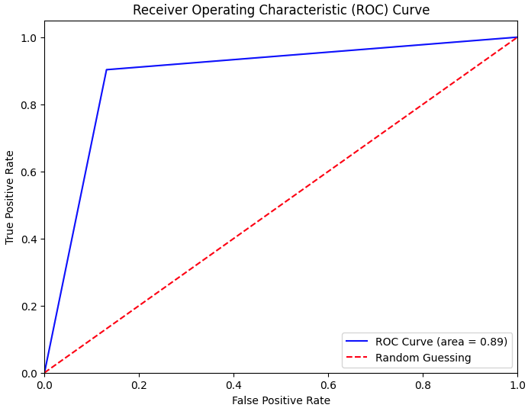

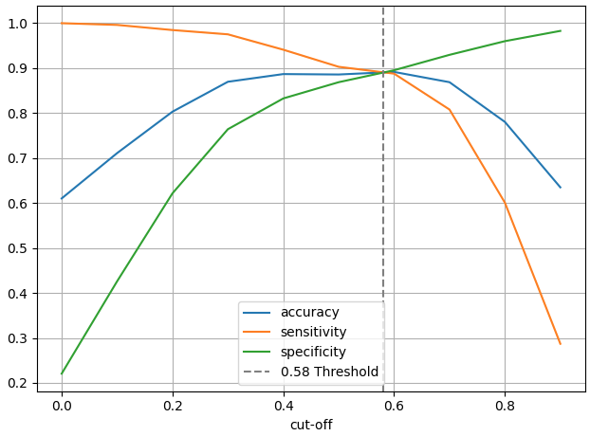

- Summary of Model (Training)
  - Probability Cutoff: 0.58
  - Model Accuracy: 0.89
  - Sensitivity (Recall): 0.9
  - Specificity: 0.87
  - Precision: 0.87
  - F1 Score: 0.89
- Confurion Matrix
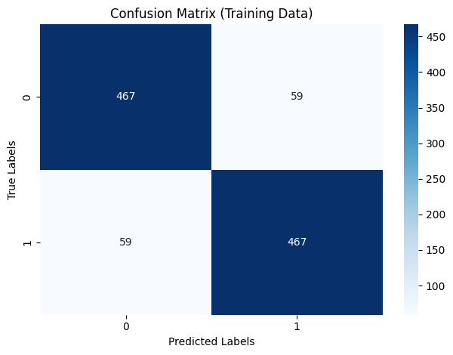

- precision-recall curve
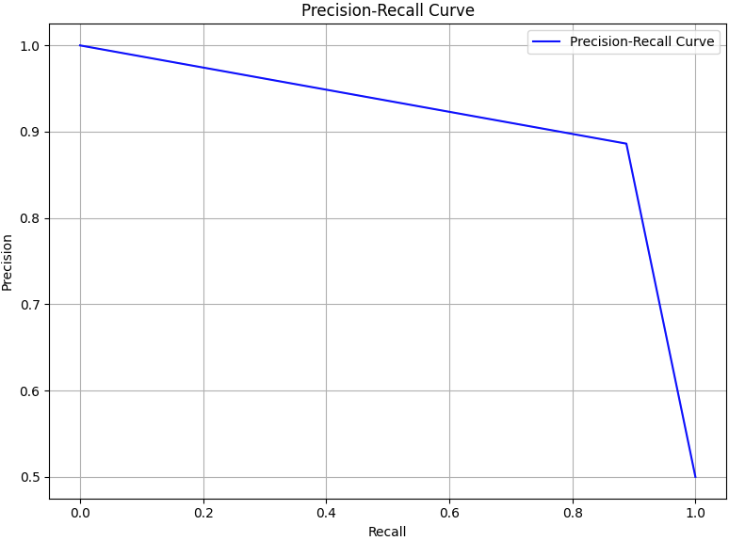

7.2 Random Forest Model
- Top features with importance score
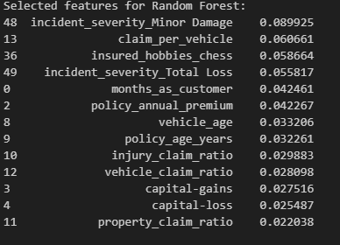
- Best estimator found
  - max_depth=15,
  - max_features=5,
  - min_samples_leaf=10,
  - min_samples_split=20,
  - n_estimators=15

- Summary of Model (Training)
  - OOB Score: 0.85
  - Model Accuracy: 0.89
  - Sensitivity (Recall): 0.91
  - Specificity: 0.87
  - Precision: 0.88
  - F1 Score: 0.89
- Confurion Matrix
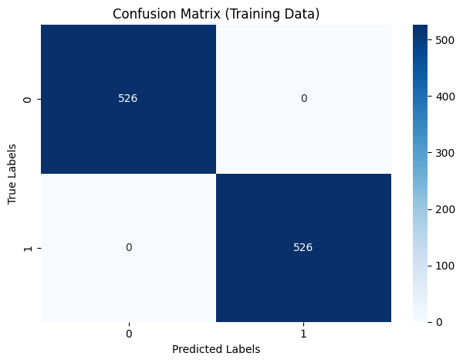

8. Prediction and Model Evaluation

Model | Hyperparameter Tuning | Training data performance | Test data performance
Logistic Regression | Probability Cutoff: 0.58 | Model Accuracy: 0.89  Sensitivity (Recall): 0.9  Specificity: 0.87  Precision: 0.87  F1 Score: 0.89 | Model Accuracy: 0.84  Sensitivity (Recall): 0.78  Specificity: 0.85  Precision: 0.64  F1 Score: 0.7
Random Forest | max_depth=15,  max_features=5,  min_samples_leaf=10,  min_samples_split=20,  n_estimators=15 | OOB Score: 0.85  Model Accuracy: 0.88  Sensitivity (Recall): 0.9  Specificity: 0.86  Precision: 0.87  F1 Score: 0.88 | OOB Score: 0.82  Model Accuracy: 0.82  Sensitivity (Recall): 0.74  Specificity: 0.82  Precision: 0.58  F1 Score: 0.65

9. Conclusion
- Feature Importance: Both models identified features such as incident_severity, insured_hobbies, vehicle_age, injury_claim and vehicle_claim as highly important for predicting fraud.
- Correlation Analysis: High correlations were found between some features (e.g., vehicle_claim and total_claim_amount), indicating potential multicollinearity, which was addressed during feature selection.
- Both logistic regression and random forest models provide robust performance for fraud detection, with logistic regression offering a slightly better F1 score.
- The optimal cutoff was chosen based on the trade-off between sensitivity and specificity, ensuring a balanced approach to fraud detection.
- Feature selection and correlation analysis helped in improving model interpretability and reducing redundancy.
- For deployment, either model can be considered, but logistic regression may be preferred for its simplicity and interpretability, while random forest can be chosen for potentially better handling of complex, non-linear relationships.
- Further improvements can be made by exploring advanced ensemble methods, additional feature engineering, or addressing class imbalance with techniques like SMOTE or cost-sensitive learning.

