**INTRODUCTION**

Vehicle Online is software through which user can get information about any car model that is present in the market before buying it. Using this software, one can know the price, mileage, maximum turning radius, engine capacity of a vehicle and the type of fuel it use whether petrol or diesel.

This software is basically divided into two parts:

1. Administrator
2. Visitor

Administrator can update the information for any selected car model in the database.

Visitors can get specifications of different car models of different makers and they can compare two models at a time which may or may not be of same company.

This software has been made using Microsoft Visual Basic Version 6.0 and the database is maintained using Microsoft Access.

**SOURCE CODE**

**Form1(Start-Up Splash Screen Form):**

Private Sub Form_Load()

Label2.Caption = "LOADING VEHICLE ONLINE....."

Label1.Caption = "Copyrighted to IEM"

Image1.Picture = LoadPicture("C:\Users\user\Desktop\VB project\cars.jpg")

End Sub

Private Sub Timer1_Timer()

ProgressBar1.Value = ProgressBar1.Value + 1

If ProgressBar1.Value = ProgressBar1.Max Then

Unload Me

Form6.Show

End If

End Sub

**Form6(Member selection form):**

Private Sub Command1_Click()

If Text1.Text = "admin" Then

Form7.Show

Unload Me

Else

MsgBox "Password don't match", vbExclamation, "Error"

End If

End Sub

Private Sub Form_Activate()

Option1.Value = False

Option2.Value = False

End Sub

Private Sub Option1_Click()

Unload Me

Form2.Show

End Sub

Private Sub Option2_Click()

Text1.Enabled = True

End Sub

**Form2(model selection form for user):**

Dim CN As ADODB.Connection

Dim RS As ADODB.Recordset

Private Sub Combo1_Click()

Dim a As String

If Combo1.Text = "Hyundai" Then

Open "C:\Users\user\Desktop\VB project\hyundai.txt" For Input As #1

While EOF(1) = False

Line Input #1, a

Combo2.AddItem a

Wend

Close #1

ElseIf Combo1.Text = "Maruti" Then

Open "C:\Users\user\Desktop\VB project\maruti.txt" For Input As #1

While EOF(1) = False

Line Input #1, a

Combo2.AddItem a

Wend

Close #1

End If

Combo1.Enabled = False

End Sub

Private Sub Form_Load()

Label1.Caption = "Choose your Vehicle"

Combo1.Text = "Makers"

Combo1.AddItem "Hyundai"

Combo1.AddItem "Maruti"

Combo2.Text = "Model"

End Sub

Private Sub Form_Activate()

Set CN = New ADODB.Connection

CN.ConnectionString = "Provider = Microsoft.Jet.OLEDB.4.0; Data Source = C:\Users\user\Desktop\VB project\vehicle.mdb;"

CN.Open

If CN.State = 1 Then

a = MsgBox("A successful connection is established", vbInformation, "Message")

End If

End Sub

Private Sub Command1_Click()

Set RS = New ADODB.Recordset

RS.Open "select Price, Engine, Fuel, Mileage, MTR,link from table1 where Model = '" & Combo2.Text & "'", CN, adOpenDynamic

Form3.Show

Form3.Label1.Caption = Combo1.Text & "-" & Combo2.Text

Form3.Text1.Text = RS(0).Value

Form3.Text2.Text = RS(1).Value

Form3.Text3.Text = RS(2).Value

Form3.Text4.Text = RS(3).Value

Form3.Text5.Text = RS(4).Value

Form5.Label1.Caption = Combo1.Text & "-" & Combo2.Text

Form5.Text6.Text = RS(0).Value

Form5.Text7.Text = RS(1).Value

Form5.Text8.Text = RS(2).Value

Form5.Text9.Text = RS(3).Value

Form5.Text10.Text = RS(4).Value

Form3.Image1.Picture = LoadPicture(RS(5).Value)

Unload Me

End Sub

**Form3(Ouput form):**

Private Sub Command1_Click()

Form4.Show

Me.Hide

End Sub

Private Sub Command2_Click()

End

End Sub

Private Sub Command3_Click()

Unload Me

Form2.Show

End Sub

Private Sub Form_Activate()

Text1.Locked = True

Text2.Locked = True

Text3.Locked = True

Text4.Locked = True

Text5.Locked = True

End Sub

**Form4(2nd model selection form to compare):**

Dim CN As ADODB.Connection

Dim RS As ADODB.Recordset

Private Sub Combo1_Click()

Dim a As String

If Combo1.Text = "Hyundai" Then

Open "C:\Users\user\Desktop\VB project\hyundai.txt" For Input As #1

While EOF(1) = False

Line Input #1, a

Combo2.AddItem a

Wend

Close #1

ElseIf Combo1.Text = "Maruti" Then

Open "C:\Users\user\Desktop\VB project\maruti.txt" For Input As #1

While EOF(1) = False

Line Input #1, a

Combo2.AddItem a

Wend

Close #1

End If

Combo1.Enabled = False

End Sub

Private Sub Combo2_Click()

Set RS = New ADODB.Recordset

RS.Open "select link from table1 where Model = '" & Combo2.Text & "'", CN, adOpenDynamic

Image1.Picture = LoadPicture(RS(0).Value)

End Sub

Private Sub Command1_Click()

Set RS = New ADODB.Recordset

RS.Open "select Price, Engine, Fuel, Mileage, MTR from table1 where Model = '" & Combo2.Text & "'", CN, adOpenDynamic

Form5.Label2.Caption = Combo1.Text & "-" & Combo2.Text

Form5.Text1.Text = RS(0).Value

Form5.Text2.Text = RS(1).Value

Form5.Text3.Text = RS(2).Value

Form5.Text4.Text = RS(3).Value

Form5.Text5.Text = RS(4).Value

Unload Form4

Me.Hide

Form5.Show

End Sub

Private Sub Form_Load()

Combo1.Text = "Makers"

Combo1.AddItem "Hyundai"

Combo1.AddItem "Maruti"

Combo2.Text = "Model"

End Sub

Private Sub Form_Activate()

Set CN = New ADODB.Connection

CN.ConnectionString = "Provider = Microsoft.Jet.OLEDB.4.0; Data Source = C:\Users\user\Desktop\VB project\vehicle.mdb;"

CN.Open

If CN.State = 1 Then

a = MsgBox("A successful connection is established", vbInformation, "Message")

End If

End Sub

**Form5(comparedoutput form):**

Private Sub Command1_Click()

End

End Sub

**Form7(admin model selection form):**

Dim CN As ADODB.Connection

Dim RS As ADODB.Recordset

Private Sub Combo1_Click()

Dim a As String

If Combo1.Text = "Hyundai" Then

Open "C:\Users\user\Desktop\VB project\hyundai.txt" For Input As #1

While EOF(1) = False

Line Input #1, a

Combo2.AddItem a

Wend

Close #1

ElseIf Combo1.Text = "Maruti" Then

Open "C:\Users\user\Desktop\VB project\maruti.txt" For Input As #1

While EOF(1) = False

Line Input #1, a

Combo2.AddItem a

Wend

Close #1

End If

Combo1.Enabled = False

End Sub

Private Sub Combo2_Click()

Set RS = New ADODB.Recordset

RS.Open "select Price, Engine, Fuel, Mileage, MTR,link from table1 where Model = '" & Combo2.Text & "'", CN, adOpenDynamic

Form8.Show

Form8.Label1.Caption = Combo1.Text & "-" & Combo2.Text

Form8.Text1.Text = RS(0).Value

Form8.Text2.Text = RS(1).Value

Form8.Text3.Text = RS(2).Value

Form8.Text4.Text = RS(3).Value

Form8.Text5.Text = RS(4).Value

Form8.Text6.Text = Combo2.Text

Form8.Image1.Picture = LoadPicture(RS(5).Value)

Me.Hide

End Sub

Private Sub Form_Load()

Label1.Caption = "Choose your Vehicle"

Combo1.Text = "Makers"

Combo1.AddItem "Hyundai"

Combo1.AddItem "Maruti"

Combo2.Text = "Model"

End Sub

Private Sub Form_Activate()

Set CN = New ADODB.Connection

CN.ConnectionString = "Provider = Microsoft.Jet.OLEDB.4.0; Data Source = C:\Users\user\Desktop\VB project\vehicle.mdb;"

CN.Open

If CN.State = 1 Then

a = MsgBox("A successful connection is established", vbInformation, "Message")

End If

End Sub

**Form8(admin model updation form):**

Dim CN As ADODB.Connection

Dim RS As ADODB.Recordset

Private Sub Command1_Click()

Dim qry

qry = "Update table1 set Price='" & Text1.Text & "', Engine = '" & Text2.Text & "', Fuel='" & Text3.Text & "', Mileage='" & Text4.Text & "', MTR='" & Text5.Text & "' where Model ='" & Text6.Text & "';"

CN.Execute qry

MsgBox "SUCCESSFULLY UPDATED"

End Sub

Private Sub Command2_Click()

MsgBox "Logged out successfully", vbInformation, "Sign Out"

End

End Sub

Private Sub Command3_Click()

Unload Me

Unload Form7

Form7.Show

End Sub

Private Sub Form_Activate()

Set CN = New ADODB.Connection

CN.ConnectionString = "Provider = Microsoft.Jet.OLEDB.4.0; Data Source = C:\Users\user\Desktop\VB project\vehicle.mdb;"

CN.Open

If CN.State = 1 Then

'a = MsgBox("A successful connection is established", vbInformation, "Message")

End If

End Sub

**BASIC FORM LAYOUT**

Start-UP Flash Screen (Form 1)

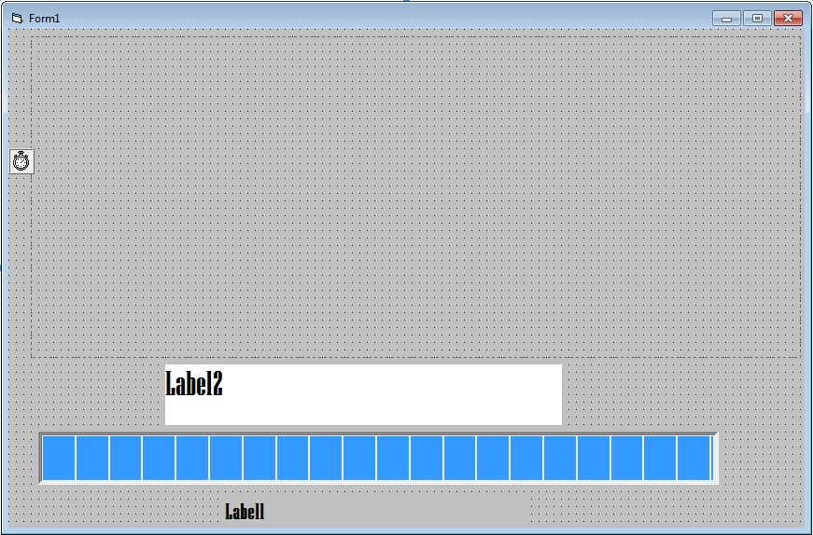

Member selection (FORM 6)

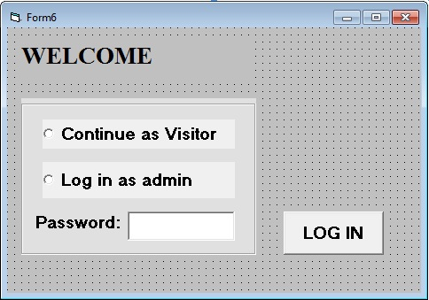

Model Selection (FORM 2)

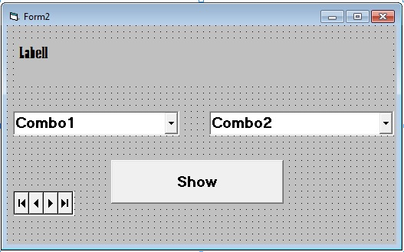

Output (FORM 3)

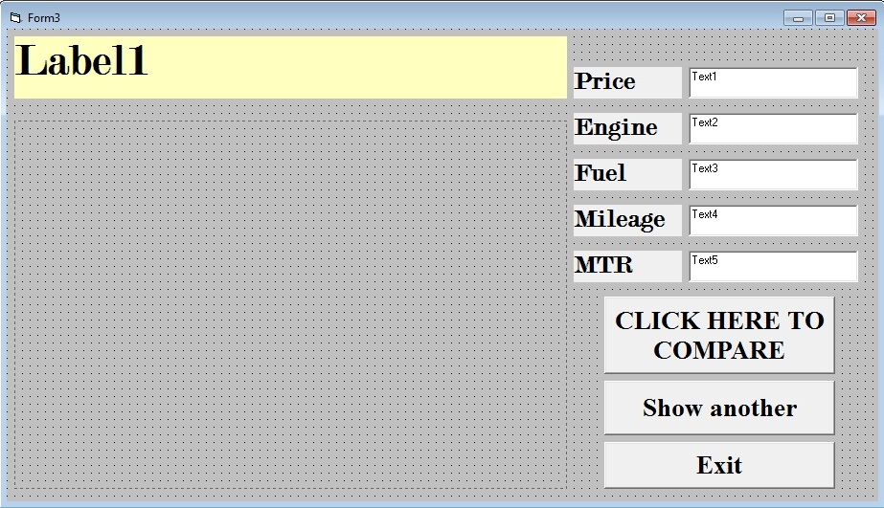

Model selection for comparing (FORM 4)

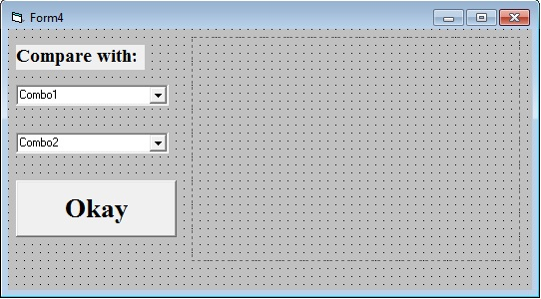

Compared output (FORM 5)

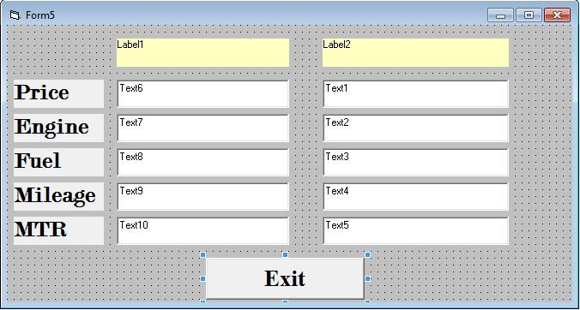

Admin Model selection (FORM 7)

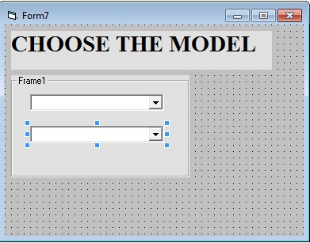

Admin updation (FORM 8)

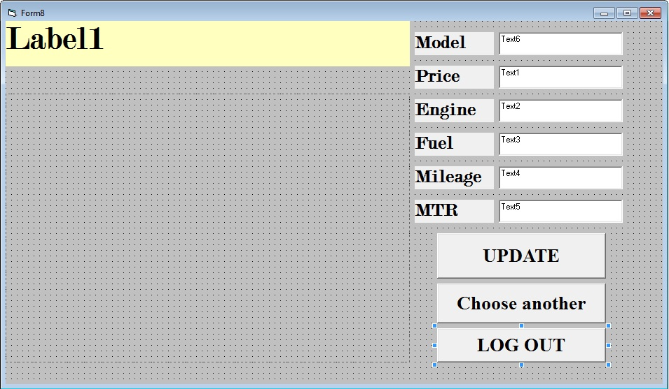

**RESULT (Output)**

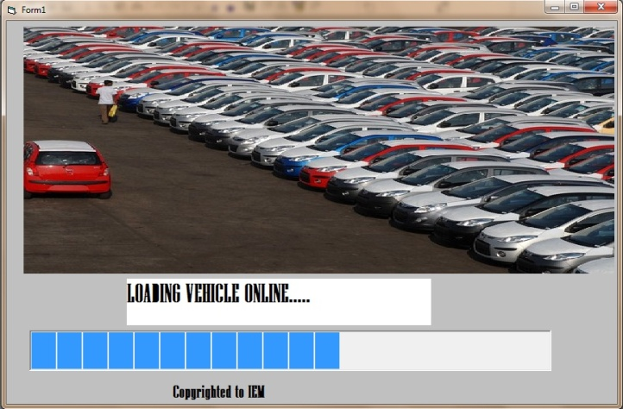

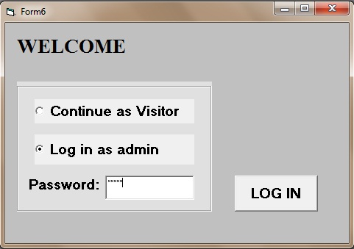

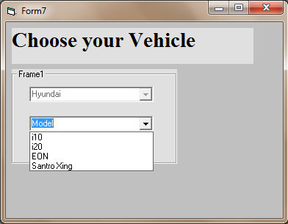

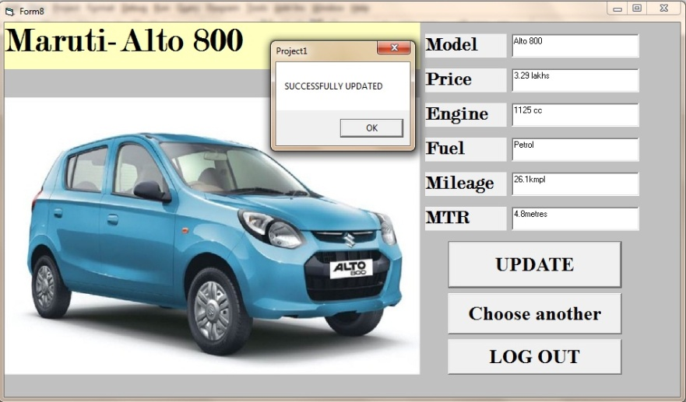

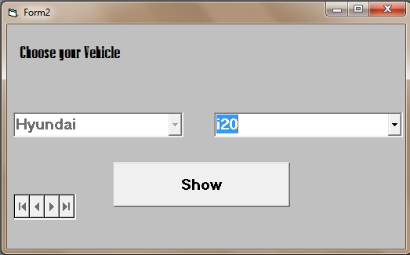

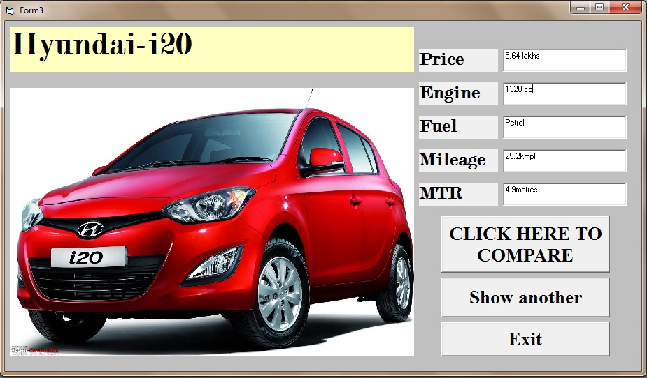

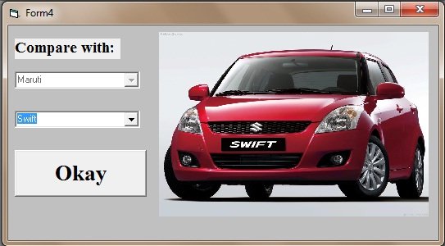

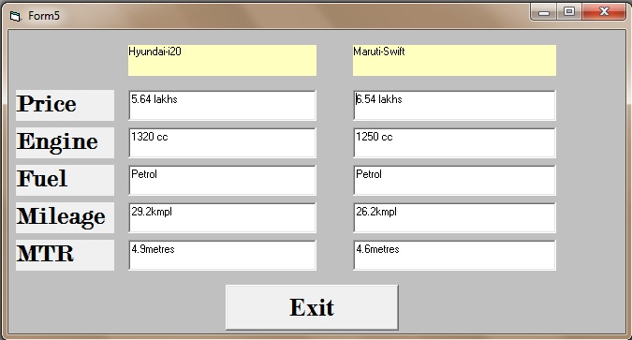

**DISCUSSION**

This project was made using Microsoft Visual Basic 6.0, using Microsoft Access as the database. Here ADODB is used for the database connectivity. There are two separate sections, one for administrator and one for the visitors. Administrator can update records of the models, the password for accessing the updating page is “admin” respectively. Users sign in as visitor. They can select the car model of which they want to know the specifications. They can compare two different models also.

**REFERENCES**

The following have been helpful in providing useful insights for this project:

1. http://www.vbtutor.net/
2. https://www.google.co.in/
3. https://www.youtube.com/