DEPARTMENT OF COMPUTER SCIENCE & ENGINEERING

Date: July 31, 2021

To whomsoever it may concern

This is to certify that Mr. Sagnik Chatterjee, a student of Manipal Institute of Technology, bearing registration No. 180905478 has successfully undergone Industrial Training from Apr 2021 to Aug 2021.

The title of the project is Implementation and Improvement of Raft Consensus Algorithms and its application in Federated Learning. We found his performance satisfactory. We wish him good success in future endeavours.

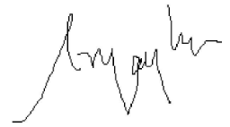

Name of the Project Guide: R Vijaya Arjunan

Designation: Associate Professor

Department: Department of Computer Science and Engineering

Institute : MIT,Manipal