**Online Voting System**



A Project submitted to the Department of Computer Science and Engineering,

Hajee Mohammad Danesh Science and Technology University

Course Title: Software Engineering

Course Code: CSE 305

|  |  |
| --- | --- |
| **Submitted To,**  Pankaj Bhowmik  Lecturer  Department of Computer Science and Engineering | **Submitted By,**  Sagor Mia  Student ID: 2102029  Level 3, Semester I |

DEPARTMENT OF COMPUTER SCIENCE AND ENGINEERING

HAJEE MOHAMMAD DANESH SCIENCE AND TECHNOLOGY UNIVERSITY, DINAJPUR-5200, BANGLADESH

### ****Prototype Model of Software Development for an Online Voting System****

The aim of this project is to develop an **Online Voting System** that ensures a secure, user-friendly, and efficient platform for conducting elections digitally. Using the **Prototype Model of Software Development**, we can iteratively refine the system based on stakeholder feedback, ensuring that all critical requirements, including security, ease of use, and scalability, are met.

### ****Steps in the Prototype Model Applied to Online Voting System****

#### ****1. Identification of Requirements****

The first phase focuses on gathering and understanding the requirements for the online voting system and defining its essential functionalities.

* **Requirement Gathering**:
  + Meet with election officials, administrators, and system users to understand their needs.
  + Identify existing challenges in traditional voting methods, such as logistical delays, vote tampering, and accessibility issues.
* **Core Functionalities**:
  + Voter authentication using unique credentials (e.g., ID, biometrics, or two-factor authentication).
  + Role-based access control for administrators, candidates, and voters.
  + Online voting interface with secure and private voting mechanisms.
  + Real-time vote counting and result display.
  + Secure backend to prevent fraud, tampering, or unauthorized access.

#### ****2. Quick Design and Planning****

* **Preliminary Design**:
  + Draft the UI for key modules:
    - **Voter Dashboard**: A portal for voters to log in, view candidate profiles, and cast votes.
    - **Admin Panel**: For managing elections, voter databases, and candidate registration.
    - **Result Viewer**: A secure screen for real-time vote tallying and publishing results.
* **Development Plan**:
  + Divide the project into smaller modules:
    - User Authentication and Authorization
    - Voting Mechanism
    - Result Calculation and Reporting
    - Security Features (e.g., encryption and fraud detection)
    - Logging and Auditing
  + Define milestones for iterative development and testing of each module.

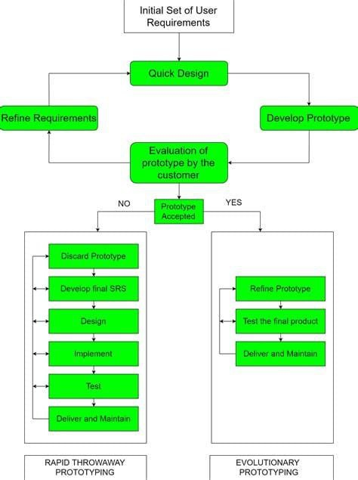

#### ****3. Create a Throwaway Prototype****

The throwaway prototype is a basic implementation that demonstrates the core functionalities of the online voting system without addressing scalability or full security.

* **Prototype Features**:
  + A mock login interface for voters and administrators.
  + A simple voting interface with a sample list of candidates.
  + Basic vote counting and result display.
* **Purpose**:
  + To demonstrate the voting process and verify basic usability.
  + To collect feedback on the system's initial design and functionality.

#### ****4. User Evaluation****

Share the prototype with stakeholders to gather feedback.

* **Stakeholders Involved**:
  + Election officials to validate the voting process.
  + Voters to test the usability of the system.
  + Administrators to test the management interface.
* **Feedback Collection**:
  + Evaluate the ease of navigation and clarity of instructions.
  + Identify missing features or areas where the system feels unintuitive.
  + Gather feedback on security concerns or perceived vulnerabilities.

#### ****5. Refinement****

Incorporate feedback from the user evaluation phase to refine the system.

* **Refinements**:
  + Improve the UI to make the voting process clearer (e.g., highlight selected candidates).
  + Add confirmation screens for vote submission to prevent accidental errors.
  + Enhance the admin panel for easier voter and candidate management.
* **Issue Resolution**:
  + Address security concerns, such as preventing duplicate logins or unauthorized access.
  + Fix bugs or inconsistencies discovered during user testing.

#### ****6. Iterative Development****

Continue developing and enhancing the system in iterative cycles.

* **First Iteration**:
  + Implement secure voter authentication using unique credentials or OTP.
  + Add real-time vote counting and display functionality.
  + Introduce basic logging of voting activity for auditing purposes.
* **Second Iteration**:
  + Implement encryption for all data transmissions.
  + Add role-based dashboards for voters, administrators, and election observers.
  + Include features for candidate registration and approval by administrators.
* **Third Iteration**:
  + Enhance security with fraud detection algorithms (e.g., detecting multiple votes from the same user).
  + Add support for multiple elections (e.g., local and national levels) within the same platform.
  + Include multilingual support for voter interfaces.

#### ****7. Regular User Testing****

Conduct regular testing to ensure that the system meets the needs of users and adheres to security standards.

* **Testing Scenarios**:
  + Simulate a complete election cycle, including voter authentication, vote casting, and result tallying.
  + Test edge cases, such as invalid login attempts or tampered data during transmission.
  + Validate system performance under high user loads.
* **Feedback Analysis**:
  + Identify and resolve any usability or security issues discovered during testing.
  + Ensure that the system is user-friendly for voters with varying technical expertise.

#### ****8. Gradual Enhancement****

Gradually enhance the system by adding features and improving the overall experience.

* **Additional Features**:
  + Introduce visual aids, such as graphs or charts, for result displays.
  + Add accessibility features for voters with disabilities (e.g., screen readers or larger font options).
  + Implement an offline backup mechanism for emergencies.
* **Improvements**:
  + Optimize the backend for scalability and faster performance during high-traffic periods.
  + Refine the UI based on user feedback from earlier testing phases.

#### ****9. Documentation****

Maintain detailed documentation throughout the development process.

* **What to Document**:
  + Initial system requirements and design decisions.
  + Changes and improvements made during each iteration.
  + Security measures implemented and how they address potential vulnerabilities.
  + User guides for voters, administrators, and candidates.
* **Purpose**:
  + To ensure all users can effectively interact with the system.
  + To facilitate future system maintenance and upgrades.

#### ****10. Integration of Features****

Integrate advanced functionalities to enhance the robustness of the system.

* **Advanced Features**:
  + Blockchain-based vote storage for enhanced security and transparency.
  + Analytics dashboard for administrators to monitor voting trends.
  + Automatic notifications to voters about election updates or deadlines.
* **Device Compatibility**:
  + Ensure the system works seamlessly on desktops, tablets, and smartphones.

#### ****11. Security Considerations****

Implement comprehensive security measures to protect the system from threats.

* **Key Measures**:
  + Encrypt all sensitive data (e.g., voter credentials and vote records).
  + Use secure protocols (e.g., HTTPS) for data transmission.
  + Implement multi-factor authentication for administrators and high-security elections.
  + Regularly audit the system for vulnerabilities and apply patches as needed.

#### ****12. User Education****

Educate users on how to use the system effectively.

* **Training**:
  + Provide interactive tutorials or help sections for voters and administrators.
  + Conduct workshops for election officials to familiarize them with the system.
* **Guidance**:
  + Include tooltips and FAQs to address common user questions.
  + Offer 24/7 technical support during the election period.

#### ****13. Deployment****

Deploy the final version of the system for live elections.

* **Steps**:
  + Conduct a mock election to verify the system's readiness.
  + Monitor the system during the live election for performance or security issues.
  + Collect feedback from stakeholders to identify areas for future improvement.

### ****Conclusion****

The **Prototype Model** is ideal for developing an Online Voting System because it allows for iterative refinement based on user feedback. By focusing on security, scalability, and usability, the system can address the unique challenges of digital voting while providing a seamless experience for voters and administrators.

Let me know if you also want a diagram for this!