**CSE321-Assignment01**

## 1 No. Ques Ans

## (a)

cd Documents

touch 22101782_1.txt 22101782_2.txt 22101782_3.txt 22101782_4.txt

mkdir Sagor1

mkdir Sagor2

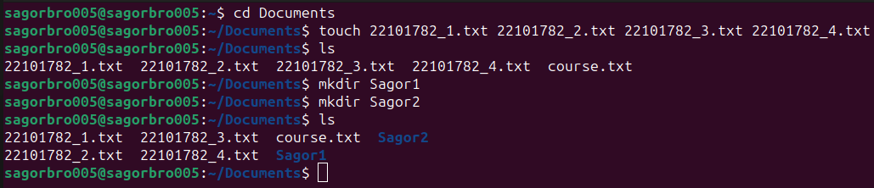

mv 22101782_1.txt /home/sagorbro005/Documents/Sagor1

mv 22101782_2.txt /home/sagorbro005/Documents/Sagor1

mv 22101782_3.txt /home/sagorbro005/Documents/Sagor1

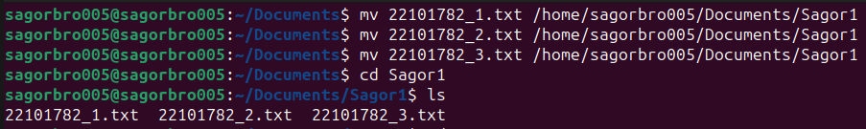

cd Sagor1

cp 22101782_1.txt /home/sagorbro005/Documents/Sagor2

cp 22101782_2.txt /home/sagorbro005/Documents/Sagor2

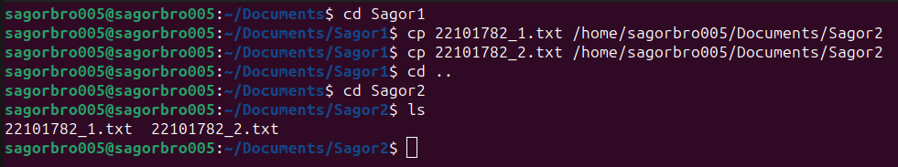

mkdir Sagor3

cp -r Sagor1 /home/sagorbro005/Documents/Sagor3

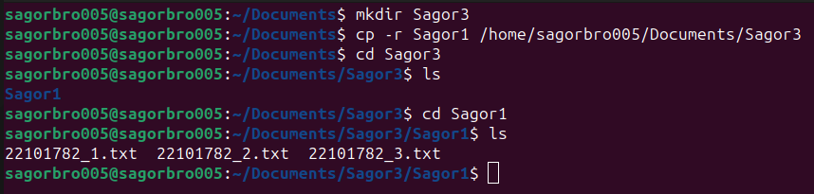

cd Sagor3

cd Sagor1

ls -l

chmod g-w 22101782_1.txt

chmod g-w 22101782_2.txt

chmod g-w 22101782_3.txt

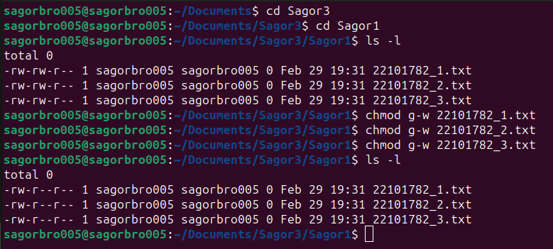

cd /home/sagorbro005/Documents/Sagor1

ls

cd ..

sudo mv Sagor3 /

cd /home/sagorbro005/Documents

rm 22101782_4.txt

rm -r Sagor1

rm -r Sagor2

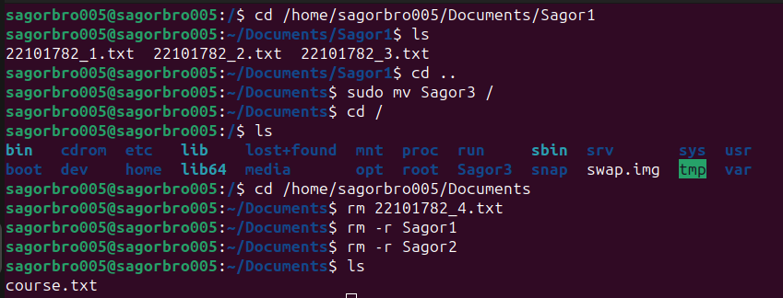

## (b)

cd Documents

cat>course.txt

Old ID: 22101782

New ID: 24141194

CSE321

14

cat course.txt

grep -c 'CSE' course.txt

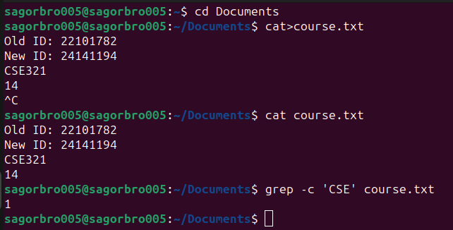

## (c)

ls -a /

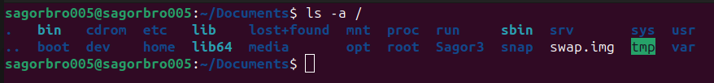

## (d)

cat>text.txt

cat text.txt

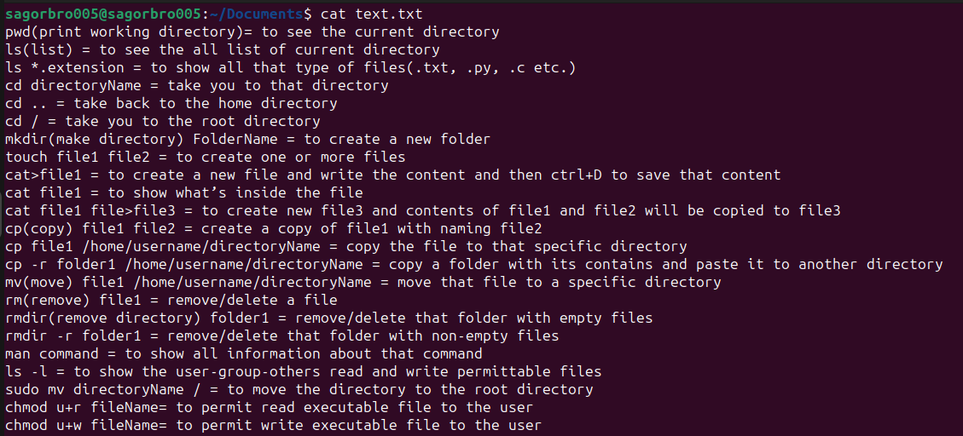

sed -n '5,17p' text.txt

