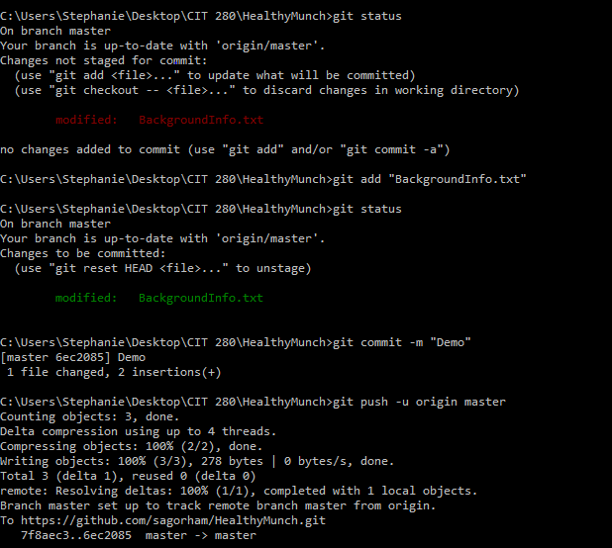

All files need to be added, committed, and pushed when any changes are made within you HealthyMunch folder.

This screenshot is what to do when you either add a new file into the HealthyMunch folder, or you have made a change one of the files in the folder.

Here is the URL for the remote repository: <https://github.com/sagorham/HealthyMunch>