Elf - An AI Chatbot
Project Documentation and User Guide
Java 8, Swing, no external libraries

Contents
1. Introduction
2. Getting started
3. The application window
4. Talking to Elf
5. The vault: passwords and passkeys
6. Settings and account
7. How Elf understands language
8. Project structure and data files
9. Extending the project
10. Troubleshooting and FAQ
11. Testing and limitations
Appendix A. Quick reference

1. Introduction
Elf is a desktop personal assistant. You type to it the way you would type to a friend, and it keeps track of your to-do list, reminders, notes and account passwords, answers questions, does simple maths and listens when you tell it how you feel. Everything runs on your own computer: there is no server, no internet connection and no account with any company.

1.1 Main features
- Accounts. Login and create-account screen, one private data folder per user, a ready-made demo account.
- Natural chat. Tasks, reminders, notes and vault entries can be written in many different ways; polite words are ignored, small spelling mistakes are fixed and a few Bangla phrases written in English letters work.
- Tasks and reminders. To-do list with done, undo and delete; reminders with real alerts (popup, chat message and sound), snooze, reschedule and a daily summary.
- Notes and memory. Tell Elf things and ask for them later ("when is my exam?"). A time inside a note can become a reminder.
- Vault. Passwords and passkeys saved from ordinary sentences, in any word order, and stored encrypted behind a separate vault passkey.
- Small helpers. Calculator, timers, short explanations of AI topics, jokes, facts, coin and dice, mood companion.
- Simple interface. Sidebar with Dashboard, Chat, Tasks, Notes, Vault, Help, Settings and Account; light and dark theme; adjustable text size.

1.2 Technology
Item | Detail
Language | Java 8 or newer (compiled for Java 8, runs on newer versions too).
User interface | Java Swing with the cross-platform "Metal" look and feel, so colours are the same on Windows, macOS and Linux.
Language understanding | Rule based: text cleaning, regular expressions, fuzzy word matching, weighted intent scoring, a time parser and a free-order account-details parser. No trained model and no network calls.
Storage | Small text files in the data folder (UTF-8). Nothing is sent anywhere.
Security | Login passwords: salted PBKDF2 hash. Vault: PBKDF2 key derivation and AES-GCM encryption.

2. Getting started

2.1 Requirements
A JDK (Java Development Kit), version 8 or newer. The program is started by compiling its sources, so the Java runtime (JRE) alone is not enough.

2.2 Starting the program
System | How to start
Mac or Linux | Open a terminal in the project folder and run ./run.sh (on a Mac you can also double-click run.command).
Windows | Double-click run.bat.
Any system, by hand | javac -encoding UTF-8 -d out src/*.java then java -cp out ElfChatBot
IntelliJ IDEA | Open the project folder and run the class ElfChatBot. The data folder is created next to the project.

The scripts compile the sources into the out/ folder and then start the program. Always start the program from the project folder, because the data/ folder is created in the folder you start it from.

2.3 First launch and the demo account
The first time Elf starts it creates the data folder and a demo account with some starter content (a few tasks, one reminder, two notes and three vault entries).
Item | Value
Username | mutant
Password | mutant1234
Full name | Mutant Freeman
Vault passkey | 1234

The demo account cannot be deleted and its login password cannot be changed, so it always works for demonstrations. Its vault passkey can be changed in Settings.
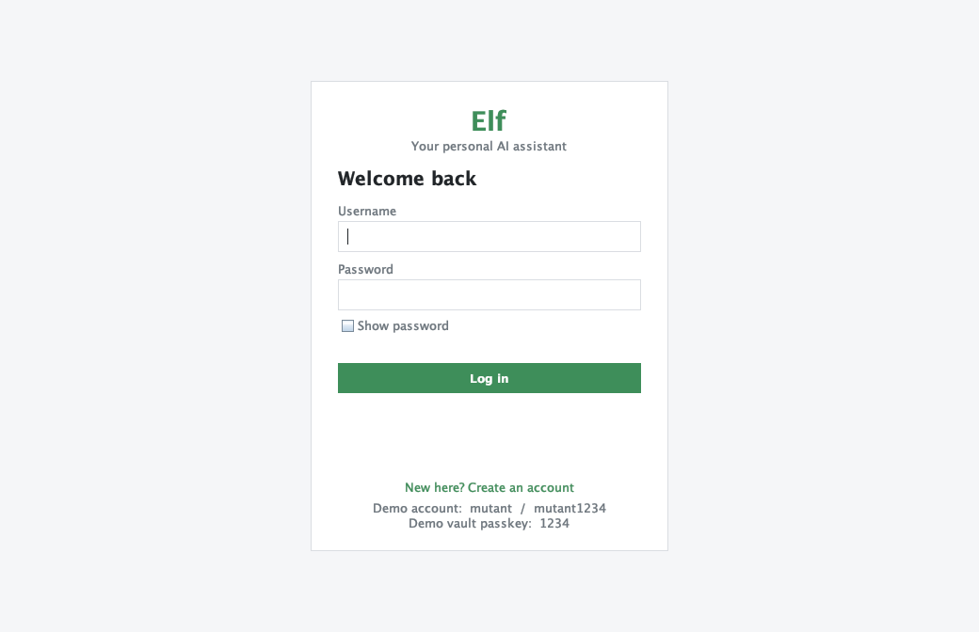
Figure 1 - Login window with the "Create an account" link and the demo hints
The login window has the same size as the main window. When you log in, the main window opens with the size and position the login window had, and logging out brings the login window back the same way.

2.4 Creating your own account
- Click "New here? Create an account".
- Full name: at least 2 characters. Username: 3 to 20 characters, letters, numbers, dot or underscore, not case sensitive, must be unique.
- Password: at least 6 characters, typed twice. There is no password recovery because nothing leaves your computer.
- After creating the account you are taken back to the login form with your username filled in.

3. The application window
After login the window shows a dark sidebar on the left and the selected page on the right. The sidebar has six pages at the top; Settings and your account are at the bottom. Small badges show the number of pending tasks and whether the vault is open or locked.
Page | Purpose
Dashboard | The home page: today's date, four counters (pending tasks, reminders coming up, notes, vault accounts), the next reminders, the pending tasks (double-click a task to finish it) and a box to tell Elf something without opening the chat.
Chat | Message bubbles with time stamps and day separators, quick buttons (What's on today?, Show tasks, Tell me a joke, Help), a "typing..." indicator and the Up / Down arrow keys to bring back earlier messages.
Tasks | The to-do list (add, done / undo, delete, clear done) and the reminder list. A reminder can be typed with its time in one line. Item numbers are the same numbers Elf uses in the chat.
Notes | Two tabs, Memories and Life story, each with search, add and delete.
Vault | Saved passwords and passkeys. Needs the vault passkey. See chapter 5.
Help | What Elf understands, grouped by topic. Select an example and press "Try it in chat" (or double-click) to send it.
Settings | Preferences and vault passkey. See chapter 6.
Account (user chip) | Profile, name and password change, log out, delete account.
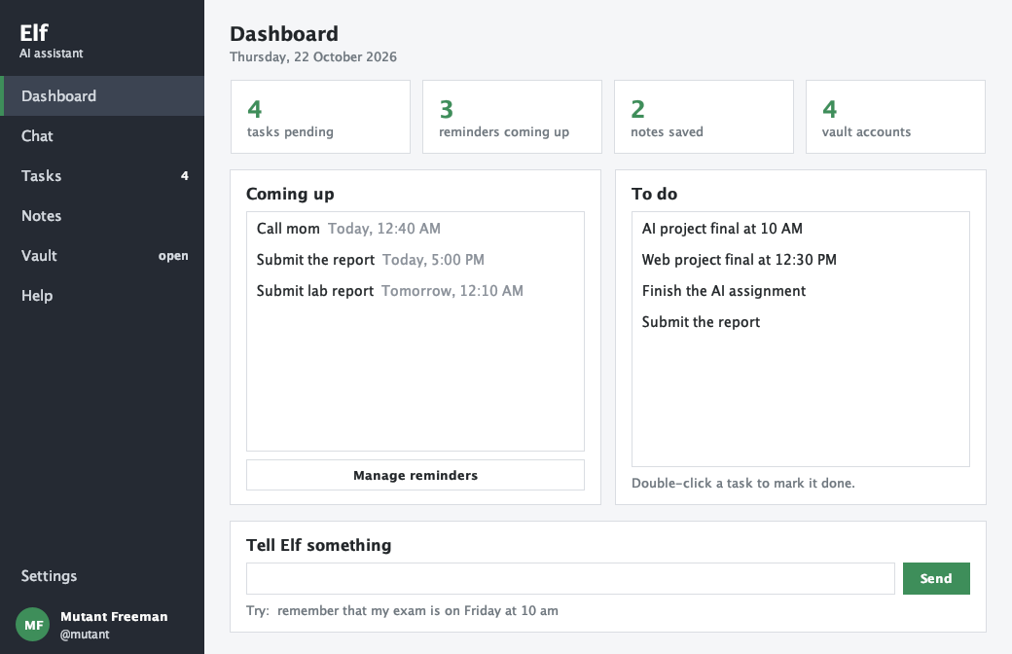
Figure 2 - Dashboard
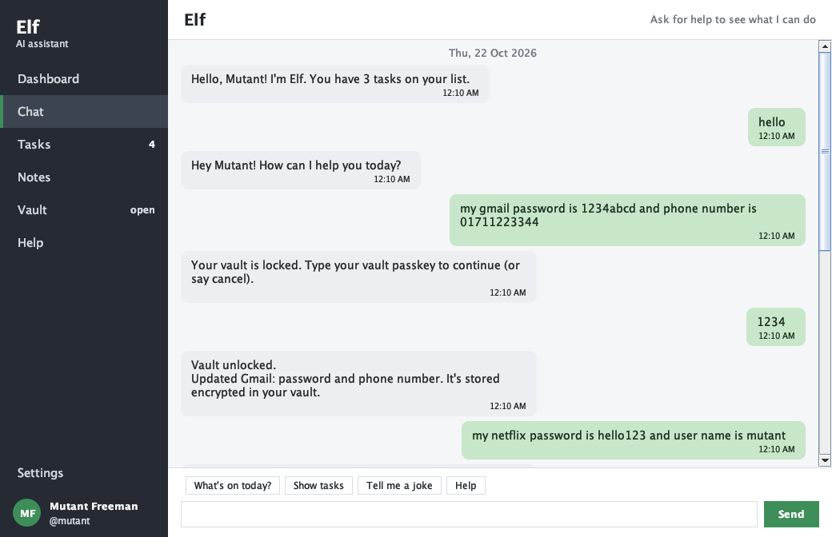
Figure 3 - Chat
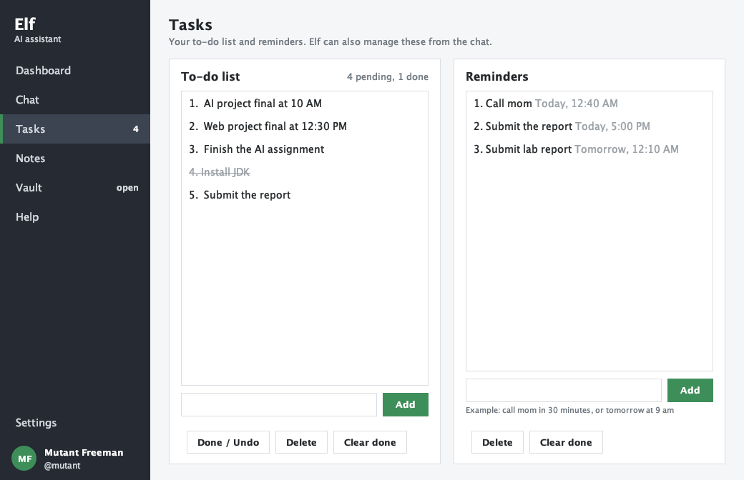
Figure 4 - Tasks page: to-do list and reminders

4. Talking to Elf
You do not have to learn commands. Write what you mean in your own words; the examples below are only samples. What Elf does with each kind of sentence is described in the tables, and the same examples are in the Help page.

4.1 Habits that make it feel natural
- Politeness is ignored: "hey Elf, could you please remind me to call mom tomorrow at 5 pm for me" works like "remind me to call mom tomorrow at 5 pm".
- Small typos in the first words are repaired ("shwo tasks", "remnd me"), and typos in intent words are tolerated ("tiem", "helo").
- Words can come in any order: "tomorrow 9 am submit report remind me" style sentences with a clear time are understood.
- Elf remembers the conversation. "another one" repeats the last joke or fact, "undo" removes what was added last, "yes" and "no" answer its questions, and it asks when something is missing instead of failing.
- A few Bangla phrases in English letters work: kemon acho, dhonnobad, kaj dekhao, amake 5 tay pani khete mone koriye dio, mon kharap.

4.2 Tasks
Say something like | What happens
add task buy milk | Adds one task.
add buy rice to my list | put charger on my todo list | Same, with other wording.
i need to buy milk, call dad and pay the bill | Adds three separate tasks (split on commas and on "and" between two-word parts).
i have to submit the report by 5 pm | Adds the task and also sets a reminder for 5 pm.
show my tasks | what do i need to do | any tasks left | kaj dekhao | Lists the tasks with numbers.
done 2 | tick off buy milk | pay the bill is done | i finished the report | Marks a task as done, by number or by matching its words.
undo 2 (reopen) | delete task 3 | remove buy milk | Reopens or deletes a task.
clear done tasks | clear all tasks | Removes finished tasks, or everything after a yes / no question.
how many tasks do i have | Counts pending tasks.

4.3 Reminders and the daily plan
Say something like | What happens
remind me to call mom in 30 minutes | Reminder at the computed time.
remind me tomorrow at 9 am to submit report | remind me on friday to pay rent | Day and time words are cut out of the text; a day without a time means 9:00.
wake me up at 6 am | ping me at 8 pm about the match | alert me in 10 minutes to take medicine | Other ways to ask for the same thing.
don't let me forget to pay rent tonight | Reminder when there is a time, otherwise a task.
set a timer for 10 minutes | A reminder that says "Time's up!".
i have a meeting with sir at 4 pm tomorrow | Not a command, but it has a time, so Elf asks whether to remind you.
show reminders | when is my next reminder | Lists reminders, or tells the next one.
what do i have tomorrow | anything on friday | what's on today | The plan for that day: reminders and, for today, pending tasks.
snooze 10 minutes | remind me again in 5 minutes | Repeats the reminder that just fired.
reschedule reminder 1 to 7 pm | Changes the time of a reminder.
cancel the reminder about mom | cancel reminder 2 | Deletes a reminder, by number or by its words.

Reminders fire while the program is open: a message appears in the chat, a small popup window opens and a sound plays (the sound can be turned off in Settings). Reminders that came due while the program was closed are shown right after the next login.

4.4 Notes, memory and life story
Say something like | What happens
remember that my exam is on Friday at 10 am | Saves a note. Because it contains a time, Elf offers a reminder as well.
my birthday is 5 march | my teacher is Mr Rahman | Facts that start with "my birthday / exam / meeting / address ..." are saved automatically.
when is my exam? | what is my birthday? | Answers from your notes by matching words.
what do you remember | do you remember exam | Lists notes, or the ones about a topic.
forget exam | delete the note about birthday | forget everything | Removes matching notes (everything needs a yes).
life story: I grew up in Dhaka | show my life story | Adds to, or reads, your life story.
what do you know about me | A short summary: profile, counts, first notes, vault size.

4.5 Vault commands
These are explained fully in chapter 5. In short: say your account details in one sentence to save them, and ask for them to read them back.
Say something like | What happens
my facebook password is 1234 and user name is mutant phone number is 01912345678 | Saves a Facebook entry with three fields.
show gmail password | Shows only the password.
my gmail data show me | Shows everything saved for Gmail.
change my gmail password to abc999 | Updates just that field.

4.6 Maths, knowledge, mood and fun
Say something like | What happens
what is 12 * (3 + 4) | 15 plus 27 | 2 ^ 10 | square root of 144 | Calculator with brackets, powers, modulo and a message for division by zero.
20% of 150 | Percentage of a number.
what is NLP | explain machine learning | what is java | how do you work | Short explanations of the topics of this project.
i feel tired | i am so happy | i am not happy | mon kharap | Mood detection (sad, stressed, angry, tired, lonely, bored, happy). Negation is understood. Elf asks a follow-up and answers with a fitting message.
tell me a joke | another one | fun fact | motivate me | Fun content; "another one" repeats the last kind.
flip a coin | roll a dice | random number between 5 and 20 | Random helpers.
what time is it | what is the date tomorrow | Time and date in your clock format.
dark mode | light mode | call me Sagor | change your name to Nova | Settings that can be changed by talking.

5. The vault: passwords and passkeys
The vault keeps account details safe. It has two kinds of entries: passwords (a service with a username, password, email, phone number and so on) and passkeys (PIN codes, lock codes and similar single secrets). Both are shown in the Vault page, in separate tabs, and both can be saved by chatting.
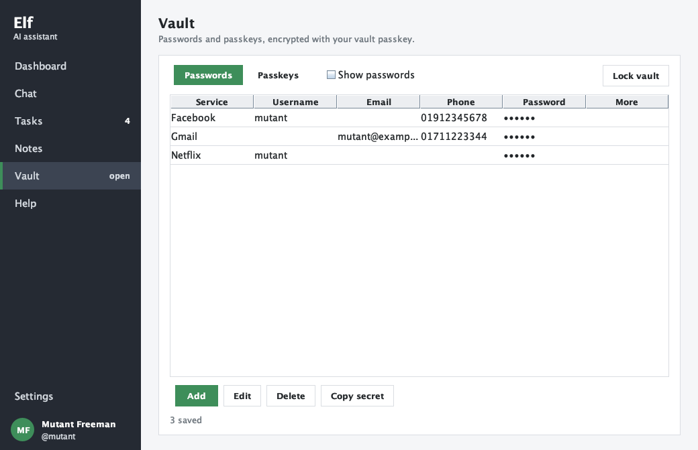
Figure 5 - Vault page (passwords are hidden until "Show passwords" is ticked)

5.1 The vault passkey
- The vault has its own passkey that is separate from your login password. The demo account uses 1234.
- A new account creates its passkey the first time the Vault page is opened (minimum 4 characters).
- The passkey can be changed, or the vault reset, in Settings. If the passkey is forgotten the vault cannot be opened; "Reset vault" removes all entries and the passkey so a new one can be created.
- The vault locks again on logout. Changing the theme or text size does not lock it. "Lock vault" in the Vault page, or "lock vault" in the chat, locks it at any time.

5.2 Saving details from a sentence
Elf looks for label words in the sentence (password, pass, pin, user name, login, id, email, phone number, website, account number, card number, note ...) and takes the text after each label as its value. The words that remain tell it which account the details belong to. The order does not matter, and the service can come before, inside or after the details.
Sentence | Saved as
my facebook password is 1234 and user name is mutant phone number is 01912345678 | facebook: password 1234, username mutant, phone 01912345678
username is mutant and password is 1234 for facebook | facebook: username, password
1234 is the password for gmail | gmail: password 1234
password for gmail is 1234 | gmail: password 1234
facebook: user mutant, pass 1234, phone 01912345678 | facebook: username, password, phone
save my netflix login: email a@b.com pass hello123 | netflix: email, password
save password gmail 1234 | gmail: password 1234
my bkash pin is 4321 | bkash: passkey 4321 (shown in the Passkeys tab)
change my facebook password to 5678 | updates the password of facebook only

- Saving to an existing service adds or replaces only the fields in the sentence; the other fields stay.
- A value must look right for its label: a phone number needs digits, an email needs an @. A label that fails this check is treated as ordinary text, so "my phone lock passkey is 4321" becomes a passkey for the service "phone lock".
- If the sentence does not say which account it is for, Elf asks "Which account or website are they for?" and uses your next message as the name.

5.3 Reading details back
Say something like | Elf answers
show gmail password | what is my gmail password | Your Gmail password is: ...
show facebook phone number | Only that field.
my gmail data show me | show all gmail details | A list of every field saved for Gmail.
show my password | Asks which account, and lists the ones you have.
list passwords | The account names with the kinds of details saved (no values).
delete netflix phone | Asks for a yes, then removes only the phone number.
delete gmail | Asks for a yes, then removes the whole entry.

5.4 When the vault is locked
If you ask for something and the vault is locked, Elf says so and waits for the passkey. Type the passkey as your next message. If it is right, the vault opens and Elf immediately does what you first asked, so you never repeat yourself. Three wrong tries cancel the request, and "cancel" stops it at any time. You can also type "unlock vault" and then the passkey.

5.5 How the vault is protected
Part | Protection
Passkey | Never stored. Only a salted PBKDF2 hash is kept (vault.meta) to check it, and a separate salt to derive the key.
Entries | Each entry (service name and every field) is encrypted as one AES-GCM block. The file vault.txt shows neither names nor values.
Chat history | Sentences that contain account details are replaced in the history by a note such as "(saved account details for facebook: username, password and phone number)". The passkey typed in the chat is stored as ********. Answers that show saved details are not written to the history.
Clipboard | "Copy secret" in the Vault page clears the clipboard again after 30 seconds.

Limits: the typed sentence is visible on screen while you type, and the decrypted values are held in memory while the vault is unlocked. The vault is a convenient place for study and everyday use, not a replacement for a professional password manager.

6. Settings and account
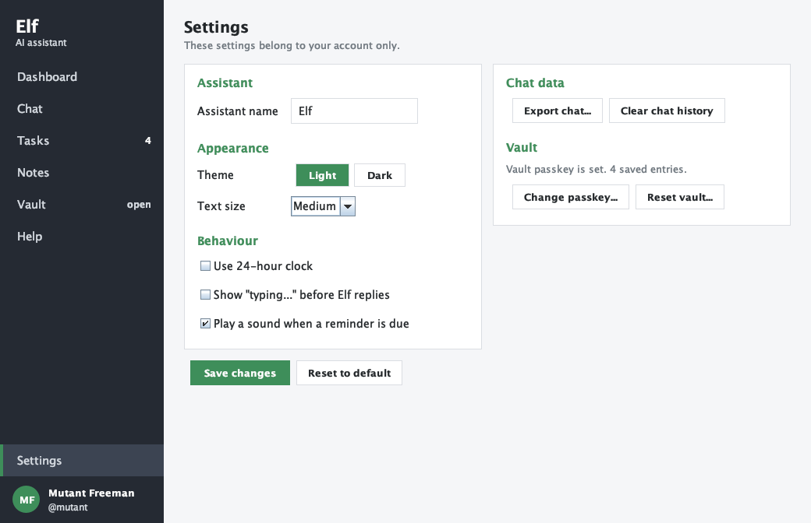
Figure 6 - Settings
Setting | Effect
Assistant name | The name shown in the sidebar and the window title and used in replies. Also changeable by chat.
Theme: Light / Dark | Re-colours the whole application. The change happens as soon as you click the button.
Text size: Small / Medium / Large | Font size 13, 14 or 16. Also applied as soon as you pick it.
24-hour clock | Affects time stamps, reminders and the answer to "what time is it".
Typing indicator | Turns the short "typing..." pause before replies on or off.
Reminder sound | Beep when a reminder fires.
Export chat | Saves the conversation to a text file that you choose.
Clear chat history | Deletes the saved conversation after a confirmation.
Vault: Change passkey / Reset vault | Change needs the current passkey. Reset deletes all entries and needs your account password.
Reset to default | Restores the assistant, appearance and behaviour settings.

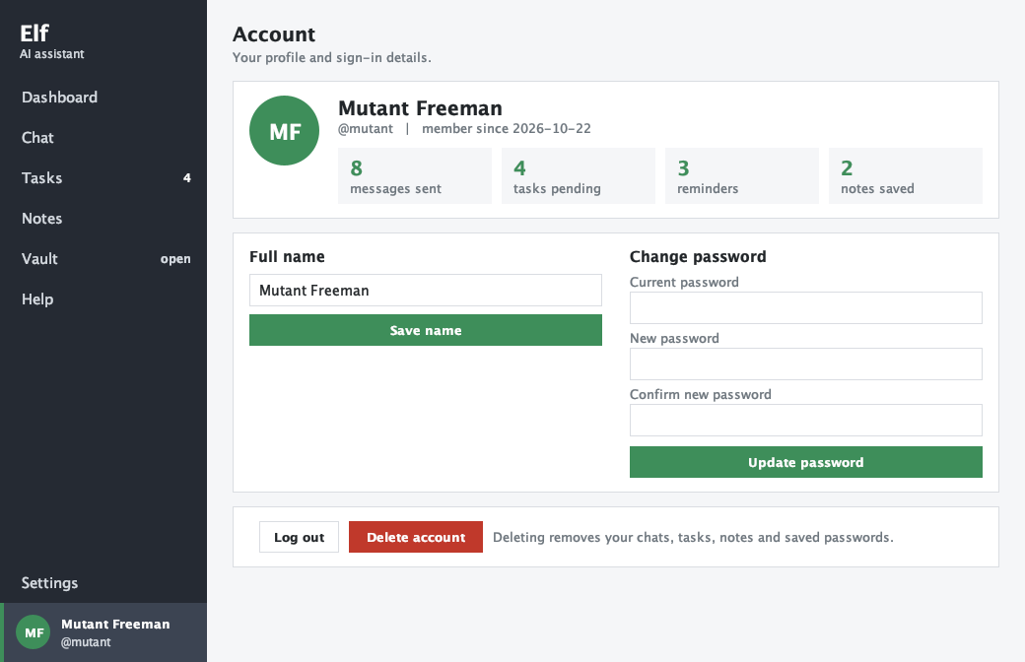
Figure 7 - Account page
- Profile with initials avatar, username, member-since date and counters.
- Change the full name; change the password (current password required).
- Log out (locks the vault) or delete the account (password required; removes the account folder with all its data).
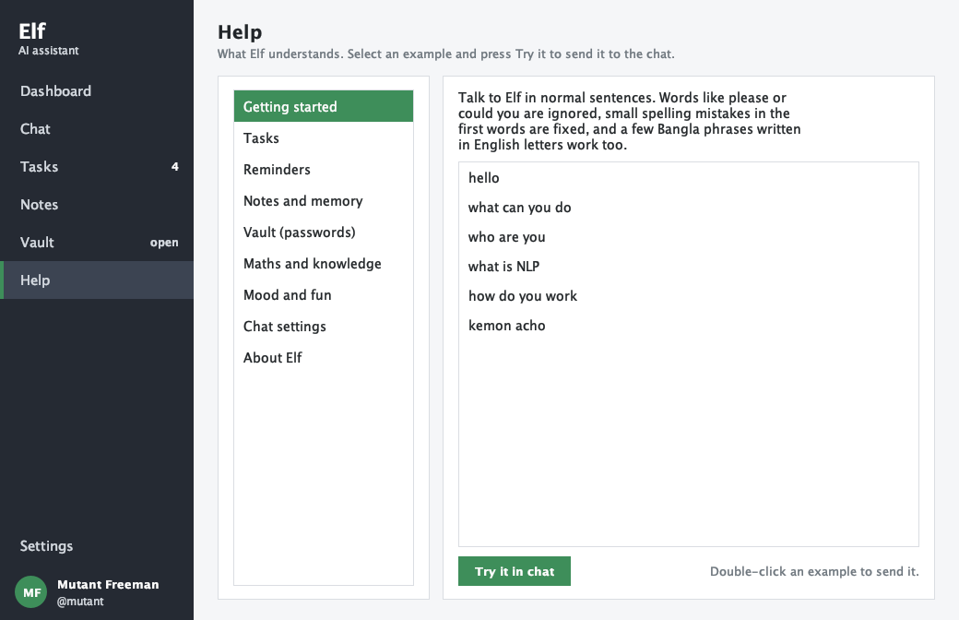
Figure 8 - Help page with clickable examples

7. How Elf understands language
Elf is rule based. The rules are organised in stages, so that many different sentences lead to the same action and so that a sentence is never matched by the wrong rule just because it contains a certain word. The stages run in the order below (ChatBotLogic.reply).

7.1 The stages
# | Stage | What it does
1 | Tidy up | Fixes typos in the first words ("shwo" to "show") by comparing them with the list of command verbs, and removes polite filler ("hey Elf, could you please ... for me").
2 | Open questions | If Elf asked something (the vault passkey, a new name, "are you sure?", "which account?", "want a reminder?"), the message is read as the answer first.
3 | Commands | Regular expressions pull the useful details out of the sentence: reminders (with TimeParser), tasks, vault entries (with VaultParser), notes, life story, renaming, undo.
4 | Calculator and knowledge | Maths written with symbols or words, and "what is X" questions about project topics.
5 | Mood | A scored word list with negation, six moods and a follow-up conversation.
6 | Memory questions | "when is my exam?" is answered from the notes.
7 | Intents | Small talk and information requests are scored against phrase lists with typo tolerance; the best score wins.
8 | Offer | A sentence that was not understood but contains a clock time becomes the offer "Want me to remind you?".
9 | Fallback | Instead of "I don't know", Elf looks at the words (a number, "remind", "task", "password") and shows the matching example. After three misses it offers to save the sentence as a note.

7.2 Techniques
Technique | How it works | Where
Text cleaning | Lower case, contractions expanded ("what's" to "what is"), punctuation removed. | TextUtil.clean
Fuzzy word match | Edit distance that counts a swapped pair of letters as one edit. Words under 4 letters must match exactly; 4-letter words only accept a swap or a missing/extra letter, so "date" is not confused with "data". | TextUtil.similar
Intent scoring | Each intent has phrases and a weight. Intents also have a word limit, so "hi" inside a long sentence is not a greeting, and special cases such as "I have no time". | ChatBotLogic.bestIntent
Entity extraction | Separates the thing (task, note, reminder text) from the command words and the time. | ChatBotLogic patterns
Time parser | Understands "in 10 minutes", "at 5 pm", "at 18:45", "tomorrow", "next monday", "tonight", "in the evening", and Bangla "kal shokal 7 tay". "At 5" picks the next 5 o'clock, am or pm. Returns the text left after the time is removed. | TimeParser
Account-details parser | Finds label words, takes each value, validates it, then works out the service name. Handles value-first sentences such as "1234 is the password for gmail". | VaultParser
Negation | A negative word one or two words before a feeling word reverses its score. | MoodDetector
Conversation state | Pending question, last intent, last added item, last fired reminder, number of misses. | ChatBotLogic, VaultChat
Calculator | Recursive-descent parser for + - * / % ^, brackets and sqrt; words like "plus" and "times" are converted first. | Calculator

7.3 Example: a vault sentence step by step
my facebook password is 1234 and user name is mutant phone number is 01912345678
- The save verb and "my" are removed from the front. Label words are found: "password", "user name" and "phone number".
- The text after each label, up to the next label, is its region. Connector words (is, to, as, colon) are dropped, and trailing "and" is cut: "1234", "mutant", "01912345678".
- Each value is validated for its label (the phone value has enough digits).
- No service was named after a label, so the words before the first label ("facebook") become the service.
- VaultChat sees a secret was given, so this is a save. If the vault is locked, Elf asks for the passkey first and then stores the entry.

8. Project structure and data files

8.1 Folder layout
Elf_An_AI_Chatbot/
src/ Java sources
out/ compiled classes, created when you compile
data/ created at the first start: all user data
Document/ short description of the data files
ReadMe/ this documentation and README.md
run.sh, run.command, run.bat start scripts
Elf_An_AI_Chatbot.iml IntelliJ module file

8.2 Classes
Class | Role
ElfChatBot | Entry point: sets the look and feel, creates the demo account on first run, opens the login window.
LoginFrame | Login and create-account forms.
MainFrame | Window with sidebar and pages, reminder timer, logout, rebuild after a theme change.
Page | Base panel (title and body) for the secondary pages.
DashboardPanel, ChatPanel, TasksPanel, NotesPanel, VaultPanel, HelpPanel, SettingsPanel, AccountPanel | The pages of the sidebar.
Theme | Light and dark colours, fonts and styling helpers for all components.
ChatBotLogic | The language engine (chapter 7): tidy-up, commands, intents, fallbacks, conversation state.
VaultChat | Everything the chat does with the vault: save, show, list, delete, unlock flow and masking for the history.
VaultParser | Reads account details from a free-form sentence.
TimeParser | Finds times and days inside sentences; formats them for display.
TextUtil, Calculator, MoodDetector, Motivator, KnowledgeBase | Helpers: text cleaning and fuzzy matching, maths, feelings, jokes and quotes, explanations of project topics.
UserManager, User, Settings | Accounts, login, password hashing, demo data; the logged-in user and the per-user preferences.
Crypto, Vault | Hashing and AES-GCM helpers; the encrypted vault with lock, unlock, passkey change and reset.
ReminderManager, MemoryManager, ChatLog, FileStore | To-do list and reminders; notes and life story; conversation log; UTF-8 file helper.

8.3 Data files
Every user has a folder data/<username>/. Files are plain UTF-8 text; a new line inside a message is saved as \n and the | character as \p.
File | Content
data/users.txt | username | full name | salt | password hash | created date
chat_history.txt | time in milliseconds | U (you) or B (Elf) | message
to-do.txt | done flag (0 or 1) | task
reminders.txt | due time in milliseconds (0 = no time) | done flag | text
memories.txt, life_story.txt | date | text
vault.meta | salt | hash of the passkey | key salt
vault.txt | one AES-GCM encrypted entry per line (Base64)
settings.properties | botName, theme, fontSize, clock24, typingDelay, reminderSound, nickname

Backup: copy the data folder. Move to another computer: copy the project together with its data folder. Start fresh: close the program and delete the data folder; it is created again with the demo account.

9. Extending the project

9.1 Add a small-talk intent
Intents are the rows of the INTENTS table in ChatBotLogic. Add a row with a name, a weight (3 for a clear phrase), the maximum number of words in the message, and the phrases. Then add a case to answerIntent.
// ChatBotLogic.java, in INTENTS
new Intent("coffee", 3, 6, "make coffee", "i need coffee", "coffee time"),

// ChatBotLogic.java, in answerIntent(...)
case "coffee":
return "I can't brew, but a short break sounds like a good idea!";

9.2 Add a command that carries details
Commands are regular expressions in ChatBotLogic. Add a Pattern, check it in the matching method (taskCommands, reminderCommands, memoryCommands ...) and use the captured group.
private static final Pattern WATER = Pattern.compile(
"^(?:i drank|i had) (\\d+) glass(?:es)? of water$", Pattern.CASE_INSENSITIVE);

Matcher m = WATER.matcher(text);
if (m.matches()) return memory.addMemory("Drank " + m.group(1) + " glasses of water");

9.3 Other common changes
Goal | Where
Add an explanation topic | KnowledgeBase.TOPICS: add {"names separated by |", "answer"}.
Understand a new field in the vault | VaultParser.LABELS: add a row with the field name followed by its label words, and a case in display(); add validation in valid() if needed.
More jokes, facts or quotes | Arrays at the top of Motivator.
More mood words | MoodDetector static block: word("tense", STRESS, -2).
Change colours | Theme.apply: every colour of both themes is set there.
Change demo data or demo passkey | UserManager (SAMPLE_* constants and seedSampleData). Delete the data folder to apply.
Add a sidebar page | Create a class that extends Page, add it to the card layout and the sidebar in MainFrame, add an example in HelpPanel.
Change reminder alert behaviour | MainFrame.checkReminders (checks every 15 seconds).
Change the minimum passkey length | Vault.MIN_PASSKEY_LENGTH.

10. Troubleshooting and FAQ
Problem | Solution
"javac not found" when starting | No JDK is installed, or it is not on your PATH. Install a JDK 8 or newer and start again. A JRE alone cannot compile the sources.
The data folder appears in an unexpected place | It is created in the folder the program is started from. Start from the project folder or use the scripts.
I forgot my login password | There is no recovery. Close the program, delete your line from data/users.txt and your data/<username> folder, then create the account again. The demo account is always mutant / mutant1234 unless data/ was changed.
I forgot my vault passkey | Settings > Vault > Reset vault. This deletes the saved entries; there is no other way to decrypt them.
Elf asks for the passkey in the chat but nothing happens | Type only the passkey as the next message. "cancel" stops the request.
A reminder did not ring | Reminders ring only while the program is open; missed ones show after the next login. Check that the time was understood in the reply ("Today, 5:00 PM").
The reminder time is wrong | Say the time more clearly ("at 5 pm", "in 20 minutes"). A bare "at 5" chooses the next 5 o'clock, morning or evening. Use "reschedule reminder 1 to 7 pm" to fix it.
Elf saved something I did not want | Say "undo" right after, or delete it from the Tasks or Notes page.
Elf did not understand a sentence | Open Help and compare with the examples, add the missing detail (a time, the account name), or use the Dashboard / Chat quick buttons.
The window looks different on my system | The cross-platform Metal look and feel is used on purpose so that the colours match everywhere.

11. Testing and limitations

11.1 What was checked
- More than 200 sample sentences were run through the language engine without opening the window: every command family, typos, politeness, negation, mood follow-ups, Banglish phrases, reminders in many wordings and 25 different ways of saving or asking for vault details.
- 34 automated checks on accounts, the vault and storage passed: sign-up rules, duplicate usernames, login, password change, vault set-up, lock and unlock, wrong passkey, passkey change, field and entry deletion, reset, the demo vault, no plain text in the vault or user files, masking in the chat history, reminders firing once, multi-line chat storage and account deletion.
- Every page was rendered in both themes to check layout and colours. The screenshots in this document come from those renderings.
- Not exercised by hand: the exact moment a reminder popup appears, the file dialog for exporting the chat, and use on Windows and Linux. These use standard Swing components.

11.2 Known limits
- Rule based: unusual wording that none of the rules cover gets a hint instead of an answer. A trained intent classifier would be the next step.
- English with a few Bangla phrases in English letters. No Bangla script, voice input or speech output.
- Offline: no weather, news or web search.
- Reminders need the program to be open.
- Only the vault and the login password hashes are encrypted; tasks, notes and chat history are plain text files.
- If a sentence mixes several requests, only the first understood one is carried out.

Appendix A. Quick reference
Topic | Examples
Tasks | add task buy milk | i need to buy milk, call dad and pay the bill | show my tasks | done 2 | tick off buy milk | delete task 3 | undo
Reminders | remind me to call mom in 30 minutes | remind me tomorrow at 9 am to submit report | wake me up at 6 am | snooze 10 minutes | reschedule reminder 1 to 7 pm | cancel the reminder about mom | show reminders
Day plan | what's on today | what do i have tomorrow | when is my next reminder
Notes | remember that my exam is on Friday at 10 am | when is my exam | what do you remember | forget exam | life story: ...
Vault save | my facebook password is 1234 and user name is mutant phone number is 01912345678 | 1234 is the password for gmail | my bkash pin is 4321
Vault read | show gmail password | my gmail data show me | show facebook phone number | list passwords
Vault manage | change my gmail password to abc999 | delete netflix phone | delete gmail | lock vault | unlock vault
Maths | what is 12 * (3 + 4) | 20% of 150 | square root of 144
Knowledge | what is NLP | explain machine learning | how do you work | where is my data stored
Feelings | i feel tired | i am so happy | i am not happy | tell me a joke | motivate me
Settings by chat | dark mode | light mode | call me Sagor | change your name to Nova
Conversation | yes / no | cancel | undo | another one | help

