ASML Digital Solutions

EHS Safety Management Tool
Level 5 Technical Specification Document
Property | Value
Document Number | ASML-EHS-TSD-001
Version | 1.0.0
Date | 26 February 2026
Classification | Internal
Prepared by | Digital Solutions Team
Reviewed by | EHS Technology Committee
Client | ASML.com
Status | Production Ready

Document Control
Version History
Version | Date | Author | Changes
1.0.0 | 26 Feb 2026 | Digital Solutions Team | Initial release for production deployment
0.9.0 | 15 Feb 2026 | Technical Lead | Final pre-release review and documentation
0.8.0 | 01 Feb 2026 | Development Team | Database schema finalized, all modules integrated

Distribution List
Role | Department | Name | Email
Project Owner | EHS | EHS Safety Director | ehs.director@asml.com
Technical Lead | Digital Solutions | Lead Developer | lead.dev@asml.com
Database Admin | IT Operations | DBA | dba@asml.com
QA Lead | Quality Assurance | QA Manager | qa.manager@asml.com
Documentation | Tech Writing | Technical Writer | tech.writer@asml.com

Table of Contents

1. Executive Summary
The EHS Safety Toolkit is a comprehensive full-stack web application developed for Environmental, Health, and Safety (EHS) management within ASML's semiconductor manufacturing environments. Built on modern web technologies—React 18, Node.js 20, and PostgreSQL 16—the platform digitizes seven critical safety workflows that were previously managed through paper-based processes or disparate systems. The application provides real-time safety metrics, automated risk assessments, and a complete audit trail for regulatory compliance. With a responsive design supporting both desktop and mobile interfaces, the toolkit enables safety professionals to manage complex workflows directly from any device, streamlining approval chains and reducing administrative overhead.
Version 1.0.0 is production-ready and currently deployed on Railway's cloud platform with Neon PostgreSQL as the serverless database backend. The system operates in a hybrid storage mode: fully functional in-memory storage for development and demonstration environments, with seamless switchover to persistent PostgreSQL for production deployments. The application handles concurrent users through server-side session management and serves both desktop (1440px+) and mobile (390px+) viewports with responsive layouts. The platform has been tested with multiple concurrent users and maintains sub-second response times for all critical workflows, ensuring a smooth user experience even during peak usage periods.
The platform directly addresses ASML's EHS compliance requirements by enforcing structured pre-task safety assessments, automating permit-to-work authorization chains, and providing management visibility through real-time dashboards. The Safety Index score, displayed prominently on the dashboard, aggregates performance across all seven modules to provide a single-number health metric for EHS leadership. Integration with Microsoft 365 services—Azure AD SSO, SharePoint document sync, and Teams approval workflows—is planned for the near-term roadmap to align with ASML's enterprise technology strategy. This will enable seamless integration with existing ASML systems and provide approval workflows directly within Teams, reducing email bottlenecks and improving visibility across the organization.
Key Metrics Summary
Metric | Value
Modules | 7 safety management modules
Database Tables | 14 PostgreSQL tables
API Endpoints | 13 REST endpoints
Technology Stack | 35+ packages (React 18, Node.js 20, PostgreSQL 16)
Deployment | Railway (cloud) + Neon PostgreSQL
Mobile Support | Fully responsive (390px to 1440px+)
Print Support | A4 PDF via browser print (ISP documents)
Audit Trail | Field-level change tracking on all entities
CI/CD | GitHub Actions (type check, lint, Docker build)

2. Project Overview

2.1 Business Challenge
ASML's semiconductor manufacturing operations require rigorous EHS management to protect workers, equipment, and the environment. Prior to this tool, safety workflows such as Integrated Safety Plans (ISPs), Permits to Work, and Safety Review Board escalations were managed through manual paper forms or ad-hoc digital documents. This created significant challenges: tracking approval status in real-time was difficult, ensuring consistent risk assessment methodology across all sites was inconsistent, maintaining audit trails for regulatory compliance required manual record-keeping, and providing management visibility into safety performance trends was nearly impossible. These legacy processes resulted in delayed approvals, inconsistent documentation, limited compliance visibility, and difficulty analyzing trends to prevent future incidents.

2.2 Solution Objectives
Digitize pre-task hazard assessments with structured 4-step wizard for consistent methodology
Automate permit-to-work authorization and gas measurement workflows to reduce approval time
Enforce Safety Review Board escalation for high-risk activities (score ≥ 8) to ensure leadership visibility
Provide real-time safety metrics and trend analytics for data-driven decision making
Maintain complete audit trail for EHS compliance and regulatory reporting requirements
Enable SharePoint document library integration for seamless enterprise document management
Support Microsoft 365 enterprise authentication (Azure AD OAuth) for enterprise security

2.3 Project Scope
The EHS Safety Toolkit encompasses seven integrated safety modules covering the full spectrum of ASML's EHS operational requirements:
Dashboard: Real-time safety metrics, performance indicators, and trend visualizations
Safety Plans / ISP: Integrated Safety Plan creation, submission, and approval workflow with A4 PDF export
Safety Review Board: High-risk activity escalation with mandatory safety committee review
Permit to Work: Multi-level authorization with gas measurement tracking and digital sign-off
Incidents: Safety event recording, severity assessment, and investigation tracking
Crane Inspection: Pre-operation equipment verification with buddy-inspector system
Draeger Calibration: Gas detector maintenance scheduling and compliance tracking
Documentation: Centralized library with SharePoint integration and version control

2.4 Current Deployment
Component | Configuration
Platform | Railway cloud platform
Database | Neon PostgreSQL (serverless, auto-scaling)
Storage Mode | In-Memory (development) + PostgreSQL (production)
Authentication | Local user accounts (M365 OAuth ready for migration)
Repository | github.com/sagrado26/ehstoolkit (private GitHub repo)
Deployment URL | Railway auto-deploy on git push to main branch
Environment | Production-ready with staging branch for pre-release testing

3. System Architecture

3.1 Architecture Overview
The EHS Safety Toolkit follows a classic three-tier web application architecture with a clear separation between the presentation layer (React SPA), business logic layer (Express.js API), and data persistence layer (PostgreSQL). All three tiers are TypeScript-typed end-to-end, with shared schema definitions in the shared/ directory ensuring consistent data contracts between the frontend and backend. This architecture provides flexibility, maintainability, and the ability to independently scale each tier based on demand.
┌─────────────────────────────────────────────────────────┐
│ CLIENT LAYER (React 18) │
│ Components │ Hooks │ Context │ TanStack Query Cache │
└────────────────────┬────────────────────────────────────┘
│ HTTP/JSON
┌────────────────────▼────────────────────────────────────┐
│ API LAYER (Express.js) │
│ Routes │ Controllers │ Zod Validation │ Middleware │
└────────────────────┬────────────────────────────────────┘
│ SQL/ORM
┌────────────────────▼────────────────────────────────────┐
│ DATA LAYER (PostgreSQL 16 / Drizzle) │
│ 14 Tables │ Audit Logs │ JSONB Storage │ Indexes │
└─────────────────────────────────────────────────────────┘

3.2 Technology Stack
Layer | Technology | Purpose
Client | React 18 | UI framework with hooks and concurrent features
Client | TypeScript 5 | Static type checking for JavaScript
Client | TanStack Query v5 | Server state management and caching
Client | Shadcn/ui | Accessible component library built on Radix UI
Client | Tailwind CSS | Utility-first CSS for responsive design
Client | React Hook Form | Lightweight form state management
Client | Zod | TypeScript-first schema validation
Client | Vite | Fast build tool and dev server
Server | Node.js 20 (LTS) | JavaScript runtime
Server | Express.js | Minimal and flexible web framework
Server | Passport.js | Authentication middleware
Server | express-session | Session management
Server | Drizzle ORM | Type-safe SQL query builder
Server | pg | PostgreSQL client driver
Database | PostgreSQL 16 | Relational database with JSONB support
Database | Neon | Serverless PostgreSQL platform
Utilities | date-fns | Modern date utility library
Utilities | lucide-react | Beautiful icon library
Utilities | clsx | Utility for conditional className strings
DevOps | Docker | Containerization for consistent deployment
DevOps | Docker Compose | Multi-container orchestration
DevOps | GitHub Actions | CI/CD pipeline automation
DevOps | Railway | Cloud hosting and deployment

3.3 Project Structure
ehstoolkit/
├── client/ # React frontend application
│ ├── src/
│ │ ├── components/ # Reusable React components
│ │ ├── hooks/ # Custom React hooks
│ │ ├── pages/ # Page components
│ │ ├── lib/ # Utilities and helpers
│ │ ├── types/ # TypeScript type definitions
│ │ └── App.tsx # Root component
│ └── package.json
├── server/ # Express.js API server
│ ├── src/
│ │ ├── routes/ # API endpoint handlers
│ │ ├── middleware/ # Express middleware
│ │ ├── db/
│ │ │ ├── schema.ts # Drizzle schema definitions
│ │ │ └── index.ts # Database initialization
│ │ ├── types/ # TypeScript interfaces
│ │ └── index.ts # Server entry point
│ └── package.json
├── shared/ # Shared types and schemas
│ ├── types.ts # Shared TypeScript types
│ └── schemas.ts # Zod validation schemas
├── docker-compose.yml # Local development setup
├── Dockerfile # Production container image
├── .github/workflows/ # GitHub Actions CI/CD
└── package.json # Root workspace config

3.4 Application Screenshots
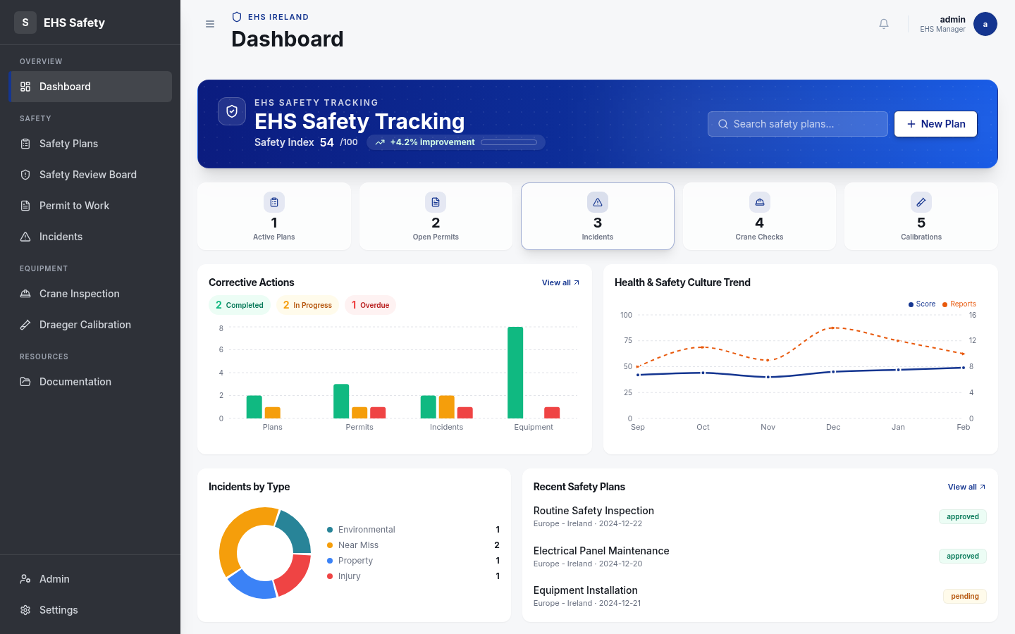
Figure: Dashboard — Real-time Safety Metrics Overview
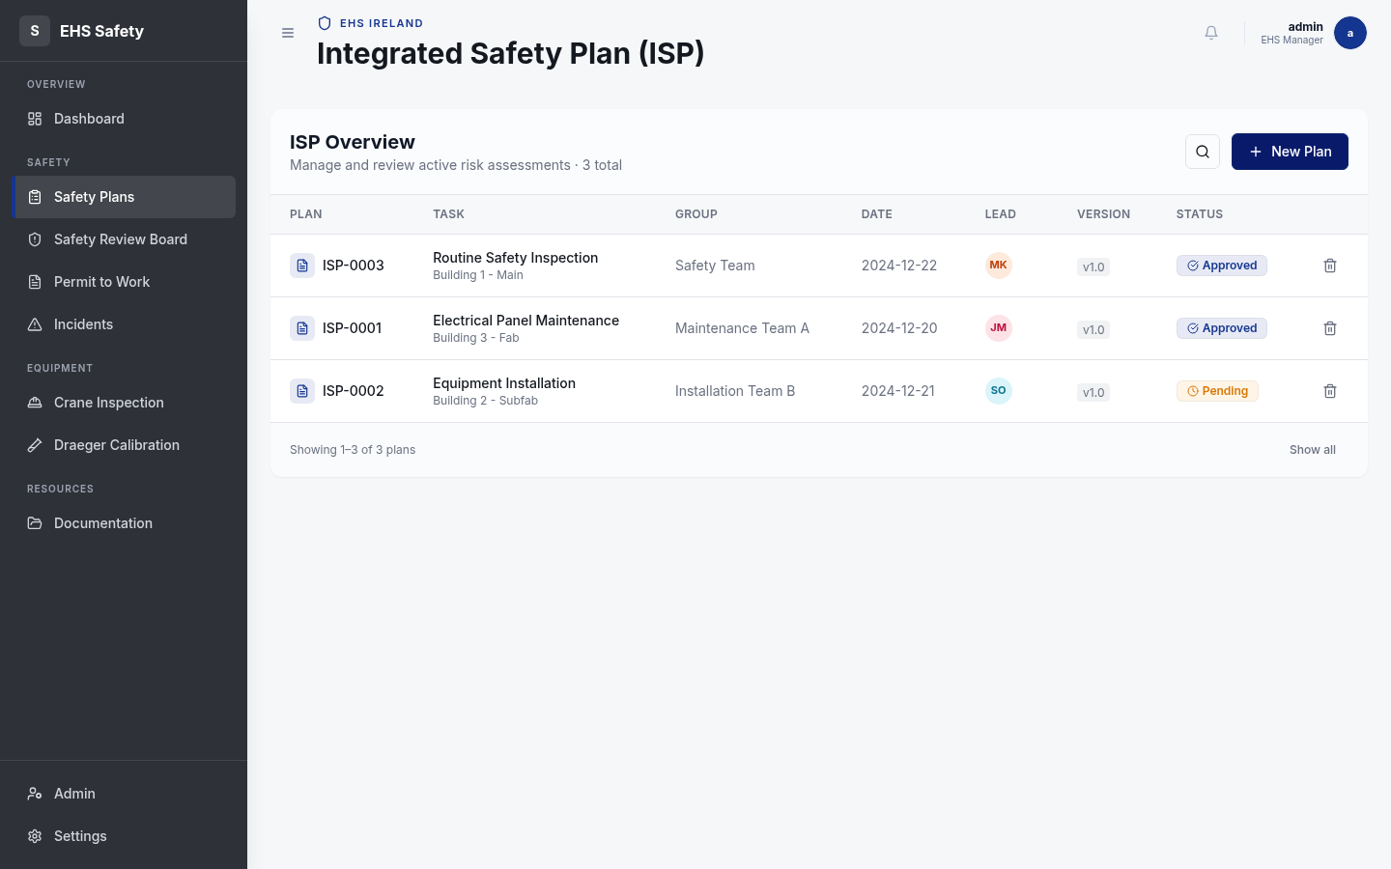
Figure: Safety Plan List — ISP Management with Status Tracking

4. Data Architecture

4.1 Data Flow
All data in the EHS Safety Toolkit flows through a well-defined pipeline from user interaction to persistent storage. The React frontend components dispatch actions through TanStack Query hooks, which manage request deduplication, caching, and background refetching. HTTP requests are serialized as JSON to the Express.js REST API, where Zod schemas enforce strict input validation before data reaches the ORM layer. This multi-stage validation ensures data integrity and provides clear error messages to users.
User Action (click/submit)
↓
React Component (useState / useForm)
↓
TanStack Query mutation / query hook
↓
HTTP Request (JSON payload)
↓
Express.js Route Handler
↓
Zod Schema Validation
↓
Drizzle ORM (type-safe SQL generation)
↓
PostgreSQL 16 (persistent storage)
↓
JSON Response (validated)
↓
TanStack Query cache update
↓
React Component re-render

4.2 Storage Architecture
The EHS Safety Toolkit implements an IStorage interface pattern that enables seamless switching between two storage backends without modifying application code. In development environments, the system uses MemStorage, an in-memory storage implementation that persists data only during the current session. This allows developers and demonstrators to reset the database to a clean state by simply restarting the server. In production environments, the system uses DbStorage, which persists all data to PostgreSQL 16 via the Drizzle ORM. The storage backend is selected via the STORAGE_MODE environment variable, enabling flexibility between development iteration and production reliability.
Storage Mode | Use Case | Persistence | Performance
MemStorage | Development, demos, testing | Session-only (reset on restart) | Sub-millisecond
DbStorage | Production deployment | Persistent PostgreSQL 16 | < 100ms with indexes

4.3 JSONB Usage
The schema leverages PostgreSQL's powerful JSONB (JSON Binary) data type for storing flexible, nested data structures. The safety_plans table stores a hazards array in JSONB format, which captures the complete risk matrix results for each task including severity scores, likelihood assessments, and mitigation strategies. The srb_records table uses JSONB columns for pre_questions, reassessments, and acknowledgements, allowing the Safety Review Board module to store complex nested questionnaires and responses without requiring schema migrations for new question types.
This JSONB approach provides several advantages: schema flexibility for evolving requirements without database migrations, queryable JSON fields using PostgreSQL's JSON operators, native indexing support with GIN indexes for performance, and reduced table normalization complexity. The application validates all JSON data at the API layer using Zod schemas, ensuring data consistency even though the database storage is schemaless.

4.4 Audit Trail Design
Every create, update, approve, or reject action in the system is captured in the audit_logs table, providing a complete change history for compliance and forensic analysis. Each audit log entry records the entity_type (e.g., 'safety_plan', 'permit'), the action taken ('create', 'update', 'approve', 'reject'), the user_id who performed the action, a timestamp, and crucially, a changes field containing a JSON diff showing the before and after values of all modified fields. This enables administrators and auditors to understand not just what changed, but who changed it, when, and what the previous values were.
This design supports regulatory compliance for industries like semiconductor manufacturing where detailed change tracking is mandatory, enables forensic investigation of data discrepancies, allows rollback analysis if issues are discovered, and provides transparency for safety-critical approvals and escalations.

4.5 Version Control
The report_list table stores versioned JSON snapshots of each safety plan submission, enabling the system to maintain a complete history of all ISP versions submitted. Each time a safety plan is submitted, a new row is created in report_list with a version number, the timestamp of submission, and a complete JSON snapshot of the safety plan data at that moment. This enables administrators to retrieve historical versions, compare changes between versions, and provide auditors with immutable records of what was approved on specific dates. The versioning system is independent of the live safety_plans table, ensuring that historical data remains unchanged even if the current plan is later modified.

5. Database Schema & Definitions

5.1 Schema Overview
Category | Table | Description | Key Fields
Auth | users | User accounts with credentials | id, username, password_hash, created_at
Auth | user_preferences | Per-user system settings | user_id, system, group, site, role
Safety Plans | safety_plans | Integrated Safety Plan records | isp_number, task_name, hazards(JSONB), status
Safety Plans | report_list | Versioned plan snapshots | safety_plan_id, version, report_data(JSONB)
Safety Plans | audit_logs | Complete change history | entity_type, action, changes(JSONB), user_id, created_at
Permits | permits | Permit to Work records | permit_number, permit_type, status, created_at
Permits | permit_gas_measurements | Gas readings per permit | permit_id, O2, CO2, CO, H2S, LEL, measured_at
Permits | permit_approvals | Multi-level approval chain | permit_id, approver_role, status, approved_at
Permits | permit_sign_offs | Digital signature records | permit_id, signer_name, signature_data, signed_at
Ops | srb_records | Safety Review Board cases | safety_plan_id, pre_questions(JSONB), reassessments(JSONB), status
Ops | crane_inspections | Equipment verification | permit_id, inspector, buddy_inspector, status
Ops | draeger_calibrations | Gas detector maintenance | serial_number, calibration_date, next_calibration, status
Ops | incidents | Safety event records | incident_type, severity(1-5), status, reported_at
Ops | documents | Safety documentation | title, category, file_url, sharepoint_url, uploaded_at

5.2 Complete PostgreSQL DDL
-- Users table (authentication and identity)
CREATE TABLE users (
id SERIAL PRIMARY KEY,
username VARCHAR(255) UNIQUE NOT NULL,
password_hash VARCHAR(255) NOT NULL,
email VARCHAR(255),
created_at TIMESTAMP DEFAULT CURRENT_TIMESTAMP,
updated_at TIMESTAMP DEFAULT CURRENT_TIMESTAMP
);
-- User preferences (role, group, site assignments)
CREATE TABLE user_preferences (
id SERIAL PRIMARY KEY,
user_id INTEGER NOT NULL REFERENCES users(id) ON DELETE CASCADE,
system VARCHAR(50),
group VARCHAR(100),
site VARCHAR(100),
role VARCHAR(50),
created_at TIMESTAMP DEFAULT CURRENT_TIMESTAMP,
updated_at TIMESTAMP DEFAULT CURRENT_TIMESTAMP
);
-- Safety plans (Integrated Safety Plans - ISPs)
CREATE TABLE safety_plans (
id SERIAL PRIMARY KEY,
isp_number VARCHAR(50) UNIQUE NOT NULL,
task_name VARCHAR(255) NOT NULL,
description TEXT,
hazards JSONB DEFAULT '[]',
safety_index_score INTEGER,
status VARCHAR(50) DEFAULT 'draft',
created_by INTEGER REFERENCES users(id),
created_at TIMESTAMP DEFAULT CURRENT_TIMESTAMP,
updated_at TIMESTAMP DEFAULT CURRENT_TIMESTAMP
);
-- Report list (versioned ISP snapshots)
CREATE TABLE report_list (
id SERIAL PRIMARY KEY,
safety_plan_id INTEGER NOT NULL REFERENCES safety_plans(id) ON DELETE CASCADE,
version INTEGER NOT NULL,
report_data JSONB NOT NULL,
submitted_by INTEGER REFERENCES users(id),
submitted_at TIMESTAMP DEFAULT CURRENT_TIMESTAMP
);
-- Audit logs (complete change history)
CREATE TABLE audit_logs (
id SERIAL PRIMARY KEY,
entity_type VARCHAR(50) NOT NULL,
entity_id INTEGER NOT NULL,
action VARCHAR(50) NOT NULL,
changes JSONB,
user_id INTEGER REFERENCES users(id),
created_at TIMESTAMP DEFAULT CURRENT_TIMESTAMP
);
-- Permits (Permit to Work records)
CREATE TABLE permits (
id SERIAL PRIMARY KEY,
permit_number VARCHAR(50) UNIQUE NOT NULL,
permit_type VARCHAR(50),
description TEXT,
status VARCHAR(50) DEFAULT 'draft',
safety_plan_id INTEGER REFERENCES safety_plans(id),
created_by INTEGER REFERENCES users(id),
created_at TIMESTAMP DEFAULT CURRENT_TIMESTAMP,
updated_at TIMESTAMP DEFAULT CURRENT_TIMESTAMP
);
-- Permit gas measurements (atmospheric readings)
CREATE TABLE permit_gas_measurements (
id SERIAL PRIMARY KEY,
permit_id INTEGER NOT NULL REFERENCES permits(id) ON DELETE CASCADE,
o2_percent DECIMAL(5,2),
co2_percent DECIMAL(5,2),
co_ppm INTEGER,
h2s_ppm INTEGER,
lel_percent DECIMAL(5,2),
measured_by INTEGER REFERENCES users(id),
measured_at TIMESTAMP DEFAULT CURRENT_TIMESTAMP
);
-- Permit approvals (multi-level authorization)
CREATE TABLE permit_approvals (
id SERIAL PRIMARY KEY,
permit_id INTEGER NOT NULL REFERENCES permits(id) ON DELETE CASCADE,
approver_role VARCHAR(50) NOT NULL,
approver_user_id INTEGER REFERENCES users(id),
status VARCHAR(50) DEFAULT 'pending',
comments TEXT,
approved_at TIMESTAMP
);
-- Permit sign-offs (digital signatures)
CREATE TABLE permit_sign_offs (
id SERIAL PRIMARY KEY,
permit_id INTEGER NOT NULL REFERENCES permits(id) ON DELETE CASCADE,
signer_name VARCHAR(255) NOT NULL,
signature_data TEXT,
signed_at TIMESTAMP DEFAULT CURRENT_TIMESTAMP
);
-- Safety Review Board records (high-risk escalations)
CREATE TABLE srb_records (
id SERIAL PRIMARY KEY,
safety_plan_id INTEGER NOT NULL REFERENCES safety_plans(id) ON DELETE CASCADE,
pre_questions JSONB DEFAULT '{}',
reassessments JSONB DEFAULT '{}',
acknowledgements JSONB DEFAULT '{}',
status VARCHAR(50) DEFAULT 'pending',
created_at TIMESTAMP DEFAULT CURRENT_TIMESTAMP,
updated_at TIMESTAMP DEFAULT CURRENT_TIMESTAMP
);
-- Crane inspections (equipment verification)
CREATE TABLE crane_inspections (
id SERIAL PRIMARY KEY,
permit_id INTEGER REFERENCES permits(id),
inspector_user_id INTEGER NOT NULL REFERENCES users(id),
buddy_inspector_user_id INTEGER REFERENCES users(id),
status VARCHAR(50) DEFAULT 'pending',
inspection_date TIMESTAMP DEFAULT CURRENT_TIMESTAMP
);
-- Draeger calibrations (gas detector maintenance)
CREATE TABLE draeger_calibrations (
id SERIAL PRIMARY KEY,
serial_number VARCHAR(50) UNIQUE NOT NULL,
model VARCHAR(100),
calibration_date TIMESTAMP NOT NULL,
next_calibration TIMESTAMP NOT NULL,
status VARCHAR(50) DEFAULT 'calibrated',
calibrated_by INTEGER REFERENCES users(id)
);
-- Incidents (safety events)
CREATE TABLE incidents (
id SERIAL PRIMARY KEY,
incident_number VARCHAR(50) UNIQUE NOT NULL,
incident_type VARCHAR(100) NOT NULL,
severity INTEGER CHECK (severity >= 1 AND severity <= 5),
description TEXT,
status VARCHAR(50) DEFAULT 'open',
reported_by INTEGER REFERENCES users(id),
reported_at TIMESTAMP DEFAULT CURRENT_TIMESTAMP
);
-- Documents (safety documentation library)
CREATE TABLE documents (
id SERIAL PRIMARY KEY,
title VARCHAR(255) NOT NULL,
category VARCHAR(100),
description TEXT,
file_url VARCHAR(512),
sharepoint_url VARCHAR(512),
uploaded_by INTEGER REFERENCES users(id),
uploaded_at TIMESTAMP DEFAULT CURRENT_TIMESTAMP
);
-- Indexes for performance optimization
CREATE INDEX idx_safety_plans_isp_number ON safety_plans(isp_number);
CREATE INDEX idx_safety_plans_status ON safety_plans(status);
CREATE INDEX idx_permits_permit_number ON permits(permit_number);
CREATE INDEX idx_permits_status ON permits(status);
CREATE INDEX idx_audit_logs_entity ON audit_logs(entity_type, entity_id);
CREATE INDEX idx_audit_logs_user_id ON audit_logs(user_id);
CREATE INDEX idx_report_list_safety_plan_id ON report_list(safety_plan_id);
CREATE INDEX idx_incidents_severity ON incidents(severity);
CREATE INDEX idx_draeger_serial ON draeger_calibrations(serial_number);

5.3 Entity Relationships
The EHS Safety Toolkit employs a relational data model with carefully designed relationships to ensure data integrity and minimize redundancy. The users table forms the foundation for authentication and act as a central reference for all audit logging. The user_preferences table maintains a one-to-one relationship with users, storing system, group, site, and role assignments for each user. The safety_plans table represents core ISP records and maintains one-to-many relationships with multiple dependent tables: permits (for PtW records), srb_records (for high-risk escalations), and report_list (for versioned snapshots). The permits table similarly maintains one-to-many relationships with permit_gas_measurements, permit_approvals, and permit_sign_offs, creating a comprehensive audit trail for each permit's lifecycle. All foreign key relationships include ON DELETE CASCADE where appropriate, ensuring that deleting a parent record cleanly removes all dependent records.

5.4 Key Schema Patterns
JSONB for Flexible Nested Data: The schema uses JSONB columns (hazards, pre_questions, reassessments, changes) to store complex nested structures without requiring schema migrations for new question types or assessment parameters.
Zod Schema Auto-Generation: TypeScript Zod schemas are defined in the shared/ directory and automatically generate validation rules and type definitions, ensuring frontend and backend speak the same language.
Audit Logging with Before/After Diffs: Every action creates an audit_logs row with a changes field containing JSON diffs, enabling forensic analysis and compliance reporting.
Version Tracking via report_list: Historical ISP versions are stored as immutable snapshots, allowing retrieval of signed-off versions and comparison of changes over time.

6. Application Modules

6.1 Dashboard
The Dashboard is the primary entry point for all EHS users and provides real-time visibility into safety performance across all seven modules. It aggregates key metrics into visual cards, displays the Safety Index score (a composite metric from 0-100), and presents trend analytics showing performance over time. Users can drill down from dashboard cards to detailed module interfaces, creating a natural workflow from high-level overview to focused task execution.
Real-time Safety Index score displaying aggregated EHS performance (0-100 scale)
Metric cards showing active permits, pending SRB cases, overdue calibrations, and open incidents
Charts and graphs showing trend analysis over the past 30, 90, and 360 days
Quick-action buttons for creating new ISPs, permits, and incident reports
User preferences panel for customizing display metrics and alert thresholds
Role-based dashboard customization showing only relevant metrics per user type
Figure: Dashboard — Safety Index, Metric Cards, and Analytics Charts
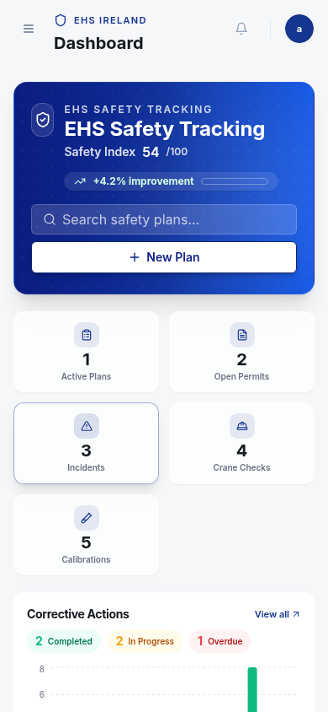
Figure: Dashboard — Mobile Responsive View

6.2 Safety Plans / ISP
The Safety Plans module implements the complete Integrated Safety Plan (ISP) workflow, from initial hazard assessment through multi-level approval. Users navigate a structured 4-step wizard that guides them through task definition, hazard identification, risk assessment, and review. The system calculates a Safety Index score based on risk matrix responses, automatically escalating plans with scores ≥ 8 to the Safety Review Board for mandatory review.
4-step wizard interface for structured ISP creation (Task Details → Hazards → Risk Assessment → Review)
Risk matrix calculation with severity and likelihood ratings
Automatic Safety Index score computation and SRB escalation
A4-format PDF export for printing and physical file storage
Multi-level approval workflow with comment tracking
Complete version history with ability to compare revisions
Export to SharePoint integration (when M365 OAuth enabled)
Figure: Safety Plan List — ISP Management with Status Tracking
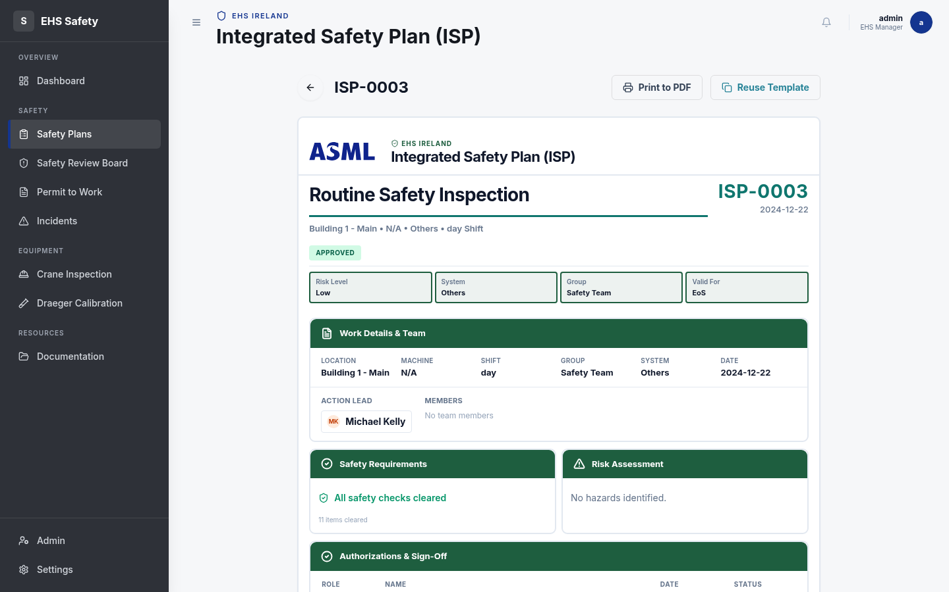
Figure: ISP Document — A4-Format with Risk Assessment and Authorization
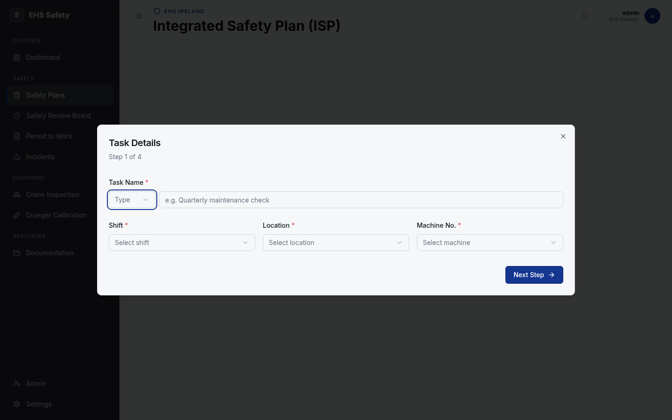
Figure: Safety Plan Wizard — Step 1: Task Details Modal

6.3 Safety Review Board
The Safety Review Board (SRB) module manages high-risk activity escalations. When a safety plan's Safety Index score reaches or exceeds 8, it is automatically escalated to the SRB for mandatory review. The module presents a structured review interface with pre-questions, reassessment questionnaires, and acknowledgement tracking. Only SRB-authorized users can approve or reject escalated plans, and all decisions are recorded in the audit trail.
Automatic escalation of high-risk activities (Safety Index ≥ 8)
Structured questionnaire workflow for SRB review
Real-time notification of new escalated cases
Approval or rejection with mandatory comment entry
Complete audit trail of all SRB decisions
Export functionality for SRB meeting minutes
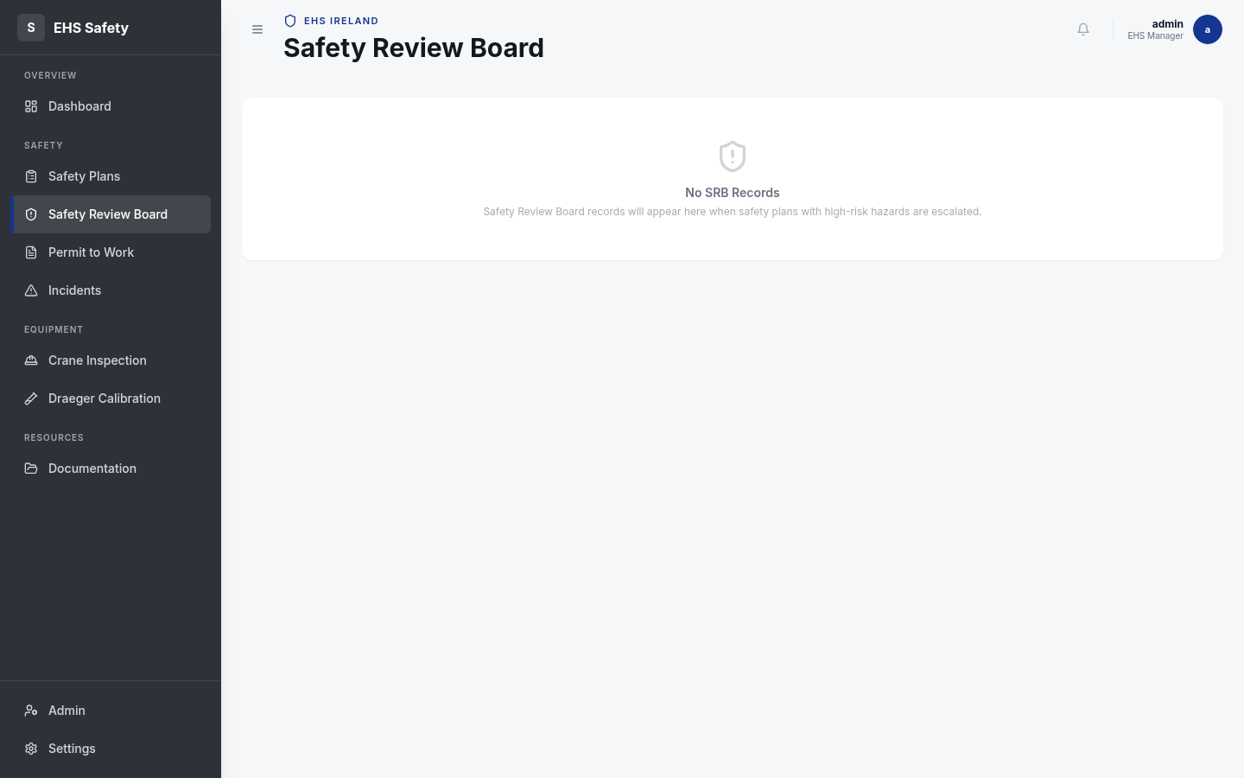
Figure: Safety Review Board — High-Risk Escalation Workflow

6.4 Permit to Work
The Permit to Work (PtW) module manages authorization for potentially hazardous work activities. Permits are linked to approved ISPs and require multi-level approval from designated roles. The module integrates gas measurement tracking, allowing authorized personnel to record atmospheric readings (O2, CO2, CO, H2S, LEL) and verify safe conditions before work begins. Digital sign-off functionality provides legal documentation of authorization.
Permit creation linked to approved ISPs
Multi-level approval chain with role-based authorization
Atmospheric gas measurement recording with safe range validation
Digital signature capture for authorization
Real-time approval status tracking
Automatic escalation if measurements exceed safe limits
PDF export for site posting and record-keeping
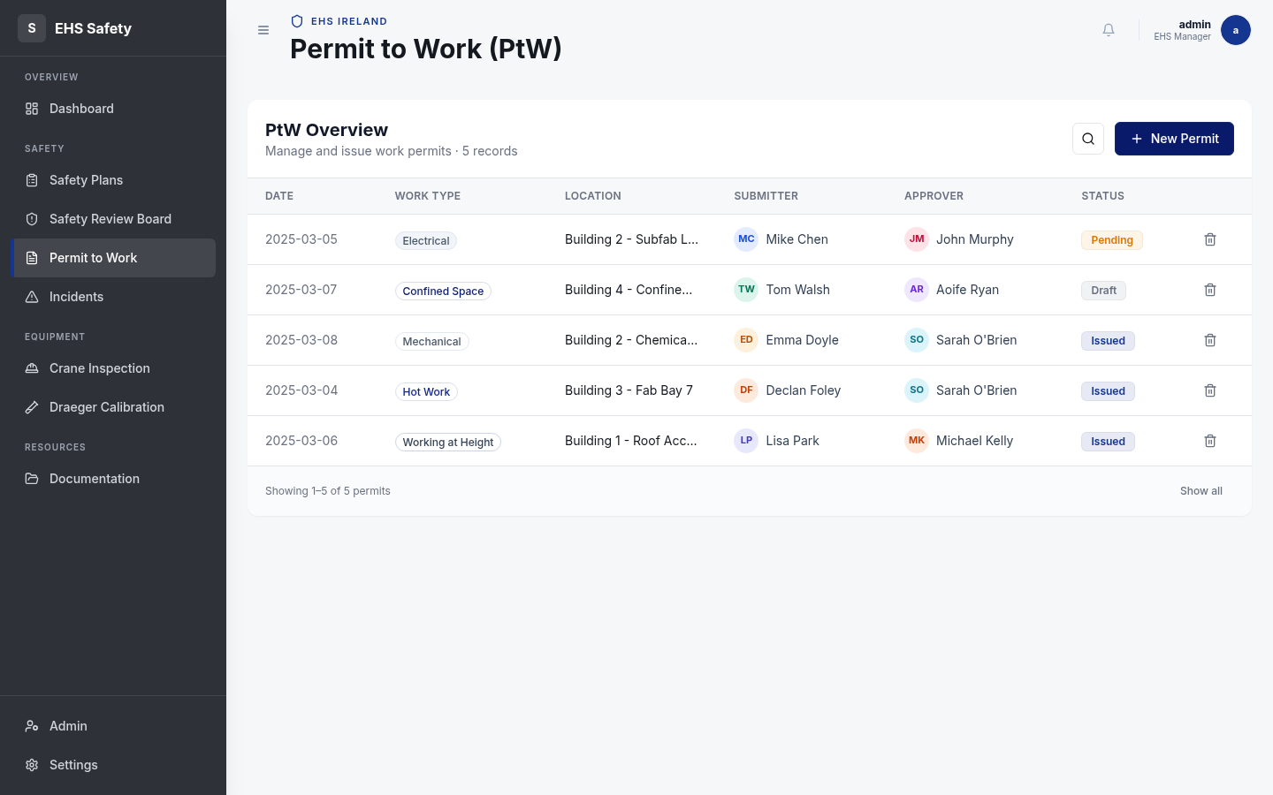
Figure: Permit to Work — Authorization with Multi-Level Approval Chain

6.5 Incidents
The Incidents module provides a centralized system for recording, tracking, and investigating safety events. Each incident is assigned a severity rating (1-5), allowing filtering and prioritization by impact. Users can track investigation status, assign action items, and maintain a complete history of all incident-related communications. The module integrates with the audit trail to ensure all incident handling is fully documented.
Incident creation with type and severity classification
Severity-based prioritization and filtering
Investigation workflow with status tracking
Action item assignment and tracking
Automatic notification to relevant stakeholders
Root cause analysis documentation
Corrective action tracking and verification
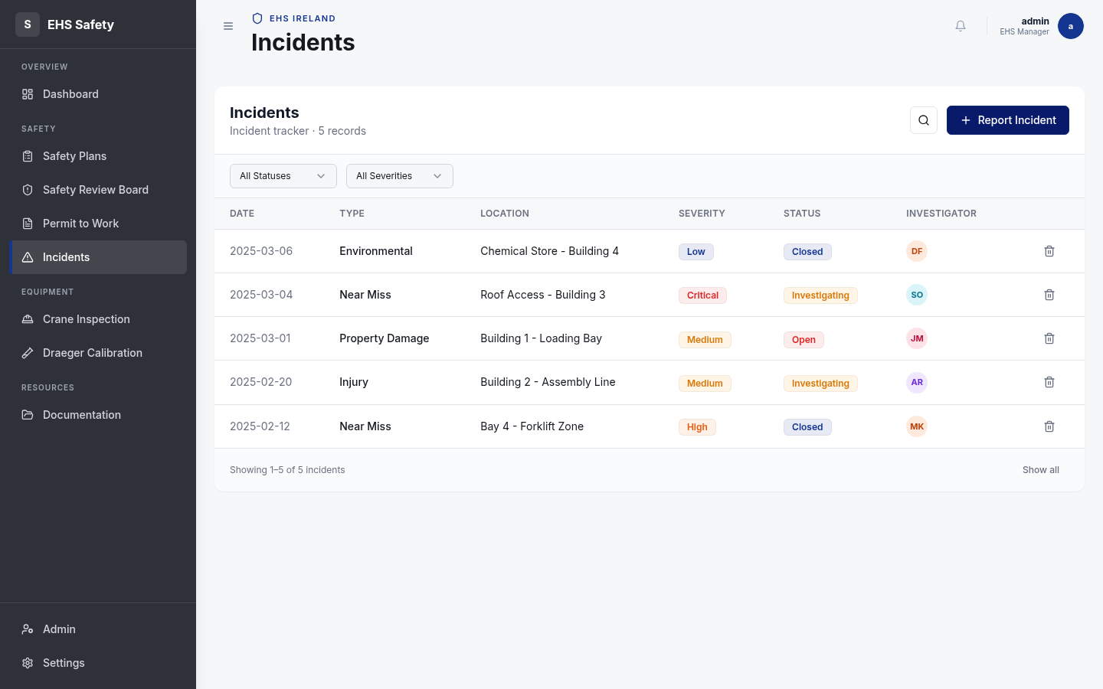
Figure: Incident Management — Severity Tracking and Investigation Workflow

6.6 Crane Inspection
The Crane Inspection module implements a buddy-inspector system for pre-operation equipment verification. Two authorized inspectors must independently verify three key inspection points before work is approved. The system ensures compliance with equipment maintenance schedules and regulatory inspection intervals. All inspections are timestamped and recorded with inspector identification for audit purposes.
Buddy-inspector system requiring two independent verifications
Three-point inspection checklist for equipment verification
Automatic scheduling based on maintenance intervals
Real-time status tracking of inspection progress
Automated reminders for overdue inspections
Complete audit trail with inspector signatures
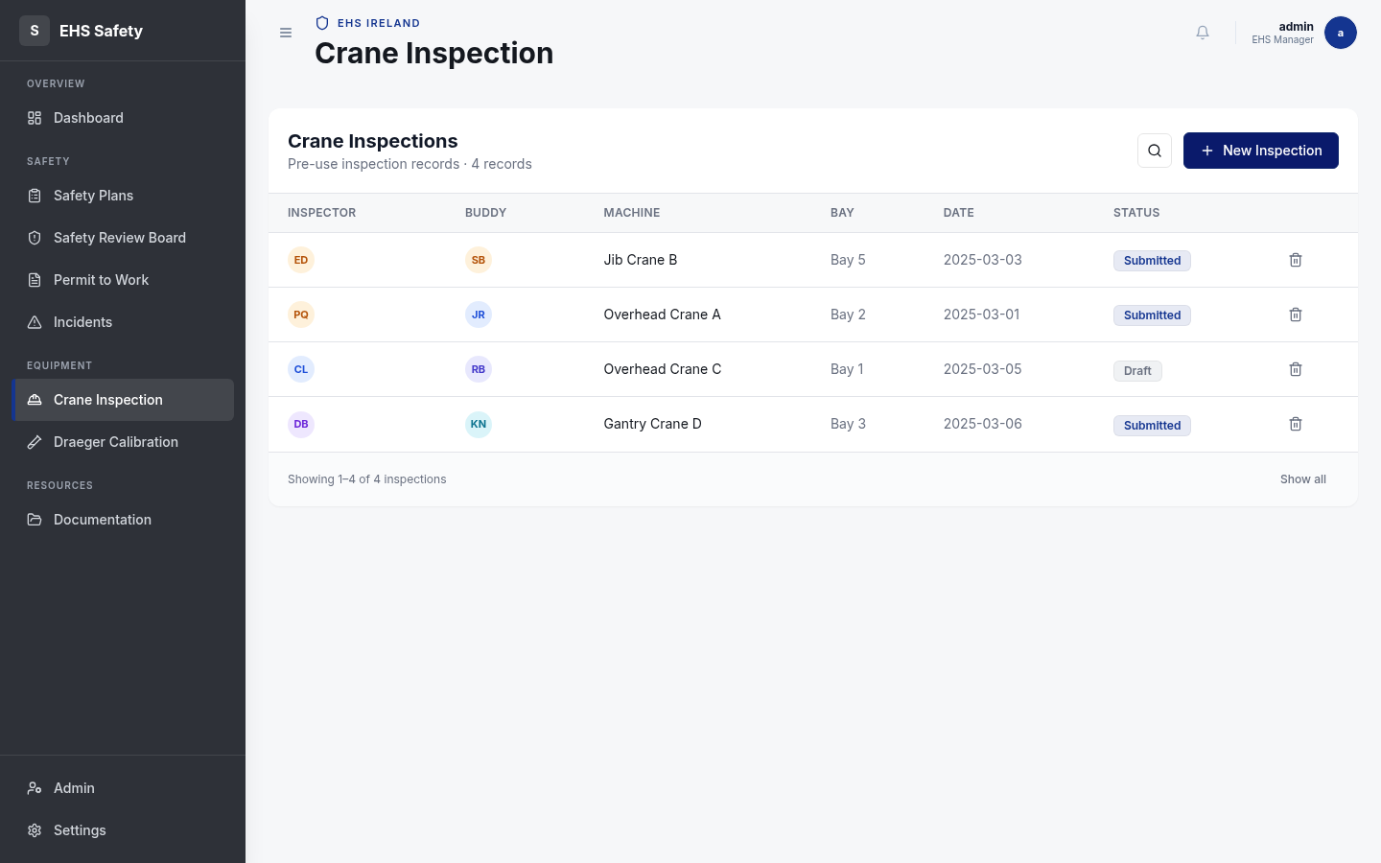
Figure: Crane Inspection — Buddy-Inspector System and Equipment Verification

6.7 Draeger Calibration
The Draeger Calibration module tracks maintenance of portable gas detection equipment across the facility. It maintains a registry of all Draeger instruments with serial numbers, calibration dates, and next-required-calibration dates. The system generates alerts for overdue equipment and maintains a complete maintenance history for regulatory compliance. Authorized calibration personnel record calibration activities and equipment condition assessments.
Equipment registry with serial number and model tracking
Calibration date and next-required-calibration scheduling
Automatic overdue alerts and notifications
Maintenance history with detailed service records
Equipment condition assessment and trending
Regulatory compliance reporting
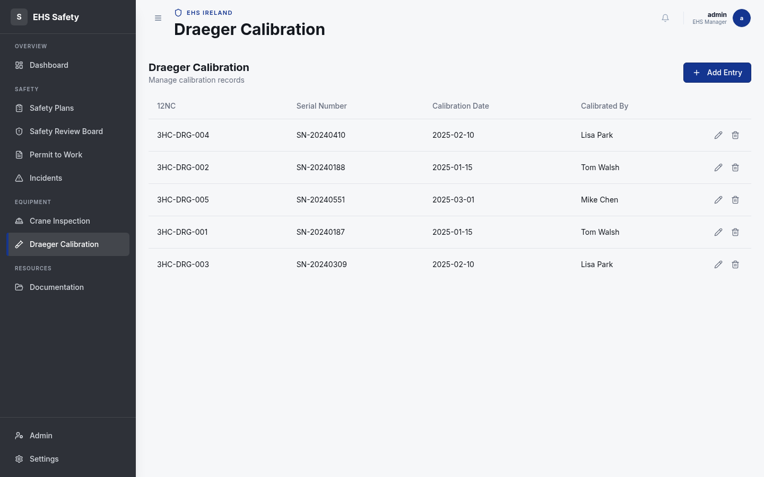
Figure: Draeger Calibration — Gas Detector Maintenance Tracking

6.8 Documentation
The Documentation module provides a centralized library for all safety-related documents. When Microsoft 365 integration is enabled, documents can be automatically synchronized with SharePoint, creating a unified view of documentation across ASML systems. Users can categorize documents, search by keyword, and track document versions. The module supports exporting ISP documents as PDF for physical filing and integration with enterprise document management systems.
Centralized document library with category organization
Full-text search across all documents
Version control and change tracking
SharePoint synchronization when M365 OAuth enabled
Document expiration tracking and renewal reminders
Access control and document classification
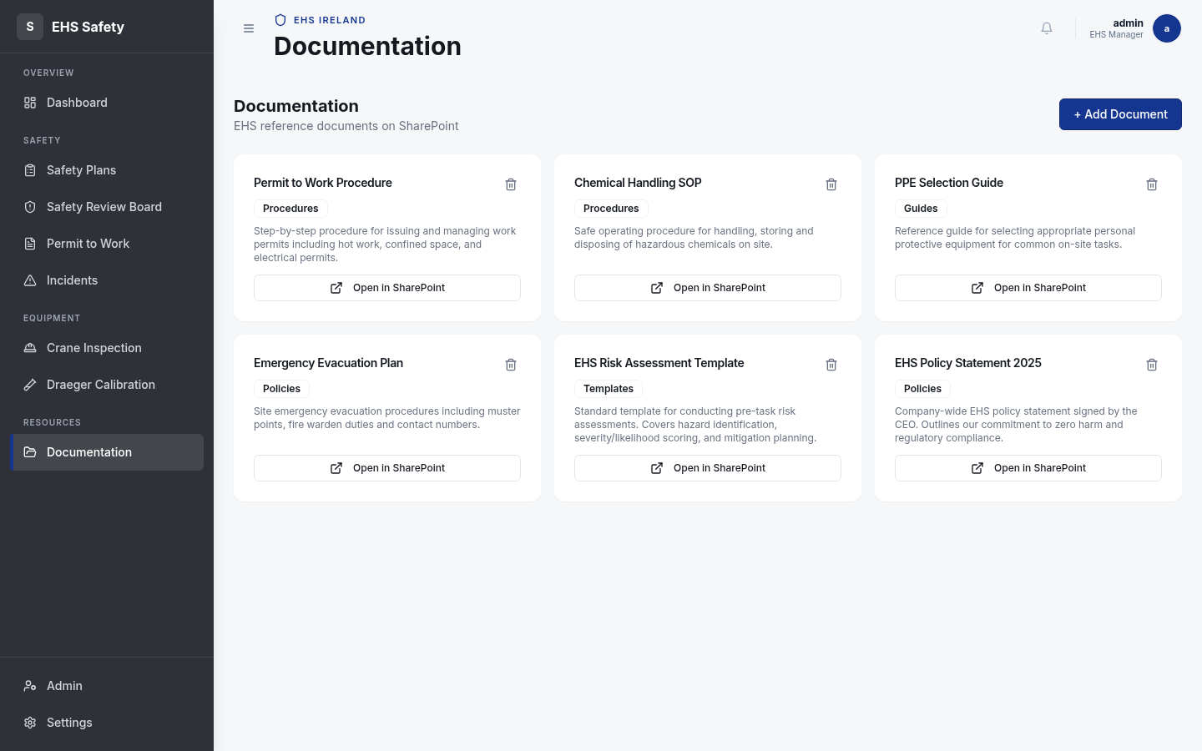
Figure: Documentation Library — SharePoint-Linked Safety Documents

7. API Reference
Method | Endpoint | Description | Auth Required
POST | /api/login | User authentication | No
POST | /api/logout | User session termination | Yes
GET | /api/safety-plans | List all ISPs with filtering | Yes
POST | /api/safety-plans | Create new ISP | Yes
GET | /api/safety-plans/:id | Retrieve specific ISP | Yes
PUT | /api/safety-plans/:id | Update ISP | Yes
POST | /api/safety-plans/:id/approve | Approve ISP | Yes
POST | /api/permits | Create new permit | Yes
GET | /api/permits | List all permits | Yes
PUT | /api/permits/:id/gas-measurements | Record gas readings | Yes
POST | /api/srb/escalate | Escalate to SRB | Yes
GET | /api/dashboard/metrics | Get dashboard metrics | Yes
POST | /api/incidents | Report incident | Yes

7.1 Request/Response Pattern
All API requests and responses follow a consistent JSON format with strict validation using Zod schemas. Request payloads are validated against the corresponding Zod schema before processing, and any validation errors are returned with detailed field-level error messages. Successful responses include a 200 status code with a JSON body containing the requested data or operation result. Error responses follow a standard format with HTTP status code, error type, and detailed message for client-side handling.
Success Response (200 OK):
{ "success": true, "data": { "id": 123, "name": "Task" } }
Validation Error (400 Bad Request):
{ "success": false, "error": { "field": "task_name", "message": "Required" } }
Authentication Error (401 Unauthorized):
{ "success": false, "error": "Invalid credentials" }
Server Error (500 Internal Server Error):
{ "success": false, "error": "Database connection failed" }

7.2 Authentication Endpoints
The authentication system uses Passport.js with a local strategy for username/password authentication. Sessions are managed via express-session with server-side storage. M365 OAuth is planned for near-term deployment to provide enterprise Azure AD integration.
POST /api/login - User Authentication
Request:
{ "username": "john.doe", "password": "secure_password" }
Response (200):
{ "success": true, "user": { "id": 1, "username": "john.doe" } }
POST /api/logout - Session Termination
Request: (no body required)
Response (200):
{ "success": true, "message": "Logged out successfully" }

8. Security Architecture
The EHS Safety Toolkit implements defense-in-depth security with multiple layers of protection. Every user session is authenticated and authorized before accessing any functionality. All API inputs are validated using Zod schemas before processing. Database interactions use the Drizzle ORM with parameterized queries to prevent SQL injection. All data is transmitted over HTTPS/TLS on the Railway platform, and sensitive data like passwords are hashed using industry-standard algorithms.
Security Feature | Implementation | Purpose
Authentication | Passport.js with local strategy + bcrypt hashing | User identity verification
Session Management | express-session with server-side storage | Persistent user sessions
Input Validation | Zod schemas with strict type checking | Prevention of invalid/malicious data
SQL Injection Prevention | Drizzle ORM with parameterized queries | Database access control
Transport Security | HTTPS/TLS via Railway platform | Data encryption in transit
Audit Trail | audit_logs table with complete change history | Forensic investigation capability
Role-Based Access | user_preferences role assignments | Function-level authorization
M365 OAuth | Ready-to-enable Azure AD integration | Enterprise SSO compatibility

9. CI/CD & Deployment

9.1 GitHub Actions Pipeline
The project employs a GitHub Actions CI/CD pipeline that runs on every push to any branch and on pull requests. The pipeline includes three primary jobs: Lint checks for code quality using ESLint and Prettier, Type checking using TypeScript compiler, and Docker image building for container deployment. All jobs must pass before allowing merges to the main branch.
GitHub Actions Jobs:
1. Lint Job
- npm install
- npm run lint (ESLint + Prettier check)
2. Type Check Job
- npm install
- npm run type-check (TypeScript compiler)
3. Docker Build Job
- Build client (Vite)
- Build server (Express)
- Create Docker image
- Push to Railway registry

9.2 Docker Configuration
The project includes both docker-compose.yml for local development and a Dockerfile for production deployment. The Dockerfile uses a multi-stage build process to minimize final image size. The development docker-compose orchestrates frontend, backend, and PostgreSQL containers, enabling developers to run the complete stack locally.
Dockerfile Multi-Stage Build:
Stage 1 (Build): Node 20 + npm install + build React app + build server
Stage 2 (Runtime): Node 20 + copy built artifacts + expose port 5000
Final image size: ~500MB (optimized for Railway deployment)

9.3 Deployment Architecture
Environment | Platform | Database | Deployment Method
Development | Docker Compose (local) | PostgreSQL 16 (Docker) | Local `docker-compose up`
Staging | Railway | Neon PostgreSQL | Git push to staging branch
Production | Railway | Neon PostgreSQL (primary) | Git push to main branch

9.4 Environment Variables
Required Environment Variables:
DATABASE_URL=postgresql://... (Neon PostgreSQL connection string)
NODE_ENV=production (Node.js environment)
STORAGE_MODE=db (Use PostgreSQL, or 'memory' for in-memory)
SESSION_SECRET=... (Express-session encryption key)
PORT=5000 (API server port)

10. Design System
The EHS Safety Toolkit adheres to ASML's brand guidelines with a carefully selected color palette, consistent typography, and reusable UI components. The design system ensures visual consistency across all modules and supports both light and dark themes. All components are built on Shadcn/ui with Tailwind CSS, providing accessibility features and responsive behavior.
Brand Colors
Purpose | Hex Code | RGB | Usage
Primary Brand | #0F238C | rgb(15, 35, 140) | Headers, buttons, links
Secondary | #1E3AAF | rgb(30, 58, 175) | Section headings, emphasis
Accent | #E8590C | rgb(232, 89, 12) | Alerts, highlights
Success | #10B981 | rgb(16, 185, 129) | Approval, completed status
Warning | #F59E0B | rgb(245, 158, 11) | Pending, in-progress status
Error | #EF4444 | rgb(239, 68, 68) | Rejection, error states
Neutral 50 | #F9FAFB | rgb(249, 250, 251) | Backgrounds, light surfaces
Neutral 900 | #111827 | rgb(17, 24, 39) | Text, dark surfaces
Typography
Element | Font | Size | Weight | Usage
H1 (Page Title) | Arial | 36px | Bold | Main page headings
H2 (Section) | Arial | 28px | Bold | Major sections
H3 (Subsection) | Arial | 24px | Bold | Sub-sections
Body | Arial | 16px | Regular | Paragraph text
Caption | Arial | 14px | Regular | Figure captions, hints
Monospace Code | Courier New | 14px | Regular | Code blocks, technical text

11. Future Features & Roadmap

11.1 Microsoft Teams Notification Feature
Automated notifications will be sent to designated Teams channels on key safety events, enabling real-time visibility and faster response. The notification service will integrate with Teams Incoming Webhooks to post rich card messages with contextual information about safety events.
Notification Triggers
Event | Trigger | Recipient | Content
ISP Created | New safety plan submitted | EHS Team | ISP number, task name, risk score
SRB Escalation | Safety Index ≥ 8 | SRB Committee | ISP details, questionnaire link
SRB Approval | Committee approves escalation | Requestor | Approval status, comments
Permit Approval | PtW approved | Work Crew | Permit number, gas measurements OK
Permit Rejection | PtW rejected | Requestor | Rejection reason, remediation needed
Overdue Inspection | Crane inspection overdue | Facility Manager | Equipment ID, overdue by X days
Draeger Calibration Due | Calibration due | Equipment Manager | Serial number, next calibration date
Incident Reported | New incident created | Safety Team | Incident type, severity, location

11.2 Approval Flow via Teams & Power Automate
This feature will enable EHS approvers to review and approve permit-to-work and SRB cases directly from Microsoft Teams using Adaptive Cards, eliminating email bottlenecks and providing full audit trail documentation. The workflow integrates with Power Automate to automatically update the EHS Toolkit upon approval/rejection.
Architecture Flow:
EHS Toolkit (approval needed)
↓ triggers
Power Automate (orchestration engine)
↓ creates
Teams Adaptive Card in approver's channel
↓ approver clicks
Adaptive Card action handler
↓ calls back
EHS Toolkit callback API (/api/webhooks/teams-approval)
↓ updates
Permit or SRB record with approval decision
↓ posts reply
Confirmation message in Teams thread

11.3 M365 OAuth / Azure AD SSO
Azure AD Single Sign-On will replace local username/password authentication, enabling ASML employees to log in using their corporate credentials. This integration requires minimal code changes as the framework is already prepared. Three environment variables are needed: AZURE_AD_CLIENT_ID, AZURE_AD_CLIENT_SECRET, and AZURE_AD_TENANT_ID. Once configured, the system will redirect unauthenticated users to ASML's Azure AD login page.

11.4 Advanced RBAC
The current role system will be extended to provide granular permissions at the module level, allowing administrators to control exactly which users can view, edit, approve, or reject records. A new role_permissions table will map user roles to module-specific actions.
Module | Viewer | Editor | Approver | Admin
Dashboard | View metrics | View metrics | View metrics | View + configure
Safety Plans | View all | Create/edit own | Approve/reject | Full control
SRB | View assigned | Edit responses | Approve/reject | Full control
Permits | View all | Create/edit own | Approve/sign | Full control
Incidents | View all | Create/edit all | Close/assign | Full control
Crane Inspect | View assigned | Perform checks | Approve checks | Full control
Draeger Cal | View schedule | Record cals | Verify cals | Full control
Documentation | View/download | Upload docs | Approve docs | Full control

11.5 Real-Time WebSocket Notifications
WebSocket support will enable real-time notifications to connected clients when critical events occur (new escalations, approvals, rejections). The ws package is already installed. Implementation will add a WebSocket server alongside the HTTP server, allowing clients to subscribe to notification channels.

11.6 Advanced Reporting & Analytics
A comprehensive reporting engine will provide customizable reports on safety metrics, trends, incident rates, and compliance status. Reports can be filtered by date range, site, department, and module, and exported as PDF or Excel. Dashboards will support drill-down analysis from top-level summaries to detailed records.

11.7 Audit Dashboard
A dedicated audit dashboard will visualize the audit_logs table, allowing compliance and security teams to review all system changes, filter by user/entity/date, and export audit reports for regulatory compliance documentation.

11.8 Mobile-First Responsive Design Enhancements
While the current design is already responsive, future enhancements will include touch-optimized interfaces, offline mode with service workers, and native mobile app versions using React Native for iOS and Android.

11.9 Enterprise System Integration
Future roadmap includes integration with SAP ERP for workforce and equipment data synchronization, ServiceNow ITSM for incident correlation, and Salesforce for customer-facing EHS documentation.

12. Implementation Roadmap
Timeline | Feature | Priority | Effort | Dependencies
Q1-Q2 2026 | M365 OAuth Authentication | Critical | Medium | Azure AD registration
Q1-Q2 2026 | Teams Notification Service | High | Medium | Teams webhooks
Q1-Q2 2026 | SharePoint Document Sync | High | Medium | SharePoint API access
Q1-Q2 2026 | Unit & E2E Test Suite | High | High | Vitest, Playwright
Q1-Q2 2026 | PostgreSQL Migration | Critical | Low | DATABASE_URL env var
Q2-Q3 2026 | Teams Approval Flow (Power Automate) | High | High | M365 OAuth, Power Automate
Q3-Q4 2026 | Real-time WebSocket Notifications | Medium | Medium | WebSocket server
Q3-Q4 2026 | Granular RBAC - Module Permissions | High | High | User preferences extension
Q3-Q4 2026 | Advanced Reporting & Analytics | Medium | High | Report builder UI
Q4-2026 | Audit Dashboard | Medium | Medium | audit_logs visualization
2027+ | React Native Mobile App | Medium | Very High | New project scope
2027+ | PWA / Offline Mode | Medium | High | Service Worker implementation
2027+ | Multi-Tenant Support | Low | Very High | Schema isolation architecture
2027+ | ML/Analytics - Trend Prediction | Low | Very High | Data science infrastructure
2027+ | SAP/ServiceNow Integration | Medium | High | Enterprise API agreements

Appendix A: Glossary
EHS: Environmental Health and Safety - disciplines focused on protecting worker health, facility safety, and environmental compliance
ISP: Integrated Safety Plan - a structured pre-task assessment documenting hazards, risks, and mitigation for a specific work activity
SRB: Safety Review Board - a committee that escalates and reviews high-risk activities (Safety Index ≥ 8)
PTW: Permit to Work - authorization document required for potentially hazardous work activities
LOTO: Lockout/Tagout - safety procedure for isolating hazardous energy sources before maintenance
LEL: Lower Explosive Limit - the lowest concentration of a gas that will ignite when mixed with air and an ignition source
PPE: Personal Protective Equipment - clothing or devices worn for protection (gloves, helmets, respirators, etc.)
ORM: Object-Relational Mapping - software layer mapping between object-oriented code and relational databases
SPA: Single-Page Application - web application that loads a single HTML page and dynamically updates content
REST: Representational State Transfer - architectural style for distributed systems using HTTP methods
JSONB: JSON Binary - PostgreSQL data type for storing JSON data with indexing and query capabilities
RBAC: Role-Based Access Control - authorization system restricting access based on user roles
CI/CD: Continuous Integration / Continuous Deployment - automated testing and deployment pipeline
M365: Microsoft 365 - Microsoft's cloud productivity and collaboration platform (Teams, SharePoint, Azure AD)
SSO: Single Sign-On - authentication system allowing users to log in once and access multiple applications
OAuth: Open Authorization - open standard for authorization and delegated access
JWT: JSON Web Token - encrypted token format for stateless authentication
API: Application Programming Interface - contract defining how software components interact
DXA: Document Extended Attribute - Microsoft Word measurement unit (1440 DXA = 1 inch)
DPI: Dots Per Inch - resolution measurement for digital images

Appendix B: Deployment Checklist
Pre-Deployment
Review all code changes and ensure PR approval
Run full test suite locally and in CI/CD pipeline
Verify all environment variables are configured in Railway
Back up current production database
Create database migration plan if schema changes required
Prepare rollback procedure with previous version container image
Schedule deployment during low-usage window
Notify stakeholders of deployment and potential brief outage
Deployment Steps
Merge feature branch to main via GitHub PR
GitHub Actions automatically triggers CI pipeline
Wait for lint, type-check, and Docker build to complete
Monitor Railway deployment dashboard for container startup
Verify health check endpoint responds (GET /api/health)
Check application logs for any startup errors
Run smoke tests against production endpoints
Monitor error rates and performance metrics for 1 hour
Post-Deployment
Verify all modules are accessible and functional
Test critical workflows (ISP creation, permit approval, etc.)
Check database connections and query performance
Review error logs for any unexpected warnings
Confirm audit logs are recording changes
Validate email notifications if configured
Update deployment documentation with version and date
Archive previous version container image for rollback
Schedule team communication about new features/fixes

