Credit Card Buyer Prediction
A binary classification model that identifies potential credit card buyers for targeted bank marketing campaigns, built on the Czech Banking Dataset.

Business Motivation
Acquiring new credit card customers through untargeted campaigns is costly and inefficient. By predicting which existing bank clients are most likely to purchase a credit card, the bank can focus marketing spend on high-probability prospects – reducing acquisition costs while increasing conversion rates. This project delivers a data-driven scoring model that ranks customers by purchase likelihood, enabling personalized outreach at scale.

Data
The project uses the Czech Banking Dataset, a realistic anonymized collection of banking records consisting of 8 interrelated tables:
Table | Description
account | Bank account information (opening date, frequency of statements)
client | Client demographics (birth date, gender, district)
disp | Disposition linking clients to accounts (owner vs. disponent)
card | Issued credit cards (type: classic, gold, junior; issue date)
trans | Transaction records (amounts, balances, types, dates)
order | Permanent orders (standing payments)
loan | Granted loans (amount, duration, status)
district | Demographic data per district (population, unemployment, crime rate)
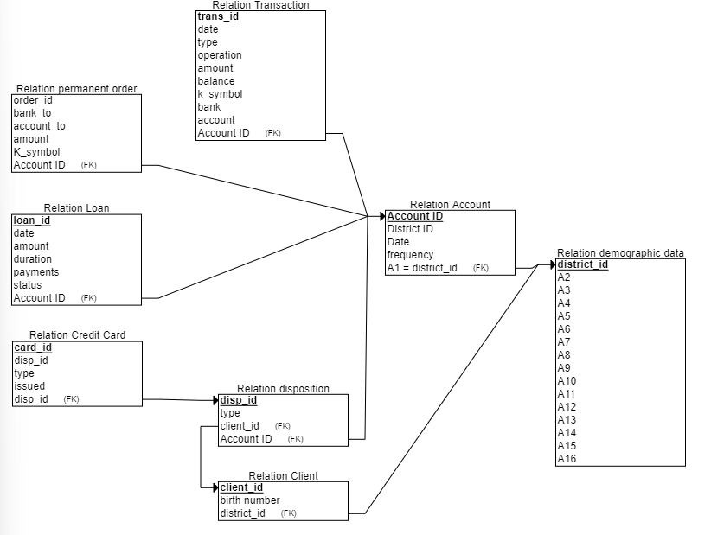
Entity-Relationship Diagram

Methodology
Raw CSVs ─► Data Cleaning & Wrangling ─► Feature Engineering ─► Preprocessing ─► SMOTE ─► Model Training ─► Evaluation
- Data Cleaning & Wrangling – Join the 8 source tables, handle missing values, parse dates, and resolve data quality issues.
- Feature Engineering – Aggregate transaction histories into rolling statistics (mean balance, transaction frequency, credit/debit ratios), encode demographic features, and derive loan- and order-based indicators.
- Preprocessing – Detect skewed distributions and apply log or power transforms, binarize sparse features, and scale all numeric features with StandardScaler. Categorical variables are one-hot encoded.
- SMOTE Oversampling – Address class imbalance (credit card holders are the minority) via Synthetic Minority Oversampling within a cross-validation-safe imblearn pipeline.
- Model Training – Train multiple classifiers with hyperparameter tuning via GridSearchCV (10-fold stratified CV, optimized on ROC-AUC).
- Evaluation – Compare models on held-out test set across accuracy, precision, recall, F1, and ROC-AUC.

Models
- Baseline Logistic Regression – untuned reference model
- Logistic Regression – tuned with regularization grid search
- Decision Tree – tuned depth and split criteria
- Random Forest – tuned number of estimators, depth, and feature sampling
- XGBoost – gradient boosted trees with tuned learning rate, depth, and regularization
- Stacking Ensemble – meta-learner combining Random Forest and XGBoost
- Voting Ensemble – soft-voting combination of Random Forest and XGBoost
- XGBoost (SHAP-reduced) – XGBoost trained on top 60 SHAP-selected features
- XGBoost (RFECV-reduced) – XGBoost trained on features selected via Recursive Feature Elimination with CV

Results

Test Set Performance (All Features)
Model | Accuracy | Precision | Recall | F1 | ROC-AUC
Baseline Logistic Regression | 0.6034 | 0.2378 | 0.7928 | 0.3659 | 0.7575
Logistic Regression | 0.7373 | 0.3202 | 0.7297 | 0.4451 | 0.8134
Decision Tree | 0.6411 | 0.2663 | 0.8468 | 0.4052 | 0.7856
Random Forest | 0.7945 | 0.3702 | 0.6036 | 0.4589 | 0.8415
XGBoost | 0.8570 | 0.5067 | 0.3423 | 0.4086 | 0.8451
Stacking Ensemble | 0.8570 | 0.5052 | 0.4414 | 0.4712 | 0.8448
Voting Ensemble | 0.8453 | 0.4649 | 0.4775 | 0.4711 | 0.8449

Test Set Performance (Reduced Features)
Model | Accuracy | Precision | Recall | F1 | ROC-AUC
XGBoost (SHAP 60) | 0.8661 | 0.5500 | 0.3964 | 0.4607 | 0.8474
XGBoost (RFECV) | 0.8427 | 0.4537 | 0.4414 | 0.4475 | 0.8487
The XGBoost model with RFECV-selected features achieves the highest ROC-AUC (0.8487) while using fewer features, indicating strong generalization. Ensemble methods (Stacking, Voting) offer the best balance between precision and recall among the full-feature models.

Model Comparison
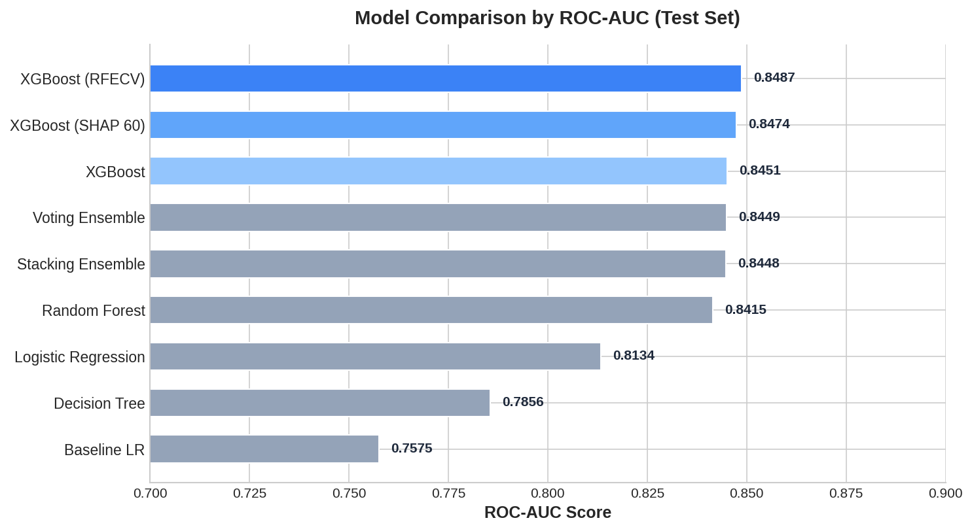
Model Comparison by ROC-AUC

Feature Importance
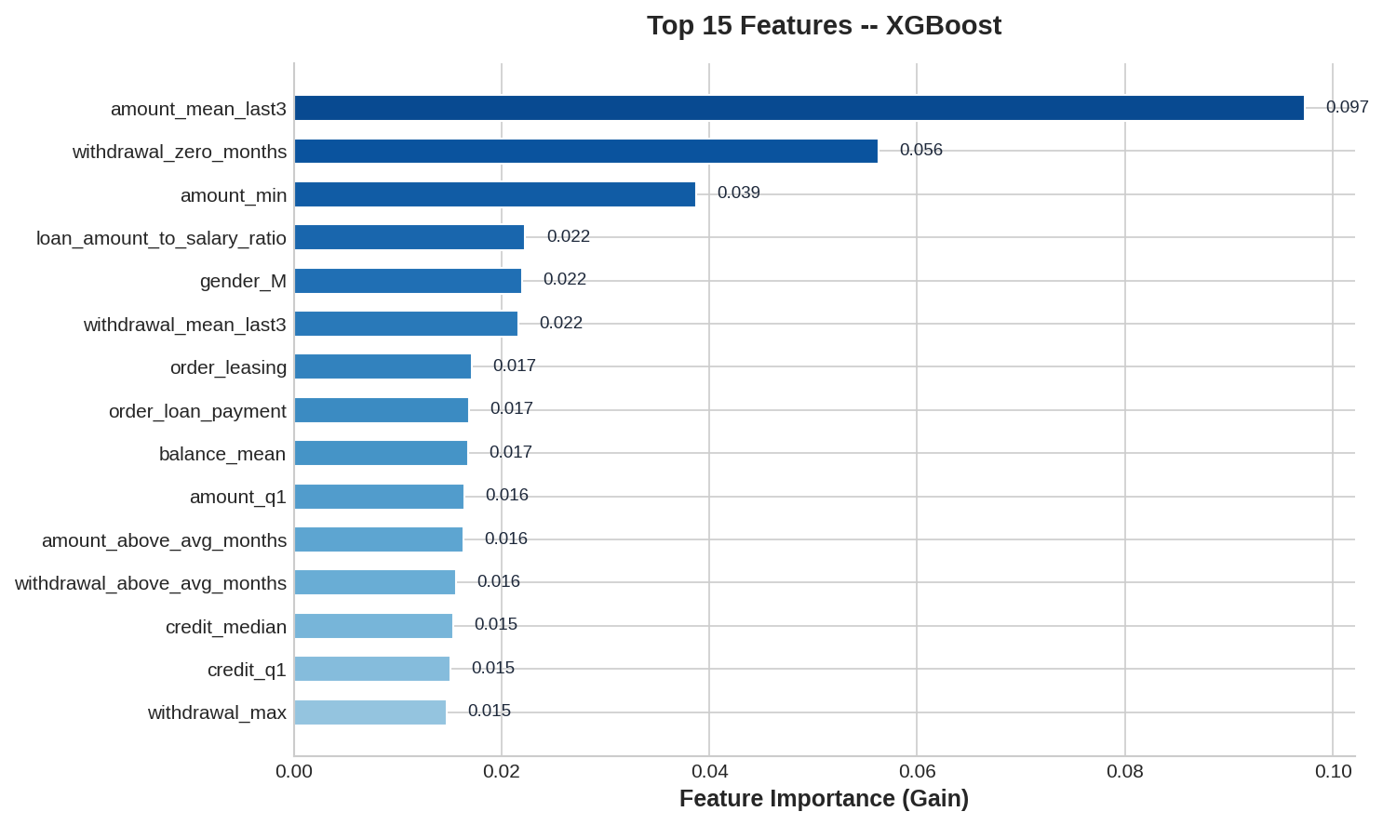
Top 15 Features – XGBoost

Installation
pip install -r requirements.txt
Then open and run MC_main.ipynb sequentially. The notebook covers the full pipeline from data loading through evaluation.

Project Structure
.
├── MC_main.ipynb # Main notebook (end-to-end pipeline)
├── model_runner.py # ModelRunner class: SMOTE pipeline, GridSearchCV, persistence
├── utilities.py # Helper functions: analysis, plotting, model I/O
├── requirements.txt # Python dependencies
├── data/ # Raw CSV tables (Czech Banking Dataset)
├── models/
│ ├── models_all_features/ # Trained models (all features)
│ └── models_reduced_features/ # Trained models (feature-selected)
├── results/ # Serialized evaluation results (.pkl)
└── img/ # Plots and diagrams

Author
Sabina Grüner

