

LDAP Integration with Content Server 5.x
Windows and Solaris Docbases

Version 1.0
September 6, 2003
Support Services

1.0 Introduction 4
1.1 Introduction 4
1.2 Intended Audience 4
2.0 Overview 4
2.1 Platforms 4
2.2 Requirements 5
2.3 Content Servers 5.x on Microsoft and UNIX 5
3.0 How does LDAP User Authentication work? 5
3.1 (Sub-heading) 5
3.2 (Sub-heading) 7
3.3 (Sub-heading) 7
4.0 why is the settings in the LDAP server so important 8
4.1 Setting a person’s set base set base should be changed to search base 8
4.2 (Sub-heading) 8
4.3 (Sub-heading) 8
5.0 What are the required three MAPPED ATTRIBUTES? 8
5.1 (Sub-heading) 8
5.2 (Sub-heading) 9
5.3 (Sub-heading) 9
6.0 Where to start with LDAP 9
6.1 (Sub-heading) 9
6.2 (Sub-heading) 9
7.0 LDAP Tools 10
7.1 (Sub-heading) 10
7.2 (Sub-heading) 10
8.0 Configuring Documentum for LDAP 10
8.1 Setting up environment for LDAP 10
8.2 Knowing the platforms you are running on 13
8.3 Configuring the LDAP Config Object 13
8.4 MAPPED ATTRIBUTES 14
9.0 Example configuration for Active directory LDAP 15
9.1 MAPPED ATTRIBUTES 15
9.2 MAPPED ATTRIBUTES 24
9.3 MAPPED ATTRIBUTES 24
10.0 Troubleshooting 24
10.1 Required information needed 24
10.2 Is this a new installation issue? 25
10.3 At what point do you get the error and what is the exact error message? 25
10.4 Was this working then started to fail? 25
10.5 What can you do if the LDAPSync job is failing? 25
10.6 I have changed my filter and now the LDAPSync job doesn’t import the new users/groups, why will it NOT import again? 28
10.7 How to troubleshoot LDAP configuration object setup issues 29
11.0 Support Notes 29
11.1 SN 17300 - How to add users to groups through the LDAP Sync job? 29
11.2 SN 11709 - How do you specify specific groups to be downloaded from LDAP via the LDAP sync job? 30
11.3 SN 20367 - Specifying a Search Filter when connecting to an LDAP server? 30
11.4 SN 22323 - What are the LDAP Search Filter operator and how to use them? 31
11.5 SN 18968 - Why doesn't standard LDAP Syntax work when entering multiple Group Object Filter names in my LDAP Config Object? 31
11.6 SN 24514 - Why would LDAP user authentication fail with RPC error? 32
11.7 SN 24363 - What files do I need to have ready if I have LDAP issues? 32
11.8 SN 15227 - How do I run the LDAP validation class file from the command line? 33
11.9 SN 24379 - Why does my LDAPSync job fail after upgrading to CS 5.2? 34
12.0 LDAP Resources 35
Summary 35
Appendix 35

Introduction
The purpose of this overview is to assist the docbase administrator in configuring docbase authentication using LDAP. A working knowledge of LDAP is essential in the configuration of Documentum and LDAP server. The LDAP administrator should be present when configuring LDAP on Documentum.

Documentum product does not administer the LDAP server and Documentum Technical Support does not make any recommendations on the configuration of the LDAP server. Please work with consulting for a topology design and implementation plan.

This overview will show how Documentum interacts with an LDAP server and it will cover the basics to the configuration and does not replace the Administration guide.

This guide will explain how Documentum works with LDAP Server. Also suggests tests a docbase administrator can perform for problem isolation and recommended known solutions.

Finally this guide is intended to bring together previous published technical support notes into one organized presentation. Use this guide as an overall understanding of Documentum’s LDAP configuration. It is not meant to replace the Administrator guide. Please read the sections that cover LDAP.
Consulting is available to customize this integration.

Intended Audience

Docbase administrators or developers that are interested in getting a base line review of the LDAP configuration and what steps they can take in getting LDAP to work out of the box unmodified.

This guide is intended to assist docbase administrators in troubleshooting LDAP problems using standard out of the box Documentum provided methods and binaries. There are also tools available from the LDAP servers.

Overview

Platforms

This guide will cover the following platforms and E-Content Server combinations.

- E-Content Servers 5.x installed on Windows and Solaris Operating systems and supported database platforms
- Active Directory
- Netscape / SunOne LDAP server
- Oracle Directory Server

Requirements
This guide assumes that a functioning working TCP/IP connection is possible between the Docbase host and LDAP server. It also assumes the LDAP server has been set up correctly and independent tests can verify that Binding Distinguished Name account can retrieve required results. Testing must be done to ensure the all values to be used in the LDAP config object are correct.

The Content Server environment must be setup correctly, please read the server install guide and release notes. Java must be installed, please read server release notes for the actual supported version. The environment for Java must also be setup correctly.

We currently only support the following LDAP Servers, Microsoft Active Directory, Oracle Directory server and Netscape / SunOne LDAP server. Please read server release notes for any changes.

The Binding Distinguished Name account must have the rights on the LDAP server to view all accounts that are authenticating to the LDAP server from the docbase.

Content Servers 5.x on Microsoft and UNIX
For E-Content Servers 5.1 to 5.2 there are differences in environment settings, please verify the requirements.

Docbase Attributes
There are three attributes that are required for every user in a docbase. They are:

Attribute: user_name - Docbase account, to enable docbase login
Attribute: user_address - Mail account, for email notification
Attribute: user_os_name - Operating system account, for user authentication

How does LDAP User Authentication work?

(Sub-heading)
Documentum’s LDAP configuration has two separate processes, LDAP authentication and Docbase user management, which interfaces with the LDAP server.

Use Documentum Administrator (DA) to configure LDAP configuration object. At a given time, Content Server points to only one LDAP configuration object. Though DA allows the configuration of multiple LDAP configuration objects. The ldap_config_id attribute in the server configuration object will be set to the default LDAP configuration object. So only one LDAP config object maybe used at a time.

The server by default performs the LDAP authentication when LDAP user (user_source attribute is set to “LDAP”) is trying to login to the docbase. The docbase administrator has option to configure user authentication to be performed by the server or external check password program. Technical Support does not support modification and compiling code, Developer Support can assist in configuring the external check password program. You can also decide which mode of authentication can be selected for LDAP user authentication either bind by search mode or the bind by distinguished name (DN) mode. This can be done by setting bind_type to either “bind_search_dn” or bind_by_dn”. The default is “bind_search_dn”. In bind by search mode, user DN is searched and passed to the ldap_simple_bind_s call with the password for authentication. In bind by DN, user DN stored in the dm_user object is used to authenticate the LDAP user.

The required attribute mapped to user_os_name should always have unique values. This is because, when logging in using DCTM client, users supply the user_name to login in to the docbase, but the authentication is done using the user_os_account. Therefore if the bind type is “bind_search_dn”, we will perform query against LDAP server to retrieve the DN using the supplied user_os_name. If there are multiple entries then we will fail the login process as there were multiple DN’s retrieved.

The per_search_filter is not used during the LDAP authentication process. This attribute value is used during the LDAP Synchronization.

Documentum’s LDAP simply imports requested data from the LDAP server. Documentum does not write to the LDAP server.

Anonymous Binding
Technical Support no longer supports anonymous binding. If there is a need for Anonymous Binding please contact Consulting.

Docbase User Management
We use the dm_LDAPSynchronization job for user management. To run the job, the LDAP config object must be setup first, since the settings are used.

Depending on the settings of the LDAP config object the dm_LDAPSynchronization will “import users and groups”, “rename users and groups” and Deactivate Users.

Active Directory supports synchronization operations importing new users and groups into the Docbase, but rename and inactive synchronization operations are not supported.

In order to run the dm_LDAPSynchronization job the follow three attributes must be set in the LDAP config object.

We do not use the ldif file to import users with LDAPSync. This is done with the DFC & LDAP JDK program, which reads from LDAP server and uses DFC API’s to create users, groups.

How does Documentum view LDAP?
To understand how Documentum integrates with LDAP we will use a fictional topology example of a LDAP configuration. Documentum uses the values that are set on the LDAP server. We do not alter them in any way. We only use the returned values to populate the docbase.

LDAP is like an instance of a hierarchical database. That is, unlike a relational database, the main relations in a hierarchical database are parent-child. So, the structure of LDAP information is like an inverted tree. This structure is very familiar to computer users as it is like file systems. However, unlike file systems paths, LDAP strings show from bottom to top.
Example using the chart below:
OU=unix,OU=it,OU=ops,DC=documentum,dc=com

Fictional topology of a LDAP configuration:

COM
|
documentum
|
________________________________________
| | |
eng ops sales
| | |
________________ __________ _______
| | | | | | | | |
qa svr clnt web it hr pay nasales mkt
| |
__________ _____
| | | | |
unix nt network west east

(Sub-heading)

(Sub-heading)

why is the settings in the LDAP server so important
Without them you will not be able to configure LDAP on the docbase. We use these values to config the LDAP config object. We have one LDAP config object and the paths are absolute. Below are some questions and answers that may help clarify.

Setting a person’s set base set base should be changed to search base for all instances
If you set a person’s set base to:
ou=west,ou=nasales,ou=sales,dc=documentum,dc=COM
Only the users in the Sales Department North America West group will be seen. No other group will be able to authenticate.

If you set a person’s set base to:
dc=COM,dc=documentum
Will you be able to authenticate all users? Yes
If you only wanted engineering and operations, excluding sales.
Then you will have to create a filter to exclude them.

Can you have a different search base for groups?
Yes, there are two search base settings Person and Group
Example:
Person Search Base: ou=west,ou=nasales,ou=sales,dc=documentum,dc=COM
Group Search Base: ou=sales,dc=documentum,dc=COM

(Sub-heading)

(Sub-heading)

What are the required three MAPPED ATTRIBUTES?

(Sub-heading)
user_name
user_os_name
user_address

User name is the display name and can be the same as the user operating system name.

We use the values given by the LDAP server for the mapped attribute user_os_name to login account. The user name must meet the required specification for adding a user.

The user name must consist of letters, numbers, dashes (-) and
underscores (_). The first character must be a letter. All characters must be ASCII
characters. The user account can not have commas or spaces. For Unix systems there is an 8-character limitation. The user’s password must consist of letters, numbers, dashes, underscores,
and periods.

Here are some examples:
Bad Examples: bob philipp or philipp,bob
Good Examples: bphilipp or bobp

The user name is also case sensitive.
Documentum Administrators know this, but a System Administrator who does not know Documentum’s requirements usually configures LDAP.
Documentum authentication is case sensitive and LDAP is not. End Users need to be aware of this.

(Sub-heading)

(Sub-heading)

Where to start with LDAP

(Sub-heading)
Verify that the Content Server environment settings are correct for using LDAP.
Need to get a topology of how the LDAP server is configured (LDAP schema).
Need to understand what is configured to ensure it meets your needs.
Technical Support does not work on design, please contact consulting to plan your topology.
We need a user account on the LDAP server that has the capability to view the schema to be used by Documentum.
Test the desired account before trying to configure LDAP on documentum with LDAP Tools.
Test the desired configuration before trying to configure LDAP on documentum with LDAP Tools.

(Sub-heading)

LDAP Tools

(Sub-heading)

Documentum does not offer tools to test your LDAP, these are available from the LDAP vendors.

Both Netscape / SunOne and Oracle LDAP server have a command that can be run to test the LDAP configuration to be used. The command is ldapsearch and comes on the install of the product. It can be used to test person and group search base.

The options we expect to see returned from ldapsearch command:
>ldapsearch –h <ldap host> -b <per_search_base> -D <bind_dn> -w <bind_pwd> "(&(objectclass=<person_obj_class>)(person filter))"

For list of groups in LDAP server
>ldapsearch –h <ldap host> -b <grp_search_base> -D <bind_dn> -w <bind_pwd> "(&(objectclass=<group_obj_class>)(group filter))"

For Active Directory you can load the Active Directory Administration tool ldp.exe.
On the Window 2000 install CDROM \ENGLISH\WIN2000\SERVER\SUPPORT\TOOLS
This is not necessary, but the LDAP settings should be tested prior to configuring LDAP on Documentum.

(Sub-heading)

Configuring Documentum for LDAP
Now that you have tested the environment you plan on using for LDAP using the LDAP tools. The following section will discuss what is needed to proceed.

Setting up environment for LDAP
Where do you get the environment setting?
You will need to read both the Content Server Install Guide and the current Release Notes for the version you are trying to configure. I will give examples below, but since this environment changes please read the manuals.

As shown in the examples below, the classpath has changed regarding the LDAP configuration. For CS 5.2 the classpath is not added to the method verb in Documentum Administrator.
The environment is pulled from the Content Servers CLASSPATH environment variable, it is important to have the correct path in your environment variables. This will be very important when upgrading to Content Server 5.2. Note that in the CS 5.2 classpath environment there is no path shown to the LDAP jar files. Only the path of $DM_HOME/classes for Unix or %DM_HOME%\install\java for Microsoft is necessary. The classpath to the LDAP jar files are now contained in the dctm.jar file.

Here is a an example of a .cshrc for CS 5.1 on Solaris.
setenv DOCUMENTUM /export/akira4/dm51
setenv DM_HOME $DOCUMENTUM/product/5.1
setenv DOCUMENTUM_SHARED $DM_HOME/dfc_share
setenv DFC_DATA $DM_HOME/dfc
setenv JAVA_HOME /usr/j2sdk1_3_1_04
#
setenv LD_LIBRARY_PATH $DM_HOME/bin:$DOCUMENTUM/share/clients/unix/solaris:/usr/lib:$JAVA_HOME/jre/lib/:/usr/lib/security:$DOCUMENTUM_SHARED/dfc:$DM_HOME/verity/_ssol26/bin
#
setenv CLASSPATH .:$DM_HOME/bin:$DOCUMENTUM_SHARED/dctm.jar:$DFC_DATA/dfc.jar:$DM_HOME/dfc:$JAVA_HOME/jre/lib/rt.jar:$JAVA_HOME/bin:$DM_HOME/classes/com/documentum/ldap/ldapjdk.jar:$DM_HOME/classes/com/documentum/ldap/ldapfilt.jar
#
setenv DISPLAY akira:0.0
setenv ORACLE_HOME /export/akira2/oracle92/product/9.2
setenv ORACLE_BASE /export/akira2/oracle92
setenv ORACLE_SID akira92
set path=(/bin /usr/bin /usr/dt/bin /usr/openwin/bin /usr/ucb /etc .)
set path = ($path $DM_HOME/bin )
set path = ($path $DOCUMENTUM/dba )
set path = ($path $ORACLE_HOME/bin )
set path = ($path $JAVA_HOME/bin )
set path = ($path /usr/ccs/bin)
echo "You are now using" `documentum -v`

Here is an example of a .cshrc for CS 5.2 on Solaris
setenv DOCUMENTUM /export/akira4/dm52
setenv DM_HOME $DOCUMENTUM/product/5.2
setenv DOCUMENTUM_SHARED $DM_HOME/dfc_share
setenv DFC_DATA $DM_HOME/dfc
setenv JAVA_HOME /usr/j2sdk1_3_1_04
#
setenv LD_LIBRARY_PATH $DM_HOME/bin:$JAVA_HOME/lib:$JAVA_HOME/jre/lib/:$DOCUMENTUM_SHARED/dfc:$DOCUMENTUM/fulltext/verity271/_ssol26/bin:/usr/lib
#
setenv CLASSPATH .:$DOCUMENTUM_SHARED/dctm.jar:$DM_HOME/bin:$DM_HOME/classes:$DOCUMENTUM/share/dfc/dfc.jar:$DM_HOME/dfc:$JAVA_HOME/jre/lib/rt.jar:$JAVA_HOME/bin:$DOCUMENTUM/product/5.2/dfc_share/config
#
setenv DISPLAY akira:0.0
setenv ORACLE_HOME /export/akira2/oracle92/product/9.2
setenv ORACLE_BASE /export/akira2/oracle92
setenv ORACLE_SID akira92
set path=(/bin /usr/bin /usr/dt/bin /usr/openwin/bin /usr/ucb /etc .)
set path = ($path $DM_HOME/bin )
set path = ($path $DOCUMENTUM/dba )
set path = ($path $ORACLE_HOME/bin )
set path = ($path $JAVA_HOME/bin )
set path = ($path /usr/sbin )
set path = ($path /usr/local/bin )
set path = ($path /usr/ccs/bin)
echo "You are now using" `documentum -v`

Here is an example for Content Server 5.1 on Microsoft, your paths may vary, please check your own environment path. Also please take note that there is a 256 character limitation in the Microsoft classpath.
EXAMPLE OF DM_HOME PATH ON CONTENT SERVER 5.1
System Properties
Environment Variables
System Variables
Variable: DM_HOME
Value: C:\Documentum\product\5.1\

EXAMPLE OF LDAP CLASS PATH FOR CONTENT SERVER
C:\Program Files\Documentum\dctm.jar;C:\Program Files\Documentum\Shared\dfc.jar; %DM_HOME%\bin;%DM_HOME%\install\java\com\documentum\ldap\LDAPSync;%DM_HOME%\install\java\com\documentum\ldap\LDAPValidation

Here is an example for Content Server 5.1 on Microsoft, your paths may vary, please check your own environment path. Also please take note that there is a 256 character limitation in the Microsoft classpath.
EXAMPLE OF DM_HOME PATH ON CONTENT SERVER 5.2
System Properties
Environment Variables
System Variables
Variable: DM_HOME
Value: C:\Documentum\product\5.1\

EXAMPLE OF LDAP CLASS PATH FOR CONTENT SERVER
C:\Program Files\Documentum\dctm.jar;C:\Documentum\config;%DM_HOME%\bin;%DM_HOME%\classes

Knowing the platforms you are running on

The LDAPSync job may be run from command line on the server but is generally run on the Documentum Administrator.

With the capability of our product to run on many platforms, please ensure you note which platforms you are running on.

The CS 5.1 requires that the classpath be set in the method verb of the LDAPSync job.
This is not an issue but the method verb must be set for the path on the content server.
Also the path to dctm.jar must be added.

A typical scenario would be for Documentum Administrator to be loaded on a Windows 2000 system while the Content Server is loaded on a Unix system. If you are running this topology please read the section below.

By default the method verb will look like:
java -classpath
"..\install\java\;..\install\java\com\documentum\ldap\ldapfilt.jar;..\install\java\com\documentum\ldap\ldapjdk.jar" com.documentum.ldap.LDAPSync

The method verb must be changed to use forward slashes and the path to dctm.jar must be added. This is only an example your path to dctm.jar will differ.
java -classpath
"../install/java/;../install/java/com/documentum/ldap/ldapfilt.jar;../install/java/com/documentum/ldap/ldapjdk.jar; /export/akira4/dm51/product/5.1/ dfc_share/dctm.jar" com.documentum.ldap.LDAPSync

For CS 5.2 the classpath is not added to the method verb in Documentum Administrator.
The environment is pulled from the Content Servers CLASSPATH environment variable, it is important to have the correct path in your environment variables. This will be very important when upgrading from Content Server to 5.2.

Configuring the LDAP Config Object
You must use Documentum Administrator to configure the LDAP config object.

See the release notes to find which Documentum Administrator to be used for your Content Server.

GENERAL INFORMATION
Ldap Object Name*: This is the object name (this can be anything)
User Type: dm_user (Can not be changed)
Import: Select choice of import (Users & Groups or Users or Groups)

Note: Rename Users,Rename Groups and Deactivate Users options is not supported for Active Directory Configurations

Rename Users: If checked will rename users changed in LDAP
Rename Groups: If checked will rename groups changed in LDAP
Deactivate Users: If checked user removed in LDAP will be deactivated.Currently the job doesn’t deactivate users which are deactivated in LDAP.

SERVER INFORMATION
Directory Type: Select the LDAP server you are using.
Netscape/Iplanet Directory Server Microsoft Active Directory Oracle Internet Directory Server
Bind Type: Bind by Searching for Distinguished Name or Bind by Saved Distinguished Name
Binding Distinguished Name*: The Bind user to access the LDAP Server. Use full path.
Binding Password*: Password for the DN user
Use External Password Checking: Only check this option, if you have modified the password-checking program. Modification of the source code is not support by Technical Support. Please contact Developer Support or Consulting for assistance.
Host Name*: LDAP host Name
Port*: LDAP port number.
Person Search Base*: To be determined by customer, see below for more information
Person Object Class*: To be determined by customer, see below for more information
Person Search Filter*: To be determined by customer, see below for more information
Group Search Base*: To be determined by customer, see below for more information
Group Object Class*: To be determined by customer, see below for more information
Group Search Filter: To be determined by customer, see below for more information

The LDAP Administrator and the Docbase Administrator must determine search base for Group and Person. Documentum has a consulting group that will work with you on the your topology, Technical Support does not make recommendations.

The LDAP Administrator must supply the Object Class that is being used.

For the filter values, LDAP command, user, group or filter may be used.
The LDAP Administrator and the Docbase Administrator must determine the value needed.

MAPPED ATTRIBUTES
user_name: Display Name, used by Documentum
user_os_name: Login Name, used to authenticate.
user_address: email address

Please test with just the three attributes listed above.

When testing is done, add only one new attribute at a time, then test.

You may use a fixed constant or an attribute set from the LDAP server.

Below is an example of setting a default folder from imported users using a constant.
In my example I want to add all users to an existing cabinet called Customers.

Select Add Row
Change the DM_attribute for the row to default_folder
Leave the LDAP attribute set to NULL
Type in the LDAP Constant value, Customers

When new users are imported with the LDAPSync job they will have a default folder of Customers.

Example configuration for Active directory LDAP

MAPPED ATTRIBUTES
Step 1 Planning
Determining requirements
What is expected and what is needed?
Will LDAP implementation meet my requirements?

For my example I will be setting up a small group of users to use LDAP, while the bulk of my users are using local authentication. There will be little growth within the group and no other department will be using LDAP. The need is for single sign on authentication and the ability to import users through LDAP. Users will not be able to change passwords from Documentum. The group is technical support server team. I will work with LDAP Administrator to ensure that the LDAP server would be able to meet my requirements.

Step 2 Testing LDAP Server configurations
Testing the LDAP settings prior to configuring Documentum for LDAP
Configuring LDAP and testing settings

Documentum does not set any environments on the LDAP server, but uses what is configured on the LDAP server. It is essential to work with the LDAP Administrator. Working with the LDAP Administrator a group was created for my group. A user was also created with admin rights to use as the Distinguished Name BIND User. This was not necessary, only a user with full read was needed.

This is for the path to the Distinguish Name Bind User “bobp” shown using Microsoft Active Directory Users and Computers.

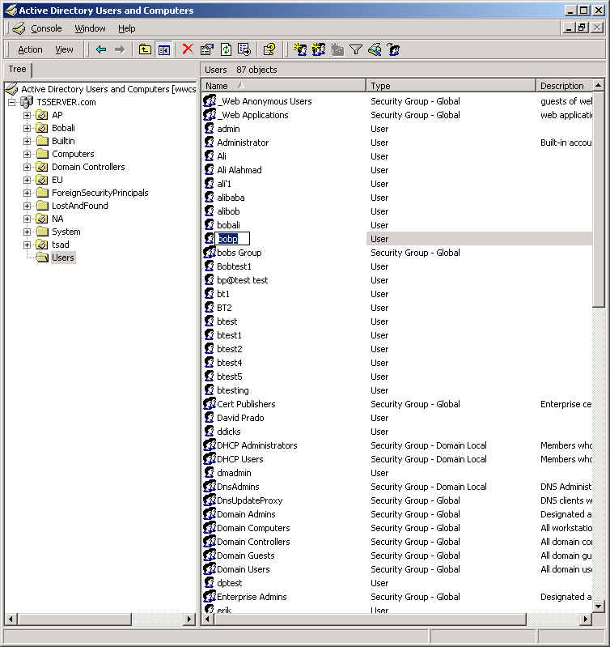

Here is a view using Microsoft’s Active Directory Administration Tool.
Please note that Documentum does not supply this tool, the tool is on Microsoft’s Windows 2000 Support Tools. It is not necessary, but is very useful. The user path used by LDAP is shown.
It is CN=bobp,CN=Users,DC=TSSERVER,DC=com

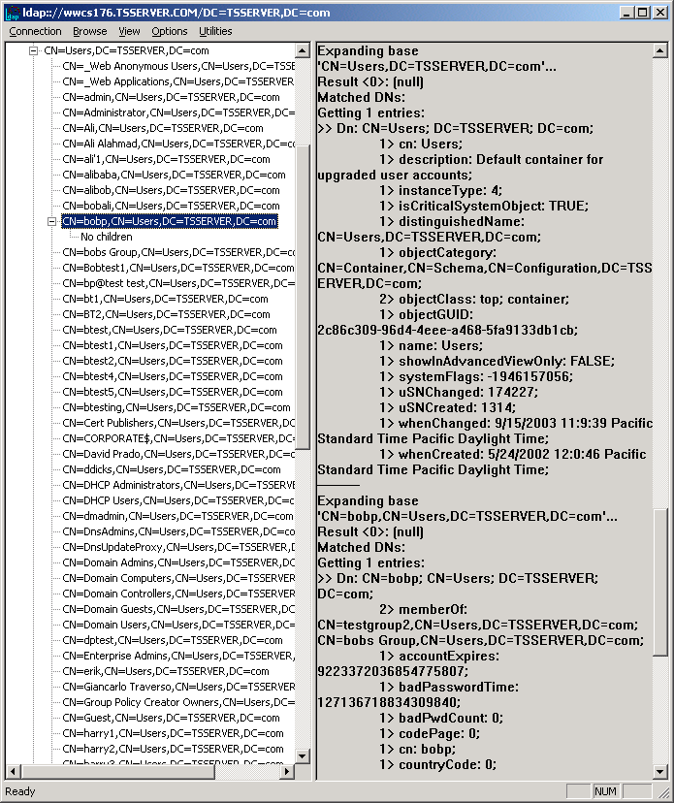

This is for the path to the server group, which contains the required users to be brought over to the docbase shown using Microsoft Active Directory Users and Computers.
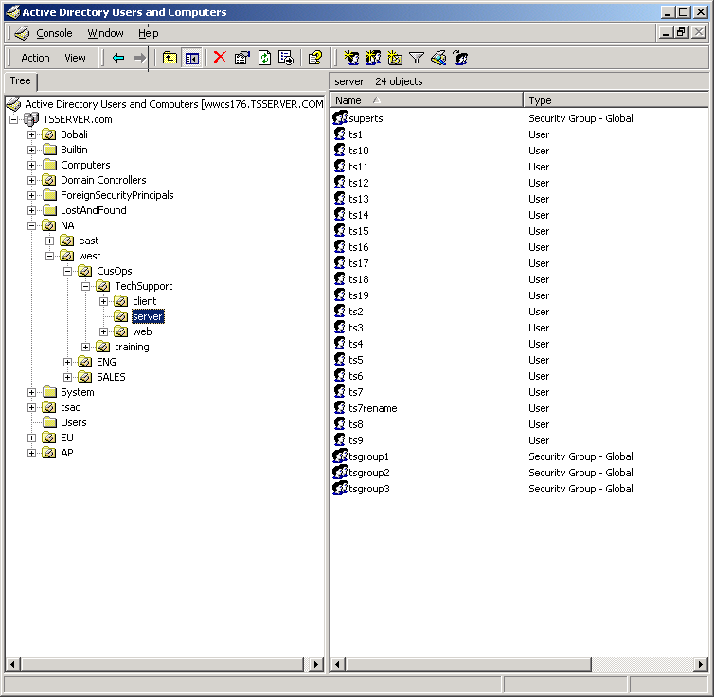

To test that the configuration that is to be used, use Microsoft’s Active Directory Administration Tool to test. Connect to the correct Host and Port, Bind using the Distinguish Name Bind User. Ensure that you can view the properties for the users in the group, browse using the tree for users.

From top pull down menu "Connection", select Connect

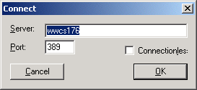
From top pull down menu "Connection", select bind

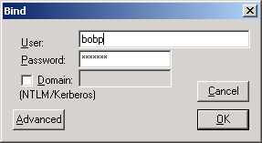

From top pull down menu "View", select view tree.

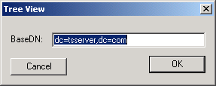

From the tree view, open some users and make sure you have access rights.
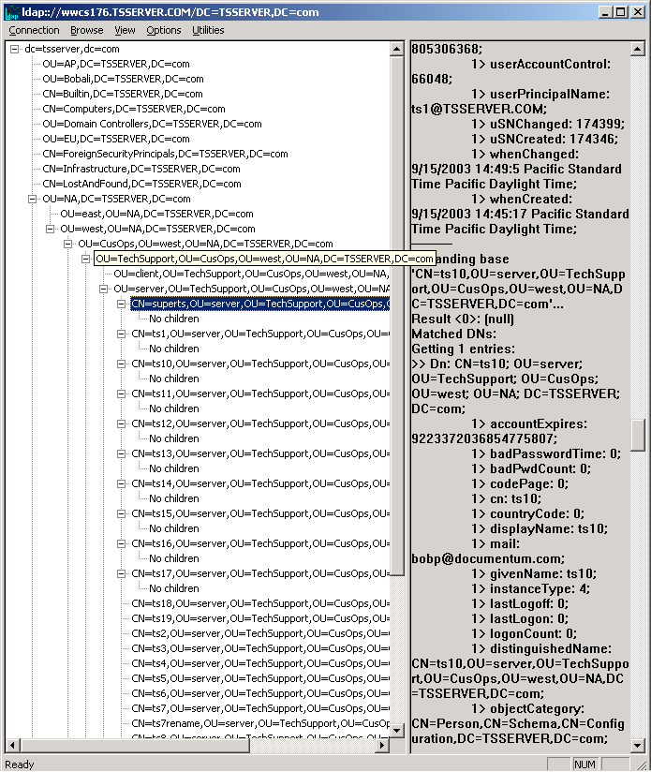

Step 3 Configuring LDAP Config Object

Use Documentum Administrator to configure the LDAP Config Object

Example using DA 5.2.2, the information used should be the same regardless of the DA version.

Log on to DA as installation owner and selected docbase.

From Administration Screen -> User Management
Select “Create a new LDAP configuration object”
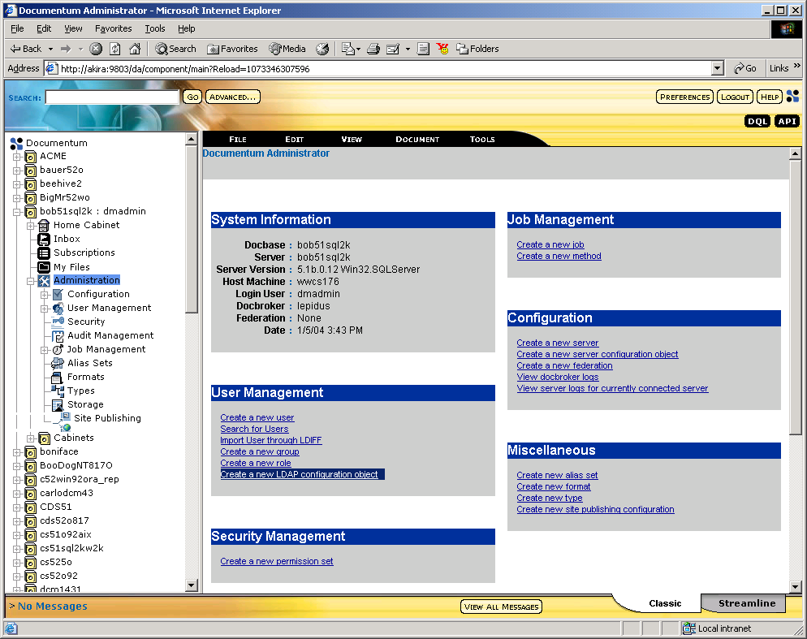

Enter Name for LDAP Config Object
Used AD_LDAP_CONFIG for example
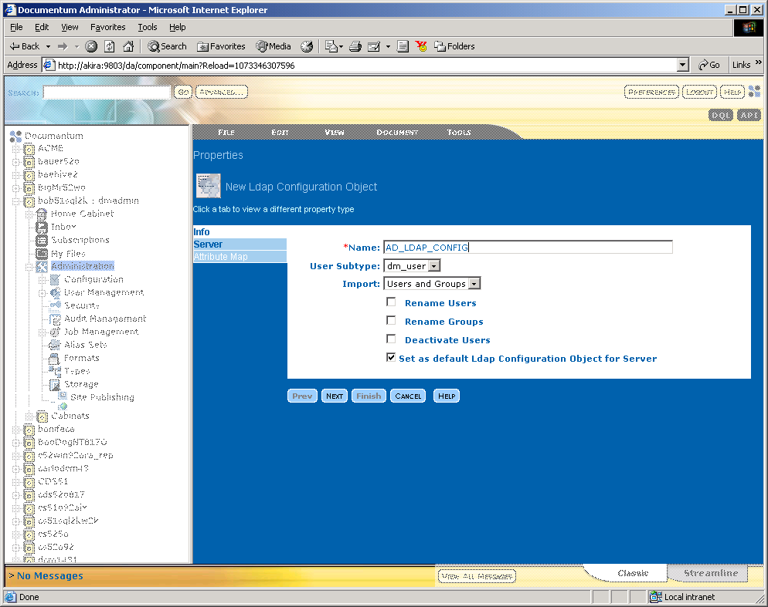

Select Server tab
Using values given by LDAP Administrator that were tested.

Directory Type: Microsoft Active Directory
Bind Type: Bind by Searching for Distinguished Name
Binding Name: CN=bobp,CN=Users,DC=TSSERVER,DC=com
Binding Password: “Enter Password for this user”
Use External Password Checking “This is checked only if you have compiled the dm_check_passwd for LDAP, Technical Support does not assist in compiling code, Developer Support can assist.”
Host Name: wwcs176 “this is the hostname of the LDAP server, IP may be used”
Port: 389 “LDAP port set on LDAP server, default is 389”
Person Object Class: User “Default set for AD”
Person Search Base: OU=server,OU=TechSupport,OU=CusOps,OU=west,OU=NA,DC=TSSERVER,DC=com
Person Search Filter: CN=* “Used the Common Name with wildcard”
Group Object Class: group “default for AD is group”
Group Search Base: OU=server,OU=TechSupport,OU=CusOps,OU=west,OU=NA,DC=TSSERVER,DC=com
Group Search Filter: CN=*

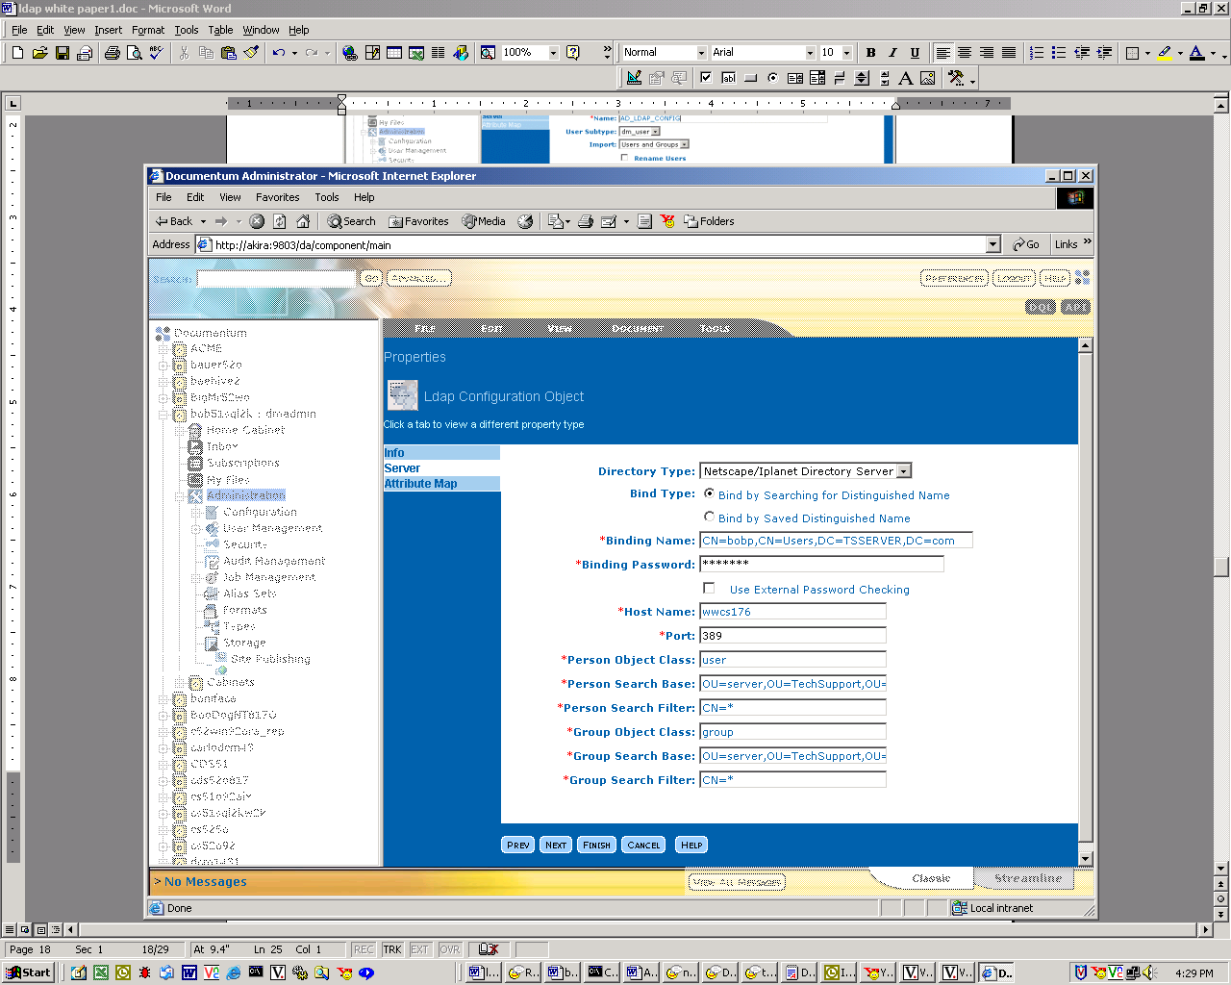

Select Attribute Map Tab or Next button

The user_os_name must be changed, there is no UID attribute in AD by default.

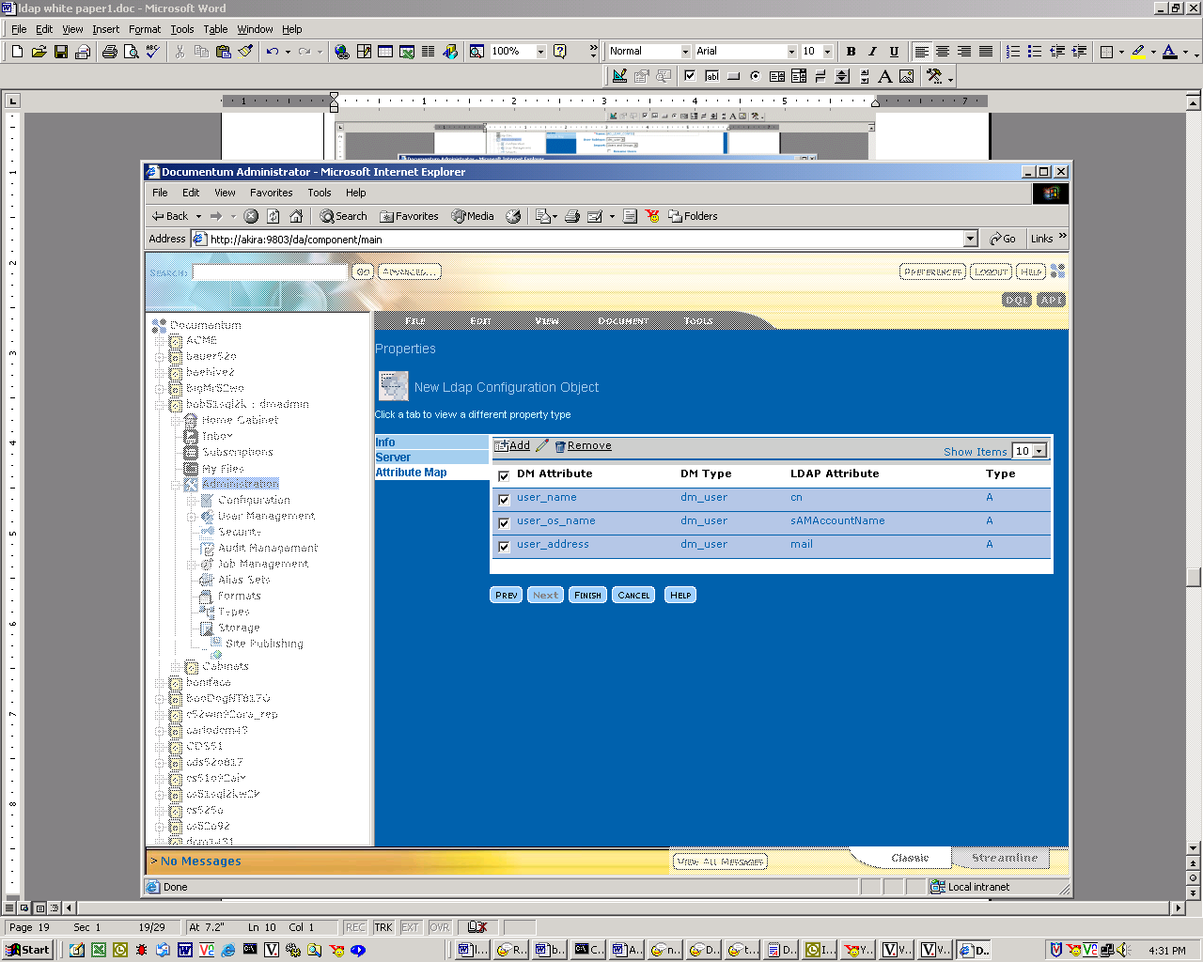

Select the Finished button to save the LDAP Configuration Object.

MAPPED ATTRIBUTES

MAPPED ATTRIBUTES

Troubleshooting

Required information needed
Technical Support will need the following information to troubleshoot.
A dump of the LDAP config object:
API> retrieve,c,dm_ldap_config
API> dump,c,l

A dump of the LDAPSync method:
API> retrieve,c,dm_method where object_name = 'LDAPSync'
API> dump,c,l

For authentication problems-
Start the docbase with the –otrace_authentication
Try with both the settings in bind_type i.e.bind_search_dn and bind_by_dn
Send the docbase log.

If it is an issue with the LDAPSync job will need the to send the reports.
Send the job report
In the job report it will point to two files, send them as well.
DFC Trace File: \Your path\trace_ldapsync_dfc.txt
DMCL Trace File: \Your path\trace_ldapsync_dmcl.txt

Get the Java version
Get the DFC version

If the customer has any ldapsearch/ldp output based on the setting’s of the LDAP configuration object.

Is this a new installation issue?
Use the LDAP tools to verify the values to be used in LDAP config object return the proper values. If the correct values are not returned, work with the LDAP Administrator to resolve this issue.

At what point do you get the error and what is the exact error message?
To isolate the problem, identify whether, it is an authentication problem or an issue with the LDAPSync method.

To test an authentication issue, use the LDAP tools.

If you are configuring for the first time ensure you are using bind by saved and then try the bind by search, it may a permission issue.

Was this working then started to fail?
Find out what was changed and use the LDAP tools to test.

What can you do if the LDAPSync job is failing?
There are several issues that can cause the LDAPSync job to fail.
Permission issues, Environment issues and time stamp issue. Java version
Permission Issues:
Run the LDAP tools to verify the configuration, if the bind Distinguished Name user is able to retrieve the correct results, the permissions on the LDAP server are good.
Ensure you are using bind by saved, you can eliminate the second bind done using bind by searching.

Environment issues:
Verify your environment is correct according to your path, the Server Install Guide and Product Release Notes.

Would recommend adding users with just theses mapped attributes to start.
If you added more mapped attributes and it fails it will be harder to troubleshoot.

A critical point:
When the LDAPSync method is run in CS 5.1 and earlier, it uses the classpath set in the method verb. It does NOT use the classpath set in the environment. When you specify the usage of classpath in method verb or command line, the classpath from the environment will not be used.
CS 5.1 has the classpath set in the method verb and CS 5.2 does not.

LDAPSync method:
To test LDAPSync from command line:
Log on as install owner
Open a command prompt
cd %DM_HOME%\bin

Test your JAVA version
java –version
The results should be Sun Java 1.3 or higher.

When you define the classpath in the java command, you need to ensure that the path to dctm.jar is specified within the classpath.

Run the LDAPSync from command line
Fill in your own values for the options and ensure your classpath is correct.
Here is the example:
java -classpath
"..\install\java\;..\install\java\com\documentum\ldap\ldapfilt.jar;..\install\java\com\documentum\ldap\ldapjdk.jar;c:\Program Files\Documentum\dctm.jar" com.documentum.ldap.LDAPSync –bDocbaseName –uDocbaseAdminUser –pPassword –t10 –nfalse

For 5.2 you don’t need to provide the classpath
java com.documentum.ldap.LDAPSync –bDocbaseName –uDocbaseAdminUser –pPassword –t10 –nfalse

If it does not add users and seems to hang, then we most likely have issues with the values being returned. Check again to see if anything has changed and the ldapsearch still works.

If it adds users from the command line, then you may edit the LDAPSync method.

Please leave out the options, see below:
java -classpath
"..\install\java\;..\install\java\com\documentum\ldap\ldapfilt.jar;..\install\java\com\documentum\ldap\ldapjdk.jar;c:\Program Files\Documentum\dctm.jar" com.documentum.ldap.LDAPSync

From IAPI
iapi32
log into to docbase

API> retrieve,c,dm_method where object_name = 'LDAPSync'
...
1000000180000256
API> dump,c,l

Check the method_verb
If it matches the entry you used on command line then exit API
If it does not:
API> get,c,l,method_verb
...
java com.documentum.ldap.LDAPSync
API> set,c,l,method_verb
SET> java -classpath
"..\install\java\;..\install\java\com\documentum\ldap\ldapfilt.jar;..\install\java\com\documentum\ldap\ldapjdk.jar;c:\Program Files\Documentum\dctm.jar" com.documentum.ldap.LDAPSync
...
OK
API> save,c,l
...

Run the LDAPSync job from Documentum Administrator.

Sometimes it may be necessary to run the Java class files in standalone mode, meaning from the Operating System command line. There are two Java classes, both of which are installed in:
$DOCUMENTUM/share/clients/classes/com/documentum/ldap
LDAPValidation.class is the validation check, which is launched when the LDAP configuration object is created or updated. LDAPSync.class is the synchronization process, executed by the job dm_LDAPSynchronization.
Here is how to run these files in standalone mode:

Solaris (this may vary from one UNIX Operating System to another):
java com.documentum.ldap.LDAPSync –b<docbase> –u<user> -t<trace level> –nfalse
java com.documentum.ldap.LDAPValidation –h<host> -p<port> -o<person obj > -g<group obj >

NT:
jview com.documentum.ldap.LDAPSync –b<docbase> –u<user> -t4 –nfalse
jview com.documentum.ldap.LDAPValidation –h<host> -p<port> -o<person obj > -g<group obj >

For LDAPValidation there are other non-required arguments:

-d | the distinguished name used to bind to the server
-w | the password for the distinguished name
-s | the search base for the person object class
-b | the search base for the group object class
-f | the search filter for the person object class
-c | the search filter for the group object class
-a | Attributes

Make sure the LDAP Directory Server is running. This is required to be started when the LDAP configuration object is validated and when the dm_LDAPSynchronization job is executed.
With the Java class files, there are three potential areas that could cause problems. The CLASSPATH environment variable may not contain $DOCUMENTUM/share/clients/classes. The JAR files need to be explicitly in the CLASSPATH, as they are treated like directories. Likewise with the LDAP JAR files where the RightSite Server is installed.
If an error like the one below occurs, then it probably is an indication of the CLASSPATH environment variable not being set properly, or the LDAP Java files are not where there suppose to be.
Example errors:
Exception in thread "main" java.lang.NoClassDefFoundError: LDAPValidation
If the error below occurs, then it probably means the LDAP JAR files are not in the CLASSPATH or are not where there are suppose to be, based on the CLASSPATH definition:
Exception in thread "main" java.lang.NoClassDefFoundError: netscape/ldap/LDAPException

I have changed my filter and now the LDAPSync job doesn’t import the new users/groups, why will it NOT import again?

LDAPSync job will import all the users and groups based on the LDAP config object parameters in its first run and then in the subsequent runs will use the timestamp stored in a_last_run attribute in the LDAP configuration object. In subsequent runs this timestamp will determine any new users/groups added or modified to be imported into the docbase.
If the filter or the base’s are changed then the set of users/groups which the LDAP configuration was initally looking at has changed therefore the job needs to perform full synchronization.
One way to perform this is to use iapi and fetch the LDAP config object and set “a_last_run” to null. Like this

retrieve,c,dm_ldap_config where object_name = ‘myldap’
set,c,l,a_last_run
<hit enter>
save,c,l

Or you can use DA and set get_empty_dates to “TRUE” in the dm_LDAPSynchronization job (By default this is set to “FALSE”). This will trigger full synchronization. This setting is useful in debugging scenario when customers have not finalized their configuration. The customers can revert back to “FALSE” once they have determined the final LDAP configuration.

How does the a_last_run effect the LDAPSync job

If for any reason the a_last_run attribute in the LDAP config object has a date timestamp greater than the modify time stamp or create time stamp in the LDAP server the LDAPSync job will not update the object.
This can be resolve by changing the time stamp on the LDAP server or resetting the a_last_run to null as shown above.

How to troubleshoot LDAP configuration object setup issues
Documentum Administrator uses a java class (GetAttrs) to make a connection to the LDAP server and get all the attributes available to map to the Documentum Server.

This class exists also on the Documentum Server in the following directory

$DM_HOME/classes/com/documentum/ldap

The following is how to use the class file

java com.documentum.ldap.GetAttrs -h<host> -p<port> -o<personObjectClass> -d<bindDN> -w<bindPassword> -g<groupObjectClass> -s<personSearchBase> -b<groupSearchBase> -f<personSearchFilter> -c<groupSearchFilter>".

This will provide a html based output that you can use to debug.

Support Notes

SN 17300 - How to add users to groups through the LDAP Sync job?

The LDAP synchronization job allows you to create users and groups in the docbase. However, if you want to run the LDAP Synchronization job and want to add users to existing groups in the docbase follow the next steps:

- Create a new class in the LDAP server. This class must be a subclass of the inetorgperson, or the class used in the LDAP_config object.
-Add a new attribute to these class (you can use any name for this attribute)
-On the LDAP server, associate the user to the new class and in the new attribute, enter the name of the group in the docbase
- Modify the LDAP_config object in the docbase and in the attribute mapping section, map the default group to the attribute you created above
-Run the LDAPSync job

SN 11709 - How do you specify specific groups to be downloaded from LDAP via the LDAP sync job?

In the ldap config object set the following:
grp_search_filter=|(cn=group1)(cn=group2)(cn=group3)
The | sign represents an OR statement.

SN 20367 - Specifying a Search Filter when connecting to an LDAP server?

eRoom allows for an optional search filter when creating the LDAP connection. A search filter implicitly (or "behind-the-scenes") narrows further any searches in the LDAP directory.
For example:
You may want to specify a search filter to only search users with a valid email address.
(mail=*)
Or only pull valid User Accounts from the Active Directory:
(samaccountname=*)
An understanding of standard LDAP operators and boolean operators is necessary to create some basic search filters.

The following LDAP standard operators can be used to form advanced search filters:

LDAP Search Operators
Formatting: <attribute> <filtertype> <value>
= This filtertype returns entries whose attribute is equal to the value.
cn=John Smith Finds the entry with common name John Smith
>= Returns entries whose attribute is greater than or equal to the value.
sn>=smith Finds all entries from smith to z*
<= Returns entries whose attribute is less than or equal to the value.
sn<=smith Finds all entries from a* to smith
=* Returns entries that have a value set for that attribute.
sn=* Finds all entries that have a value set for the sn attribute
~= Returns entries whose attribute value approximately matches the specified value.
sn~=smit Might find the entry sn=smith

Boolean operators can also be nested within the LDAP filter.
or = |
not = !
and = &

Boolean example:
OR example
This filter matches any entry that has a surname (lastname) value OR has an email address set in the LDAP directory:
(|(sn=*)(mail=*))
AND with OR example
This filter matches the previous filter AND includes the organizational unit attribute of North America:
(&(ou=NA)(|(sn=*)(mail=*)))

SN 22323 - What are the LDAP Search Filter operator and how to use them?

A search filter is an expression, in parentheses, which is used to select a subset of entries to be returned.
Here are some examples of search filters,( these can be used as examples when configuring the LDAP Configuration object from the Administrator ) :
(sn=smith) equality
(sn=*smi*th*) substring
(sn~=jones) approximate match (soundalike)
(sn<=smith) less than or equal/greater than or equal
(!(age<=21)) There are only LE/GE operators, so (age>21) is not a valid filter
(telephonenumber=*) presence
(!(sn=smith)) negation
(&(sn=smith)(l=London)) AND combination
(|(sn=smith)(sn=jones)) OR combination

SN 18968 - Why doesn't standard LDAP Syntax work when entering multiple Group Object Filter names in my LDAP Config Object?

This is because the docbase build the syntax on the backend when the job connects to the LDAP server and performs a search.
If you need to have multiple Group Object Filters use a comma separater between the entries in your LDAP config object.
A feature request has been logged with Technical Publications to document syntax requirements. The FR request number is 56270.

SN 24514 - Why would LDAP user authentication fail with RPC error?
The RPC error can occur when the bind type is set to Bind by Saved Distinguished Name and the Binding Distinguished Name user does not have permissions to access parts of the path.
Here is a fictional example of the issue:
Example setting in LDAP config object
Bind Type:
Bind by Saved Distinguished Name
Binding Distinguished Name:
cn=bobp,ou=server,ou=TechSupport,dc=tsserver,dc=com

Person Search Base:
ou=TechSupport,ou=dc=tsserver

Chart Diagram:
com
|
tsserver
|
TechSupport
______|______
| |
server client

If the read access to server organization unit, but not client organization unit you will receive the RPC error.
Example of error:
[DM_SESSION_E_RPC_ERROR]error: "RPC error 116 occurred: (116) Error performing send/receive. errno: 0, message: Error 0"
Work Around:
Give access to bind user for all paths below Person Search Base.
or
Do not use Bind by Saved Distinguished Name
Change it to Bind by Searching for Distinguished Name

SN 24363 - What files do I need to have ready if I have LDAP issues?
If you are having issues with LDAP authentication.
Get the LDAP config object:
API> retrieve,c,dm_ldap_config
API> dump,c,l
Turn on authentication tracing and get the Docbase log.
Unix, start the docbase with tracing.
Example:
dm_start_docbasename -otrace_authentication

Microsoft, edit the Service to add tracing

Start->Programs->Documentum->Documentum Server Manager
Select Edit Service
In the command field, add -otrace_authentication after docbase name and before -security
Example for docbase with name 51docbase:
-docbase 51docbase -otrace_authentication -security

From the command line on Content Server system.
Connect using API with the user in question.

Send the docbase logs.
Get the environment setting:
Microsoft:
From command prompt type, set
Unix:
Type env
Send the results.

If you have issues with the LDAPSync:
Get all information listed above from LDAP authentication issues.
Make sure that you have tested outside documentum using LDAP tools.

Get the LDAPSync method:
API> retrieve,c,dm_method where object_name = 'LDAPSync'
API> dump,c,l

Get the LDAPSyncronization log
Get the trace for LDAP dmcl
Get the trace for LDAP dfc

SN 15227 - How do I run the LDAP validation class file from the command line?

To validate if the Ldap configuration object is created correctly, you can run the LDAPValidation.class directly from the command prompt with the following flags:

-h hostname
-p portid
-o person object
-s person search base
-b group search base
-a attrribute

For example:

moth% java com.documentum.ldap.LDAPValidation -hmoth -p389 -oinetOrgPerson -so=documentum.com -bo=documentum.com -auid

The correct result should like this:

java.lang.NoClassDefFoundError
<DMW_DECLARE NAME="LDAP_ERR" VALUE="">
<DMW_SET NAME="LDAP_ERR" VALUE="000000000">
<DMW_DECLARE NAME="LDAP_ERR_STRING" VALUE="">
<DMW_SET NAME="LDAP_ERR_STRING" VALUE="">
<DMW_DECLARE NAME="LDAP_ENCRYPT_PW" VALUE="">

SN 24379 - Why does my LDAPSync job fail after upgrading to CS 5.2?

Environments have changed in Content Server 5.2
Please read the Content Server Installation Guide and the Product Release Notes for the absolute values.

If you are doing an upgrade on Microsoft, the new entries will be appended to the end of the Environment Variable. It will not remove the old entries.

This is very important because there is a 256-character limitation, also the old environment will be listed first. So the new environment will not show.

Here is an example of 5.2 ClassPath:
C:\Program Files\Documentum\dctm.jar;
C:\Documentum\product\5.2\install\java;
C:\Documentum\config;
C:\Program Files\Documentum\dfc\dfc.jar;
C:\Documentum\_jvm\bin;
C:\Documentum\_jvm\lib\rt.jar

If you compare this classpath to pre 5.2 classpath you can see that the path to the ldapfilt.jar and ldapjdk.jar are no longer listed. Only the path to %DM_HOME%\install\java is needed.

For Unix please read the Content Server Installation Guide and the Product Release Notes for the Environment Variable settings.

The other issue is that the LDAPSync method verb no longer needs to the classpath variable set.

It should now look like:
java com.documentum.ldap.LDAPSync

It will pull the environment settings from the server environment variables.

LDAP Resources
Windows IT Library: http://www.windowsitlibrary.com/Content/596/toc.html
http://www.faqs.org/rfcs/rfc1960.html
http://www.ietf.org/rfc/rfc2254.txt
http://www.umich.edu/~dirsvcs/ldap/
http://www.microsoft.com/technet/treeview/default.asp?url=/technet/tcevents/itevents/network/tnq40004.asp
http://www.novell.com
http://www.iplanet.com
http://www.labmice.net/ActiveDirectory/AD_troubleshooting.htm
http://support.microsoft.com/?kbid=218185

Summary

Appendix

Documentum  A Division of EMC  6801 Koll Center Parkway  Pleasanton, CA 94566-7047  phone (925) 600-6800  fax (925) 600-6850  www.documentum.com | © 2002 Documentum, Inc. All rights reserved. Documentum, and the corporate logo are trademarks or registered trademarks of Documentum, Inc. in the United States and throughout the world. All other company and product names are used for identification purposes only and may be trademarks of their respective owners. Documentum cannot guarantee completion of any future products or product features mentioned in this document, and no reliance should be placed on their availability. Printed in the U.S.A.

