Overview
This document describes the steps to install webtop D6 on Websphere 6.1.0.1.

Preparing webtop.war file

- Download the latest webtop.war file from \\plefilesvr\Builds\_SystemBuilds_D6\
- unjar the webtop.war file in temp folder and update the dfc.properties with appropriate values.
- Jar the webtop.war file again.

Installing webtop.war file

- Start the IBM Websphere server.
- Login to administrative console.
http://localhost:port/admin
- Click on Applications → Install new application
- Now you should see the following screen

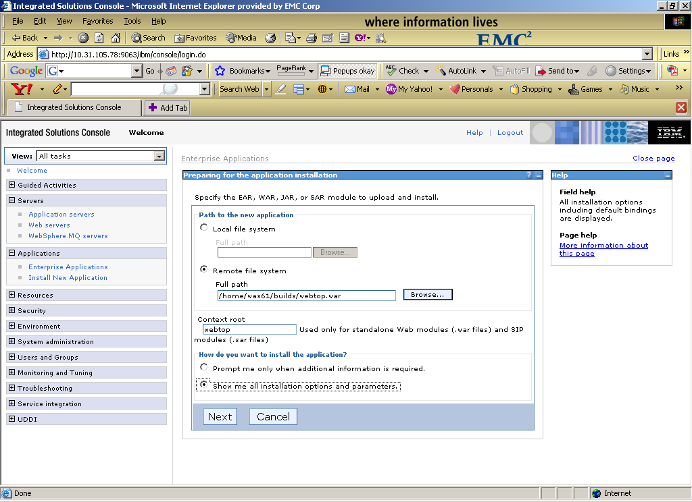

In this screen, enter the following information
- Path to the new application: Select the path from where you want to install webtop.war file.
- Context root: Context root of the web application, preferred value is webtop
- Select the radio button “show me all installation options and parameters” under the heading how do you want to install the application.
- Click on Next button

Now you should see the following screen and click next in this screen

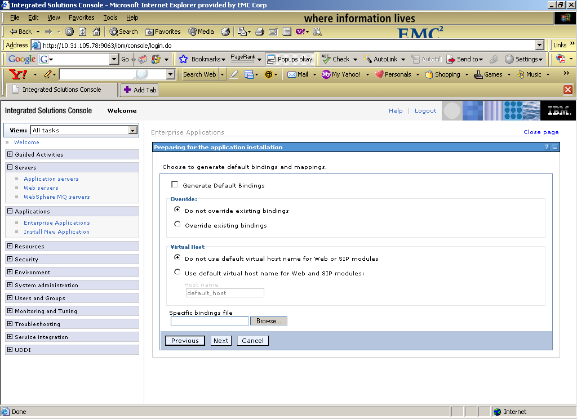

Click continue in the following screen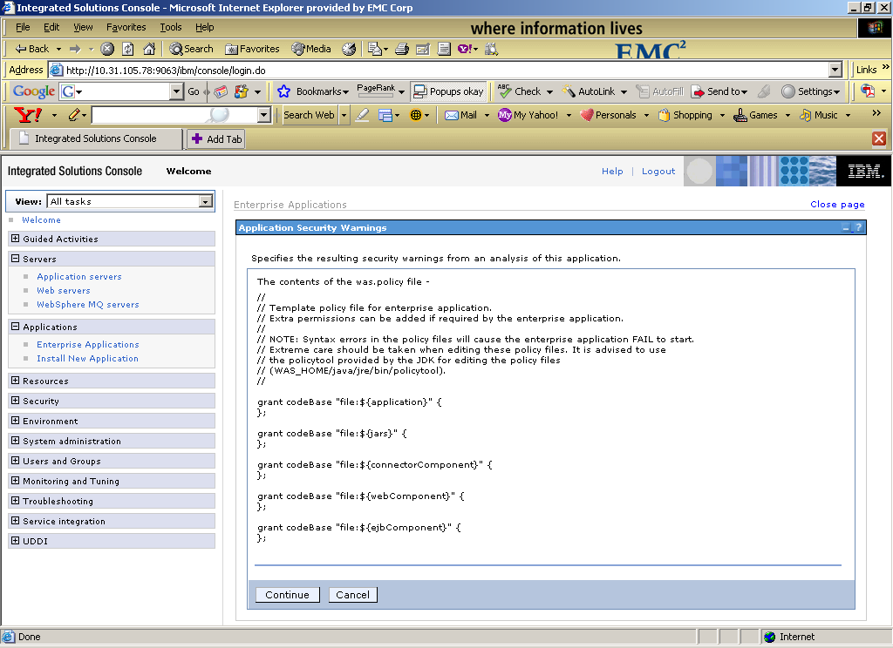

In the following screen Enable the check box “Precompile java server Pages files” in the above screen Specify the Application name as webtop and click next 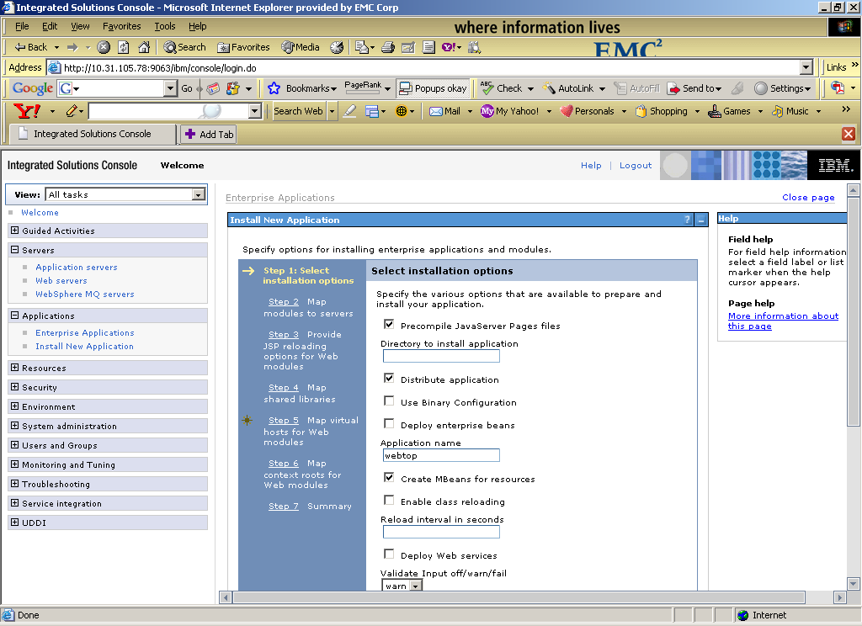

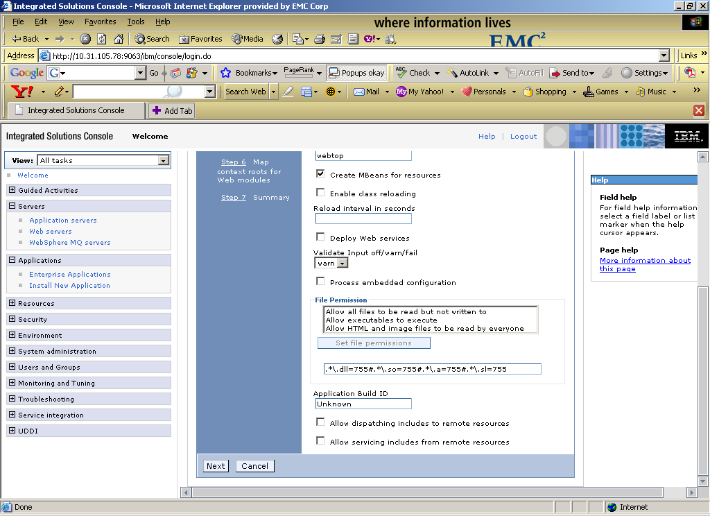

In the following screen select the check box webtop.war and click next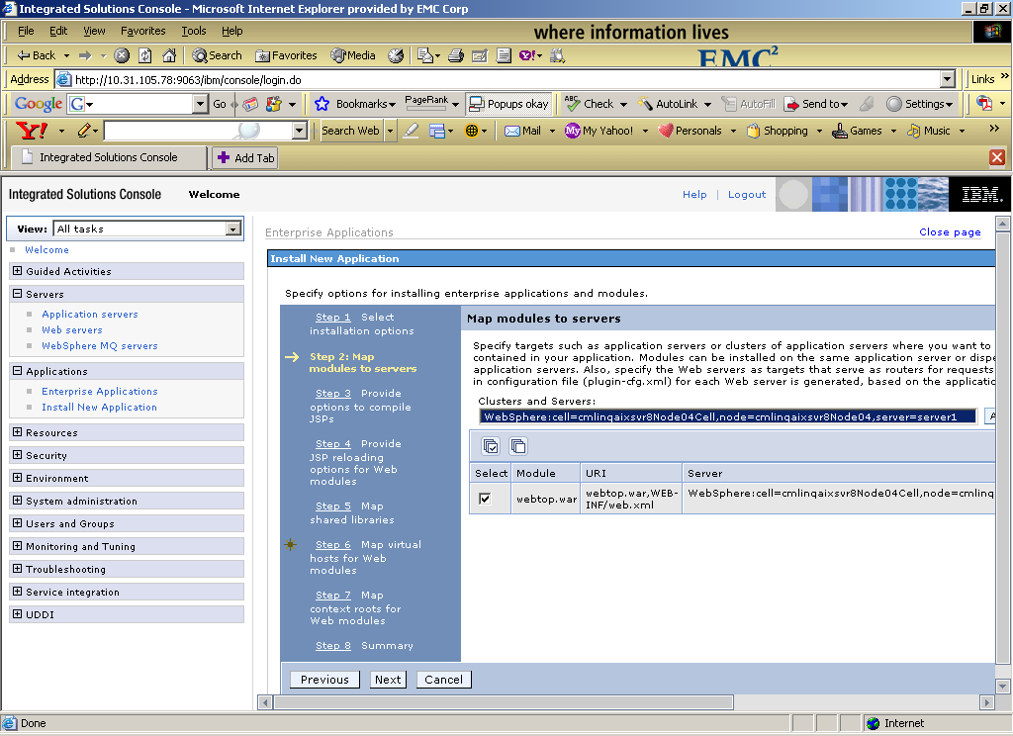

In this screen select the check box and specify the JDK source Level text box “15” and click next
Reason:

The JSP is being compiled using source 1.3 (java version), as recently there was a change in menubar_body.jsp, it require the source to be set on 1.5.

This option can be set while installing the webtop. Please find the below link to get more info on setting this option in websphere.

http://publib.boulder.ibm.com/infocenter/wasinfo/v6r1/index.jsp?topic=/com.ibm.websphere.zseries.doc/info/zseries/ae/trun_app_instwiz.html

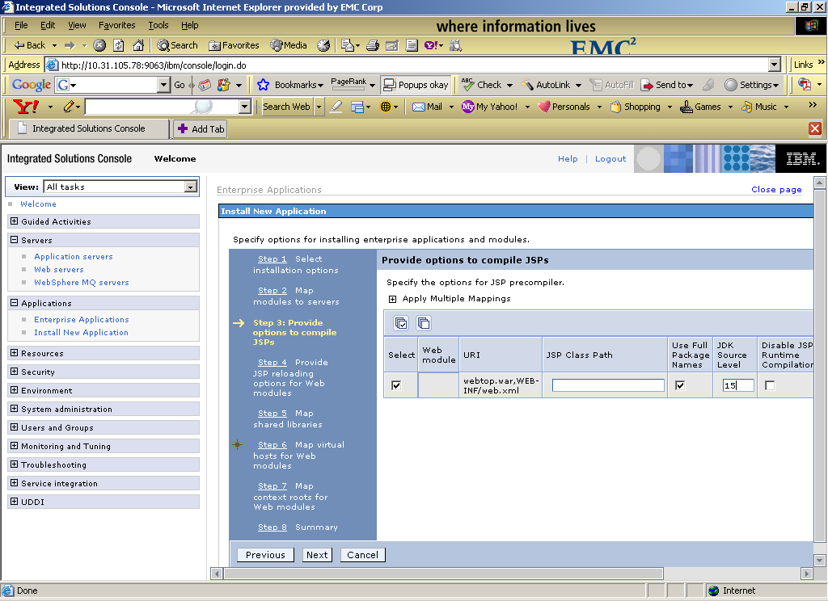
In the following screen click next
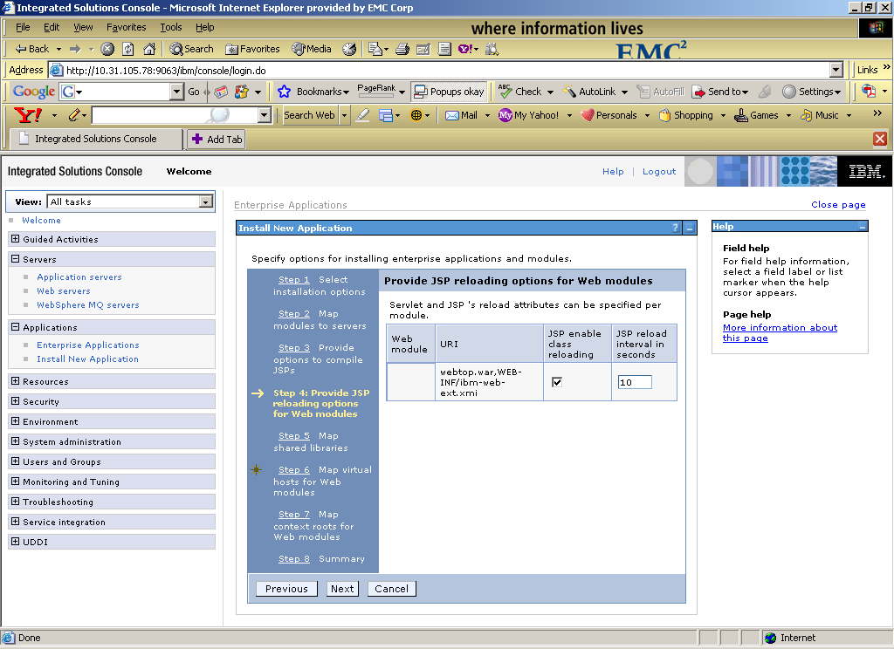
In the following screen select the both the check boxes and click next.
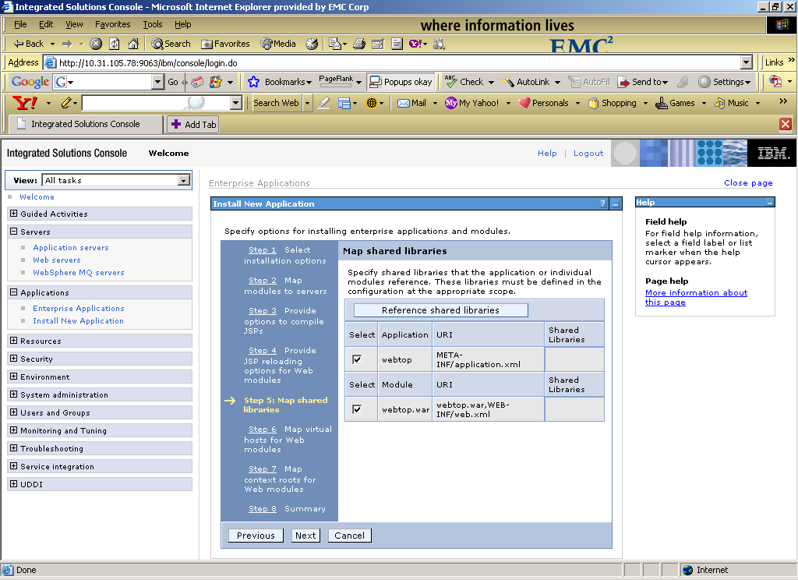

In the following screen select the check box and click next.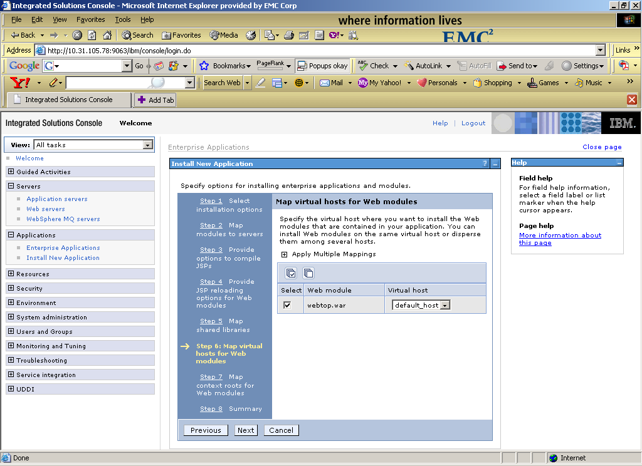

In the following screen click next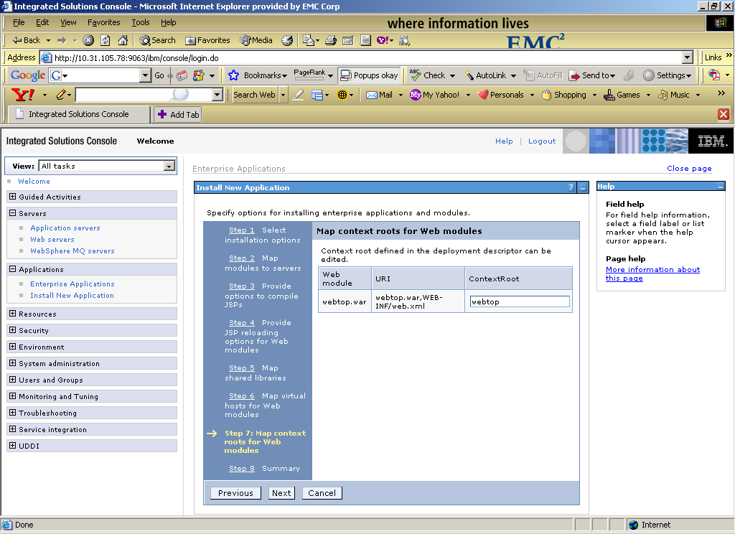

In the final screen click finish 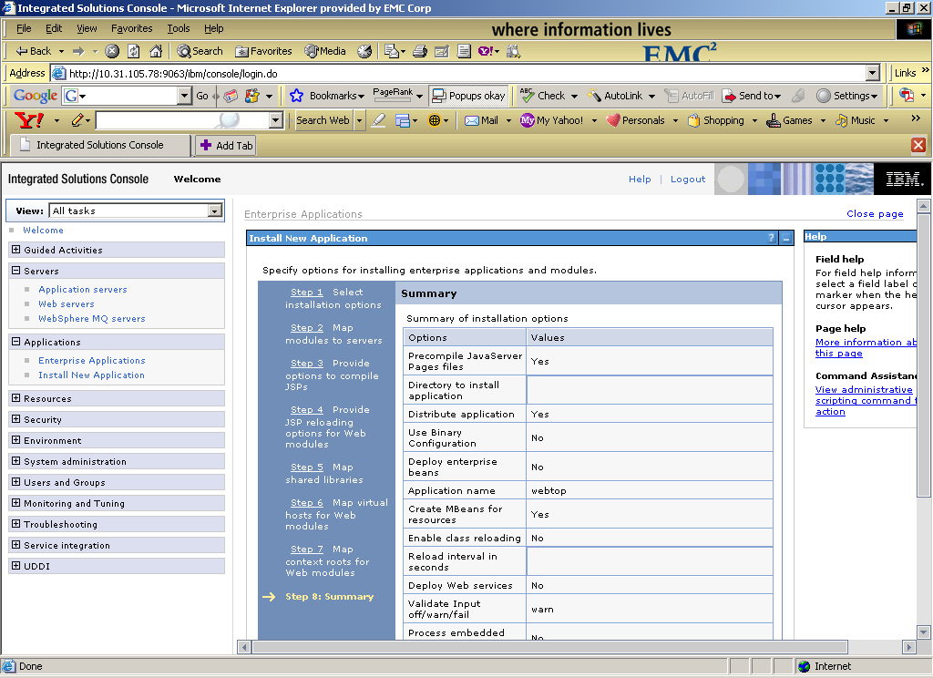

- Now it will take few minute to install the webtop.war file. After successful installation you should see the following screen 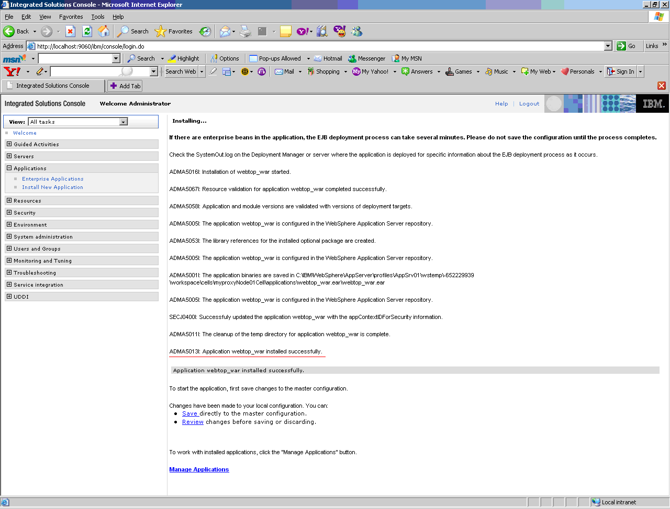

In this screen you should see the message "ADMA5013I: Application webtop_war installed successfully”

Classloader Setting for webtop.war file
After successful installation of webtop, you need to set the classloader policy, the steps are given below
- Click on Applications → Enterprise Applications
- Now you should see the following screen
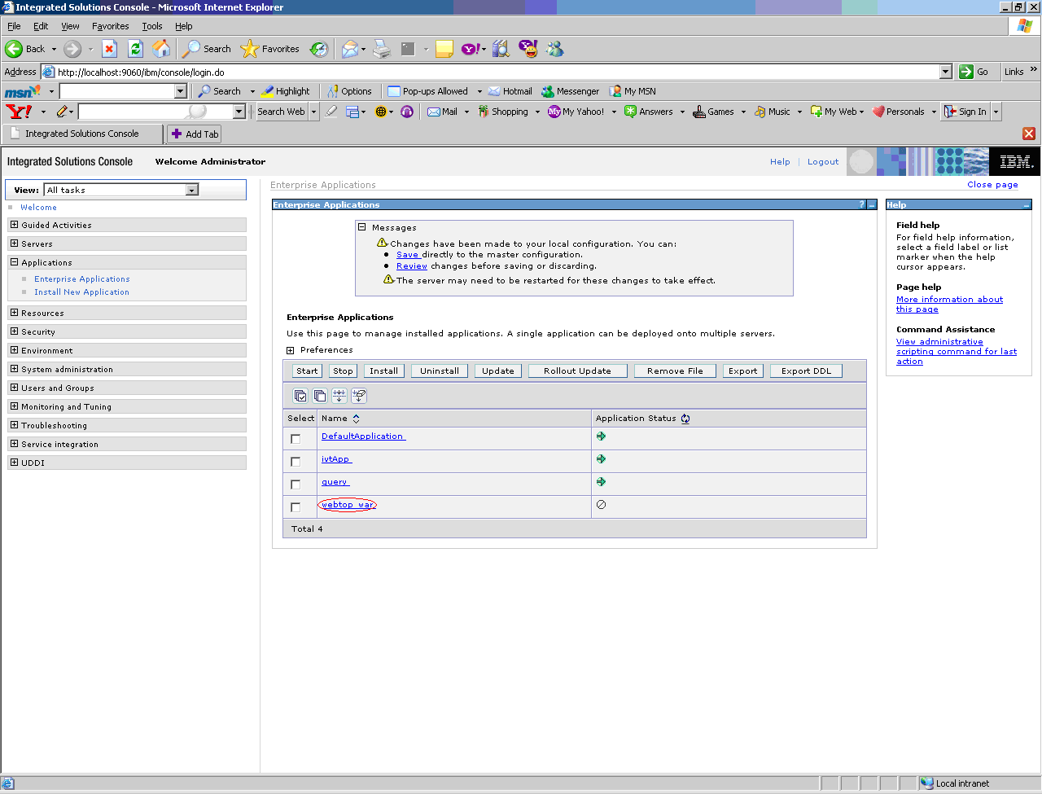

Click on webtop_war link, available in Enterprise Application table.

- Now you should see the following screen
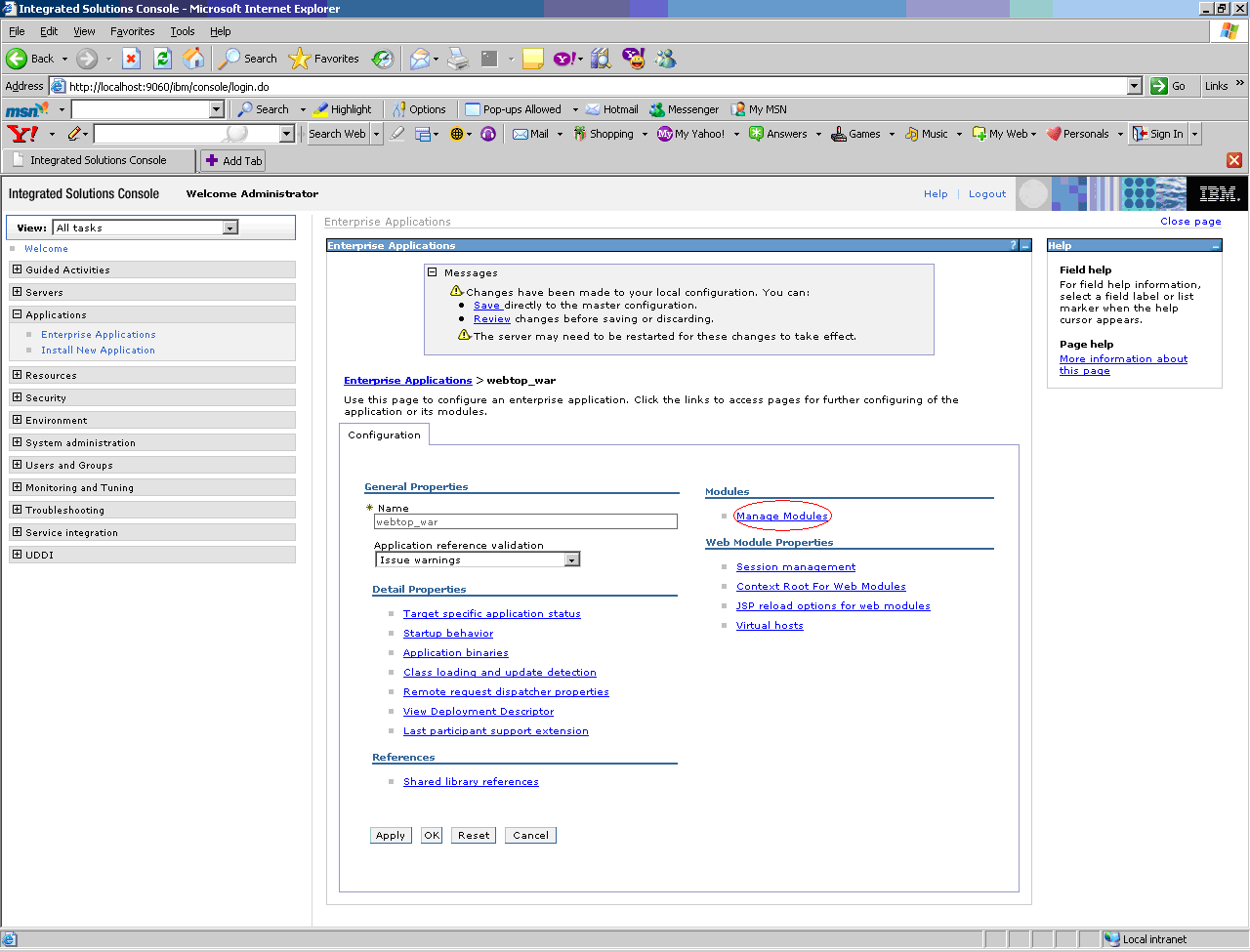

Click on Manage Modules link available under Modules section

- Now you should see the following screen
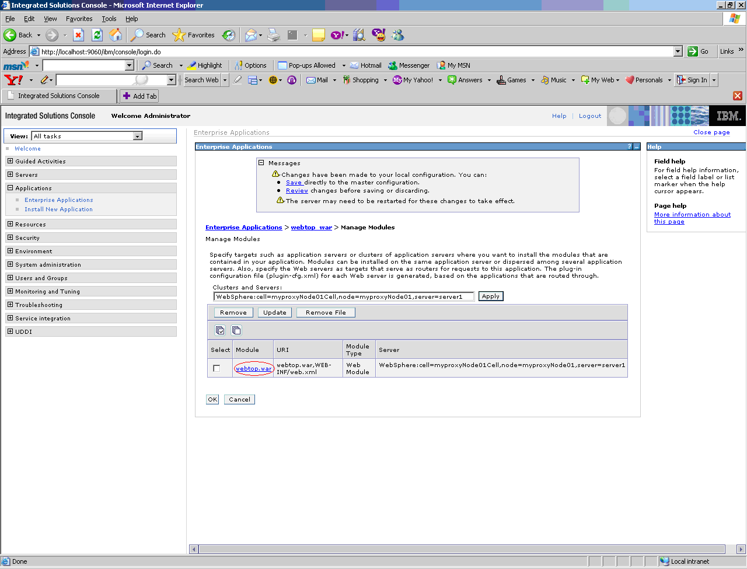
Click on webtop.war link

- Now you should see the following screen
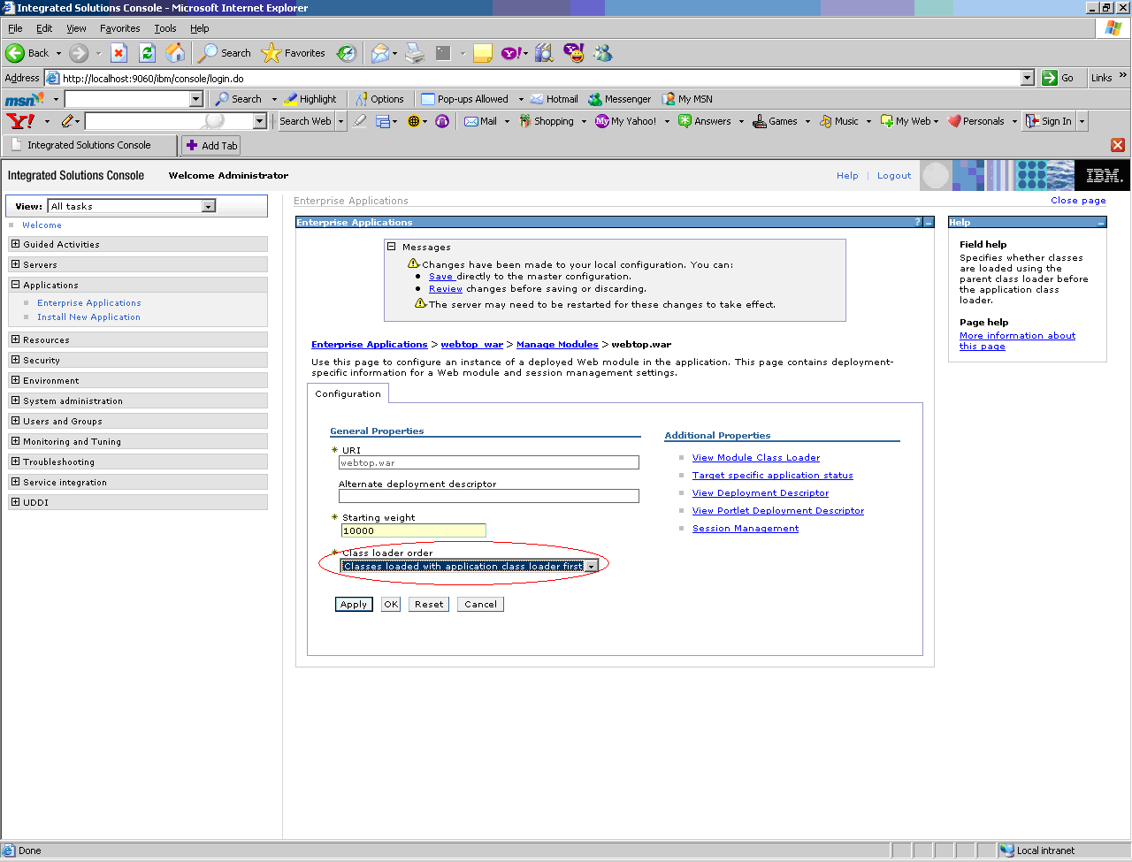

  - In Class loader order drop-down select ‘Class loaded with application class loader first’ option.
  - Click on Ok button.
- Now you should see the following screen
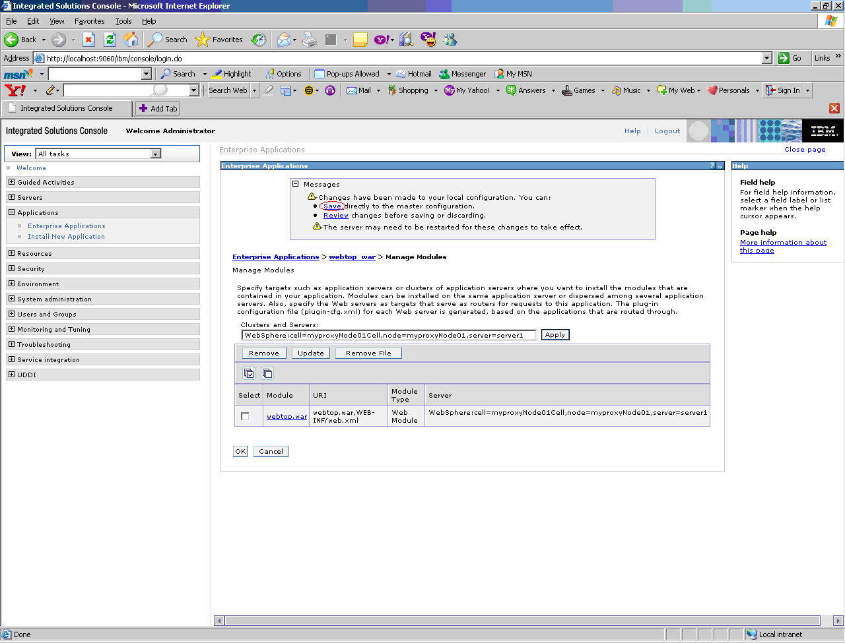

Click on Save link available in Messages section. It will take few minutes to save the changes.

- Now you should see the following screen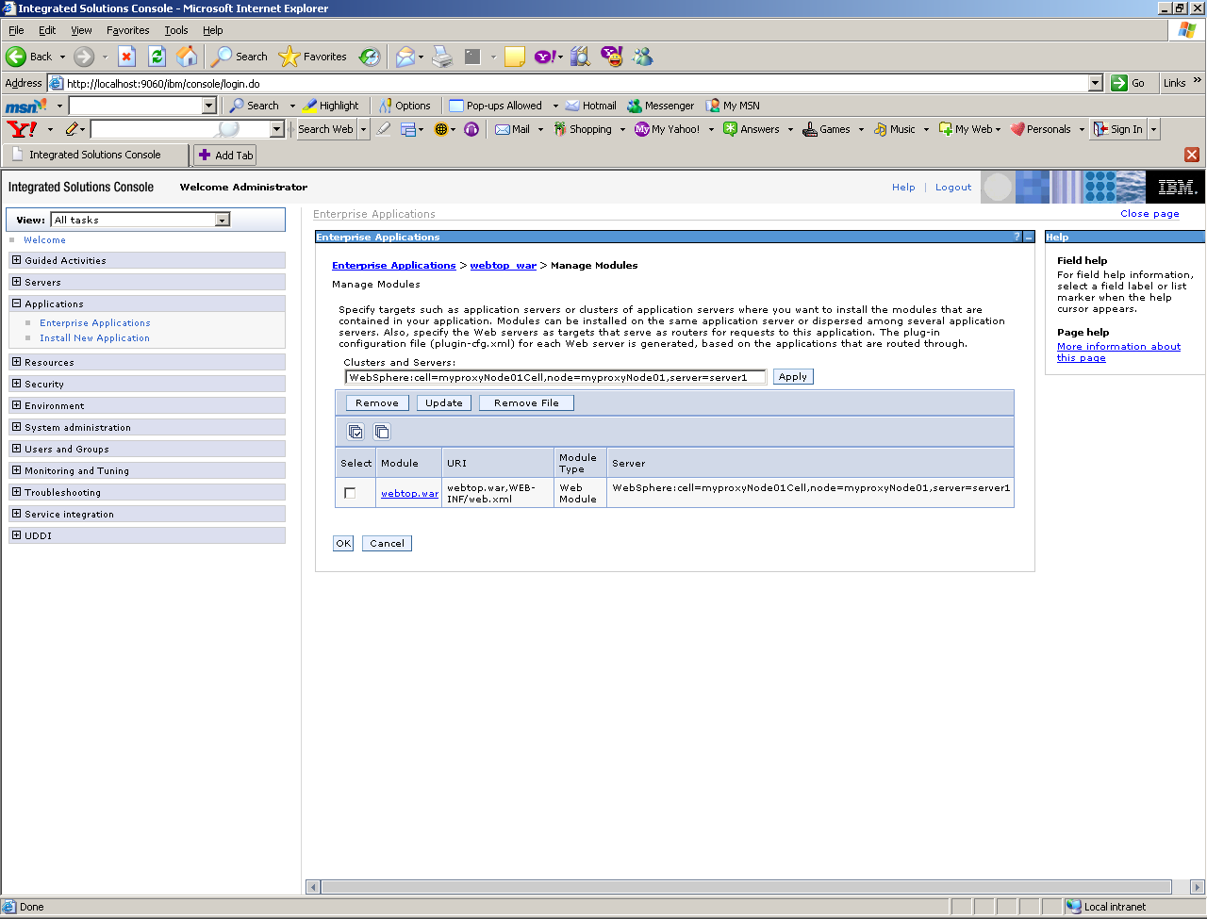

Logout of the console and stop the websphere server.

Set the JSP Compiler option for webtop.war
- Go to <WAS INSTALL HOME>\ AppServer\profiles\AppSrv01\config\cells\<Machine Name>Node01Cell\applications\webtop_war.ear\deployments\webtop_war\webtop.war\WEB-INF
- Open ibm-web-ext.xmi file.
- Add the following line under other <jspAttributes > element
<jspAttributes xmi:id="JSPAttribute_3" name="useJDKCompiler" value="true"/>

- Now you should see the content of the file as below
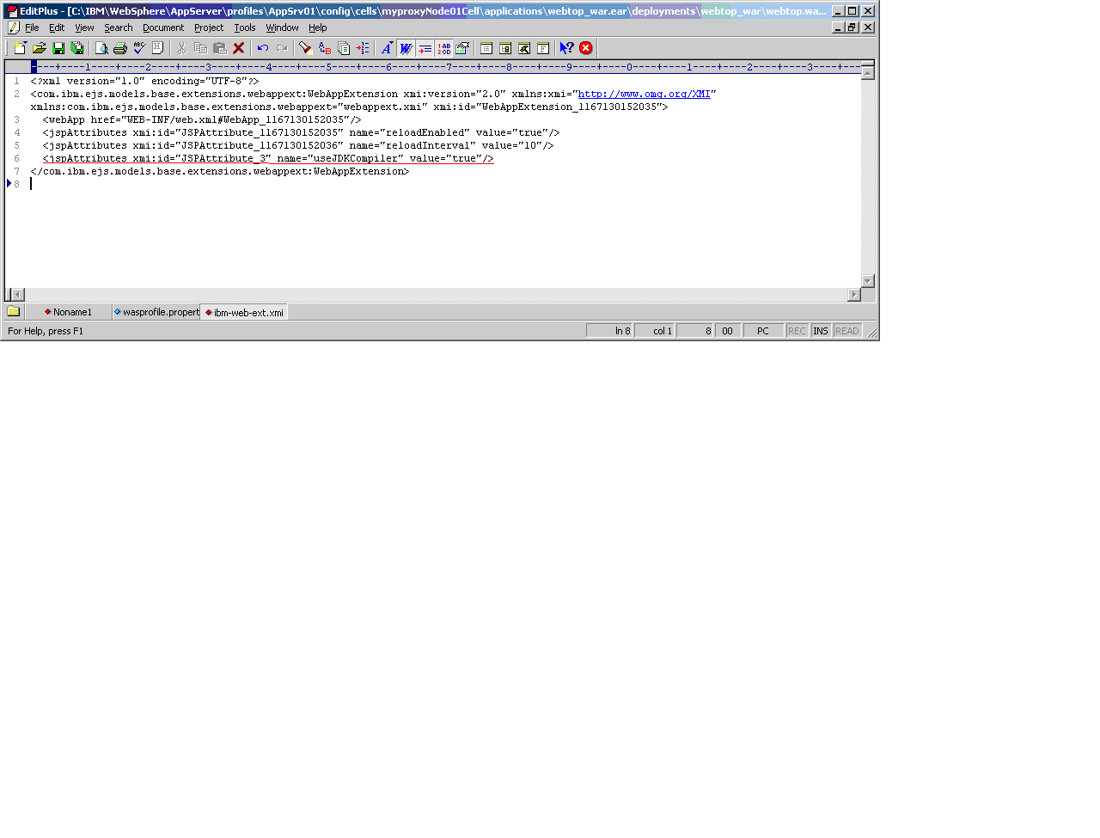

Apply Hot Fix for DatagridRowEventTag

If you are using webtop Build 5 or below, while opening the webtop home page you would see the following error message

[Servlet Error]-[/webtop/classic/homecabinet/homecabinet_classic.jsp]: com.ibm.ws.jsp.translator.JspTranslationException: JSPG0228E: Exception caught while translating /webtop/classic/homecabinet/homecabinet_classic.jsp: error in statically included file
/webcomponent/navigation/doclist/doclist_body.jsp(274,26) --> JSPG0008E: Custom Tag has invalid attributes

To resolve this issue you will have to apply the hotfix provided in DatagridRowEventTag_Hotfix.zip file

The steps to apply this hot fix is given below
- Stop the Websphere.
- Go to Unzip the DatagridRowEventTag_Hotfix.zip in the following folder
<WAS INSTALL HOME>\ AppServer\profiles\AppSrv01\installedApps\<Machine Name>Node01Cell\webtop_war.ear\webtop.war

Start the websphere and test the webtop
- Clear the server log files and start the websphere.
- Access the webtop, you should be able to login to webtop.

