Active Directory Installation

You must have Windows 2003 Server (or similar) installed.

- From the Start button, select All Programs -> Administrative Tools -> Manage Your Server

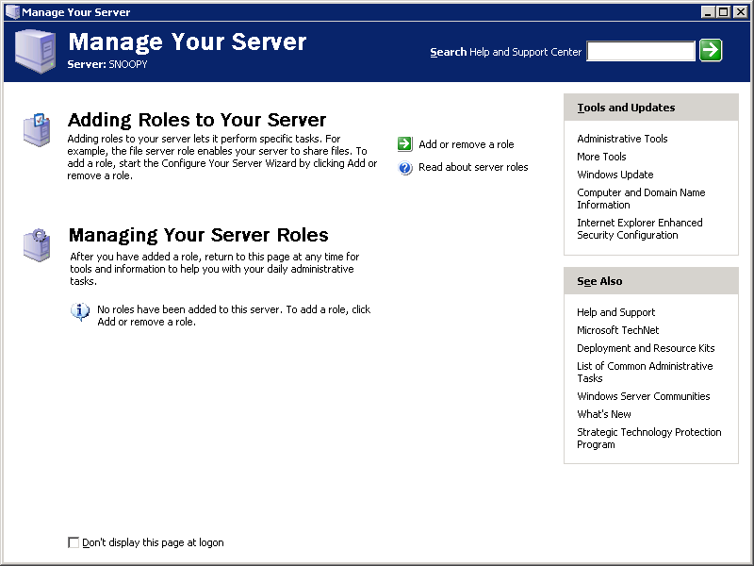

- Select Add or remove a role

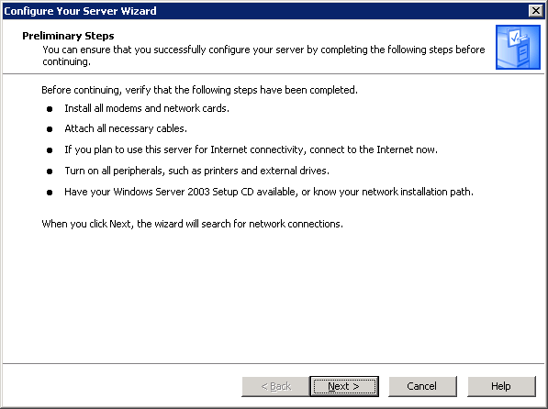

Click Next.

- Select Domain Controller (Active Directory). Click Next.

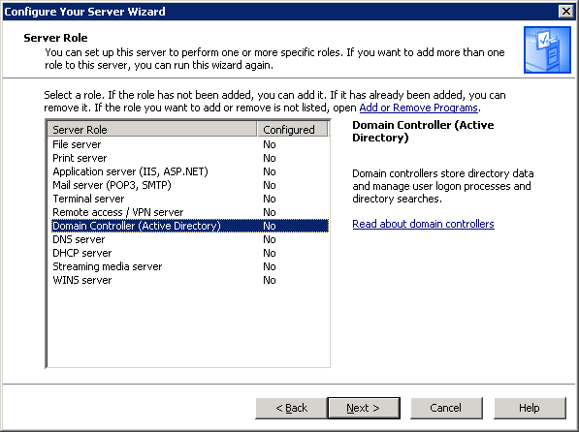
- Click Next.

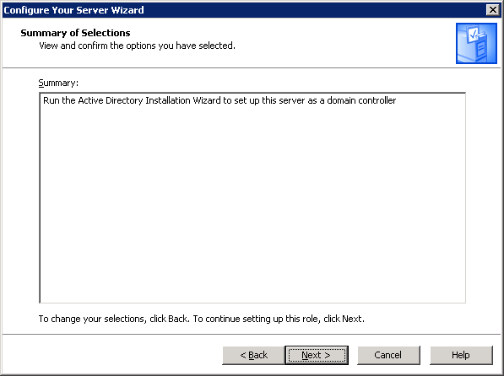

- The Active Directory Installation Wizard starts. Click Next.

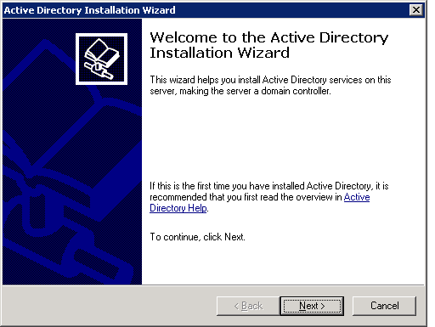

- Click Next.

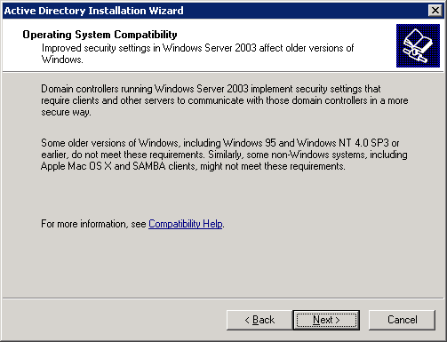
- Select Domain controller for a new domain. Click Next.

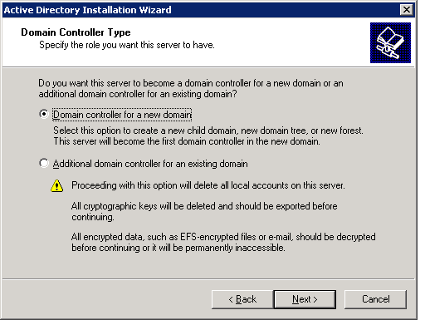

- Select Domain controller for a new domain. Click Next.

- Type in the DNS name for the server, e.g., maximodev.mro.com. Click next.

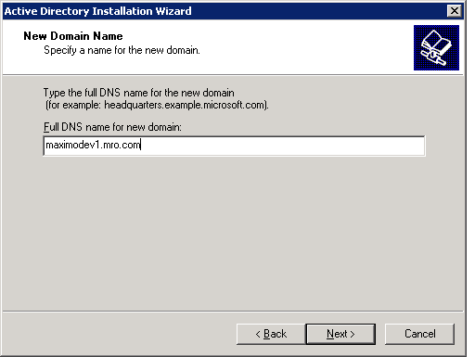

- Accept the Domain NetBIOS Name and click Next.

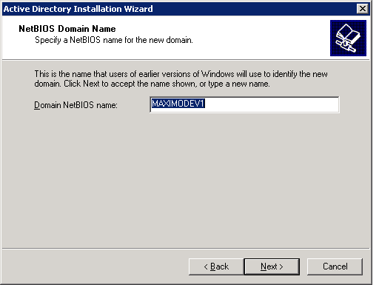
- Specify database and log folders. Click Next.

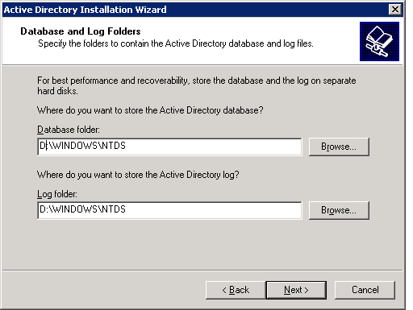

- Specify the share system volume. Click Next.

- If get DNS diagnostic failure, select Install and configure the DNS server….
Click Next.
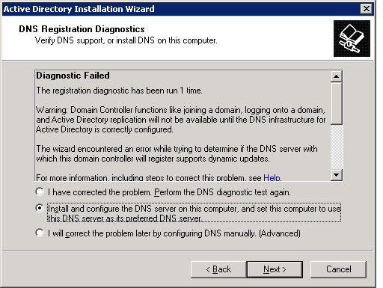

- Select permsion compatible only with Windows 2000 or Windows Server 2003 OS. Click Next.
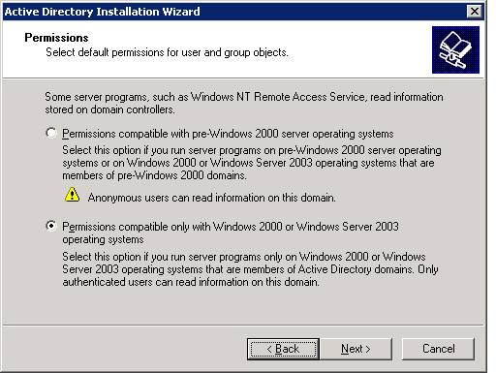
- Type in password for restore mode, e.g. devadmin. Click Next.

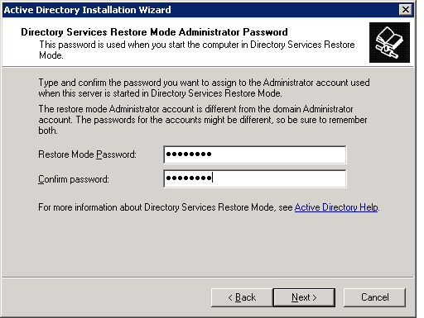

- Confirm summary. Click Next.

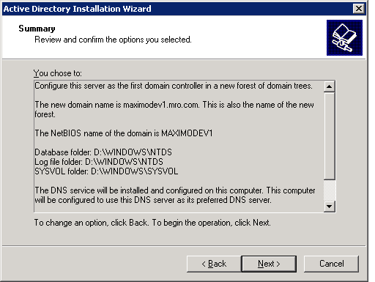
- Installation starts.

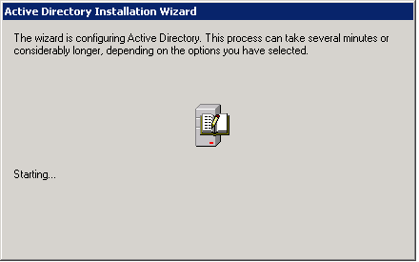

- Click Finish.

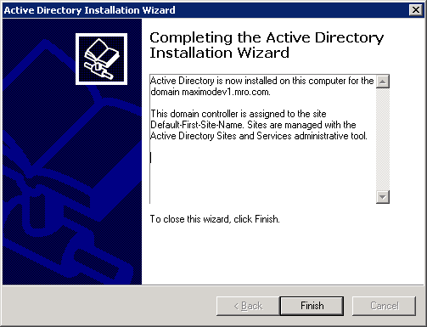

- Restart the machine.

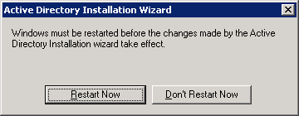

- After machine is restarted, you’ll see this screen. Click Finish.

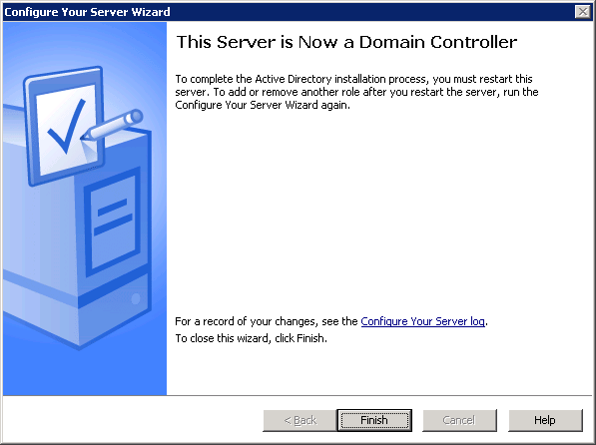

- Now we are back to Manage Your Server page. Notice now it has a section for Domain Controller (Active Directory).

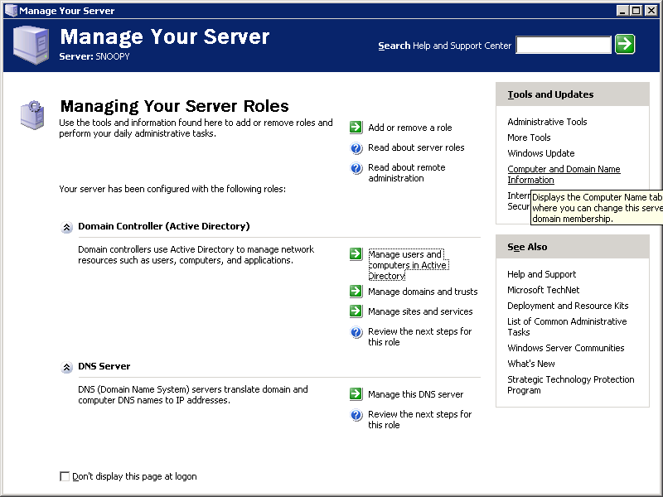

Now we are ready to configure the Active Directory server.
Active Directory Configuration

NOTE: To be able to create users with less restrictive passwords, such as those we use in MAXIMO, you must log in the server machine as administrator and change the security policy. Steps as followed:

- From the Start button, select Administrative Tools -> Domain Controller Security Policy.
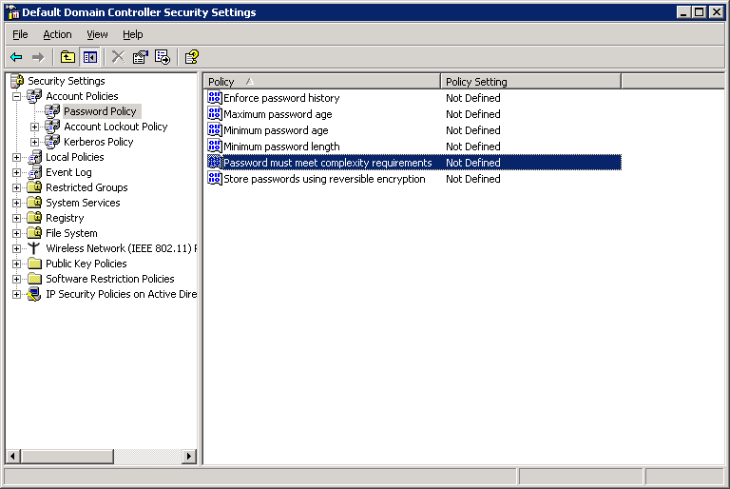

- From the left pane, click and open Security Settings -> Account Policies -> Password Policy. Right mouse click on the Password must meet complexity requirements, and select Properties. Select Define this policy setting, and check Disabled. Click OK.

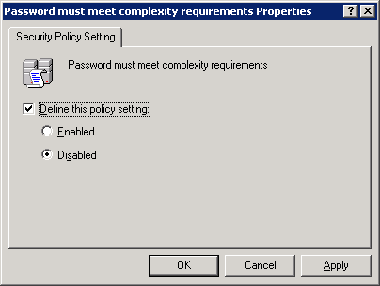

- On the Default Domain Controller Security Settings page, right mouse click on Minimum password length and select Properties. Check Define this policy setting, and set minimum password length to 6. Click OK.

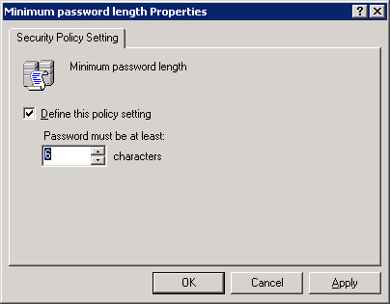

- Right mouse click Enforce password history, and select Properties. Select Define this policy setting, and accept the default value 0. Click OK.

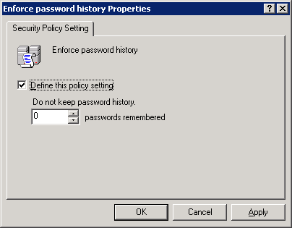

- After these changes, the Default Domain Controller Security Setting page looks like this:

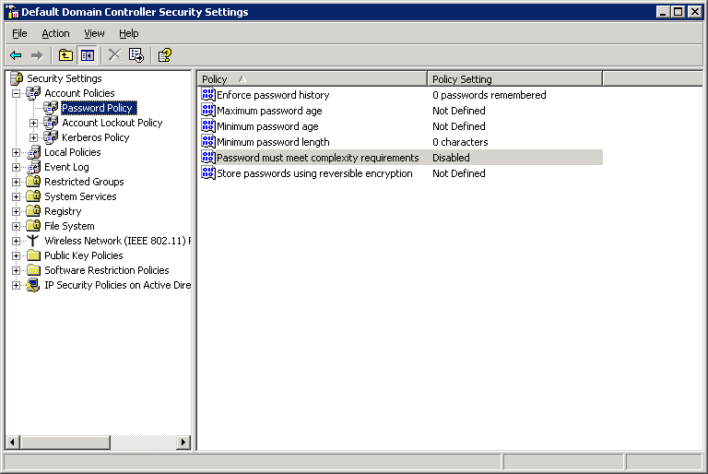

- From Start button, select Administrative Tools -> Domain Security Policy. Follow steps similar to those above, change the password policy settings so that the page looks like this:

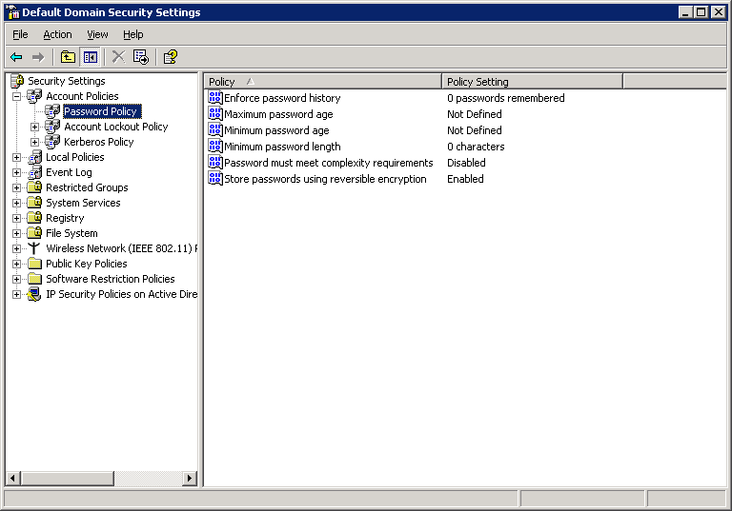
- From Start button, select Administrative Tools -> Manage Your Server, click on Manage users and computers in Active Directory.

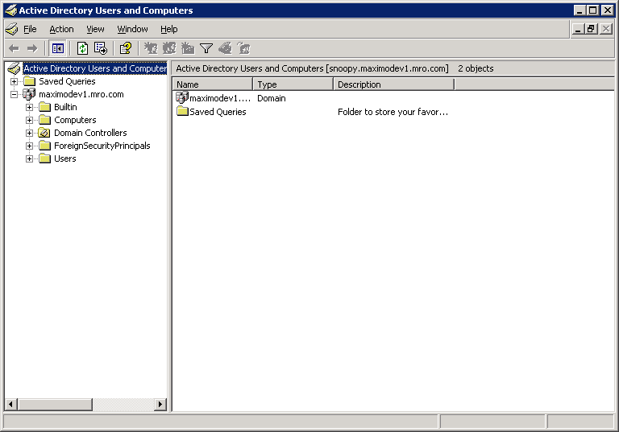

- From the left pane, right mouse click maximodev1.mro.com and select New -> Organization Unit. Type in the organization unit name you want to create, e.g. Bedford. Click OK.

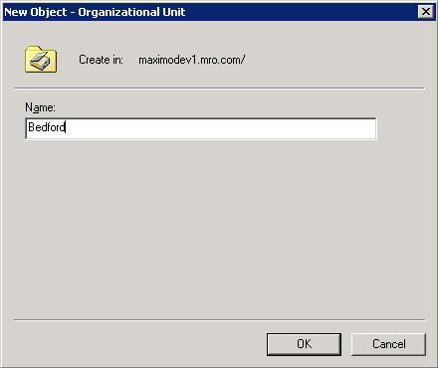

- Now Bedford appears as an element in the left pane tree. Right mouse click on Bedford, select New -> Group. Type in new group name, such as maximousers. Use other default options. Click OK. A new security group named maximousers will be created for the organization unit Bedford.

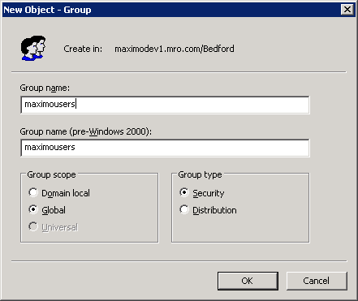

- Follow similar steps, create security groups ActuateAdministrators, ActuateUsers, ActuateOperators and WeblogicAdmin.

- Right mouse click on Bedford from the left pane, select New -> User. Type in user information. Click Next.

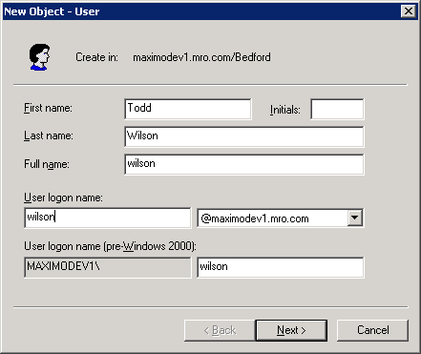

- Enter password for user Wilson. Check Password never expires.

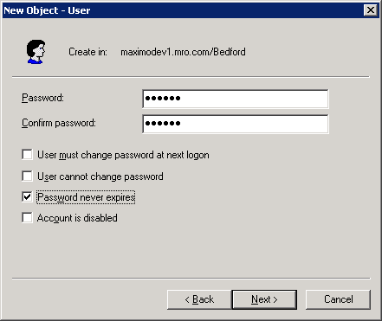
- The user Wilson will be created. Click Finish.

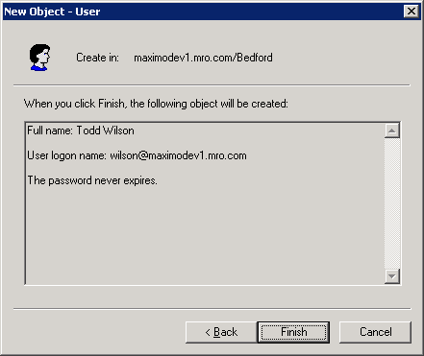

- User Wilson is added to the organization unit Bedford:
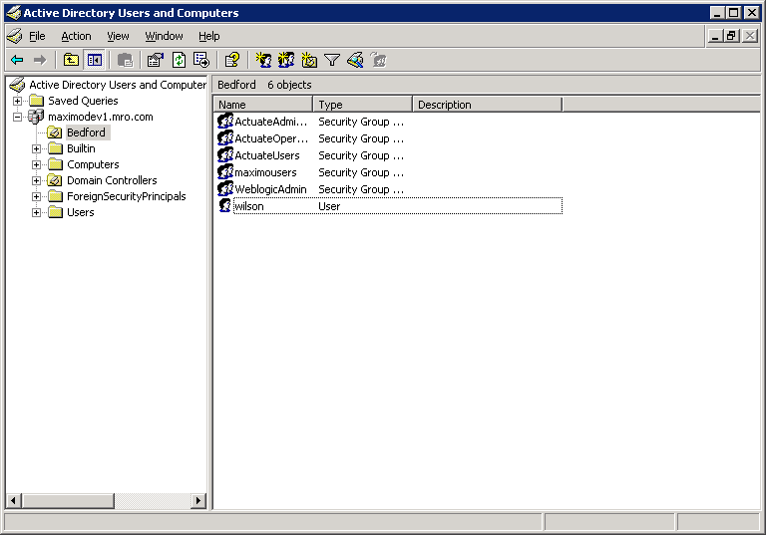
- Right mouse click on the user Wilson, select Properties.

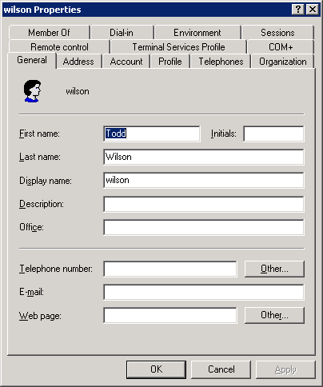

- Click on the Member Of tab.

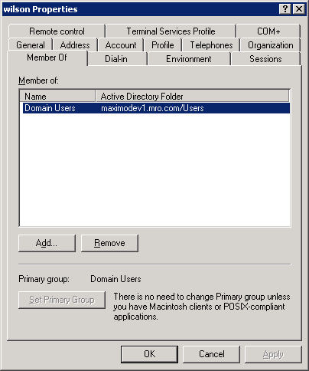

- Click on Add…, enter the names ActuateUsers and maximousers in the text box. Use the Check Names button on the right side to verify its correctness. Make sure to use semi-colon (;) between names. Click OK.

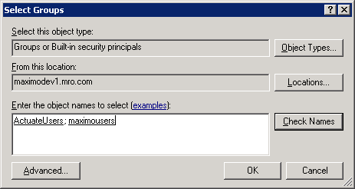
- User Wilson now belongs to three groups.

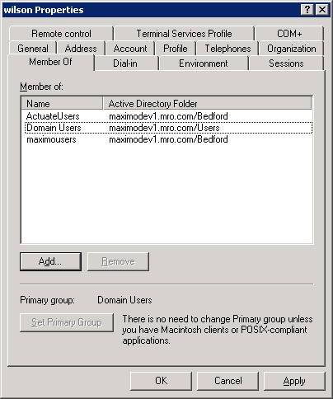

- Create user devadmin under Users.
- Create other maximo users under Bedford. You will need users for weblogic and websphere administrative account. So, create a user called weblogic and websphere.

