**Write a JavaScript program to calculate area of triangle, area of rectangle and area of circle.**

**Program:**

<!DOCTYPE html>

<html>

<head>

<meta http-equiv="Content-Type" content="text/html; charset=utf-8">

<title>JavaScript functions to find the area of shapes</title>

</head>

<body style="text-align: center;">

<h4>JavaScript function to find the area of a Triangle</h4>

<label for="side1">Enter the value of base:</label>

<input type="number" id="side1" placeholder="Enter value of base">

<br><br>

<label for="side2">Enter the value of height:</label>

<input type="number" id="side2" placeholder="Enter value of height">

<br><br>

<button onclick="calculateTriangleArea()">Click Here!</button>

<p>Area of Triangle: <span id="triangleDisplay"></span></p>

<script type="text/javascript">

function calculateTriangleArea() {

var side1 = parseInt(document.getElementById("side1").value);

var side2 = parseInt(document.getElementById("side2").value);

var area = (side1 * side2) / 2;

document.getElementById("triangleDisplay").innerHTML = area;

}

</script>

<hr>

<h4>JavaScript function to find the area of a Rectangle</h4>

<label for="side3">Enter the value of length:</label>

<input type="number" id="side3" placeholder="Enter value of length">

<br><br>

<label for="side4">Enter the value of width:</label>

<input type="number" id="side4" placeholder="Enter value of width">

<br><br>

<button onclick="calculateRectangleArea()">Click Here!</button>

<p>Area of Rectangle: <span id="rectangleDisplay"></span></p>

<script type="text/javascript">

function calculateRectangleArea() {

var side3 = parseInt(document.getElementById("side3").value);

var side4 = parseInt(document.getElementById("side4").value);

var area = side3 * side4;

document.getElementById("rectangleDisplay").innerHTML = area;

}

</script>

<hr>

<h4>JavaScript function to find the area of a Circle</h4>

<label for="radius">Enter the value of radius:</label>

<input type="number" id="radius" placeholder="Enter value of radius">

<br><br>

<button onclick="calculateCircleArea()">Click Here!</button>

<p>Area of Circle: <span id="circleDisplay"></span></p>

<script type="text/javascript">

function calculateCircleArea() {

var radius = parseInt(document.getElementById("radius").value);

var area = Math.PI * radius * radius;

document.getElementById("circleDisplay").innerHTML = area;

}

</script>

</body>

</html>

**Output**:

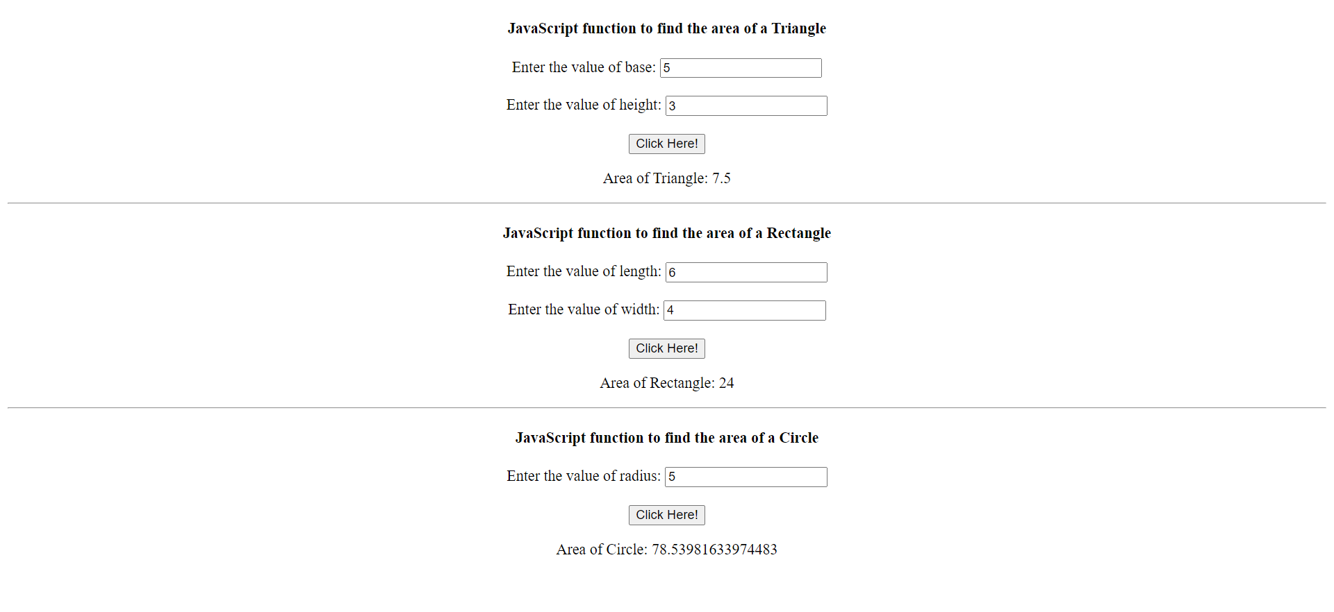

**Write a JavaScript program to generate the multiplication table of a given number.**

**Program:**

<!DOCTYPE html>

<html>

<head>

<meta http-equiv="Content-Type" content="text/html; charset=utf-8">

<title>Multiplication Table</title>

</head>

<body>

<h1>Multiplication Table</h1>

Enter a number: <input type="text" id="num" /><br /><br />

Enter limit: <input type="text" id="limit" />

<input type="button" value="Calculate" onClick="multiply()"/>

<p id="result"></p>

<script>

function multiply() {

var num = parseInt(document.getElementById("num").value);

var limit = parseInt(document.getElementById("limit").value);

var out = '';

for (var i = 1; i <= limit; i++) {

var product = i * num;

out += i + " * " + num + " = " + product + "<br />";

}

document.getElementById("result").innerHTML = out;

}

</script>

</body>

</html>

**Output:**

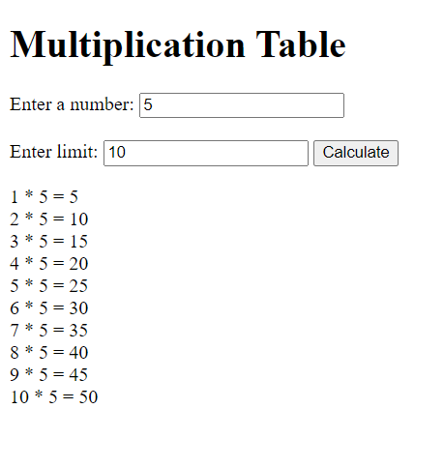

const prompt = require("prompt-sync")();

// Function to reverse a string

function reverseString(str) {

let newString = '';

for (let i = str.length - 1; i >= 0; i--) {

newString += str[i];

}

return newString;

}

// Function to replace characters in a string

function replaceString(str1, str2) {

let newString = str1.replace(str1, str2);

return newString;

}

// Function to check if a string is a palindrome

function checkPalindrome(str) {

const len = str.length;

for (let i = 0; i < len / 2; i++) {

if (str[i] !== str[len - 1 - i]) {

return 'It is not a palindrome';

}

}

return 'It is a palindrome';

}

// Take input from the user

const inputString = prompt("Enter a string: ");

// Reverse the string

const reversedString = reverseString(inputString);

console.log(`Reversed string: ${reversedString}`);

const string1 = prompt("Enter a string: ");

const string2 = prompt("Replace with: ");

// Replace characters in the string

const replacedString = replaceString(string1, string2);

console.log(`String after replacement: ${replacedString}`);

const string3 = prompt("Enter a string: ");

// Check if the string is a palindrome

const palindromeResult = checkPalindrome(string3);

console.log(palindromeResult);

**Write a JavaScript program to following operations on a given string,**

**i. Reverse string ii. Replace characters of a string iii. String is Palindrome**

**Program:**

const reverseString = input => input.split('').reverse().join('');

const replaceCharacters = (input, oldChar, newChar) => input.replace(new RegExp(oldChar, 'g'), newChar);

const isPalindrome = input => {

const cleanedString = input.replace(/\s/g, '').toLowerCase();

return cleanedString === cleanedString.split('').reverse().join('');

};

const inputString = "hello world";

const oldChar = "o";

const newChar = "a";

const reversed = reverseString(inputString);

const replaced = replaceCharacters(inputString, oldChar, newChar);

const isPalindromeResult = isPalindrome(inputString);

console.log("Original String: " + inputString);

console.log("Reversed String: " + reversed);

console.log("String with Replacement: " + replaced);

console.log("Is Palindrome? " + isPalindromeResult);

**Output:**

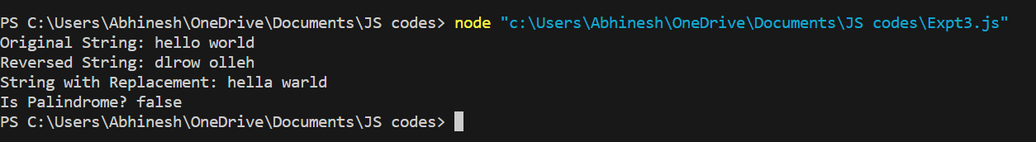

**Write a JavaScript program to compare two strings using various methods.**

**Program:**

const readline = require('readline');

// Create an interface for reading input

const rl = readline.createInterface({

input: process.stdin,

output: process.stdout

});

// Function to compare two strings

function compareStrings(string1, string2) {

const result = string1.toUpperCase() === string2.toUpperCase();

return result;

}

// Ask the user to enter the first string

rl.question('Enter the first string: ', (string1) => {

// Ask the user to enter the second string

rl.question('Enter the second string: ', (string2) => {

const result = compareStrings(string1, string2);

if (result) {

console.log('The strings are similar.');

} else {

console.log('The strings are not similar.');

}

// Close the interface

rl.close();

});

});

**Output:**



**To create a Javascript Program Program that will create a countdown timer.**

**Program:**

<!DOCTYPE html>

<html>

<head>

</head>

<body>

<label for="min">Minutes:</label>

<input id="min" type="number">

<label for="sec">Seconds:</label>

<input id="sec" type="number">

<button onclick="count()">Start Countdown</button>

<p>Time remaining: <span id="m"></span> Minutes <span id="s"></span> Seconds</p>

<script>

var m = document.getElementById("m");

var s = document.getElementById("s");

var intervalId;

function count() {

var min = parseInt(document.getElementById("min").value);

var sec = parseInt(document.getElementById("sec").value);

var seconds = min * 60 + sec;

intervalId = setInterval(function () {

var minn = Math.floor(seconds / 60);

var secc = seconds % 60;

m.innerText = minn;

s.innerText = secc;

seconds--;

if (seconds < 0) {

clearInterval(intervalId);

m.innerText = "0";

s.innerText = "0";

alert("Time's up!");

}

}, 1000);

}

</script>

</body>

</html>

**Output:**

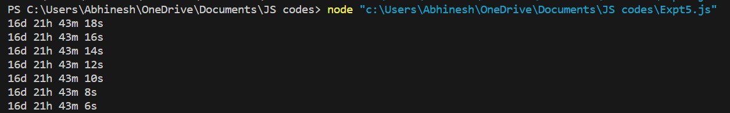

**Write a JavaScript program that will create an array and perform following operations**

**i. To remove specific element from the array**

**ii.Check if an array contains a specified value.**

**iii.To empty an array**

**Program:**

// i. To remove a specific element from the array

function removeElementFromArray(arr, elementToRemove) {

const index = arr.indexOf(elementToRemove);

if (index !== -1) {

arr.splice(index, 1); // Remove 1 element at the found index

}

return arr;

}

const arrayToRemoveFrom = ["shift", "splice", "filter", "pop"];

const elementToRemove = "splice";

console.log("Original Array:", arrayToRemoveFrom);

const newArrayAfterRemoval = removeElementFromArray(arrayToRemoveFrom, elementToRemove);

console.log("Array after removing element:", newArrayAfterRemoval);

// ii. Check if an array contains a specified value

function checkIfArrayContainsValue(arr, value) {

return arr.includes(value);

}

const arrayToCheck = ['you', 'will', 'learn', 'javascript'];

const valueToCheck = 'javascript';

if (checkIfArrayContainsValue(arrayToCheck, valueToCheck)) {

console.log('Array contains the specified value.');

} else {

console.log('Array does not contain the specified value.');

}

// iii. To empty an array

function emptyArray(arr) {

arr.length = 0; // Set the array length to 0

return arr;

}

const arrayToEmpty = [1, 2, 3];

console.log("Original Array:", arrayToEmpty);

const emptyArrayResult = emptyArray(arrayToEmpty);

console.log("Empty Array Result:", emptyArrayResul

**Output:**

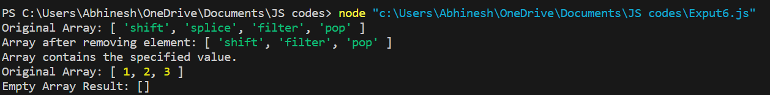

**Write a JavaScript program to illustrate different Set operations like**

**a. Union b. Intersection c. Difference d. Set Difference**

**Program:**

function union(a, b) {

let unionSet = new Set(a);

for (let i of b) {

unionSet.add(i);

}

return unionSet;

}

function intersection(setA, setB) {

let intersectionSet = new Set();

for (let i of setB) {

if (setA.has(i)) {

intersectionSet.add(i);

}

}

return intersectionSet;

}

function difference(setA, setB) {

let differenceSet = new Set(setA);

for (let i of setB) {

differenceSet.delete(i);

}

return differenceSet;

}

function subset(setA, setB) {

for (let i of setB) {

if (!setA.has(i)) {

return false;

}

}

return true;

}

const setA = new Set(['apple', 'mango', 'orange', 'banana']);

const setB = new Set(['apple', 'banana']);

const resultUnion = union(setA, setB);

console.log("Union Result:", resultUnion);

const resultIntersection = intersection(setA, setB);

console.log("Intersection Result:", resultIntersection);

const resultDifference = difference(setA, setB);

console.log("Difference Result:", resultDifference);

const isSubset = subset(setA, setB);

console.log("Is setB a subset of setA:", isSubset);

**Output:**

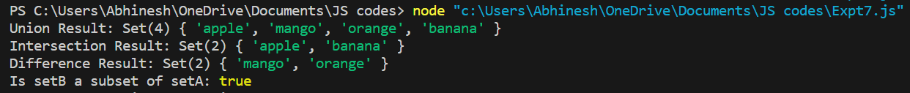

**Write a JavaScript program to create a Home page of any website and change background colour using**

**i. On mouse over event**

**ii. On focus event**

**Program:**

<!DOCTYPE html>

<html>

<head>

<title>Homepage</title>

<script>

function changeColor() {

document.body.style.backgroundColor = 'Red';

setTimeout(changeColor2, 2000);

}

function changeColor2() {

document.body.style.backgroundColor = 'Pink';

setTimeout(changeColor3, 2000);

}

function changeColor3() {

document.body.style.backgroundColor = 'Green';

setTimeout(changeColor4, 2000);

}

function changeColor4() {

document.body.style.backgroundColor = 'Red';

}

function myFunction(x) {

x.style.background = 'yellow';

}

</script>

</head>

<body>

<a onmouseover="changeColor()">Change Background Color</a><br>

Enter your name: <input type="text" onfocus="myFunction(this)">

</body>

</html>

**Output:**

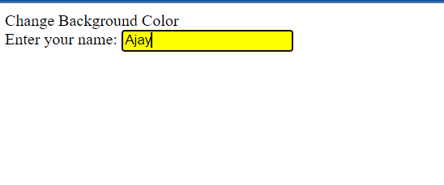

**Design and implement a simple calculator using Java script for operations like addition, multiplication, subtraction, division, square of a number etc. a. Design a calculator like text field for input and output, buttons for numbers and operations etc. b. Validate input values c. Prompt/ alerts for invalid values etc.**

**Program:**

<!DOCTYPE html>

<html>

<head>

<title>Simple Calculator</title>

</head>

<body>

<h1>Simple Calculator</h1>

<div>

<input type="text" id="previousOutput" disabled>

</div>

<div>

<input type="text" id="display" disabled>

</div>

<div>

<button onclick="appendToDisplay('1')">1</button>

<button onclick="appendToDisplay('2')">2</button>

<button onclick="appendToDisplay('3')">3</button>

<button onclick="appendToDisplay('+')">+</button>

</div>

<div>

<button onclick="appendToDisplay('4')">4</button>

<button onclick="appendToDisplay('5')">5</button>

<button onclick="appendToDisplay('6')">6</button>

<button onclick="appendToDisplay('-')">-</button>

</div>

<div>

<button onclick="appendToDisplay('7')">7</button>

<button onclick="appendToDisplay('8')">8</button>

<button onclick="appendToDisplay('9')">9</button>

<button onclick="appendToDisplay('*')">*</button>

</div>

<div>

<button onclick="appendToDisplay('0')">0</button>

<button onclick="clearDisplay()">C</button>

<button onclick="calculateResult()">=</button>

<button onclick="appendToDisplay('/')">/</button>

</div>

<script>

function appendToDisplay(value) {

document.getElementById('display').value += value;

}

function clearDisplay() {

document.getElementById('display').value = '';

}

function calculateResult() {

try {

const expression = document.getElementById('display').value;

const result = eval(expression);

document.getElementById('previousOutput').value = expression + ' = ' + result;

document.getElementById('display').value = result;

} catch (error) {

document.getElementById('previousOutput').value = 'Error';

document.getElementById('display').value = '';

}

}

</script>

</body>

</html>

**Output:**

