What is ArgoCD
Argo CD is a Kubernetes-native continuous deployment (CD) tool. Unlike external CD tools that only enable push-based deployments, Argo CD can pull updated code from Git repositories and deploy it directly to Kubernetes resources.
Press enter or click to view image in full size
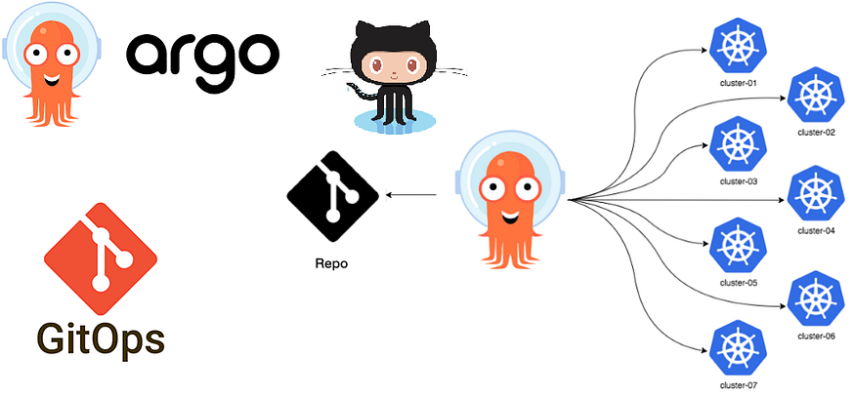
argoCD
What is GitOps?
GitOps is a way of implementing Continuous Deployment for cloud-native applications. It focuses on a developer-centric experience when operating infrastructure, by using tools developers are already familiar with, including Git and Continuous Deployment tools.
The core idea of GitOps is to have a Git repository that always contains declarative descriptions of the infrastructure currently desired in the production environment and an automated process to make the production environment match the described state in the repository. If you want to deploy a new application or update an existing one, you only need to update the repository — the automated process handles everything else. It’s like having cruise control for managing your applications in production.
Press enter or click to view image in full size
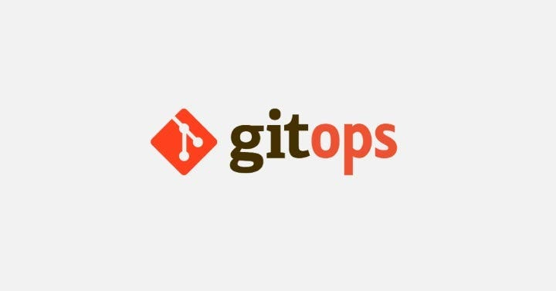
gitOps
How to achieve GitOps using Argo CD?
Every enterprise uses Git as its source code management software to store code. Developers can commit their infrastructure configurations, such as Kubernetes resources definition, in Git to create environments needed for application deployment.
Once a developer implements a feature ( with a new application and K8S configurations) and merges with the main branch, the CI process is initiated for generating and testing an image.
After the review and approval of the application, the pull request in Git is merged with the main branch. With the help of the GitOps agent, Argo CD will immediately identify the new versions of a configuration that was recently merged and compare it with the running application in the destination environment (it can be pre-prod or prod).
In case of a mismatch, it highlights out-of-sync status, and in the backend, Argo CD uses the Kubernetes controller to reconcile the new changes to cluster resources. Once the Kubernetes resources are ready, it informs the user the application is in sync.
Argo CD also uses an agent to constantly monitor the end environment and check its status with Git. Argo CD synchronizes the current state with the declared state of configurations and ensures that new configurations are correctly deployed to a Kubernetes cluster.
As all the records of all changes, including all details of the environment, at every stage of the process are stored in Git, Argo CD helps roll back applications to previous states in a single click.
Benefits of Argo CD:
- Improve developer productivity
Argo CD provides developers with a self-service environment for application deployment. Software development teams can focus on creativity and writing business logic instead of time and energy on manual and remedial deployments.
2. Improved software delivery compliance
Allow your developers, Ops, and DevOps teams to use a single platform for infrastructure change management. Apply organizational policies to restrict access to Kubernetes resources and minimize your application downtime and outages.
3. Increased collaboration in SDLC
While working on Argo CD, every team member can work from the same system to achieve GitOps and understand the status of individual processes. The single Git repository fosters collaboration amongst team members by assigning tasks to individuals and deploying code from each person as necessary.
4. Faster deployments
Argo CD allows teams to perform more rapid deployments into Kubernetes clusters across multi-cloud. Quicker releases of application changes mean shorter time to market and more flexibility in responding to customer demand.
Prerequisites:
- A running Kubernetes cluster
How to install ArgoCD?
- For this tutorial, you must have a running kubernetes cluster like I have minikube running on my server.
- Create the namespace for argoCD
kubectl create namespace argocd
- Install ArgoCD using the below command
kubectl apply -n argocd -f https://raw.githubusercontent.com/argoproj/argo-cd/stable/manifests/install.yaml
- After installing the ArgoCD, you can run the below command to check what resources it has created.
ubuntu@ip-172-31-7-106:~$ kubectl get all -n argocd
NAME READY STATUS RESTARTS AGE
pod/argocd-application-controller-0 1/1 Running 0 106m
pod/argocd-applicationset-controller-787bfd9669-4mxq6 1/1 Running 0 106m
pod/argocd-dex-server-bb76f899c-slg7k 1/1 Running 0 106m
pod/argocd-notifications-controller-5557f7bb5b-84cjr 1/1 Running 0 106m
pod/argocd-redis-b5d6bf5f5-482qq 1/1 Running 0 106m
pod/argocd-repo-server-56998dcf9c-c75wk 1/1 Running 0 106m
pod/argocd-server-5985b6cf6f-zzgx8 1/1 Running 0 106m
NAME TYPE CLUSTER-IP EXTERNAL-IP PORT(S) AGE
service/argocd-applicationset-controller ClusterIP 10.102.163.101 <none> 7000/TCP,8080/TCP 106m
service/argocd-dex-server ClusterIP 10.101.227.215 <none> 5556/TCP,5557/TCP,5558/TCP 106m
service/argocd-metrics ClusterIP 10.111.59.189 <none> 8082/TCP 106m
service/argocd-notifications-controller-metrics ClusterIP 10.96.102.185 <none> 9001/TCP 106m
service/argocd-redis ClusterIP 10.97.229.117 <none> 6379/TCP 106m
service/argocd-repo-server ClusterIP 10.102.16.58 <none> 8081/TCP,8084/TCP 106m
service/argocd-server ClusterIP 10.98.71.135 <none> 80/TCP,443/TCP 106m
service/argocd-server-metrics ClusterIP 10.109.248.207 <none> 8083/TCP 106mNAME READY UP-TO-DATE AVAILABLE AGE
deployment.apps/argocd-applicationset-controller 1/1 1 1 106m
deployment.apps/argocd-dex-server 1/1 1 1 106m
deployment.apps/argocd-notifications-controller 1/1 1 1 106m
deployment.apps/argocd-redis 1/1 1 1 106m
deployment.apps/argocd-repo-server 1/1 1 1 106m
deployment.apps/argocd-server 1/1 1 1 106mNAME DESIRED CURRENT READY AGE
replicaset.apps/argocd-applicationset-controller-787bfd9669 1 1 1 106m
replicaset.apps/argocd-dex-server-bb76f899c 1 1 1 106m
replicaset.apps/argocd-notifications-controller-5557f7bb5b 1 1 1 106m
replicaset.apps/argocd-redis-b5d6bf5f5 1 1 1 106m
replicaset.apps/argocd-repo-server-56998dcf9c 1 1 1 106m
replicaset.apps/argocd-server-5985b6cf6f 1 1 1 106mNAME READY AGE
statefulset.apps/argocd-application-controller 1/1 106m
ubuntu@ip-172-31-7-106:~$
- Now in order to access the UI of ArgoCD, you need to run the below command
kubectl edit svc argocd-server -n argocd #enable Node Port
- Now, in order to log into the UI you need the credentials. So, for a username, you can write admin and the password is stored in the secret called argocd-initial-admin-secret in the cluster.
- You need to run the below command to get the value of the secret.
kubectl get secret argocd-initial-admin-secret -n argocd -o yaml
- The secret base64 encoded so, you have to decode the secret by running the below command.
echo "secret value" | base64 --decode
- After running the above command you can have the decoded value of the secret and using that as a password you can log in to the UI.
- Now, the installation has been completed.
Now, the installation is completed.

So, now I have an application running on my kubernetes cluster. Below are the manifest files for that.
- Deployment file
apiVersion: apps/v1
kind: Deployment
metadata:
name: swiggy-app
labels:
app: swiggy-app
spec:
replicas: 3
selector:
matchLabels:
app: swiggy-app
template:
metadata:
labels:
app: swiggy-app
spec:
terminationGracePeriodSeconds: 30
containers:
- name: swiggy-app
image: veeranarni/hotstar:latest
imagePullPolicy: "Always"
ports:
- containerPort: 3000
2. Service file
apiVersion: v1
kind: Service
metadata:
name: swiggy-app
labels:
app: swiggy-app
spec:
type: LoadBalancer
ports:
- port: 80
targetPort: 3000
selector:
app: swiggy-app
Press enter or click to view image in full size
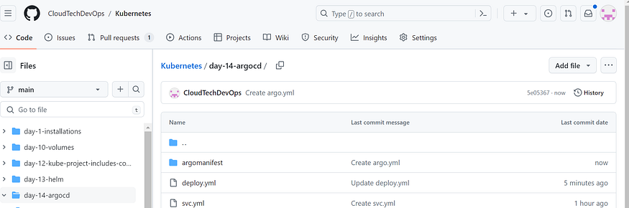
Repository
So, now in order for argoCD to sync with this repository we need to write some manifest file for that. Here is the manifest file for that.
apiVersion: argoproj.io/v1alpha1
kind: Application
metadata:
name: myapp-argo-application
namespace: argocd
spec:
project: default
source:
repoURL: https://github.com/CloudTechDevOps/Kubernetes.git
targetRevision: HEAD
path: day-14-argocd
destination:
server: https://kubernetes.default.svc
namespace: myapp
syncPolicy:
syncOptions:
- CreateNamespace=true
automated:
selfHeal: true
prune: true
- argoproj.io/v1alpha1 is an API version of argoCD. The API Version might get changed once argoCD has some new release. Always refer to the documentation for the latest information.
- I am defining my repository URL in repoURL section.
- targetRevision is set to HEAD so that it will always fetch the latest commit.
- path is set to ‘day-14-argocd’ because I have my application’s manifest files in ‘day-14-argocd’ folder.
- In the destination section we have server section and it is set to https://kubernetes.default.svc which is the internal service of the kubernetes API Server.
ubuntu@ip-172-31-7-106:~$ kubectl get svc
NAME TYPE CLUSTER-IP EXTERNAL-IP PORT(S) AGE
kubernetes ClusterIP 10.96.0.1 <none> 443/TCP 137m
ubuntu@ip-172-31-7-106:~$
- namespace is set to myapp , because we want to create our application in that namespace. Now, we actually don’t have the namespace already created because we want argoCD to create that automatically.
- In order for argoCD to create the namespace automatically we need to define the below attributes.
syncPolicy:
syncOptions:
- CreateNamespace=true
- We want argoCD to automatically sync any changes in the git repository but by default, it is turned off. So in order to enable that we need to define the below attributes.
automated:
selfHeal: true
prune: true
- If you apply any changes from the backend using kubectl utility then we want to override that with whatever we have in our git repository in order to do that we have selfHeal: true for that.
- If we rename any component or delete the entire component then we want argoCD to delete that component in the cluster as well and in order to do that we have prune: true for that.
- argoCD will check the changes in the git repository every 3 minutes. If you want argoCD to check the changes as soon as it has done then you can implement the webhook for that.
- Now, that we have our file ready we need to run the below command to apply that.
kubectl apply -f application.yaml
- Once you apply the file you can check your application in the UI.
Press enter or click to view image in full size
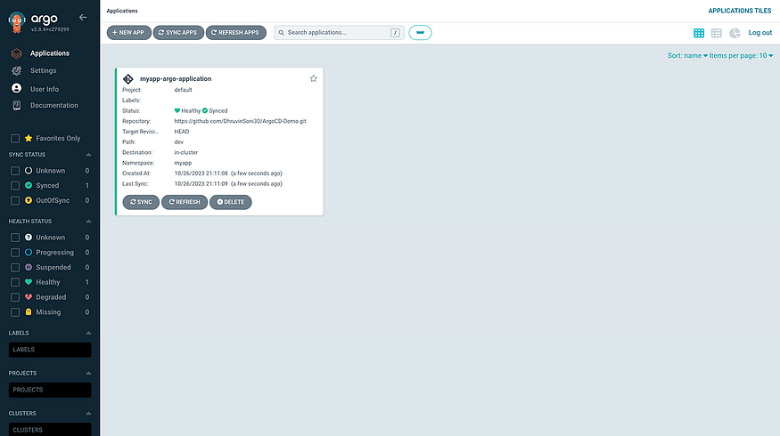
Application
- You can click on your application and check the various details.
Press enter or click to view image in full size
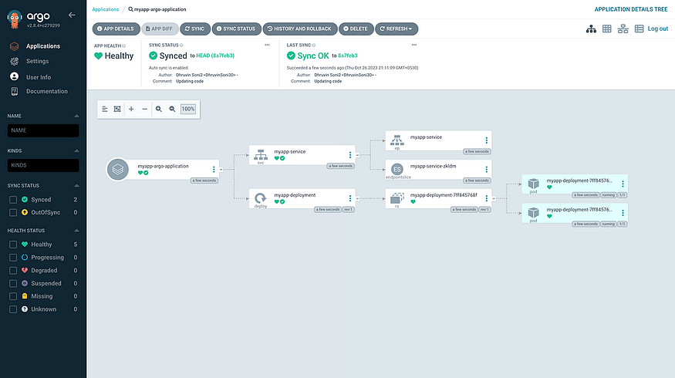
Workflow
Press enter or click to view image in full size
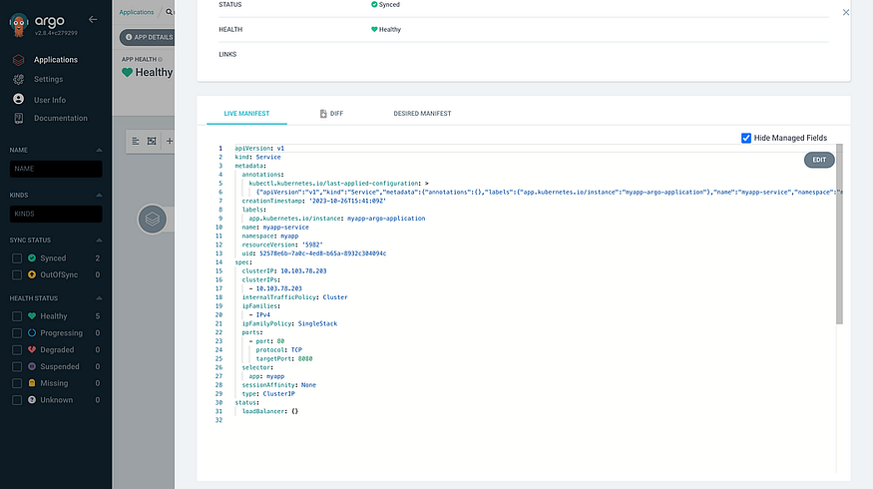
Manifest file
Press enter or click to view image in full size
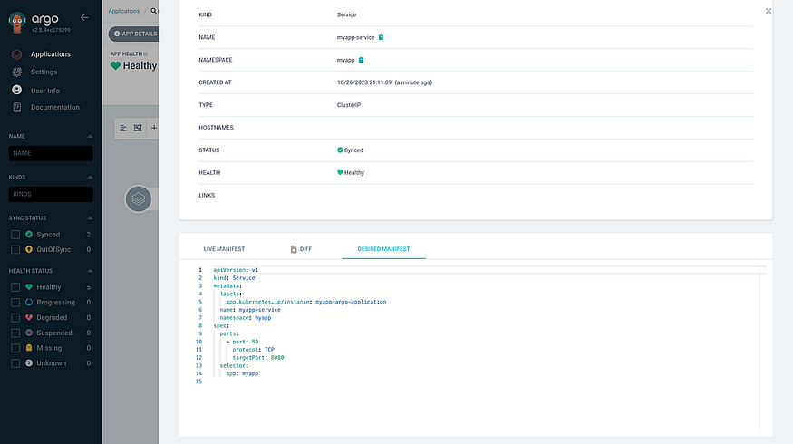
Manifest file
Press enter or click to view image in full size
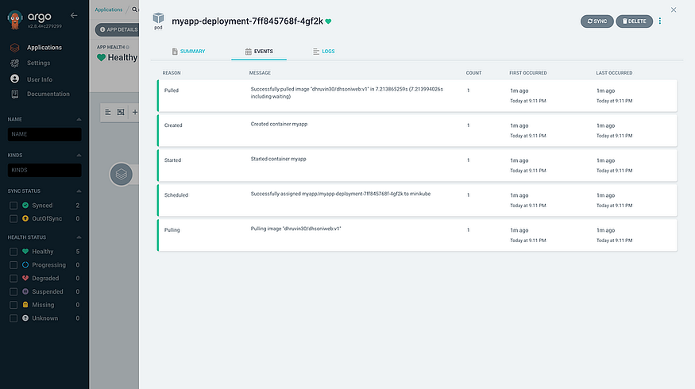
Events of pod creation
- Now let’s say you want to increase the replica for your application. You just need to commit your changes in the git repository deployment.yml
Changes
- As soon as you commit the changes in the repository, argoCD will look for the changes and apply the changes in the cluster.
Press enter or click to view image in full size
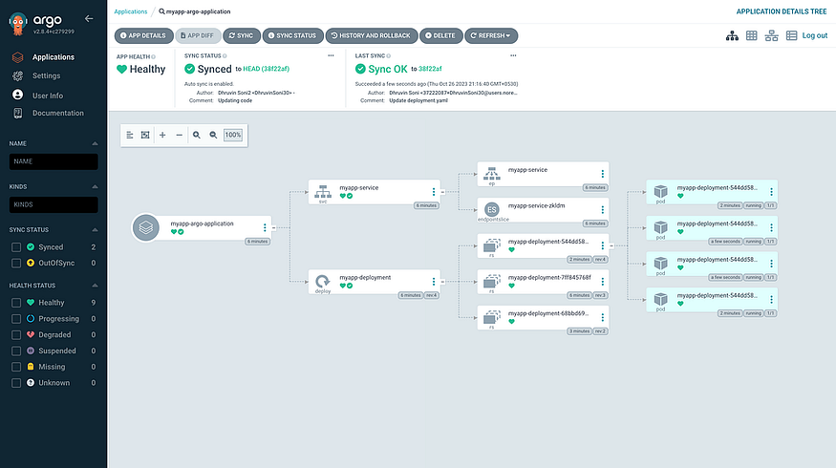
Changes in cluster
- As you can see, now we have a total of 4 pods in the cluster.
ubuntu@ip-172-31-7-106:~$ kubectl get pods -n myapp
NAME READY STATUS RESTARTS AGE
myapp-deployment-544dd58bc4-4sntz 1/1 Running 0 13h
myapp-deployment-544dd58bc4-wkf5j 1/1 Running 0 13h
myapp-deployment-544dd58bc4-xt7hb 1/1 Running 0 13h
myapp-deployment-544dd58bc4-zjmn8 1/1 Running 0 13h
ubuntu@ip-172-31-7-106:~$
- Now you can perform different changes as per your need and argoCD will take care of the further action.

