AZURE PRIVATE LINK
Detailed Solution Architect Study Note
Private Endpoint • Private DNS • Hybrid Connectivity • Private Link Service • Security • Design Patterns

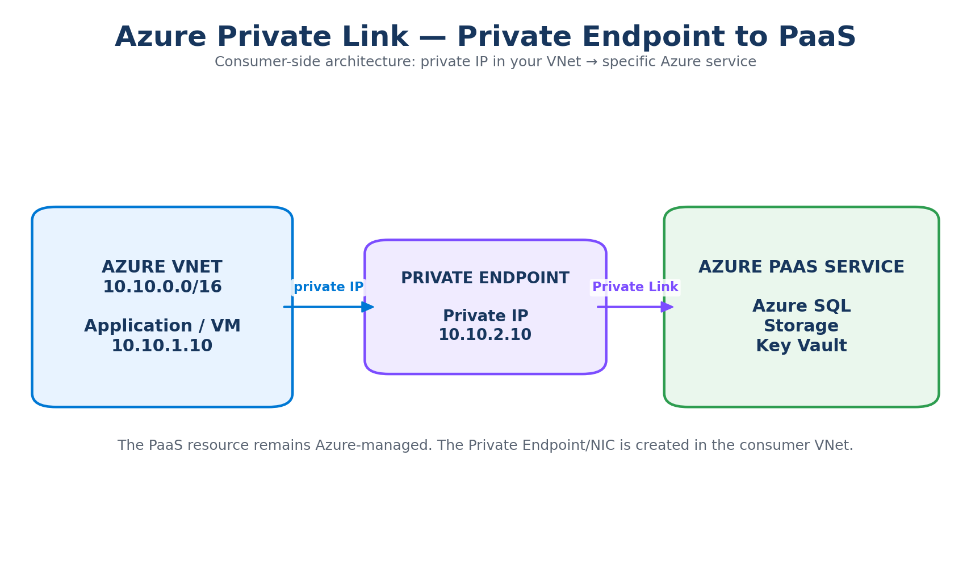
Based on the supplied slide and expanded with current Microsoft Azure architecture guidance.

1. Source Slide – What We Are Expanding
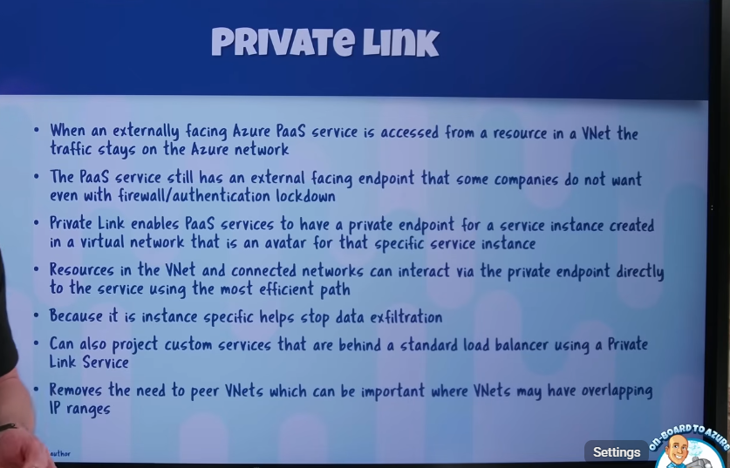
The supplied slide introduces the core ideas of Azure Private Link. The following sections turn those points into a complete architect-level note, including DNS, routing, security, hybrid access, Private Link Service, and comparisons.

2. Executive Summary
Azure Private Link provides private connectivity from a virtual network to supported Azure services and customer/partner services. A Private Endpoint places a network interface with a private IP in the consumer VNet. The service remains managed in its own service boundary; the endpoint provides the private access path.
Architectural rule of thumb
VNet Peering connects networks. Private Link connects a consumer to a specific service. Private Endpoint is the consumer-side construct; Private Link Service is the provider-side construct.

- Private Endpoint: consume an Azure PaaS resource or another Private Link resource privately.
- Private Link Service: publish your own service, normally behind a Standard Load Balancer, for private consumption.
- Private DNS is critical because the service FQDN must resolve to the Private Endpoint private IP.
- Private Link does not replace identity, authorization, TLS, firewall policy, or application security.

3. Core Architecture and Terminology
The main components are:
Component | Role | Typical Example
Private Endpoint | Consumer-side private network interface | VM → Azure SQL
Private Link | Underlying private connectivity mechanism | Private endpoint → service
Private Link Service | Provider-side publication mechanism | Customer → your SaaS API
Private DNS Zone | Private name resolution | privatelink.database.windows.net
Standard Load Balancer | Provider-side front end for classic Private Link Service | PLS → LB → VMs

4. Detailed Explanation of the Seven Points in the Slide

4.1 Traffic can remain on the Microsoft network
Azure services can communicate over the Microsoft backbone. However, 'traffic stays on the Azure backbone' should not be treated as synonymous with 'the service has a private endpoint'. Private Link adds a private endpoint/private IP path and is the stronger choice when the architecture requires private access and reduced public exposure.

4.2 A PaaS service may still have a public endpoint
A supported PaaS resource can have a public endpoint even when consumers are using a Private Endpoint. Creating a Private Endpoint does not automatically mean that public network access is disabled. If the security requirement is private-only access, configure the PaaS resource's network access settings accordingly.
Example
Azure SQL has a normal service FQDN. A production application can be configured to resolve that name to the Private Endpoint IP and, where supported and required, public network access can be disabled.

4.3 Private Endpoint provides private access to a specific resource
A Private Endpoint is deployed into a subnet in the consumer VNet and receives a private IP address. The PaaS resource itself does not move into the VNet. This is a key distinction.

4.4 Connected networks can consume the private endpoint
Resources in the same VNet, appropriately connected VNets, and hybrid/on-premises environments can use the Private Endpoint when routing and DNS are correctly designed. The endpoint is still a service-specific path, not general VNet-to-VNet connectivity.

4.5 Instance-specific access helps reduce data-exfiltration paths
Private Endpoints are associated with specific Private Link resources and target subresources. This granularity helps reduce unintended service access. It is not a complete exfiltration control by itself; identity, RBAC, network controls, DNS, service firewalls and public-access settings remain important.

4.6 Private Link Service can publish a custom service
If your organization owns an application and wants other organizations or teams to consume it privately, you can place the application behind a Standard Load Balancer and publish it through a Private Link Service.
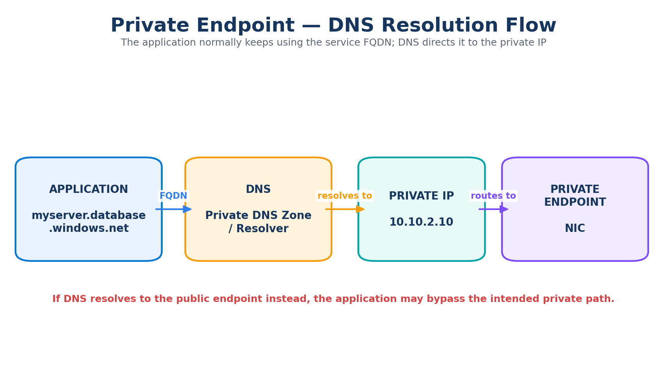

4.7 Private Link reduces the need for VNet peering
A consumer does not need general Layer-3 connectivity to the provider network merely to consume the published service. This is especially valuable for multi-tenant architectures, cross-organization service publishing, and environments where address spaces overlap.
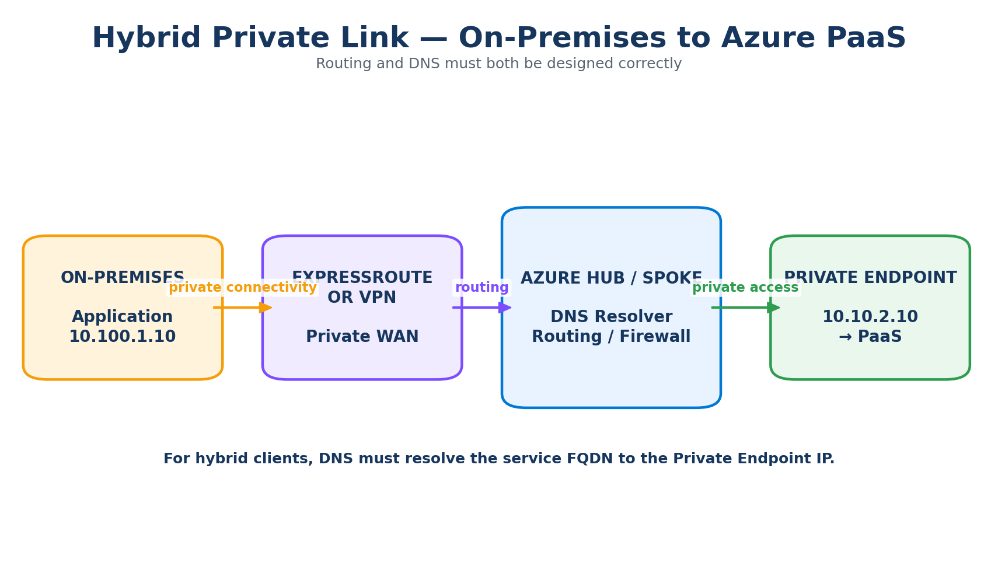

5. DNS – The Most Important Missing Topic
Private Endpoint deployments depend heavily on DNS. An application generally continues to use the service's normal FQDN. DNS must make that FQDN resolve to the Private Endpoint private IP for the workload to use the private path.
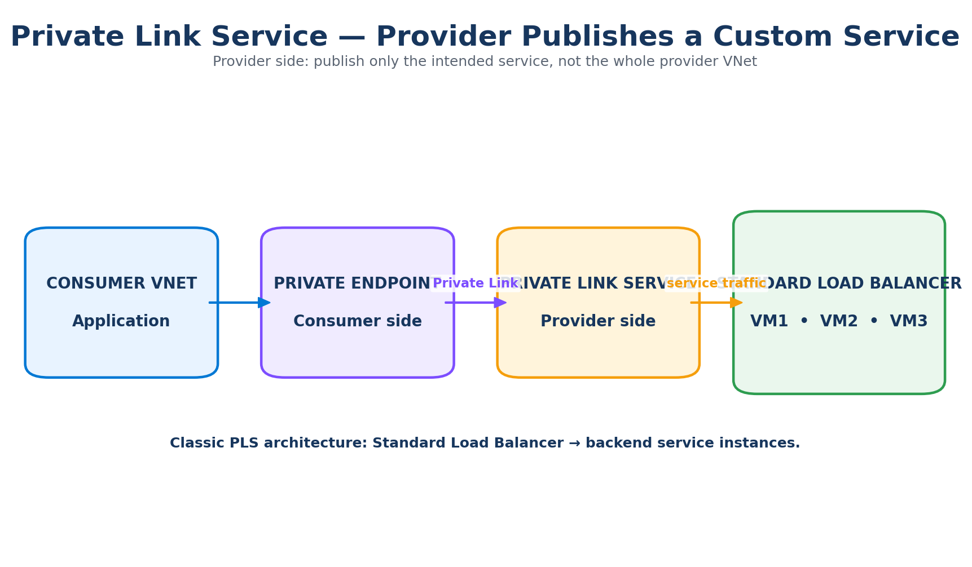

5.1 Private DNS Zones
Azure services use service-specific private DNS zones. Examples include privatelink.database.windows.net for Azure SQL and privatelink.blob.core.windows.net for Blob Storage. The exact zone depends on the service and its Private Endpoint documentation.
- Link the private DNS zone to the VNets that need resolution.
- Use a DNS Zone Group with the Private Endpoint where appropriate.
- Avoid creating conflicting DNS designs that cause the same FQDN to resolve to the wrong endpoint.
- Test with nslookup or dig from the actual workload network.

5.2 DNS Zone Group
A Private DNS Zone Group associates a Private Endpoint with one or more relevant private DNS zones. It helps keep the endpoint and its DNS records integrated. Microsoft recommends service-specific DNS designs rather than putting unrelated services into one private DNS zone.

5.3 Hybrid DNS
When on-premises clients consume Azure Private Endpoints, DNS becomes a hybrid architecture problem. The on-premises DNS infrastructure must be able to resolve the service FQDN to the Private Endpoint IP. Common designs use conditional forwarding, Azure DNS Private Resolver, or DNS forwarders.
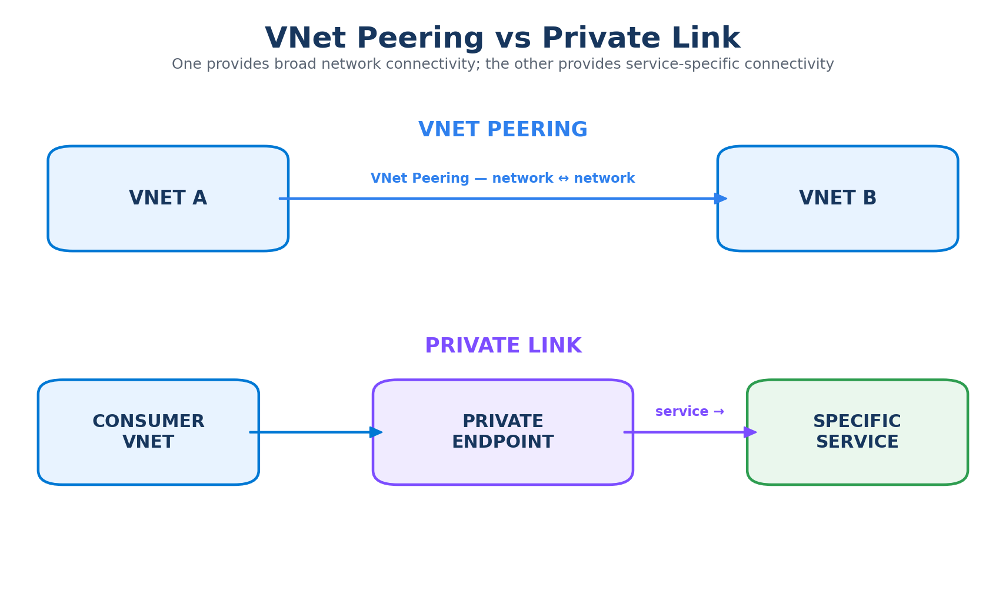

6. Creating a Private Endpoint – Logical Workflow
- Identify a supported Azure resource/service and the required target subresource.
- Choose the subscription/resource group and region for the Private Endpoint.
- Select the consumer VNet and subnet.
- Choose dynamic or static private IP allocation when supported.
- Configure the Private Endpoint connection to the target resource.
- Configure Private DNS integration or the organization's central DNS architecture.
- Approve the connection when approval is required.
- Validate DNS resolution and network connectivity from the workload.
Important
The target resource and the Private Endpoint are separate resources. Deleting the endpoint does not mean the PaaS resource itself is deleted.

7. Target Subresources
Some Azure services expose multiple subresources. Storage is a useful example: Blob, File, Queue and Table can have different private endpoint target subresources. Always check the service-specific Private Link documentation before assuming one endpoint covers every service interface.
Concept | Meaning
Resource | The Azure resource you want to access privately.
Target subresource / group ID | The specific service interface exposed through the Private Endpoint.
Private IP | The private address assigned to the endpoint's NIC in the VNet.

8. Public Network Access and Private-Only Design
A robust production pattern is to first establish and validate Private Endpoint connectivity, then apply the service's supported public network access restrictions if the requirement is private-only access.
Layer | Question
DNS | Does the FQDN resolve to the private endpoint?
Routing | Can the workload reach the private endpoint IP?
Network policy | Do NSGs/UDRs/firewalls allow the traffic?
PaaS network settings | Is public access disabled or restricted as required?
Identity | Is the caller authorized?
Application | Is TLS/connection configuration correct?

9. Security Model
Private Link should be treated as one layer in a defense-in-depth architecture.
Security Layer | Purpose | Example
Private Link | Private network path | VM → Private Endpoint → SQL
DNS | Control name resolution | Private DNS Zone
NSG | Subnet/NIC traffic filtering where supported | Allow only approved source subnets
UDR / Firewall | Centralized routing and inspection | Spoke → Firewall → Private Endpoint
Service network controls | Restrict PaaS network access | Disable public network access
Identity | Authenticate caller | Managed Identity / Microsoft Entra ID
Authorization | Control permissions | RBAC / database permissions
TLS | Protect application data in transit | HTTPS/TLS

10. NSG, UDR and Azure Firewall Considerations
Advanced enterprise designs may apply network policies around Private Endpoints. Current Azure documentation also supports enabling network security group and route-table policies for private endpoints where appropriate. If a centralized security model is required, UDRs and Azure Firewall can be incorporated, but routing must be tested carefully.
Design principle
Do not assume that creating a Private Endpoint automatically sends traffic through your firewall. The desired inspection path must be explicitly designed with routing and DNS.

11. Private Link Service – Detailed Provider Architecture
Private Link Service is used when an organization wants to publish its own service privately. In the classic architecture, the application is behind an Azure Standard Load Balancer. The provider creates a Private Link Service that references the load balancer front end.
Microsoft's current documentation states that standard Private Link Service deployments using a load balancer require an Azure Standard Load Balancer, not the Basic SKU.

11.1 Consumer-provider workflow
- Provider deploys the application behind a Standard Load Balancer.
- Provider creates a Private Link Service referencing the load balancer front end.
- Consumer creates a Private Endpoint targeting the provider's Private Link Service.
- A private endpoint connection request is created.
- Provider approves or rejects the connection as appropriate.
- Consumer DNS is configured to use the private endpoint.
- Application traffic flows privately to the provider service.

11.2 SaaS example
Imagine a company provides a payment API to several customers. Instead of giving every customer network access to the provider VNet, the provider publishes only the payment API through Private Link Service.

12. Private Link vs VNet Peering
Characteristic | VNet Peering | Private Link
Primary model | Network-to-network | Service-to-network
Connectivity scope | Broad network connectivity | Specific service
General routing | Yes | No general provider-VNet routing
Overlapping address spaces | Problematic for general routing | Can support service access
Cross-organization service consumption | Less suitable | Strong use case
Service isolation | Lower | Higher
Typical use | Hub/spoke connectivity | PaaS/private SaaS access

13. Private Link vs Service Endpoints
Feature | Service Endpoint | Private Endpoint
Private IP/NIC in consumer VNet | No | Yes
Private service access model | No private endpoint | Yes
DNS complexity | Lower | Higher
Specific service instance | Less granular | Yes
On-premises private access | Different/limited model | Supported with routing and DNS
Private Link Service support | No | Yes
Microsoft current guidance | Available for supported services | Recommended for private access to supported PaaS
Microsoft's current service endpoint guidance recommends Private Link/private endpoints for secure and private access to supported Azure platform services.

14. Overlapping IP Address Spaces
Private Link is useful when the consumer and provider networks have overlapping IP address ranges because the design does not require general Layer-3 routing between the two VNets.
Example
Consumer VNet: 10.1.0.0/16
Provider VNet: 10.1.0.0/16
General VNet peering is unsuitable for this overlap, but the consumer can still access the provider's published service through a Private Endpoint/Private Link architecture.

15. Enterprise Hub-and-Spoke Pattern
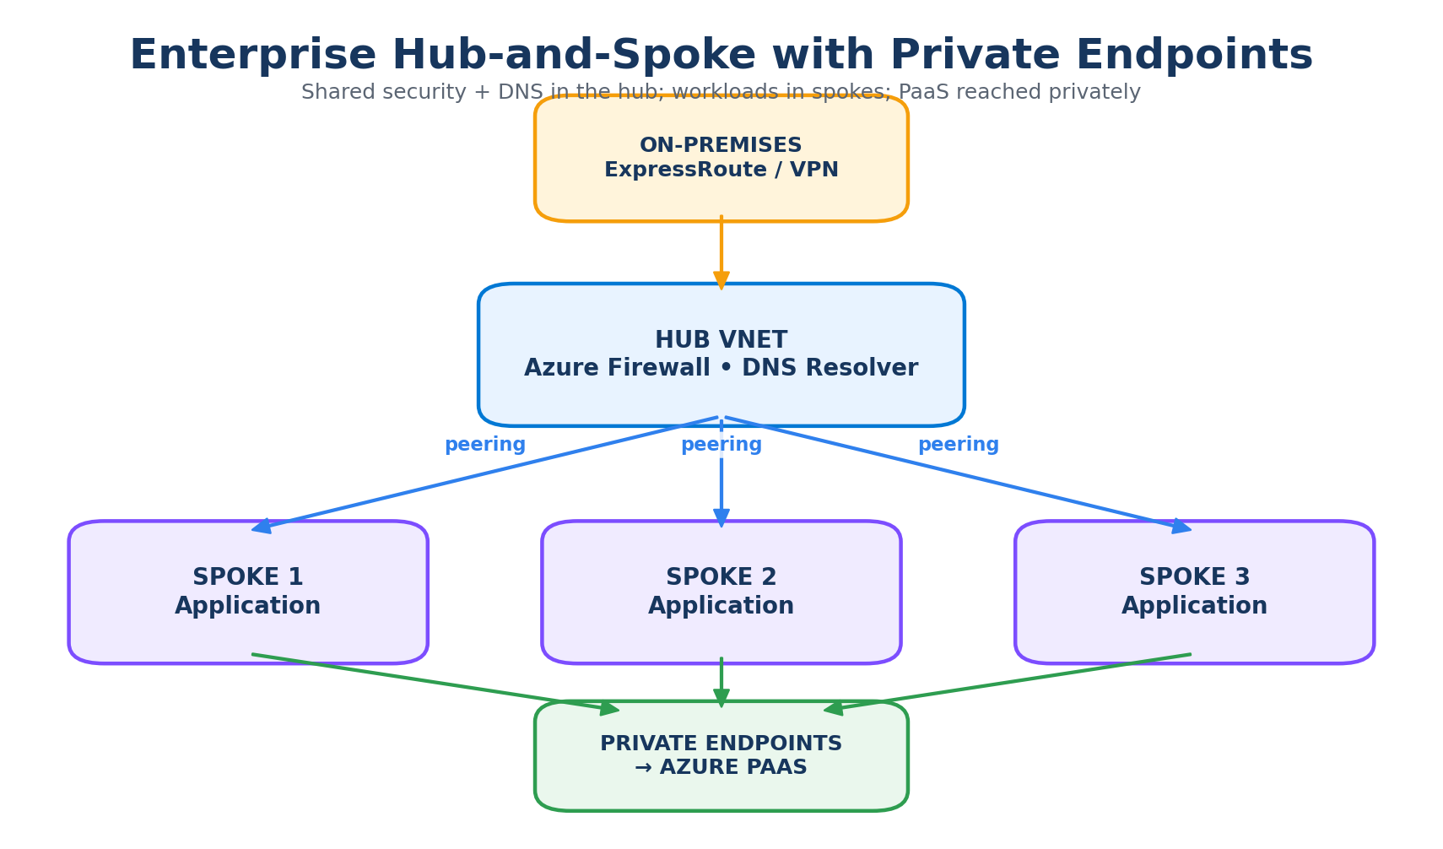
In large enterprises, the hub can provide shared network services such as Azure Firewall, DNS infrastructure and connectivity to on-premises. Spokes host applications, while Private Endpoints provide private access to PaaS services.
- Hub: shared security, DNS and hybrid connectivity.
- Spokes: application workloads.
- Private Endpoints: service-specific private access.
- Private DNS: centralized or delegated name-resolution architecture.
- ExpressRoute/VPN: hybrid connectivity where required.

16. Azure Virtual WAN and Private Link
Azure Virtual WAN and Private Link solve different problems. Virtual WAN provides large-scale connectivity between branches, VNets and hubs. Private Link provides private service consumption. They can be combined in an enterprise architecture.
Conceptually:
Branch → VPN/ExpressRoute → Virtual WAN Hub → VNet → Private Endpoint → PaaS Service

17. Troubleshooting Private Endpoint Connectivity
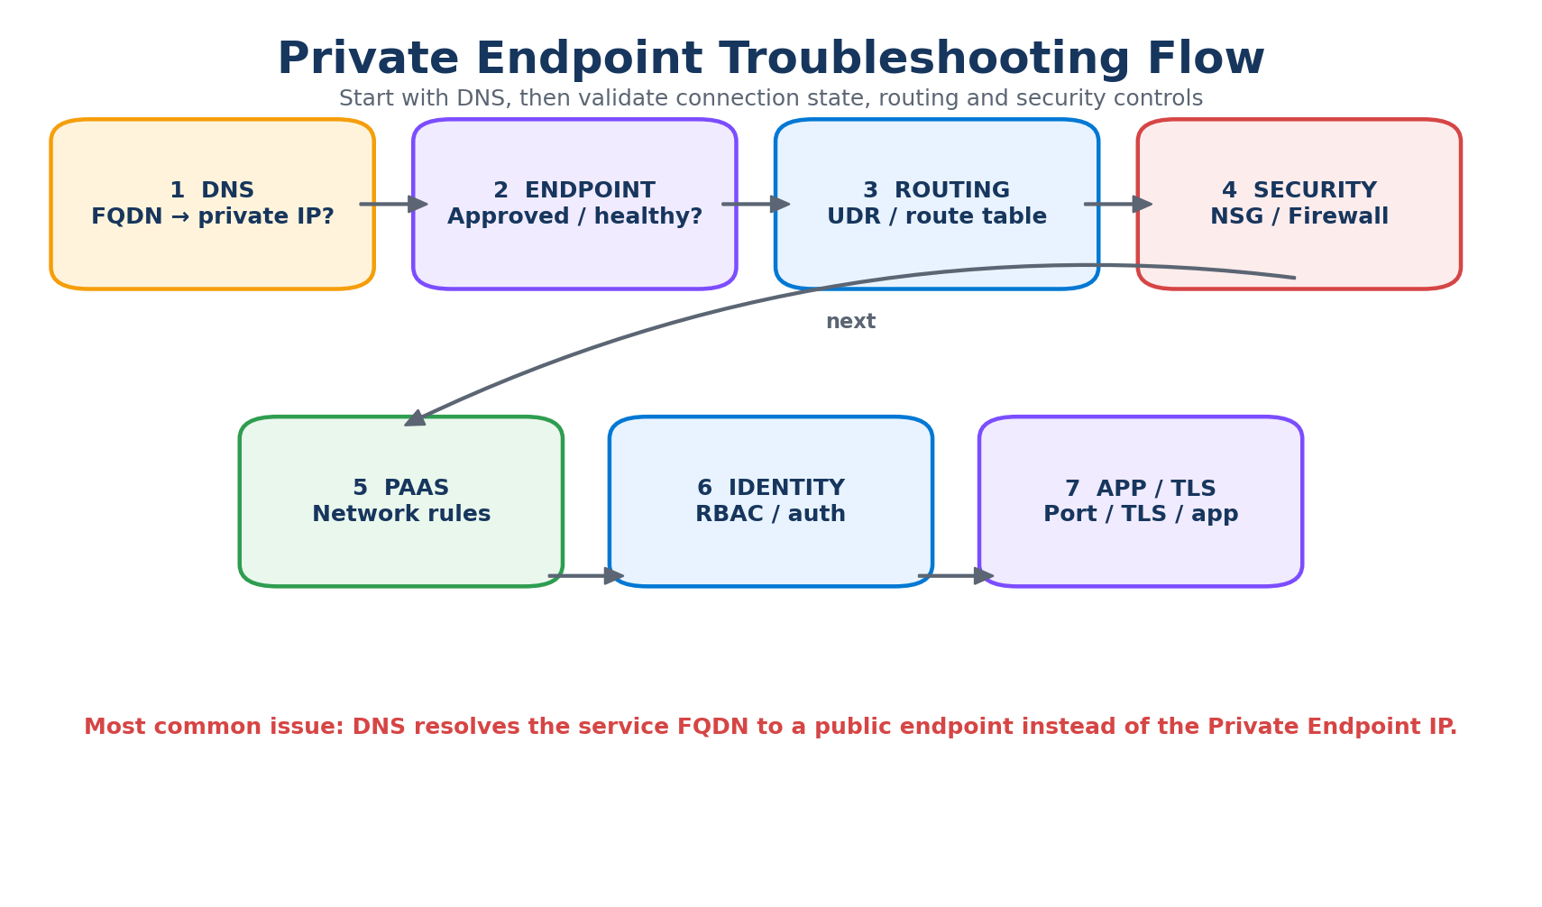
Use this order when diagnosing a problem:
- DNS: run nslookup/dig and confirm the service FQDN resolves to the Private Endpoint private IP.
- Private Endpoint state: verify the connection is approved and the endpoint is in a healthy state.
- Routing: confirm the workload has a valid route to the endpoint subnet/IP.
- NSG/UDR/Firewall: confirm network controls allow the required traffic.
- PaaS network rules: verify the target resource allows the intended private endpoint access.
- Identity: confirm the workload has the required permissions.
- TLS/application: validate port, certificate, TLS and application connection settings.
Common failure
A Private Endpoint can be correctly deployed while the application still fails because DNS resolves the service FQDN to the public endpoint. Always test DNS from the actual workload location.

18. Design and Operational Considerations
- Private Link has its own pricing model; review current Azure pricing before large-scale deployment.
- Plan IP address capacity for Private Endpoint subnets.
- Plan DNS architecture before creating many endpoints.
- Avoid unmanaged one-off DNS configurations across many spokes.
- Use naming, tagging and lifecycle standards for endpoints and DNS zones.
- Document which application consumes which Private Endpoint and target subresource.
- For multi-tenant Private Link Service, define a clear consumer approval and offboarding process.
- Monitor connection state, DNS failures, network flows and service-level errors.

19. Architecture Decision Guide
Requirement | Preferred direction
Need private access from VNet to Azure PaaS | Private Endpoint / Private Link
Need private-only access to supported PaaS | Private Endpoint + DNS + service network restrictions
Need on-premises private access to PaaS | Private Endpoint + ExpressRoute/VPN + hybrid DNS
Need to publish your own service privately | Private Link Service + Standard Load Balancer
Need broad connectivity between application VNets | VNet Peering / Virtual WAN / appropriate network connectivity
Need access to one service without exposing the whole provider network | Private Link
Need service access despite overlapping VNet address spaces | Private Link

20. Interview and Certification Questions
Q: What is Azure Private Link?
A: Private connectivity from a VNet to supported services using a private endpoint, avoiding public Internet exposure for the service connection.
Q: What is a Private Endpoint?
A: A network interface in a VNet with a private IP that provides private connectivity to a Private Link resource.
Q: Does the PaaS resource move into the VNet?
A: No. The endpoint/NIC is in the VNet; the PaaS resource remains Azure-managed.
Q: What is Private Link Service?
A: A provider-side mechanism for publishing a service, classically behind a Standard Load Balancer, to consumers through Private Endpoints.
Q: Does Private Link require VNet peering?
A: No. It provides service-level connectivity.
Q: Why is DNS important?
A: The application FQDN must resolve to the Private Endpoint private IP.
Q: Does creating a Private Endpoint automatically disable public access?
A: No. Public network access is a separate service configuration.
Q: Can Private Link work with overlapping IP ranges?
A: Yes, for service consumption because it avoids general Layer-3 connectivity between the provider and consumer VNets.
Q: Does Private Link replace RBAC?
A: No. Network access and identity/authorization are separate controls.
Q: What load balancer is required for the classic Private Link Service architecture?
A: Standard Load Balancer.

21. Final One-Page Revision Sheet
Remember these four statements
1. Private Endpoint = consumer side.
2. Private Link Service = provider side.
3. Private Link connects a consumer to a specific service, not an entire network.
4. DNS is critical because the service FQDN must resolve to the private endpoint IP.

Term | Remember
Private Link | Private service connectivity mechanism
Private Endpoint | Private IP/NIC in consumer VNet
Private DNS | Resolves service FQDN to private endpoint IP
Private Link Service | Provider-side service publishing
Standard Load Balancer | Classic backend/front end for PLS
VNet Peering | Broad network-to-network connectivity
Service Endpoint | Older/alternative PaaS VNet access model

22. Microsoft References
- Private Endpoint overview: https://learn.microsoft.com/en-us/azure/private-link/private-endpoint-overview
- Private Endpoint DNS integration: https://learn.microsoft.com/en-us/azure/private-link/private-endpoint-dns-integration
- Create a Private Endpoint: https://learn.microsoft.com/en-us/azure/private-link/create-private-endpoint-portal
- Private Link Service overview: https://learn.microsoft.com/en-us/azure/private-link/private-link-service-overview
- Private Link availability: https://learn.microsoft.com/en-us/azure/private-link/availability
- Secure your Private Link deployment: https://learn.microsoft.com/en-us/azure/private-link/secure-private-link
- Service endpoints overview: https://learn.microsoft.com/en-us/azure/virtual-network/virtual-network-service-endpoints-overview
- Private access to Azure PaaS: https://learn.microsoft.com/en-us/azure/networking/design-guide/private-platform-as-a-service

