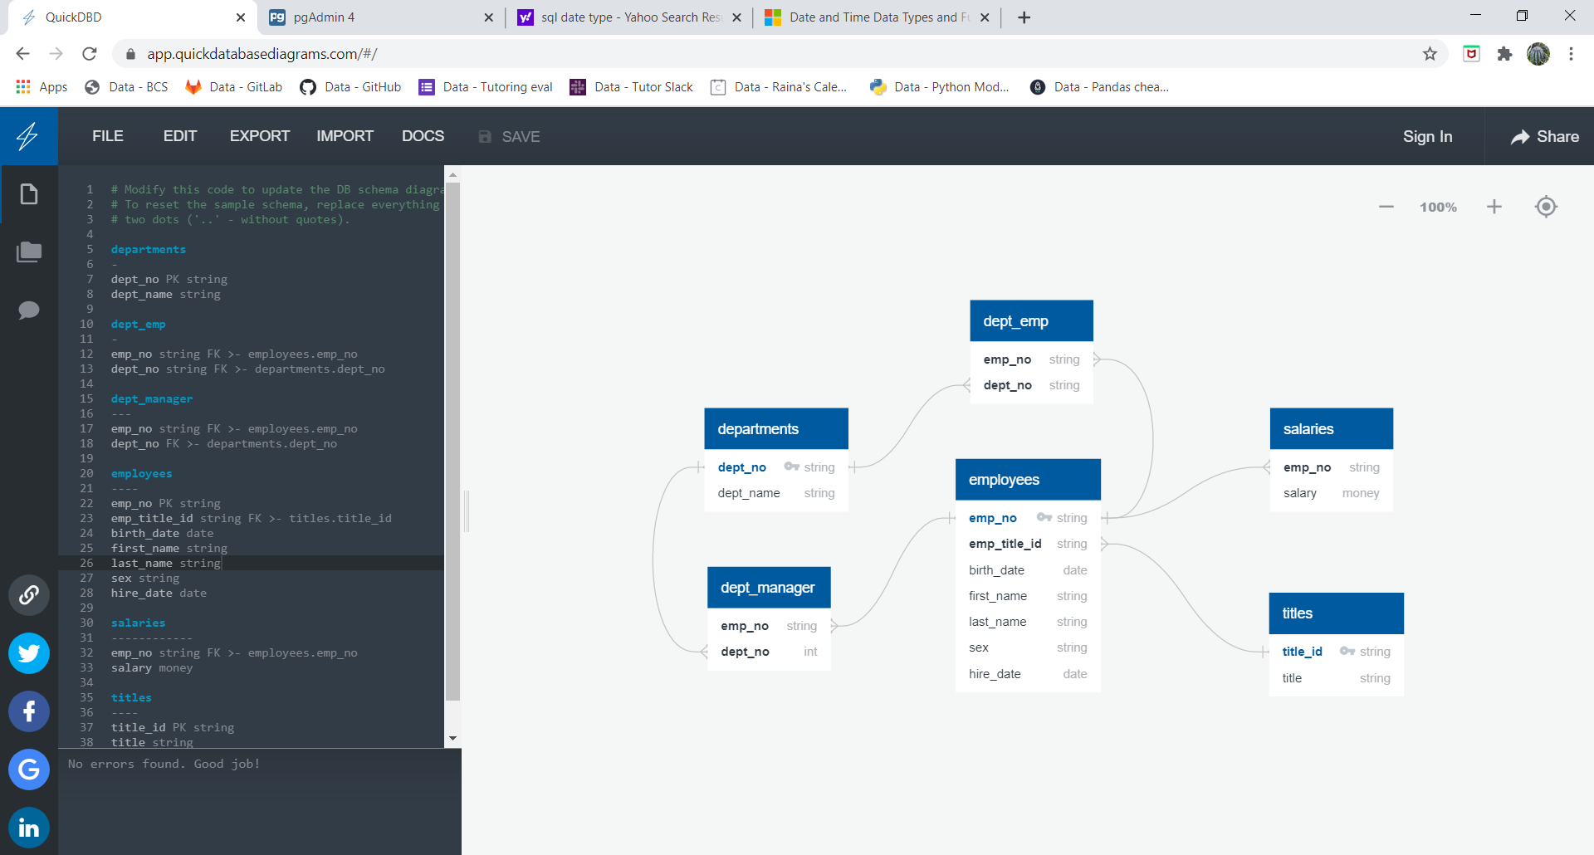

Must be missing a csv called managers.

departments

-

dept_no PK string

dept_name string

dept_emp

-

emp_no string FK >- employees.emp_no

dept_no string FK >- departments.dept_no

dept_manager

---

emp_no string FK >- employees.emp_no

dept_no FK >- departments.dept_no

employees

----

emp_no PK string

emp_title_id string FK >- titles.title_id

birth_date date

first_name string

last_name string

sex string

hire_date date

salaries

------------

emp_no string FK >- employees.emp_no

salary money

titles

----

title_id PK string

title string