**Breast Cancer Detection Using Machine Learning**

Sagun Rupakheti, 19436773

Student, University of Northampton, rupakhetisagun@gmail.com

Demo Video: [CSY3025-Artificial-Intelligence-Breast Cancer Detection Using Machine Learning-19436773-Sagun Rupakheti - MediaSpace Northampton (kaltura.com)](https://northampton.mediaspace.kaltura.com/media/CSY3025-Artificial-Intelligence-Breast%20Cancer%20Detection%20Using%20Machine%20Learning-19436773-Sagun%20Rupakheti/1_wl48w8dd)

**ABSTRACT**

The purpose of this paper is to demonstrate the use of Artificial Intelligence (AI) in real-life instances and applications. The paper talks about the use of AI in detection of breast cancer, or in other words, to distinguish between cancerous and non-cancerous tumors in the breast region. A few research papers have been studied for background information which helped to get insight about importance, need and usefulness of a breast cancer detection model.

Breast Cancer Wisconsin (Diagnostic) has been used for the dataset. Feature engineering and data visualization have been done to visualize and understand the dataset used. The outliers from the dataset have been removed followed by oversampling using SMOTE Tomek. A total of 10 features have been selected out of the 30 features and then the various classifiers are tested. For the machine learning (ML) model, three different classifiers are tested to select the one with the optimum accuracy. The classifiers are compared and evaluated according to how effectively one could categorize malignant and benign tumors. The confusion matrix then obtained confirmed that there was only one false positive and one false negative data assuring the effectiveness of the chosen XGBoost classifier. Finally, hyperparameter tuning and cross validation are done to ensure the final authenticity of the accuracy.

**Keywords**

Machine Learning, Artificial Intelligence, Breast Cancer, Malignant, XGBoost

**1. INTRODUCTION**

Breast cancer is arguably one of the most widespread cancers in the world. Both men and women suffer from breast cancer however, it is dominantly seen in women. Early detection of breast cancer is the most curable but due to lack of awareness and resources, most patients die within 5 years of diagnosis. There are two types of tumors namely malignant and benign. Malignant referring to the tumors that grow and spread and are cancerous whereas benign tumors mean the tumors that do not grow at a fast pace or not at all and do not spread to any other parts of the body. The focus has always been in identifying the malignant tumors also known as cancers which can eventually become a life-threatening condition if not treated properly or treated on time.

The first breast cancer case can be traced back to ancient Egypt in the1600 BC [12]. Remains of a 2,700-year-old Russian king and an Egyptian mummy have been diagnosed with prostate cancer. With this, it is safe to assume that cancers are not modern-day diseases and have existed since a long time. There have been no specific reasons proved to cause cancers as the theories of carcinogens and chemicals causing cancers, do not apply to the ancient people who had a very clean lifestyle and environment.

In the 1750’s a group of surgeons started performing breast cancer surgery where the affected area was removed which is nowadays known as mastectomy. As the early diagnosis and these group of people believed that breast cancer was localized and did not consider the nature of a malignant cancer, the procedure was done removing the breast or parts of the breast that had the tumor. In the year 2020, a total of 2.3 million women were diagnosed with breast cancer and there was around a total of 658,000 deaths [11] caused by breast cancer.

The modern-day treatments for breast cancer include mastectomy, radiation therapy, chemotherapy, hormone therapy, targeted therapy, and immunotherapy [13]. Each patient is treated with a different procedure fitting the nature and intensity of the cancer. A mammogram which is an X-ray picture of the breast is initially taken to look for the early stages of breast cancer. However, in women with denser breast tissue, it becomes difficult to diagnose using mammograms, as the whiter cells which resembles the cancerous cells can be confused with dense breast tissue. This is where Artificial Intelligence (AI) can play a vital role in confirmation of the diagnosis. Mammograms and Biopsy cannot be replaced with such algorithms anytime soon, but they can provide aid in correct and early diagnosis which in turn will ultimately improve the survival rate of breast cancer patients.

Machine learning is not new to cancer research. R. J. Simes performed a clinical trial in the year 1985, researching on developing a model based on decision trees to help diagnose cancer. Despite having started this trend since more than 35 years, the research is ongoing, and the scope of AI in medicine and health is far more than we can visualize. The main aim of this paper is to study an algorithm that can distinguish between malignant and benign breast tumors. The diagnostic accuracy is considered the main domain of concern.

**2. RELATED WORK**

Below are some research papers that were taken as a reference which have covered the scope of machine learning in breast cancer detection. The future and current trends of breast cancer detection have been discussed.

**Paper 1:**

Habib et al. [1] studied genetic programming and machine learning algorithms in the year 2019 to accurately distinguish between malignant and benign breast tumors. The proposed method used three different experiments where the Wisconsin Breast Cancer (WBC) dataset was used.

Support vector machine (SVM), K-nearest neighbor (KNN), Decision tree (DT) , Gradient Boosting Classifier (GB), Random Forest (RF) , Logistic Regression (LR), AdaBoost Classifier (AB), Gaussian Naive Bayes (GNB), and Linear Discriminant Analysis (LDA) classifiers were tested to find the optimum classifier with high accuracy among which GP was selected due to its flexibility. Using effective configuration, feature selection and combination, and automatic machine learning classifier, the experiment was concluded with the drawback of higher time consumption by the model.

**Critical Evaluation:**

Rather than testing out number of classifiers, the authors could have first done a thorough review and research on the optimum use and trends of classifiers for such models. This could have saved a lot of time and their drawback of time consumption could have been negligible.

**Paper 2:**

Abdullah et al. [2] conducted a survey study on image classification for breast cancer to distinguish between benign and malignant cancers in the year 2017. The study compared various databases for breast data, feature extraction and selection, various classifier models i.e., supervised, unsupervised and semi supervised models, compared the performances by these classifiers and finally compared the outputs of the classifiers.

All the images used were histopathological images which are obtained by microscopic examination of biopsy. The study concluded with the finding that classifiers require local feature extraction and due to the ever-evolving nature of cancers, Global Feature extraction helps in extracting more intricate details of an image rather than local features. Thus, Convolutional Neural Network (CNN) with Global Features provide better accuracy in determining malignant tumors in breast cancer.

**Critical Evaluation:**

The paper has a couple of findings among which they state that the malignancy information is usually concentrated in an area defined as ROI [2]. But malignancy as clinically defined is spread to several different parts, not just the breast area. So, such hypothesis can be refined by predicting the spread of the cancer cells which would help and prevent patients from developing a more complex and vast cancer.

**Paper 3:**

Weiming et al. [3] in the year 2017 conducted a study to diagnose breast cancer using histopathological images and machine learning. The BreakHis dataset was used to develop the model.

Patch extraction, image augmentation, transfer learning using Visual Geometry Group Network (VGGNet) CNN architecture, assembling patch sampling models and, splitting the training and testing data into 8:2 ratio were the approaches used to create the model. The study was concluded with the finding that a shallow model (5 patches per image in the study) can perform well in a deeper VGGNet and certain small tasks can yield a better performance than a complex model as the test model built by the authors surpassed the current best results.

**Critical Evaluation:**

The authors did not experiment or either did not document the trial-and-error process of gathering information for selection of the classifier. Since this paper included a unique use of dataset, understanding the efficiency of this database would have been better if it had been experimented with a few many other classifiers.

**Paper 4:**

Yadavendra et al. [4] did a study on breast cancer tumor classification using machine learning in the year 2020. Histopathology images dataset was used dividing the training, testing and validation data as 60%, 20% and 20% respectively.

The proposed method used logistic regression, random forest decision tree classifier, SVM, AdaBoost classifier, Bagging classifier, Voting classifier, CNN classifier to compare and contrast the different outputs yielded by these classifiers. The study found that the Xception CNN model provided the best scores for precision, recall and F1 score.

**Critical Evaluation:**

The authors included a unique dataset, understanding the efficiency of this database would has been better as the many classifiers are used with this dataset. However, Random Forest Classifier has better scores than logistic regression which may have been cross validated to check the optimum solution.

**Paper 5:**

Omar et al. [5] in the year 2018 conducted a research on the performance of machine learning techniques in the classification of a breast cancer dataset called Wisconsin Breast Cancer. The purpose of the study was to maximize the accuracy of models to distinguish between malignant and benign tumors. Support Vector Machine (SVM) and K-Nearest Neighbor (KNN) were used to develop the model. The paper was concluded with the fact that SVM provides better accuracy which provided a significant better accuracy of 98.1%.

**Critical Evaluation:**

The paper has used the dataset and classifiers as close to the model talked about in this paper. The findings of the paper seem very vague and centric which do not provide a lot of core information on underpinning the techniques themselves.

**Paper 6:**

Patrizia et al. [6] in the year 2019 conducted a research on prognosis of breast cancer using a machine learning approach. Surveillance Program, Epidemiology, and End Results (SEER) dataset was used with unsupervised Machine Learning (ML) approach.

Combining SVM and random optimization, the test and training data were divided into 30% and 70% respectively. The paper concluded that a combination of ML algorithms and Reverse Osmosis (RO) improves the precision of the predicting model and might hold the potential of improving precisions. The paper also focused on the need of validation of privacy in terms of Electronic Health Records (EHR).

**Critical Evaluation:**

The paper has stated many factors and possibilities of pathological characters age, menopause status, Body Mass Index (BMI), etc. which provide insight into the statistical grouping of cancer patients. The paper provided a blend of medical and machine learning methods however, the authors seemed a little biased towards focusing on the medical aspect of the prognosis.

**Paper 7:**

Siham et al. [7] conducted a study on analysis of various machine learning techniques in breast cancer detection in the year 2020. Imbalanced data is one of the major concerns during model development and specially in medical data as these require very precise and accurate collection which is outnumbered by benign data.

Using the WBC dataset and Breast Cancer Dataset, the classifiers J48, Naive Bayes (NB), Sequential Minimal Optimization (SM0) were compared to find the appropriate algorithm for detection. The paper mainly focuses on resampling techniques to further enhance the process of classification. Resample filter was used with all the classifiers in the preprocessing stage which proved to improve the classifier’s performance. The paper concluded with presenting a 99.04% accuracy obtained by the model.

**Critical Evaluation:**

The authors included a literature review section reviewing various papers and their outcomes. These are only mere numbers, and no further elaboration has been done to explain the process and techniques used.

**Paper 8:**

Jayesh et al. [8] in the year 2020 researched on automated breast cancer detecting using a hybrid extreme ML classifier. In the field of medical imaging, the breast imaging technique is mammograms which are dominantly the dataset used for developing the model.

The paper proposes the use of extreme learning machines (ELM) with Fruitfly Optimization Algorithm (ELM-FOA). Mammographic Image Analysis Society (MIAS) database was used to develop the proposed method which could detect and classify the tumors with 99.04% accuracy.

**Critical Evaluation:**

The false positives and false negatives provided by the model seem a little on the higher side. This created doubts in the reliability of the model.

**Paper 9:**

Bin et al. [9] conducted a study on mammographic image classification of breast cancer using ML approach in the year 2018 for classifying benign and malignant cancers.

MIAS dataset was used and using supervised learning, CNN-4d model was built consisting of four convolution layers and a dropout of 0.7. Local histogram equalization, balancing data, followed by training, a training accuracy of 93.42% and testing accuracy of 89.05% was achieved. The paper concluded that CNN could play a very important role in medical imaging.

**Paper 10:**

Mariem et al. [10] in the year 2018 researched on classification of breast cancer using machine learning. The purpose of the authors for the research is to determine if a person has benign or malignant tumor.

Two different classifiers NB and KNN were compared using WBC dataset. The obtained accuracies were cross validated, and the paper was concluded with the fact that KNN achieved higher accuracy of 97.51% however NB too had a good accuracy of 96.19%. Considering the run-time, NB performed faster and efficiently.

**Critical Evaluation:**

The related work section of the paper has vague information stating that SVM provides the highest accuracy when used with WBC dataset, not providing the relevant source for the proclaimed information.

**3. PROTOTYPE AND METHODS**

The methods and resources used by the prototype have been discussed in this section. A series of steps have been followed to develop the machine learning model.

**3.1. Dataset Used for Research**

In this study, Breast Cancer Wisconsin (Diagnostic) dataset has been used to develop the model. The dataset was created by Dr. William H. Wolberg in the year 1995, who used fluid samples taken from patients with solid breast masses. He used a graphical computer program called Xcyt which is a system for remote cytological diagnosis mainly used for prognosis of breast cancer. Xcyt uses a curve fitting algorithm which computes 10 features from each cell then calculates the mean value, extreme value and standard error for each feature [14]. The images were collected by digitizing the fine needle aspirate (FNA) of a breast mass which describe the characteristics of a cell nuclei.

A total of 569 instances are present in the dataset with 10 attributes namely radius, texture, perimeter, area, smoothness, compactness, concavity, concave points, symmetry, and fractal dimension. 30 numeric predictive attributes are present with two classes Malignant and Benign which are distributed to have 212 and 357 data, respectively. Altogether 30 features are available in the dataset for which feature selection can be done according to the necessity.

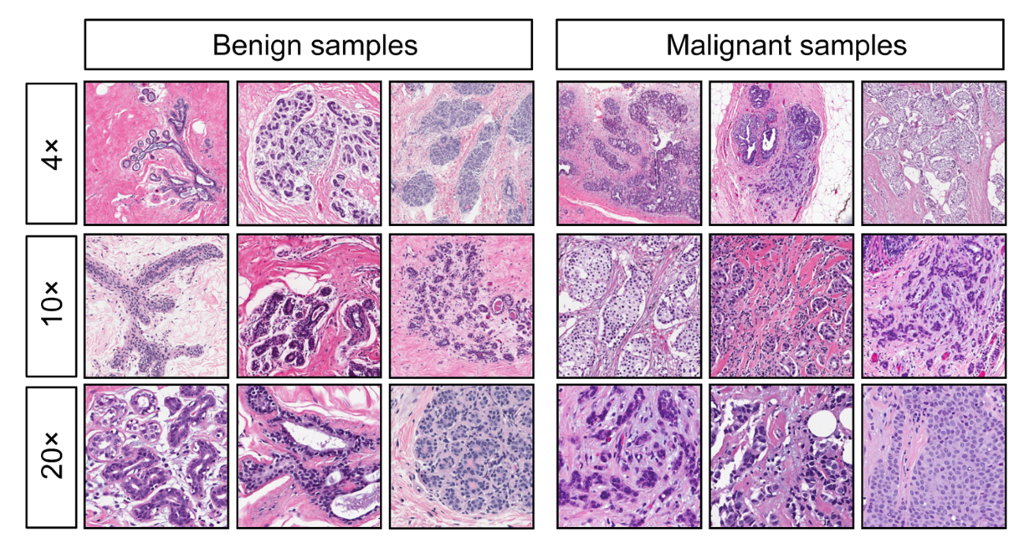

Figure 1: Benign and Malignant sample images present in the dataset

The studies using this dataset have quite a high success rate which is deemed very important as detecting cancers needs to be as accurate and precise as possible.

**3.2. Implementation**

Considering the various factors and outcomes studied from literature reviews and many more sources, the model was implemented.

**3.2.1. Feature Engineering**

Feature Engineering is basically the process of extracting information from raw data. The obtained features from feature engineering can be used to improve and correct machine learning algorithms. Pandas and NumPy are used to visualize and extract the data from the dataset.

Imputation is the process of determining missing values. For this, using the isnull() function returned if there were any missing values in the features of the dataset. Since there were no missing values, the next step was to check if there was any imbalance in the distribution of the data.

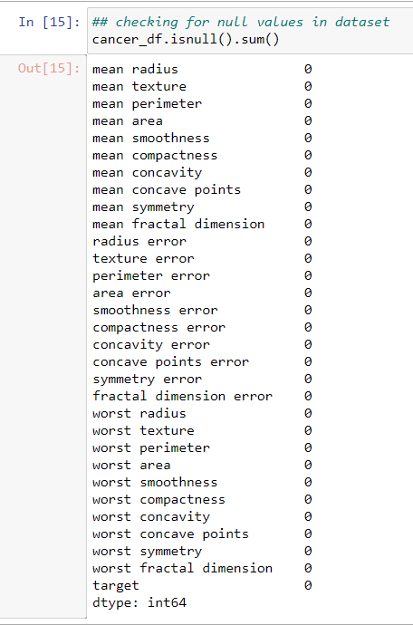

Figure 2: All the features in the dataset

Using the hist() function, the skewed data distribution was analyzed. Then after, to view the normal distribution of the data, a logarithmic operation had to be carried out. The correlation of the features in the dataset were checked using heatmap() function.

**3.2.2. Data Visualization**

A multivariate analysis approach is used as there are a total of 30 features that need to be analyzed. It is technique used for analysis when there are more than two variables in the data. The function pairplot() in turn gave two targets i.e., malignant and benign tumors visualization from the data. Both the targets were seen to be overlapping so for the same reason, the SVM classifier below is used to differentiate the overlapped target data. The separation of overlapping target data is important as the data appears as valid instances of both the malignant and benign classes which in turn is responsible of noise in the data.

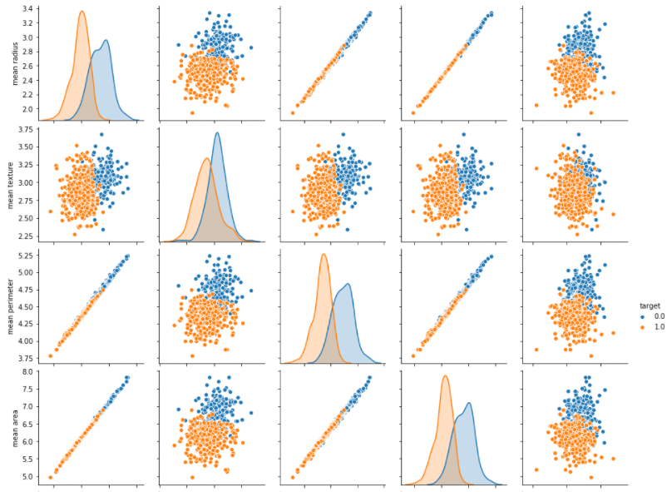

Figure 3: Figures showing the clustering of the data with outliers

**3.2.3. Removing outliers**

Outliers are the data or set of data that do not form clusters in the process of clustering. These data usually do not provide any aid in building the model rather create problems and errors which makes it necessary to get rid of them. After data visualization, there could be seen data that were not forming clusters, and which were isolated from the rest.

So, to remove the outliers, interquartile range is used. Interquartile range (IQR) finds out the areas that contain the bulk of values which could be associated with clusters. The data except the ones in the first quartile which is 1.5 times smaller than the IQR and the data from third quartile which is 1.5 times greater than the IQR is removed from the dataset.



Figure 4: Removing Outliers

The total of 569 instances got reduced to 482 instances after removing the outliers. The total for target classes also decreased to 306 for benign and 176 for malignant. Due to this removement, the dataset now had become unbalanced as the data for malignant tumors decreased significantly.

**3.2.4. Oversampling**

As removing outliers made the dataset imbalanced, oversampling was done to replicate the existing data and balance the dataset. SMOTE Tomek which is an oversampling technique that focuses on creating new instances using interpolation between positive instances and helps to overcome overfitting problems, was used for oversampling. After oversampling, the dataset was balanced as it increased the malignant data from 176 to 226.

**3.2.5. Feature Selection**

Lasso has been used to select the features for the model. However, in the real-time scenario a domain expertise is required which analyze the correct features to be selected.

Lasso regression, a type of linear regression uses shrinkage, a method that shrinks data towards a central point. It performs L1 regularization which limits the size of coefficients that which can make some coefficients zero, which results in elimination of those features.

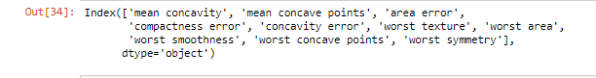

Figure 5: All the selected 10 features

A total of 10 features out of 30 features had been selected by the Lasso regression. Finally, the dataset was split into 80% training data and 20% testing data.

**3.2.6. Training and Classifiers**

Classification is an important domain since the data obtained after removing the outliers is overlapped and needs to be classified into the given classes. To trial and test various classifiers is an important process to get the maximum accuracy by the final model. For the same, three classifiers Support Vector Machine (SVM), Random Forest Classifier and eXtreme Gradient Boosting (XGBoost) were used for testing and the final dataset and the accuracies provided by the classifiers were analyzed to select the best suited classifier for the model.

**3.2.6.1. SVM**

It is a classification method in which each data item is plotted as a point in n-dimensional space where n refers to total number of features present. The value of each feature is associated with the value of each coordinate that it is plotted as. Using these plotted points, the data is separated and classified as groups. Here, a linear SVM classifier

The accuracy yielded by this classifier was 92%.

ALGORITHM 1: Support Vector Classifier (SVC) Algorithm

input: Collect the dataset with separated training and testing data

Step 1: Import SVC for classification

Step 2: Create an object of SVC

Step 3: Fit the training data into the model

Step 4: Use prediction on the model

Step 4: Get the accuracy score of the test data

output: 92.45% accuracy

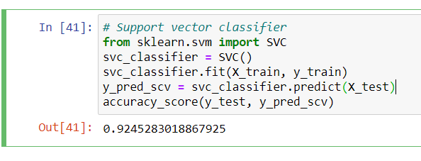

Figure 6: Image showing the implementation of SVC algorithm and accuracy

**3.2.6.2. Random Forest Classifier**

Random Forest Classifier is a classifier that uses a group of decision trees. For classification, each tree selects the class based on the features or attributes. Then after the forest selects the classification which is the most selected by the trees.

The parameters passed in the random forest object signify the number of trees in the forest represented by n_estimators, function to measure the quality of split for which ‘entropy’ is for information gain, represented by criterion and random_state for randomness of the samples when bootstrapping.

The classifier yielded a 96% accuracy.

ALGORITHM 2: Random Forest Classifier Algorithm

input: Collect the dataset with separated training and testing data

Step 1: Import Random Forest Classifier for classification

Step 2: Create an object of RandomForestClassifier and add n_estimators, criterion and random_state

Step 3: Fit the training data into the model

Step 4: Use prediction on the model

Step 4: Get the accuracy score of the test data

output: 96.23% accuracy

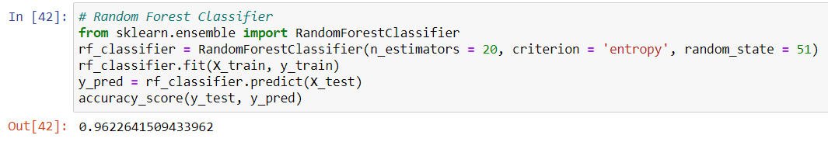

Figure 7: Image showing the implementation of Random Forest Classifier algorithm and accuracy

**3.2.6.3. XGBoost (eXtreme Gradient Boosting)**

Gradient Boosting Algorithm (GBA) is used when enough data is available for making a high prediction. XGBoost algorithm is a GBA which has been quite popular for its gradient boosted decision trees which is designed for speed and performance. Making the best use of available resources to train the model has been the most prominent feature of XGBoost.

Boosting is an ensemble technique where the errors made by older models are corrected by adding new models. A series of models are added until no further improvements can be made. In case of gradient boosting, new models are added that predict the errors of the previous models. Since it uses a gradient descent algorithm it minimizes the loss while adding new models.

Using this algorithm to create the model, the accuracy yielded was 98%.

ALGORITHM 3: XGBoost Algorithm

input: Collect the dataset with separated training and testing data

Step 1: Import XGBoost for classification

Step 2: Create an object of XGBoost and set the random state

Step 3: Fit the training data into the model

Step 4: Use prediction on the model

Step 4: Get the accuracy score of the test data

output: 98.11% accuracy

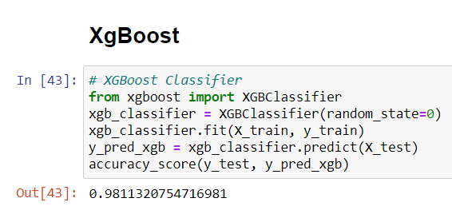

Figure 8: Image showing the implementation of XGBoost algorithm and accuracy

**3.2.7. Final Selection and Analysis**

Since XGBoost provided the most accuracy, the classifier was used for the completion of the model.

Table 1: Classifiers and accuracies

| Classifier | Accuracy |
| --- | --- |
| SVC | 92% |
| Random Forest | 96% |
| XGBoost | 98% |

***SVM < Random Forest Classifier < XGBoost***

The confusion matrix obtained for the predictions made by the XGBoost classifier showed that there was only one false positive and one false negative data which indicated that the performance provided by the classifier was almost accurate.

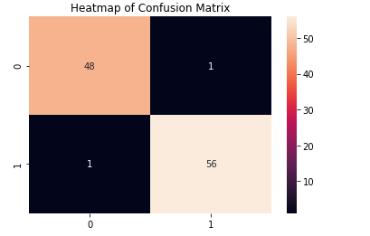

Figure 9: Image showing the confusion matrix of the classifier XGBoost

**3.2.8. Hyperparameter tuning**

Hyperparameter tuning is the process to finding the correct architecture for a model for which random search has been used. It does so by finding the best performance on the validation data of all the hyperparameters of the algorithm.

Through random search, the best parameters and best estimators have been used to get the best values obtained by the tuning. After hyperparameter tuning, the accuracy significantly increased to 99%.

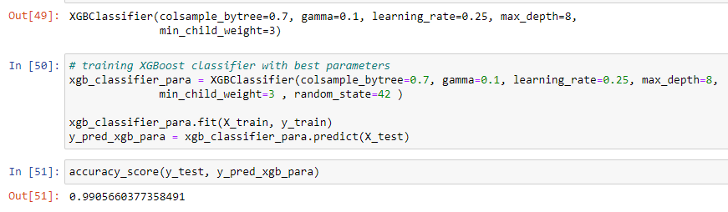

Figure 10: Image showing the hyperparameter tuning for the classifier

**3.2.9. Cross Validation for overfitting**

There is a possibility of overfitting in the model obtained from hyperparameter tuning. To minimize the overfitting, cross validation is used to find the cross validation mean. The total mean accuracy which is the mean accuracy for the model is obtained at the end of total 97%.

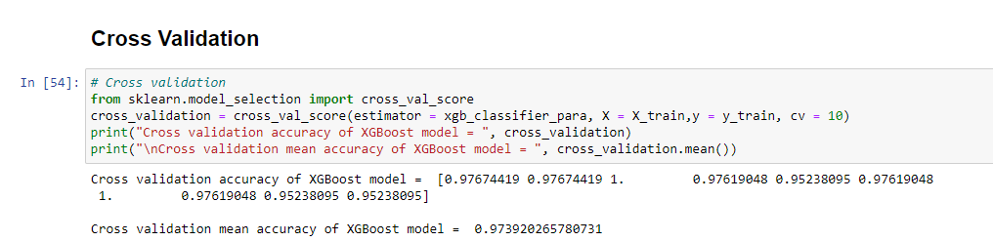

Figure 11: Image showing the cross validation for the classifier

**3.3. Final output**

The final average accuracy obtained by the model is 97.39%. Since cancer is a deadly disease which requires as accurate prediction and diagnosis as possible, the obtained accuracy seems moderately acceptable but cannot still be trusted on. The final model can be further sharpened by trying a different classifier or a different dataset. Other datasets such as BreakHis dataset, SEER, etc. can be tried and tested to aim for a much better result.

The implementation process yields the results below. Providing the image related to a malignant tumor results in classifying the image as malignant and the same is classified for benign.

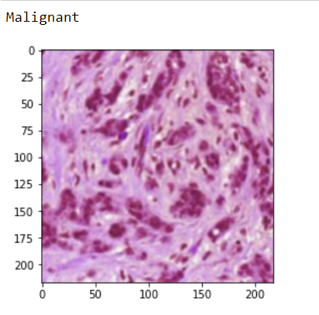

Figure 12: Classification of malignant tumor

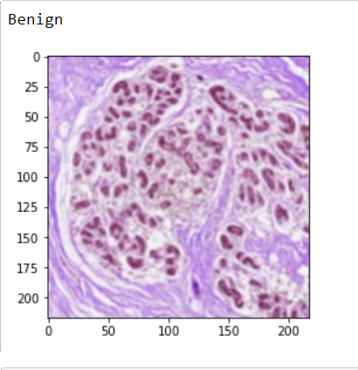

Figure 12: Classification of benign tumor

**4. CONCLUSIONS**

Breast cancer is a serious threat specially to women mainly because of the high mortality rate. The status and characteristics of cancer changes with time which might also make them lethal. Research on such sensitive areas is required with thorough and constant investigation, appropriate data and proper clinical data management.

In this paper, the accuracy of classifiers to classify benign and malignant cancers is investigated, which in turn indicated that XGBoost classifier provides the most accuracy. With areas such as detecting cancers, the result is expected to be as accurate as possible as it revolves around a sensitive realm of issues and concerns. Despite having a total of 97% of accuracy, the model cannot still be considered optimum to have trust on a 100%. However, such models help in confirmation of diagnosis for patients as well as doctors.

Overall, the report provides an insight into what is needed to create such machine learning models, what are the integral parts of such AI technologies and what group of people or area do such applications provide help. As the application is concerned with the medical field, there is no underpinning of a specific group of people for the usability of the application talked about in this paper. It would be safe to assume that application of machine learning in the health field benefits not just a group of people but every individual in a way or so.

**ACKNOWLEDGEMENTS**

I would like to express my humble gratitude towards Dr. Roshan Koju, our Artificial Intelligence module leader for his constant support and guidance throughout the project.

# REFERENCES

1. Dhahri, H., Al Maghayreh, E., Mahmood, A., Elkilani, W., Faisal Nagi, M. (2019). Automated Breast Cancer Diagnosis Based on Machine Learning Algorithms. Journal of Healthcare Engineering, pp.1–11.
2. Nahid, A. A., and Kong, Y. (2017). Involvement of Machine Learning for Breast Cancer Image Classification: A Survey. Computational and Mathematical Methods in Medicine, pp.1–29
3. Zhi, W., Yueng, H. W. F., Chen, Z., Zandavi, S. M., Lu, Z., Chung, Y. Y. (2017). Using Transfer Learning with Convolutional Neural Networks to Diagnose Breast Cancer from Histopathological Images. Lecture Notes in Computer Science, pp. 669–676
4. Yadavendra, and Chand, S. (2020). A comparative study of breast cancer tumor classification by classical machine learning methods and deep learning method. Machine Vision and Applications, 31(6)
5. Obaid, I. O., Mohammed, A. M., Ghani, A. K. M., Mostafa, S. (2018) Evaluating the Performance of Machine Learning Techniques in the Classification of Wisconsin Breast Cancer. International Journal of Engineering and Technology, pp 160-166
6. Ferroni, P., Zanzotto, F., Riondino, S., Scarpato, N., Guadagni, F., Roselli, M. (2019). Breast Cancer Prognosis Using a Machine Learning Approach. Cancers, 11(3), pp. 328
7. Mohammed, A. Siham, Darrab , S., Noaman, A. S., Saake, G. (2020). Analysis of Breast Cancer Detection Using Different Machine Learning Techniques. Communications in Computer and Information Science, 1234
8. Melekoodappattu, J. G., and Subbian, P. S. (2020). Automated breast cancer detection using hybrid extreme learning machine classifier. Journal of Ambient Intelligence and Humanized Computing
9. Li, B., Ge, Y., Zhao, Y., Guan, E., Yan, W. (2018). Benign and malignant mammographic image classification based on Convolutional Neural Networks. ICMLC 2019. pp 247-251
10. Amrane, M., Oukid, S., Gagaoua, I., Ensari, T. (2018). Breast cancer classification using machine learning. 2018 Electric Electronics, Computer Science, Biomedical Engineerings’ Meeting (EBBT)
11. World Health Organization (2021) Breast Cancer. WHO[online]. Available from: [Breast cancer (who.int)](https://www.who.int/news-room/fact-sheets/detail/breast-cancer) [Accessed 26/04/21]
12. Maurer Foundation breast cancer education (2012) Is Breast Cancer Modern Illness?. Maurer Foundation[online] Available from: [A Brief History of Breast Cancer (maurerfoundation.org)](https://www.maurerfoundation.org/a-brief-history-of-breast-cancer/#:~:text=Breast%20cancer%20can%20also%20be,1600%20BC%20Edwin%20Smith%20Papyrus.) [Accessed 20/04/21]
13. WebMD (2021) Breast Cancer Treatment. WebMD[online]. Available from: [Treatments for Breast Cancer (webmd.com)](https://www.webmd.com/breast-cancer/breast-cancer-treatment) [Accessed 20/04/21]
14. Rohit Dwivedi (2021) How Does Support Vector Machine (SVM) Works In Machine Learning?. Analytic Steps[online]. Available from: [How Does Support Vector Machine (SVM) Algorithm Works In Machine Learning? | Analytics Steps](https://www.analyticssteps.com/blogs/how-does-support-vector-machine-algorithm-works-machine-learning) [Accessed 20/04/21]
15. AIFusion (2020) Breast Cancer Detection Using Machine Learning Classifier. YouTube[online]. Available from: [(350) Breast Cancer Detection Using Machine Learning Classifier - YouTube](https://www.youtube.com/watch?v=-jM4_OkcADw&ab_channel=AIFusion) [Accessed 26/04/21]