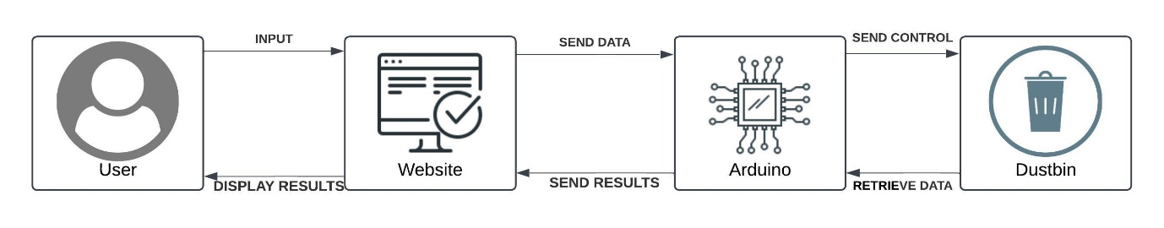

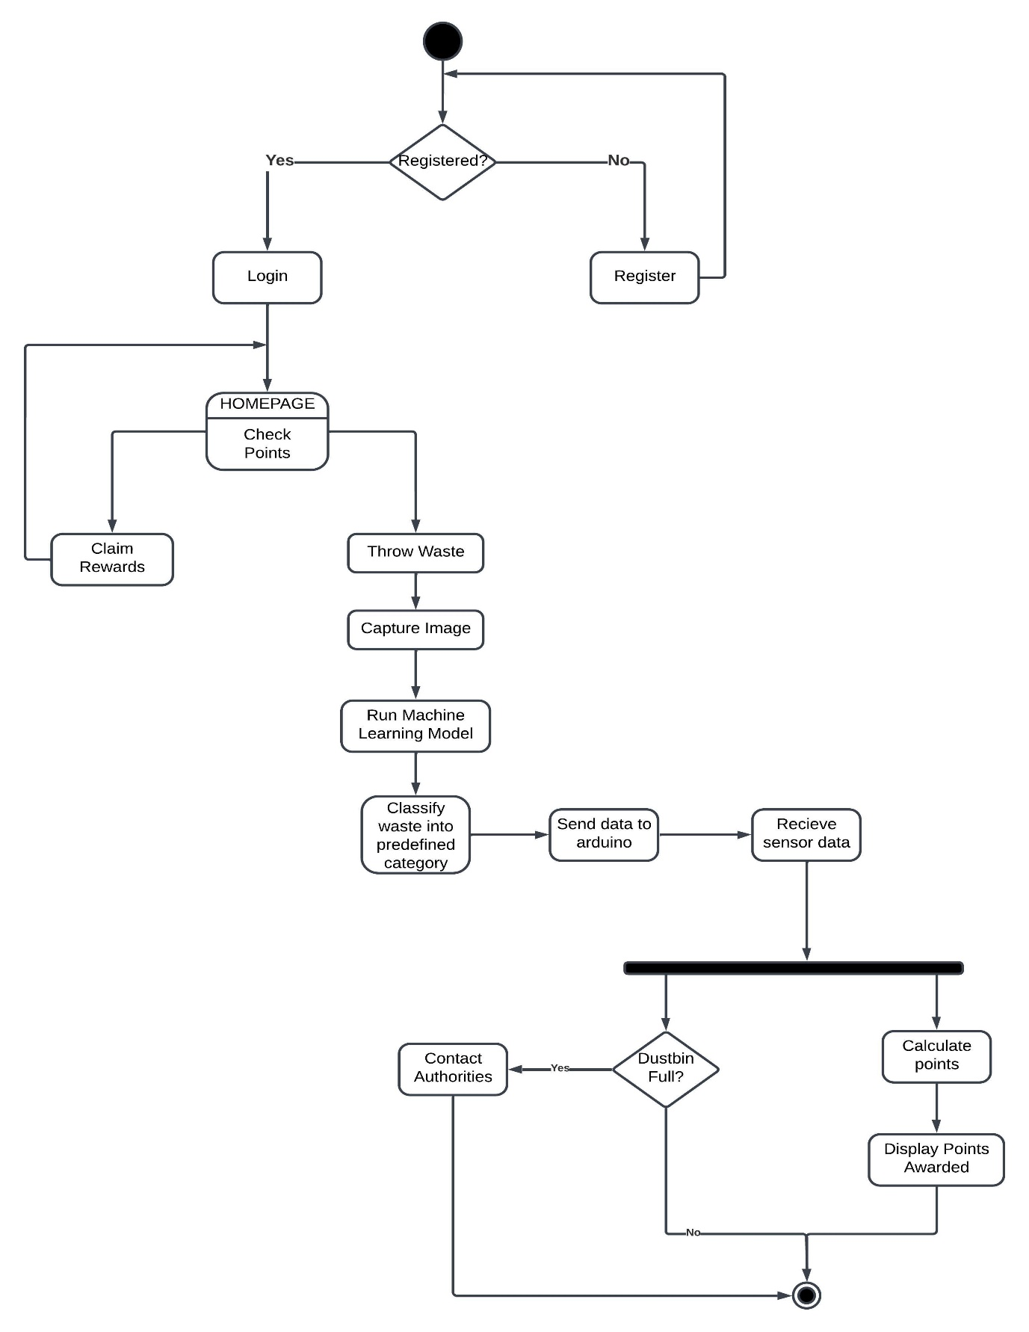
Figure 1. Main Components of Proposed Invention

Figure 2. Website Activity Diagram
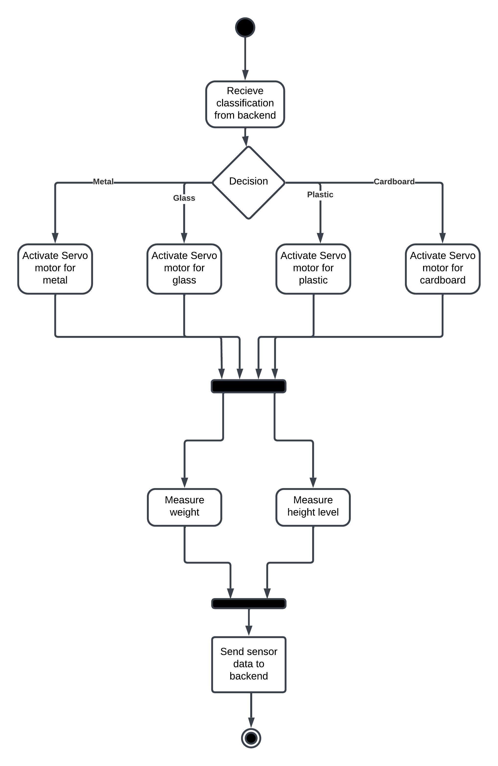

Figure 3. Arduino Activity Diagram
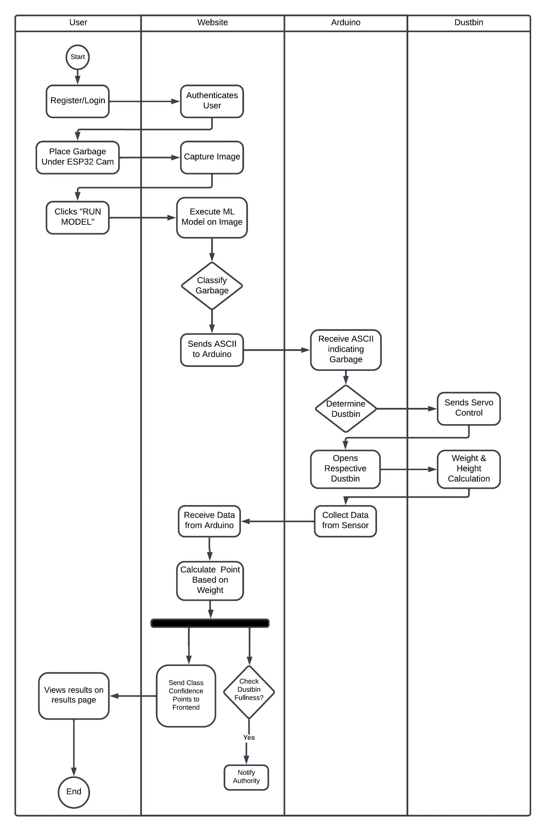

Figure 4. Swimlane Flowchart Showing the Work of Different Components
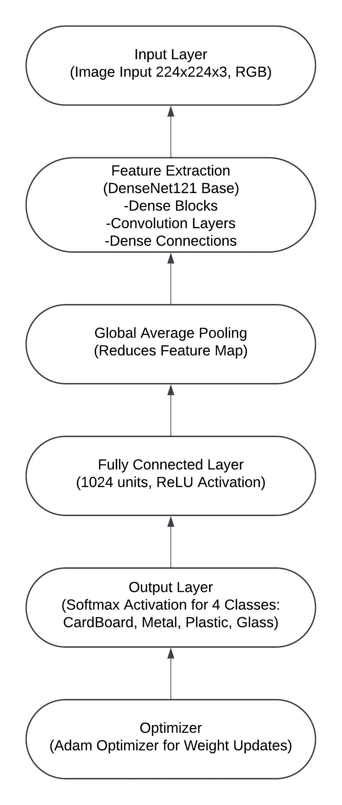
Figure 5. CNN Layers

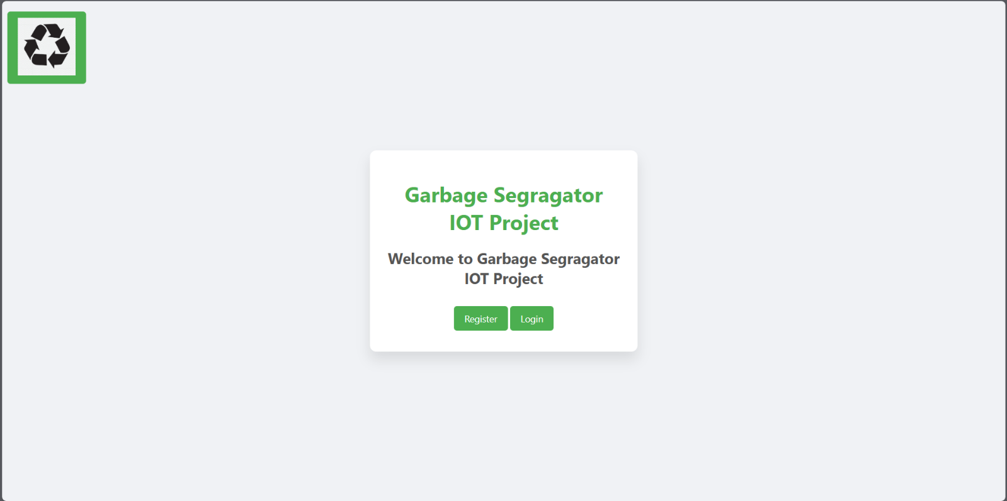

Figure 6. Website Home Page

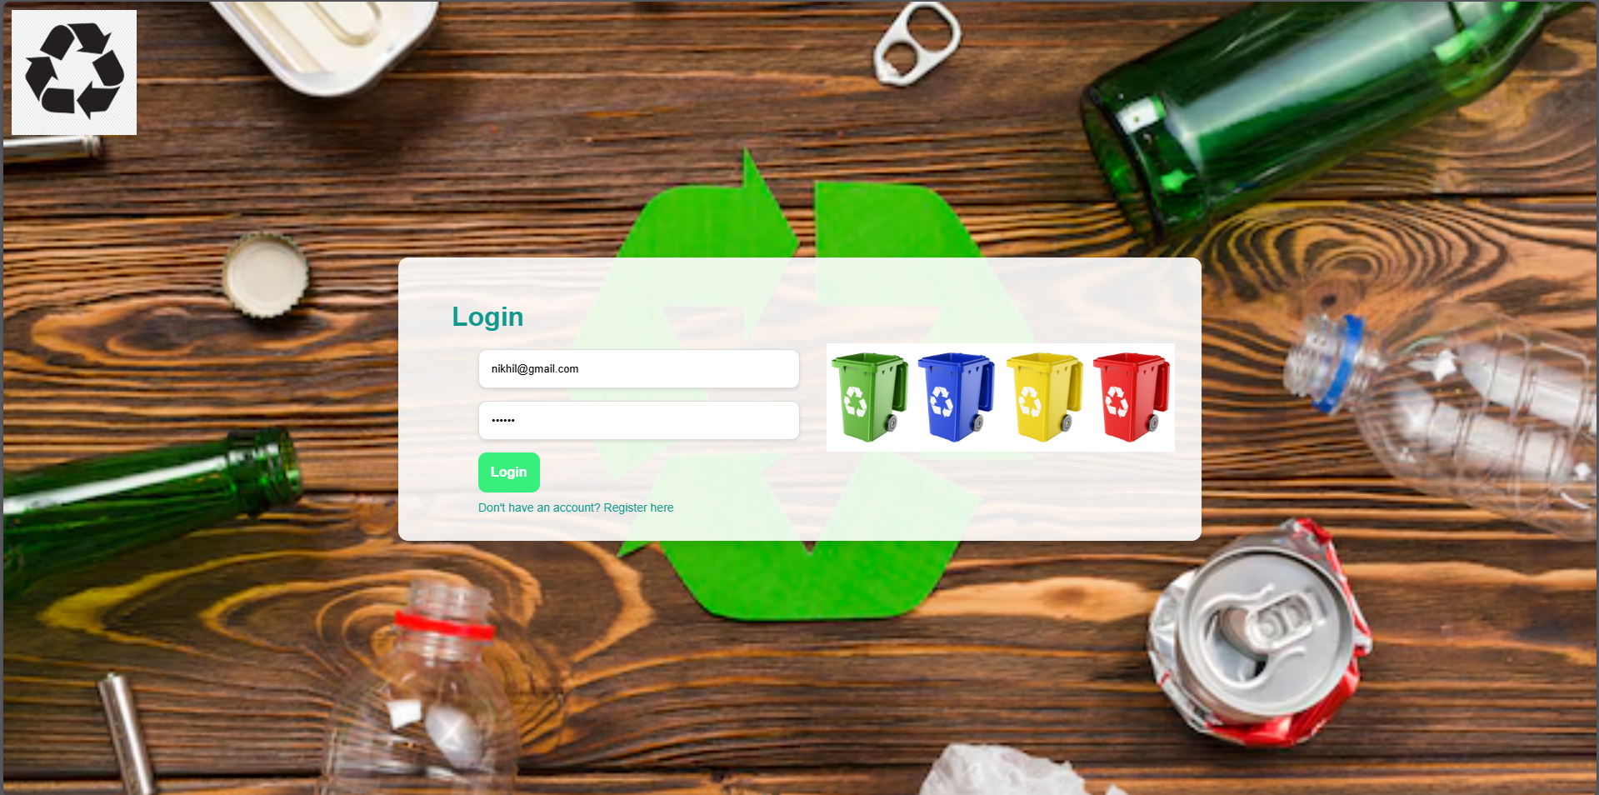

Figure 7. Website Login Page

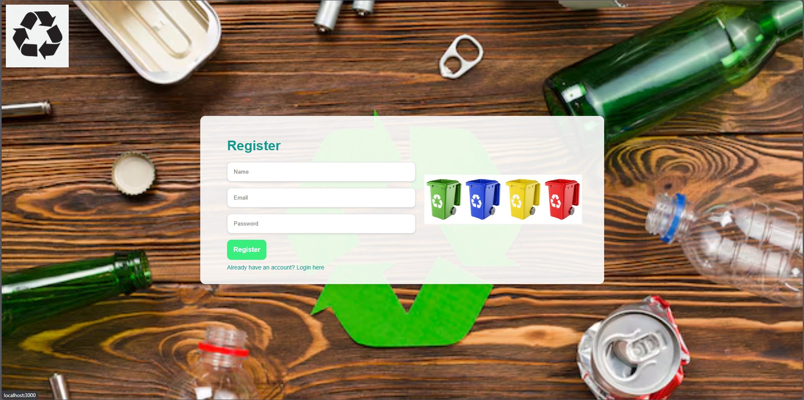

Figure 8. Website Registration Page

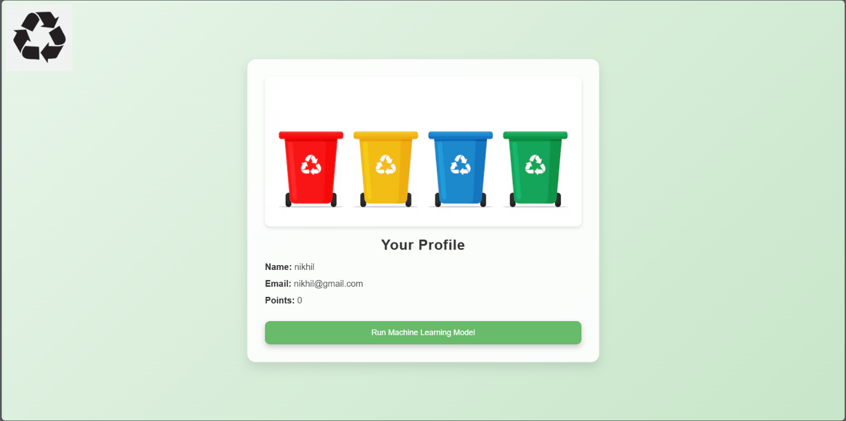

Figure 9. Website Profile Page



Figure 10. Website Result Page
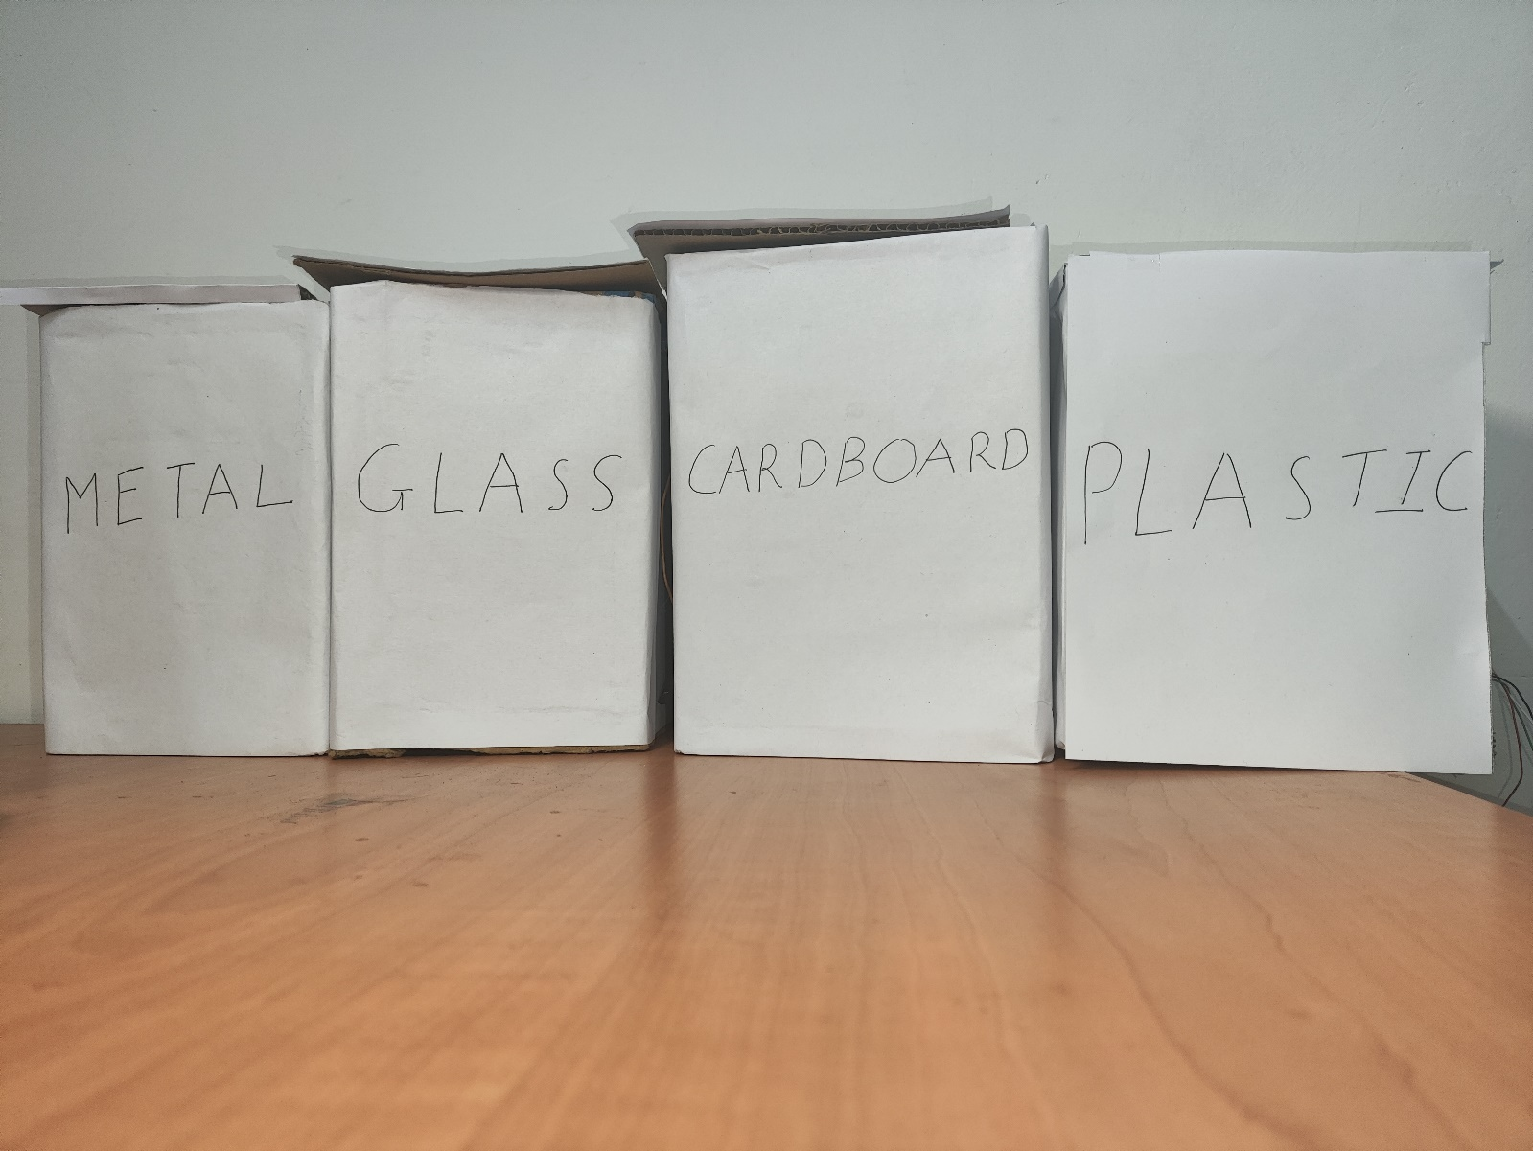
Real-Time Images of Smart Dustbin with Rewards

Figure 11. Full View
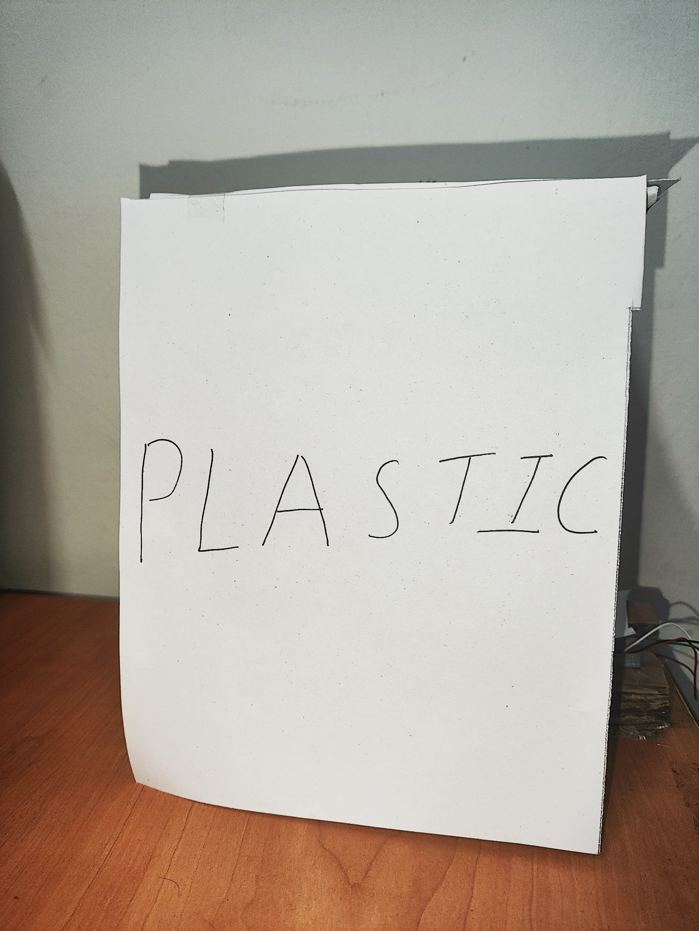

Figure 12. Front View of Plastic Dustbin
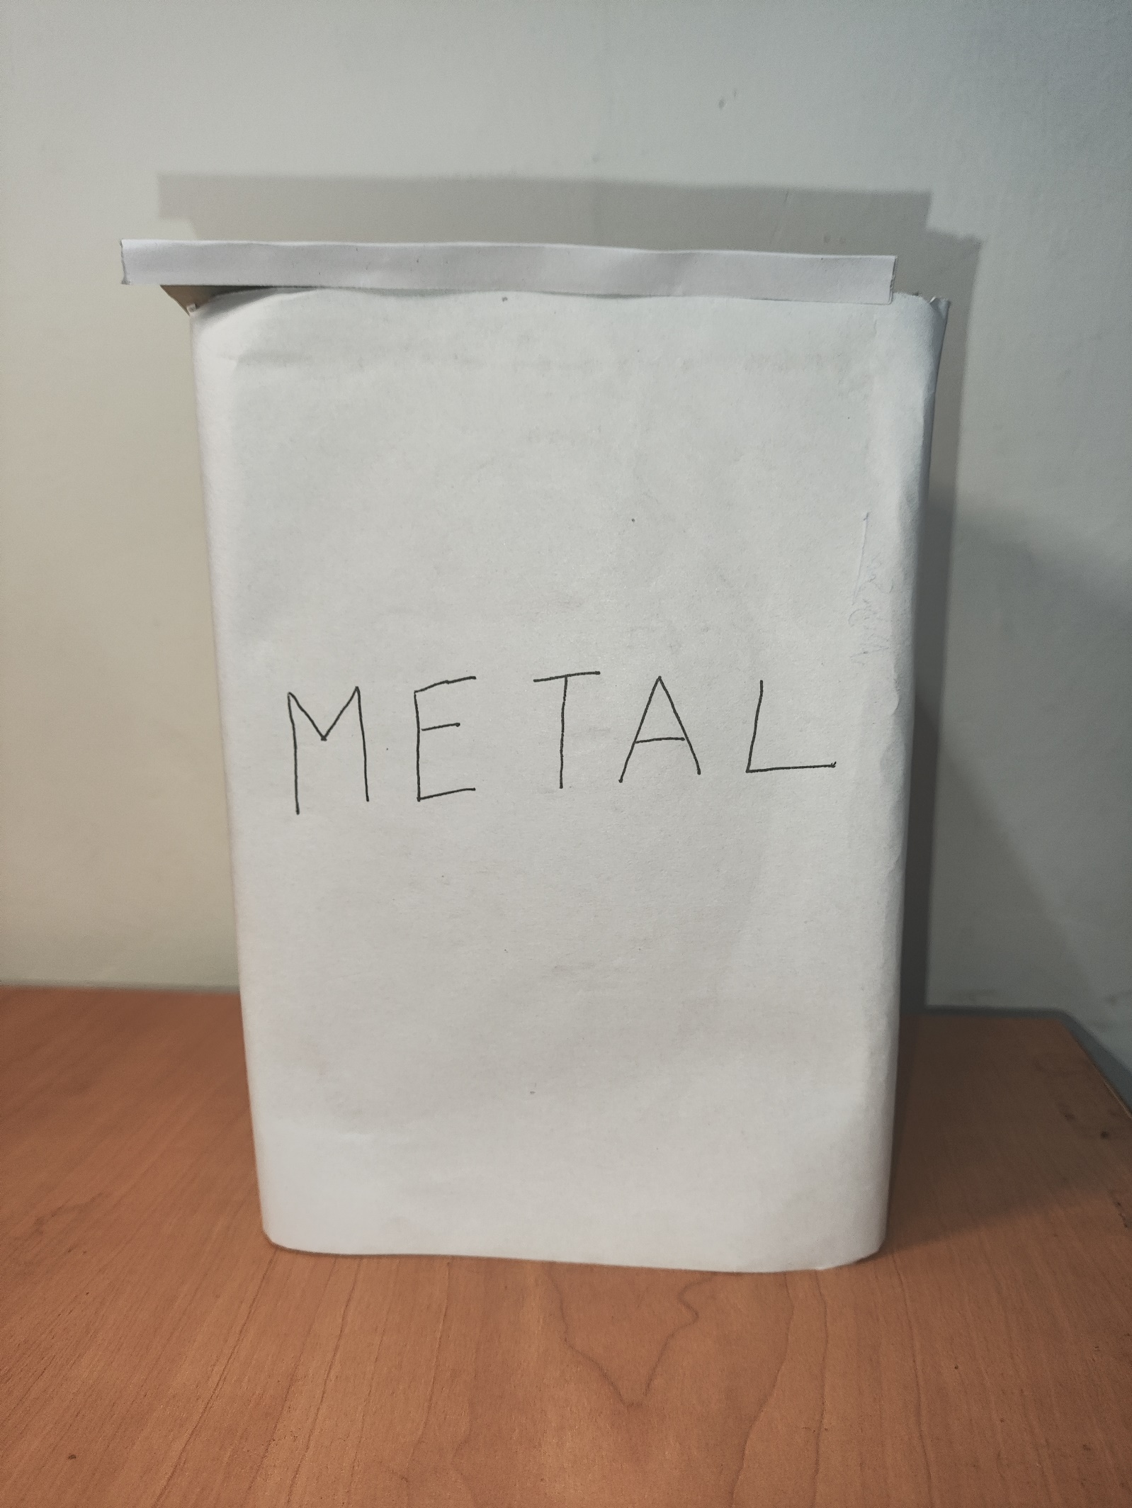

Figure 13. Front View of Metal Dustbin

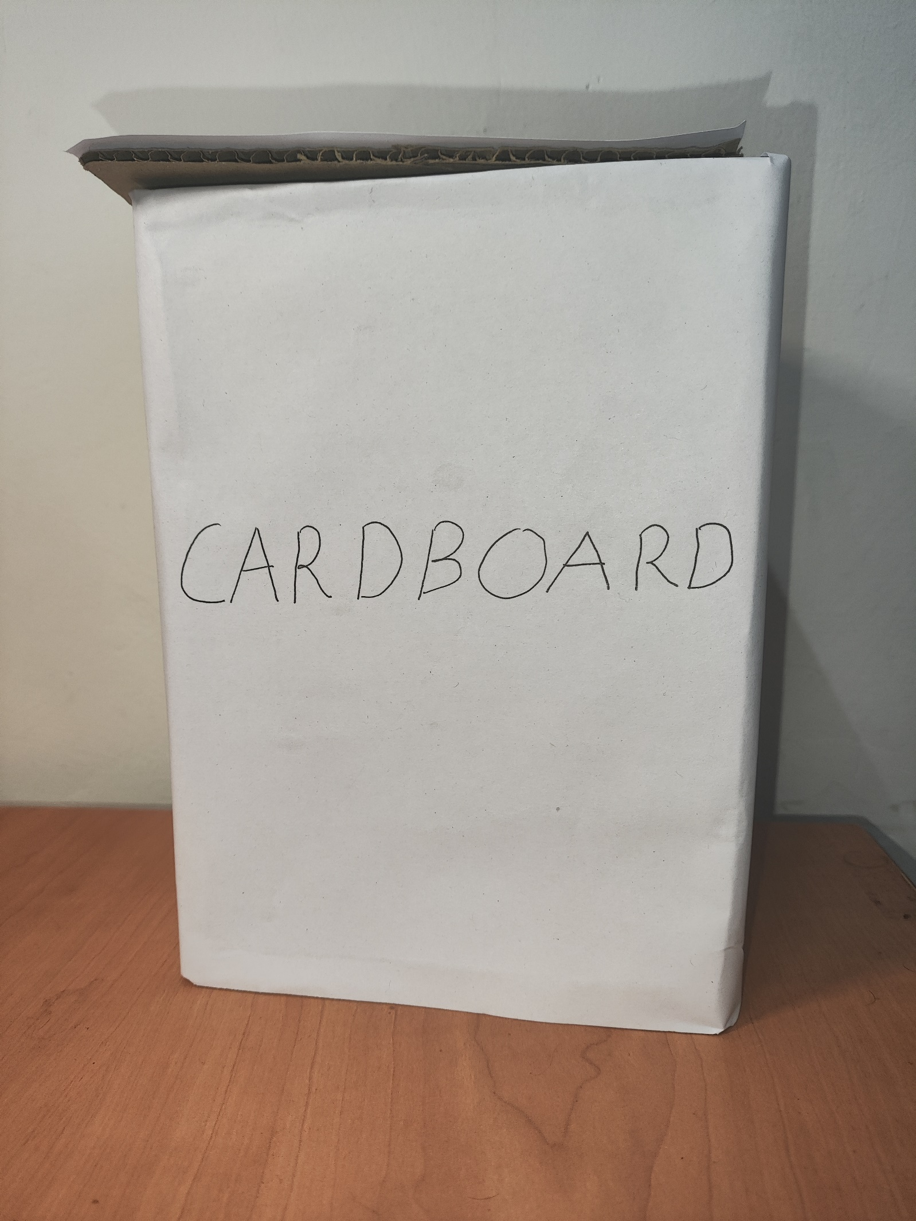

Figure 14. Front View of Cardboard Dustbin

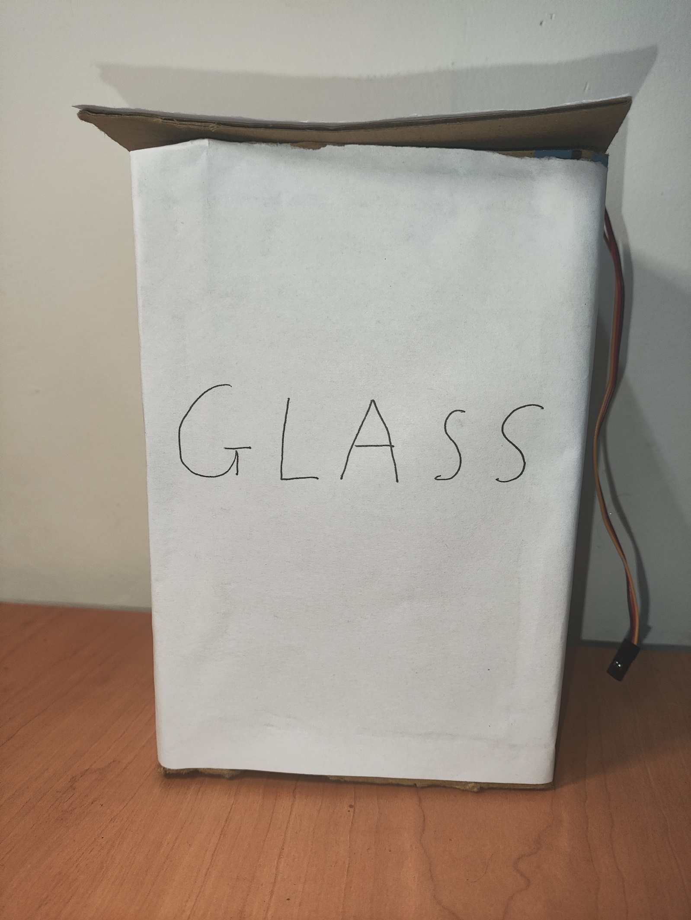

Figure 15. Front View of Glass Dustbin

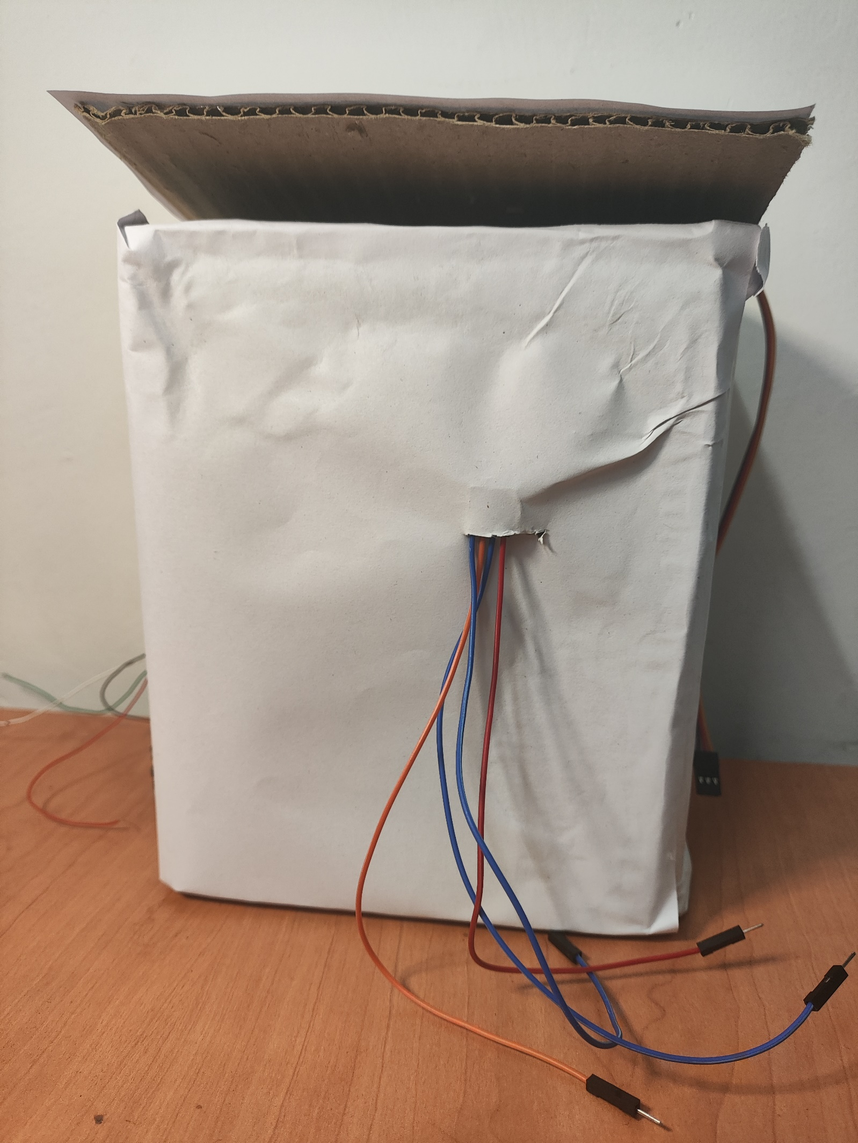

Figure 16. Rear View of Dustbins

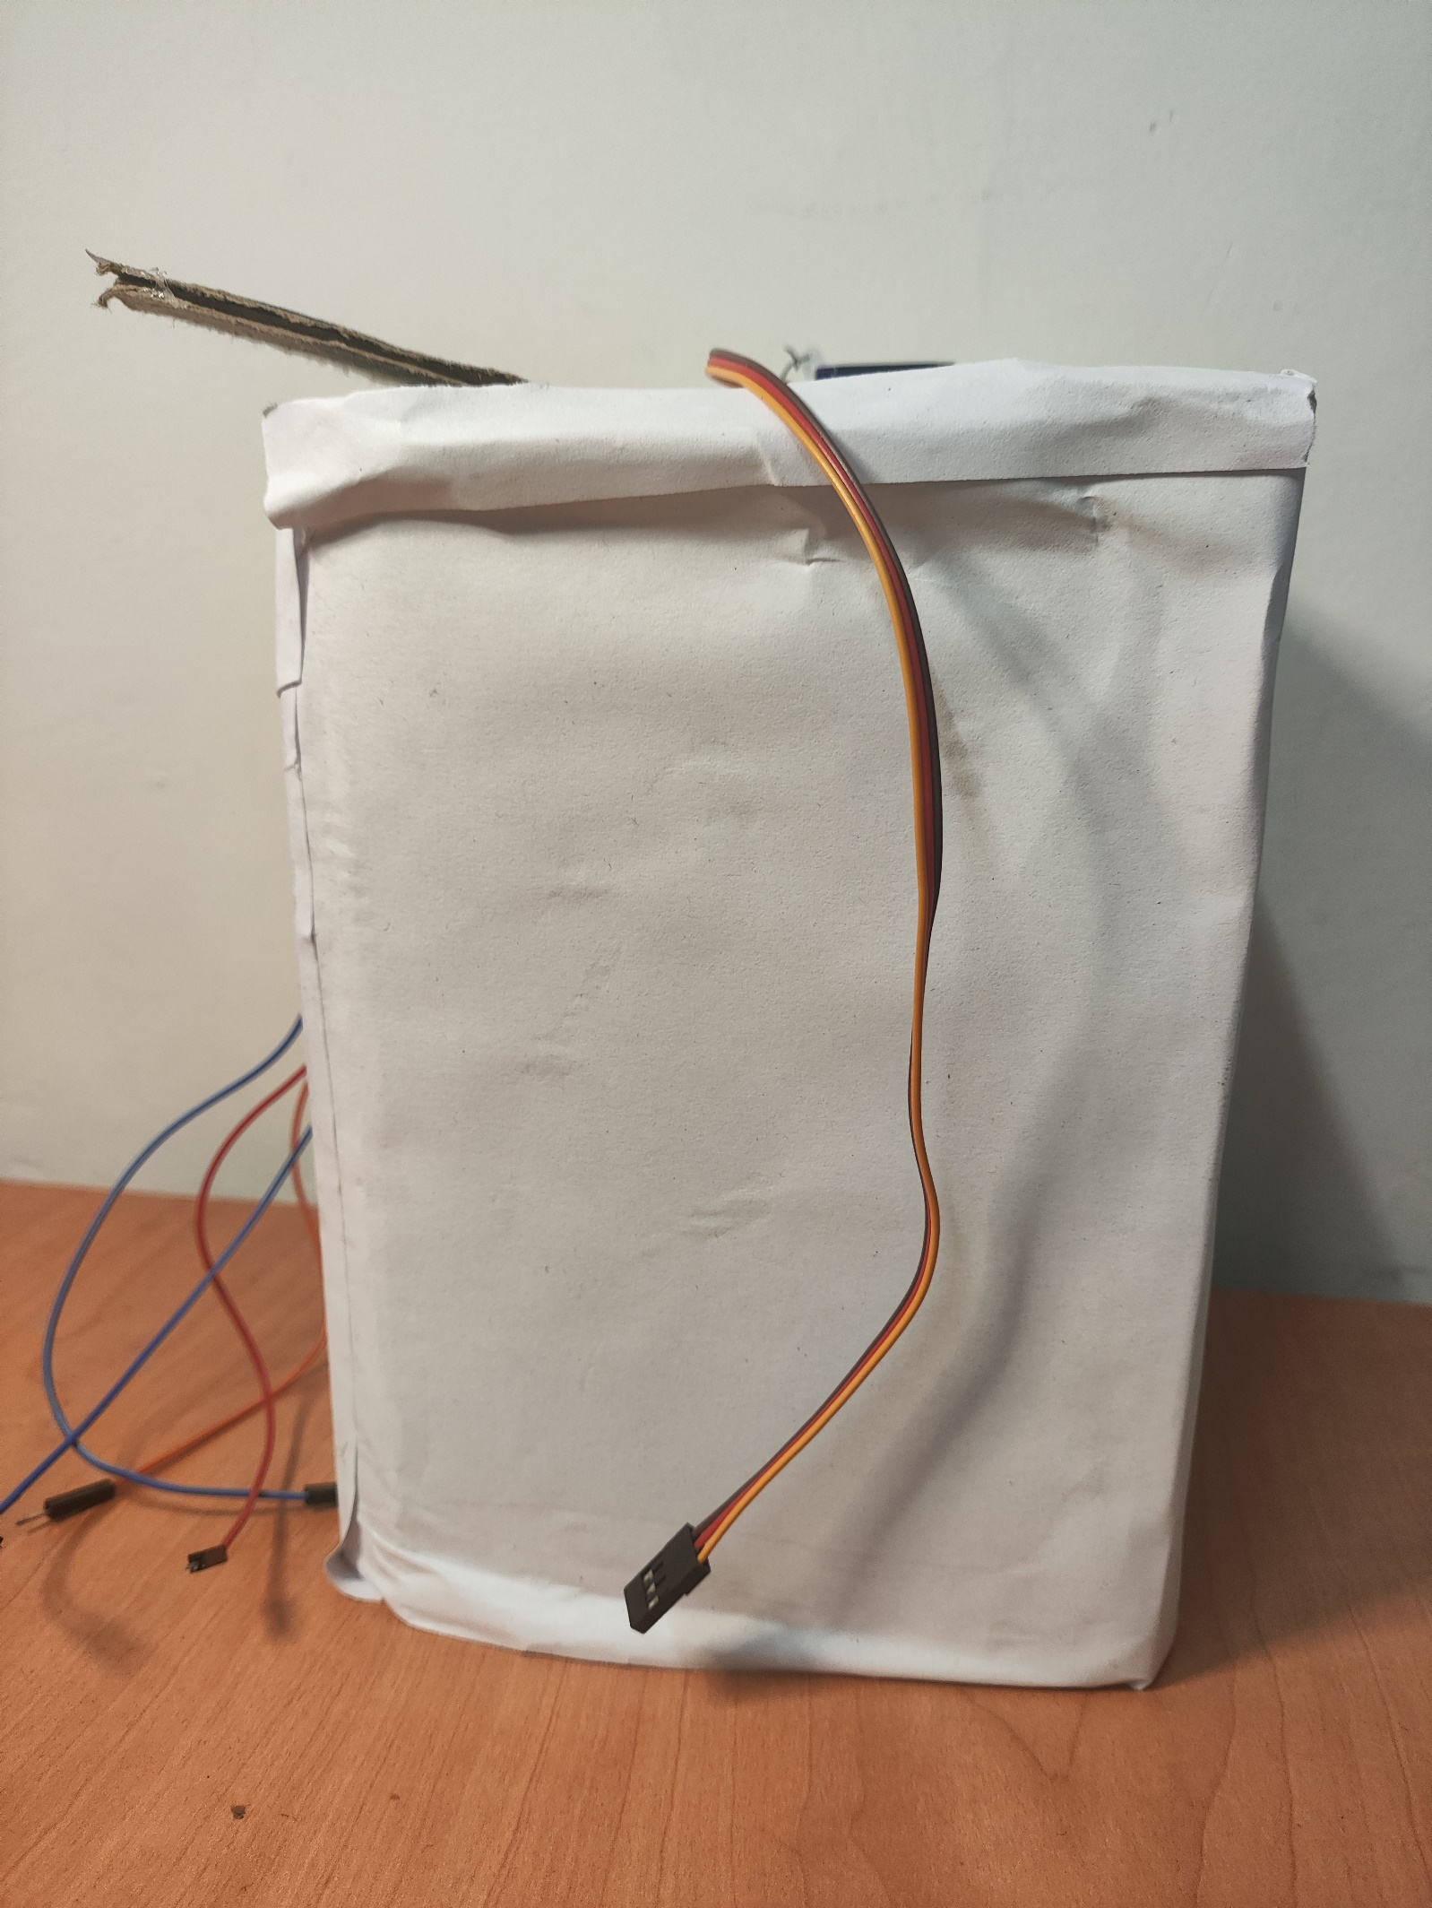

Figure 17. Right View of Dustbins

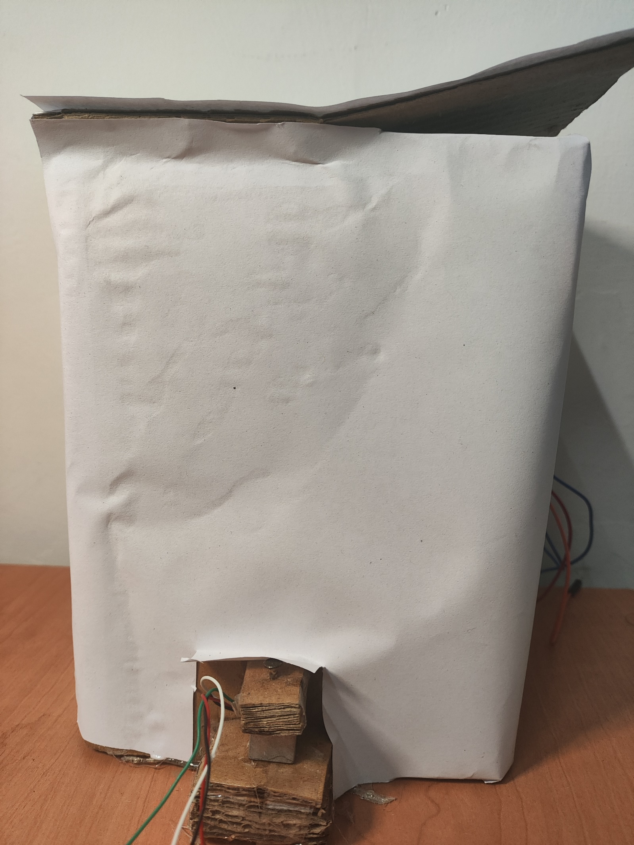

Figure 18. Left View of Dustbins

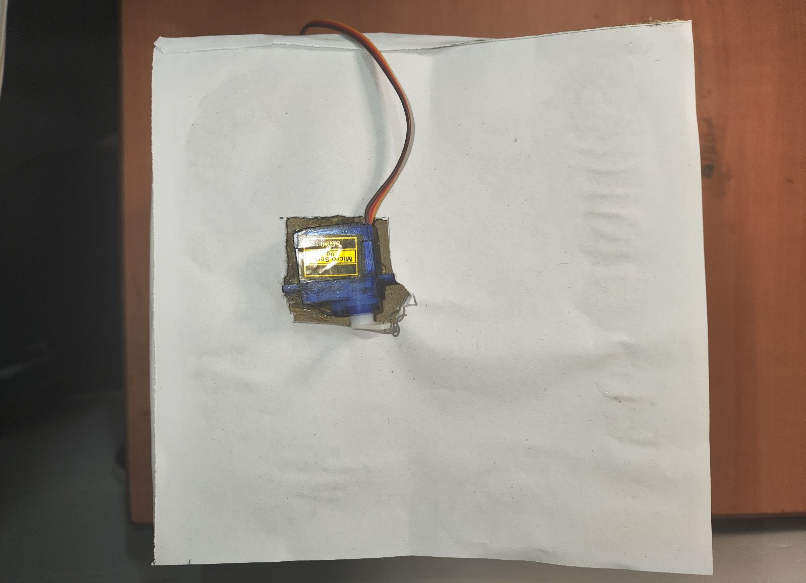

Figure 19. Top View of Dustbins

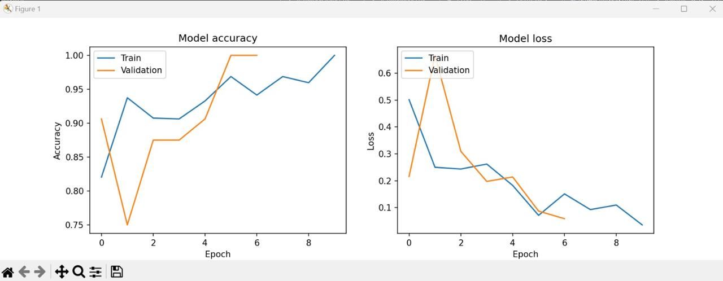

Figure 20. Model Accuracy and Loss Graph

