fmganalysisforhusband.R

Saha

2019-10-31

library(sjPlot)

## Install package "strengejacke" from GitHub (`devtools::install_github("strengejacke/strengejacke")`) to load all sj-packages at once!

library(sjmisc)

## Learn more about sjmisc with 'browseVignettes("sjmisc")'.

library(graphics)  
library(ggplot2)  
library(dplyr)

##   
## Attaching package: 'dplyr'

## The following objects are masked from 'package:stats':  
##   
## filter, lag

## The following objects are masked from 'package:base':  
##   
## intersect, setdiff, setequal, union

library(scales)  
  
  
fmgissue= read.csv("fmgissue1.csv")  
  
summary(fmgissue)

## Date Qualification Gender Village   
## 21-05-18:5 Class IX :1 Female:4 Bjabcho FMG :1   
## 22-05-18:4 Class VI :1 Male :5 Bongo FMG :1   
## Class VIII:1 Chapcha FMG :1   
## Class X :4 Darla FMG :1   
## None :2 Dophulakha FMG:1   
## Dungna FMG :1   
## (Other) :3   
## Do.you.think.agriculture.is.lucrative.profession.  
## Min. :1.000   
## 1st Qu.:1.000   
## Median :2.000   
## Mean :1.556   
## 3rd Qu.:2.000   
## Max. :2.000   
##   
## Do.you.think.men.and.women.have.equal.opportunities.for.income.generation.  
## Min. :1.000   
## 1st Qu.:1.000   
## Median :2.000   
## Mean :1.667   
## 3rd Qu.:2.000   
## Max. :2.000   
##   
## Do.you.have.surplus.production.of.vegetables.  
## Min. :1.000   
## 1st Qu.:1.000   
## Median :1.000   
## Mean :1.444   
## 3rd Qu.:2.000   
## Max. :2.000   
##   
## Do.you.have.assured.market.for.your.vegetable.produces.  
## Min. :1   
## 1st Qu.:1   
## Median :1   
## Mean :1   
## 3rd Qu.:1   
## Max. :1   
##   
## Do.you.have.transportation.means.for.your.farm.produces.  
## Min. :1.000   
## 1st Qu.:1.000   
## Median :1.000   
## Mean :1.222   
## 3rd Qu.:1.000   
## Max. :2.000   
##   
## Do.you.have.accessibility..road.connectivity..problem.in.your.area.with.rest.of.the.county..district.or.county.  
## Min. :1.000   
## 1st Qu.:1.000   
## Median :1.000   
## Mean :1.444   
## 3rd Qu.:2.000   
## Max. :2.000   
##   
## Do.you.have.any.cold..storage.structures..facilities.in.your.area.  
## Min. :1   
## 1st Qu.:1   
## Median :1   
## Mean :1   
## 3rd Qu.:1   
## Max. :1   
##   
## Do.you.have.prior.business.experiences.in.vegetable.marketing.  
## Min. :1.000   
## 1st Qu.:1.000   
## Median :1.000   
## Mean :1.444   
## 3rd Qu.:2.000   
## Max. :2.000   
##   
## Do.you.undertake.processing.of.vegetables.to.increase.the.shelf.life.  
## Min. :1.000   
## 1st Qu.:1.000   
## Median :1.000   
## Mean :1.222   
## 3rd Qu.:1.000   
## Max. :2.000   
##   
## Would.you.like.to.take.up.vegetable.marketing.business.for.livelihood.  
## Min. :1.000   
## 1st Qu.:1.000   
## Median :2.000   
## Mean :1.667   
## 3rd Qu.:2.000   
## Max. :2.000   
##   
## What.is.your.household.approx..annual.ependiture.for.meals.  
## Min. : 24000   
## 1st Qu.: 34500   
## Median : 60000   
## Mean : 58722   
## 3rd Qu.: 75000   
## Max. :100000   
##   
## What.is.the.approximate...money.spent.to.buy.your.food.from.outside.the.district..country.in.a.year.  
## <10% :1   
## 10-20%:3   
## 20-40%:3   
## 40-60%:1   
## 60-80%:1   
##   
##   
## What.other.profession.you.are.considering.to.adopt.  
## Agriculture activities :1   
## Business (Hotel) :1   
## Farming :1   
## Floriculture and Livestock farming :1   
## Labour works (non-agriculure) :4   
## Moving to city for other oppurtunities:1   
##   
## Land.Holding.Dry.land. Percent.cultivated. Land.Holding.Wetland.  
## Min. : 0.400 Min. : 50.0 Min. :0.300   
## 1st Qu.: 1.800 1st Qu.: 72.5 1st Qu.:0.500   
## Median : 2.000 Median :100.0 Median :0.580   
## Mean : 4.778 Mean : 85.0 Mean :0.686   
## 3rd Qu.: 2.000 3rd Qu.:100.0 3rd Qu.:0.600   
## Max. :25.000 Max. :100.0 Max. :1.450   
## NA's :1 NA's :4   
## Percent.cultivated..1 Land.Holding.Orchard. Percent.Cultivated.  
## Min. :100 Min. :0.700 Min. :100   
## 1st Qu.:100 1st Qu.:0.850 1st Qu.:100   
## Median :100 Median :1.000 Median :100   
## Mean :100 Mean :1.067 Mean :100   
## 3rd Qu.:100 3rd Qu.:1.250 3rd Qu.:100   
## Max. :100 Max. :1.500 Max. :100   
## NA's :5 NA's :6 NA's :6   
## What.is.the.source.of.labour. What.is.the.range.of.your.income.per.month.  
## Both :3 <Nu. 6450:7   
## Manual:6 >Nu. 6450:2   
##   
##   
##   
##   
##   
## The.approx.share.of.income.from.agriculture.activities.out.of.total.income.  
## <20% :2   
## 20-40%:4   
## 40-60%:2   
## 60-80%:1   
##   
##   
##   
## What.percent.of.surplus.production.usually.you.have.in.vegetables.  
## <50% of total consumption:4   
## No surplus :5   
##   
##   
##   
##   
##

mydat3=fmgissue[5:14]  
lab2 = c("Do you think agriculture is lucrative profession?",  
 "Do you think men and women have equal opportunities for income generation?",  
 "Do you have surplus production of vegetables?",  
 "Do you have assured market for your vegetable produces?",  
 "Do you have transportation means for your farm produces?",  
 "Do you have connectivity problem in your area with rest of the county/ district/ country?",  
 "Do you have any cold storage facilities in your area?",  
 "Do you have prior business experiences in vegetable marketing?",  
 "Do you undertake processing of vegetables to increase the shelf life?",  
 "Would you like to take up vegetable marketing business for livelihood?")  
  
names(mydat3)=lab2  
plot_likert(  
 mydat3,  
 title = "Issue",  
 grid.range = c(1.2, 1.0),  
 expand.grid = FALSE,  
 legend.labels = c("No","Yes"),  
 catcount = 2,  
 geom.colors = "RBu",  
 values = "sum.outside",  
 show.prc.sign = TRUE  
)

## Warning in sj.setGeomColors(gp, geom.colors, (catcount + adding),  
## show.legend, : Too less colors provided for plot. Using default color  
## palette.

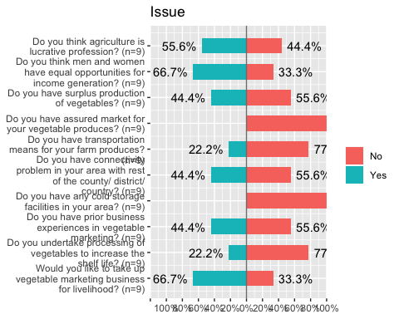

fmgimpact= read.csv("fmgimpact1.csv")  
  
summary(fmgimpact)

## Date Qualification Gender Village   
## 10-Dec-18:5 Class IX :1 Female:4 Bjabcho FMG :1   
## 12-Dec-18:4 Class VI :1 Male :5 Bongo FMG :1   
## Class VIII :1 Chapcha FMG :1   
## Class X :3 Darla FMG :1   
## Metakha FMG:1 Dophulakha FMG:1   
## None :2 Dungna FMG :1   
## (Other) :3   
## Do.you.think.agriculture.is.lucrative.profession.  
## Min. :2   
## 1st Qu.:2   
## Median :2   
## Mean :2   
## 3rd Qu.:2   
## Max. :2   
##   
## Do.you.think.men.and.women.have.equal.opportunities.for.income.generation.  
## Min. :1.000   
## 1st Qu.:2.000   
## Median :2.000   
## Mean :1.889   
## 3rd Qu.:2.000   
## Max. :2.000   
##   
## Do.you.have.surplus.production.of.vegetables.  
## Min. :1.000   
## 1st Qu.:2.000   
## Median :2.000   
## Mean :1.778   
## 3rd Qu.:2.000   
## Max. :2.000   
##   
## Do.you.have.assured.market.for.your.vegetable.produces.  
## Min. :2   
## 1st Qu.:2   
## Median :2   
## Mean :2   
## 3rd Qu.:2   
## Max. :2   
##   
## Do.you.have.transportation.means.for.your.farm.produces.  
## Min. :1.000   
## 1st Qu.:1.000   
## Median :1.000   
## Mean :1.444   
## 3rd Qu.:2.000   
## Max. :2.000   
##   
## Do.you.have.accessibility..road.connectivity..problem.in.your.area.with.rest.of.the.county..district.or.country.  
## Min. :1.000   
## 1st Qu.:1.000   
## Median :1.000   
## Mean :1.444   
## 3rd Qu.:2.000   
## Max. :2.000   
##   
## Do.you.have.any.cold..storage.structures..facilities.in.your.area.  
## Min. :1   
## 1st Qu.:1   
## Median :1   
## Mean :1   
## 3rd Qu.:1   
## Max. :1   
##   
## Do.you.have.prior.business.experiences.in.vegetable.marketing.  
## Min. :1.000   
## 1st Qu.:2.000   
## Median :2.000   
## Mean :1.778   
## 3rd Qu.:2.000   
## Max. :2.000   
##   
## Do.you.undertake.processing.of.vegetables.to.increase.the.shelf.life.  
## Min. :1.000   
## 1st Qu.:1.000   
## Median :2.000   
## Mean :1.556   
## 3rd Qu.:2.000   
## Max. :2.000   
##   
## Would.you.like.to.take.up.vegetable.marketing.business.for.livelihood.  
## Min. :2   
## 1st Qu.:2   
## Median :2   
## Mean :2   
## 3rd Qu.:2   
## Max. :2   
##   
## What.is.your.household.approx.annual.ependiture.for.meals.  
## Min. : 25000   
## 1st Qu.: 34500   
## Median : 60000   
## Mean : 62589   
## 3rd Qu.: 88800   
## Max. :100000   
##   
## What.is.the.approximate...money.spent.to.buy.your.food.from.outside.the.district..country.in.a.year.  
## <10% :1   
## 10-20%:3   
## 20-40%:4   
## 40-60%:1   
##   
##   
##   
## What.other.profession.you.are.considering.to.adopt.  
## Agricultural marketing :6   
## Agriculture activities :1   
## Farming :1   
## Floriculture and agriculture:1   
##   
##   
##   
## Land.Holding.Dry.land Percent.cultivated Land.Holding.Wetland  
## Min. : 0.400 Min. : 60.00 Min. :0.300   
## 1st Qu.: 1.800 1st Qu.:100.00 1st Qu.:0.500   
## Median : 2.000 Median :100.00 Median :0.580   
## Mean : 4.778 Mean : 93.33 Mean :0.686   
## 3rd Qu.: 2.000 3rd Qu.:100.00 3rd Qu.:0.600   
## Max. :25.000 Max. :100.00 Max. :1.450   
## NA's :4   
## Percent.cultivated.1 Land.Holding.Orchard Percent.Cultivated  
## Min. :100 Min. :0.700 Min. :100   
## 1st Qu.:100 1st Qu.:0.850 1st Qu.:100   
## Median :100 Median :1.000 Median :100   
## Mean :100 Mean :1.067 Mean :100   
## 3rd Qu.:100 3rd Qu.:1.250 3rd Qu.:100   
## Max. :100 Max. :1.500 Max. :100   
## NA's :4 NA's :6 NA's :6   
## What.is.the.source.of.labour. What.is.the.range.of.your.income.per.month.  
## Both :4 <Nu. 6450:1   
## Manual:5 >Nu. 6450:8   
##   
##   
##   
##   
##   
## The.approx.share.of.income.from.agriculture.activities.out.of.total.income.  
## >80% :1   
## 40-60%:5   
## 60-80%:3   
##   
##   
##   
##   
## What.percent.of.surplus.production.usually.you.have.in.vegetables.  
## <50% of total consumption:2   
## >50% of total consumption:5   
## No surplus :2   
##   
##   
##   
##

mydat4=fmgimpact[5:14]  
  
  
names(mydat4)=lab2  
plot_likert(  
 mydat4,  
 title = "Impact",  
 grid.range = c(1.7, 1.7),  
 legend.labels = c("No","Yes"),  
 expand.grid = FALSE,  
 geom.colors = "RBu",  
 values = "sum.outside",  
 show.prc.sign = TRUE  
)

## Warning in sj.setGeomColors(gp, geom.colors, (catcount + adding),  
## show.legend, : Too less colors provided for plot. Using default color  
## palette.

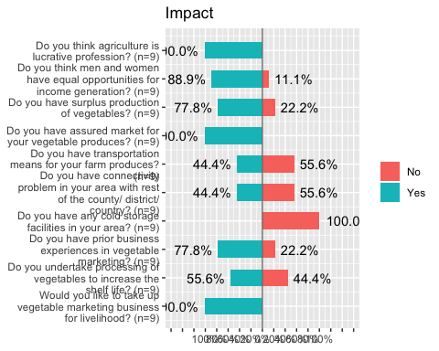

fmgexp= cbind(fmgissue[16], fmgimpact[16]);fmgexp

## What.is.the.approximate...money.spent.to.buy.your.food.from.outside.the.district..country.in.a.year.  
## 1 <10%  
## 2 20-40%  
## 3 40-60%  
## 4 60-80%  
## 5 10-20%  
## 6 10-20%  
## 7 20-40%  
## 8 20-40%  
## 9 10-20%  
## What.is.the.approximate...money.spent.to.buy.your.food.from.outside.the.district..country.in.a.year.  
## 1 <10%  
## 2 20-40%  
## 3 20-40%  
## 4 40-60%  
## 5 10-20%  
## 6 10-20%  
## 7 20-40%  
## 8 20-40%  
## 9 10-20%

names(fmgexp)= c("Issue", "Impact")  
  
plot_likert(  
 fmgexp,  
 title = "Percent expenditure to buy food from other districts",  
 grid.range = c(1.0, 1.0),  
 expand.grid = FALSE,  
 catcount = 5,  
 geom.colors = "RBu",  
 values = "show",  
 show.prc.sign = TRUE  
)

## Warning in sj.setGeomColors(gp, geom.colors, (catcount + adding),  
## show.legend, : Too less colors provided for plot. Using default color  
## palette.

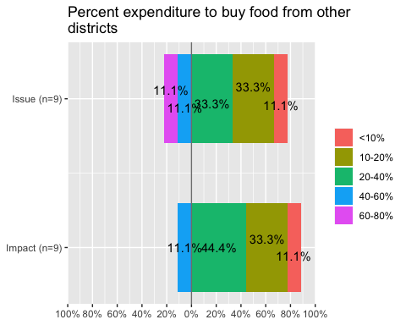

exp1= table(fmgexp[1])  
exp2= table(fmgexp[2])  
exp1=as.data.frame(exp1)  
  
exp1 <- exp1 %>%  
 arrange(desc(Var1)) %>%  
 mutate(lab.ypos = cumsum(Freq) - 0.5*Freq)  
exp1

## Var1 Freq lab.ypos  
## 1 60-80% 1 0.5  
## 2 40-60% 1 1.5  
## 3 20-40% 3 3.5  
## 4 10-20% 3 6.5  
## 5 <10% 1 8.5

bp4<- ggplot(exp1, aes(x="", y=Freq, fill=Var1))+  
 geom_bar(width = 1, stat = "identity")+  
 labs(title="Issue")+  
 geom_text(aes(y = lab.ypos, label = percent(Freq/sum(Freq))), color = "white", size=4.5)+  
 xlab("Percent expenditure to buy food from other districts")+ylab("")+  
 labs(fill = "Percent expenditure")  
bp4

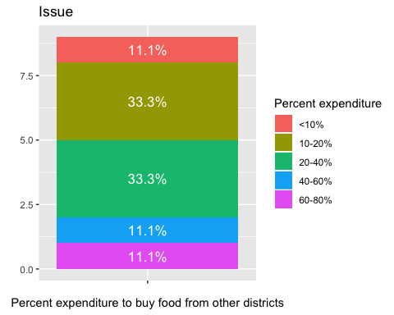

mycols= c("red3","orange2","green4","deeppink3","darkslateblue","red2", "mediumorchid3", "forestgreen")  
ggplot(exp1, aes(x = "", y = Freq, fill = Var1)) +  
 geom_bar(width = 1, stat = "identity", color = "white") +  
 coord_polar("y", start = 0)+  
 ggtitle("Issue-Percent expenditure to buy food from other districts")+  
 geom_text(aes(y = lab.ypos, label = percent(Freq/sum(Freq))), color = "white", size=4.5)+  
 scale_fill_manual(values = mycols) +  
 labs(fill="Percent Expenditure")+  
 theme_void()

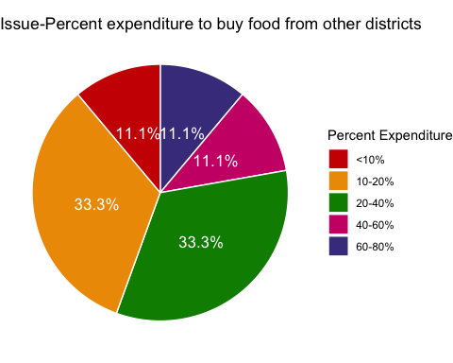

p<-ggplot(data=exp1, aes(x=Var1, y=Freq)) +  
 geom_bar(stat="identity",fill="salmon")  
p + coord_flip()+  
 ggtitle("Issue-Percent expenditure to buy food from other districts")+  
 geom_text(aes(label=percent(Freq/sum(Freq))), hjust=1, size=3.5)+  
 xlab("Expenditure to buy food from other district")+ylab("%")

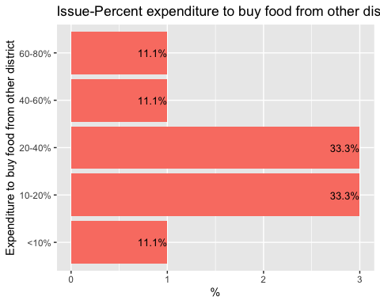

exp2=as.data.frame(exp2)  
  
exp2 <- exp2 %>%  
 arrange(desc(Var1)) %>%  
 mutate(lab.ypos = cumsum(Freq) - 0.5*Freq)  
exp2

## Var1 Freq lab.ypos  
## 1 40-60% 1 0.5  
## 2 20-40% 4 3.0  
## 3 10-20% 3 6.5  
## 4 <10% 1 8.5

bp5<- ggplot(exp2, aes(x="", y=Freq, fill=Var1))+  
 geom_bar(width = 1, stat = "identity")+  
 labs(title="Impact")+  
 geom_text(aes(y = lab.ypos, label = percent(Freq/sum(Freq))), color = "white", size=4.5)+  
 xlab("Percent expenditure to buy food from other districts")+ylab("")+  
 labs(fill = "Percent expenditure")  
bp5

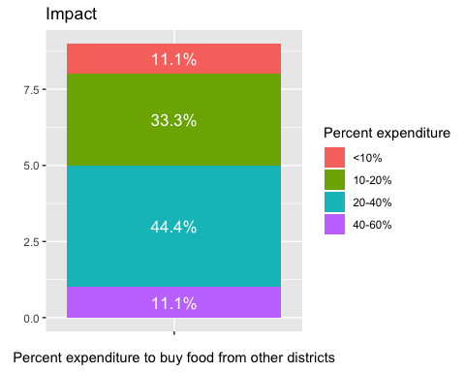

mycols= c("red3","orange2","green4","deeppink3","darkslateblue","red2", "mediumorchid3", "forestgreen")  
ggplot(exp2, aes(x = "", y = Freq, fill = Var1)) +  
 geom_bar(width = 1, stat = "identity", color = "white") +  
 coord_polar("y", start = 0)+  
 ggtitle("Impact-Percent expenditure to buy food from other districts")+  
 geom_text(aes(y = lab.ypos, label = percent(Freq/sum(Freq))), color = "white", size=4.5)+  
 scale_fill_manual(values = mycols) +  
 labs(fill = "Percent expenditure")+  
 theme_void()

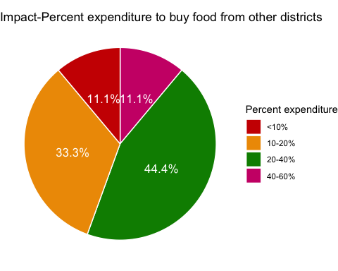

p<-ggplot(data=exp2, aes(x=Var1, y=Freq)) +  
 geom_bar(stat="identity",fill="salmon")  
p + coord_flip()+  
 ggtitle("Impact-Percent expenditure to buy food from other districts")+  
 geom_text(aes(label=percent(Freq/sum(Freq))), hjust=1, size=3.5)+  
 xlab("Percent Expenditure")+ylab("%")

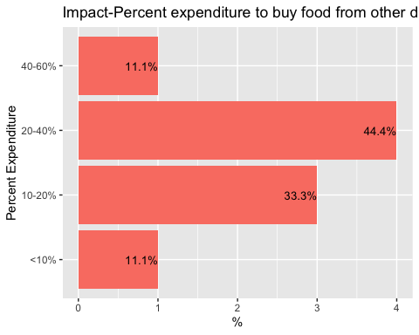

fmgaoccup= cbind(fmgissue[17], fmgimpact[17]);fmgaoccup

## What.other.profession.you.are.considering.to.adopt.  
## 1 Agriculture activities  
## 2 Farming  
## 3 Moving to city for other oppurtunities  
## 4 Labour works (non-agriculure)  
## 5 Labour works (non-agriculure)  
## 6 Labour works (non-agriculure)  
## 7 Floriculture and Livestock farming  
## 8 Business (Hotel)  
## 9 Labour works (non-agriculure)  
## What.other.profession.you.are.considering.to.adopt.  
## 1 Agricultural marketing  
## 2 Farming  
## 3 Agricultural marketing  
## 4 Agricultural marketing  
## 5 Agricultural marketing  
## 6 Agricultural marketing  
## 7 Floriculture and agriculture  
## 8 Agriculture activities  
## 9 Agricultural marketing

names(fmgaoccup)= c("Issue", "Impact")  
  
plot_likert(  
 fmgaoccup,  
 title = "Alternate occupation to agriculture",  
 grid.range = c(1.0, 1.3),  
 expand.grid = FALSE,  
 geom.colors = "RBu",  
 values = "show",  
 show.prc.sign = TRUE  
)

## Warning in sj.setGeomColors(gp, geom.colors, (catcount + adding),  
## show.legend, : Too less colors provided for plot. Using default color  
## palette.

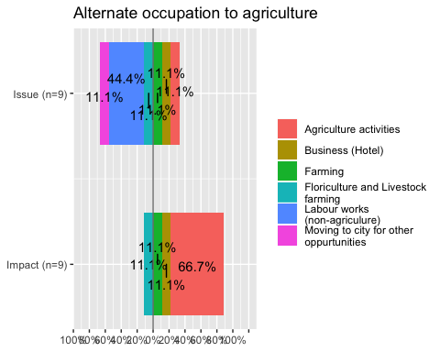

aoccup1= table(fmgaoccup[1])  
aoccup2= table(fmgaoccup[2])  
aoccup1=as.data.frame(aoccup1)  
  
aoccup1 <- aoccup1 %>%  
 arrange(desc(Var1)) %>%  
 mutate(lab.ypos = cumsum(Freq) - 0.5*Freq)  
aoccup1

## Var1 Freq lab.ypos  
## 1 Moving to city for other oppurtunities 1 0.5  
## 2 Labour works (non-agriculure) 4 3.0  
## 3 Floriculture and Livestock farming 1 5.5  
## 4 Farming 1 6.5  
## 5 Business (Hotel) 1 7.5  
## 6 Agriculture activities 1 8.5

bp6<- ggplot(aoccup1, aes(x="", y=Freq, fill=Var1))+  
 geom_bar(width = 1, stat = "identity")+  
 labs(title="Issue")+  
 xlab("Alternate occupation")+ylab("")+  
 geom_text(aes(y = lab.ypos, label = percent(Freq/sum(Freq))), color = "white", size=4.5)+  
 labs(fill= "Alternate Occupation")  
bp6

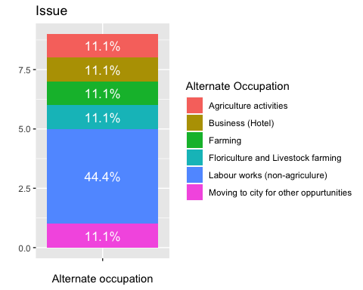

mycols= c("red3","orange2","green4","deeppink3","darkslateblue","red2", "mediumorchid3", "forestgreen")  
ggplot(aoccup1, aes(x = "", y = Freq, fill = Var1)) +  
 geom_bar(width = 1, stat = "identity", color = "white") +  
 coord_polar("y", start = 0)+  
 ggtitle("Issue-Alternate occupation")+  
 geom_text(aes(y = lab.ypos, label = percent(Freq/sum(Freq))), color = "white", size=4.5)+  
 scale_fill_manual(values = mycols) +  
 labs(fill= "Alternate occupation")+  
 theme_void()

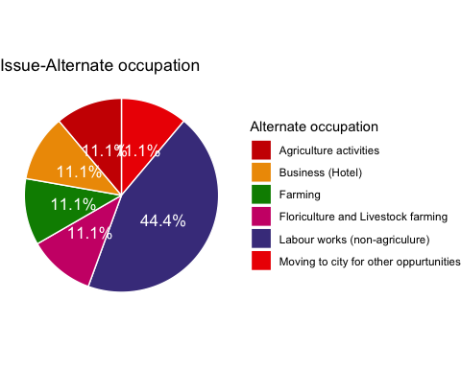

p<-ggplot(data=aoccup1, aes(x=Var1, y=Freq)) +  
 geom_bar(stat="identity",fill="salmon")  
p + coord_flip()+  
 ggtitle("Issue-Alternate occupation")+  
 geom_text(aes(label=percent(Freq/sum(Freq))), hjust=1, size=3.5)+  
 xlab("Alternate occupation")+ylab("%")+  
 scale_x_discrete(limits=c("Moving to city for other oppurtunities", "Floriculture and Livestock farming", "Business (Hotel)", "Agriculture activities", "Farming" ,"Labour works (non-agriculure)"))

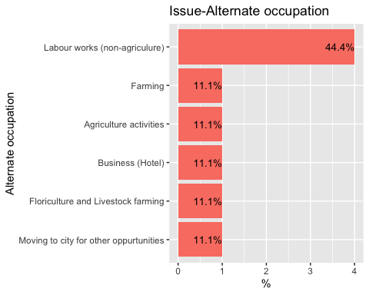

aoccup2=as.data.frame(aoccup2)  
  
aoccup2 <- aoccup2 %>%  
 arrange(desc(Var1)) %>%  
 mutate(lab.ypos = cumsum(Freq) - 0.5*Freq)  
aoccup2

## Var1 Freq lab.ypos  
## 1 Floriculture and agriculture 1 0.5  
## 2 Farming 1 1.5  
## 3 Agriculture activities 1 2.5  
## 4 Agricultural marketing 6 6.0

bp7<- ggplot(aoccup2, aes(x="", y=Freq, fill=Var1))+  
 geom_bar(width = 1, stat = "identity")+  
 labs(title="Impact")+  
 labs(fill= "Alternate occupation")+  
 geom_text(aes(y = lab.ypos, label = percent(Freq/sum(Freq))), color = "white", size=4.5)+  
 xlab("Alternate occupation")+ylab("")  
bp7

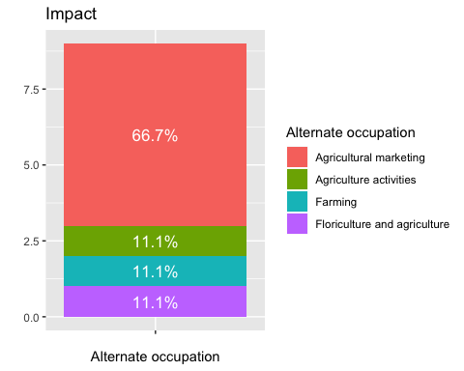

mycols= c("red3","orange2","green4","deeppink3","darkslateblue","red2", "mediumorchid3", "forestgreen")  
ggplot(aoccup2, aes(x = "", y = Freq, fill = Var1)) +  
 geom_bar(width = 1, stat = "identity", color = "white") +  
 coord_polar("y", start = 0)+  
 ggtitle("Impact-Alternate occupation")+  
 geom_text(aes(y = lab.ypos, label = percent(Freq/sum(Freq))), color = "white", size=4.5)+  
 scale_fill_manual(values = mycols) +  
 labs(fill = "Alternate occupation")+  
 theme_void()

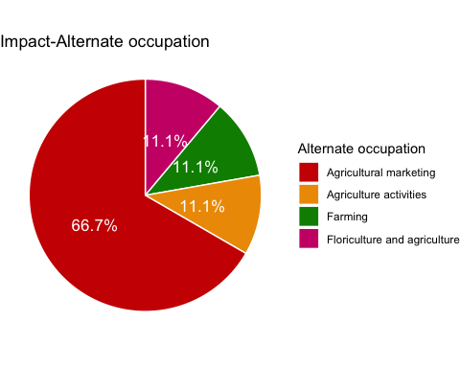

p<-ggplot(data=aoccup2, aes(x=Var1, y=Freq)) +  
 geom_bar(stat="identity",fill="salmon")  
p + coord_flip()+  
 ggtitle("Impact-Alternate occupation")+  
 geom_text(aes(label=percent(Freq/sum(Freq))), hjust=1, size=3.5)+  
 xlab("Alternate occupation")+ ylab("%")+  
 scale_x_discrete(limits=c( "Agriculture activities", "Farming", "Floriculture and agriculture", "Agricultural marketing"))

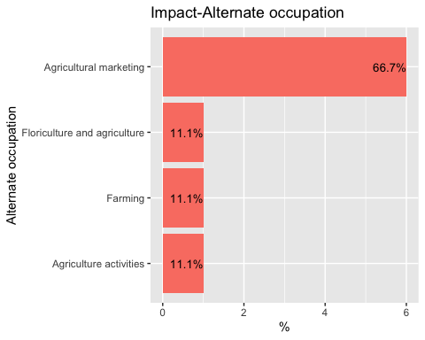

fmglb= cbind(fmgissue[24], fmgimpact[24]);fmglb

## What.is.the.source.of.labour. What.is.the.source.of.labour.  
## 1 Both Both  
## 2 Manual Manual  
## 3 Manual Manual  
## 4 Manual Both  
## 5 Both Manual  
## 6 Manual Both  
## 7 Manual Manual  
## 8 Both Both  
## 9 Manual Manual

names(fmglb)= c("Issue", "Impact")  
  
plot_likert(  
 fmglb,  
 title = "Labour Source",  
 grid.range = c(1.0, 1.4),  
 expand.grid = FALSE,  
 catcount = 2,  
 geom.colors = "RBu",  
 values = "sum.outside",  
 show.prc.sign = TRUE  
)

## Warning in sj.setGeomColors(gp, geom.colors, (catcount + adding),  
## show.legend, : Too less colors provided for plot. Using default color  
## palette.

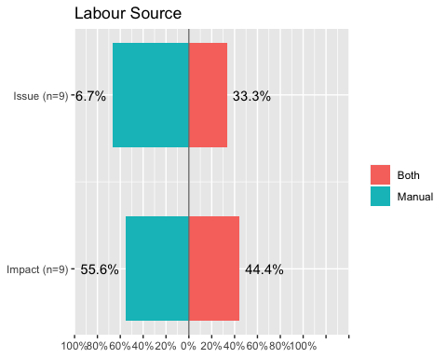

lb1= table(fmglb[1])  
lb2= table(fmglb[2])  
lb1=as.data.frame(lb1)  
  
lb1 <- lb1 %>%  
 arrange(desc(Var1)) %>%  
 mutate(lab.ypos = cumsum(Freq) - 0.5*Freq)  
lb1

## Var1 Freq lab.ypos  
## 1 Manual 6 3.0  
## 2 Both 3 7.5

bp8<- ggplot(lb1, aes(x="", y=Freq, fill=Var1))+  
 geom_bar(width = 1, stat = "identity")+  
 labs(title="Issue")+  
 geom_text(aes(y = lab.ypos, label = percent(Freq/sum(Freq))), color = "white", size=4.5)+  
 labs(fill= "Alternate occupation")+  
 xlab("Labour source")+ylab("")  
bp8

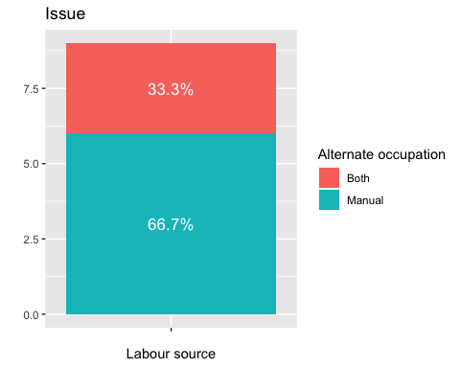

mycols= c("red3","orange2","green4","deeppink3","darkslateblue","red2", "mediumorchid3", "forestgreen")  
ggplot(lb1, aes(x = "", y = Freq, fill = Var1)) +  
 geom_bar(width = 1, stat = "identity", color = "white") +  
 coord_polar("y", start = 0)+  
 ggtitle("Issue-Labour source")+  
 geom_text(aes(y = lab.ypos, label = percent(Freq/sum(Freq))), color = "white", size=4.5)+  
 scale_fill_manual(values = mycols) +  
 labs(fill= "Labour source")+  
 theme_void()

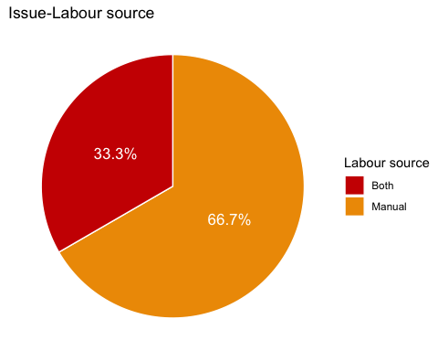

p<-ggplot(data=lb1, aes(x=Var1, y=Freq)) +  
 geom_bar(stat="identity",fill="salmon")  
p + coord_flip()+  
 ggtitle("Issue-Labour source")+  
 geom_text(aes(label=percent(Freq/sum(Freq))), hjust=1, size=3.5)+  
 xlab("Labour source")+ylab("%")

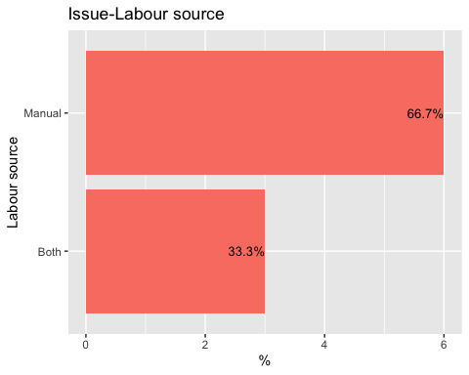

lb2=as.data.frame(lb2)  
  
lb2 <- lb2 %>%  
 arrange(desc(Var1)) %>%  
 mutate(lab.ypos = cumsum(Freq) - 0.5*Freq)  
lb2

## Var1 Freq lab.ypos  
## 1 Manual 5 2.5  
## 2 Both 4 7.0

bp9<- ggplot(lb2, aes(x="", y=Freq, fill=Var1))+  
 geom_bar(width = 1, stat = "identity")+  
 labs(title="Impact")+  
 labs(fill="Labour source")+  
 geom_text(aes(y = lab.ypos, label = percent(Freq/sum(Freq))), color = "white", size=4.5)+  
 xlab("Labour source")+ylab("")  
bp9

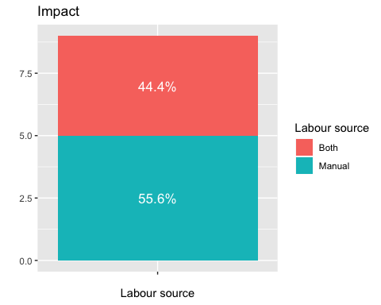

mycols= c("red3","orange2","green4","deeppink3","darkslateblue","red2", "mediumorchid3", "forestgreen")  
ggplot(lb2, aes(x = "", y = Freq, fill = Var1)) +  
 geom_bar(width = 1, stat = "identity", color = "white") +  
 coord_polar("y", start = 0)+  
 ggtitle("Impact-Labour source")+  
 geom_text(aes(y = lab.ypos, label = percent(Freq/sum(Freq))), color = "white", size=4.5)+  
 scale_fill_manual(values = mycols) +  
 labs(fill= "Labour source")+  
 theme_void()

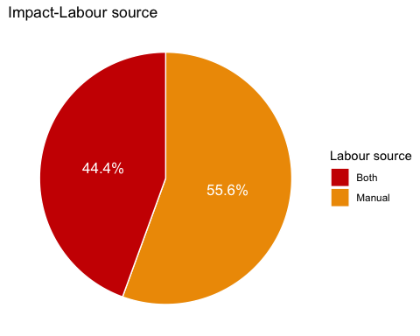

p<-ggplot(data=lb2, aes(x=Var1, y=Freq)) +  
 geom_bar(stat="identity",fill="salmon")  
p + coord_flip()+  
 ggtitle("Impact-Labour source")+  
 geom_text(aes(label=percent(Freq/sum(Freq))), hjust=1, size=3.5)+  
 xlab("Labour source")+ylab("%")

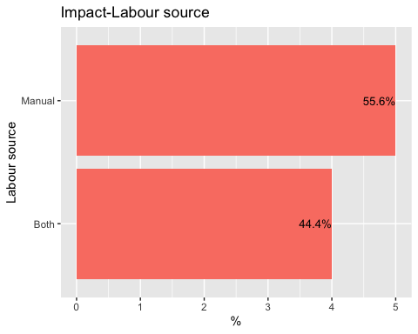

fmginc= cbind(fmgissue[25], fmgimpact[25]);fmginc

## What.is.the.range.of.your.income.per.month.  
## 1 <Nu. 6450  
## 2 <Nu. 6450  
## 3 <Nu. 6450  
## 4 <Nu. 6450  
## 5 >Nu. 6450  
## 6 <Nu. 6450  
## 7 <Nu. 6450  
## 8 >Nu. 6450  
## 9 <Nu. 6450  
## What.is.the.range.of.your.income.per.month.  
## 1 >Nu. 6450  
## 2 >Nu. 6450  
## 3 >Nu. 6450  
## 4 <Nu. 6450  
## 5 >Nu. 6450  
## 6 >Nu. 6450  
## 7 >Nu. 6450  
## 8 >Nu. 6450  
## 9 >Nu. 6450

names(fmginc)= c("Issue", "Impact")  
  
plot_likert(  
 fmginc,  
 title = "Income per month",  
 grid.range = c(1.2, 1.4),  
 expand.grid = FALSE,  
 catcount = 2,  
 geom.colors = "RBu",  
 values = "sum.outside",  
 show.prc.sign = TRUE  
)

## Warning in sj.setGeomColors(gp, geom.colors, (catcount + adding),  
## show.legend, : Too less colors provided for plot. Using default color  
## palette.

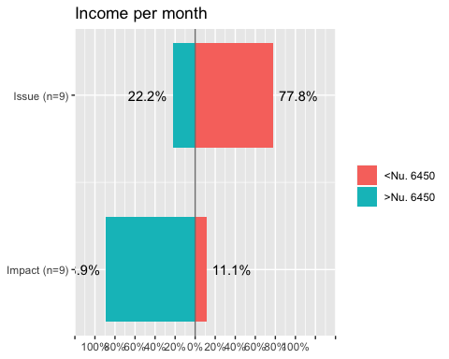

inc1= table(fmginc[1])  
inc2= table(fmginc[2])  
inc1=as.data.frame(inc1)  
  
inc1 <- inc1 %>%  
 arrange(desc(Var1)) %>%  
 mutate(lab.ypos = cumsum(Freq) - 0.5*Freq)  
inc1

## Var1 Freq lab.ypos  
## 1 >Nu. 6450 2 1.0  
## 2 <Nu. 6450 7 5.5

bp10<- ggplot(inc1, aes(x="", y=Freq, fill=Var1))+  
 geom_bar(width = 1, stat = "identity")+  
 labs(title="Issue")+  
 labs(fill="Income (Nu.)")+  
 geom_text(aes(y = lab.ypos, label = percent(Freq/sum(Freq))), color = "white", size=4.5)+  
 xlab("Income per month")+ylab("")  
bp10

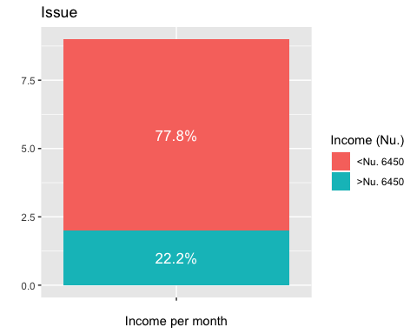

mycols= c("red3","orange2","green4","deeppink3","darkslateblue","red2", "mediumorchid3", "forestgreen")  
ggplot(inc1, aes(x = "", y = Freq, fill = Var1)) +  
 geom_bar(width = 1, stat = "identity", color = "white") +  
 coord_polar("y", start = 0)+  
 ggtitle("Issue-Income per month")+  
 geom_text(aes(y = lab.ypos, label = percent(Freq/sum(Freq))), color = "white", size=4.5)+  
 scale_fill_manual(values = mycols) +  
 labs(fill= "Income (Nu.)")+  
 theme_void()

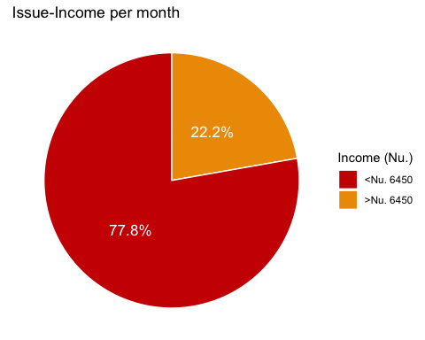

p<-ggplot(data=inc1, aes(x=Var1, y=Freq)) +  
 geom_bar(stat="identity",fill="salmon")  
p + coord_flip()+  
 ggtitle("Issue-Income per month")+  
 geom_text(aes(label=percent(Freq/sum(Freq))), hjust=1, size=3.5)+  
 xlab("Income (Nu.)")+ylab("%")+  
 scale_x_discrete(limits=c( ">Nu. 6450", "<Nu. 6450"))

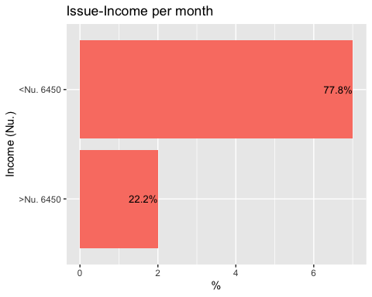

inc2=as.data.frame(inc2)  
  
inc2 <- inc2 %>%  
 arrange(desc(Var1)) %>%  
 mutate(lab.ypos = cumsum(Freq) - 0.5*Freq)  
inc2

## Var1 Freq lab.ypos  
## 1 >Nu. 6450 8 4.0  
## 2 <Nu. 6450 1 8.5

bp11<- ggplot(inc2, aes(x="", y=Freq, fill=Var1))+  
 geom_bar(width = 1, stat = "identity")+  
 labs(title="Impact")+  
 labs(fill="Income (Nu.)")+  
 geom_text(aes(y = lab.ypos, label = percent(Freq/sum(Freq))), color = "white", size=4.5)+  
 xlab("Income per month")+ylab("")  
bp11

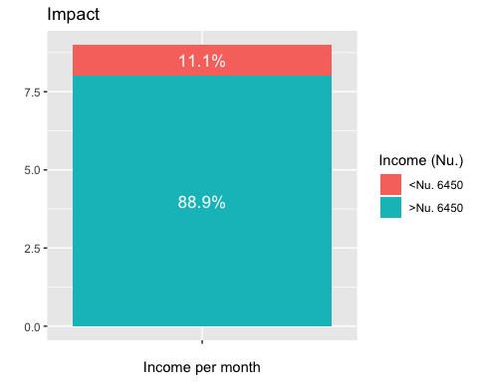

mycols= c("red3","orange2","green4","deeppink3","darkslateblue","red2", "mediumorchid3", "forestgreen")  
ggplot(inc2, aes(x = "", y = Freq, fill = Var1)) +  
 geom_bar(width = 1, stat = "identity", color = "white") +  
 coord_polar("y", start = 0)+  
 ggtitle("Impact-Income per month")+  
 geom_text(aes(y = lab.ypos, label = percent(Freq/sum(Freq))), color = "white", size=4.5)+  
 scale_fill_manual(values = mycols) +  
 labs(fill="Income (Nu.)")+  
 theme_void()

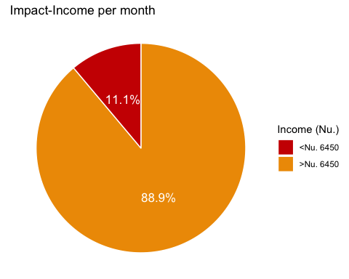

p<-ggplot(data=inc2, aes(x=Var1, y=Freq)) +  
 geom_bar(stat="identity",fill="salmon")  
p + coord_flip()+  
 ggtitle("Impact-Income per month")+  
 geom_text(aes(label=percent(Freq/sum(Freq))), hjust=1, size=3.5)+  
 xlab("Income (Nu.)")+ylab("%")

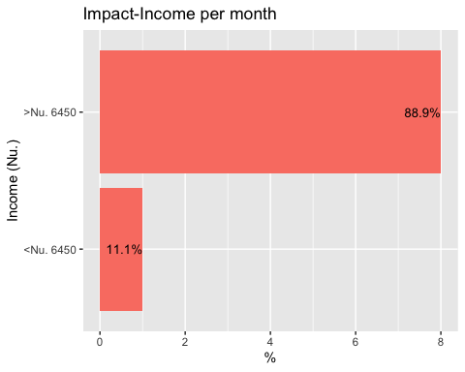

fmgainc= cbind(fmgissue[26], fmgimpact[26]);fmgainc

## The.approx.share.of.income.from.agriculture.activities.out.of.total.income.  
## 1 20-40%  
## 2 40-60%  
## 3 <20%  
## 4 20-40%  
## 5 20-40%  
## 6 40-60%  
## 7 <20%  
## 8 60-80%  
## 9 20-40%  
## The.approx.share.of.income.from.agriculture.activities.out.of.total.income.  
## 1 40-60%  
## 2 60-80%  
## 3 40-60%  
## 4 60-80%  
## 5 40-60%  
## 6 40-60%  
## 7 60-80%  
## 8 >80%  
## 9 40-60%

names(fmgainc)= c("Issue", "Impact")  
  
plot_likert(  
 fmgainc,  
 title = "Income share from agriculture",  
 grid.range = c(1.0, 1.4),  
 expand.grid = FALSE,  
 catcount = 4,  
 geom.colors = "RBu",  
 values = "hide",  
 show.prc.sign = TRUE  
)

## Warning in sj.setGeomColors(gp, geom.colors, (catcount + adding),  
## show.legend, : Too less colors provided for plot. Using default color  
## palette.

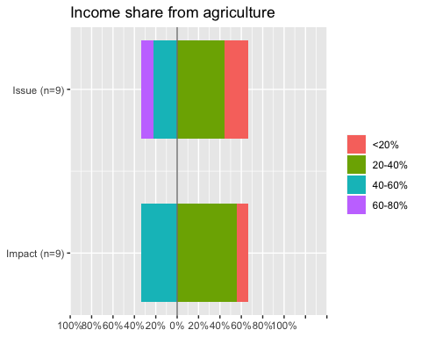

ainc1= table(fmgainc[1])  
ainc2= table(fmgainc[2])  
ainc1=as.data.frame(ainc1)  
  
ainc1 <- ainc1 %>%  
 arrange(desc(Var1)) %>%  
 mutate(lab.ypos = cumsum(Freq) - 0.5*Freq)  
ainc1

## Var1 Freq lab.ypos  
## 1 60-80% 1 0.5  
## 2 40-60% 2 2.0  
## 3 20-40% 4 5.0  
## 4 <20% 2 8.0

bp10<- ggplot(ainc1, aes(x="", y=Freq, fill=Var1))+  
 geom_bar(width = 1, stat = "identity")+  
 labs(title="Issue")+  
 labs(fill="% Income Share")+  
 geom_text(aes(y = lab.ypos, label = percent(Freq/sum(Freq))), color = "white", size=4.5)+  
 xlab("Income share from agriculture")+ylab("")  
bp10

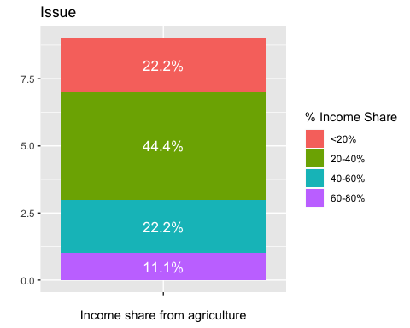

mycols= c("red3","orange2","green4","deeppink3","darkslateblue","red2", "mediumorchid3", "forestgreen")  
ggplot(ainc1, aes(x = "", y = Freq, fill = Var1)) +  
 geom_bar(width = 1, stat = "identity", color = "white") +  
 coord_polar("y", start = 0)+  
 ggtitle("Issue-Income share from agriculture")+  
 geom_text(aes(y = lab.ypos, label = percent(Freq/sum(Freq))), color = "white", size=4.5)+  
 scale_fill_manual(values = mycols) +  
 labs(fill="% Income share")+  
 theme_void()

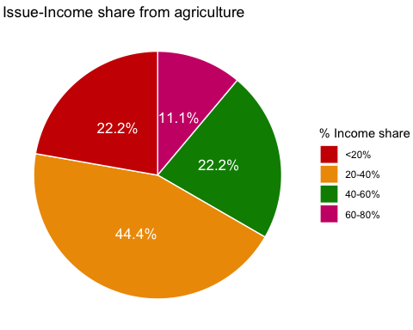

p<-ggplot(data=ainc1, aes(x=Var1, y=Freq)) +  
 geom_bar(stat="identity",fill="salmon")  
p + coord_flip()+  
 ggtitle("Issue-Income share from agriculture")+  
 geom_text(aes(label=percent(Freq/sum(Freq))), hjust=1, size=3.5)+  
 xlab("% Income share")+ylab("%")

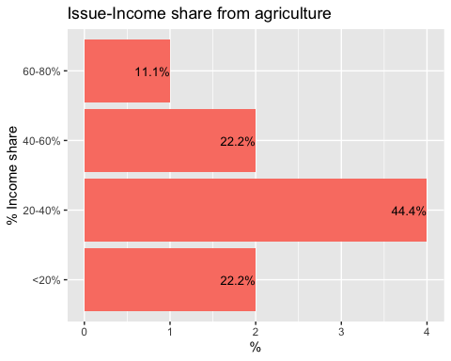

ainc2=as.data.frame(ainc2)  
  
ainc2 <- ainc2 %>%  
 arrange(desc(Var1)) %>%  
 mutate(lab.ypos = cumsum(Freq) - 0.5*Freq)  
ainc2

## Var1 Freq lab.ypos  
## 1 60-80% 3 1.5  
## 2 40-60% 5 5.5  
## 3 >80% 1 8.5

bp011<- ggplot(ainc2, aes(x="", y=Freq, fill=Var1))+  
 geom_bar(width = 1, stat = "identity")+  
 labs(title="Impact")+  
 labs(fill="% Income share")+  
 geom_text(aes(y = lab.ypos, label = percent(Freq/sum(Freq))), color = "white", size=4.5)+  
 xlab("Income share from agriculture")+ylab("")  
bp011

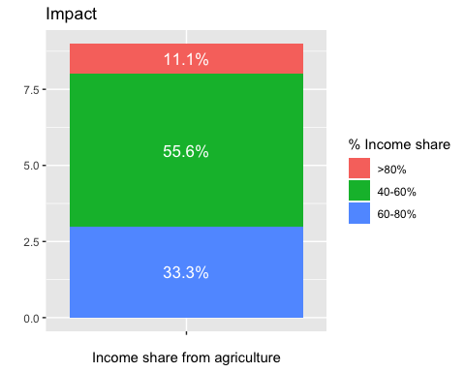

mycols= c("red3","orange2","green4","deeppink3","darkslateblue","red2", "mediumorchid3", "forestgreen")  
ggplot(ainc2, aes(x = "", y = Freq, fill = Var1)) +  
 geom_bar(width = 1, stat = "identity", color = "white") +  
 coord_polar("y", start = 0)+  
 ggtitle("Impact-Income share from agriculture")+  
 geom_text(aes(y = lab.ypos, label = percent(Freq/sum(Freq))), color = "white", size=4.5)+  
 scale_fill_manual(values = mycols) +  
 labs(fill= "% Income share")+  
 theme_void()

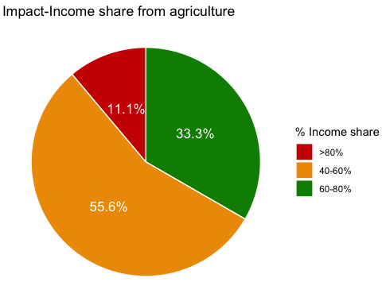

p<-ggplot(data=ainc2, aes(x=Var1, y=Freq)) +  
 geom_bar(stat="identity",fill="salmon")  
p + coord_flip()+  
 ggtitle("Impact-Income share from agriculture")+  
 geom_text(aes(label=percent(Freq/sum(Freq))), hjust=1, size=3.5)+  
 xlab("% Income share")+ylab("%")

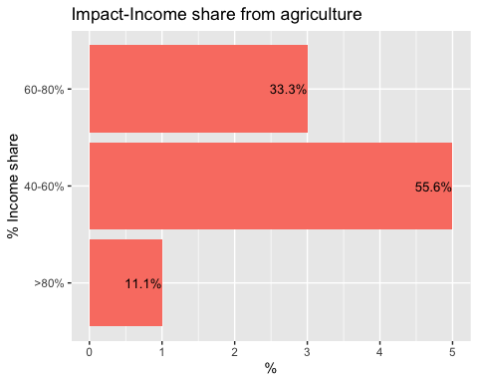

fmgpsur= cbind(fmgissue[27], fmgimpact[27]);fmgpsur

## What.percent.of.surplus.production.usually.you.have.in.vegetables.  
## 1 <50% of total consumption  
## 2 No surplus  
## 3 No surplus  
## 4 <50% of total consumption  
## 5 <50% of total consumption  
## 6 No surplus  
## 7 No surplus  
## 8 <50% of total consumption  
## 9 No surplus  
## What.percent.of.surplus.production.usually.you.have.in.vegetables.  
## 1 >50% of total consumption  
## 2 >50% of total consumption  
## 3 No surplus  
## 4 >50% of total consumption  
## 5 >50% of total consumption  
## 6 No surplus  
## 7 >50% of total consumption  
## 8 <50% of total consumption  
## 9 <50% of total consumption

names(fmgpsur)= c("Issue", "Impact")  
  
plot_likert(  
 fmgpsur,  
 title = "Percent Surplus",  
 grid.range = c(1.0, 1.4),  
 expand.grid = FALSE,  
 legend.labels = c("<50% of total consumption", "No surplus", ">50% of total consumption"),  
 catcount = 3,  
 geom.colors = "RBu",  
 values = "show",  
 show.prc.sign = TRUE  
)

## Warning in sj.setGeomColors(gp, geom.colors, (catcount + adding),  
## show.legend, : Too less colors provided for plot. Using default color  
## palette.

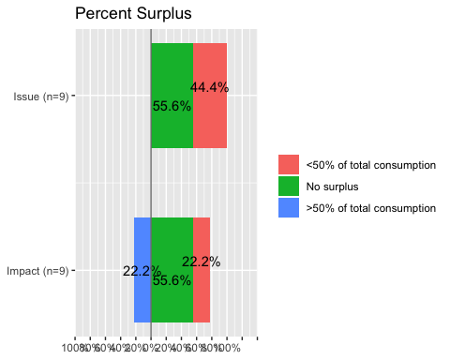

psur1= table(fmgpsur[1])  
psur2= table(fmgpsur[2])  
psur1=as.data.frame(psur1)  
  
psur1 <- psur1 %>%  
 arrange(desc(Var1)) %>%  
 mutate(lab.ypos = cumsum(Freq) - 0.5*Freq)  
psur1

## Var1 Freq lab.ypos  
## 1 No surplus 5 2.5  
## 2 <50% of total consumption 4 7.0

bp10<- ggplot(psur1, aes(x="", y=Freq, fill=Var1))+  
 geom_bar(width = 1, stat = "identity")+  
 labs(title="Issue")+  
 labs(fill="% Surplus")+  
 geom_text(aes(y = lab.ypos, label = percent(Freq/sum(Freq))), color = "white", size=4.5)+  
 xlab("% Surplus")+ylab("")  
bp10

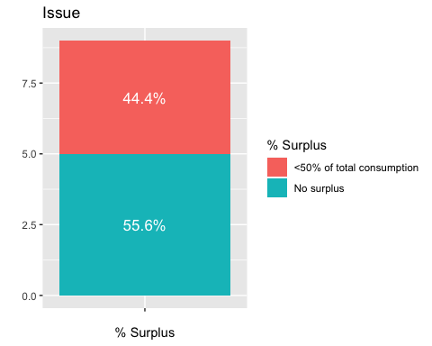

mycols= c("red3","orange2","green4","deeppink3","darkslateblue","red2", "mediumorchid3", "forestgreen")  
ggplot(psur1, aes(x = "", y = Freq, fill = Var1)) +  
 geom_bar(width = 1, stat = "identity", color = "white") +  
 coord_polar("y", start = 0)+  
 ggtitle("Issue-Percent surplus")+  
 geom_text(aes(y = lab.ypos, label = percent(Freq/sum(Freq))), color = "white", size=4.5)+  
 scale_fill_manual(values = mycols) +  
 labs(fill="% Surplus")+  
 theme_void()

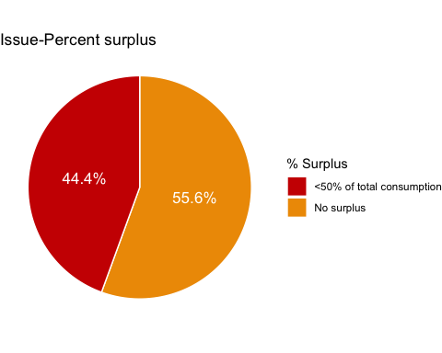

p<-ggplot(data=psur1, aes(x=Var1, y=Freq)) +  
 geom_bar(stat="identity",fill="salmon")  
p + coord_flip()+  
 ggtitle("Issue-Percent surplus")+  
 geom_text(aes(label=percent(Freq/sum(Freq))), hjust=1, size=3.5)+  
 xlab("% Surplus")+ylab("%")

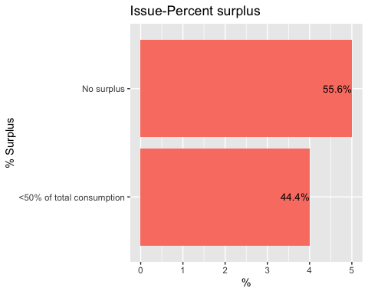

psur2=as.data.frame(psur2)  
  
psur2 <- psur2 %>%  
 arrange(desc(Var1)) %>%  
 mutate(lab.ypos = cumsum(Freq) - 0.5*Freq)  
psur2

## Var1 Freq lab.ypos  
## 1 No surplus 2 1.0  
## 2 >50% of total consumption 5 4.5  
## 3 <50% of total consumption 2 8.0

bp11<- ggplot(psur2, aes(x="", y=Freq, fill=Var1))+  
 geom_bar(width = 1, stat = "identity")+  
 labs(title="Impact")+  
 labs(fill= "% Surplus")+  
 geom_text(aes(y = lab.ypos, label = percent(Freq/sum(Freq))), color = "white", size=4.5)+  
 xlab("% surplus")+ylab("")  
bp11

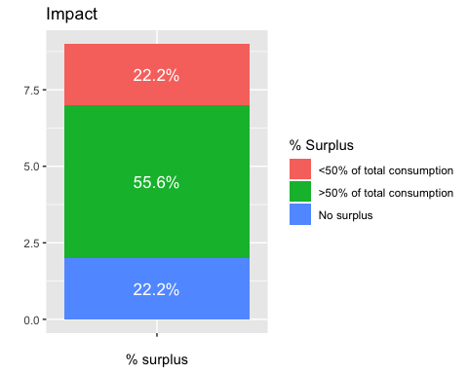

mycols= c("red3","orange2","green4","deeppink3","darkslateblue","red2", "mediumorchid3", "forestgreen")  
ggplot(psur2, aes(x = "", y = Freq, fill = Var1)) +  
 geom_bar(width = 1, stat = "identity", color = "white") +  
 coord_polar("y", start = 0)+  
 ggtitle("Impact-Percent surplus")+  
 geom_text(aes(y = lab.ypos, label = percent(Freq/sum(Freq))), color = "white", size=4.5)+  
 scale_fill_manual(values = mycols) +  
 labs(fill="% Surplus")+  
 theme_void()

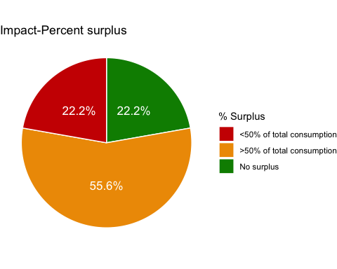

p<-ggplot(data=psur2, aes(x=Var1, y=Freq)) +  
 geom_bar(stat="identity",fill="salmon")  
p + coord_flip()+  
 ggtitle("Impact-Percent surplus")+  
 geom_text(aes(label=percent(Freq/sum(Freq))), hjust=1, size=3.5)+  
 xlab("% Surplus")+ylab("%")

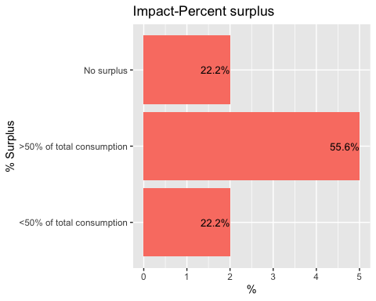

vegis=read.csv("fmgissueveg.csv")  
vegim=read.csv("fmgimpactveg.csv")  
  
v1= table(vegis[3])  
v2= table(vegim[3])  
  
v1=as.data.frame(v1)  
  
v1 <- v1 %>%  
 arrange(desc(Var1)) %>%  
 mutate(lab.ypos = cumsum(Freq) - 0.5*Freq)  
v1

## Var1 Freq lab.ypos  
## 1 Turnip 4 2.0  
## 2 Tomato 2 5.0  
## 3 Squash 5 8.5  
## 4 Slipper gourd 1 11.5  
## 5 Saag 8 16.0  
## 6 Radish 8 24.0  
## 7 Pumpkin 5 30.5  
## 8 Potato 5 35.5  
## 9 Onion 1 38.5  
## 10 Green Leaves 1 39.5  
## 11 Cucumber 1 40.5  
## 12 Coriander 2 42.0  
## 13 Chili 7 46.5  
## 14 Cauliflower 3 51.5  
## 15 Carrot 3 54.5  
## 16 Cabbage 6 59.0  
## 17 Broccoli 4 64.0  
## 18 Brinjal 1 66.5  
## 19 Bittergourd 1 67.5  
## 20 Bean 8 72.0

bp13<- ggplot(v1, aes(x="", y=Freq, fill=Var1))+  
 geom_bar(width = 0.5, stat = "identity")+  
 labs(title="Issue")+  
 xlab("Vegetables produced")  
bp13

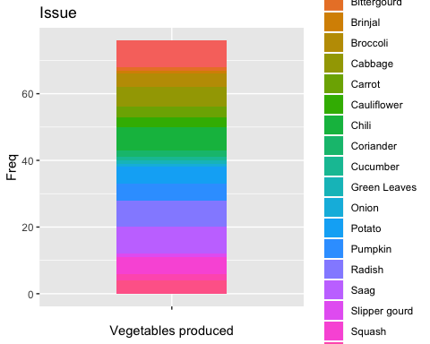

#mycols= c("red3","orange2","green4","deeppink3","darkslateblue","red2", "mediumorchid3", "forestgreen")  
ggplot(v1, aes(x = "", y = Freq, fill = Var1)) +  
 geom_bar(width = 1, stat = "identity", color = "white") +  
 coord_polar("y", start = 0)+  
 ggtitle("Issue-Vegetables Produced")+  
 geom_text(aes(y = lab.ypos, label = percent(Freq/sum(Freq))), color = "white", size=4.5)+  
 #scale_fill_manual(values = mycols) +  
 labs(fill= "Vegetables produced")+  
 theme_void()

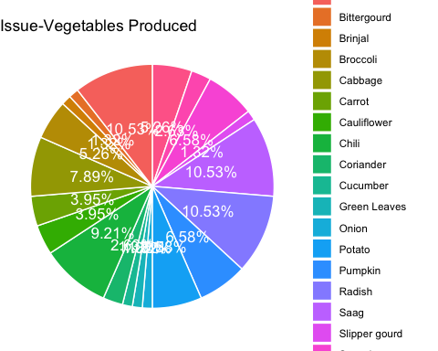

p<-ggplot(data=v1, aes(x=Var1, y=Freq)) +  
 geom_bar(stat="identity",fill="salmon")  
p + coord_flip()+  
 ggtitle("Issue-Vegetables Produced")+  
 geom_text(aes(label=percent(Freq/sum(Freq))), hjust=1, size=3.5)+  
 xlab("Vegetables Produced")+ylab("%")

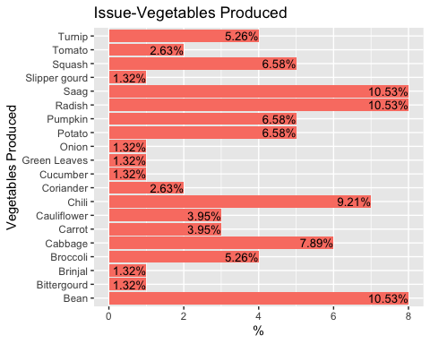

# scale_x_discrete(limits=c("Produce unavailable", "Farmers not competitive", "FGM is not aware", "Tender supplier supplies all vegetables", "Budget limitations", "Unfavouralble financial rules and regulations", "Expensive local vegetables"))  
  
  
v2=as.data.frame(v2)  
  
v2 <- v2 %>%  
 arrange(desc(Var1)) %>%  
 mutate(lab.ypos = cumsum(Freq) - 0.5*Freq)  
v2

## Var1 Freq lab.ypos  
## 1 Turnip 2 1.0  
## 2 Tomato 1 2.5  
## 3 Squash 3 4.5  
## 4 Slipper Gourd 1 6.5  
## 5 Sag 3 8.5  
## 6 Saag 3 11.5  
## 7 Radish 8 17.0  
## 8 Pumpkin 3 22.5  
## 9 Potato 4 26.0  
## 10 Onion 2 29.0  
## 11 Green leaves 1 30.5  
## 12 Cucumber 1 31.5  
## 13 Coriander 2 33.0  
## 14 Chili 5 36.5  
## 15 Cauliflower 7 42.5  
## 16 Carrot 5 48.5  
## 17 Cabbage 7 54.5  
## 18 Broccoli 5 60.5  
## 19 Brinjal 1 63.5  
## 20 Bean 7 67.5

bp3<- ggplot(v2, aes(x="", y=Freq, fill=Var1))+  
 geom_bar(width = 1, stat = "identity")+  
 labs(title="Impact")+  
 xlab("Vegetables Produced")+  
 geom_text(aes(y = lab.ypos, label = percent(Freq/sum(Freq))), color = "white", size=4.5)+  
 labs(fill="Vegetables Produced")  
  
bp3

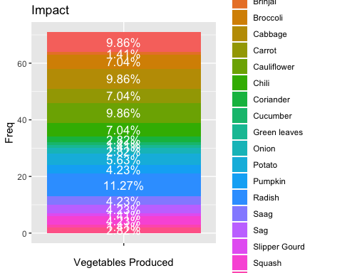

#mycols= c("red3","orange2","green4","deeppink3","olivedrab", "darkslateblue","mediumorchid3" )  
ggplot(v2, aes(x = "", y = Freq, fill = Var1)) +  
 geom_bar(width = 1, stat = "identity", color = "white") +  
 coord_polar("y", start = 0)+  
 ggtitle("Impact-Vegetables Produced")+  
 geom_text(aes(y = lab.ypos, label = percent(Freq/sum(Freq))), color = "white", size=4.5)+  
 #scale_fill_manual(values = mycols) +  
 labs(fill="Vegetables Produced")+  
 theme_void()

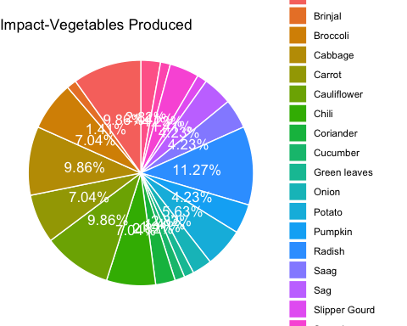

p<-ggplot(data=v2, aes(x=Var1, y=Freq)) +  
 geom_bar(stat="identity",fill="salmon")  
p + coord_flip()+  
 ggtitle("Impact-Vegetables Produced")+  
 geom_text(aes(label=percent(Freq/sum(Freq))), hjust=1, size=3.5)+  
 xlab("vegetables Produced")+ylab("%")

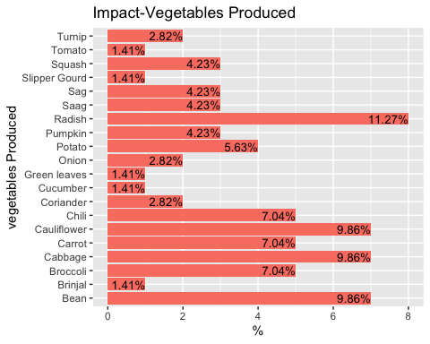

vegsuris=read.csv("fmgissuesur.csv")  
vegsurim=read.csv("fmgimpactsur.csv")  
  
s1= table(vegsuris[3])  
s2= table(vegsurim[3])  
  
s1=as.data.frame(s1)  
  
s1 <- s1 %>%  
 arrange(desc(Var1)) %>%  
 mutate(lab.ypos = cumsum(Freq) - 0.5*Freq)  
s1

## Var1 Freq lab.ypos  
## 1 Tubers 1 0.5  
## 2 Radish 2 2.0  
## 3 Pumpkin 2 4.0  
## 4 Potato 1 5.5  
## 5 Green Leaves 4 8.0  
## 6 Chili 2 11.0  
## 7 Carrot 1 12.5  
## 8 Beans 1 13.5

bp13<- ggplot(s1, aes(x="", y=Freq, fill=Var1))+  
 geom_bar(width = 0.5, stat = "identity")+  
 labs(title="Issue")+  
 labs(fill="Surplus Vegetables")+  
 geom_text(aes(y = lab.ypos, label = percent(Freq/sum(Freq))), color = "white", size=4.5)+  
 xlab("Surplus Vegetables")+ylab("")  
bp13

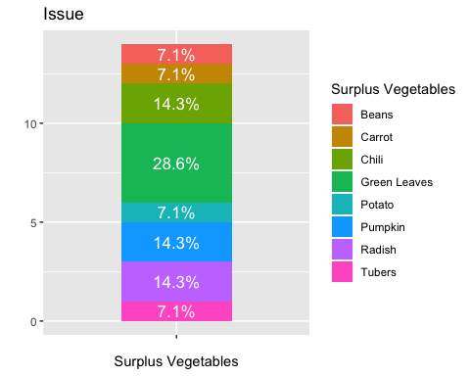

mycols= c("red3","orange2","green4","deeppink3","darkslateblue","red2", "mediumorchid3", "forestgreen")  
ggplot(s1, aes(x = "", y = Freq, fill = Var1)) +  
 geom_bar(width = 1, stat = "identity", color = "white") +  
 coord_polar("y", start = 0)+  
 ggtitle("Issue-Surplus Vegetables")+  
 geom_text(aes(y = lab.ypos, label = percent(Freq/sum(Freq))), color = "white", size=4.5)+  
 labs(fill="Surplus Vegetables")+  
 scale_fill_manual(values = mycols) +  
 theme_void()

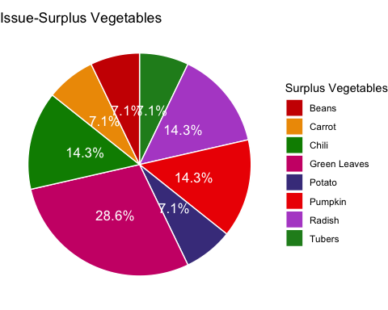

p<-ggplot(data=s1, aes(x=Var1, y=Freq)) +  
 geom_bar(stat="identity",fill="salmon")  
p + coord_flip()+  
 ggtitle("Issue-Vegetables Surplus")+  
 geom_text(aes(label=percent(Freq/sum(Freq))), hjust=1, size=3.5)+  
 xlab("surplus Vegetables")+ylab("%")

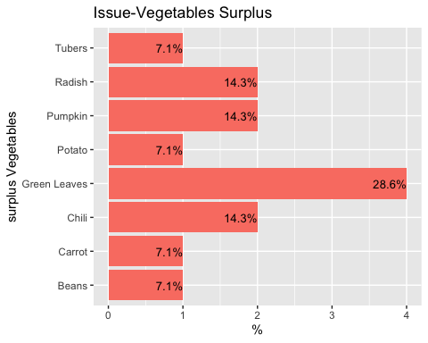

#scale_x_discrete(limits=c("Produce unavailable", "Farmers not competitive", "FGM is not aware", "Tender supplier supplies all vegetables", "Budget limitations", "Unfavouralble financial rules and regulations", "Expensive local vegetables"))  
  
  
s2=as.data.frame(s2)  
  
s2 <- s2 %>%  
 arrange(desc(Var1)) %>%  
 mutate(lab.ypos = cumsum(Freq) - 0.5*Freq)  
s2

## Var1 Freq lab.ypos  
## 1 Radish 5 2.5  
## 2 Pumpkin 4 7.0  
## 3 Potato 3 10.5  
## 4 Green leaves 7 15.5  
## 5 Cole crops 4 21.0  
## 6 Chili 2 24.0  
## 7 Chayote 1 25.5  
## 8 Carrot 2 27.0  
## 9 Beans 2 29.0

bp3<- ggplot(s2, aes(x="", y=Freq, fill=Var1))+  
 geom_bar(width = 1, stat = "identity")+  
 labs(title="Impact")+  
 geom_text(aes(y = lab.ypos, label = percent(Freq/sum(Freq))), color = "white", size=4.5)+  
 labs(fill="Surplus Vegetables")+  
 xlab("Surplus Vegetables")+ylab("")  
  
bp3

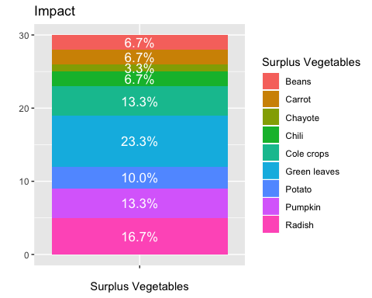

mycols= c("red3","orange2","green4","deeppink3","olivedrab", "darkslateblue","mediumorchid3", "yellowgreen", "cadetblue3")  
ggplot(s2, aes(x = "", y = Freq, fill = Var1)) +  
 geom_bar(width = 1, stat = "identity", color = "white") +  
 coord_polar("y", start = 0)+  
 ggtitle("Impact-Surplus Vegetables")+  
 geom_text(aes(y = lab.ypos, label = percent(Freq/sum(Freq))), color = "white", size=4.5)+  
 scale_fill_manual(values = mycols) +  
 labs(fill="Surplus Vegetables")+  
 theme_void()

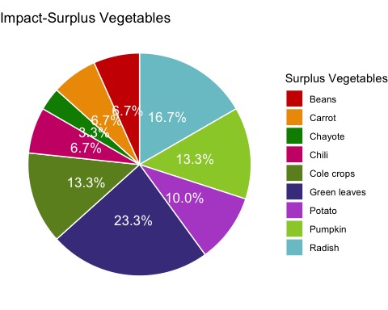

p<-ggplot(data=s2, aes(x=Var1, y=Freq)) +  
 geom_bar(stat="identity",fill="salmon")  
p + coord_flip()+  
 ggtitle("Impact- Surplus Vegetables")+  
 geom_text(aes(label=percent(Freq/sum(Freq))), hjust=1, size=3.5)+  
 xlab("Surplus Vegetables")+ylab("%")

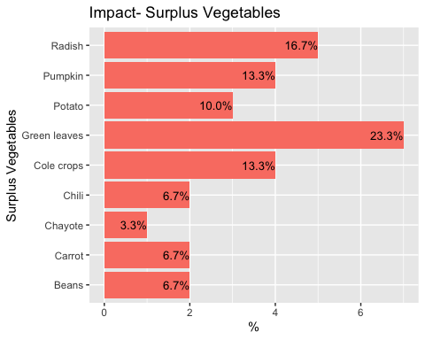

veglksuris=read.csv("fmgissuelksur.csv")  
veglksurim=read.csv("fmgimpactlksur.csv")  
  
l1= table(veglksuris[3])  
l2= table(veglksurim[3])  
  
  
l1=as.data.frame(l1)  
  
  
l1 <- l1 %>%  
 arrange(desc(Var1)) %>%  
 mutate(lab.ypos = cumsum(Freq) - 0.5*Freq)  
l1

## Var1 Freq lab.ypos  
## 1 Unpredictable weather conditions 2 1.0  
## 2 Susceptibility to various pests and natural disasters 2 3.0  
## 3 Seed and seedling shortage 1 4.5  
## 4 Low fertility of Soil 2 6.0  
## 5 Lack of Knowledge on improved production techniques 1 7.5  
## 6 Lack of human resource 1 8.5  
## 7 Lack of financial capability 2 10.0  
## 8 Lack of assured market for the produce 4 13.0

bp13<- ggplot(l1, aes(x="", y=Freq, fill=Var1))+  
 geom_bar(width = 0.5, stat = "identity")+  
 labs(title="Issue")+  
 geom_text(aes(y = lab.ypos, label = percent(Freq/sum(Freq))), color = "white", size=4.5)+  
 labs(fill= "Reasons")+  
 xlab("Reason for lack of surplus")+ylab("")  
bp13

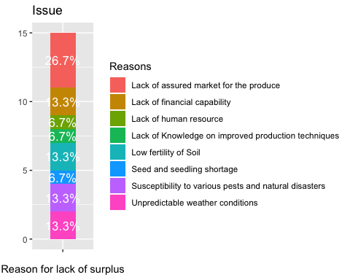

mycols= c("red3","orange2","green4","deeppink3","darkslateblue","red2", "mediumorchid3", "forestgreen")  
ggplot(l1, aes(x = "", y = Freq, fill = Var1)) +  
 geom_bar(width = 1, stat = "identity", color = "white") +  
 coord_polar("y", start = 0)+  
 ggtitle("Issue-Reason for lack of surplus")+  
 geom_text(aes(y = lab.ypos, label = percent(Freq/sum(Freq))), color = "white", size=4.5)+  
 scale_fill_manual(values = mycols) +  
 labs(fill="Reasons")+  
 theme_void()

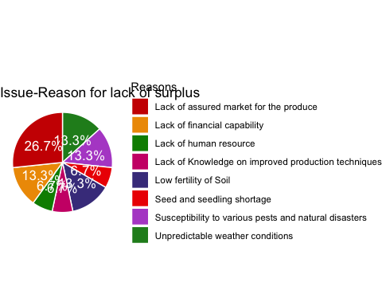

p<-ggplot(data=l1, aes(x=Var1, y=Freq)) +  
 geom_bar(stat="identity",fill="salmon")  
p + coord_flip()+  
 ggtitle("Issue-Reason for lack of surplus")+  
 geom_text(aes(label=percent(Freq/sum(Freq))), hjust=1, size=3.5)+  
 xlab("Reasons")+ylab("%")+  
 scale_x_discrete(limits=c("Seed and seedling shortage", "Lack of human resource", "Lack of Knowledge on improved production techniques", "Unpredictable weather conditions", "Susceptibility to various pests and natural disasters", "Low fertility of Soil", "Lack of financial capability", "Lack of assured market for the produce"))

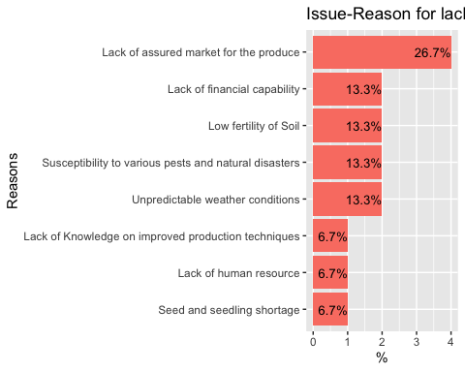

l2=as.data.frame(l2)  
  
l2 <- l2 %>%  
 arrange(desc(Var1)) %>%  
 mutate(lab.ypos = cumsum(Freq) - 0.5*Freq)  
l2

## Var1 Freq lab.ypos  
## 1 Unpredictable whether conditions 1 0.5  
## 2 Susceptibility to various pests and natural disasters 1 1.5  
## 3 Low fertility of soil 1 2.5  
## 4 Lack of financial capability 2 4.0  
## 5 Farm labour shortage 1 5.5

bp3<- ggplot(l2, aes(x="", y=Freq, fill=Var1))+  
 geom_bar(width = 1, stat = "identity")+  
 labs(title="Impact")+  
 labs(fill="Reasons")+  
 xlab("Reason for lack of surplus")+ylab("")+  
 geom_text(aes(y = lab.ypos, label = percent(Freq/sum(Freq))), color = "white", size=4.5)  
bp3

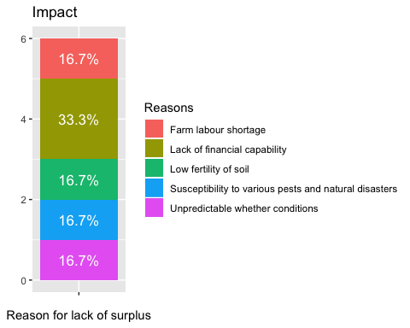

mycols= c("red3","orange2","green4","deeppink3","olivedrab", "darkslateblue","mediumorchid3" )  
ggplot(l2, aes(x = "", y = Freq, fill = Var1)) +  
 geom_bar(width = 1, stat = "identity", color = "white") +  
 coord_polar("y", start = 0)+  
 ggtitle("Impact-Reason for lack of surplus")+  
 geom_text(aes(y = lab.ypos, label = percent(Freq/sum(Freq))), color = "white", size=4.5)+  
 scale_fill_manual(values = mycols) +  
 labs(fill="Reasons")+  
 theme_void()

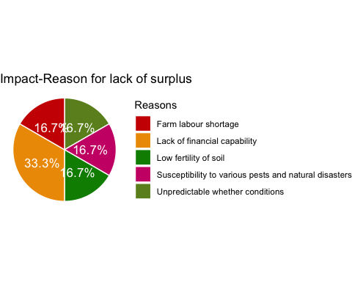

p<-ggplot(data=l2, aes(x=Var1, y=Freq)) +  
 geom_bar(stat="identity",fill="salmon")  
p + coord_flip()+  
 ggtitle("Impact-Reason for lack of surplus")+  
 geom_text(aes(label=percent(Freq/sum(Freq))), hjust=1, size=3.5)+  
 xlab("Reasons")+ylab("%")+  
 scale_x_discrete(limits=c("Unpredictable whether conditions", "Susceptibility to various pests and natural disasters", "Low fertility of soil", "Farm labour shortage", "Lack of financial capability"))

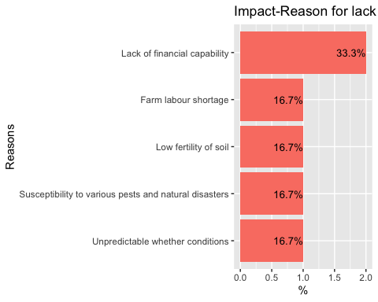

vegwasis=read.csv("fmgissuewas.csv")  
vegwasim=read.csv("fmgimpactwas.csv")  
  
w1= table(vegwasis[3])  
w2= table(vegwasim[3])  
  
  
w1=as.data.frame(w1)  
w1 <- w1 %>%  
 arrange(desc(Var1)) %>%  
 mutate(lab.ypos = cumsum(Freq) - 0.5*Freq)  
w1

## Var1 Freq lab.ypos  
## 1 Throw them in field untill it gets rotten 6 3.0  
## 2 Burn them 3 7.5  
## 3 Animal feed 3 10.5

bp13<- ggplot(w1, aes(x="", y=Freq, fill=Var1))+  
 geom_bar(width = 0.5, stat = "identity")+  
 labs(title="Issue")+  
 labs(fill="Farm waste management practices")+  
 geom_text(aes(y = lab.ypos, label = percent(Freq/sum(Freq))), color = "white", size=4.5)+  
 xlab("Farm waste management practices")+ylab("")  
bp13

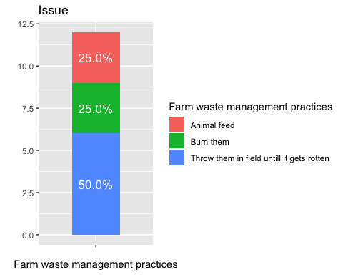

mycols= c("red3","orange2","green4","deeppink3","darkslateblue","red2", "mediumorchid3", "forestgreen")  
ggplot(w1, aes(x = "", y = Freq, fill = Var1)) +  
 geom_bar(width = 1, stat = "identity", color = "white") +  
 coord_polar("y", start = 0)+  
 ggtitle("Issue-Farm waste management practices")+  
 geom_text(aes(y = lab.ypos, label = percent(Freq/sum(Freq))), color = "white", size=4.5)+  
 scale_fill_manual(values = mycols) +  
 labs(fill="Farm waste management practices")+  
 theme_void()

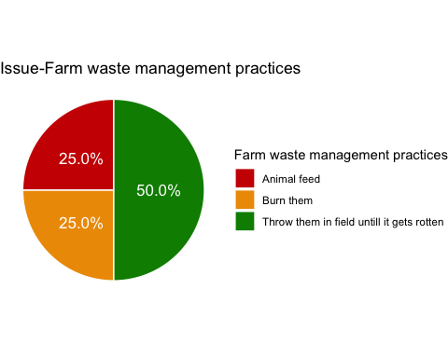

p<-ggplot(data=w1, aes(x=Var1, y=Freq)) +  
 geom_bar(stat="identity",fill="salmon")  
p + coord_flip()+  
 ggtitle("Issue-Farm waste management practices")+  
 geom_text(aes(label=percent(Freq/sum(Freq))), hjust=1, size=3.5)+  
 xlab("Farm waste management practices")+ylab("%")

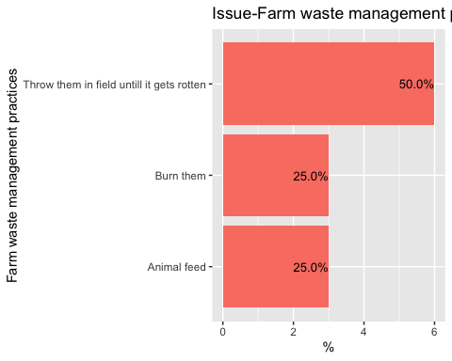

#scale_x_discrete(limits=c("Produce unavailable", "Farmers not competitive", "FGM is not aware", "Tender supplier supplies all vegetables", "Budget limitations", "Unfavouralble financial rules and regulations", "Expensive local vegetables"))  
  
  
w2=as.data.frame(w2)  
  
w2 <- w2 %>%  
 arrange(desc(Var1)) %>%  
 mutate(lab.ypos = cumsum(Freq) - 0.5*Freq)  
w2

## Var1 Freq lab.ypos  
## 1 Throw them in field untill it gets rotten 4 2.0  
## 2 Composting 8 8.0  
## 3 Burn them 1 12.5  
## 4 Animal feed 2 14.0

bp3<- ggplot(w2, aes(x="", y=Freq, fill=Var1))+  
 geom_bar(width = 1, stat = "identity")+  
 labs(title="Impact")+  
 labs(fill="Farm waste management practices")+  
 geom_text(aes(y = lab.ypos, label = percent(Freq/sum(Freq))), color = "white", size=4.5)+  
 xlab("Farm waste management practices")+ylab("")  
  
bp3

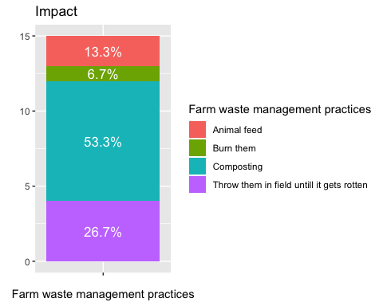

mycols= c("red3","orange2","green4","deeppink3","olivedrab", "darkslateblue","mediumorchid3" )  
ggplot(w2, aes(x = "", y = Freq, fill = Var1)) +  
 geom_bar(width = 1, stat = "identity", color = "white") +  
 coord_polar("y", start = 0)+  
 ggtitle("Impact-Farm waste management practices")+  
 geom_text(aes(y = lab.ypos, label = percent(Freq/sum(Freq))), color = "white", size=4.5)+  
 scale_fill_manual(values = mycols) +  
 labs(fill="Farm waste management practices")+  
 theme_void()

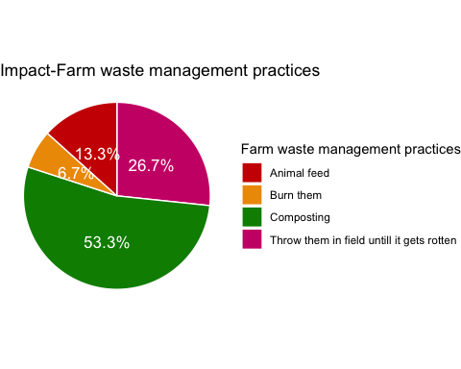

p<-ggplot(data=w2, aes(x=Var1, y=Freq)) +  
 geom_bar(stat="identity",fill="salmon")  
p + coord_flip()+  
 ggtitle("Impact-Farm waste management practices")+  
 geom_text(aes(label=percent(Freq/sum(Freq))), hjust=1, size=3.5)+  
 xlab("Farm waste management practices")+ylab("%")+  
 scale_x_discrete(limits=c("Burn them", "Animal feed", "Throw them in field untill it gets rotten", "Composting"))

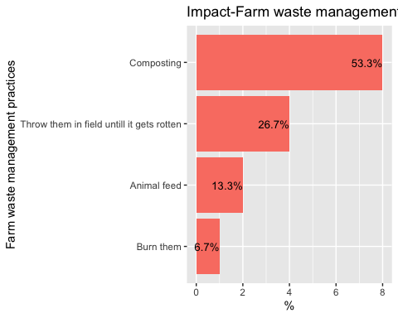

vegmaris=read.csv("fmgissuemar.csv")  
vegmarim=read.csv("fmgimpactmar.csv")  
m1= table(vegmaris[3])  
m2= table(vegmarim[3])  
  
  
  
m1=as.data.frame(m1)  
  
m1 <- m1 %>%  
 arrange(desc(Var1)) %>%  
 mutate(lab.ypos = cumsum(Freq) - 0.5*Freq)  
m1

## Var1 Freq lab.ypos  
## 1 No idea on marketing 1 0.5  
## 2 Don\x92t like doing business 2 2.0

bp13<- ggplot(m1, aes(x="", y=Freq, fill=Var1))+  
 geom_bar(width = 0.5, stat = "identity")+  
 labs(title="Issue")+  
 geom_text(aes(y = lab.ypos, label = percent(Freq/sum(Freq))), color = "white", size=4.5)+  
 labs(fill="Reasons")+  
 geom_text(aes(y = lab.ypos, label = percent(Freq/sum(Freq))), color = "white", size=4.5)+  
 xlab("Reason for not taking up Agriculture Marketing")+ylab("")  
bp13

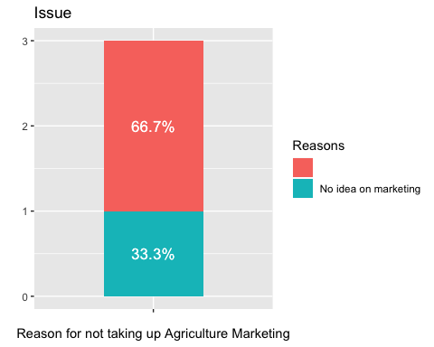

mycols= c("red3","orange2","green4","deeppink3","darkslateblue","red2", "mediumorchid3", "forestgreen")  
ggplot(m1, aes(x = "", y = Freq, fill = Var1)) +  
 geom_bar(width = 1, stat = "identity", color = "white") +  
 coord_polar("y", start = 0)+  
 ggtitle("Issue-Reason for not taking up Agriculture Marketing")+  
 geom_text(aes(y = lab.ypos, label = percent(Freq/sum(Freq))), color = "white", size=4.5)+  
 scale_fill_manual(values = mycols) +  
 labs(fill="Reasons")+  
 theme_void()

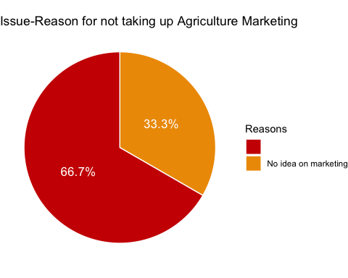

p<-ggplot(data=m1, aes(x=Var1, y=Freq)) +  
 geom_bar(stat="identity",fill="salmon")  
p + coord_flip()+  
 ggtitle("Issue-Reason for not taking up Agriculture Marketing")+  
 geom_text(aes(label=percent(Freq/sum(Freq))), hjust=1, size=3.5)+  
 xlab("Reasons")+ylab("%")

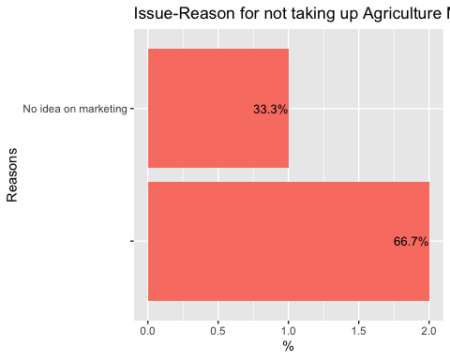

#scale_x_discrete(limits=c("Produce unavailable", "Farmers not competitive", "FGM is not aware", "Tender supplier supplies all vegetables", "Budget limitations", "Unfavouralble financial rules and regulations", "Expensive local vegetables"))  
  
m2=as.data.frame(m2)  
  
m2 <- m2 %>%  
 arrange(desc(Var1)) %>%  
 mutate(lab.ypos = cumsum(Freq) - 0.5*Freq)  
m2

## Var1 Freq lab.ypos  
## 1 Not applicable 9 4.5

bp130<- ggplot(m2, aes(x="", y=Freq, fill=Var1))+  
 geom_bar(width = 0.5, stat = "identity")+  
 labs(title="Impact")+  
 geom_text(aes(y = lab.ypos, label = percent(Freq/sum(Freq))), color = "white", size=4.5)+  
 labs(fill="Reasons")+  
 geom_text(aes(y = lab.ypos, label = percent(Freq/sum(Freq))), color = "white", size=4.5)+  
 xlab("Reason for not taking up Agriculture Marketing")+ylab("")  
bp130

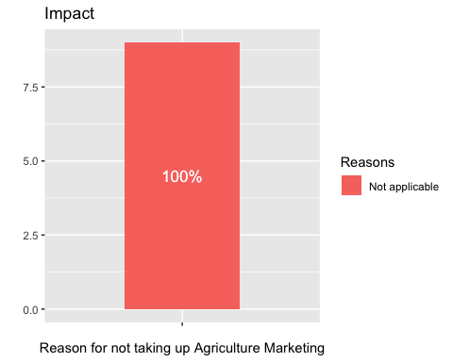

mycols= c("red3","orange2","green4","deeppink3","darkslateblue","red2", "mediumorchid3", "forestgreen")  
ggplot(m2, aes(x = "", y = Freq, fill = Var1)) +  
 geom_bar(width = 1, stat = "identity", color = "white") +  
 coord_polar("y", start = 0)+  
 ggtitle("Impact-Reason for not taking up Agriculture Marketing")+  
 geom_text(aes(y = lab.ypos, label = percent(Freq/sum(Freq))), color = "white", size=4.5)+  
 scale_fill_manual(values = mycols) +  
 labs(fill="Reasons")+  
 theme_void()

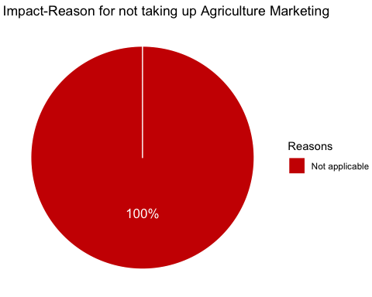

p<-ggplot(data=m2, aes(x=Var1, y=Freq)) +  
 geom_bar(stat="identity",fill="salmon")  
p + coord_flip()+  
 ggtitle("Impact-Reason for not taking up Agriculture Marketing")+  
 geom_text(aes(label=percent(Freq/sum(Freq))), hjust=1, size=3.5)+  
 xlab("Reasons")+ylab("%")

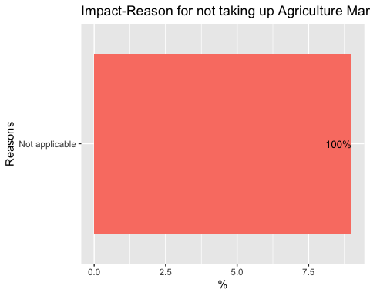

#scale_x_discrete(limits=c("Produce unavailable", "Farmers not competitive", "FGM is not aware", "Tender supplier supplies all vegetables", "Budget limitations", "Unfavouralble financial rules and regulations", "Expensive local vegetables"))  
  
  
  
fmgmeal= cbind(fmgissue[15], fmgimpact[15]);fmgmeal

## What.is.your.household.approx..annual.ependiture.for.meals.  
## 1 75000  
## 2 24000  
## 3 34500  
## 4 25000  
## 5 100000  
## 6 100000  
## 7 60000  
## 8 60000  
## 9 50000  
## What.is.your.household.approx.annual.ependiture.for.meals.  
## 1 75000  
## 2 30000  
## 3 34500  
## 4 25000  
## 5 100000  
## 6 100000  
## 7 88800  
## 8 60000  
## 9 50000

names(fmgmeal)= c("Issue", "Impact")  
  
exp1= table(fmgmeal[1])  
exp2= table(fmgmeal[2])  
exp1=as.data.frame(exp1)  
exp1 <- exp1 %>%  
 arrange(desc(Var1)) %>%  
 mutate(lab.ypos = cumsum(Freq) - 0.5*Freq)  
exp1

## Var1 Freq lab.ypos  
## 1 100000 2 1.0  
## 2 75000 1 2.5  
## 3 60000 2 4.0  
## 4 50000 1 5.5  
## 5 34500 1 6.5  
## 6 25000 1 7.5  
## 7 24000 1 8.5

bp4<- ggplot(exp1, aes(x="", y=Freq, fill=Var1))+  
 geom_bar(width = 1, stat = "identity")+  
 labs(title="Issue")+  
 xlab("Annual expenditure on meals")+ylab("")+  
 labs(fill="Expenditure (Nu.)")+  
 geom_text(aes(y = lab.ypos, label = percent(Freq/sum(Freq))), color = "white", size=4.5)  
   
bp4

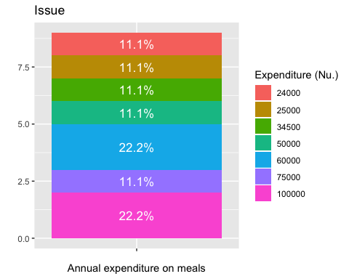

mycols= c("red3","orange2","green4","deeppink3","darkslateblue","red2", "mediumorchid3", "forestgreen")  
ggplot(exp1, aes(x = "", y = Freq, fill = Var1)) +  
 geom_bar(width = 1, stat = "identity", color = "white") +  
 coord_polar("y", start = 0)+  
 ggtitle("Issue-Annual expenditure on meals")+  
 geom_text(aes(y = lab.ypos, label = percent(Freq/sum(Freq))), color = "white", size=4.5)+  
 scale_fill_manual(values = mycols) +  
 labs(fill="Expenditure (Nu.)")+  
 theme_void()

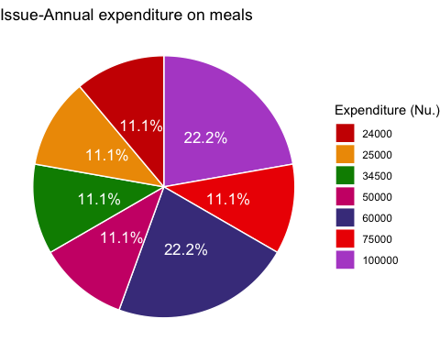

p<-ggplot(data=exp1, aes(x=Var1, y=Freq)) +  
 geom_bar(stat="identity",fill="salmon")  
p + coord_flip()+  
 ggtitle("Issue-Annual expenditure on meals")+  
 geom_text(aes(label=percent(Freq/sum(Freq))), hjust=1, size=3.5)+  
 xlab("Expenditure (Nu.)")+ylab("%")

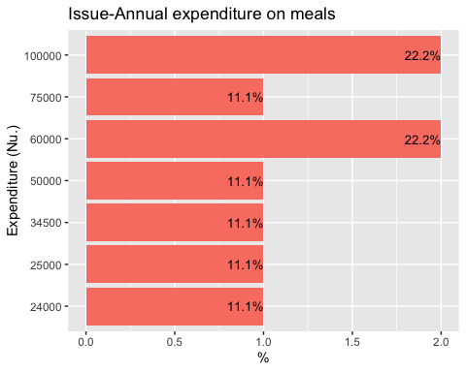

exp2=as.data.frame(exp2)  
  
exp2 <- exp2 %>%  
 arrange(desc(Var1)) %>%  
 mutate(lab.ypos = cumsum(Freq) - 0.5*Freq)  
exp2

## Var1 Freq lab.ypos  
## 1 100000 2 1.0  
## 2 88800 1 2.5  
## 3 75000 1 3.5  
## 4 60000 1 4.5  
## 5 50000 1 5.5  
## 6 34500 1 6.5  
## 7 30000 1 7.5  
## 8 25000 1 8.5

bp5<- ggplot(exp2, aes(x="", y=Freq, fill=Var1))+  
 geom_bar(width = 1, stat = "identity")+  
 labs(title="Impact")+  
 labs(fill="Expenditure (Nu.)")+  
 geom_text(aes(y = lab.ypos, label = percent(Freq/sum(Freq))), color = "white", size=4.5)+  
 xlab("Annual expenditure on meals")+ylab("")  
bp5

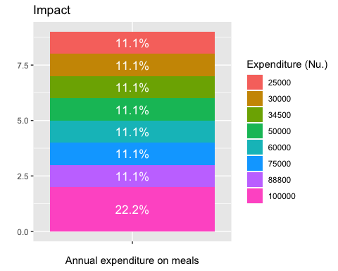

mycols= c("red3","orange2","green4","deeppink3","darkslateblue","red2", "mediumorchid3", "forestgreen")  
ggplot(exp2, aes(x = "", y = Freq, fill = Var1)) +  
 geom_bar(width = 1, stat = "identity", color = "white") +  
 coord_polar("y", start = 0)+  
 ggtitle("Impact-Annual expenditure on meals")+  
 geom_text(aes(y = lab.ypos, label = percent(Freq/sum(Freq))), color = "white", size=4.5)+  
 scale_fill_manual(values = mycols) +  
 labs(fill="Expenditure (Nu.)")+  
 theme_void()

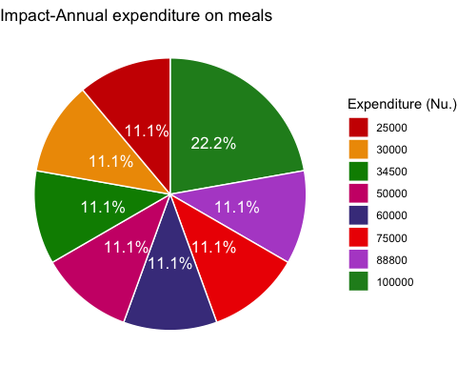

p<-ggplot(data=exp2, aes(x=Var1, y=Freq)) +  
 geom_bar(stat="identity",fill="salmon")  
p + coord_flip()+  
 ggtitle("Impact-Annual expenditure on meals")+  
 geom_text(aes(label=percent(Freq/sum(Freq))), hjust=1, size=3.5)+  
 xlab("Expenditure (Nu.)")+ylab("%")

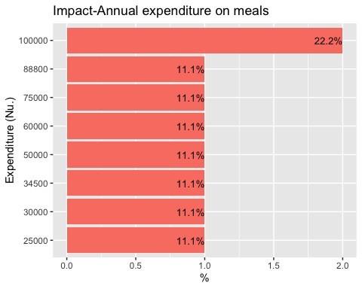

land= read.csv("land.csv")  
  
land1=subset(land, Type=="Dry")  
  
ld<-ggplot(data=land1, aes(x=Village, y=Land.Holding)) +  
 geom_bar(stat="identity",fill="cornflowerblue", position=position_dodge())+  
 geom_text(aes(label=Land.Holding), vjust=1.6, color="white", size=3.5)+  
 theme_minimal()+  
 xlab("FMG")+ylab("Land Holding(acre)")+  
 ggtitle("Dry Land")  
ld

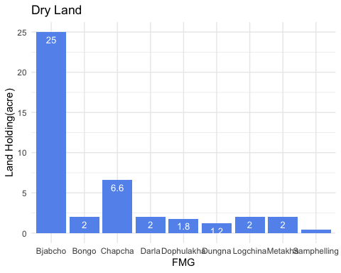

land2=subset(land, Type=="Wet")  
  
lw<-ggplot(data=land2, aes(x=Village, y=Land.Holding)) +  
 geom_bar(stat="identity",fill="darkgreen", position=position_dodge())+  
 geom_text(aes(label=Land.Holding), vjust=1.6, color="white", size=3.5)+  
 theme_minimal()+  
 xlab("FMG")+ylab("Land Holding(acre)")+  
 ggtitle("Wet Land")  
lw

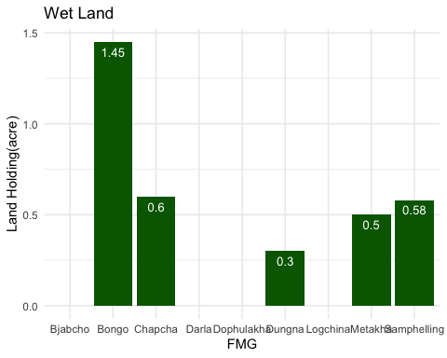

land3=subset(land, Type=="Orchard")  
  
lo<-ggplot(data=land3, aes(x=Village, y=Land.Holding)) +  
 geom_bar(stat="identity",fill="orange", position=position_dodge())+  
 geom_text(aes(label=Land.Holding), vjust=1.6, color="white", size=3.5)+  
 theme_minimal()+  
 xlab("FMG")+ylab("Land Holding(acre)")+  
 ggtitle("Orchard")  
lo

## Warning: Removed 3 rows containing missing values (geom_bar).

## Warning: Removed 3 rows containing missing values (geom_text).

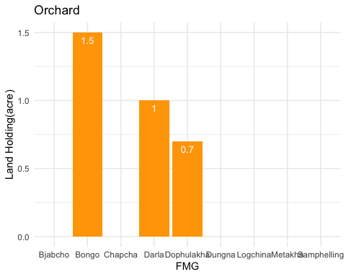

genqual= read.csv("genqualification.csv")  
# genqual <- droplevels(group_by(genqual,Gender) %>%  
# mutate(pos = cumsum(Len) - (0.5 * Len)))  
  
gen<-ggplot(data=genqual, aes(x=Gender, y=Len, fill=Qualification, label= Len)) +  
 geom_bar(stat="identity")+  
 geom_text(size=3.5, position = position_stack(vjust=0.5))+  
 ggtitle("Qualification and Gender of FMG respondents")+  
 ylab("Number")  
gen

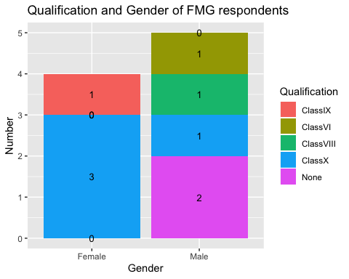

# gen1<-ggplot(genqual, aes(x = Gender, y = Len)) +  
# geom_bar(aes(fill = Qualification), stat="identity") +  
# geom_text(aes(label = Len, y = pos), size = 3)  
# gen1  
#   
# genqual  
  
male=droplevels(subset(genqual,Gender=="Male"))  
female=droplevels(subset(genqual,Gender=="Female"))  
male=as.data.frame(male)  
  
male <- male %>%  
 arrange(desc(Qualification)) %>%  
 mutate(lab.ypos = cumsum(Len) - 0.5*Len)  
male

## Gender Len Qualification lab.ypos  
## 1 Male 2 None 1.0  
## 2 Male 1 ClassX 2.5  
## 3 Male 1 ClassVIII 3.5  
## 4 Male 1 ClassVI 4.5  
## 5 Male 0 ClassIX 5.0

bp134<- ggplot(male, aes(x="", y=Len, fill=Qualification))+  
 geom_bar(width = 0.5, stat = "identity")+  
 labs(title="Qualifcation(Male respondent) ")+  
 geom_text(aes(y = lab.ypos, label = percent(Len/sum(Len))), color = "white", size=4.5)+  
 labs(fill="Qualification")+  
 geom_text(aes(y = lab.ypos, label = percent(Len/sum(Len))), color = "white", size=4.5)+  
 xlab("Male Qualifcation")+ylab("%")  
bp134

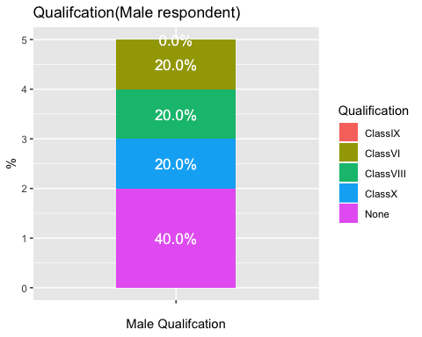

female=as.data.frame(female)  
  
female <-female %>%  
 arrange(desc(Qualification)) %>%  
 mutate(lab.ypos = cumsum(Len) - 0.5*Len)  
female

## Gender Len Qualification lab.ypos  
## 1 Female 0 None 0.0  
## 2 Female 3 ClassX 1.5  
## 3 Female 0 ClassVIII 3.0  
## 4 Female 0 ClassVI 3.0  
## 5 Female 1 ClassIX 3.5

bp135<- ggplot(female, aes(x="", y=Len, fill=Qualification))+  
 geom_bar(width = 0.5, stat = "identity")+  
 labs(title="Qualifcation(Female respondent) ")+  
 geom_text(aes(y = lab.ypos, label = percent(Len/sum(Len))), color = "white", size=4.5)+  
 labs(fill="Qualification")+  
 geom_text(aes(y = lab.ypos, label = percent(Len/sum(Len))), color = "white", size=4.5)+  
 xlab("Female Qualifcation")+ylab("%")  
bp135

