schoolanalysis.R

Saha

2019-10-28

library(sjPlot)

## #refugeeswelcome

library(sjmisc)  
library(graphics)  
library(ggplot2)  
library(dplyr)

##   
## Attaching package: 'dplyr'

## The following objects are masked from 'package:stats':  
##   
## filter, lag

## The following objects are masked from 'package:base':  
##   
## intersect, setdiff, setequal, union

library(scales)  
  
schoolissue= read.csv("schoolissue1.csv")  
  
summary(schoolissue)

## Date Qualification Gender Village..School  
## 21-05-18:12 b.Ed :7 Male:12 Chapcha MSS :1   
## B.Ed :2 Chimuna PS :1   
## M.Ed :1 Chongaykha PS :1   
## Masters:2 Chongaykha PS2:1   
## Chukha CS :1   
## Dungna LSS :1   
## (Other) :6   
## Do.you.think.school.contribute.in.development.of.rural.community.particularly.agrarians.  
## No :6   
## Yes:6   
##   
##   
##   
##   
##   
## Do.you.buy.all.the.school.vegetable.requirements.from.farmers.  
## No :10   
## Yes: 2   
##   
##   
##   
##   
##   
## Do.you.trust.that.the.vegetables.supplied.by.quoted.suppliers.from.markets.are.safe.for.students.health.and.ensure.nutritional.requirements.  
## No :10   
## Yes: 2   
##   
##   
##   
##   
##   
## Do.you.believe.that.the.vegetables.supplied.by.local.farmers.are.safe.and.ensure.nutritional.security.of.students.  
## No : 1   
## Yes:11   
##   
##   
##   
##   
##   
## Is.buying.vegetables.from.local.producers..farmers.cheaper.  
## No :11   
## Yes: 1   
##   
##   
##   
##   
##   
## Do.your.students.think.farming.as.one.of.the.prospective.occupations.  
## No :7   
## Yes:5   
##   
##   
##   
##   
##   
## Contribution.by.school.to.rural.agriculture.development.in.terms.of.  
## Both : 1   
## Monetary : 1   
## Non-monetary:10   
##   
##   
##   
##

mydat=schoolissue[5:10]  
  
  
lab= c("Do you think school contribute in development of rural community particularly agrarians",   
 "Do you buy all the school vegetable requirements from farmers",   
 "Do you trust that the vegetables supplied by quoted suppliers from markets are safe for students health and ensure nutritional requirements",  
 "Do you believe that the vegetables supplied by local farmers are safe and ensure nutritional security of students",   
 "Is buying vegetables from local producers farmers cheaper",   
 "Do your students think farming as one of the prospective occupations")  
  
names(mydat)= lab  
#plot_likert(mydat)  
  
plot_likert(  
 mydat,  
 title = "Issue",  
 grid.range = c(1.4, 1.4),  
 expand.grid = FALSE,  
 geom.colors = "RBuYl",  
 values = "sum.outside",  
 show.prc.sign = TRUE  
)

## Warning in sj.setGeomColors(gp, geom.colors, (catcount + adding),  
## show.legend, : Too less colors provided for plot. Using default color  
## palette.

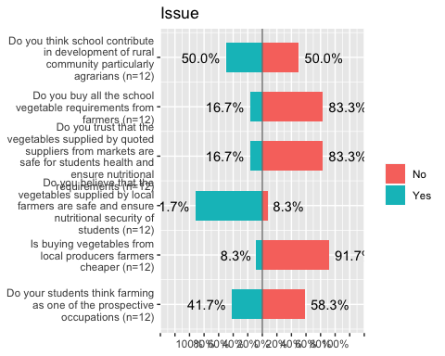

schoolimpact= read.csv("schoolimpact1.csv")  
  
summary(schoolimpact)

## Date Qualification Gender Village   
## 10-Dec-18:6 B.Ed :9 Male:12 Chapcha MSS :1   
## 12-Dec-18:6 M.Ed :1 Chhukha CS :1   
## Masters:2 Chimuna PS :1   
## Chongaykha PS :1   
## Chongaykha PS2:1   
## Dungna LSS :1   
## (Other) :6   
## Do.you.think.school.contribute.in.development.of.rural.community.particularly.agrarians.  
## Min. :2   
## 1st Qu.:2   
## Median :2   
## Mean :2   
## 3rd Qu.:2   
## Max. :2   
##   
## Do.you.buy.all.the.school.vegetable.requirements.from.farmers.  
## Min. :1.00   
## 1st Qu.:1.75   
## Median :2.00   
## Mean :1.75   
## 3rd Qu.:2.00   
## Max. :2.00   
##   
## Do.you.trust.that.the.vegetables.supplied.by.quoted.suppliers.from.markets.are.safe.for.students.health.and.ensure.nutritional.requirements.  
## Min. :1.000   
## 1st Qu.:1.000   
## Median :1.000   
## Mean :1.333   
## 3rd Qu.:2.000   
## Max. :2.000   
##   
## Do.you.believe.that.the.vegetables.supplied.by.local.farmers.are.safe.and.ensure.nutritional.security.of.students.  
## Min. :2   
## 1st Qu.:2   
## Median :2   
## Mean :2   
## 3rd Qu.:2   
## Max. :2   
##   
## Is.buying.vegetables.from.local.producers..farmers.cheaper.  
## Min. :1.000   
## 1st Qu.:1.000   
## Median :1.000   
## Mean :1.167   
## 3rd Qu.:1.000   
## Max. :2.000   
##   
## Do.your.students.think.farming.as.one.of.the.prospective.occupations.  
## Min. :2   
## 1st Qu.:2   
## Median :2   
## Mean :2   
## 3rd Qu.:2   
## Max. :2   
##   
## Contribution.by.school.to.rural.agriculture.development.in.terms.of.  
## Both :10   
## Monetary : 1   
## Non-Monetary: 1   
##   
##   
##   
##

mydat2=schoolimpact[5:10]  
  
  
names(mydat2)= lab  
#plot_likert(mydat2)  
  
plot_likert(  
 mydat2,  
 title = "Impact",  
 grid.range = c(1.5, 1.2),  
 legend.labels = c("No","Yes"),  
 expand.grid = FALSE,  
 geom.colors = "RBu",  
 values = "sum.outside",  
 show.prc.sign = TRUE  
)

## Warning in sj.setGeomColors(gp, geom.colors, (catcount + adding),  
## show.legend, : Too less colors provided for plot. Using default color  
## palette.

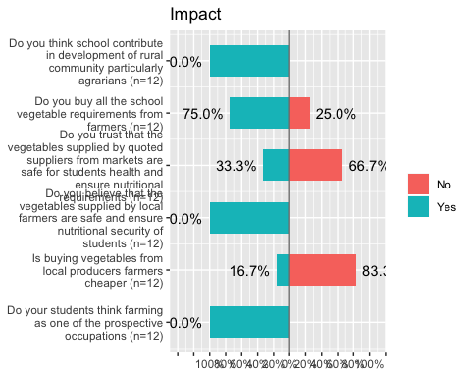

schcontri= cbind(schoolissue[11], schoolimpact[11]);schcontri

## Contribution.by.school.to.rural.agriculture.development.in.terms.of.  
## 1 Non-monetary  
## 2 Non-monetary  
## 3 Non-monetary  
## 4 Monetary  
## 5 Non-monetary  
## 6 Non-monetary  
## 7 Non-monetary  
## 8 Non-monetary  
## 9 Both  
## 10 Non-monetary  
## 11 Non-monetary  
## 12 Non-monetary  
## Contribution.by.school.to.rural.agriculture.development.in.terms.of.  
## 1 Both  
## 2 Both  
## 3 Both  
## 4 Both  
## 5 Both  
## 6 Both  
## 7 Both  
## 8 Monetary  
## 9 Both  
## 10 Both  
## 11 Both  
## 12 Non-Monetary

names(schcontri)= c("Issue", "Impact");schcontri

## Issue Impact  
## 1 Non-monetary Both  
## 2 Non-monetary Both  
## 3 Non-monetary Both  
## 4 Monetary Both  
## 5 Non-monetary Both  
## 6 Non-monetary Both  
## 7 Non-monetary Both  
## 8 Non-monetary Monetary  
## 9 Both Both  
## 10 Non-monetary Both  
## 11 Non-monetary Both  
## 12 Non-monetary Non-Monetary

plot_likert(  
 schcontri,  
 title = "Contribution by school to rural agriculture development in terms of",  
 grid.range = c(1.2, 1.4),  
 expand.grid = FALSE,  
 #legend.labels = c("Monetary","Non-monetary", "Both"),  
 catcount = 3,  
 geom.colors = "RBuG",  
 values = "show",  
 show.prc.sign = TRUE  
)

## Warning in sj.setGeomColors(gp, geom.colors, (catcount + adding),  
## show.legend, : Too less colors provided for plot. Using default color  
## palette.

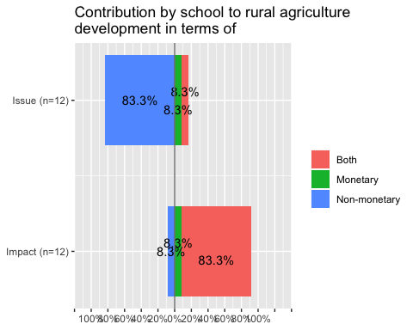

freq1= table(schcontri[1])  
freq2= table(schcontri[2])  
freq1=as.data.frame(freq1)  
  
freq1 <- freq1 %>%  
 arrange(desc(Var1)) %>%  
 mutate(lab.ypos = cumsum(Freq) - 0.5*Freq)  
freq1

## Var1 Freq lab.ypos  
## 1 Non-monetary 10 5.0  
## 2 Monetary 1 10.5  
## 3 Both 1 11.5

bp1<- ggplot(freq1, aes(x="", y=Freq, fill=Var1))+  
 geom_bar(width = 1, stat = "identity")+  
 ggtitle("Issue") +  
 xlab("Contribution to rural community") + ylab(" ")+  
 geom_text(aes(y = lab.ypos, label = percent(Freq/sum(Freq))), color = "white", size=4.5)+  
 labs(fill = "Contribution in terms of")  
bp1

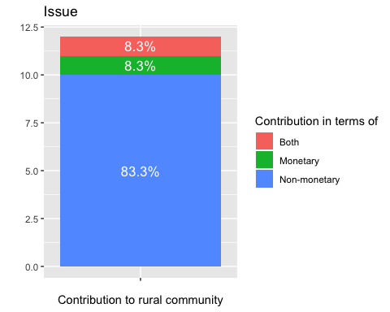

mycols= c("red3","orange2","green4")  
ggplot(freq1, aes(x = "", y = Freq, fill = Var1)) +  
 geom_bar(width = 1, stat = "identity", color = "white") +  
 coord_polar("y", start = 0)+  
 ggtitle("Issue-Contribution to rural community")+  
 geom_text(aes(y = lab.ypos, label = percent(Freq/sum(Freq))), color = "white", size=4.5)+  
 scale_fill_manual(values = mycols) +  
 labs(fill="Contribution in terms of")+  
 theme_void()

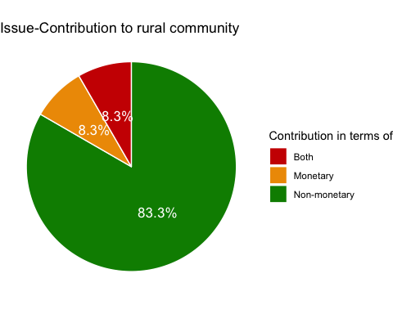

p<-ggplot(data=freq1, aes(x=Var1, y=Freq)) +  
 geom_bar(stat="identity",fill="salmon")  
p + coord_flip()+  
 ggtitle("Issue-Contribution to rural community")+  
 geom_text(aes(label=percent(Freq/sum(Freq))), hjust=1, size=3.5)+  
 xlab("Contribution in terms of")+ ylab("%")

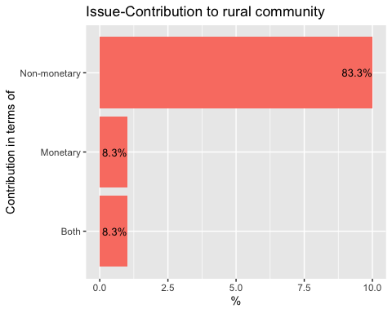

freq2=as.data.frame(freq2)  
freq2 <- freq2 %>%  
 arrange(desc(Var1)) %>%  
 mutate(lab.ypos = cumsum(Freq) - 0.5*Freq)  
freq2

## Var1 Freq lab.ypos  
## 1 Non-Monetary 1 0.5  
## 2 Monetary 1 1.5  
## 3 Both 10 7.0

bp01<- ggplot(freq2, aes(x="", y=Freq, fill=Var1))+  
 geom_bar(width = 1, stat = "identity")+  
 ggtitle("Impact") +  
 xlab("Contribution to rural community") + ylab(" ")+  
 geom_text(aes(y = lab.ypos, label = percent(Freq/sum(Freq))), color = "white", size=4.5)+  
 labs(fill = "Contribution in terms of")  
bp01

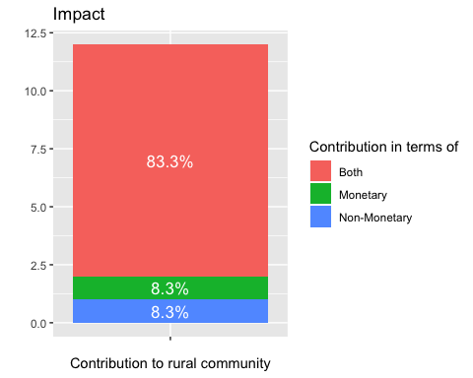

mycols= c("red3","orange2","green4")  
ggplot(freq2, aes(x = "", y = Freq, fill = Var1)) +  
 geom_bar(width = 1, stat = "identity", color = "white") +  
 coord_polar("y", start = 0)+  
 ggtitle("Impact-Contribution to rural community")+  
 geom_text(aes(y = lab.ypos, label = percent(Freq/sum(Freq))), color = "white", size=4.5)+  
 scale_fill_manual(values = mycols) +  
 labs(fill="Contribution in terms of")+  
 theme_void()

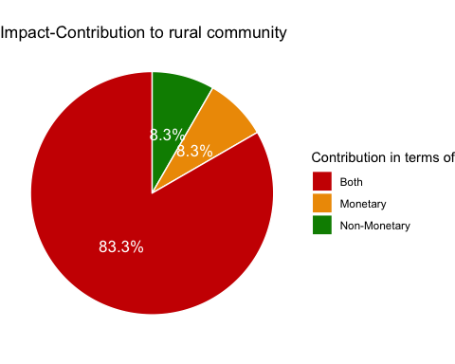

p<-ggplot(data=freq2, aes(x=Var1, y=Freq)) +  
 geom_bar(stat="identity",fill="salmon")  
p + coord_flip()+  
 ggtitle("Impact-Contribution to rural community")+  
 geom_text(aes(label=percent(Freq/sum(Freq))), hjust=1, size=3.5)+  
 xlab("Contribution in terms of")+ ylab("%")

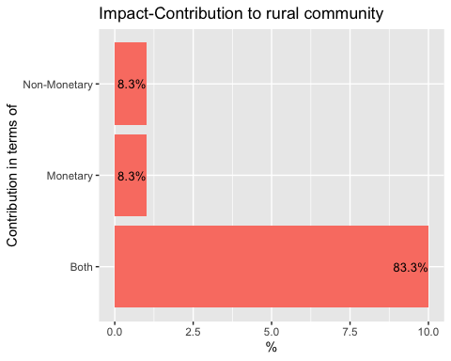

buyissue=read.csv("schoolissuebuy.csv")  
buyimpact=read.csv("schoolimpactbuy.csv")  
  
f1= table(buyissue[3])  
f2= table(buyimpact[3])  
  
f1=as.data.frame(f1)  
  
f1 <- f1 %>%  
 arrange(desc(Var1)) %>%  
 mutate(lab.ypos = cumsum(Freq) - 0.5*Freq)  
f1

## Var1 Freq lab.ypos  
## 1 Unfavourable financial rules and regulations 6 3.0  
## 2 Tender supplier supplies all vegetables 1 6.5  
## 3 Produce unavailable 2 8.0  
## 4 FGM is not aware 1 9.5  
## 5 Farmers not competitive 1 10.5  
## 6 Expensive local vegetables 8 15.0  
## 7 Budget limitations 5 21.5

bp2<- ggplot(f1, aes(x="", y=Freq, fill=Var1))+  
 geom_bar(width = 0.5, stat = "identity")+  
 labs(title="Issue")+  
 xlab("Limitations in buying farmer's produce")+ ylab(" ")+  
 geom_text(aes(y = lab.ypos, label = percent(Freq/sum(Freq))), color = "white", size=4.5)+  
 labs(fill = "Reasons for not buying")  
   
bp2

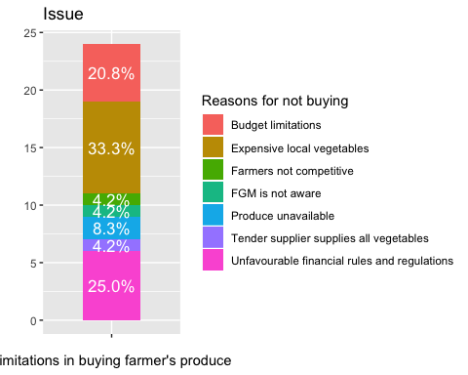

mycols= c("red3","orange2","green4","deeppink3","darkslateblue","red2", "mediumorchid3", "forestgreen")  
ggplot(f1, aes(x = "", y = Freq, fill = Var1)) +  
 geom_bar(width = 1, stat = "identity", color = "white") +  
 coord_polar("y", start = 0)+  
 ggtitle("Issue-Limitations in buying farmer's produce")+  
 geom_text(aes(y = lab.ypos, label = percent(Freq/sum(Freq))), color = "white", size=4.5)+  
 scale_fill_manual(values = mycols) +  
 labs(fill="Reasons for not buying")+  
 theme_void()

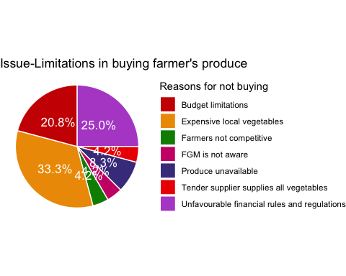

p<-ggplot(data=f1, aes(x=Var1, y=Freq)) +  
 geom_bar(stat="identity",fill="salmon")  
p + coord_flip()+  
 ggtitle("Issue-Limitations in buying farmer's produce")+  
 geom_text(aes(label=percent(Freq/sum(Freq))), hjust=1, size=3.5)+  
 scale_x_discrete(limits=c( "Farmers not competitive", "FGM is not aware", "Tender supplier supplies all vegetables", "Produce unavailable","Budget limitations", "Unfavourable financial rules and regulations", "Expensive local vegetables"))+  
 xlab("Reasons for not buying")+ ylab("%")

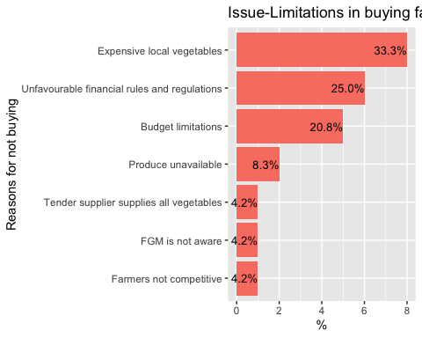

f2=as.data.frame(f2)  
f2 <- f2 %>%  
 arrange(desc(Var1)) %>%  
 mutate(lab.ypos = cumsum(Freq) - 0.5*Freq)  
f2

## Var1 Freq lab.ypos  
## 1 Unfavourable financial rules and regulations 2 1.0  
## 2 Produce unavailable 4 4.0  
## 3 Expensive local vegetables 3 7.5  
## 4 Budget limitations 6 12.0

bp3<- ggplot(f2, aes(x="", y=Freq, fill=Var1))+  
 geom_bar(width = 1, stat = "identity")+  
 labs(title="Impact")+  
 xlab("Limitations in buying farmer's produce")+  
 geom_text(aes(y = lab.ypos, label = percent(Freq/sum(Freq))), color = "white", size=4.5)+  
 labs(fill = "Reasons for not buying")  
  
bp3

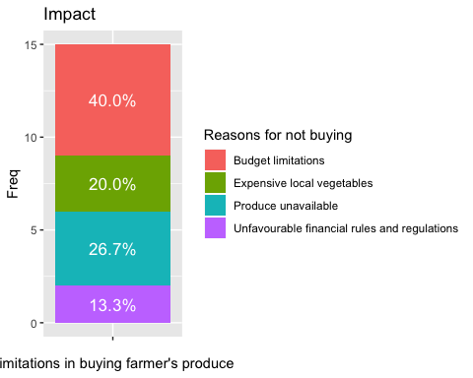

mycols= c("red3","orange2","green4","deeppink3","olivedrab", "darkslateblue","mediumorchid3" )  
ggplot(f2, aes(x = "", y = Freq, fill = Var1)) +  
 geom_bar(width = 1, stat = "identity", color = "white") +  
 coord_polar("y", start = 0)+  
 ggtitle("Impact-Limitations in buying farmer's produce")+  
 geom_text(aes(y = lab.ypos, label = percent(Freq/sum(Freq))), color = "white", size=4.5)+  
 scale_fill_manual(values = mycols) +  
 labs(fill="Reasons for not buying")+  
 theme_void()

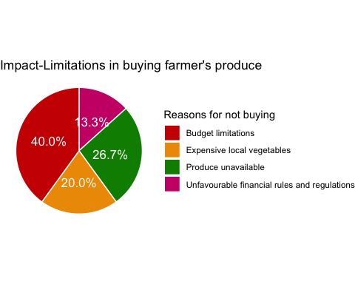

p<-ggplot(data=f2, aes(x=Var1, y=Freq)) +  
 geom_bar(stat="identity",fill="salmon")  
p + coord_flip()+  
 ggtitle("Impact-Limitations in buying farmer's produce")+  
 geom_text(aes(label=percent(Freq/sum(Freq))), hjust=1, size=3.5)+  
 xlab("Reasons for not buying")+ylab("%")+  
 scale_x_discrete(limits=c("Unfavourable financial rules and regulations", "Expensive local vegetables", "Produce unavailable","Budget limitations"))

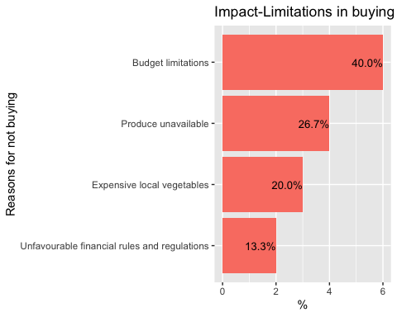

Sgenqual= read.csv("sgenqualification.csv")  
  
Sgen<-ggplot(data=Sgenqual, aes(x=Gender, y=Len, fill=Qualification)) +  
 geom_bar(stat="identity")+  
 ggtitle("Qualification and Gender of School respondents")+  
 ylab("Number")  
Sgen

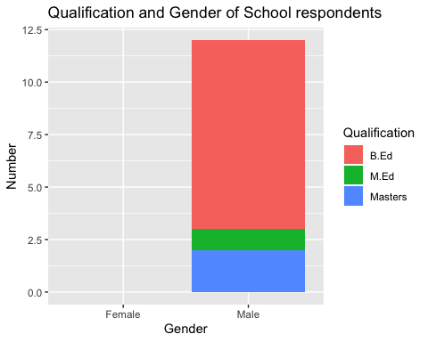

ggplot(data=Sgenqual, aes(fill=Qualification, y=Len, x=Gender)) +   
 geom_bar( stat="identity", position="fill")+  
 ggtitle("Qualification and Gender of School respondents (Percent)")+  
 ylab("%")

## Warning: Removed 3 rows containing missing values (geom_bar).

