Lesson 06 Demo 03

Implementing Variables in Jinja2 Filters

Objective: To implement variables in Jinja2 filters for processing in Ansible, define the variables, and apply Jinja2 filters in the templates
Tools required: Linux terminal
Prerequisites: None

Steps to be followed:
- Create a playbook and configure it using Jinja2
- Create a playbook and configure it using default filters

Step 1: Create a playbook and configure it using Jinja2

- Run the following command to create a file: (Use VS Code)

jinja_template.yml
- Copy and paste the below script into the jinja_template.yml file:
---
- name: Data Manipulation
hosts: localhost
gather_facts: false
vars:
my_name: Demo of Ansible Jinja2
tasks:
- name: Print message
debug:
msg:
- "My name is {{ my_name }}"
- "My name is {{ my_name | lower }}"
- "My name is {{ my_name | upper }}"
- "My name is {{ my_name | capitalize }}"
- "My name is {{ my_name | title }}"
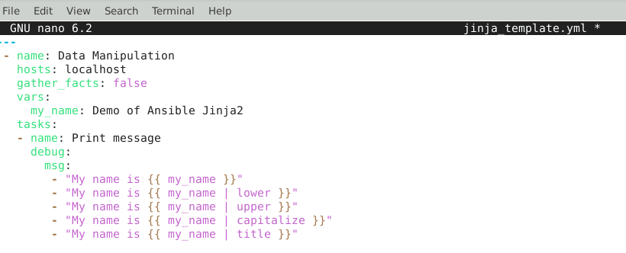
- Run the following command to execute the Ansible playbook named template.yml that uses Jinja2 templates:
ansible-playbook jinja_template.yml

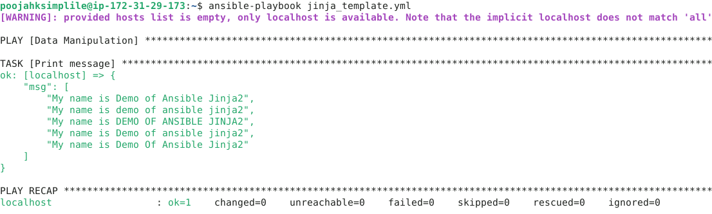

Step 2: Create a playbook and configure it using default filters

- Run the following command to create a new file:

jinja_default.yml

- Copy and paste the below script into the jinja_default.yml file:

---
- name: Data Manipulation
hosts: localhost
gather_facts: false
vars:
first_name: Demo of
tasks:
- name: Print message
debug:
msg:
- "My name is {{ first_name }} {{ last_name | default('Ansible Jinja2') }}"
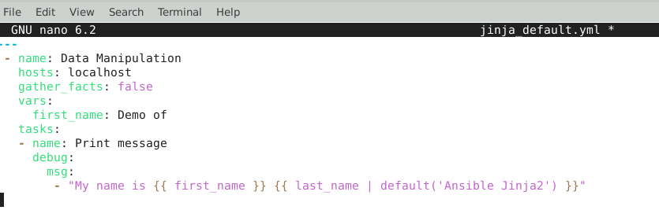
- Run the following command to execute the Ansible playbook:
ansible-playbook jinja_default.yml
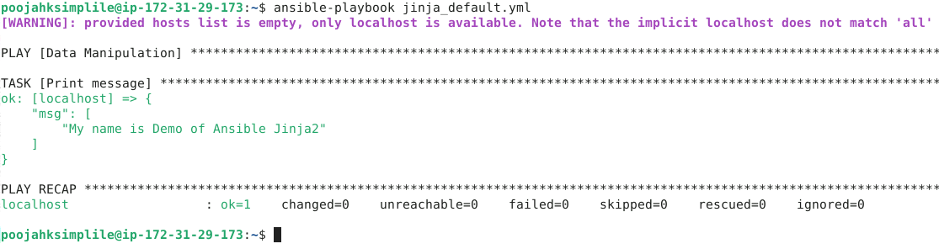
By following these steps, you have successfully implemented variables in Jinja2 filters for processing in Ansible, defined the variables, and applied Jinja2 filters in the templates.

