Lesson 05 Demo 05

Configuring Tasks with Handlers

Objective: To configure an Ansible playbook to execute tasks on localhost and trigger handlers for subsequent actions upon task completion
Tools required: Linux terminal
Prerequisites: None

Steps to be followed:
- Create the playbook and inventory file
- Run the playbook

Step 1: Create the playbook and inventory file

- Run the following command to create a folder:
mkdir ansible_demo
- Run the following command to navigate inside the ansible_demo folder:
cd ansible_demo
- Run the following command to create a YAML file:
sudo nano simple_playbook.yml

- Enter the below script into the simple_playbook.yml file to define a task that creates a file at /tmp/hello_world.txt on the localhost and notifies a handler to display a debug message:
---
- name: Simple Demo Playbook
hosts: localhost
tasks:
- name: Create a file
file:
path: /tmp/hello_world.txt
state: touch
notify: Restart demo service

handlers:
- name: Restart demo service
debug:
msg: "Handler executed: Restart demo service"
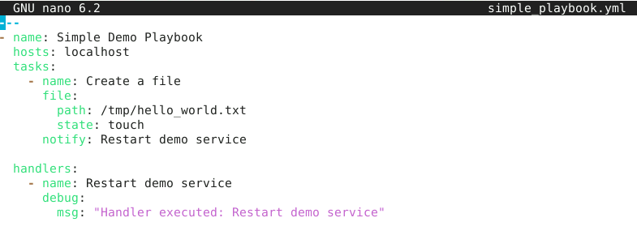
- Run the following command to create an inventory file for specifying the managed hosts:
sudo nano hosts.ini
- Enter the below content inside the hosts.ini file:
[local]
Localhost ansible_connection=local
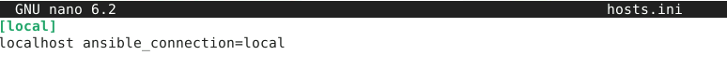

Step 2: Run the playbook

- Run the playbook using the following command:
ansible-playbook -i hosts.ini simple_playbook.yml
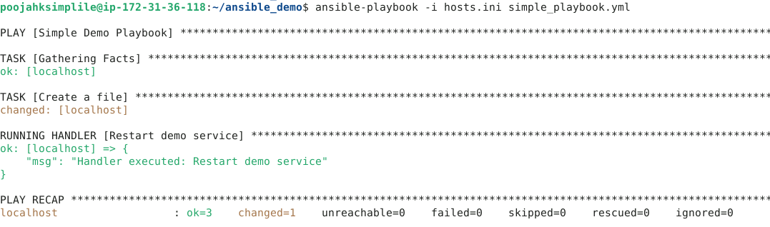

Ansible connects to the hosts specified in the inventory file and executes the tasks defined in the playbook.
By following these steps, you have successfully configured an Ansible playbook to execute tasks on localhost and trigger handlers for subsequent actions upon task completion.

