Lesson 06 Demo 01

Setting up Jinja2

Objective: To install and configure Jinja2 to enable the creation of dynamic HTML templates, thereby separating the presentation layer from the business logic in web applications. This facilitates the development of scalable, maintainable, and reusable web projects.
Tools required: Linux terminal
Prerequisites: None

Steps to be followed:
- Install Jinja2
- Verify the installation of Jinja2

Step 1: Install Jinja2

- Run the following command to update the package list:
sudo apt-get update -y
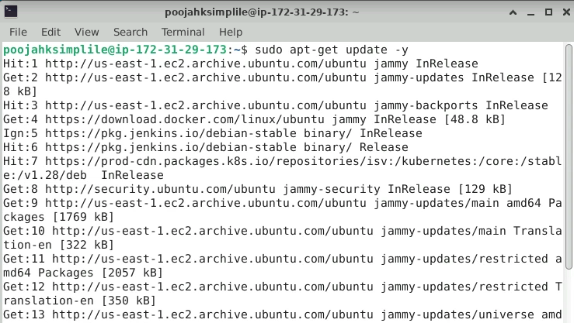

- Run the following command to install Python 3, ensuring that the latest version of Python is available:
sudo apt-get install -y python3
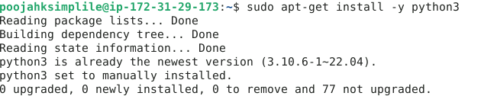
- Run the following command to install Jinja2 for Python 3, ensuring the template engine is available for use in Python projects:
sudo apt-get install -y python3-jinja2

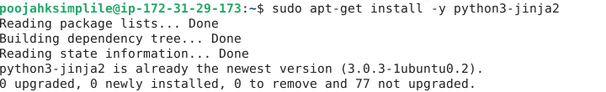

Step 2: Verify the installation of Jinja2

- Run the following command to verify the installation of Jinja2 in a Python environment and display its version:
python3 -c "import jinja2; print(jinja2.__version__)"

- Run the following command to check if the python3-jinja2 package is installed on the system:
dpkg-query -l | grep python3-jinja2

By following these steps, you have successfully installed Jinja2 for Python 3 and confirmed its installation and version. This ensures that the Jinja2 template engine is ready for use in Python projects.

