Lesson 06 Demo 05

Combining Loops and Conditionals in Jinja2

Objective: To combine loops and conditionals in Jinja2 for dynamically generating content based on varying data conditions
Tools required: Linux terminal
Prerequisites: None

Steps to be followed:
- Prepare data and template files
- Render and execute a template with a Python script

Step 1: Prepare data and template files

- Run the following command to create a file:
sudo nano combined_data.yaml
- Copy and paste the below script into the combined_data.yaml file:
products:
- name: Laptop
price: 1000
in_stock: true
- name: Smartphone
price: 500
in_stock: false
- name: Tablet
price: 300
in_stock: true
discount: 10
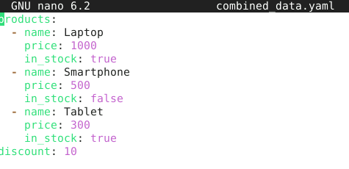

- Run the following command to create another file:
sudo nano combined_template.j2

- Copy and paste the below script into the combined_template.j2 file:
Product List:
{% for product in products %}
- {{ product.name }} - ${{ product.price }}
{% if product.in_stock %}
({{ discount }}% off)
{% else %}
(Out of stock)
{% endif %}
{% endfor %}
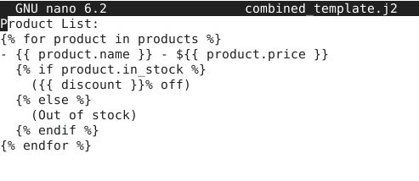
Step 2: Render and execute a template with a Python script
- Run the following command to create a file:
sudo nano render_combined_template.py
- Copy and paste the below script into the render_combined_template.py file:
from jinja2 import Environment, FileSystemLoader
import yaml

# Load data from YAML file
with open('combined_data.yaml', 'r') as file:
data = yaml.safe_load(file)

# Set up Jinja2 environment
env = Environment(loader=FileSystemLoader('.'))
template = env.get_template('combined_template.j2')

# Render template with data
rendered_text = template.render(data)

# Print or save the rendered text
with open('combined_output.txt', 'w') as output_file:
output_file.write(rendered_text)

print(rendered_text)
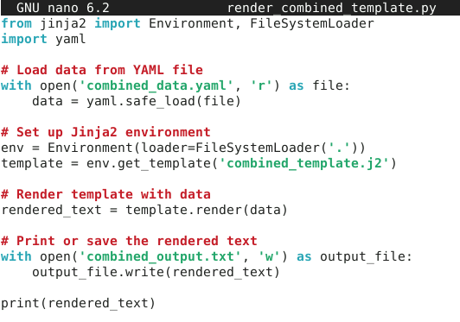
- Run the Python script using the following command:
python render_combined_template.py
Below is the following output:
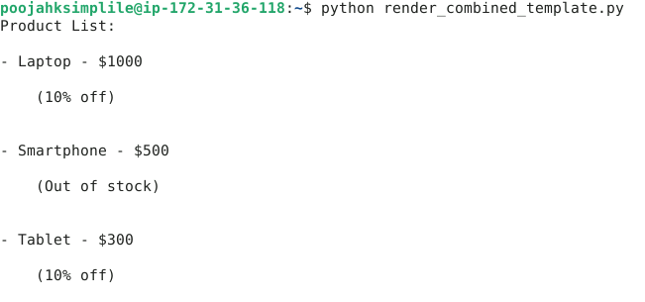
By following these steps, you have successfully combined loops and conditionals in Jinja2 for dynamically generating content based on varying data conditions.

