Lesson 06 Demo 02

Accessing Variables in Jinja2

Objective: To access and process variables in Jinja2 for formatting, transforming data, and applying logic within templates
Tools required: Linux terminal
Prerequisites: None

Steps to be followed:
- Create a file and define the template
- Load the Python script

Step 1: Create a file and define the template

- create a file: (
Use VS Code

template.j2
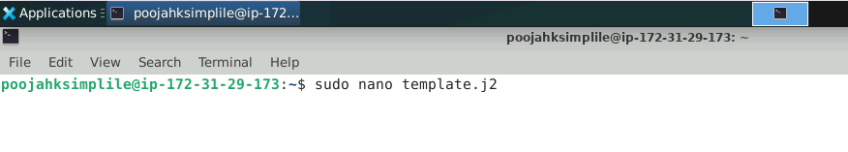
- Copy and paste the below script into the template.j2 file:
Hello, {{ name }}!
You have {{ notifications }} new notifications.
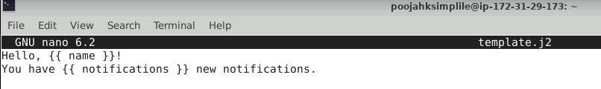

Step 2: Load the Python script

- create a new file: (use VS Code)
render_template.py

- Copy and paste the below script into the template.j2 file:
from jinja2 import Environment, FileSystemLoader

# Load the template from the file system
file_loader = FileSystemLoader('.')
env = Environment(loader=file_loader)

# Specify the template file
template = env.get_template('template.j2')

# Define the variables
context = {
'name': 'ABCD',
'notifications': 5
}

# Render the template with the variables
output = template.render(context)

print(output)

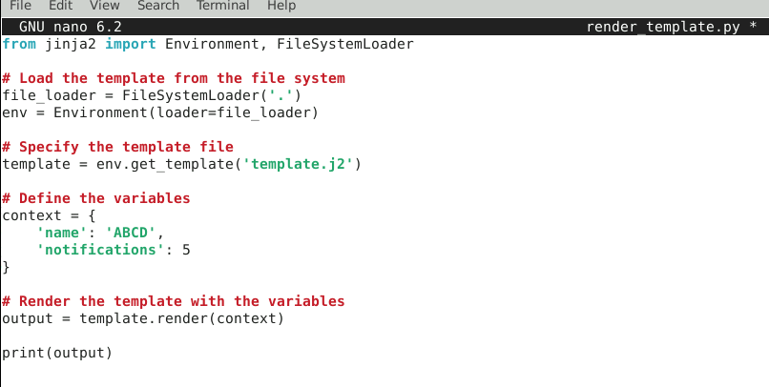
- Run the following command to execute the script:
python render_template.py
Below is the output after running the script:
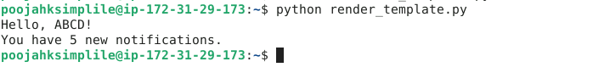
By following these steps, you have successfully accessed and processed variables in Jinja2 for formatting, transforming data, and applying logic within templates.

