**CleverMart – AI Smart Shop Platform**

**Empowering small business owners with AI-driven shop operations and smart customer experience**

**💡 App Concept**

**CleverMart** is a dual-mode application designed for:

* **Business Owners**: Manage store operations, financials, inventory, and reports.
* **Customers**: Interact via QR scan and AI Assistant (chat/voice) to browse products, place orders, and get instant help.

**🧱 App Architecture Overview**

| **Layer** | **Components** |
| --- | --- |
| **Frontend (Power Apps)** | Owner Dashboard, Customer Chat App, QR Code Entry Screen |
| **Backend (SharePoint)** | Products, Orders, Customers, Inventory, Transactions, Invoices |
| **Automation** | Power Automate (Flows for ordering, invoicing, notifications, AI calls) |
| **AI Services** | Power Virtual Agents (Chatbot), Azure Cognitive Services (Voice/Text) |
| **Data Intelligence** | Power BI Embedded (Sales and Inventory Reports) |

**🔧 Core Features by Role**

**🧑‍💼 Business Owner Features (via Power Apps Canvas App)**

* 📦 Product Management (Add/Edit/Delete)
* 🛒 Order Tracking & Status Update
* 💰 Finance & Invoicing (Auto-PDF generation via Power Automate)
* 📊 Sales & Inventory Reports (Power BI Embedded)
* 📇 QR Code Generation per shop or product
* 🔔 Stock Alerts, Customer Orders via Notification Flow

**🧑‍🧱 Customer Experience (QR → Chat)**

* 📱 Scan QR → Launch AI assistant (Power Virtual Agents)
* 💬 Browse Products via chat/voice
* 🛍 Place order via conversational flow
* 📟 Receive invoice via email or chat
* 🎤 Talk to Voice Assistant (Azure Speech to Text)

**↻ Services and Data Flow**

**1. QR Scan & Entry Flow**

* Power Apps generates a unique QR code (via Power Automate).
* QR redirects to PVA chat page OR launches the app directly.

**2. Customer Chatbot Flow**

* Built in Power Virtual Agents
* Queries SharePoint using Power Automate flows
* Fetches products, validates stock, creates orders

**3. Order Placement Flow**

* PVA triggers Flow to:
  + Log order in SharePoint
  + Calculate total and apply discounts
  + Trigger invoice generation

**4. Invoice Generation Flow**

* **Trigger**: New confirmed order
* Compose invoice using Word template or HTML
* Save PDF to SharePoint / Email to customer

**5. Voice Interaction**

* Azure Speech-to-Text + PVA to enable spoken queries
* Azure TTS reads order summary or products aloud

**🧹 Components Breakdown**

**🔹 SharePoint Lists**

| **List Name** | **Key Fields** |
| --- | --- |
| **Products** | Name, SKU, Price, Description, StockQty, Image, Category |
| **Orders** | Customer, OrderDate, Status, TotalAmount, LineItems (JSON/Text) |
| **Customers** | Name, Phone, Email, LastPurchase, PreferredLang |
| **Invoices** | OrderID, PDFLink, DateIssued, TotalAmount |

**🤖 AI Assistant Configuration (Power Virtual Agents)**

**Intents:**

* “Browse products”
* “What’s the price of [item]?”
* “I want to buy something”
* “Where is my order?”

**Power Automate Flows (from PVA):**

* GetProductsList
* PlaceOrder
* CheckOrderStatus
* GenerateInvoice

**Voice Support:**

* Azure Direct Line Speech for voice input/output

**📊 Power BI Integration (Owner Dashboard)**

Embed a report inside Power Apps to track:

* Top selling products
* Revenue trends
* Stock levels
* Daily orders

**🧠 AI Services**

| **Feature** | **Tool** |
| --- | --- |
| Chatbot Assistant | Power Virtual Agents |
| Voice Interaction | Azure Speech Services |
| Text-to-Speech | Azure Cognitive Services |
| Order Prediction (future) | Azure ML or GPT prompts |

**📱 UI/UX Layout Suggestions**

**🔵 Owner App**

* **Home**: KPIs, Daily Orders, Alerts
* **Products**: Gallery + Edit
* **Orders**: Status Update
* **Reports**: Embed Power BI
* **Settings**: QR Code Setup, Preferences

**🔵 Customer Chat App**

* **Welcome** → "Scan QR to start"
* **PVA Web Chat** (embedded)
* **Voice Button** (enabled if speech available)

**⚙️ Power Automate Flows**

| **Flow Name** | **Trigger** | **Purpose** |
| --- | --- | --- |
| PlaceCustomerOrder | From PVA | Add order, calculate total, confirm |
| GenerateInvoicePDF | Order Completed | Create PDF invoice and email it |
| StockAlert | Scheduled (daily) | Alert if any product is below threshold |
| SendQRtoOwner | On Product Created | Generate QR code for shop/product |
| ReadProductAloud | Voice query in PVA | Convert product info to audio |

**✅ Pros and ❌ Cons of This Architecture**

| **✅ Pros** | **❌ Cons** |
| --- | --- |
| Full Microsoft stack — seamless integration | May need premium license for Azure/OpenAI connectors |
| Scales easily across stores/shops | Limited real-time stock sync if large-scale traffic |
| AI-first interface (chat + voice) with zero coding | Advanced features may require custom connectors |
| Easy reporting and visibility through Power BI | Requires careful data design to avoid duplication across flows |
| Mobile/tablet support out of the box | Azure AI billing could scale with heavy use |

**🗓️ Suggested Development Timeline**

| **Day** | **Task** |
| --- | --- |
| 1 | Finalize data model + SharePoint list setup |
| 2-3 | Build Power Apps Owner dashboard + test product management |
| 4 | Setup QR generation + customer redirection |
| 5-6 | Build and connect PVA chatbot (chat + product ordering) |
| 7 | Add invoice generation + email flow |
| 8 | Integrate Azure TTS/Voice + test chat flows |
| 9 | Build Power BI dashboard + embed in Owner app |
| 10 | End-to-end testing, polish UI, deploy |

Task 2

Sketch App Wireframes

1-Home Screen

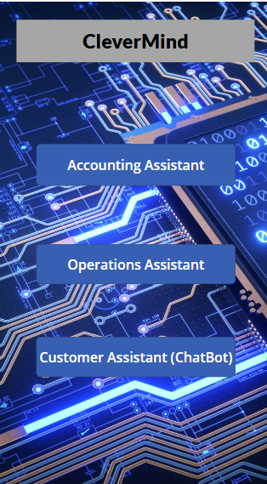

2- Products Screen

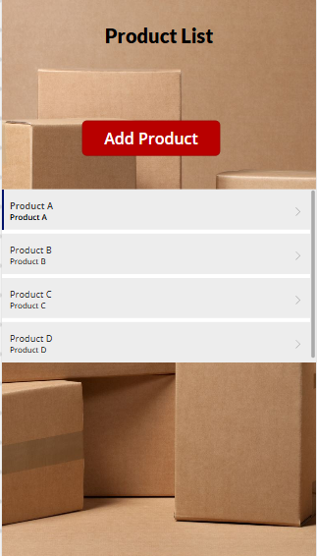

3-Orders Screen

4-Vendors Screen

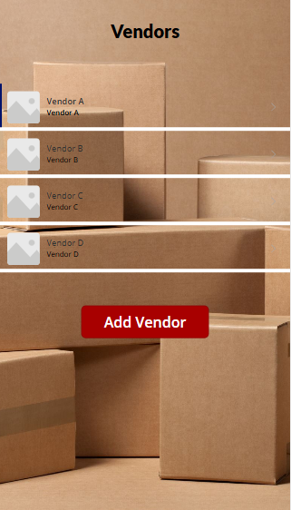

5-Insights Screen

