CleverMart – AI Smart Shop Platform
Empowering small business owners with AI-driven shop operations and smart customer experience

💡 App Concept
CleverMart is a dual-mode application designed for:
- Business Owners: Manage store operations, financials, inventory, and reports.
- Customers: Interact via QR scan and AI Assistant (chat/voice) to browse products, place orders, and get instant help.

🧱 App Architecture Overview
Layer | Components
Frontend (Power Apps) | Owner Dashboard, Customer Chat App, QR Code Entry Screen
Backend (SharePoint) | Products, Orders, Customers, Inventory, Transactions, Invoices
Automation | Power Automate (Flows for ordering, invoicing, notifications, AI calls)
AI Services | Power Virtual Agents (Chatbot), Azure Cognitive Services (Voice/Text)
Data Intelligence | Power BI Embedded (Sales and Inventory Reports)

🔧 Core Features by Role
🧑‍💼 Business Owner Features (via Power Apps Canvas App)
- 📦 Product Management (Add/Edit/Delete)
- 🛒 Order Tracking & Status Update
- 💰 Finance & Invoicing (Auto-PDF generation via Power Automate)
- 📊 Sales & Inventory Reports (Power BI Embedded)
- 📇 QR Code Generation per shop or product
- 🔔 Stock Alerts, Customer Orders via Notification Flow
🧑‍🧱 Customer Experience (QR → Chat)
- 📱 Scan QR → Launch AI assistant (Power Virtual Agents)
- 💬 Browse Products via chat/voice
- 🛍 Place order via conversational flow
- 📟 Receive invoice via email or chat
- 🎤 Talk to Voice Assistant (Azure Speech to Text)

↻ Services and Data Flow
1. QR Scan & Entry Flow
- Power Apps generates a unique QR code (via Power Automate).
- QR redirects to PVA chat page OR launches the app directly.
2. Customer Chatbot Flow
- Built in Power Virtual Agents
- Queries SharePoint using Power Automate flows
- Fetches products, validates stock, creates orders
3. Order Placement Flow
- PVA triggers Flow to:
  - Log order in SharePoint
  - Calculate total and apply discounts
  - Trigger invoice generation
4. Invoice Generation Flow
- Trigger: New confirmed order
- Compose invoice using Word template or HTML
- Save PDF to SharePoint / Email to customer
5. Voice Interaction
- Azure Speech-to-Text + PVA to enable spoken queries
- Azure TTS reads order summary or products aloud

🧹 Components Breakdown
🔹 SharePoint Lists
List Name | Key Fields
Products | Name, SKU, Price, Description, StockQty, Image, Category
Orders | Customer, OrderDate, Status, TotalAmount, LineItems (JSON/Text)
Customers | Name, Phone, Email, LastPurchase, PreferredLang
Invoices | OrderID, PDFLink, DateIssued, TotalAmount
🤖 AI Assistant Configuration (Power Virtual Agents)
Intents:
- “Browse products”
- “What’s the price of [item]?”
- “I want to buy something”
- “Where is my order?”
Power Automate Flows (from PVA):
- GetProductsList
- PlaceOrder
- CheckOrderStatus
- GenerateInvoice
Voice Support:
- Azure Direct Line Speech for voice input/output

📊 Power BI Integration (Owner Dashboard)
Embed a report inside Power Apps to track:
- Top selling products
- Revenue trends
- Stock levels
- Daily orders

🧠 AI Services
Feature | Tool
Chatbot Assistant | Power Virtual Agents
Voice Interaction | Azure Speech Services
Text-to-Speech | Azure Cognitive Services
Order Prediction (future) | Azure ML or GPT prompts

📱 UI/UX Layout Suggestions
🔵 Owner App
- Home: KPIs, Daily Orders, Alerts
- Products: Gallery + Edit
- Orders: Status Update
- Reports: Embed Power BI
- Settings: QR Code Setup, Preferences
🔵 Customer Chat App
- Welcome → "Scan QR to start"
- PVA Web Chat (embedded)
- Voice Button (enabled if speech available)

⚙️ Power Automate Flows
Flow Name | Trigger | Purpose
PlaceCustomerOrder | From PVA | Add order, calculate total, confirm
GenerateInvoicePDF | Order Completed | Create PDF invoice and email it
StockAlert | Scheduled (daily) | Alert if any product is below threshold
SendQRtoOwner | On Product Created | Generate QR code for shop/product
ReadProductAloud | Voice query in PVA | Convert product info to audio

✅ Pros and ❌ Cons of This Architecture
✅ Pros | ❌ Cons
Full Microsoft stack — seamless integration | May need premium license for Azure/OpenAI connectors
Scales easily across stores/shops | Limited real-time stock sync if large-scale traffic
AI-first interface (chat + voice) with zero coding | Advanced features may require custom connectors
Easy reporting and visibility through Power BI | Requires careful data design to avoid duplication across flows
Mobile/tablet support out of the box | Azure AI billing could scale with heavy use

🗓️ Suggested Development Timeline
Day | Task
1 | Finalize data model + SharePoint list setup
2-3 | Build Power Apps Owner dashboard + test product management
4 | Setup QR generation + customer redirection
5-6 | Build and connect PVA chatbot (chat + product ordering)
7 | Add invoice generation + email flow
8 | Integrate Azure TTS/Voice + test chat flows
9 | Build Power BI dashboard + embed in Owner app
10 | End-to-end testing, polish UI, deploy

Task 2
Sketch App Wireframes

1-Home Screen
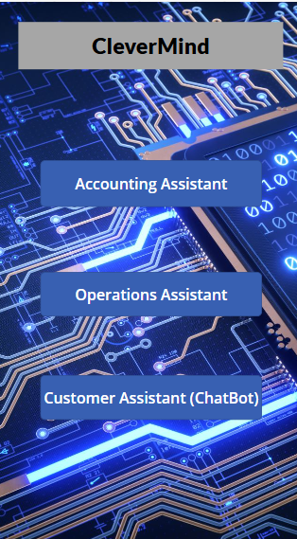
2- Products Screen
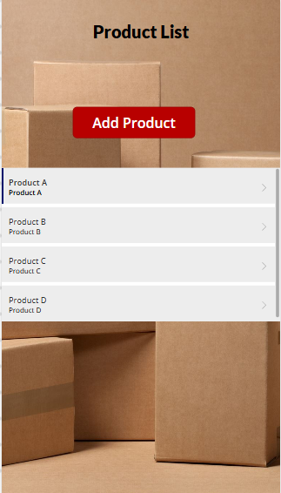

3-Orders Screen
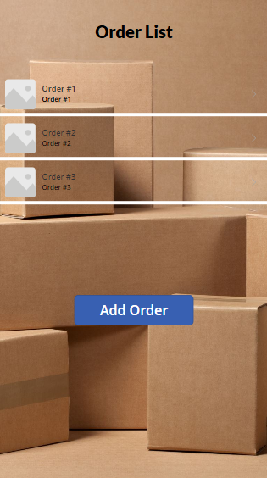

4-Vendors Screen

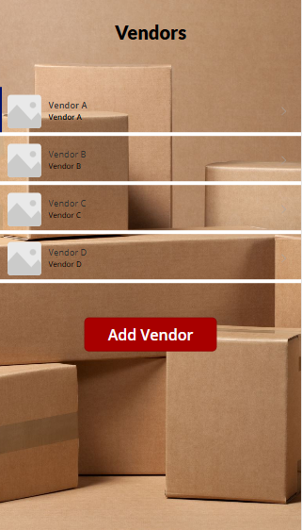

5-Insights Screen
