AM2320
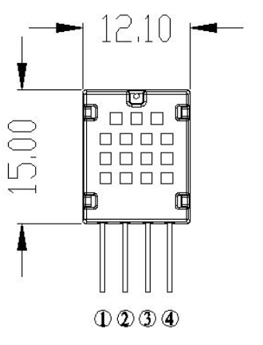
Temperature and humidity combined sensor AM2320 digital temperature and humidity sensor is adigital signal output has been calibrated.

Pin | Name | Description
1 | VDD | Power Supply
2 | SDA | Serial data, bidirectional port
3 | GND | Ground
4 | SCL | Serial Clock Input Port (Single Bus Ground)

Electrical Characteristic
Parameter | Condition | Min | Typ | Max | Unit
Supply Voltage |  | 3.1 | 5 | 5.5 | v
Power Consumption | Dormancy | 8 | 10 |  | µA
Power Consumption | Measure |  | 950 |  | µA
Power Consumption | Average |  | 350 |  | µA
Low-level output voltage | I_{CC}⁵ | 0 |  | 300 | MV
High-level output voltage | Rp<25 kΩ | 90% |  | 100% | VDD
Low-level output voltage |  | 0 |  | 30% | VDD
High-level output voltage |  | 70% |  | 100% | VDD
Rpu⁶ | VDD = 5V  VIN = VSS | 30 | 45 | 60 | kΩ
Output Current |  |  | 8 |  | MA
 |  | 10 | 20 |  | µA
Sampling Period |  |  | 2.0 |  | s

Relative Humidity Characteristic
Parameter | Condition | Min | Typ | Max | Unit
Resolution |  |  | 0.1 |  | %RH
Range |  | 0 |  | 99.9 | %RH
Accuracy | 25°C |  | ±3 |  | %RH
Repeatability |  |  | ±0.1 |  | %RH
Interchangeability |  | Completely interchangeable
Response Time | 1/e(63%) |  | <5 |  | S
Sluggish |  |  | ±0.3 |  | %RH
Drift | Typical Values |  | <0.5 |  | %RH/yr

Temperature Characteristic
Parameter | Condition | Min | Typ | Max | Unit
Resolution |  |  | 0.1 |  | °C
Resolution |  |  | 16 |  | bit
Accuracy |  |  | ±0.5 |  | °C
Range |  | -40 |  | 80 | °C
Repeatability |  |  | ±0.2 |  | °C
Interchangeability
Response Time | 1/e(63%) |  | <5 |  | S
Drift |  |  | ±0.1 |  | °C/yr

