

**COMPILER CONSTRCTION**

**DELIVERABLE: 1+2+3**



**GROUP PARTNERS**

**22F-3851 ABDUL QUDOOS**

**22F-3263 SAMI SHAHZAD**

**22F-3363 SYED NOOR UL GHANI**

**LEXER.PY**

import ply.lex as lex

reserved = {

    'int': 'INT', 'float': 'FLOAT', 'bool': 'BOOL', 'string': 'STRING',

    'if': 'IF', 'else': 'ELSE', 'while': 'WHILE', 'for': 'FOR',

    'switch': 'SWITCH', 'case': 'CASE', 'print': 'PRINT', 'return': 'RETURN'

}

tokens = [

    'ID', 'NUMBER', 'STRING', 'PLUS', 'MINUS', 'TIMES', 'DIVIDE',

    'LPAREN', 'RPAREN', 'LBRACE', 'RBRACE', 'SEMICOLON', 'ASSIGN',

    'EQ', 'NEQ', 'LT', 'GT', 'LEQ', 'GEQ', 'AND', 'OR', 'NOT'

] + list(reserved.values())

# Token regex rules

t_PLUS = r'\+'

t_MINUS = r'-'

t_TIMES = r'\*'

t_DIVIDE = r'/'

t_LPAREN = r'\('

t_RPAREN = r'\)'

t_LBRACE = r'\{'

t_RBRACE = r'\}'

t_SEMICOLON = r';'

t_ASSIGN = r'='

t_EQ = r'=='

t_NEQ = r'!='

t_LT = r'<'

t_GT = r'>'

t_LEQ = r'<='

t_GEQ = r'>='

t_AND = r'&&'

t_OR = r'\|\|'

t_NOT = r'!'

t_STRING = r'"([^"\n])*"'

def t_ID(t):

    r'[a-zA-Z_][a-zA-Z0-9_]*'

    t.type = reserved.get(t.value, 'ID')

    return t

def t_NUMBER(t):

    r'\d+(\.\d+)?'

    t.value = float(t.value) if '.' in t.value else int(t.value)

    return t

t_ignore = ' \t'

def t_newline(t):

    r'\n+'

    t.lexer.lineno += len(t.value)

# Handling comments properly

def t_COMMENT(t):

    r'(/\*[\s\S]*?\*/|//[^\n]*)'

    pass

def t_error(t):

    print(f"Illegal character '{t.value[0]}' at line {t.lexer.lineno}")

    t.lexer.skip(1)

lexer = lex.lex()

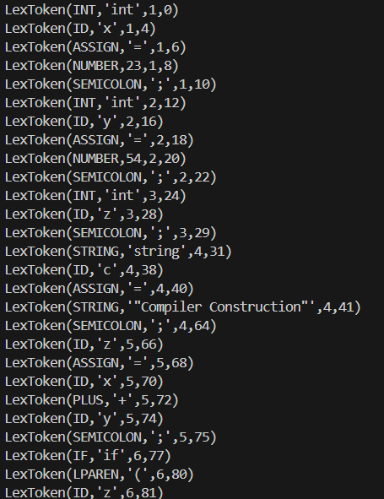

**SYNTAX.PY**

import ply.yacc as yacc

from lexer import tokens

# Symbol Table

symbol_table = {}

precedence = (

    ('left', 'OR'),

    ('left', 'AND'),

    ('left', 'NOT'),

    ('left', 'GT', 'LT', 'GEQ', 'LEQ', 'EQ', 'NEQ'),

    ('left', 'PLUS', 'MINUS'),

    ('left', 'TIMES', 'DIVIDE'),

)

def p_program(p):

    '''program : statement_list'''

    p[0] = p[1]

def p_statement_list(p):

    '''statement_list : statement

                      | statement_list statement'''

    p[0] = [p[1]] if len(p) == 2 else p[1] + [p[2]]

def p_statement_declaration(p):

    '''statement : INT ID SEMICOLON

                 | FLOAT ID SEMICOLON

                 | BOOL ID SEMICOLON

                 | STRING ID SEMICOLON

                 | INT ID ASSIGN expression SEMICOLON

                 | FLOAT ID ASSIGN expression SEMICOLON

                 | BOOL ID ASSIGN expression SEMICOLON

                 | STRING ID ASSIGN expression SEMICOLON'''

    var_type = p[1]

    var_name = p[2]

    if len(p) == 4:

        symbol_table[var_name] = {"type": var_type, "value": None}

        p[0] = ("declaration", var_type, var_name)

    else:

        symbol_table[var_name] = {"type": var_type, "value": p[4]}

        p[0] = ("declaration", var_type, var_name, p[4])

def p_statement_assignment(p):

    '''statement : ID ASSIGN expression SEMICOLON'''

    var_name = p[1]

    if var_name not in symbol_table:

        print(f"Semantic Error: Variable '{var_name}' is not declared.")

    else:

        symbol_table[var_name]["value"] = p[3]

    p[0] = ("assignment", var_name, p[3])

# if-else etc

def p_statement_if_else(p):

    '''statement : IF LPAREN expression RPAREN statement ELSE statement

                 | IF LPAREN expression RPAREN LBRACE statement_list RBRACE ELSE LBRACE statement_list RBRACE'''

    if len(p) == 8:

        p[0] = ("if_else", p[3], [p[5]], [p[7]])

    else:

        p[0] = ("if_else", p[3], p[6], p[10])

# --- Loops (While) ---

def p_statement_while(p):

    '''statement : WHILE LPAREN expression RPAREN statement

                 | WHILE LPAREN expression RPAREN LBRACE statement_list RBRACE'''

    p[0] = ("while", p[3], [p[5]] if len(p) == 6 else p[6])

# --- Print Statement ---

def p_statement_print(p):

    '''statement : PRINT LPAREN expression RPAREN SEMICOLON'''

    p[0] = ("print", p[3])

# --- Expressions (Arithmetic, Relational, Boolean) ---

def p_expression_arithmetic(p):

    '''expression : expression PLUS expression

                  | expression MINUS expression

                  | expression TIMES expression

                  | expression DIVIDE expression'''

    p[0] = ("binary_op", p[2], p[1], p[3])

def p_expression_relational(p):

    '''expression : expression GT expression

                  | expression LT expression

                  | expression GEQ expression

                  | expression LEQ expression

                  | expression EQ expression

                  | expression NEQ expression'''

    p[0] = ('relational_op', p[2], p[1], p[3])

def p_expression_boolean(p):

    '''expression : expression AND expression

                  | expression OR expression

                  | NOT expression'''

    if len(p) == 3:

        p[0] = ("unary_op", "NOT", p[2])

    else:

        p[0] = ("binary_op", p[2], p[1], p[3])

def p_expression_number(p):

    '''expression : NUMBER'''

    p[0] = ("number", p[1])

def p_expression_identifier(p):

    '''expression : ID'''

    var_name = p[1]

    if var_name not in symbol_table:

        print(f"Semantic Error: Variable '{var_name}' is not declared.")

    p[0] = ("identifier", var_name)

def p_expression_string(p):

    '''expression : STRING'''

    p[0] = ("string", p[1][1:-1])

def p_error(p):

    if p:

        print(f"Syntax Error at '{p.value}' (Line {p.lineno})")

    else:

        print("Syntax Error at EOF")

parser = yacc.yacc()

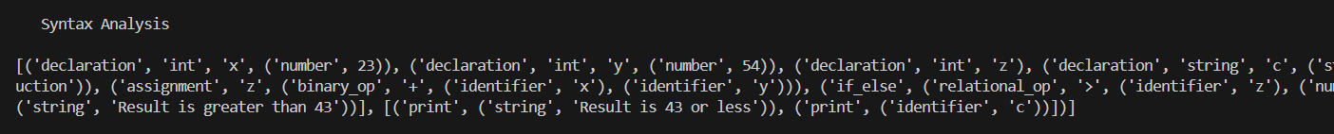

**SEMANTIC.PY**

import syntax

def analyze(node):

    if isinstance(node, list):

        for stmt in node:

            analyze(stmt)

    elif isinstance(node, tuple):

        if node[0] == "declaration":

            symbol_table[node[2]] = node[1]

            print(f"Declared: {node[2]} as {node[1]}")

        elif node[0] == "assignment":

            if node[1] not in symbol_table:

                print(f"Semantic Error: Undeclared variable '{node[1]}'")

            else:

                print(f"Assigned value to {node[1]}")

        elif node[0] == "binary_op":

            left = analyze(node[2])

            right = analyze(node[3])

            if left != right:

                print(f"Semantic Error: Type mismatch ({left} vs {right}) in '{node[1]}' operation")

            return left

        elif node[0] == "identifier":

            if node[1] not in symbol_table:

                print(f"Semantic Error: Undeclared variable '{node[1]}'")

            return symbol_table.get(node[1], None)

symbol_table = {}

if __name__ == "__main__":

    ast = syntax.parse('int x = 10; print(x);')

    analyze(ast)

**Sample code:**

int x = 23;

int y = 54;

int z;

string c ="Compiler Construction";

z = x + y;

if (z > 43) {

print("Result is greater than 43");

} else {

print("Result is 43 or less");

print(c);

}

**Abstract Syntax Tree (AST) :**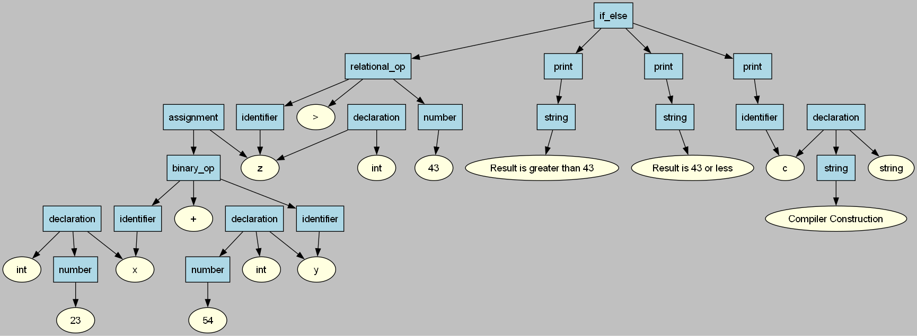

**IR.py**

temp_count = 0

label_count = 0

def new_temp():

    global temp_count

    temp_count += 1

    return f"t{temp_count}"

def new_label():

    global label_count

    label_count += 1

    return f"L{label_count}"

def generate_expr_ir(expr):

    if expr[0] == "number":

        return str(expr[1]), []

    elif expr[0] == "identifier":

        return expr[1], []

    elif expr[0] == "string":

        return expr[1], []

    elif expr[0] == "binary_op":

        op = expr[1]

        left_var, left_ir = generate_expr_ir(expr[2])

        right_var, right_ir = generate_expr_ir(expr[3])

        temp = new_temp()

        instr = (op, temp, left_var, right_var)

        return temp, left_ir + right_ir + [instr]

    else:

        raise ValueError(f"Unknown expression type: {expr[0]}")

def generate_statement_ir(stmt):

    if stmt[0] == "assignment":

        var = stmt[1]

        expr_var, expr_ir = generate_expr_ir(stmt[2])

        return expr_ir + [("=", var, expr_var)]

    elif stmt[0] == "if_else":

        cond = stmt[1]

        then_stmt = stmt[2]

        else_stmt = stmt[3]

        cond_var, cond_ir = generate_expr_ir(cond)

        L1 = new_label()

        L2 = new_label()

        L_loop_start = new_label()

        then_ir = []

        if isinstance(then_stmt, list):

            for s in then_stmt:

                then_ir.extend(generate_statement_ir(s))

        else:

            then_ir = generate_statement_ir(then_stmt)

        else_ir = []

        if isinstance(else_stmt, list):

            for s in else_stmt:

                else_ir.extend(generate_statement_ir(s))

        else:

            else_ir = generate_statement_ir(else_stmt)

        # Simulate a loop for the first if (i < 5)

        if cond[1] == "<":  # Treat as a loop

            ir = ([("label", L_loop_start)] +

                  cond_ir +

                  [("ifnot", cond_var, L1)] +

                  then_ir +

                  [("goto", L_loop_start)] +

                  [("label", L1)] +

                  else_ir +

                  [("label", L2)])

        else:  # Regular if-else

            ir = (cond_ir +

                  [("ifnot", cond_var, L1)] +

                  then_ir +

                  [("goto", L2)] +

                  [("label", L1)] +

                  else_ir +

                  [("label", L2)])

        return ir

    elif stmt[0] == "print":

        expr_var, expr_ir = generate_expr_ir(stmt[1])

        return expr_ir + [("print", expr_var)]

    elif stmt[0] == "declaration":

        var_name = stmt[1]

        if len(stmt) > 2:

            expr_var, expr_ir = generate_expr_ir(stmt[2])

            return expr_ir + [("=", var_name, expr_var)]

        return [("=", var_name, 0)]

    else:

        raise ValueError(f"Unknown statement type: {stmt[0]}")

def generate_ir(ast):

    ir = []

    for stmt in ast:

        ir.extend(generate_statement_ir(stmt))

    return ir

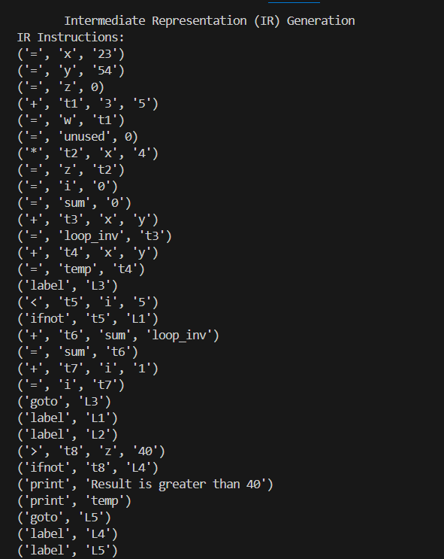

**OC.py**

def get_used_vars(ir):

    used_vars = set()

    for instr in ir:

        if instr[0] in ("=", "+", "-", "*", ">", "<", "ifnot", "print"):

            for i in range(2, len(instr)):

                if isinstance(instr[i], str) and not instr[i].startswith("L"):

                    used_vars.add(instr[i])

    return used_vars

def constant_folding(ir):

    new_ir = []

    for instr in ir:

        if instr[0] in ("+", "-", "*", ">", "<"):

            op, result, left, right = instr

            try:

                left_val = int(left)

                right_val = int(right)

                if op == "+":

                    new_ir.append(("=", result, str(left_val + right_val)))

                elif op == "-":

                    new_ir.append(("=", result, str(left_val - right_val)))

                elif op == "*":

                    new_ir.append(("=", result, str(left_val * right_val)))

                elif op == ">":

                    new_ir.append(("=", result, str(int(left_val > right_val))))

                elif op == "<":

                    new_ir.append(("=", result, str(int(left_val < right_val))))

            except ValueError:

                new_ir.append(instr)

        else:

            new_ir.append(instr)

    return new_ir

def dead_code_elimination(ir):

    used_vars = get_used_vars(ir)

    optimized_ir = []

    for instr in ir:

        if instr[0] == "=" and instr[1] not in used_vars:

            continue

        optimized_ir.append(instr)

    return optimized_ir

def strength_reduction(ir):

    new_ir = []

    for instr in ir:

        if instr[0] == "*" and isinstance(instr[3], str):

            try:

                val = int(instr[3])

                if val == 2:

                    new_ir.append(("<<", instr[1], instr[2], "1"))

                elif val == 4:

                    new_ir.append(("<<", instr[1], instr[2], "2"))

                else:

                    new_ir.append(instr)

            except ValueError:

                new_ir.append(instr)

        else:

            new_ir.append(instr)

    return new_ir

def loop_invariant_code_motion(ir):

    new_ir = []

    loop_start = None

    loop_end = None

    invariants = []

    in_loop = False

    for i, instr in enumerate(ir):

        if instr[0] == "label" and not in_loop:

            loop_start = instr[1]

            in_loop = True

        elif instr[0] == "label" and in_loop and i > 0 and ir[i-1][0] == "goto" and ir[i-1][1] == loop_start:

            loop_end = instr[1]

            in_loop = False

        elif in_loop and instr[0] in ("+", "-", "*"):

            # Check if operands are loop-invariant (not modified in loop)

            op, result, left, right = instr

            modified_vars = set()

            for j in range(i, len(ir)):

                if ir[j][0] == "=" and ir[j][1] in (left, right):

                    modified_vars.add(ir[j][1])

                if ir[j][0] == "label" and ir[j][1] == loop_end:

                    break

            if left not in modified_vars and right not in modified_vars:

                invariants.append(instr)

                continue

        new_ir.append(instr)

    # Move invariants before loop

    if invariants and loop_start:

        for i, instr in enumerate(new_ir):

            if instr[0] == "label" and instr[1] == loop_start:

                new_ir[i:i] = invariants

                break

    return new_ir

def common_subexpression_elimination(ir):

    new_ir = []

    seen_expressions = {}

    for instr in ir:

        if instr[0] in ("+", "-", "*"):

            op, result, left, right = instr

            expr_key = (op, left, right)

            if expr_key in seen_expressions:

                # Replace with the previous result

                new_ir.append(("=", result, seen_expressions[expr_key]))

            else:

                seen_expressions[expr_key] = result

                new_ir.append(instr)

        else:

            new_ir.append(instr)

    return new_ir

def optimize_ir(ir):

    ir = constant_folding(ir)

    ir = common_subexpression_elimination(ir)

    ir = loop_invariant_code_motion(ir)

    ir = strength_reduction(ir)

    ir = dead_code_elimination(ir)

    return ir

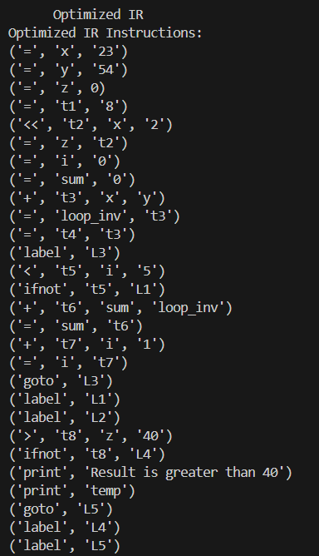

**Code_gen.py:**

registers = ["eax", "ebx", "ecx", "edx"]

register_map = {}

stack_offset = 0

variable_locations = {}

def allocate_register(var):

    global stack_offset

    if var in register_map:

        return register_map[var]

    for reg in registers:

        if reg not in register_map.values():

            register_map[var] = reg

            variable_locations[var] = reg

            return reg

    stack_offset -= 4

    variable_locations[var] = f"dword [ebp{stack_offset}]"

    return variable_locations[var]

def free_register(var):

    if var in register_map:

        del register_map[var]

    if var in variable_locations:

        del variable_locations[var]

def get_location(var):

    if isinstance(var, int):

        return str(var)

    if var in variable_locations:

        return variable_locations[var]

    return allocate_register(var)

def generate_assembly(ir, filename="output.s"):

    global stack_offset

    stack_offset = 0

    register_map.clear()

    variable_locations.clear()

    with open(filename, "w") as f:

        # Header

        f.write("global _main\n")

        f.write("extern _printf\n")

        f.write("extern _exit\n\n")

        # Data section

        f.write("section .data\n")

        f.write('    fmt_int db "%d", 10, 0\n')

        f.write('    fmt_str db "%s", 10, 0\n')

        f.write('    msg db "Operation result stored", 10, 0\n')

        f.write('    str1 db "Result is greater than 40", 10, 0\n\n')

        # BSS section

        f.write("section .bss\n")

        f.write("    res resb 4\n\n")

        # Text section

        f.write("section .text\n")

        f.write("_main:\n")

        f.write("    push ebp\n")

        f.write("    mov ebp, esp\n")

        f.write(f"    sub esp, {abs(stack_offset) + 64}\n\n")

        # Generate code from IR

        for instr in ir:

            asm = ir_to_asm(instr)

            if asm:

                for line in asm.split('\n'):

                    if line.strip():

                        f.write(f"    {line}\n")

        # Cleanup and exit

        f.write("\n    ; Program exit\n")

        f.write("    push msg\n")

        f.write("    push fmt_str\n")

        f.write("    call _printf\n")

        f.write("    add esp, 8\n")

        f.write("    mov esp, ebp\n")

        f.write("    pop ebp\n")

        f.write("    push 0\n")

        f.write("    call _exit\n")

def ir_to_asm(instr):

    if not isinstance(instr, tuple):

        return f"; unhandled: {instr}"

    op = instr[0]

    if op == "=":

        dest, src = instr[1], instr[2]

        loc_dest = get_location(dest)

        if isinstance(src, int):

            if "dword [" in loc_dest:

                return f"mov dword {loc_dest}, {src}"

            return f"mov {loc_dest}, {src}"

        else:

            loc_src = get_location(src)

            if "dword [" in loc_dest and "dword [" in loc_src:

                return f"mov eax, {loc_src}\nmov dword {loc_dest}, eax"

            elif "dword [" in loc_dest:

                return f"mov dword {loc_dest}, {loc_src}"

            elif "dword [" in loc_src:

                return f"mov eax, {loc_src}\nmov {loc_dest}, eax"

            return f"mov {loc_dest}, {loc_src}"

    elif op in ("+", "add"):

        dest, src1, src2 = instr[1], instr[2], instr[3]

        loc_dest = get_location(dest)

        loc_src1 = get_location(src1)

        loc_src2 = get_location(src2)

        asm = []

        # Load first operand

        if isinstance(src1, int):

            asm.append(f"mov eax, {src1}")

        else:

            if "dword [" in loc_src1:

                asm.append(f"mov eax, dword {loc_src1}")

            else:

                asm.append(f"mov eax, {loc_src1}")

        # Perform operation

        if isinstance(src2, int):

            asm.append(f"add eax, {src2}")

        else:

            if "dword [" in loc_src2:

                asm.append(f"add eax, dword {loc_src2}")

            else:

                asm.append(f"add eax, {loc_src2}")

        # Store result

        if "dword [" in loc_dest:

            asm.append(f"mov dword {loc_dest}, eax")

        else:

            asm.append(f"mov {loc_dest}, eax")

        return "\n".join(asm)

    elif op == "*":

        dest, src1, src2 = instr[1], instr[2], instr[3]

        loc_dest = get_location(dest)

        loc_src1 = get_location(src1)

        loc_src2 = get_location(src2)

        asm = []

        # Load first operand

        if isinstance(src1, int):

            asm.append(f"mov eax, {src1}")

        else:

            if "dword [" in loc_src1:

                asm.append(f"mov eax, dword {loc_src1}")

            else:

                asm.append(f"mov eax, {loc_src1}")

        # Perform multiplication

        if isinstance(src2, int):

            asm.append(f"imul eax, {src2}")

        else:

            if "dword [" in loc_src2:

                asm.append(f"imul eax, dword {loc_src2}")

            else:

                asm.append(f"imul eax, {loc_src2}")

        # Store result

        if "dword [" in loc_dest:

            asm.append(f"mov dword {loc_dest}, eax")

        else:

            asm.append(f"mov {loc_dest}, eax")

        return "\n".join(asm)

    elif op == ">":

        dest, src1, src2 = instr[1], instr[2], instr[3]

        loc_dest = get_location(dest)

        loc_src1 = get_location(src1)

        loc_src2 = get_location(src2)

        asm = []

        # Load first operand

        if isinstance(src1, int):

            asm.append(f"mov eax, {src1}")

        else:

            if "dword [" in loc_src1:

                asm.append(f"mov eax, dword {loc_src1}")

            else:

                asm.append(f"mov eax, {loc_src1}")

        # Compare

        if isinstance(src2, int):

            asm.append(f"cmp eax, {src2}")

        else:

            if "dword [" in loc_src2:

                asm.append(f"cmp eax, dword {loc_src2}")

            else:

                asm.append(f"cmp eax, {loc_src2}")

        # Set result

        asm.append("setg al")

        asm.append("movzx eax, al")

        # Store result

        if "dword [" in loc_dest:

            asm.append(f"mov dword {loc_dest}, eax")

        else:

            asm.append(f"mov {loc_dest}, eax")

        return "\n".join(asm)

    elif op == "ifnot":

        cond, label = instr[1], instr[2]

        loc_cond = get_location(cond)

        if isinstance(cond, int):

            if cond == 0:

                return f"jmp {label}"

            else:

                return f"; condition is always true"

        if "dword [" in loc_cond:

            return f"cmp dword {loc_cond}, 0\nje {label}"

        else:

            return f"cmp {loc_cond}, 0\nje {label}"

    elif op == "goto":

        return f"jmp {instr[1]}"

    elif op == "label":

        return f"{instr[1]}:"

    elif op == "print":

        expr = instr[1]

        if isinstance(expr, str) and expr.startswith('"'):

            if expr == '"Result is greater than 40"':

                return f"push str1\npush fmt_str\ncall _printf\nadd esp, 8"

            else:

                return f"; Unhandled string: {expr}"

        else:

            loc = get_location(expr)

            if "dword [" in loc:

                return f"mov eax, dword {loc}\npush eax\npush fmt_int\ncall _printf\nadd esp, 8"

            else:

                return f"push {loc}\npush fmt_int\ncall _printf\nadd esp, 8"

    return f"; unhandled op: {op}"

**output.s:**

global _main

extern _printf

extern _exit

section .data

fmt_int db "%d", 10, 0

fmt_str db "%s", 10, 0

msg db "Operation result stored", 10, 0

str1 db "Result is greater than 40", 10, 0

section .bss

res resb 4

section .text

_main:

push ebp

mov ebp, esp

sub esp, 64

mov eax, 23

mov ebx, 54

mov ecx, 0

mov eax, eax

imul eax, 4

mov edx, eax

mov ecx, edx

mov dword dword [ebp-4], 0

mov dword dword [ebp-8], 0

mov eax, eax

add eax, ebx

mov dword dword [ebp-12], eax

mov eax, dword [ebp-12]

mov dword dword [ebp-16], eax

mov eax, eax

add eax, ebx

mov dword dword [ebp-20], eax

mov eax, dword [ebp-20]

mov dword dword [ebp-24], eax

; unhandled op: <

cmp dword dword [ebp-28], 0

je L1

mov eax, dword dword [ebp-8]

add eax, dword dword [ebp-16]

mov dword dword [ebp-32], eax

mov eax, dword [ebp-32]

mov dword dword [ebp-8], eax

mov eax, dword dword [ebp-4]

add eax, 1

mov dword dword [ebp-36], eax

mov eax, dword [ebp-36]

mov dword dword [ebp-4], eax

jmp L2

L1:

L2:

mov eax, ecx

cmp eax, 40

setg al

movzx eax, al

mov dword dword [ebp-40], eax

cmp dword dword [ebp-40], 0

je L3

push str1

push fmt_str

call _printf

add esp, 8

mov eax, dword dword [ebp-24]

push eax

push fmt_int

call _printf

add esp, 8

jmp L4

L3:

L4:

; Program exit

push msg

push fmt_str

call _printf

add esp, 8

mov esp, ebp

pop ebp

push 0

call _exit

**Final.py**

import os

import subprocess

from lexer import lexer

from syntax import parser

from semantic import analyze

from Ast_Table import generate_ast_dot

from IR import generate_ir

from OC import optimize_ir

from codegen import generate_assembly

if __name__ == "__main__":

    base_dir = r"C:\Users\abdul\OneDrive\Desktop\CC"

    input_file = os.path.join(base_dir, "test_code.txt")

    ir_file = os.path.join(base_dir, "ir.txt")

    optimized_ir_file = os.path.join(base_dir, "optimized_ir.txt")

    ast_dot_file = os.path.join(base_dir, "ast.dot")

    assembly_file = os.path.join(base_dir, "output.s")

    if not os.path.exists(base_dir):

        print(f"Error: Directory {base_dir} does not exist.")

        exit(1)

    try:

        print(f"Reading input from {input_file}")

        with open(input_file, "r") as file:

            data = file.read()

    except FileNotFoundError as e:

        print(f"Error: Input file not found - {e}")

        exit(1)

    except Exception as e:

        print(f"Unexpected Error while reading input file: {e}")

        exit(1)

    print("\n      Lexical Analysis ")

    try:

        lexer.input(data)

        for tok in lexer:

            print(tok)

    except Exception as e:

        print(f"Lexical Analysis Error: {e}")

        exit(1)

    print("\n      Syntax Analysis ")

    try:

        ast = parser.parse(data, lexer=lexer)

        if ast is None:

            print("Error: Parsing failed, AST is None.")

            exit(1)

        print("Generated AST:", ast)

    except Exception as e:

        print(f"Syntax Analysis Error: {e}")

        exit(1)

    print("\n      Semantic Analysis ")

    semantic_passed = False

    try:

        analyze(ast)

        semantic_passed = True

        print("Semantic analysis passed successfully.")

    except Exception as e:

        print(f"Semantic Error: {e}. Continuing to later phases for debugging.")

    print("\n      AST Visualization ")

    try:

        if os.path.exists(ast_dot_file):

            print(f"Warning: {ast_dot_file} already exists, overwriting.")

        test_file = os.path.join(base_dir, "test_write.txt")

        with open(test_file, "w") as f:

            f.write("test")

        print(f"Successfully wrote test file to {test_file}")

        os.remove(test_file)

        if not generate_ast_dot(ast, filename=ast_dot_file):

            print("Failed to generate AST visualization, but continuing.")

        else:

            print("AST visualization generated successfully.")

            png_file = ast_dot_file.replace('.dot', '.png')

            subprocess.run(["dot", "-Tpng", ast_dot_file, "-o", png_file], check=True)

            if os.path.exists(png_file):

                print(f"Confirmed: {png_file} exists.")

            else:

                print(f"Error: {png_file} was not created.")

    except subprocess.CalledProcessError as e:

        print(f"Graphviz Error: Ensure 'dot' is installed and in PATH. Error: {e}")

    except Exception as e:

        print(f"AST Visualization Error: {e}. Continuing to IR generation.")

    print("\n      Intermediate Representation (IR) Generation ")

    try:

        ir = generate_ir(ast)

        print("IR Instructions:")

        with open(ir_file, "w") as f:

            for instr in ir:

                print(instr)

                f.write(str(instr) + "\n")

        print(f"IR saved to {ir_file}")

    except Exception as e:

        print(f"IR Generation Error: {e}. Continuing to optimization.")

    print("\n      Optimized IR ")

    try:

        optimized_ir = optimize_ir(ir)

        print("Optimized IR Instructions:")

        with open(optimized_ir_file, "w") as f:

            for instr in optimized_ir:

                print(instr)

                f.write(str(instr) + "\n")

        print(f"Optimized IR saved to {optimized_ir_file}")

    except Exception as e:

        print(f"IR Optimization Error: {e}. Continuing to code generation.")

    print("\n      Code Generation ")

    try:

        generate_assembly(optimized_ir, filename=assembly_file)

        print(f"Assembly code saved to {assembly_file}")

    except Exception as e:

        print(f"Code Generation Error: {e}")

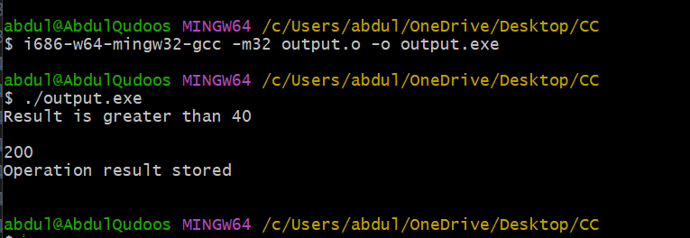

* nasm -f win32 output.s -o output.o
* i686-w64-mingw32-gcc -m32 output.o -o output.exe
* ./output.exe