The University of Azad Jammu and Kashmir
Department of Software Engineering
Digital Image Processing Lab
Lab Task # 03 — Image Enhancement and Intensity Transformations
Student name | Sahadat Ali
Roll number | 2024-SE-36
Semester / Session | Fifth / 2024-28 (SE)
Lab instructor | Engr. Fahad Nisar
Assigned / Due | November 02, 2026 / November 09, 2026, 11:59 PM
Report date | November 08, 2026
Files submitted | 2024-SE-36-LAB03.docx (this report), 2024-SE-36-LAB03.ipynb (notebook), input_image.png

Objective
To calculate, implement and compare grayscale intensity transformations, histogram enhancement and thresholding while preventing overflow and interpreting their effects.
Method and conventions
- Python 3, NumPy, OpenCV and Matplotlib in a Jupyter notebook; the notebook was run from top to bottom and all cells and outputs are kept.
- Each of the 11 dry runs was calculated by hand first (typed tables below) and then verified in Python. In total 37 of 37 verification checks passed.
- Arithmetic uses wider types (int16 / float64); results are clipped to 0–255 before the conversion to uint8 and fractions are truncated unless rounding is requested.
- All images are displayed with the grayscale limits 0–255 and the original image is never modified (checked at the end of the notebook).

Input image and validation
The input file (a colour photo) was loaded with cv2.IMREAD_GRAYSCALE, which converts it to one 8-bit channel, and validated to be a 2-D, 8-bit (uint8) array of at least 300 × 300 pixels. A read-only copy named original is kept unchanged for all comparisons.
Table 1. Properties of the input image
Property | Value
Shape (rows x cols) | 1452 x 1160
dtype | uint8
Minimum | 14
Maximum | 255

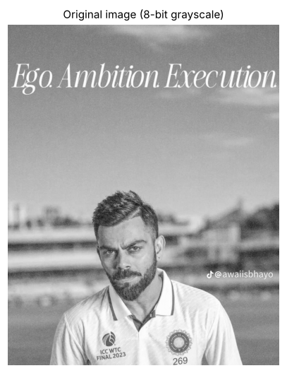
Figure 1. Input image after conversion to 8-bit grayscale.

1. Brightness adjustment
Task: Produce a brighter and a darker image with β = +40 and β = −40, implement +40 again with nested loops and verify that it matches NumPy.

Dry run
Pixels [30, 80, 128, 180, 240]: calculate brightness +40 and −40; show raw values, clipping and final uint8 values; explain any lost detail.
Table 2. Dry run 1(a): brightness +40
r | r + 40 (raw) | After clipping 0–255 | Final uint8 | Plain uint8 (wraps – wrong)
30 | 70 | 70 | 70 | 70
80 | 120 | 120 | 120 | 120
128 | 168 | 168 | 168 | 168
180 | 220 | 220 | 220 | 220
240 | 280 | 255 | 255 | 24

Table 3. Dry run 1(b): brightness −40
r | r − 40 (raw) | After clipping 0–255 | Final uint8 | Plain uint8 (wraps – wrong)
30 | -10 | 0 | 0 | 246
80 | 40 | 40 | 40 | 40
128 | 88 | 88 | 88 | 88
180 | 140 | 140 | 140 | 140
240 | 200 | 200 | 200 | 200

Python verification (all passed):
- +40 hand calculation [70,120,168,220,255] matches Python
- −40 hand calculation [0,40,88,140,200] matches Python
- Same pixels through the image function u8() give the same result

Lost detail: with +40 the pixel 240 becomes 280, which is clipped to 255, so 25 grey levels of information are cut off. Every input r ≥ 215 ends at 255, so (for example) 230 and 240 become indistinguishable. With −40 the pixel 30 becomes −10 and is clipped to 0; every input r ≤ 40 ends at 0, so dark detail disappears.
Why a wider type is needed: if the arithmetic stayed in uint8 the results would wrap modulo 256 – 240 + 40 would give 24 (very dark instead of very bright) and 30 − 40 would give 246 (very bright instead of very dark), as the last column of the tables shows.

Result on the image
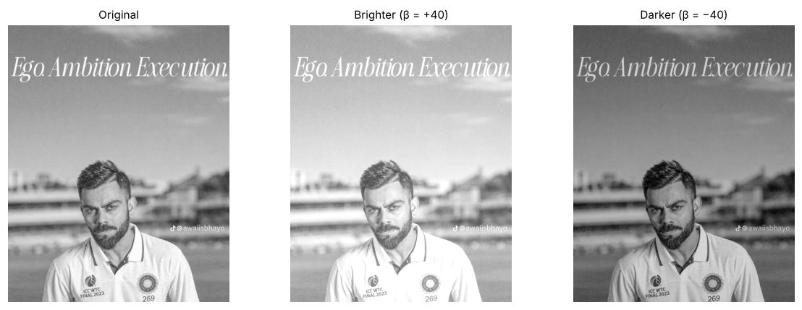
Figure 2. Original, brighter (β = +40) and darker (β = −40) images (display range 0–255).
Python verification (all passed):
- Nested-loop +40 result equals the NumPy result

Observation: Adding 40 raised the mean intensity from 164.9 to 202.4 and subtracting 40 lowered it to 124.9. Brightness only shifts all pixels by the same amount, but clipping removed information: pixels at 255 grew from 177 to 188,553 after +40 (this image is already bright, so the bright sky and the white shirt lose their tone differences), and pixels at 0 grew from 0 to 1,749 after −40. With plain uint8 arithmetic 185,207 bright pixels (r ≥ 216) would have wrapped around to dark values. The nested-loop result is identical to the NumPy result, but NumPy does it in one vectorised step.

2. Linear contrast from zero
Task: Apply s = αr + β with α = 1.5 and β = 0, then compare brightness and highlight clipping with the original.

Dry run
Pixels [30, 80, 128, 180, 240]: calculate 1.5r, clip to 0–255, truncate and identify the saturated pixels.
Table 4. Dry run 2: s = 1.5 r
r | 1.5 r (raw) | After clipping 0–255 | Truncated uint8 | Saturated?
30 | 45 | 45 | 45 | No
80 | 120 | 120 | 120 | No
128 | 192 | 192 | 192 | No
180 | 270 | 255 | 255 | Yes
240 | 360 | 255 | 255 | Yes

Python verification (all passed):
- Hand calculation [45,120,192,255,255] matches Python
- Saturated pixels are exactly r = 180 and r = 240

The pixels 180 and 240 give 270 and 360, which are above 255, so both are saturated and become 255 although they were 60 grey levels apart. In general every pixel with r ≥ 170 is saturated, because 1.5 × 170 = 255.
All values in this example (45, 120, 192) are whole numbers, so truncation does not change them; it would only matter for values such as 1.5 × 31 = 46.5 → 46.

Result on the image
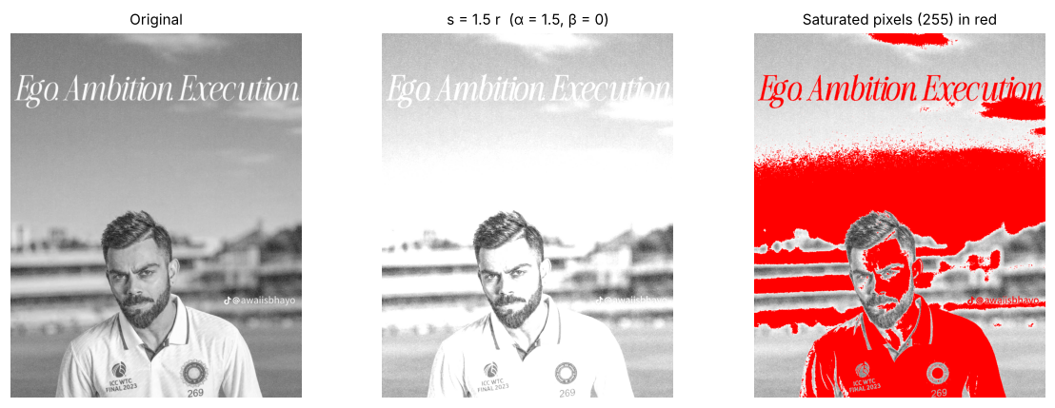
Figure 3. Original, linear contrast s = 1.5r and the saturated pixels (255) marked in red.
Observation: Multiplying by 1.5 raised the mean from 164.9 to 227.2, but the standard deviation did not grow (40.1 → 37.9) because of clipping. 45.3 % of the pixels are now saturated at 255 (originally 0.01 %), as the red overlay shows: every pixel with r ≥ 170 is merged into pure white, so most of the sky and the shirt lose their detail. Scaling from zero therefore changes brightness much more than useful contrast and clips the highlights heavily.

3. Contrast centered at 128
Task: Apply s = (r − 128)α + 128 with α = 1.5 and α = 0.5 and compare both results with linear contrast from zero.

Dry run
Pixels [30, 80, 128, 180, 240]: calculate (r − 128)α + 128 for α = 1.5 and 0.5 with intermediate values and clipping; explain the result at r = 128.
Table 5. Dry run 3(a): α = 1.5
r | r − 128 | × 1.5 | + 128 (raw) | Clipped & truncated
30 | -98 | -147 | -19 | 0
80 | -48 | -72 | 56 | 56
128 | 0 | 0 | 128 | 128
180 | 52 | 78 | 206 | 206
240 | 112 | 168 | 296 | 255

Table 6. Dry run 3(b): α = 0.5
r | r − 128 | × 0.5 | + 128 (raw) | Clipped & truncated
30 | -98 | -49 | 79 | 79
80 | -48 | -24 | 104 | 104
128 | 0 | 0 | 128 | 128
180 | 52 | 26 | 154 | 154
240 | 112 | 56 | 184 | 184

Python verification (all passed):
- α = 1.5 hand calculation [0,56,128,206,255] matches
- α = 0.5 hand calculation [79,104,128,154,184] matches
- r = 128 maps to 128 for both α (fixed point)

At r = 128 the term (r − 128) is zero, so the output is 128 whatever α is: 128 is the pivot (fixed point) of this transform. Pixels below 128 are pushed away from the pivot (downwards) and pixels above 128 upwards when α > 1; when α < 1 all pixels are pulled towards 128.
With α = 1.5 the pixel 30 gives −19 → clipped to 0 and 240 gives 296 → clipped to 255, so both ends of the range clip; with α = 0.5 nothing clips and the range shrinks to 79–184.

Result on the image
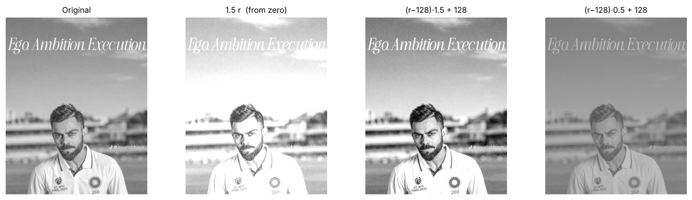
Figure 4. Original, linear contrast from zero (1.5r) and contrast centered at 128 with α = 1.5 and α = 0.5.
Table 7. Comparison of contrast operations
Image | Mean | Std. dev. | Min | Max | % pixels = 0 | % pixels = 255
Original | 164.86 | 40.05 | 14 | 255 | 0 | 0.01
1.5 r (from zero) | 227.21 | 37.9 | 21 | 255 | 0 | 45.33
(r−128)·1.5 + 128 | 178.96 | 53.1 | 0 | 255 | 0.16 | 11.62
(r−128)·0.5 + 128 | 146.18 | 20.03 | 71 | 191 | 0 | 0

Observation: Centered contrast with α = 1.5 increases the standard deviation to 53.1 (original 40.1). The mean rises only moderately (164.9 → 179.0), because most pixels lie above the pivot 128 and are pushed upwards; it clips mainly at the bright end (0.16 % of pixels become 0 and 11.6 % become 255), which is far fewer saturated pixels than 1.5r from zero (45.3 %), and the contrast is higher (standard deviation 53.1 against 37.9 for 1.5r). With α = 0.5 the output is squeezed into 71–191 (standard deviation 20.0), nothing clips and the image looks flat and washed out. So the centered form changes mainly contrast around a mid-grey pivot, whereas αr from zero mixes a contrast change with a strong brightness change.

4. Image negative
Task: Create the image negative s = 255 − r and explain one situation where it helps inspection.

Dry run
Pixels [30, 80, 128, 180, 240]: calculate 255 − r, apply the negative again and compare with the original.
Table 8. Dry run 4: image negative
r | s = 255 − r | 255 − s (negative again) | Equals original?
30 | 225 | 30 | Yes
80 | 175 | 80 | Yes
128 | 127 | 128 | Yes
180 | 75 | 180 | Yes
240 | 15 | 240 | Yes

Python verification (all passed):
- Hand calculation [225,175,127,75,15] matches
- Applying the negative twice returns the original pixels

The negative reverses the order of the grey levels (dark ↔ bright). Applying it a second time gives 255 − (255 − r) = r, so the original pixels [30, 80, 128, 180, 240] are recovered exactly – the operation is lossless.
Because 255 is odd, no integer pixel is its own negative: 128 becomes 127 (the mathematical fixed point is 127.5).

Result on the image
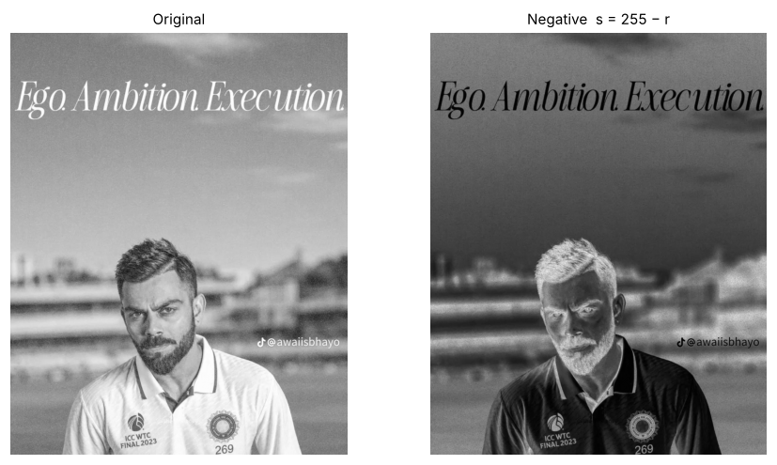
Figure 5. Original image and its negative s = 255 − r.
Python verification (all passed):
- Negative of the negative equals the original

Observation: The negative reverses light and dark (mean 164.9 → 90.1; the two means add up to 255) and applying it twice restores the original exactly. Situation where it helps inspection: when white or light-grey detail is embedded in a large dark region (for example in X-ray or scanned film images), the negative turns that detail into dark marks on a light background, which is often easier to examine.

5. Gamma correction
Task: Apply s = 255 (r/255)^γ for γ = 0.5 and γ = 2.0, compare the effect on dark regions and confirm that 0 and 255 stay fixed.

Dry run
Pixels [0, 64, 128, 192, 255]: show normalisation, power and scaling for γ = 0.5 and 2.0 (full precision, truncate only the final output); explain any difference from the rounded slide example.
Table 9. Dry run 5(a): γ = 0.5
r | r/255 | (r/255)^0.5 | 255 × power | Truncated output
0 | 0.000000 | 0.000000 | 0.0000 | 0
64 | 0.250980 | 0.500979 | 127.7498 | 127
128 | 0.501961 | 0.708492 | 180.6654 | 180
192 | 0.752941 | 0.867722 | 221.2691 | 221
255 | 1.000000 | 1.000000 | 255.0000 | 255

Table 10. Dry run 5(b): γ = 2.0
r | r/255 | (r/255)^2 | 255 × power | Truncated output
0 | 0.000000 | 0.000000 | 0.0000 | 0
64 | 0.250980 | 0.062991 | 16.0627 | 16
128 | 0.501961 | 0.251965 | 64.2510 | 64
192 | 0.752941 | 0.566920 | 144.5647 | 144
255 | 1.000000 | 1.000000 | 255.0000 | 255

Table 11. Full precision vs. rounded-normalisation (slide-style) values
γ | r | Full precision (truncated) | Rounded r/255 to 2 d.p. | Difference
0.5 | 64 | 127 | 127 | 0
0.5 | 128 | 180 | 180 | 0
0.5 | 192 | 221 | 220 | -1
2 | 64 | 16 | 15 | -1
2 | 128 | 64 | 63 | -1
2 | 192 | 144 | 143 | -1

Python verification (all passed):
- γ = 0.5 hand calculation [0,127,180,221,255] matches
- γ = 2.0 hand calculation [0,16,64,144,255] matches
- Image function gives the same result for the dry-run pixels

Method: normalise (r/255), raise to the power γ, then scale back (× 255). All intermediate values are kept at full precision and only the final result is truncated.
Difference from the rounded slide example: 64/255 is 0.250980…, not exactly 0.25, and 128/255 is 0.501961…, not 0.50. If the normalised value is rounded to two decimals (0.25, 0.50, 0.75) before the power is taken, the outputs change by up to 1 grey level (for example γ = 2.0, r = 64: 16.06 → 16 at full precision but 15.94 → 15 with 0.25). The slide values were not available to me, so this comparison assumes the slide rounds r/255 to two decimals.
End points: 0^γ = 0 and 1^γ = 1 for every γ, so 0 stays 0 and 255 stays 255.

Result on the image
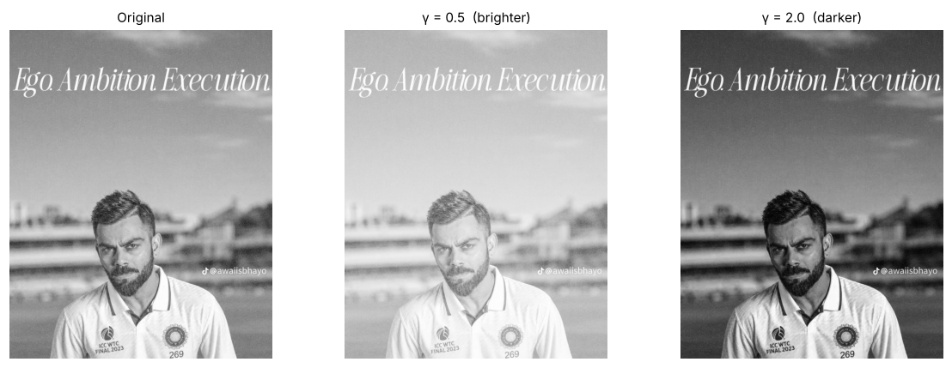
Figure 6. Original, γ = 0.5 (brighter) and γ = 2.0 (darker).
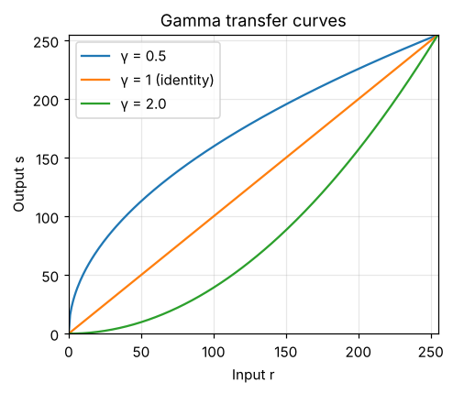
Figure 7. Gamma transfer curves s = 255 (r/255)^γ.
Table 12. Effect of gamma on the dark regions (pixels with r < 64)
Image | Mean of dark-region pixels | Mean of whole image
Original | 52.8482 | 164.8567
γ = 0.5 | 115.0962 | 202.8599
γ = 2.0 | 10.7948 | 112.4315

Python verification (all passed):
- 0 and 255 stay fixed for γ = 0.5
- 0 and 255 stay fixed for γ = 2.0

Observation: γ = 0.5 brightened the image (mean 164.9 → 202.9) and lifted the dark regions strongly: the 1.1 % of pixels below 64 (hair, beard and shadows) had a mean of 52.8 and now have 115.1. γ = 2.0 darkened the image (mean 112.4) and crushed those shadows to a mean of 10.8; because this image is bright, γ = 2.0 gives the more balanced overall look while γ = 0.5 pushes the sky towards white. 0 and 255 stay fixed for both values because 0^γ = 0 and 1^γ = 1. Convention: with s = 255 (r/255)^γ, γ < 1 brightens and γ > 1 darkens; many libraries and display standards use the inverse form s = 255 (r/255)^(1/γ), so the convention must always be checked.

6. Grayscale histogram
Task: Plot a labelled 256-bin histogram over 0–256 for the original image and interpret it in two sentences.

Dry run
A = [[0, 50, 50, 100], [100, 150, 200, 255]]: find the non-zero frequencies, probabilities and total pixel count; explain why a histogram does not show pixel positions.
Table 13. Dry run 6: histogram of A (non-zero frequencies)
Intensity | Frequency | Probability = freq / 8
0 | 1 | 0.125
50 | 2 | 0.25
100 | 2 | 0.25
150 | 1 | 0.125
200 | 1 | 0.125
255 | 1 | 0.125

Python verification (all passed):
- Frequencies [1,2,2,1,1,1] for values [0,50,100,150,200,255] and 8 pixels
- cv2.calcHist matches the hand count
- A different arrangement of the same pixels has an identical histogram

The table lists only the intensities that occur (all other frequencies are zero). The total is 8 pixels (2 × 4), the frequencies add up to 8 and the probabilities (frequency / 8) add up to 1.
A histogram does not show pixel positions because it only counts how many pixels have each intensity; the pixels are tallied by value and their rows and columns are discarded. The notebook demonstrates this with a rearranged copy of A that has exactly the same histogram although it is a different image.

Result on the image
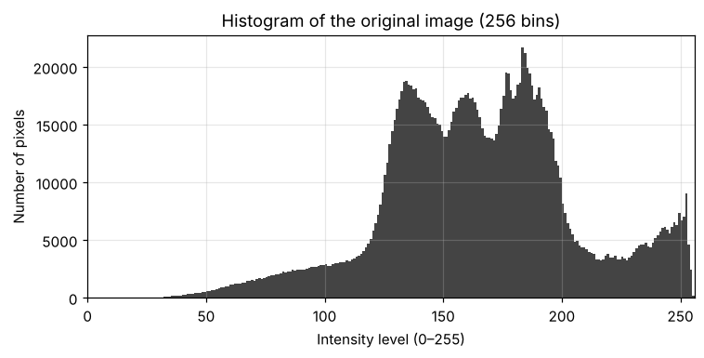
Figure 8. 256-bin histogram of the original image.
Python verification (all passed):
- cv2.calcHist agrees with np.bincount

Observation: The histogram is concentrated in the bright-to-mid range: 76.8 % of the pixels lie between 64 and 191, in three overlapping peaks near levels 135, 160 and 183 (mostly the sky and the blurred background), plus a small bright bump near 250 (the white shirt and the lettering), while only 1.1 % of the pixels are below 64 and the darkest levels (hair, beard, shadows) form a thin tail. With a mean of 164.9, a median of 164 and a standard deviation of only 40.1, this is a bright, fairly low-contrast image that leaves the darkest quarter of the range almost unused, so contrast enhancement should help.

7. Global histogram equalization
Task: Apply cv2.equalizeHist, show the original/equalized images with their histograms and discuss detail and noise.

Dry run
Pixels [50, 50, 100, 150]: frequencies, cumulative counts and CDF; map with 255 × CDF and with 255 × (CDF − CDFmin)/(1 − CDFmin) (round to nearest, .5 upward); compare the second with OpenCV.
Table 14. Dry run 7(a): frequencies, cumulative counts and CDF
Intensity | Frequency | Cumulative count | CDF = cum / 4
50 | 2 | 2 | 0.5
100 | 1 | 3 | 0.75
150 | 1 | 4 | 1

Table 15. Dry run 7(b): the two mappings
Intensity | CDF | 255 × CDF | Rounded (A) | (CDF − CDFmin)/(1 − CDFmin) | × 255 | Rounded (B)
50 | 0.5 | 127.5 | 128 | 0 | 0 | 0
100 | 0.75 | 191.25 | 191 | 0.5 | 127.5 | 128
150 | 1 | 255 | 255 | 1 | 255 | 255

Table 16. Output lists
Method | Output list
A: 255 × CDF | [128, 128, 191, 255]
B: 255 × (CDF − CDFmin)/(1 − CDFmin) | [0, 0, 128, 255]
cv2.equalizeHist | [0, 0, 128, 255]

Python verification (all passed):
- Mapping A hand calculation [128,128,191,255] matches
- Mapping B hand calculation [0,0,128,255] matches
- Mapping B is identical to OpenCV's output

Method A (255 × CDF) never maps the darkest occurring level to 0: 50 → 128, so the lower half of the output range is left unused. Method B subtracts CDFmin = 0.5 first, so the darkest occurring level goes to 0 and the brightest to 255 and the full range is used. 127.5 is rounded up to 128 in both methods.
Output lists – A: [128, 128, 191, 255]; B: [0, 0, 128, 255]. OpenCV returns [0, 0, 128, 255], so method B is the one cv2.equalizeHist implements.

Result on the image
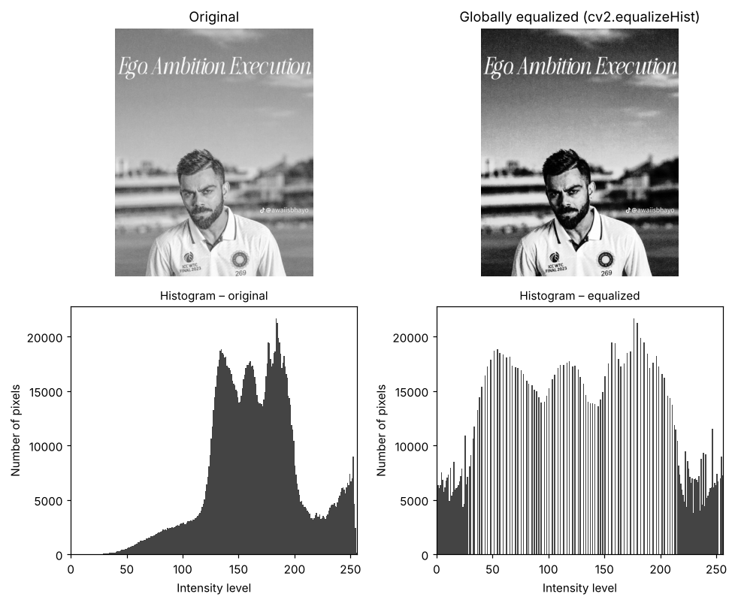
Figure 9. Original and globally equalized image with their histograms.
Table 17. Original vs. global equalization
Image | Mean | Std. dev. | Entropy (bits) | Std. dev. in smooth 16×16 patch | Fine-detail/noise measure
Original | 164.8567 | 40.054 | 7.2455 | 0.5286 | 1.2548
Equalized | 128.5012 | 73.5704 | 7.0228 | 1.0208 | 2.1758

Observation: Equalization stretched the narrow histogram over the full range: the standard deviation rose from 40.1 to 73.6 and the face, hair, beard, jersey and stadium structures show clearly more detail. The price is a much darker, heavier sky (mean 164.9 → 128.5), a comb-like histogram with gaps where levels were merged (entropy 7.25 → 7.02 bits) and stronger noise: the film grain in the smooth sky is amplified – in a smooth 16×16 patch the standard deviation rose from 0.53 to 1.02 and the fine-detail/noise measure from 1.25 to 2.18.

8. CLAHE (contrast-limited adaptive histogram equalization)
Task: Apply cv2.createCLAHE (clipLimit = 2.0, tileGridSize = (8, 8)) and compare with global equalization, especially across uneven lighting.

Dry run
Four-bin histogram [6, 2, 0, 0] with an absolute cap of 4: clip, redistribute the excess equally (fractions allowed), calculate the new CDF and explain why neighbouring tile mappings need interpolation.
Table 18. Dry run 8: clip, redistribute, new CDF (cap = 4, excess = 2, +0.5 per bin)
Bin | Original count | After clipping | + redistributed | New count | Cumulative | New CDF | CDF without clipping
0 | 6 | 4 | 0.5 | 4.5 | 4.5 | 0.5625 | 0.75
1 | 2 | 2 | 0.5 | 2.5 | 7 | 0.875 | 1
2 | 0 | 0 | 0.5 | 0.5 | 7.5 | 0.9375 | 1
3 | 0 | 0 | 0.5 | 0.5 | 8 | 1 | 1

Python verification (all passed):
- Clipped histogram is [4,2,0,0] with excess 2
- New histogram [4.5,2.5,0.5,0.5] and total count unchanged (8)
- New CDF [0.5625, 0.875, 0.9375, 1.0]

Clipping: bin 0 holds 6 counts, 2 more than the cap of 4, so 2 counts are removed. Shared equally over four bins this adds 0.5 to each bin, giving [4.5, 2.5, 0.5, 0.5] (the total stays 8). The new CDF is [0.5625, 0.875, 0.9375, 1.0] instead of [0.75, 1, 1, 1] without clipping: the first step of the mapping is smaller, so the dominant bin is stretched less and contrast amplification is limited.
Why interpolation is needed: CLAHE computes a separate mapping for every tile. Two neighbouring pixels on either side of a tile border would be mapped by different curves and could get clearly different outputs, producing visible block edges. OpenCV therefore blends the mappings of the four nearest tile centres with bilinear interpolation, so the transformation changes smoothly across the image.
Note: this is a simplified model. OpenCV redistributes integer counts (and may iterate), and the absolute cap used here is not the clipLimit parameter; for 64×64 tiles and 256 bins clipLimit = 2.0 corresponds to a cap of 2.0 × 4096 / 256 = 32 counts per bin.

Result on the image
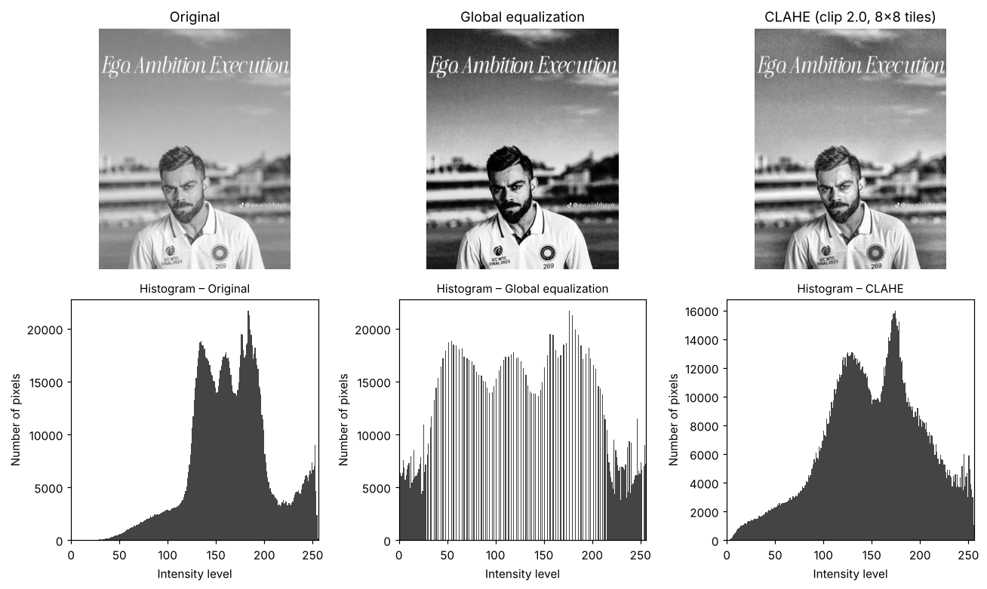
Figure 10. Original, global equalization and CLAHE (clipLimit 2.0, 8×8 tiles) with their histograms.
Table 19. Original vs. global equalization vs. CLAHE
Image | Std. dev. | Entropy (bits) | Smooth-patch std. dev. | Fine-detail/noise measure
Original | 40.054 | 7.2455 | 0.5286 | 1.2548
Global equalization | 73.5704 | 7.0228 | 1.0208 | 2.1758
CLAHE | 51.3368 | 7.6619 | 1.1446 | 2.439

Table 20. Local contrast (std. dev.) in the four quadrants – uneven lighting check
Image | Top-left | Top-right | Bottom-left | Bottom-right
Original | 25.2934 | 24.2153 | 48.7698 | 52.8601
Global equalization | 55.0589 | 53.8982 | 86.3374 | 90.211
CLAHE | 31.9448 | 35.236 | 64.9092 | 63.2215

Table 21. Mean intensity in the four quadrants
Image | Top-left | Top-right | Bottom-left | Bottom-right
Original | 161.3139 | 166.2016 | 165.0336 | 166.8777
Global equalization | 119.1702 | 131.5858 | 133.306 | 129.9428
CLAHE | 150.7263 | 153.0333 | 144.0246 | 155.1314

Observation: CLAHE splits the image into 8 × 8 = 64 tiles (each 181 × 145 pixels here – the tuple (8, 8) counts tiles, not pixels per tile) and limits the contrast gain of each tile (clipLimit = 2.0). The image is unevenly detailed: the top half is smooth sky (local standard deviation 24–25) while the bottom half contains the face, shirt and stadium (49–53). Global equalization applies a single curve: it multiplies the local contrast in every quadrant (to 54–90) but pulls the quadrant means down from about 161–167 to 119–133, giving a dark, harsh result. CLAHE raises local contrast more moderately (to 32–35 in the sky and 63–65 in the lower half) and keeps the quadrant means closer to the original (144–155), so the face and jersey gain detail without darkening the sky as much; it also has the highest entropy (7.66 bits). The cost is noise/texture amplification: the fine-detail/noise measure is 2.44 for CLAHE, 2.18 for global equalization and 1.25 for the original (the measure also counts real texture, so it cannot separate noise from detail).

9. Fixed binary thresholding
Task: Apply cv2.THRESH_BINARY at T = 127, display the binary image and report its unique values.

Dry run
Pixels [0, 80, 127, 128, 180, 255]: apply r > T → 255 else 0 for T = 127 and T = 180 and compare the white-pixel counts.
Table 22. Dry run 9: r > T → 255, otherwise 0
r | r > 127 ? | Output (T = 127) | r > 180 ? | Output (T = 180)
0 | No | 0 | No | 0
80 | No | 0 | No | 0
127 | No | 0 | No | 0
128 | Yes | 255 | No | 0
180 | Yes | 255 | No | 0
255 | Yes | 255 | Yes | 255

Python verification (all passed):
- T = 127 → [0,0,0,255,255,255] and equals OpenCV
- T = 180 → [0,0,0,0,0,255] and equals OpenCV (180 is NOT > 180)

The rule is a strict comparison r > T. For T = 127 the pixel 127 is not greater than 127 and becomes 0, while 128 becomes 255. For T = 180 the pixel 180 is not greater than 180 and becomes 0.
White-pixel count: T = 127 → 3 white pixels (128, 180, 255); T = 180 → 1 white pixel (255). Raising the threshold always reduces (or keeps) the number of white pixels.

Result on the image
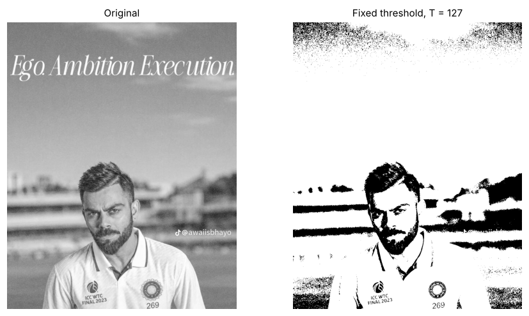
Figure 11. Original image and the fixed-threshold binary image (T = 127).
Python verification (all passed):
- Binary image contains only 0 and 255

Observation: The binary image contains only the values [0, 255] and 86.1 % of the pixels are white. Because this image is bright, T = 127 lies below almost all of the main histogram groups: the sky, the shirt, the stadium and most of the skin become white, and only the darkest parts (hair, beard, eyes, shadows and some grain at the top of the sky) remain black, so a fixed threshold separates the objects poorly.

10. Otsu thresholding
Task: Apply cv2.THRESH_BINARY with cv2.THRESH_OTSU, report the returned threshold and compare its mask with the fixed-threshold mask.

Dry run
Pixels [0, 1, 4, 5] (no rescaling): try T = 0…4, find w0, w1, μ0, μ1 and w0·w1·(μ0 − μ1)², choose the smallest T among ties, predict the mask and verify with OpenCV.
Table 23. Dry run 10: between-class variance for every candidate T
T | Class 0 (r ≤ T) | Class 1 (r > T) | w0 | w1 | μ0 | μ1 | w0·w1·(μ0 − μ1)²
0 | {0} | {1,4,5} | 0.25 | 0.75 | 0 | 3.3333 | 2.0833
1 | {0,1} | {4,5} | 0.5 | 0.5 | 0.5 | 4.5 | 4
2 | {0,1} | {4,5} | 0.5 | 0.5 | 0.5 | 4.5 | 4
3 | {0,1} | {4,5} | 0.5 | 0.5 | 0.5 | 4.5 | 4
4 | {0,1,4} | {5} | 0.75 | 0.25 | 1.6667 | 5 | 2.0833

Python verification (all passed):
- Tie at T = 1, 2, 3 (value 4.0); smallest T = 1
- Predicted mask [0,0,255,255] equals the OpenCV mask
- OpenCV returns the same threshold (1)

T = 1, 2 and 3 all split the pixels as {0, 1} | {4, 5} because no pixel has a value of 2 or 3, so they give the same between-class variance 4.0, the maximum. The smallest tied threshold, T = 1, is chosen. T = 0 and T = 4 both give only 2.0833.
Predicted mask with r > 1: [0, 0, 255, 255]. OpenCV returns the threshold 1.0 and exactly the same mask.

Result on the image
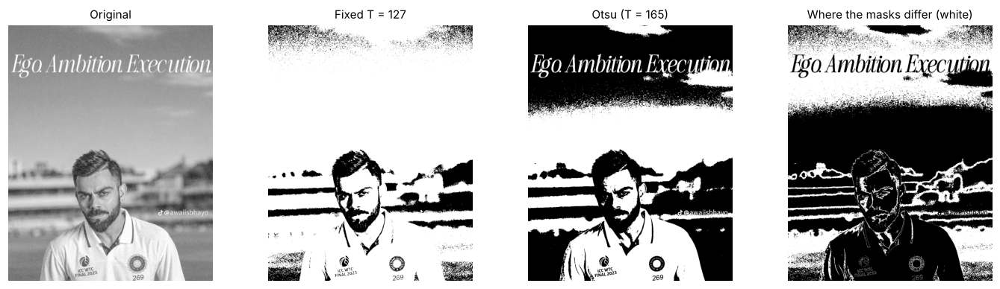
Figure 12. Original, fixed (T = 127), Otsu and the pixels where the two masks differ.
Observation: Otsu chose T = 165 automatically by maximising the between-class variance; it lies between the middle and the upper histogram peaks and gives 48.7 % white pixels against 86.1 % for T = 127. The two masks agree on 62.6 % of the pixels; the 629,810 pixels that differ are exactly those with values from 128 to 165, which are white for the fixed threshold but black for Otsu. Otsu's mask separates the bright shirt, clouds and lettering from the darker sky, face and background better than the fixed threshold, because T was taken from this image's own histogram instead of being guessed.

11. Adaptive Gaussian thresholding
Task: Apply cv2.adaptiveThreshold (Gaussian weighting, binary output, blockSize = 11, C = 2) and compare with the fixed and Otsu thresholds.

Dry run
Neighbourhood [[100,100,100],[100,120,140],[140,140,140]] with Gaussian weights [[1,2,1],[2,4,2],[1,2,1]]/16: weighted mean, T = mean − 2, classify the centre pixel and a pixel equal to T.
Table 24. Dry run 11(a): pixel × Gaussian weight (weights = [1 2 1; 2 4 2; 1 2 1] / 16)
Row | Col 1 | Col 2 | Col 3 | Row sum
1 | 6.25 | 12.5 | 6.25 | 25
2 | 12.5 | 30 | 17.5 | 60
3 | 8.75 | 17.5 | 8.75 | 35

Table 25. Dry run 11(b): threshold and classification
Quantity | Value
Weighted mean | 120
C | 2
T = mean − C | 118
Centre pixel r | 120
r > T ? | Yes
Output for the centre pixel | 255
A pixel with r = T (118) | 118
r > T ? | No
Output for that pixel | 0

Python verification (all passed):
- Weighted mean = 120 and T = 118
- Centre pixel 120 > 118 → 255, equal-to-T pixel → 0
- OpenCV (blockSize = 3, C = 2) also gives 255 for the centre pixel

Weighted mean = (400 + 960 + 560) / 16 = 120 (row sums of the product table: 25 + 60 + 35). T = 120 − 2 = 118.
The centre pixel 120 > 118, so its output is 255. A pixel equal to T (118) is not greater than T, so its output is 0 – the comparison is strict.
OpenCV (blockSize = 3, C = 2) gives 255 for the centre pixel, which agrees with the hand calculation. For the image task blockSize = 11 is used.

Result on the image
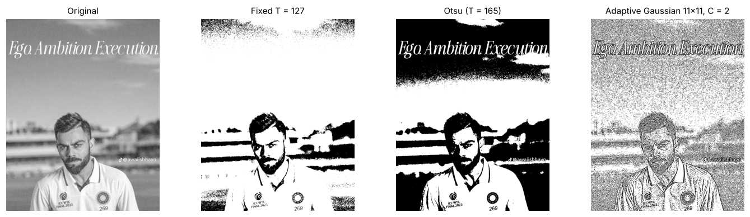
Figure 13. Original, fixed, Otsu and adaptive Gaussian (11×11, C = 2) thresholding.
Table 26. Comparison of the three thresholding methods
Method | Threshold | % white pixels | % agreement with adaptive
Fixed (T = 127) | global, 127 | 86.0782 | 75.8127
Otsu | global, 165 | 48.6857 | 62.4808
Adaptive Gaussian (11×11, C = 2) | local, per pixel | 73.8123 | 100

Observation: The adaptive result has 73.8 % white pixels and agrees with the fixed and Otsu masks on 75.8 % and 62.5 % of the pixels. Each pixel is compared with the Gaussian-weighted mean of its own 11 × 11 neighbourhood minus 2, so the output follows local edges and fine structure (eyes, eyebrows, hair, beard, lettering, logos) whatever the absolute brightness is, while smooth areas such as the sky and the blurred stadium become mostly white with salt-and-pepper speckle caused by the film grain. Local thresholds help when illumination is uneven (shadows, gradients, scanned documents) or when fine detail matters; global thresholds are better when the lighting is uniform and the histogram has clearly separated groups.

Key concepts
Clipping. Clipping forces every value that falls outside the valid range 0–255 to the nearest limit (negative values become 0, values above 255 become 255; np.clip). It keeps the order of the grey levels but destroys the differences between all values that are pushed to the same limit, so detail is lost in shadows and highlights.
Overflow. uint8 arithmetic is modulo 256: 240 + 40 gives 24 and 30 − 40 gives 246 instead of 255 and 0. NumPy does not warn for arrays. The safe procedure is to convert to a wider type (int16 or float) before the arithmetic, clip to 0–255 and only then convert back to uint8 (conversion of floats truncates the fraction).
Brightness versus contrast. Brightness is an additive shift (s = r + β): every pixel moves by the same amount, so the mean changes but the differences between pixels stay the same, until clipping occurs. Contrast is a multiplicative change of the spread (s = αr, or s = (r − 128)α + 128 around a pivot): it changes the differences between pixels. Multiplying from zero also moves the mean, so it mixes both effects, while the centered form keeps the pivot 128 fixed.
Gamma convention. This lab uses s = 255 (r/255)^γ: γ < 1 expands the dark values and brightens the image, γ > 1 compresses them and darkens it, and 0 and 255 never change. Other sources (display gamma, some libraries) use the inverse exponent 1/γ, which reverses the meaning of γ < 1 and γ > 1.
Global versus local enhancement. Global methods (equalizeHist) apply one mapping to the whole image; they are quick and suitable when the lighting is fairly uniform, but they can amplify noise and fail in unevenly lit scenes. Local methods (CLAHE) compute a mapping per tile with a limited contrast gain, which brings out detail in both dark and bright areas at the cost of more texture/noise amplification and two parameters (clip limit, tile grid).
Global versus local thresholding. Global thresholds (fixed or Otsu) are useful when the background is evenly lit and the histogram shows separated groups; Otsu chooses the threshold automatically. Adaptive thresholds compare each pixel with its local mean minus a constant and are useful for uneven illumination, shadows and documents, but they respond to every small local change, so smooth areas and noise can look speckled; blockSize and C must be tuned.

Conclusion
Brightness and contrast changes, the negative and gamma correction were implemented safely with wider arithmetic types and clipping; their dry runs were calculated by hand and matched Python exactly. Histogram equalization and CLAHE improved the visibility of detail, with CLAHE giving a more natural result than global equalization while still amplifying grain, and the fixed, Otsu and adaptive thresholds showed when a global or a local decision is more suitable. All 37 verification checks in the notebook passed.

