BIA-4530
Milestone: 2 Analysis
- Description:
- Formula 1 (F1) teams manage multiple drivers and keep their record across international locations and need a centralized database to track each driver’s profile, nationality, team affiliation and salary details.
In my module, before it was difficult to compare driver’s salaries, compare why the salary has been differentiated and if a particular team has an impact on the salary ranges.
My objective is to create a database that will help organize all drivers, their teams and salary information in a structured way that will support queries and visualization for business analysis.
I will look into team’s information about how they are managing their drivers, their background, and their salary trends. I will connect relationship of a team with its drivers.
One team= Many drivers
One driver= One or many salary records.

- Site references, resources:
- I gathered information from F1 official team’s driver roster and their official newsletter. I also used sources like Forbes and Motorsports for salary information.

- Discussion of data gathered, sources, quantity:
- My data so far:
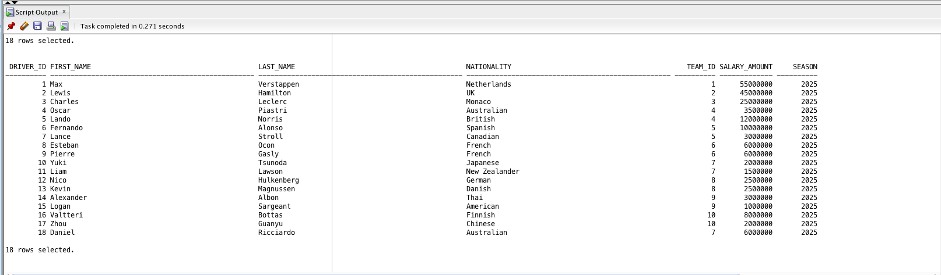
- Sources:
Forbes
Official F1 pages
Wikipedia
Sports newsletter

- Preliminary ERD:
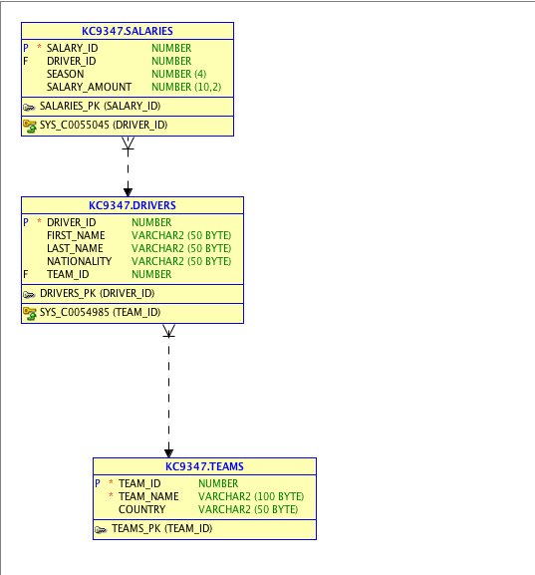

- Journal time
- Defined business problems/key entities- 0.75 hour
- Created and cleaned dataset in SQL- 1 hour
- Added salaries and verified dataset- 0.50 hour
- Imported dataset into data modeler- 0.75 hour
- Defined structure- 1 hour
- Wrote milestone analysis- 0.50 hour

